A Deep Learning Framework for Cross-Material Multiaxial Fatigue Life Prediction: From Feature Fusion to Transfer Learning

Peng Zhang^{1#} and Keke Tang¹*
¹School of Aerospace Engineering and Applied Mechanics, Tongji University, Shanghai 200092, China

# Presenter: peng05@tongji.edu.cn
*Corresponding author: kktang@tongji.edu.cn
Abstract:
This study presents a deep learning framework for cross-material multiaxial fatigue life prediction that addresses the challenge of predicting fatigue behavior across different metallic materials with limited experimental data. The methodology employs a dual-stream feature fusion architecture integrating temporal loading path characteristics with material-specific properties, followed by a feature-discriminative transfer learning strategy. The framework leverages Temporal Convolutional Networks for extracting features from loading sequences while incorporating material properties as structured inputs. A two-stage fine-tuning strategy with material similarity weighting enables data-efficient adaptation, maintaining high prediction accuracy with minimal target material data (10-20% of datasets). Validation across five metallic alloy categories demonstrates superior performance compared to conventional approaches, with multi-source transfer learning achieving robust cross-material generalization while reducing extensive testing requirements for new materials.
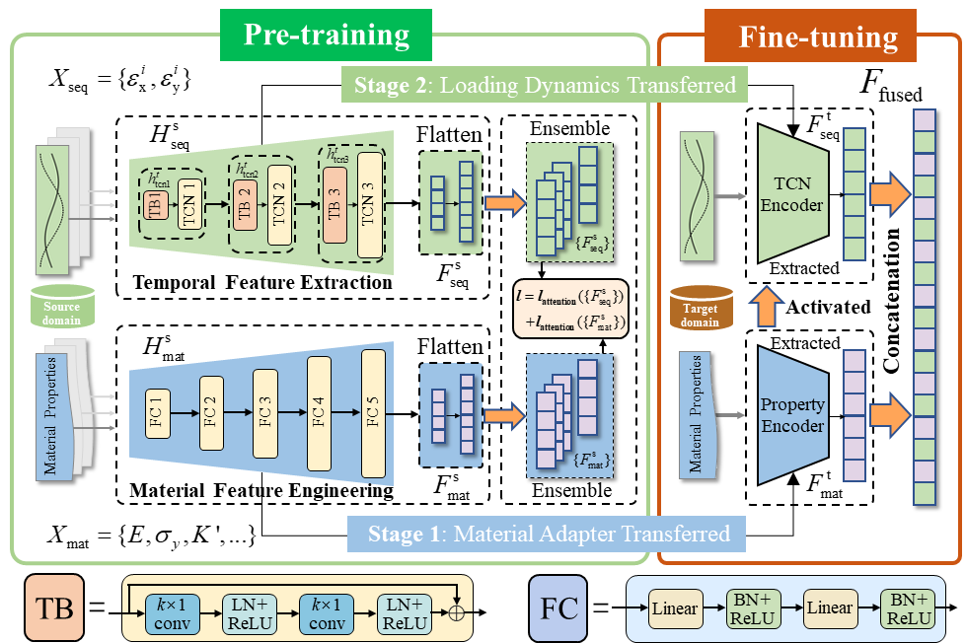
Figure 1. Dual-stream feature fusion framework with two-stage transfer learning strategy.

References
Zhang P, Wang A, Tang K. Cross-material transfer learning for multiaxial fatigue prediction: A data-efficient adaptive framework. Engineering Fracture Mechanics, 2025: 111372.
Zhang P, Tang K. A TCN-based feature fusion framework for multiaxial fatigue life prediction: Bridging loading dynamics and material characteristics. International Journal of Fatigue, 2025, 197: 108915.

