Oscillatory dynamics of Li-ion battery electrode governed by microstructure and kinetics: A phase-field study

E. Parma^{#,1,2}, Bai-Xiang Xu^{*,2}, and R. Nagao¹
¹Institute of Applied Mechanics, TU Darmstadt, Darmstadt, Germany
²Institute of Chemistry, University of Campinas, Campinas, Brazil

*Corresponding author: xu@mfm.tu-darmstadt.de
#Presenter: eduardoopfparma@gmail.com

Li-ion batteries were shown to display spontaneous voltage oscillations during their galvanostatic operation [1]. This behavior arises from an uneven current distribution, with few particles experiencing disproportionately large current densities [2,3]. Studying this process has potential not only for revealing the fundamentals of phase-separation in Li-ion battery electrodes but also for developing new electrode characterization protocols. This work explores these two aspects by employing phase-field simulations. We demonstrate that oscillation period changes with (dis)charge capacity, and this trend is determined by the particle radius distribution, what could be used to gain information from the electrode microstructure. Oscillation period and amplitude data also displayed linear relationships with inverse of the exchange current density, suggesting that oscillations could be used for estimating electrode kinetics. Overall, we find that characterizing the oscillations open a new approach for non-invasive electrode characterization methods and health monitoring.
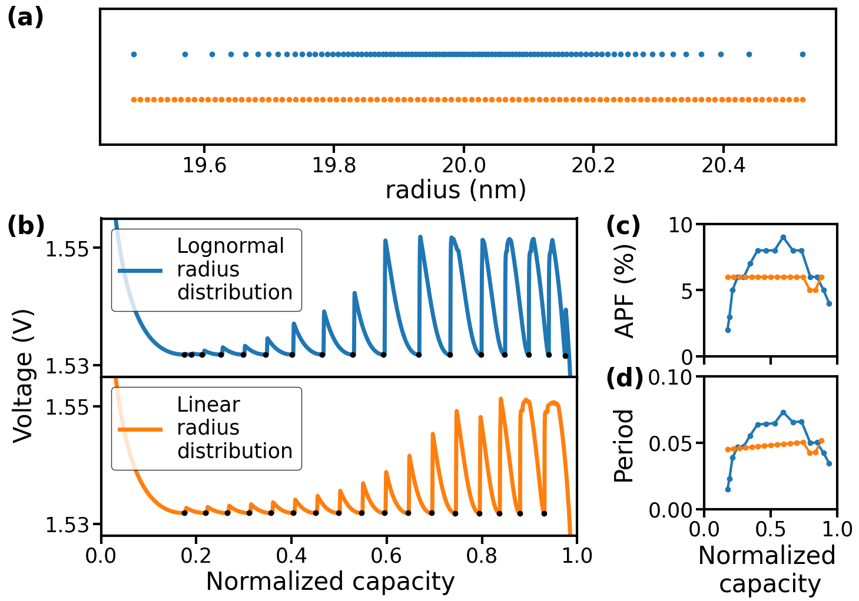
Figure 1. Dependency of Active Particle Fraction (APF) and oscillation period on particle radius distribution.

Acknowledgements
CNPq (421313/2023-4), FAPESP (20/12632-5, 2023/08663-0 and 24/03807-7), Shell (Division 1 – Dense Energy Carriers – 17/11986-5) and ANP.

References
[1] D. Li, Y. Sun, Z. Yang, L. Gu, Y. Chen and H. Zhou (2018), “Electrochemical Oscillations in Li-ion Batteries”, Joule, 2, 1265–1277
[2] E. Parma, and R. Nagao (2023) “Modulating Li-ion battery voltage oscillations in phase field simulations”, J. Energy Storage 2023, 73, 109190
[3] E. Parma, G. F. Costa and R. Nagao, “Modeling Li-ion battery voltage oscillations and the impact of exchange current density on oscillation properties”, J. Phys. Chem. C 2022, 126, 29, 11900–11906

