Multiscale Simulation of Hysteresis and Eddy-Current Losses in Electrical Steels

E. Foya¹, Y. Yang¹, M. Fathidoost¹, B.X. Xu¹
¹Mechanics of Functional Materials Division, Institute of Materials Science, Technical University of Darmstadt, Darmstadt, Germany

*Corresponding author: yangyiwei.yang@mfm.tu-darmstadt.de
# Presenter: eren.foya@tu-darmstadt.de

The improvement of efficiency and optimal design of magnetic core materials requires a fundamental understanding of magnetic and eddy current losses, as well as their dependence on microstructural features such as defects and grain morphology. To address this, physics-based, microstructure-informed multiscale simulations are employed, with microstructural data extracted from SEM images. Through the combination of micromagnetic simulations and computational homogenisation, the micro–macro magnetic hysteresis behaviour and effective conductivities of Fe–Si electrical steels are evaluated. In this way, key microstructural parameters—including grain size, boundary phases, and morphology—are identified as critical factors influencing performance. To mitigate the high computational cost of micromagnetic simulations, a machine-learning-based hysteron framework is introduced. Trained on high-throughput micromagnetic simulation data, these hysterons are incorporated into the homogenisation scheme, allowing efficient determination of microstructure-informed effective material properties and providing new insights into the design of low-loss electrical steels.

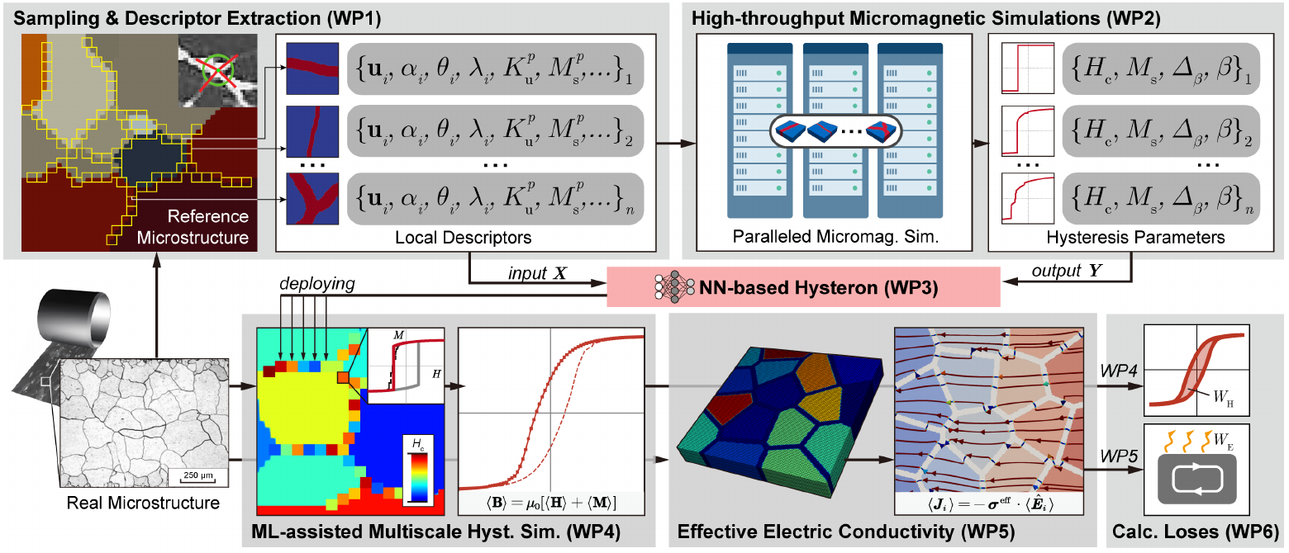
Figure 1. ML-assisted multiscale simulation framework for calculating hysteresis and eddy current losses of magnetic core materials.

References
Gusenbauer, M., H. Oezelt, J. Fischbacher, et al. (2020), “Extracting local nucleation fields in permanent magnets using machine learning.” npj Comput Mater 6, 89.
Kumari, G., T.Q. Pham, H. Suen, T. Rahman, P. Kwon, S.N. Foster and C.J. Boehlert (2023), “Improving the soft magnetic properties of binder jet printed iron-silicon alloy through boron addition.” Mater. Chem.
Phys. 296, 127181.
Kuehn, P., Y. Yang, G. Chen, S.N. Foster, H. Egger and B.-X. Xu (2025), “Multiphysics simulations of microstructure influence on hysteresis and eddy current losses of electrical steel.” arXiv: 2502.01559.
Yang Y., et al. (2024), “Coercivity influence of nanostructure in SmCo-1:7 magnets: Machine learning of high- throughput micromagnetic data. 2024. arXiv: 2408.03198.
Yang, Y., P. Kuehn, M. Fathidoost, and B.-X. Xu (2023), “Micromagnetics and Multiscale Hysteresis Simulations of Permanent Magnets” COMPEL 42.5, 993-1006.

