Revealing in-plane geometry effect mechanism on fatigue crack growth

Guangxv Chen, ^{1,2}, Zhenduo Zhang, ^{1,2}, Xianqiao Wang, ³, Keke Tang, ^{1,2,∗}

¹School of Aerospace Engineering and Applied Mechanics, Tongji University, Shanghai 200092, China
²Key Laboratory of AI-aided Airworthiness of Civil Aircraft Structures, Civil Aviation Administration of
China, Tongji University, Shanghai, 200092, China
³School of ECAM, University of Georgia, Athens, GA 30602, USA

*Corresponding author: kktang@tongji.edu.cn
# Presenter: chenguangxv@tongji.edu.cn

Existing fatigue assessment procedure universally relies on the extrapolation of da/dN - ΔK curve from standard specimen to real-world structure. However, extensive experimental evidence has shown that this curve exhibits marked shifts depending on structure geometry. This kind of geometry effects not only undermines the reliability of the well-established assessment method, but also raises again the question of what a proper crack driving force parameter is. Unfortunately, the underlying mechanisms of geometry effect remain poorly understood, with particularly conflicting observations regarding in-plane geometry effects. To address this, the present study developed a dual-scale computational framework that simulates micro-structure evolution at the crack tip under different in-plane geometry effect. This framework systematically revealed the mechanism of geometry effects and evaluated mainstream crack driving force parameters. The results shown that the observed experimental discrepancies can be reconciled through our findings, and CTOD and equivalent plastic strain were identified as superior crack driving force parameters compare to others. Furthermore, crack closure was found to play no significant role in slip field evolution, challenging the validity of numerous existing crack closure models.
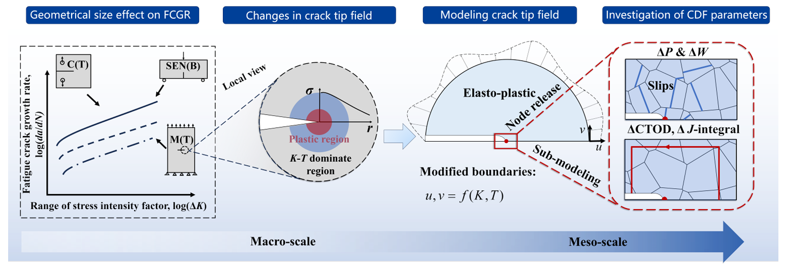
Figure 1. Work flow of present work

References
Pandey V., S. Samant, I. Singh and B. Mishra (2020), “An improved methodology based on continuum damage mechanics and stress triaxiality to capture the constraint effect during fatigue crack propagation,” International Journal of Fatigue, 140, 105823.
Huang X., H. Qi, S. Li, X. Yang and D. Shi (2025), “A fatigue crack growth model considering in-plane constraint effects”, Engineering Fracture Mechanics, 320.

