Enhancing compressive strength of composite lattice intersection by symmetric ply interleaving

Yongqi Liu#,¹, Wenkai Chang², Bingnong Jiang², Shuhua Peng², Shuai He*,², Guohua Nie*,², Chun Hui Wang*,²
¹School of Aerospace Engineering and Applied Mechanics, Tongji University, Shanghai, China
² School of Mechanical and Manufacturing Engineering, The University of New South Wales, Sydney, Australia

*Corresponding author: shuai.he@unsw.edu.au, ghnie@tongji.edu.cn, chun.h.wang@unsw.edu.au
# Presenter: 872067058@qq.com

Composite lattice and lattice-stiffened structures offer significant weight-saving potential over traditional stringer-stiffened counterparts, owning to their superior specific stiffness and strengths. However, conventional lattice nodes rely on ply overlapping or drop-offs, leading to fibre waviness and discontinuities that compromise compressive strength. This paper introduces a novel symmetric ply interleaving concept for lattice nodes that offers enhanced strength performance over traditional ply-overlapping and discontinuous designs. The proposed symmetric lattice intersections can be fabricated through a specially designed single-sided mould without compromising mechanical performance, providing a new direction for the simplified manufacturing of symmetric tapered laminates. Experimental results show that, for an 8-ply laminate lattice, the symmetric design improved the compressive strength by 114% over the discontinuous design and 17% over the asymmetric design. A computational model was developed for the uniaxial unit cell to analyse the influence of rib thickness on strength and progressive failure mechanisms. For ribs thinner than 12 plies, symmetric interleaved nodes fail by buckling, with matrix damage and delamination initiating in the tapering region. As the rib thickness increases, the nodes can maintain structural stability until fibre compression failure. For ribs with 16 plies, the symmetric design achieved 84% and 50% higher strength than the asymmetric and discontinuous design, respectively. Extending the model to lattice structures, using a Kagome-shaped unit cell, revealed improvements of 100% and 33% over the asymmetric and discontinuous configurations when the rib thickness increased to 26 plies. These findings provide valuable insights for optimising and manufacturing of high-performance composite lattice structures.

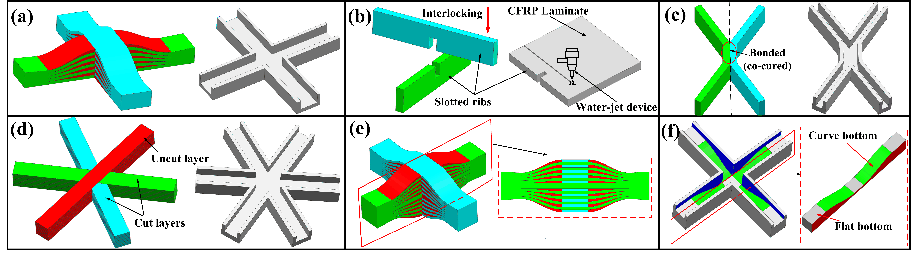
Figure 1. Intersections of composite lattice structures with different fabrication methods: (a) asymmetric ply overlap and the flat-bottomed mould, (b) interlocking method and the machining process of slotted ribs, (c) X-lattice composite structure and the design of mould, (d) ply drop-off and the corresponding mould, (e) the proposed symmetric ply interleaving and (f) the proposed curve-bottomed mould designed for symmetric lattice intersections.

Acknowledgements
The first author acknowledges the China Scholarship Council (CSC) for providing funds (No. 202306260087) to support his study and research at the University of New South Wales, Sydney, Australia.

