Influence of geometry and polarization parameters on piezoelectric response of polypropylene piezoelectrets with an arch structure
Z. Ruan#¹, X. Zhang*¹
¹School of Physics Science and Engineering, Tongji University, Shanghai, China
*Corresponding author: x.zhang@tongji.edu.cn
# Presenter: ruanzehai@tongji.edu.cn
Flexible piezoelectret sensors offer significant advantages for electronic skin applications, requiring no external power and showing promise in robotic perception. However, the study of the influence of geometry and polarization parameter on piezoelectrets remains limited. This study designed and fabricated polypropylene (PP) piezoelectrets with an arch structure. The piezoelectric response of such PP piezoelectrets was analyzed theoretically and simulated with Comsol Multiphysics software. Experiments were conducted to verify their accuracy.
The results show that the arched PP piezoelectret base on 38 um thick PP films can be fabricated via two process routes: fusion-bonding followed by contact polarization, or polarization followed by fusion-bonding. In contact polarization, piezoelectricity is achieved only when the voltage reaches the critical value V_{B} (calculated as 2.37 kV for an air layer thickness of 200 μm and ε_{p} = 2.3). The d₃₃ coefficient increases with the polarization voltage and stabilizes after reaching 2 V_{B} (4.76 kV). For the pre-polarization process, a built-in electric field of at least 2352 V is required (corresponding to polarizing the top and bottom PP films to ±1176 V each). Furthermore, the d₃₃ coefficient decreases with increasing air layer thickness but increases with unit width. The results are reasonably agreed with the theoretical prediction and simulation results.
In addition, the fabricated PP piezoelectret films are applied in electronic skin. Experiments demonstrate that the device exhibits excellent multi-directional force detection performance and response characteristics, highlighting significant application potential.
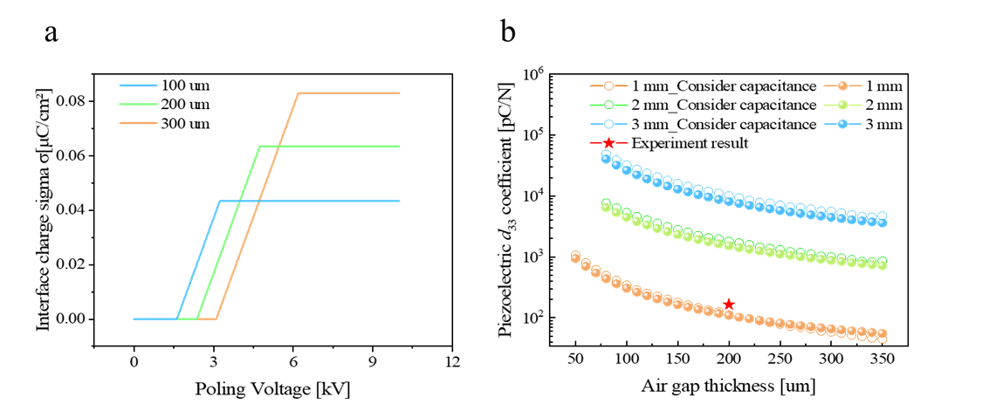
Figure 1. (a) Relationship between contact polarization voltage and interfacial charge density. (b) Relationship between the d₃₃ coefficient and air layer thickness in arched PP piezoelectrets
Acknowledgements
This work is supported by the National Natural Science Foundation of China (NSFC, Grant Nos. 12374451 and 62201392)
References
G.M. Sessler (1987), Physical principles of electrets, in: G.M. Sessler (Ed.), Electrets, Springer-Verlag, Berlin, Heidelberg.
H.v. Seggern, S. Zhukov, S. Fedosov (2011), “Importance of geometry and breakdown field on the piezoelectric d₃₃ coefficient of corona charged ferroelectret sandwiches”, IEEE Transactions on Dielectrics and Electrical Insulation 18 (1) 49-56.

