**Ultrahigh Capacitive Energy Storage in a Heterogeneous PbHfO3/SrHfO3 Composite**

**Yan Li¹, and Tongqing Yang*,1**

¹Key Laboratory of Advanced Civil Engineering Materials of the Ministry of Education, Functional Materials Research Laboratory, School of Materials Science and Engineering, Tongji University, Shanghai, China

*Corresponding author: Yangtongqing@tongji.edu.cn

# Presenter: 2011222@tongji.edu.cn

Dielectric capacitors capable of rapid charge–discharge operations are crucial for pulsed power and high-energy electronic systems, yet their recoverable energy density (*W*rec) remains far below that of electrochemical devices due to the intrinsic trade-off between polarization (Δ*P*) and breakdown strength (*E*B). Here, a heterostructure strategy is proposed to overcome this limitation by integrating antiferroelectric PbHfO3 (PH) and linear SrHfO3 (SH) into a laminated architecture. By optimizing the PH/SH thickness ratio, tailored *P-E* loops can be constructed, featuring a large Δ*P*, low remanent polarization (*P*r), and enhanced *E*B. Finite-element analysis and spectroscopic measurements further reveal that the strong dielectric and electron affinity mismatch between PH and SH layers induces interfacial deep traps and Maxwell–Wagner–Sillars polarization, which promote charge trapping and electric-field redistribution, thereby suppressing carrier injection and electrical breakdown. Benefiting from these synergistic effects, the optimized PH/SH laminated ceramic achieves an ultrahigh breakdown strength of 75 kV·mm-1 and an outstanding recoverable energy density of 20.2 J·cm-3 with an efficiency of 83.5%. This study demonstrates a viable pathway for reconciling the long-standing Δ*P*-*E*B trade-off in ceramic dielectrics through the combination of phase-field-guided structural optimization and heterointerface engineering, providing design insights for next-generation high-performance energy storage capacitors.

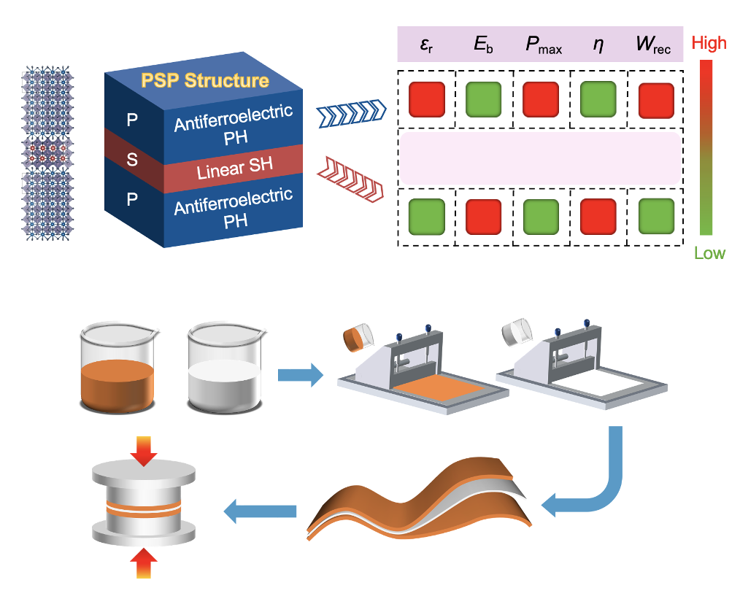

(b)

(a)

Figure 1. a) Schematic illustration of the dielectric energy-storage characteristics of the PSP structure. b) Fabrication process of the single-layer and trilayer compositesSmart material deformation analysis.

**References**

D. Li, X. Zeng, Z. Li, Z.-Y. Shen, H. Hao, W. Luo, X. Wang, F. Song, Z. Wang, Y. Li, Progress and Perspectives in Dielectric Energy Storage Ceramics, J. Adv. Ceram. 10 (2021) 675−703.

Q. Li, L. Chen, M.R. Gadinski, S. Zhang, G. Zhang, H.U. Li, E. Iagodkine, A. Haque, L.-Q. Chen, T.N. Jackson, Q. Wang, Flexible High-Temperature Dielectric Materials from Polymer Nanocomposites, Nature 523 (2015) 576–579.

X. Liu, J. Zhu, Y. Li, T. Yang, X. Hao, W. Gong, High-Performance PbZrO3-Based Antiferroelectric Multilayer Capacitors Based on Multiple Enhancement Strategy, Chem. Eng. J. 446 (2022) 136729.

H. Wang, Y. Liu, T. Yang, S. Zhang, Ultrahigh Energy-Storage Density in Antiferroelectric Ceramics with Field-Induced Multiphase Transitions, Adv. Funct. Mater. 29 (2019) 1807321.

W. Chao, J. Wei, T. Yang, Y. Li, Phase Transition Behavior of Pb(Hf, Sn, Ti, Nb)O3 Ceramics at Morphotropic Phase Boundary, J. Am. Ceram. Soc. 103 (2020) 2185–2192.

J. Wei, T. Yang, H. Wang, Excellent Energy Storage and Charge-Discharge Performances in PbHfO3 Antiferroelectric Ceramics, J. Eur. Ceram. Soc. 39 (2019) 624–630.

Y. Li, T. Yang, X. Liu, Improving Energy Storage Properties of PbHfO3-Based Antiferroelectric Ceramics with Lower Phase Transition Fields, Inorg. Chem. Front. 11 (2024) 196.