**CARR Pricing**

The Pricing Model:

Include three tabs for each rate type: Self-Pricing, Import Rates, View Rates



* Self-Pricing: The CARR pricing model will have a Self-Pricing tab, when applicable, which will mimic the self-pricing logic currently available in the CARR.
* Import: Whether US Pricing or Self Pricing, the Pricing department will generate the final approved rates outside of the CARR and import the rates. The import function will use a standard Excel template for each type of rating. The pricing user will browse to the file and import the rates.
* View: The View Rates tab is where the users can view the final rates imported by pricing.

In the Shipping Profile, the selection can be made for the user to select US Pricing or Self Pricing. This selection will only be available if the estimated revenue falls withing the pre-defined threshold, otherwise the pricing will automatically be defined as US Pricing.

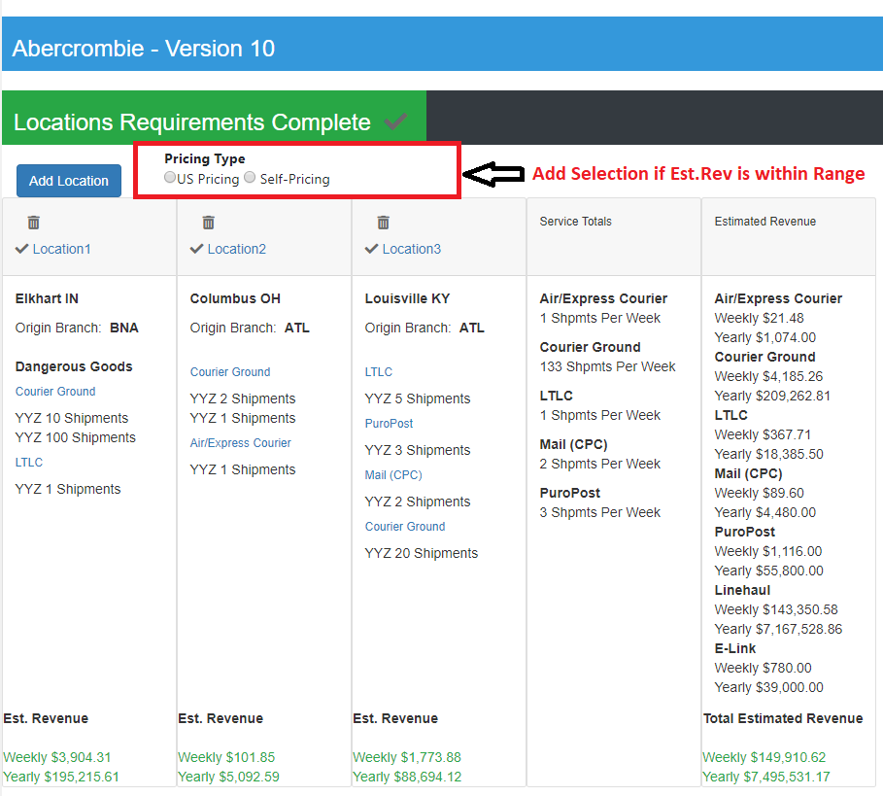

**Courier Pricing**

The Courier Pricing screen will have three tabs, Self-Pricing, Import Rates and View Rates.

**Self-Pricing Tab**

The Self-Pricing tab is hidden if this not selected on Shipping Profile

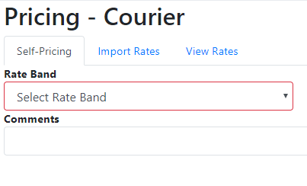

**Import Rates Tab**

The Import Rates Tab can only be viewed/accessed by Pricing users. Standard Template must be used to upload rates.

The template format is displayed on the page for reference. The user navigates to the Excel file for upload. Rates are imported into the database.

The Import Rates screen will have to accommodate for the various Courier Rate Templates – 6 zone, 33 zone, Point to Point.

**View Rates Tab**

This tab shows a table export of the rates which are uploaded by the pricing department.

**LTL Pricing**

The LTL Pricing screen will have a tab for selecting the LTL Induction Pricing. Then for each induction selected, there will be three tabs: Self-pricing, Import Rates and View Rates.

The Self-Pricing Tab is hidden is this is a US Pricing solution.

The Import Rates tabs are viewed and accessible only to Pricing users.

The View Rates tabs are where the users view the rates imported by pricing.

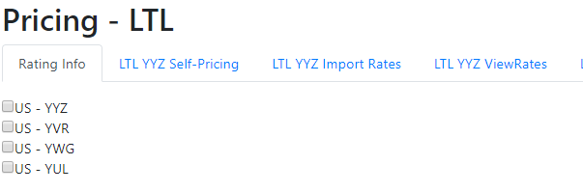

**CPC Pricing**

The CPC Pricing screen will contain tabs for Self-Pricing, Import Rates and View Rates for both CPC Expedited and CPC XpressPost.

The Self-Pricing Tab is hidden is this is a US Pricing solution.

The Import Rates tabs are viewed and accessible only to Pricing users.

The View Rates tabs are where the users view the rates imported by pricing.

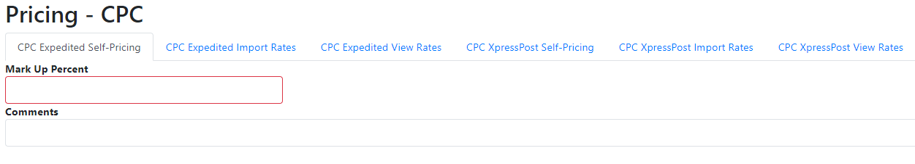

**PuroPost Pricing**

The PuroPost Pricing screen will have tabs to Import and View rates for both PuroPost and PuroPost Plus.

The Import Rates tabs are viewed and accessible only to Pricing users.

The View Rates tabs are where the users view the rates imported by pricing.

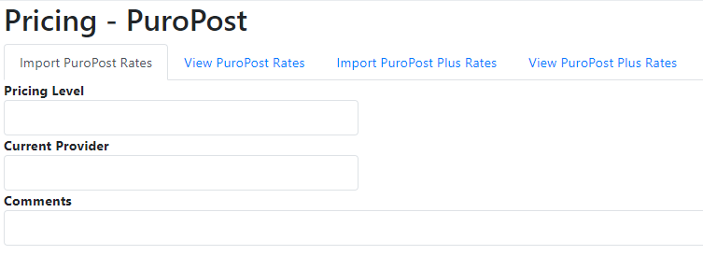

**Linehaul Pricing**

The Linehaul pricing screen will be a little different since the rates are only one line. The Linehaul pricing screen will show a table of the linehaul pricing that has been created from the Linehaul Pricing tool.

Pricing Users can edit, delete and add to this table. When adding a row to this table, a popup screen will be displayed, and the user will manually enter the values.

