Moving Cloud Reasoning Based on the KSI Principle for Inverted Pendulum Stabilization

Abstract
We investigate a moving-cloud reasoning method based on the KSI principle for stabilization of an inverted pendulum. The method represents uncertain concepts using expected value, entropy, and hyper-entropy, estimates the movement between an antecedent cloud and an observation cloud, and transfers that movement to a consequent. We separate cloud geometry, stochastic perturbation, rule aggregation, and controller dynamics so that the reasoning algorithm can be inspected independently of the plant. The movement equation is expressed as a product of antecedent displacement and a stochastic factor; this makes the zero-displacement condition explicit. Pseudocode details cloud preparation, sample accumulation, multi-rule evaluation, control execution, and experimental scoring. The reported aggregate measurements give 742 ms for 20 operations, compared with 2058 ms for the preceding moving-cloud method and 1375 ms for T–S cloud modeling. These imply time reductions of 63.95% and 46.04%. The reported hyper-entropy intervals have widths 0.47 and 0.19, a ratio of 2.47. Recalculation of the tabulated transient results shows lower overshoot in the four numerical comparison cases, but a 6.40% increase in pendulum transient time at He = 0.14. The evidence therefore supports a favorable aggregate computation–performance trade-off in the recorded cases, rather than uniform improvement or a formal stochastic-stability guarantee. Exact reproduction still requires the random-number operator, complete controller matrices, timing environment, and raw experimental records.
Keywords: KSI principle; moving-cloud reasoning; compensating inference; hyper-entropy; inverted pendulum; fuzzy control; stochastic reasoning

1 Introduction
An uncertainty-aware controller must distinguish uncertainty in the meaning of a rule from variability in the measurements supplied to that rule. Fuzzy sets describe graded membership in a concept [1, 2], whereas a cloud model introduces stochastic variability into the qualitative-to-quantitative relationship. Its numerical characteristics are an expected location Ex, an entropy descriptor En, and a hyper-entropy descriptor He [3]. This representation is attractive when an operator’s linguistic description, such as “small positive angle,” is not adequately represented by a single fixed membership curve.
For closed-loop control, representing uncertainty is only the first requirement. The reasoning procedure must also have a clear output meaning, limited latency, predictable behavior at rule boundaries, and a relationship to the stability analysis of the plant. A cloud simulation can generate many drops, but more drops do not automatically yield a better controller. They can reduce Monte Carlo error in the reasoning estimate while increasing computation time and delay. The cloud representation, inference operator, and feedback controller must therefore be evaluated together.
The KSI principle develops the moving or compensating view of fuzzy reasoning. The compensating method of Kwak and colleagues [4], the subsequent distance-measure formulation [5], and the moving-distance fuzzy modus ponens/tollens study [6] provide the conceptual context. Their reductive objective is that an observation identical to a rule antecedent should reproduce the corresponding consequent. This is a property of a specified inference construction. It should not be generalized into a claim that every conventional fuzzy controller lacks logical consistency; approximate reasoning methods differ in their implication, aggregation, and matching definitions [7].

1.1 Developments in KSI reasoning and fuzzy control through 2026
The 2025 interval T–S study extends moving amounts to interval membership functions and evaluates the resulting model on turf-color data [8]. In August 2026, Kwak and colleagues published an LCM-based fuzzy modus ponens/tollens framework that aligns fuzzy vectors of unequal dimension and links distance-driven reasoning to fuzzy control [9]. These developments are directly relevant to the present inference mechanism. They do not establish stochastic-cloud properties automatically: interval endpoints and random cloud descriptors require different definitions and proof conditions.
The 2023 KSI preprint on optimal fuzzy modus ponens and tollens provides an iterative moving-difference formulation [10]. It is cited as a preprint, with its DOI and version retained, rather than described as a peer-reviewed journal result. An earlier extended-distance study is likewise available as an arXiv preprint [11]. Together with the peer-reviewed interval and LCM work, these sources motivate a precise distinction between a reasoning principle, a concrete numerical algorithm, and an independently reproducible control implementation.
Recent pendulum control work advances several neighboring approaches. A 2026 adaptive fuzzy sliding-mode study combines uncertainty approximation with a hierarchical sliding surface [12]. Another 2026 study considers interval type-2 T–S modeling and subsystem LQR control [13]. Shalbafian and Amiri examine nonlinear stabilization and tracking of a rotary inverted pendulum [14]. These approaches address robustness and control design; the present paper focuses on the computational structure of the reasoning layer. Their reported errors and timings cannot be ranked against the present results without a shared platform and disturbance protocol.

1.2 Research question and contributions
The central question is whether the KSI movement operation can be applied to membership clouds with a lighter online computation while keeping its semantics and controller interface explicit. The proposed procedure evaluates cloud widths and distances, draws stochastic factors, computes average movements, and de-cloudifies the resulting consequent. Its online expressions do not require numerical differentiation or integration of the certainty curve. That feature is a statement about this implementation, not a claim that every competing cloud method necessarily uses calculus at runtime.
The contributions are a unified notation for cloud movement, a detailed pseudocode specification, a conditional reductivity and variance analysis, and a careful reanalysis of the reported computation and pendulum metrics. The control discussion separates dynamic output feedback from static state feedback, because these architectures are not interchangeable. The experimental section shows actual tabulated values and correctly recomputed effect sizes. It also identifies the evidence needed before the observed hyper-entropy interval can be interpreted as a robust operating region.
The remaining sections review closely related methods, develop the reasoning algorithm, explain the pendulum interface, analyze the reported results, and state the remaining reproducibility and stability questions.

2 Related work and technical positioning

2.1 Cloud representations and computational choices
Cloud models have been combined with image segmentation [15] and membership-cloud control of active power filters [16]. These applications illustrate the portability of uncertainty representations, but their output meanings and evaluation budgets differ from pendulum stabilization. Expected location, dispersion, and uncertainty about dispersion should be separately identifiable in a control experiment. Otherwise, changing He may simultaneously change the cloud shape, sampled control noise, and effective loop gain, making it difficult to attribute a performance difference.
A conventional normal cloud often generates a random entropy before drawing a cloud drop and evaluating its membership. The precise treatment of negative entropy samples, small widths, and normalization must be stated. Replacing a stochastic quantity by an arithmetic mean can reduce online cost, but also changes its distribution. A useful comparison therefore records both the numerical output and the uncertainty information preserved by each reasoning operator, rather than comparing runtime alone.

2.2 Fuzzy identification and stability
The T–S framework describes nonlinear behavior through local models and normalized rule blending [17, 18]. Adaptive and evolving identification methods estimate or update these models from data [19, 20], while gravitational-search hyperplane clustering has been used for T–S model identification [21]. These are identification methods; their presence in a bibliography does not identify the exact “T–S cloud” controller used in a separate experiment. The historical comparator name is therefore retained without assigning it a more specific implementation than the records support.
Stability analysis of fuzzy control relies on conditions for the combined system [22, 23]. A collection of locally stabilizing controllers can fail after blending if cross terms, scheduling behavior, delays, or input limits are ignored. Sampled-data interval type-2 control [24] and event-triggered fuzzy control [25] address additional mechanisms that are absent from an inference-only calculation. A proof that a cloud output is bounded is not a proof that the pendulum remains upright.

2.3 Pendulum control comparisons
The cart–pendulum benchmark is nonlinear, underactuated, and unstable near the upright equilibrium. Output-feedback stabilization with uncertainty [26], adaptive fuzzy-compensated PD control [27], optimized PID design [28], and self-tuning fuzzy adaptive control [29] illustrate different ways to obtain stabilizing feedback. Predictor-based output-feedback control [30] and experimentally evaluated robust nonlinear control [31] further show that transient behavior depends on both the feedback design and the implementation.
Recent work includes optimized interval type-2 fuzzy control [32], T–S stabilization with constraints and disturbance rejection [33], fuzzy descriptor-based rotary control [34], EKF-based fuzzy adaptive sliding control [35], and self-triggered RBF–ARX predictive control [36]. In 2025, fuzzy-LQR experimental validation and robot-based digital pendulum control provided additional practical benchmarks [37, 38]. A comparative study spanning linear, nonlinear, and AI controllers is useful context [39], but no cross-paper score should be treated as a controlled comparison without matching plant, sensor, actuator, and initial-state conditions.

2.4 Comparison dimensions
The relevant trade-offs are online reasoning cost, offline controller synthesis, state-estimation burden, rule interpretability, uncertainty representation, and stability certification. A type-2 controller may require type reduction; an MPC controller may require an online optimization; a cloud method may require random sampling. Each cost depends on implementation. A small observer or optimized matrix controller can be faster than an inefficient stochastic reasoning routine, so a universal speed ordering by model class would be unjustified.
For the present method, the distinctive operation is movement of a consequent according to cloud-adjusted antecedent displacement. This differs from identifying local T–S matrices, optimizing a controller gain, or training a neural policy. The most informative experiment therefore holds the plant and controller architecture fixed and changes the reasoning operator. A second experiment can then compare complete controller designs under an equal hardware and sampling budget.

Table 1. Recent reasoning and control studies. Each addresses a different part of the inference–control system; cross-paper runtime comparisons are not implied.
Study | Method emphasis | Relationship to moving clouds
Kong et al. (2025) [8] | Interval T–S modeling with KSI reasoning | Related movement semantics; interval uncertainty differs from stochastic cloud sampling.
Kwak et al. (2026) [9] | LCM-based fuzzy modus ponens and tollens | A current distance-driven inference foundation; cloud reductivity needs separate conditions.
Mohammed et al. (2026) [12] | Adaptive fuzzy sliding-mode pendulum control | A robustness-oriented controller baseline under matched plant conditions.
Dao (2026) [13] | Interval type-2 T–S and subsystem LQR | Separates uncertainty representation from local feedback synthesis.
Shalbafian and Amiri (2026) [14] | Nonlinear rotary-pendulum stabilization and tracking | Relevant nonlinear control design; rotary and cart plants are not interchangeable.

3 Moving cloud reasoning

3.1 Notation and representation
Consider a rule with m inputs and one output: if x₁ is A₁ and … and x_{m} is A_{m}, then y is B. Let c_{j} denote the expected location of the j-th antecedent cloud and x_{j} the observed input. Using different symbols prevents the antecedent center and the observation from being inadvertently set equal. Let c_{B} be the consequent center, b_{j} > 0 its antecedent width parameter, and b_{B} > 0 the consequent width. The expected curves are
$μ_{A_{j}}\left(s\right)=exp​\left[−\frac{{\left(s−c_{j}\right)}^{2}}{2b_{j}^{2}}\right], μ_{B}\left(y\right)=exp​\left[−\frac{{\left(y−c_{B}\right)}^{2}}{2b_{B}^{2}}\right] \left(1\right)$
The observation cloud A′_j is centered at x_{j}. Its width and hyper-entropy may be measured, selected from a sensor model, or inherited from a declared calibration rule. They should not be inferred silently from the distance to c_{j}, because doing so changes the uncertainty model as the observation moves. Entropy and hyper-entropy conventions also need units and a clear relationship to b_{j}; the terms are not universal substitutes for Gaussian standard deviation and variance.
Table 2. Principal notation and the implementation contract of the cloud method.
Symbol | Meaning | Domain or units
R, m, g | Number of rules, inputs, and draws | Positive integers
c_j, x_j | Rule center and observed input | Same physical units before normalization
b_j | Expected-curve width | Strictly positive
En, He | Entropy and hyper-entropy descriptors | Nonnegative; convention must be declared
J, N_jk | Stochastic generator and returned perturbation | Distribution, dependence and units required
s_y, Δ_j | Output movement scale and normalized displacement | Output units; dimensionless displacement
u, u_max | Control command and actuator magnitude bound | Force or calibrated actuator units

If inputs have unlike units, such as metres, radians, metres per second, and radians per second, their movements cannot be averaged directly. Define positive reference scales s_{j} and dimensionless movements Δ_{j} = (x_{j}−c_{j})/s_{j}. A consequent scale s_{y} converts the averaged movement into output units. For already normalized variables, s_{j} = s_{y} = 1 recovers the numerical convention. These scales are model parameters, not harmless display choices, and must be included in replication records.

3.2 Geometry and branch conditions
The piecewise formulas select a left or right cloud width according to the position relative to the center. The sign gate can be expressed without a nested sign/min expression:
$r\left(s;c\right)=\left\{\begin{matrix}1, & s≤c, \\ 0, & s>c.\end{matrix}\right. \left(2\right)$
Let a = sqrt(ln 8) b for the boundary quantity appearing in the original width expressions. The corresponding right width is a for s ≤ c+a and s−c otherwise; the left width is its reflection about c. The actual width used by the entropy expression is selected by r. A boundary implementation must use the same convention at equality for every cloud, including the moved consequent.
$M_{r}\left(s;c,b\right)=max\left[a,s−c\right], M_{l}\left(s;c,b\right)=M_{r}\left(2c−s;c,b\right) \left(3\right)$
$M\left(s\right)=rM_{l}\left(s\right)+\left(1−r\right)M_{r}\left(s\right), E\left(s\right)=Hexp​\left[−\frac{ΔL{\left(s\right)}^{2}}{2M{\left(s\right)}^{2}}\right] \left(4\right)$
Here H is the amplitude parameter used in the width-based entropy expression, and ΔL is the selected left/right boundary-distance term. The geometry must define both branches of ΔL explicitly. The original expression specifies a right-distance term s−c+a, while the complete left-distance convention and evaluation-grid choices are not uniquely fixed by the aggregate experimental record. The geometry routine in Algorithm 1 consequently treats them as required model definitions. Equation (4) should not be replaced by a generic Gaussian standard deviation without checking its meaning against the original implementation.
This distinction is material: b describes the expected membership curve, H scales the entropy expression, and He parameterizes uncertainty in the stochastic mechanism. Reusing one symbol for all three quantities can produce dimensional errors even when the resulting code runs. Positive widths and finite outputs should be checked before the controller is enabled.
Algorithm 1 Prepare a cloud and evaluate its geometry
INPUT center c; expected-curve width b; amplitude H; hyper-entropy He
explicit left/right distance functions; evaluation point s
OUTPUT expected membership, selected width M, and entropy descriptor E
01 Require b > 0, H ≥ 0, He ≥ 0, and finite inputs.
02 membership ← exp(−(s − c)^2 / (2*b^2))
03 a ← sqrt(log(8))*b
04 right_width ← max(a, s − c)
05 left_width ← max(a, c − s)
06 IF s ≤ c: choose left_width and the left-distance function.
07 ELSE: choose right_width and the right-distance function.
08 Require selected width > 0; evaluate selected distance ΔL.
09 E ← H*exp(−ΔL^2 / (2*selected_width^2))
10 RETURN membership, selected_width, E, and He.

3.3 Stochastic movement and consequent translation
The random-number operator J receives the antecedent and observation-cloud descriptors and returns a factor N_{jk} for input j and draw k. Its distribution is not uniquely defined by the word “normal” or by listing four arguments. A reproducible definition needs its mean, scale, any dependence between clouds, and its random-stream policy. The movement law is multiplicative:
$N_{jk}=J\left(En_{A_{j}},En_{A_{j}^{′}},He_{A_{j}},He_{A_{j}^{′}}\right), m_{jk}=Δ_{j}N_{jk} \left(5\right)$
${\overset{‾}{m}}_{j}=\frac{1}{g}\sum_{k=1}^{g}{m_{jk}}, \overset{‾}{m}=\frac{1}{m}\sum_{j=1}^{m}{{\overset{‾}{m}}_{j}} \left(6\right)$
$y^{′}=c_{B}+s_{y}\overset{‾}{m}, μ_{B^{′}}\left(y\right)=μ_{B}\left(y−s_{y}\overset{‾}{m}\right) \left(7\right)$
Equation (5) preserves the product of displacement and stochastic factor. An expression such as Δ_{j} − c_{j} N_{jk} is a different algorithm and generally fails to give zero movement at an exact match. The revised pseudocode follows the multiplicative equation; aggregate results alone cannot identify which code path produced the historical measurements.
For shape-preserving translation, the output cloud retains b_{B}, En_{B}, and He_{B} in translated coordinates. If the method recomputes its entropy or hyper-entropy after movement, the recomputation rule must be supplied. In particular, equal centers alone are insufficient to prove that the entire output cloud equals the consequent: the shape and stochastic law must also coincide.
Algorithm 2 Single-rule KSI moving-cloud inference
INPUT observed inputs x; antecedent clouds A; consequent B
input scales s_j; output scale s_y; draw count g; RNG; exact J
OUTPUT crisp y; moved cloud B'; movement diagnostics
01 Validate cloud definitions and positive normalization scales.
02 FOR input j = 1 to m:
03 Build observation cloud A'_j centered at x_j by calibration.
04 Evaluate A_j and A'_j descriptors with Algorithm 1.
05 displacement ← (x_j − center(A_j)) / s_j
06 sum_movement ← 0
07 FOR draw k = 1 to g:
08 N ← J(descriptors(A_j), descriptors(A'_j), RNG)
09 sum_movement ← sum_movement + displacement*N
10 mean_movement[j] ← sum_movement / g
11 total_movement ← mean(mean_movement[1..m])
12 shift ← s_y*total_movement
13 B' ← Translate(B, shift) under the declared shape-update rule.
14 y ← center(B) + shift
15 RETURN y, B', and the recorded descriptor and movement values.

The generator is deliberately passed as an explicit input. Assigning an arbitrary Gaussian mean and variance would produce an executable demonstration, but not an independently verified reproduction of this method. A successful replication must supply J before executing Algorithm 2 and preserve the random seed and generator version.

3.4 Reductivity and sampling variability
If every observation center equals its antecedent center, then Δ_{j} = 0 for all j. Provided N_{jk} is finite, Eq. (5) gives m_{jk} = 0 for every draw and therefore y′ = c_{B} exactly. This is a pathwise statement about the crisp location, not merely equality in expectation. Full cloud reductivity additionally requires the output descriptor update to leave the consequent distribution unchanged under identical inputs.
If E[N_{jk}] = 1, the expected normalized movement for input j is Δ_{j}. If E[N_{jk}] = 0, it is zero regardless of displacement, which would erase the intended deterministic movement on average. Thus the mean of J is a central semantic choice. No particular value is assumed to have been used in the historical experiment without its implementation record.
Under independent draws and independent input factors with Var(N_{jk}) = σ_{j}², the variance of the output center is
$Var\left(y^{′}∣x\right)=\frac{s_{y}^{2}}{m^{2}g}\sum_{j=1}^{m}{Δ_{j}^{2}}σ_{j}^{2} \left(8\right)$
Correlated factors add covariance terms. Consequently, the usual 1/sqrt(g) Monte Carlo standard-error scaling applies only under the stated sampling assumptions. Averaging cloud draws does not remove model bias, calibration error, or feedback delay. The uncertainty represented by He and the numerical uncertainty of estimating a cloud mean are distinct quantities.

3.5 Multi-rule extension and computational cost
For R rules, let y′_r be each single-rule output. A multi-rule system also requires nonnegative rule scores ρ_{r} and a normalization policy. Movement and rule relevance should not be conflated: Algorithm 2 returns a moved consequent, not automatically a probability that the rule applies. The scoring function must be specified separately.
wr=ρrs​ρs, y=r​wryr′, wr≥0, r​wr=1 9
If all scores are zero, the controller needs a declared fallback. A valid implementation can use a certified backup controller, the nearest valid rule, or an explicit invalid-output state. Adding a small denominator constant without changing the numerator makes the weights sum to less than one and should not be described as exact normalization.
Algorithm 3 Multi-rule inference with a defined fallback
INPUT R cloud rules; observation x; fixed scoring function; RNG state
OUTPUT blended output, rule weights, and validity status
01 FOR each rule r:
02 ρ_r ← declared nonnegative relevance score for rule r and x
03 (y_r, cloud_r, diagnostics_r) ← Algorithm 2 for rule r
04 IF any required output is invalid: invoke the backup policy.
05 IF sum(ρ) = 0: invoke the declared no-coverage policy.
06 ELSE w ← ρ / sum(ρ)
07 output ← sum_r w_r*y_r
08 RETURN output, w, diagnostics, and fallback status.

With g draws per input and R rules, movement accumulation costs O(Rmg). The extra cost of geometry evaluation or a membership grid must be added if it is not constant per input. Streaming the sums requires O(1) extra scalar memory per processed input; storing all draws requires O(g) memory, and retaining the full diagnostic history costs more. The rule base and controller matrices are additional storage. Avoiding derivative/integral evaluation can reduce constants, but O(Rmg) is not independent of the selected cloud resolution.

4 Integration with an inverted pendulum

4.1 Plant and coordinate conventions
Let r denote cart displacement, θ the pole angle from upright, and u the horizontal actuator force. Use x = [r, θ, r_{dot}, θ_{dot}]ᵀ. The sign of θ, the force direction, pole inertia, friction model, and actuator conversion must be documented together; changing one convention changes the feedback signs. A standard cart–pole model, with θ positive when the pole leans in the positive cart direction, is
$\left(M+m\right)\ddot{r}+b\dot{r}+mℓcos\left(θ\right)\ddot{θ}−mℓsin\left(θ\right){\dot{θ}}^{2}=u \left(10\right)$
$\left(J_{p}+mℓ^{2}\right)\ddot{θ}+mℓcos\left(θ\right)\ddot{r}−mgℓsin\left(θ\right)=0 \left(11\right)$
Here M is cart mass, m is pole mass, ℓ is pivot-to-center-of-mass distance, J_{p} is pole inertia about its center of mass, and b is viscous cart friction. This model is a reproducible physical reference, not a declaration of the unknown physical parameters used in the reported apparatus. A rotary pendulum requires different equations and should not be compared as though it were the same plant.
The small-angle intuition is that cart motion initially counters the pole’s fall, while sustained cart displacement must also be corrected. A qualitative “pendulum first” rule is useful for interpretation but does not derive a stable numerical controller. Force saturation, rail limits, measurement noise, and sample-and-hold behavior can change the outcome. Swing-up from a downward state is also different from local stabilization near upright and is outside the evidence reported here.

4.2 Local models and controller architecture
The recorded method uses three angle regions labeled negative, zero, and positive, with local models near −π/6, 0, and +π/6. The local state matrices should be associated with the same state ordering and time domain. A matrix with diagonal entries near one may represent a discrete transition, but its numerical appearance is not sufficient to establish that interpretation. Sampling interval and discretization method must be supplied.
The source formulation includes dynamic output-feedback controllers of the form
${\dot{x}}_{c}=A_{cr}x_{c}+B_{cr}y, u_{r}=C_{cr}x_{c}, y=Cx \left(12\right)$
Replacing this by u_{r} = −K_{r} x changes both the controller state and sensor requirements. The complete controller needs A_{cr}, B_{cr}, C_{cr}, the state initialization, and the blend or switching rule. Only a subset of these numerical matrices is present in the recorded manuscript. Appendix A preserves those matrices for traceability, but they are not sufficient to regenerate the closed-loop responses.
A static state-feedback implementation can be evaluated as a separate replication variant if full state measurements or an observer are available. Its local gains must be synthesized and documented independently. It should not be presented as the original dynamic output-feedback experiment merely because both variants have three fuzzy regions.

4.3 Closed-loop execution
Algorithm 4 Execute the declared cloud controller
INPUT validated plant interface; cloud rules; complete controller model
sample period Ts; actuator limit; backup controller; RNG state
OUTPUT applied control and time-stamped diagnostic record
01 Initialize controller and observer states once before the run.
02 AT each sampling instant:
03 Acquire measurements; estimate only states not directly measured.
04 Check sensor validity, rail limits, and the allowed angle region.
05 Compute rule outputs and weights using Algorithms 2 and 3.
06 Evaluate each local controller with the declared state ordering.
07 Blend outputs using the declared controller architecture.
08 Apply the specified saturation and rate-limit policy.
09 If invalid or late, execute the predefined backup policy.
10 Apply the command; advance controller states by the declared rule.
11 Log measurements, states, weights, command, seed position, and time.

For a dynamic controller, line 10 must state whether each local controller has an independent state or whether the controller matrices are blended around one shared state. These alternatives produce different cross terms. The RNG should be initialized once per trial rather than reset at every sample. Resetting a seed inside a reasoning call can create repeated perturbations and invalidate an assumed independent-noise model.

4.4 Stability and robustness conditions
Under static parallel distributed compensation, plant weights w_{i} and controller weights w_{j} generally give an effective matrix Σ_{i} Σ_{j} w_{i} w_{j}(A_{i}−B_{iK}_j). Checking only A_{i}−B_{iK}_i misses i ≠ j cross terms. A sufficient common quadratic condition for a continuous-time analysis is
$P≻0, A_{cl,ij}^{T}P+PA_{cl,ij}≺0 \text{for every admissible pair }\left(i,j\right) \left(13\right)$
Here A_{cl},ij = A_{i}−B_{iK}_j for the stated static-feedback convention. A dynamic controller requires an augmented plant/controller state, and a discrete-time model requires A_{cl}ᵀ P A_{cl}−P < 0 instead. These conditions are sufficient, can be conservative, and must be solved with the actual matrices. They do not follow from a plot in which a state appears to settle.
Random rule weights can be handled by a common certificate valid for every admissible weight combination, or by a specifically derived stochastic condition. Saturation and delays require additional treatment, such as an invariant operating region or a delay-aware certificate. The present aggregate evidence supplies no numerical certificate, so the result is described as observed stabilization over reported cases rather than proven global or mean-square stability.

5 Experimental protocol and reported results

5.1 Evidence and measurement definitions
The available results consist of a reported hyper-entropy interval, aggregate reasoning timings, and selected overshoot/transient entries. They do not include raw cart-position, angle, command, or repeated-run traces. Consequently, response curves are not reconstructed from summary statistics: many incompatible trajectories can have the same peak and settling values. All experimental plots below use the numerical entries directly. Figure 6 is separately identified as an analytic design illustration.
Overshoot must be defined relative to a target and initial condition. For regulation to zero, a percentage overshoot formula that divides by the zero target is invalid. A replication should report peak absolute angle and cart excursion in physical units, or explicitly define its normalized measure. The historical Ov column is retained as a reported value because its normalization is not supplied. Tr is reported in seconds; its exact settling band and persistence rule are unreported.
Algorithm 5 Run matched closed-loop comparisons
INPUT controllers; common plant; initial states; He grid; seeds; horizon
OUTPUT one complete record per controller, condition, and trial
01 Fix the sample period, sensor noise, actuator bounds, and disturbances.
02 FOR each initial state and hyper-entropy value:
03 FOR each independent trial seed:
04 Reset plant and controller states to the same condition.
05 Run each controller under the paired scenario.
06 Log the entire state, input, and reasoning-time histories.
07 Mark divergence or limit violation using predefined criteria.
08 Compute peaks and settling time only for valid trajectories.
09 Report successes / attempted trials and timing distributions.
10 Preserve failed trials; never replace them with zero error.

Algorithm 5 defines a proposed controlled replication, not an additional completed experiment. The number of trials should be selected to support the desired precision. Common random numbers can improve paired comparisons, but the mapping from cloud draws to each controller must be documented and should not impose artificial correlations in the plant noise.

5.2 Reported hyper-entropy interval
The earlier moving-cloud method is reported to stabilize over He = 0.04–0.23, while the proposed method is reported over He = 0.03–0.50. Their interval widths are 0.19 and 0.47, respectively. The width ratio is 2.4737, or a 147.37% increase relative to the earlier interval width. This is different from comparing upper endpoints or saying that uncertainty tolerance is universally multiplied by 2.47.
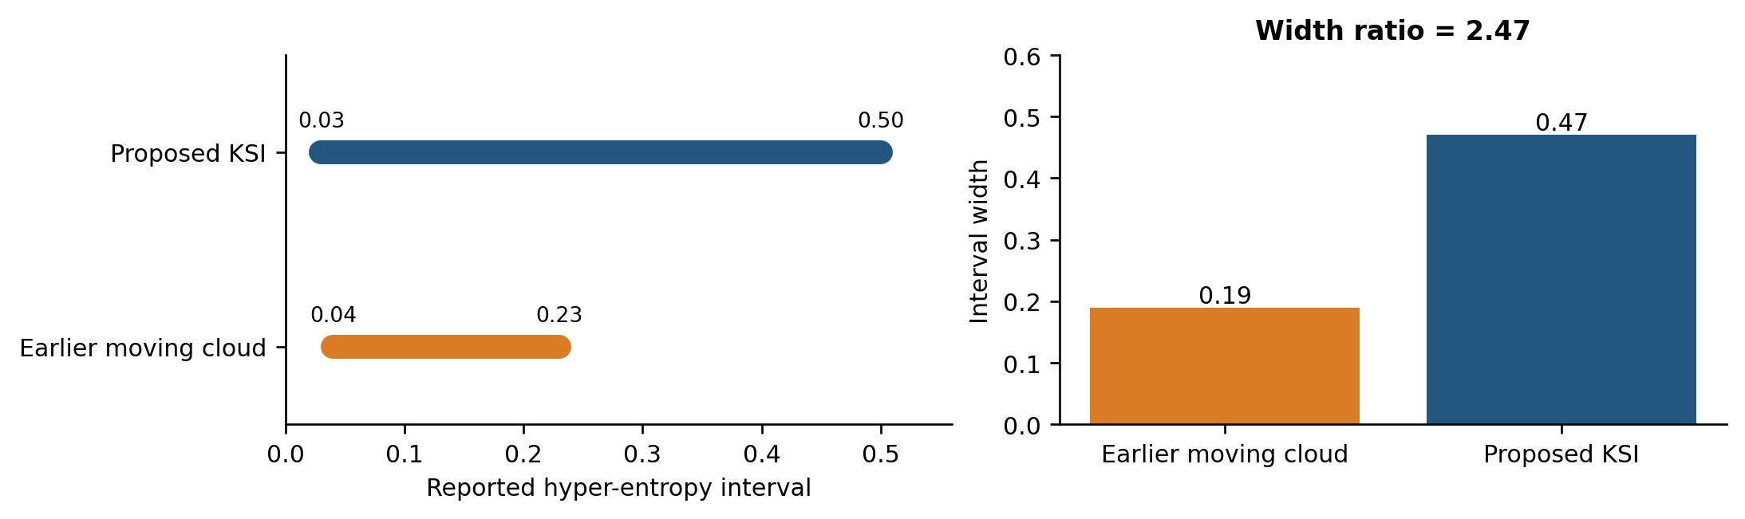
Figure 1. Reported hyper-entropy intervals and their widths. Continuous bars summarize the stated intervals; they do not establish that every intermediate value was tested or that stabilization probability is one.
The He scale is meaningful only with fixed cloud parameterization, input normalization, and random-number law. A wider recorded interval can indicate useful tolerance to the tested uncertainty setting, but cannot be generalized across rescaled clouds. Repeated trials at each He are needed to estimate a stabilization probability and its confidence interval. The original low-He rows contain ambiguous method/failure labels at He = 0.01 and 0.02; they are not used to construct numerical success probabilities.

5.3 Reasoning time and real-time interpretation
Table 3. Reported aggregate reasoning times and arithmetic derivatives. Per-operation values are totals divided by 20; the distribution of individual operation times is unavailable.
Method | 20 operations (ms) | Per operation (ms) | Ratio to KSI
Earlier moving | 2058 | 102.90 | 2.77
T–S cloud | 1375 | 68.75 | 1.85
Proposed KSI | 742 | 37.10 | 1.00

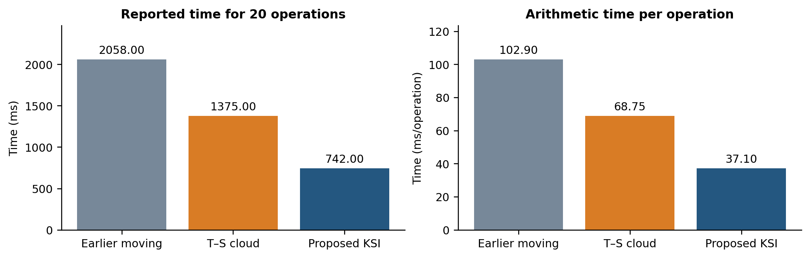
Figure 2. Aggregate time and arithmetic mean time per operation. These are transformations of Table 3, not measured per-call latency distributions.
The proposed time of 742 ms is 63.95% below 2058 ms for the earlier moving-cloud method and 46.04% below 1375 ms for T–S cloud modeling. Expressed as speedup ratios, the earlier methods take 2.77 and 1.85 times as long. These ratios describe the recorded measurement, not a hardware-independent complexity constant. Cloud count, programming language, random-number generation, memory allocation, and the timed code region all affect the result.
Dividing by 20 gives 37.10 ms per operation for the proposed method. Its reciprocal is approximately 26.95 operations per second if operations run serially and no other work is performed. That calculation does not establish a safe control-loop rate. Sensing, state estimation, communication, actuator output, and worst-case reasoning latency must fit inside the sample period. A claim of real-time feasibility therefore requires latency percentiles or worst-case bounds on the actual target platform.

5.4 Overshoot and transient response
Table 4. Numerical comparison rows retained for He = 0.13 and 0.14. Ov retains the original unspecified normalization; Tr is in seconds.
He | Object | T–S Ov | KSI Ov | T–S Tr (s) | KSI Tr (s)
0.13 | Cart | 1.11 | 0.89 | 4.83 | 4.60
0.13 | Pendulum | 6.93 | 0.83 | 4.22 | 1.65
0.14 | Cart | 1.11 | 0.83 | 4.83 | 4.60
0.14 | Pendulum | 6.93 | 0.85 | 4.22 | 4.49

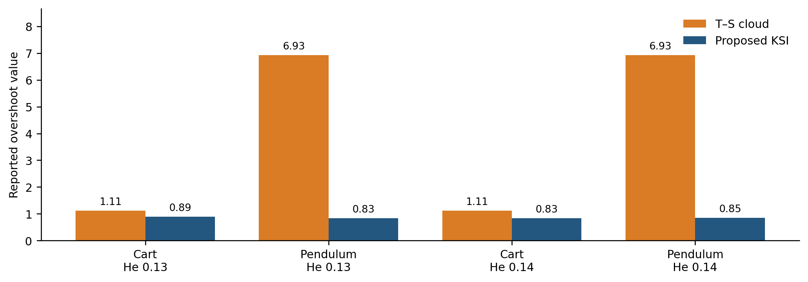
Figure 3. Reported overshoot values from Table 4. Physical units cannot be assigned until the original overshoot definition is supplied.
The proposed values are lower in all four numerical rows. For the cart, the values decrease from 1.11 to 0.89 at He = 0.13 and to 0.83 at He = 0.14. For the pendulum, the decreases are from 6.93 to 0.83 and 0.85. The latter differences are large, so their units, normalization, and trace provenance should be checked before interpreting them as a particular percentage of physical angle overshoot.
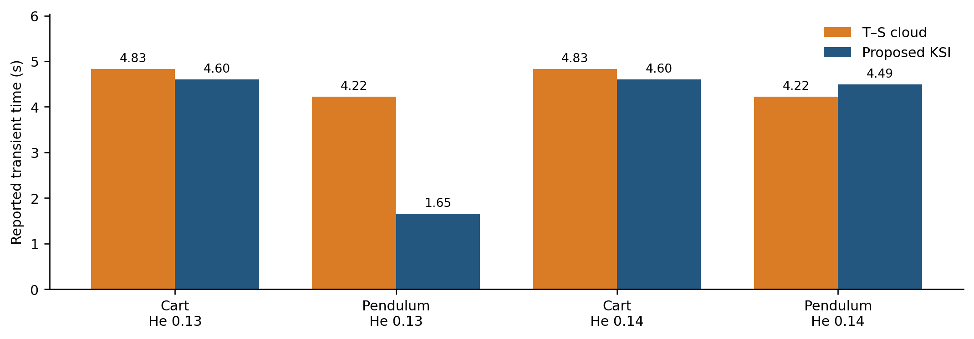
Figure 4. Reported transient times from Table 4. The pendulum at He = 0.14 has a longer transient under the proposed method.
For the cart, transient time decreases from 4.83 to 4.60 s at both He values. For the pendulum at He = 0.13, it decreases from 4.22 to 1.65 s. At He = 0.14, however, it increases from 4.22 to 4.49 s. A fair summary is therefore lower reported overshoot with a condition-dependent transient-time effect. It is not a uniform improvement of every control metric.

5.5 Corrected effect-size calculation
For a lower-is-better metric E, the percentage reduction is 100(E_{baseline}−E_{KSI})/E_{baseline}. A negative value denotes deterioration. Table 5 recomputes the percentages from the raw entries; it does not overwrite the raw measurements or infer a different experimental outcome.

Table 5. Percentages recalculated from Table 4. Several previously stated percentages do not follow from the listed raw values; these arithmetic results are conditional on the raw entries being correct.
He | Object | Overshoot reduction (%) | Transient-time reduction (%)
0.13 | Cart | 19.82 | 4.76
0.13 | Pendulum | 88.02 | 60.90
0.14 | Cart | 25.23 | 4.76
0.14 | Pendulum | 87.73 | -6.40

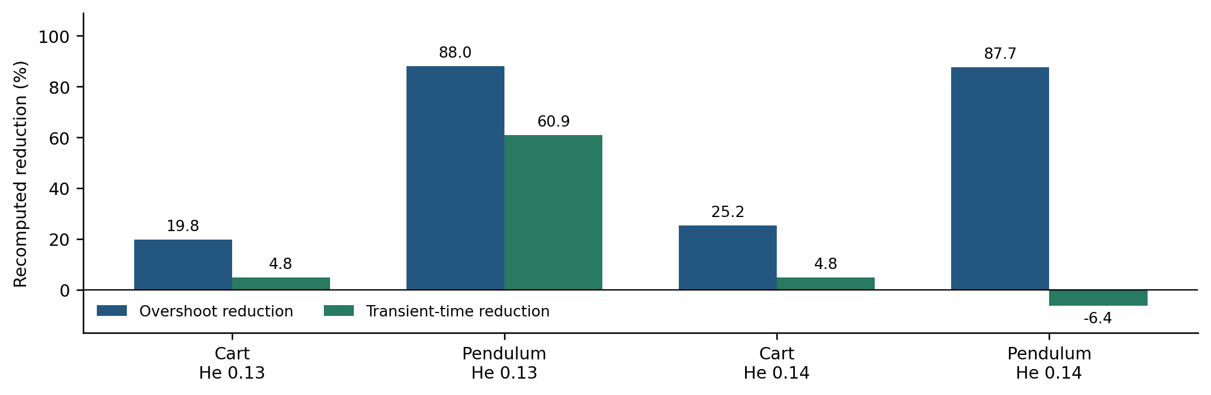
Figure 5. Recomputed reductions in overshoot and transient time. The negative bar makes the He = 0.14 pendulum trade-off visible.
The cart overshoot reductions are 19.82% and 25.23%, while the pendulum reductions are 88.02% and 87.73%. The transient-time reductions are 4.76%, 60.90%, 4.76%, and −6.40%. These values differ substantially from some improvement percentages in the historical table. The correct response is to retain the raw entries, recompute transparently, and reconcile the source logs; it is not to select whichever column gives the strongest claim.

5.6 Sampling and latency trade-offs
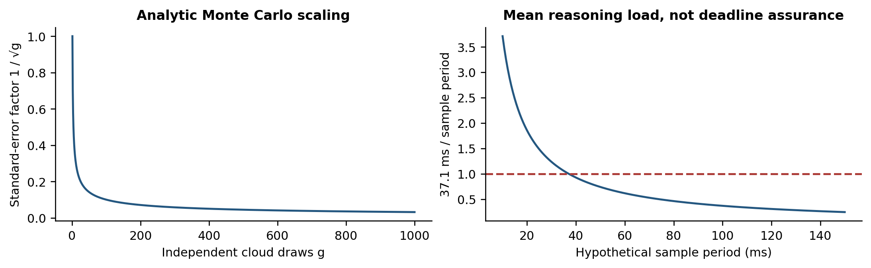
Figure 6. Analytic design illustrations. Left: the 1/sqrt(g) standard-error factor under independent sampling. Right: mean reasoning load using 37.1 ms divided by a hypothetical sample period. Neither panel reports a new experiment or a stability boundary.
Under the independence assumptions of Eq. (8), quadrupling g halves the numerical standard error while approximately quadrupling movement-accumulation work. Reducing g can improve latency but increase randomness in the control output. Increasing the sample period reduces average computational load but can worsen delay-induced behavior. These competing effects motivate a joint experiment over g, He, and sample period. The present aggregate timing and interval cannot determine the best setting.

5.7 Sensitivity and robustness protocol
The next study should vary one physical or stochastic factor at a time before evaluating combined stress cases. Cloud-drop count g should be tested at the declared nominal value and at lower and higher levels; He should be expressed relative to the calibrated nominal value; sensor noise should be injected from a measured noise model; actuator saturation should be applied at the documented rail and at controlled tighter limits; and plant-parameter drift should perturb mass, length, friction, or gain within a prespecified engineering range. Each condition should use the same initial state and disturbance realization across controllers, with at least 30 paired seeds when the platform permits it.
Table 6. Minimum robustness matrix for a moving-cloud pendulum comparison. The matrix specifies what must be measured; it is not a claim that the unreported experiment has already been run.
Factor | Low / nominal / high levels | Primary outcome | Failure or timing log
Cloud draws g | 0.5g₀ / g₀ / 2g₀ | Variance and reasoning cost | Draw count and p95 latency
Hyper-entropy He | 0.5He₀ / He₀ / 1.5He₀ | Overshoot and settling | Divergence and stability rate
Sensor noise σ | 0 / 0.5σ / σ / 2σ | IAE and peak angle | Noise seed and invalid sample
Actuator bound | u_max / 0.8u_max / 0.6u_max | Control energy | Saturation duration and rail hits
Plant drift | 0% / 5% / 10% | Success across models | Parameter version and failure type

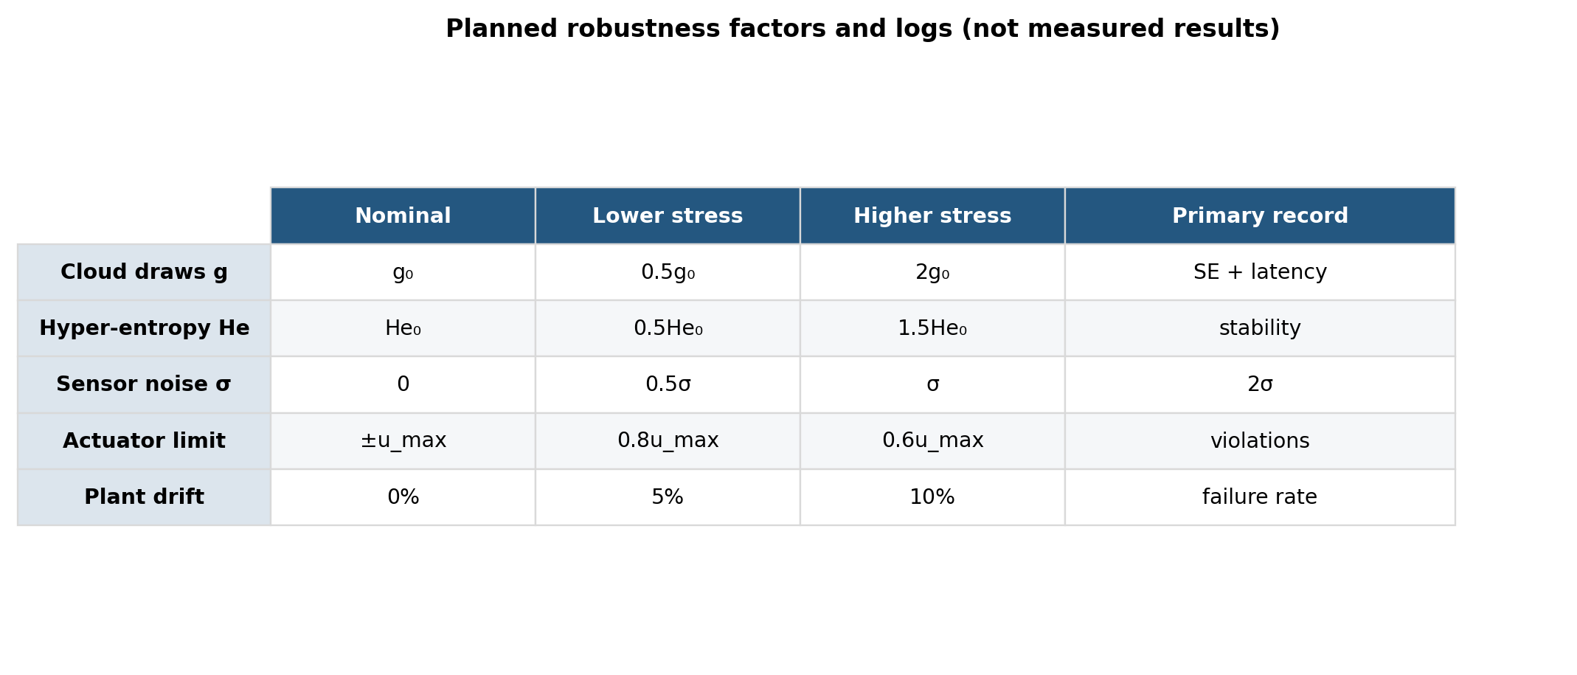
Figure 7. Planned sensitivity matrix linking each perturbation to the primary measurements and failure logs. It is a validation design, not an empirical performance heatmap.
The primary outcomes are peak absolute angle, cart excursion, explicitly defined settling time, integrated absolute error, control energy, saturation duration, divergence count, success rate, and reasoning-time percentiles. Report unconditional success over all attempted trials as well as conditional transient metrics over successful trials. A controller that settles quickly only after frequent rail violations is not equivalent to one that settles slightly more slowly without violating the actuator limit.
Algorithm 6 Evaluate paired robustness across cloud and plant perturbations
INPUT controllers; nominal plant; perturbation grid; initial states; seed list
OUTPUT paired trajectories, reliability counts, metric summaries, and latency quantiles
01 Freeze sample period, state ordering, actuator limits, and settling definition.
02 FOR each perturbation condition and initial state:
03 FOR each seed s:
04 Generate one sensor-noise and disturbance realization.
05 Reset every controller and plant to the same state.
06 Run each controller with the same realization and log every sample.
07 Mark saturation, angle-limit, timeout, divergence, or invalid-cloud events.
08 Compute metrics for all trials; mark conditional metrics as missing after failure.
09 END FOR
10 Report successes / attempts, failure types, and latency p50, p95, and maximum.
11 END FOR
12 Compare paired trial outcomes with confidence intervals and effect sizes.
13 RETURN raw logs and a table whose denominators include failed trials.

The analysis should include an ablation with deterministic movement or He = 0 when that limit is mathematically defined, a cloud-count ablation, and a controller baseline with the same plant and sample deadline. If controller matrices are synthesized from identified local models, the identification data and synthesis objective must be held constant across the inference variants. These controls separate the effect of stochastic reasoning from the effects of feedback gains, sampling, and implementation language.

6 Discussion and validation requirements

6.1 Meaning of the current evidence
The main supported result is a lower reported aggregate inference time alongside favorable overshoot values in the listed cases. The broader He interval is encouraging but remains an empirical interval with an unspecified trial density and success criterion. The arithmetic correction reveals that transient performance is mixed. These observations define useful hypotheses for replication rather than a completed proof of robust controller superiority.
The inference mechanism has a clear advantage in traceability: an output can be decomposed into antecedent displacement, stochastic factor, average rule movement, and consequent translation. That interpretation is valuable only if the exact generator and scaling are preserved. A generic random substitute or a different controller architecture can keep the same algorithm name while changing the result. The reproducibility record must therefore treat cloud definitions and controller state equations as part of the method.

6.2 Minimum mathematical specification
The stochastic law J needs a distribution, parameter interpretation, and dependence structure. The geometry requires both boundary-distance branches, exact evaluation points, and rules for zero widths. The output cloud needs a translation or shape-update definition. The multi-rule extension needs relevance scores, normalization, and fallback behavior. Finally, the controller requires complete matrices, synthesis conditions, initial states, and timing conventions. These requirements are specific enough to be checked against executable code.
A full reductivity claim should be tested at the distribution level: identical antecedent and observation clouds should reproduce all relevant consequent descriptors, not only the center. Robustness experiments should separately perturb input measurements, cloud uncertainty parameters, physical plant parameters, and sample delay. Changing all of them together would make an observed failure difficult to interpret.

6.3 Experimental reporting
The next experiment should record the platform, processor, compiler or interpreter, numerical precision, random generator, cloud count, sample period, and exact timed region. Latency should include median, high percentile, and maximum, with warm-up behavior separated if relevant. Control performance should include rail-limit violations, angle-limit violations, peak actuator effort, integrated absolute error, and control energy, alongside an explicit settling-time definition.
Repeated failures must remain in the analysis. An algorithm that is very accurate on successful trials but frequently fails cannot be compared only on its successful subset. Report the number of successful trials out of all attempted trials for every condition, and separate conditional transient metrics from unconditional reliability. Shared initial states and disturbance realizations support paired comparisons, but the resulting dependence must be reflected in uncertainty estimates.

6.4 Relationship to recent control methods
The 2026 fuzzy sliding-mode and interval type-2 T–S studies address uncertainty through different controller structures [12, 13]. The new LCM/KSI publication develops a related inference foundation [9]. These should guide controlled baselines and logical-property checks, rather than serve as evidence that the present method is faster or more accurate without direct tests. An appropriate comparison would hold the nonlinear plant, sensing, actuation, operating region, and sample deadline constant while measuring both reasoning behavior and closed-loop outcomes.
Data-driven identification can complement moving-cloud reasoning by estimating local dynamics; it does not remove the need for a verified feedback design. Conversely, a certified controller can use a simpler deterministic inference layer if the stochastic descriptors do not improve performance. An ablation with He = 0 or a deterministic movement factor, when well-defined, is a direct way to test the contribution of cloud randomness.

7 Conclusions
The KSI moving-cloud method offers a structured way to transfer antecedent displacement to a consequent while retaining an explicit stochastic factor. Detailed pseudocode clarifies the geometry, movement, averaging, rule blending, and controller interface. At exact antecedent-center agreement, the multiplicative movement law gives zero crisp displacement for every finite random draw; full cloud reductivity requires the additional shape-preservation condition.
The recorded results show a 742 ms total for 20 operations and a broader stated He interval than the earlier moving-cloud method. Recomputed transient comparisons support lower overshoot in the four numerical rows, with a deterioration in one pendulum transient-time case. The appropriate conclusion is a promising but conditional computation–performance trade-off. Complete stochastic and controller definitions, raw repeated-run records, and a stability certificate for the implemented architecture are needed before stronger claims can be established.

Appendix A Reported local matrices
The matrices below preserve the numerical local-model and controller-state values from the experimental record. The local plant uses negative, zero, and positive angle regions. State ordering, sign convention, continuous/discrete-time interpretation, and sampling interval must be reconciled with Eqs. (10)–(12) before simulation. The controller input and output matrices and complete synthesis record are not supplied by these arrays alone.
$$A_{1}=A_{3}=\left[\begin{matrix}0 & 0 & 1 & 0 \\ 0 & 0 & 0 & 1 \\ 0 & 0.861 & −7.929 & −0.0348 \\ 0 & 48.72 & −34.81 & −1.971\end{matrix}\right], A_{2}=\left[\begin{matrix}0 & 0 & 1 & 0 \\ 0 & 0 & 0 & 1 \\ 0 & 0.9466 & −8.019 & −0.037 \\ 0 & 50.79 & −32.51 & −1.993\end{matrix}\right].$$
$$B_{1}=B_{3}={\left[0 0 0.793 3.487\right]}^{T}, B_{2}={\left[0 0 0.8 3.775\right]}^{T}, C_{i}=\left[\begin{matrix}1 & 0 & 0 & 0 \\ 0 & 1 & 0 & 0\end{matrix}\right].$$
$$A_{c1}=A_{c3}=\left[\begin{matrix}0.8574 & −0.0101 & 0.0235 & −0.0133 \\ −0.0614 & 0.9619 & 0.0295 & −0.0145 \\ −0.6031 & −0.0946 & 0.8339 & 0.0926 \\ 0.7189 & −0.0318 & 0.1020 & 0.9232\end{matrix}\right],$$
$$A_{c2}=\left[\begin{matrix}0.8515 & −0.0315 & 0.0241 & −0.0134 \\ −0.0626 & 0.9627 & 0.0290 & −0.0140 \\ −0.6284 & −0.0945 & 0.8293 & 0.0945 \\ 0.7306 & −0.0289 & 0.1048 & 0.9221\end{matrix}\right].$$
The arrays are retained for parameter traceability and are not a substitute for the missing feedback matrices. Replacing them with independently synthesized LQR gains would define a separate experiment. A reproducibility package should include the complete plant and controller specification together with its own numerical test demonstrating agreement between the equations and executable implementation.

References
[1] Zadeh, L. A. (1965). Fuzzy sets. Information and Control, 8(3), 338–353. https://doi.org/10.1016/S0019-9958(65)90241-X
[2] Zadeh, L. A. (1975). The concept of a linguistic variable and its applications to approximate reasoning. Information Sciences 8, pp. 199-249. https://doi.org/10.1016/0020-0255(75)90036-5
[3] Li, D., Liu, C., and Gan, W. (2009). A new cognitive model: Cloud model. International Journal of Intelligent Systems, 24(3), 357–375. https://doi.org/10.1002/int.20340
[4] Kwak, S.-I., Ryu, U.-S., Kim, K.-J. (2019). A fuzzy reasoning method based on compensating operation and its application to fuzzy systems. Iranian Journal of Fuzzy Systems 16(3), pp. 17-34. https://doi.org/10.22111/IJFS.2018.4175
[5] Kwak, S.-I., Kim, U.-H., Kim, K.-J., Son, I.-M. (2020). Fuzzy reasoning method based on distance measure and its reductive property. WSEAS Transactions on Computer Research 8, pp. 73-89. https://doi.org/10.37394/232018.2020.8.10
[6] Kwak, C.-J., Ri, K.-C., Kwak, S.-I., Kim, K.-J., Ryu, U.-S., Kwon, O.-C., Kim, N.-H. (2021). Fuzzy modus ponens and tollens based on moving distance in SISO fuzzy system. Romanian Journal of Information Science and Technology 24(3), pp. 257-283.
[7] Mizumoto, M., Zimmermann, H. J. (1982). Comparison of fuzzy reasoning methods. Fuzzy Sets and Systems 8, pp. 253-283. https://doi.org/10.1016/S0165-0114(82)80004-3
[8] Kong, H.-U., Kwak, S.-I., Jang, Y.-J., Hwang, C.-J., Ri, O.-S., Jo, Y.-H., Nam, J.-H., Ryu, U.-S. (2025). New interval fuzzy modeling method based on KSI principle and its application in turf color image evaluation. Journal of Industrial and Management Optimization 21(12), pp. 6713-6735. https://doi.org/10.3934/jimo.2025146
[9] Kwak, S.-I., Jang, Y.-J., Ri, O.-S., Kim, N.-H., Ryu, U.-S., Choe, M.-O., Hwang, C.-J., and Chae, H.-G. (2026). New fuzzy modus ponens and tollens based on least common multiple and its application to fuzzy control. International Journal of Machine Learning and Cybernetics, 17, 431. https://doi.org/10.1007/s13042-026-03162-w
[10] Kwak, S.-I., Yu, H.-U., Jang, Y.-J., Hwang, C.-J., Ri, O.-S., and Chae, H.-G. (2023). Optimal Fuzzy Modus Ponens and Tollens Algorithm Based on KSI Principle. Research Square preprint, version 1, posted 4 December. https://doi.org/10.21203/rs.3.rs-3690916/v1
[11] Son, I. M., Kwak, S. I., Han, U. J., Pak, J. H., Han, M., Pyon, J. R., Ryu, U. S. (2020). A novel fuzzy approximate reasoning method based on extended distance measure in SISO fuzzy system. arXiv:2003.13450.
[12] Mohammed, T. K., Ezez, S. F., Siraj, A. Z., et al. (2026). Adaptive fuzzy sliding mode control applied to inverted pendulum. Scientific Reports 16, 14938. https://doi.org/10.1038/s41598-026-45197-7
[13] Dao, Q.-T. (2026). Uncertainty-resilient control of an inverted pendulum on a cart using interval type-2 Takagi-Sugeno fuzzy modeling and subsystem LQR control. Automation 7(3), 92. https://doi.org/10.3390/automation7030092
[14] Shalbafian, A., Amiri, F. (2026). Nonlinear control design for stabilization and tracking of a rotary inverted pendulum. Scientific Reports. https://doi.org/10.1038/s41598-026-57277-9
[15] Li, W., Wang, Y., Du, J., Lai, J. (2017). Synergistic integration of graph-cut and cloud model strategies for image segmentation. Neurocomputing 257, pp. 37-46. https://doi.org/10.1016/j.neucom.2016.12.072
[16] Li, Y., Fan, X. (2014). Recursive integral proportional-integral control based on membership cloud for active power filter. IET Power Electronics. https://doi.org/10.1049/iet-pel.2014.0285
[17] Takagi, T., Sugeno, M. (1985). Fuzzy identification of systems and its applications to modeling and control. IEEE Transactions on Systems, Man, and Cybernetics, 15(1), 116–132. https://doi.org/10.1109/TSMC.1985.6313399
[18] Sugeno, M., and Kang, G. T. (1988). Structure identification of fuzzy model. Fuzzy Sets and Systems, 28(1), 15–33. https://doi.org/10.1016/0165-0114(88)90113-3
[19] Angelov, P. P., and Filev, D. P. (2004). An approach to online identification of Takagi–Sugeno fuzzy models. IEEE Transactions on Systems, Man, and Cybernetics, Part B, 34(1), 484–498. https://doi.org/10.1109/TSMCB.2003.817053
[20] Filho, O. D. R., Serra, G. L. D. O. (2018). Recursive fuzzy instrumental variable based evolving neuro-fuzzy identification for non-stationary dynamic system in a noisy environment. Fuzzy Sets and Systems 338, pp. 50-89. https://doi.org/10.1016/j.fss.2017.05.016
[21] Li, C., Zhou, J. Z., Fu, B., Kou, P., Xiao, J. (2012). T-S fuzzy model identification with a gravitational search-based hyperplane clustering algorithm. IEEE Transactions on Fuzzy Systems 20(2), pp. 305-317. https://doi.org/10.1109/TFUZZ.2011.2173693
[22] Tanaka, K., and Sugeno, M. (1992). Stability analysis and design of fuzzy control systems. Fuzzy Sets and Systems, 45(2), 135–156. https://doi.org/10.1016/0165-0114(92)90113-I
[23] Tanaka, K., and Wang, H. O. (2001). Fuzzy Control Systems Design and Analysis: A Linear Matrix Inequality Approach. Wiley. https://doi.org/10.1002/0471224596
[24] Du, Z., Yan, Z., Zhao, Z. (2019). Interval type-2 fuzzy tracking control for nonlinear systems via sampled-data controller. Fuzzy Sets and Systems 356, pp. 92-112. https://doi.org/10.1016/j.fss.2018.02.013
[25] Su, X., Xia, F., Liu, J., Wu, L. (2018). Event-triggered fuzzy control of nonlinear systems with its application to inverted pendulum systems. Automatica 94, pp. 236-248.
[26] Lee, J., Mukherjee, R., Khalil, H. K. (2015). Output feedback stabilization of an inverted pendulum on a cart in the presence of uncertainties. Automatica 54, pp. 146-157. https://doi.org/10.1016/j.automatica.2015.01.013
[27] Wang, X., Dong, H., Sun, X., Yao, X. (2016). PD control of inverted pendulum based on adaptive fuzzy compensation. Journal of Intelligent & Fuzzy Systems 31(6). https://doi.org/10.3233/JIFS-169186
[28] Reddy, N. S., Saketh, M. S., Pal, P., Dey, R. (2016). Optimal PID controller design of inverted pendulum dynamics: a hybrid pole-placement and firefly algorithm approach. IEEE CMI, pp. 305-310.
[29] Abut, T., Soyguder, S. (2019). Real-time control and application with self-tuning PID-type fuzzy adaptive controller of an inverted pendulum. Industrial Robot 46(1), pp. 159-170. https://doi.org/10.1108/IR-10-2018-0206
[30] Ghommam, J., Mnif, F. (2017). Predictor-based output feedback stabilization of an inverted pendulum on a cart with time-delay/uncertainty. ISA Transactions. https://doi.org/10.1016/j.isatra.2017.01.015
[31] Feng, Y., Gao, Y., Zhao, X., Yan, X.-G., Spurgeon, S. K. (2020). Dynamic output-feedback sliding-mode control with application to an inverted pendulum. IFAC-PapersOnLine. https://doi.org/10.1016/j.ifacol.2020.12.1182
[32] Kelekci, E., Yaren, T., Kizir, S. (2022). Design of optimized interval type-2 fuzzy logic controller based on continuity, monotonicity and smoothness properties for a cart-pole inverted pendulum. Transactions of the Institute of Measurement and Control 44(12), pp. 2291-2307. https://doi.org/10.1177/01423312221081309
[33] Nguyen, T.-V.-A., Dong, B.-T., Bui, N.-T. (2023). Enhancing stability control of inverted pendulum using Takagi-Sugeno fuzzy model with disturbance rejection and input-output constraints. Scientific Reports 13, 14412. https://doi.org/10.1038/s41598-023-41258-3
[34] Pham, D.-B., Dao, Q.-T., Bui, N.-T., et al. (2024). Robust-optimal control of rotary inverted pendulum through fuzzy descriptor-based techniques. Scientific Reports 14, 5593. https://doi.org/10.1038/s41598-024-56202-2
[35] Saleem, O., Alsuwian, T., Amin, A. A., Ali, S., Alqarni, Z. A. (2024). Stabilization control of rotary inverted pendulum using a novel EKF-based fuzzy adaptive sliding-mode controller: design and experimental validation. Automatika 65(2), pp. 538-558. https://doi.org/10.1080/00051144.2024.2312309
[36] Tian, B., Peng, H., Kang, T. (2024). RBF-ARX model-based predictive control approach to an inverted pendulum with self-triggered mechanism. Chaos, Solitons & Fractals 186, 115291. https://doi.org/10.1016/j.chaos.2024.115291
[37] Abut, T. (2025). An inverted pendulum system control with fuzzy linear quadratic regulator method: experimental validation. Computers, Materials & Continua 85(2), pp. 4023-4042. https://doi.org/10.32604/cmc.2025.066920
[38] Costanzo, M., Mazza, R., Natale, C. (2025). Digital control of an inverted pendulum using a velocity-controlled robot. Machines 13(6), 528. https://doi.org/10.3390/machines13060528
[39] Irfan, S., Zhao, L., Ullah, S., Mehmood, A., Butt, M. F. U. (2024). Control strategies for inverted pendulum: a comparative analysis of linear, nonlinear, and artificial intelligence approaches. PLoS ONE 19(3), e0298093. https://doi.org/10.1371/journal.pone.0298093

