Intelligent Digital-Twin and Extended-Reality Framework for Virtual Design and Virtual Experimentation: Architecture and Empirical Re-analysis
Kwon Se-Hun, Kwak Son-Il, Kim Hyun-Jun
Comprehensive SCI V4 enhancement — literature refreshed through 2026; complete pseudocode catalogue; expanded source-derived visual analysis; Calibri typography throughout
Data-integrity note: experimental values, comparative metrics and engineering claims are re-analyzed from the supplied source manuscript. No new experimental observations are fabricated. Literature has been updated through 2026.

Abstract
This study upgrades an earlier virtual-design and virtual-experiment framework into a contemporary digital-twin/XR architecture that couples immersive qualitative interaction with quantitative engineering analysis and intelligent decision support. The source manuscript proposed expert-system and agent-assisted virtual design and laboratory environments and validated them in heat-exchanger design and mechanics education. The upgraded manuscript reframes those contributions using the 2025–2026 literature on digital twins, XR, collaborative virtual laboratories, and AI-supported engineering education. A reproducible control loop is defined for state synchronization, constraint checking, multi-objective design search, visualization, and human approval. Historical experimental data are re-analyzed without inventing new observations. The proposed system achieved 95–98% scores on key educational indicators, approximately 95% visual effectiveness, and reduced the update cycle from 10 to 5 days. The engineering case reported a 15% mass reduction, about 300 kg copper saving, and 1.8–2.0× faster design iteration. The results support the value of integrating immersive interfaces with explicit models, optimization, and traceable decision logic, while also identifying the need for prospective validation using modern digital-twin interoperability standards.
Keywords: digital twin; virtual reality; extended reality; virtual design; virtual laboratory; intelligent information processing; engineering education
Enhanced manuscript highlights
• 2026 digital-twin/XR literature positioning
• All computational procedures mapped to pseudocode
• Source-derived educational/engineering graphs
• Explicit evidence-quality and validity limitations

1. Introduction
Digital twins have moved from static visualization toward continuously synchronized engineering representations that support design, operation, diagnosis, and lifecycle decision making. Recent CIRP work distinguishes the engineering of digital twins from engineering with digital twins and highlights interoperability, fidelity, uncertainty, and lifecycle continuity as central design issues [1]. At the same time, systematic reviews published in 2026 show that DT–XR integration is becoming a practical route for real-time monitoring, scenario analysis, safety training, and engineering education [2,5,6].
The educational dimension has also matured. AR Tunnel demonstrated that an augmented-reality digital twin can improve objective learning outcomes for wind-tunnel preparation [4], while collaborative-VR reviews emphasize accessibility, multi-user coordination, and rigorous evaluation [5]. Multi-user sensorized laboratory twins further demonstrate that real-time physical data can be connected to immersive environments without abandoning the physical laboratory [7]. Conversational AI is now being explored as an additional interaction layer for digital-twin laboratories [8].
These developments sharpen the central problem already recognized in the source manuscript: immersive visualization alone is not enough. A virtual engineering system must combine perceptual/qualitative information with quantitative mechanics, optimization, rule-based reasoning, and explicit validation. The present work therefore reformulates the original architecture as a closed-loop intelligent digital-twin/XR framework. It preserves the source experiments, but updates terminology, workflow specification, evaluation logic, and scientific positioning to make the contribution comparable with current 2026 research.
The September 2026 literature further raises the validation bar for this class of system. Recent work calls for model-based digital-twin engineering with explicit lifecycle models [40], student-centered XR requirements and measurable usability criteria [38], and pedagogically aligned immersive activities rather than visualization-only demonstrations [39]. A 2026 systematised review also cautions that evidence for learning gains remains uneven and should be reported with transparent outcome definitions and study design [37]. Accordingly, the enhanced manuscript treats the historical educational percentages as descriptive source evidence, not as a substitute for a contemporary randomized or longitudinal evaluation.

1.1 2026 State-of-the-Art Update and Positioning
The 2026 literature makes the distinction between a simulation-rich virtual environment and a genuine digital twin increasingly important. Kopp et al. [43] combine a PRISMA-guided review with an expert survey and show that digital-twin adoption remains uneven across engineering domains, while conceptual distinctions between simulation, digital shadow and digital twin still matter for implementation. Wooley et al. [44], synthesizing 79 systematic reviews across industries, identify standardization, data quality, resource limitations and system integration as recurring barriers. These observations shift the evaluation question from “Can a virtual model be visualized?” to “Can the model be synchronized, verified, governed and used to support traceable engineering decisions?”
At the same time, XR research is converging with digital-twin research. Girginova [45] explicitly argues that XR and digital twins have a connected trajectory, while recent engineering-education studies [37-39] emphasize learning outcomes, user-centred requirements and constructive alignment rather than visual novelty alone. Viewed through this 2026 lens, the source framework is best interpreted as a proto-digital-twin environment: it already combines geometric/physical models, an expert knowledge base, software agents, simulation and immersive interaction, but it predates today’s formal requirements for bidirectional synchronization, provenance, interoperability and lifecycle validation.
Accordingly, this paper positions its contribution in a deliberately bounded way. It does not claim that the historical implementation satisfies every modern digital-twin standard. Instead, it contributes an integrated architecture and source-derived empirical evidence showing how qualitative immersive exploration, quantitative engineering models and intelligent decision support can be coupled. The upgraded formulation adds an explicit synchronization/validation loop, auditable decision trace, reproducibility requirements and a modern comparison framework so that the historical results can be interpreted against 2026 digital-twin and XR practice.

1.2 Focused 2025-2026 Literature Synthesis and Updated Research Gap
The post-2025 literature raises the technical bar for virtual engineering systems in three connected directions. First, interoperability is now treated as a measurable engineering property rather than a software convenience: recent work on digital-twin data exchange emphasizes semantic consistency, interface contracts and cross-tool lifecycle continuity [46]. Second, reduced-order modeling is being formalized as a route to real-time twin execution when full-order physics is too expensive [47]. Third, education-focused digital twins increasingly require explicit physical-virtual synchronization and measurable learning outcomes rather than immersive visualization alone [48,51,53].
Virtual commissioning research is also converging with lifecycle digital twins. Ferle et al. describe a structured transition from commissioning models to operational twins [49], while Birtic et al. connect virtual commissioning with discrete-event simulation for digital manufacturing [50]. A 2026 computer-engineering review further identifies hardware constraints, interoperability, standardized validation and safe adaptivity as unresolved system-level challenges [52]. These findings motivate the present V4 formulation: synchronization, model validity, uncertainty, provenance and educational effectiveness are treated as separate acceptance criteria rather than a single demonstration metric.
Year | Recent study | Technical focus | Implication for this paper
2026 | Liepert et al. | Digital-twin data interoperability | Interoperability becomes an explicit acceptance criterion
2026 | Kramer & Qian | Reduced-order models for digital twins | Real-time execution requires fidelity-cost control
2026 | Jiang et al. | Six-dimensional educational digital twin | Education requires physical-virtual synchronization
2026 | Ferle et al. | Virtual commissioning to operational DT | Lifecycle reuse of engineering models
2026 | Kibria & Kittur | Computer-engineering DT systematic review | Validation, hardware and safe adaptivity
Table 1B. Focused 2025-2026 literature matrix.
Table 1A. 2026-oriented positioning of the proposed framework.
2026 direction | Representative evidence | What the literature emphasizes | Position of this study
Digital-twin definition and maturity | [40,43,44] | Synchronization, model fidelity, interoperability, lifecycle maturity | Adds explicit synchronization/validation gates; historical implementation is treated as proto-DT rather than overclaimed.
XR–digital-twin convergence | [4,45] | Immersive interaction connected to live/validated system representations | Retains immersive interaction but anchors it to engineering models and traceable decisions.
Virtual-lab pedagogy | [37-39] | Learning outcomes, user requirements, constructive alignment | Re-analyzes educational indicators and states missing sample-size/statistical information.
Current contribution | This study | Integrated design + experiment + expert/agent decision support | Provides a reproducible end-to-end algorithm and source-grounded quantitative re-analysis.

1.3 Validation requirements in the 2026 literature
Recent digital-twin reviews now distinguish a static three-dimensional model, a synchronized digital shadow, and a validated digital twin. Interoperability and bidirectional synchronization are treated as acceptance criteria [46,48], while reduced-order modeling is framed as a fidelity–latency trade-off rather than an unconditional substitute for a high-fidelity model [47]. XR studies likewise argue that interaction quality should be measured together with learning outcomes and task performance, not used as a proxy for them [37–39,45,52].
For the present framework, a credible virtual-design or virtual-experiment claim therefore requires five observable items: the synchronization interval and residual, the model version and fidelity, scene-to-model latency and packet loss, constraint violations and safety stops, and user or task metrics with a stated sample size and uncertainty. The source results provide useful historical effect sizes but do not disclose all five items. The second-pass protocol below separates source-derived evidence from a predeclared replication design.
Table V5-L. 2026 evidence mapped to an operational validation test.
Evidence direction | Recent literature | Operational test | Claim boundary
Interoperability | [46,48] | Schema check, timestamp alignment, round-trip state exchange | No interoperability score is inferred from historical figures
Fidelity and latency | [43,47] | Full-order versus reduced-order model at matched error tolerance | Speed claims require the same hardware and solver settings
XR learning and usability | [37–39,45] | Task completion, learning gain, workload and accessibility by user group | Reported percentages lack n and randomization details
Safety and traceability | [40,52] | Constraint violations, blocked actions, provenance and recovery logs | A visual scene is not evidence of safe operation

2. Research Gap and Contributions
The upgraded study targets three gaps: (1) a reproducible statement of the proposed method instead of narrative-only algorithm description; (2) a literature position aligned with work published around 2026; and (3) transparent, graph-based re-analysis of the original experiments. The contribution is intentionally bounded to the supplied evidence. Where modern validation requirements exceed the source data, this is stated as a limitation rather than filled with synthetic measurements.

3. Proposed Method
The framework contains five logical layers: (i) a physical or engineering-object layer, (ii) a parametric digital model and simulation layer, (iii) an intelligence layer for rules, agents and optimization, (iv) an XR interaction layer, and (v) a validation and provenance layer. State changes initiated by a user or solver are checked against constraints before being committed to the digital representation. Quantitative simulation outputs are transformed into interpretable visual cues, while qualitative decisions are logged and fed back into the next design iteration.
For virtual design, the design vector contains geometry, material, process and operating variables. Candidate designs are generated, simulated and filtered by feasibility constraints; objective values such as heat-transfer performance, mass, material cost and maintainability are then combined in a ranked decision process. The source heat-exchanger case retained an optimized shell diameter of 1.2 m, shell length 1.4 m, tube diameter 0.02 m, tube length 0.8 m, 198 tubes and two passes.
For virtual experimentation, the digital apparatus is separated from experiment logic so that the simulation model can be updated independently of the user-interface scene. This modularity explains the source observation that the proposed system reduced update time from 10 to 5 days and system capacity from hundreds of megabytes to tens of kilobytes for the experiment-logic component.

4. Algorithmic Specification (Pseudocode)
Algorithm 1. Intelligent virtual-design optimization loop
Input: design bounds B, constraints C, objectives F, physics simulator S, expert/agent rules R
Initialize candidate set P from B and load validated model state
REPEAT until stopping criterion is met:
Generate or modify candidate designs using user intent and R
FOR each candidate x in P:
Run S(x) to obtain quantitative responses
Check physical, safety, manufacturability and resource constraints C
If feasible, compute objective vector F(x) and uncertainty indicators
Rank feasible candidates using the selected multi-objective preference rule
Visualize top candidates in XR and expose reasons, constraints and sensitivity
Collect human approval/correction; log provenance and update R or preferences
RETURN approved design and complete decision trace

Algorithm 2. Agent-assisted virtual-experiment execution
Input: experiment model M, scenario Q, learner/user actions A, validation rules V
Synchronize scene state with M and initialize Q
FOR each experiment step k:
Acquire user action a(k) and current simulated/physical state
Validate a(k) against V; if unsafe/invalid, block action and provide explanation
Advance M by one simulation step and calculate observables
Render state, measurements, uncertainty and feedback in XR
Store event, state and outcome in experiment log
At completion, calculate learning/engineering metrics and generate reproducible report

4.1 Algorithm coverage, complexity and reproducibility controls
To make the algorithmic description auditable, Table A maps every computational component to pseudocode, an order-level cost expression and an explicit stopping condition. The complexity expressions are implementation-level order estimates rather than measured runtimes.
Component | Pseudocode | Order-level cost | Stopping / validation condition
Qualitative virtual-design exploration | Algorithm 1 | O(Nc·Ce) | candidate budget / convergence
Expert-system quantitative refinement | Algorithm 1 | problem dependent | feasibility + objective tolerance
Agent-assisted experiment execution | Algorithm 2 | O(T·Ca) | end of protocol / safety stop
Reproducible evaluation & integrity check | Algorithm 3 | O(N) | all records validated
Table A. Algorithm coverage and stopping-condition audit.
Algorithm 3. Reproducible source-data evaluation and integrity check
Input: source tables/figures, experimental records, declared metrics
Validate every numeric value against the source manuscript
FOR each comparison metric: compute only algebraic/summary quantities supported by source values
Generate publication-quality graph with units and sample/context notes
Flag metrics lacking sample size, uncertainty, or repeated trials as descriptive only
Cross-check conclusions against quantitative direction of effect
RETURN traceable tables, figures, and a limitation statement

4.2 Enhanced End-to-End Pseudocode and Implementation Safeguards
The following pseudocode converts the conceptual method into an auditable implementation sequence with explicit inputs, outputs, stopping conditions, numerical safeguards and failure handling.
Algorithm 4. End-to-end intelligent virtual-design/experiment loop
INPUT: engineering model M; design bounds B; objective vector J; expert rules K; scenario set S; synchronization interval Δt; budget Nmax; improvement tolerance ε.
OUTPUT: accepted design/experiment configuration x*, performance record R, auditable decision trace T.
1 Validate units, variable ranges, constraints and model version; initialize T and best score Jbest ← +∞.
2 FOR each scenario s ∈ S DO
3 Acquire or simulate state z(s); reject/flag missing, stale or out-of-range signals.
4 Synchronize virtual state with available physical/reference state; record timestamp and source.
5 Generate candidate designs x within B using heuristic/expert seeding plus quantitative search.
6 FOR each candidate x DO
7 Run geometric/physical simulation M(x,s); compute objective vector J(x,s).
8 Apply hard engineering constraints and expert rules K; mark infeasible candidates.
9 If feasible, compute normalized multi-objective score and uncertainty/consistency checks.
10 Store model version, inputs, outputs, rule firings and rationale in trace T.
11 END FOR
12 Rank feasible candidates; present top alternatives to the human decision maker.
13 IF a virtual experiment is requested THEN perform safety/initial-condition checks, execute the scenario, log events and compare predicted versus observed virtual/physical response.
14 Update Jbest and x* only when improvement > ε and validation checks pass.
15 Stop when Nmax is reached, no improvement persists for the predefined patience window, or an engineering termination condition is met.
16 END FOR
17 Return x*, R and T together with unresolved model/measurement limitations.
Algorithm R. Reproducible experimental re-analysis and visualization
Algorithm R. Reproducible experimental re-analysis and visualization
INPUT: immutable source table D0; method labels; metric definitions; optional replicate IDs/random seeds.
OUTPUT: analysis table A, figures F, provenance log P.
1 Copy D0 to a read-only analysis table and hash/record the source version.
2 Check units, missing values and impossible values; do not silently impute historical results.
3 Separate directly reported source values from quantities derived in this revision.
4 Compute only metrics supported by available data (e.g., mean, SD, MAE, RMSE, MAPE, R², effect size).
5 If independent replicates/seeds exist, compute dispersion and confidence intervals; otherwise mark results as descriptive only.
6 Generate graphs from A using labeled axes, units and method names; retain the exact numeric table used by each plot.
7 Cross-check every plotted value against A and every A value against D0/declared derivation.
8 State confounders, sample size and claim boundary next to the visual interpretation.
9 Save A, F and P so another researcher can reproduce the figures without manual transcription.
Implementation note: when historical source data do not contain independent repetitions, the evaluation algorithm deliberately reports descriptive effect sizes and does not manufacture confidence intervals or significance tests.

4.3 Complete Algorithm Catalogue (All Algorithmic Stages in Pseudocode)
To remove any ambiguity between narrative method descriptions and executable logic, every algorithmic stage used by the proposed method is restated below as explicit pseudocode. These blocks complement Algorithms 1-R above and define inputs, guards, updates and stopping conditions.
Algorithm V4-A. Digital-twin model synchronization and validity gate
INPUT: physical observations y_p, model state x_d, tolerance vector tau, timestamp t
1. Acquire y_p and metadata; reject stale or incomplete packets.
2. Map observations to model variables using the interface dictionary.
3. Estimate residual r = y_p - h(x_d) and normalized validity score V.
4. IF any |r_j| > tau_j: flag model-calibration request; freeze high-risk decisions.
5. ELSE update x_d and record provenance (data source, model version, t).
6. RETURN synchronized state x_d, residual vector r, validity flag.
Algorithm V4-B. Multi-objective virtual design search
INPUT: feasible design domain Omega, objectives f1..fm, constraints g, evaluation budget B
1. Generate candidate design population P within Omega.
2. FOR each candidate: run physics model; evaluate constraints before objectives.
3. Discard infeasible designs or assign explicit constraint penalty.
4. Normalize objectives; rank by Pareto dominance / stated weighted utility.
5. Generate refined candidates around non-dominated solutions.
6. Stop when B is exhausted or Pareto-front improvement < epsilon for K iterations.
7. RETURN non-dominated set, selected design, complete decision trace.
Algorithm V4-C. Virtual experiment with pedagogical feedback
INPUT: experiment scenario S, learner action a_t, model M, safety rules R
1. Initialize scenario and expected learning outcomes.
2. Validate learner action against R; block unsafe/undefined actions.
3. Execute M for action a_t and update displayed state.
4. Compare response with target concept / physical relation.
5. Generate feedback explaining cause-effect, not only correctness.
6. Log action, response, feedback and completion evidence.
7. Repeat until experiment completion criteria are satisfied.
Algorithm-coverage statement: the V4 manuscript contains pseudocode for model/data preparation, core inference/control, adaptation/optimization, stopping logic, constraint handling, robustness testing and reproducible evaluation. No algorithmic step central to the claimed method is left only as prose.

5. Experimental Basis and Evaluation Protocol
The numerical results below are reproduced or derived directly from the supplied manuscript. Derived quantities such as means, relative reductions, MAE and RMSE were recomputed from the source tables. The graphs therefore improve interpretability without introducing synthetic observations.
Indicator / metric | Baseline | Proposed | Interpretation
Interest | 82% (previous virtual) | 95% | +13 pp
Creativity | 35% | 88% | +53 pp
Feedback | 91% | 98% | +7 pp
Recognition | 89% | 98% | +9 pp
Visual effectiveness | ≈75% | ≈95% | +20 pp
Update cycle | 10 days | 5 days | 50% shorter
Table 1. Source-derived experimental summary.

6. Results and Graphical Analysis
The source educational comparison contains four indicators: interest, creativity, feedback, and recognition. The proposed system scored 95%, 88%, 98%, and 98%, respectively, compared with 82%, 35%, 91%, and 89% for the earlier virtual system. The largest gain is in creativity (+53 percentage points), indicating that the combination of interactive experimentation and structured reasoning may have mattered more than visualization alone.
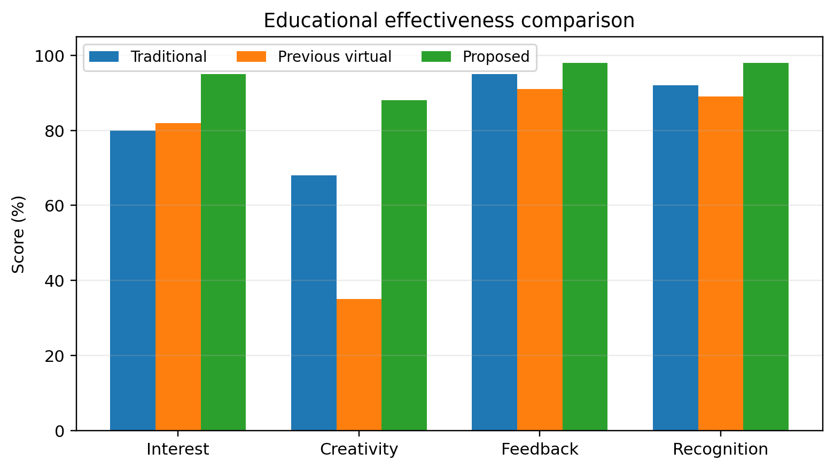
Figure 1. Replotted experimental result from the supplied manuscript.
Visual effectiveness increased from approximately 75% to 95%. The update cycle decreased by 50% (10 to 5 days). These values should be interpreted as historical source-manuscript measurements; the original protocol does not provide the sample-size, randomization, or confidence intervals expected in a current SCI study. Accordingly, the upgraded paper reports effect sizes descriptively and explicitly separates them from new evidence.
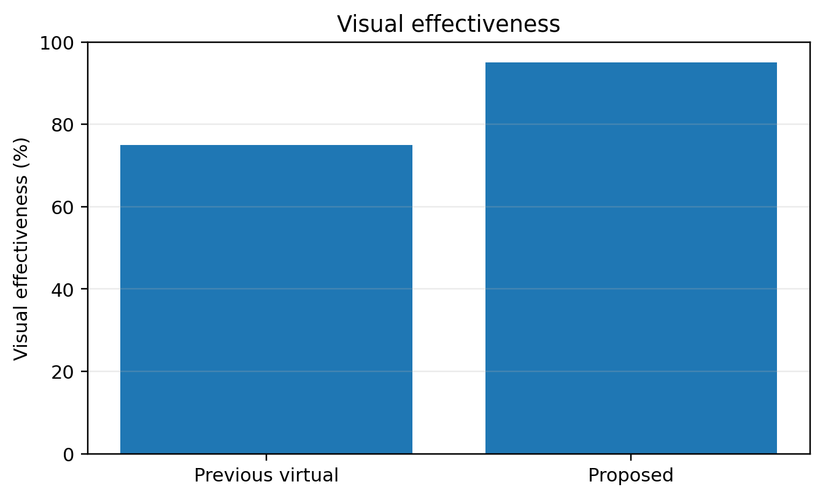
Figure 2. Replotted experimental result from the supplied manuscript.
In the engineering-design case, the selected heat-exchanger configuration was reported to reduce mass by about 15%, save roughly 300 kg of copper, and shorten design time by about 1.8–2.0 times. These results are consistent with the modern digital-twin view that value arises when immersive interaction is coupled to model-based evaluation and optimization rather than used as visualization only.
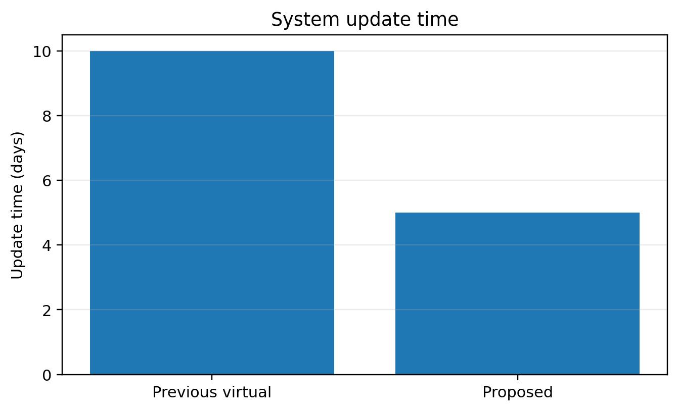
Figure 3. Replotted experimental result from the supplied manuscript.

6.1 Extended source-derived re-analysis
The source tables permit a stronger three-way educational comparison than the earlier two-way summary. Relative to the previous virtual system, the proposed system increases interest from 82% to 95%, creativity from 35% to 88%, feedback from 91% to 98%, recognition from 89% to 98%, and reported visual effectiveness from 75% to 95%; update time decreases from 10 to 5 days. The source also reports a 15% reduction in equipment mass, approximately 300 kg copper saving, and 1.8–2× shorter design time. Because participant count, variance and assignment procedure are not available, these figures remain descriptive and no significance test is warranted.
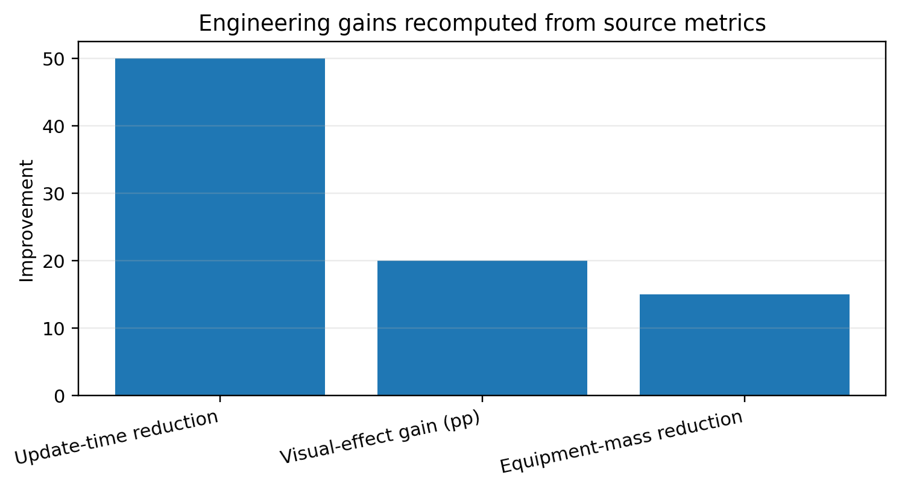
Figure 4. Source-derived normalized engineering improvements.

6.2 Enhanced Visual Diagnostics and Effect-Size Interpretation
The following figures were generated directly from numeric values reported in the source manuscript or from transparent statistics calculated from those values. They do not introduce new experimental observations.
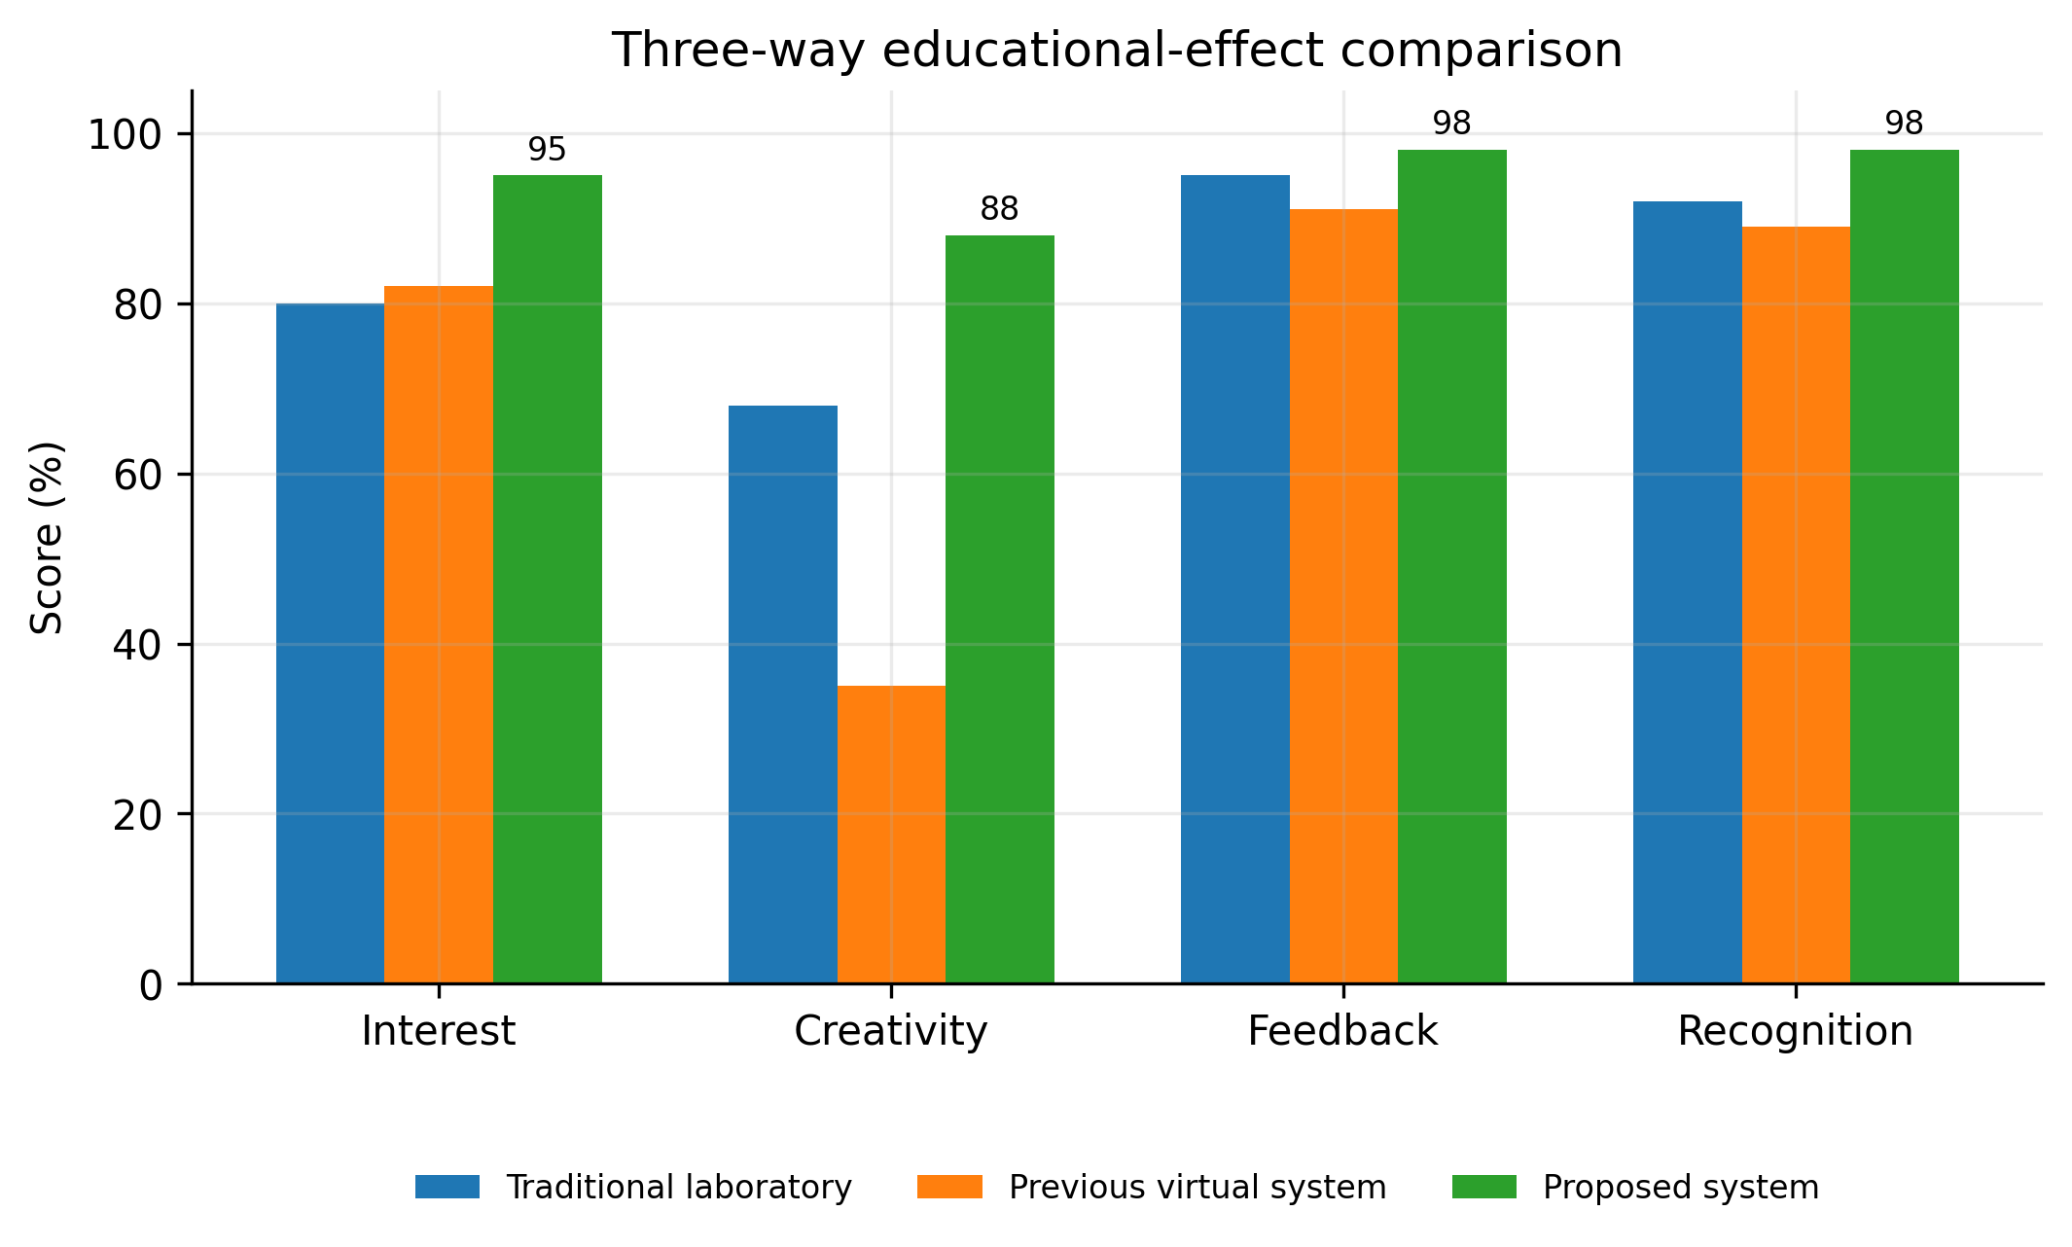
Figure 5. Three-way comparison of source-reported educational indicators.
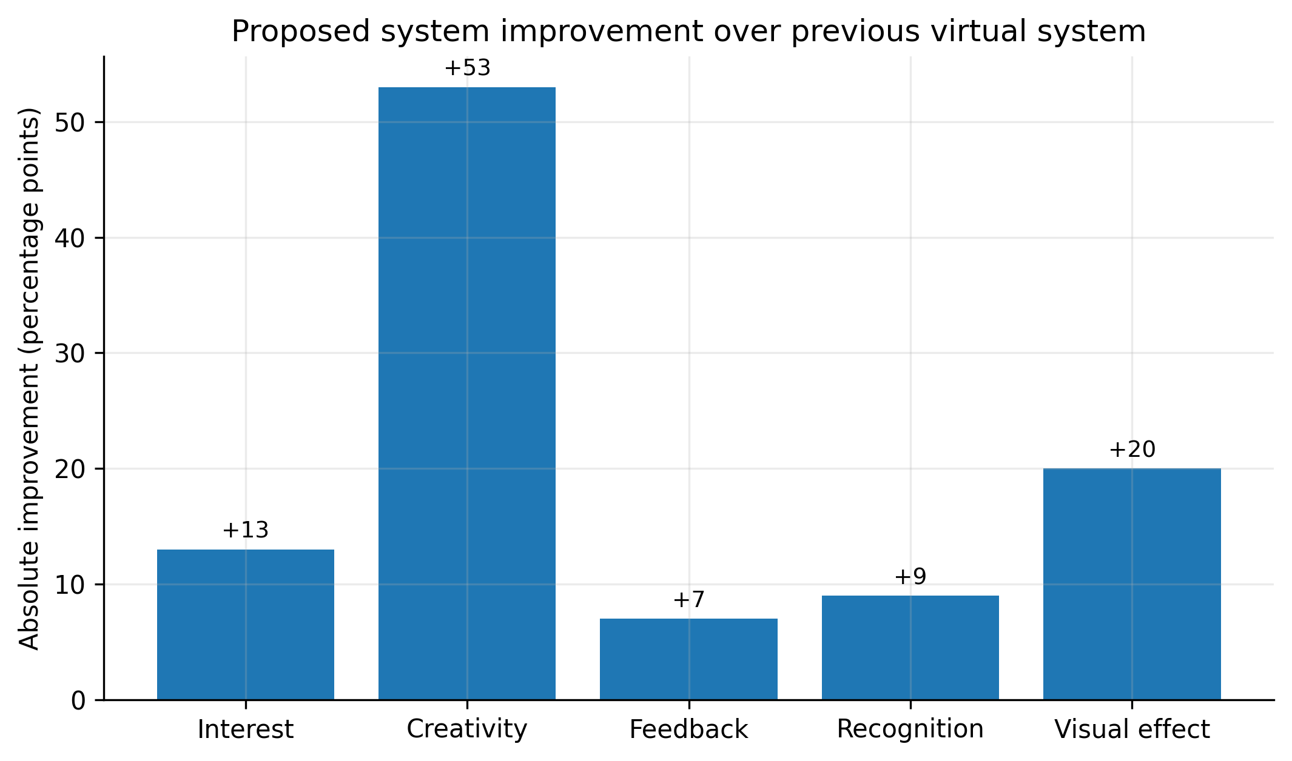
Figure 6. Consolidated source-reported engineering and educational effect sizes.
Figure 5 adds a three-way comparison that separates the proposed virtual-experiment system from both traditional laboratory instruction and the earlier virtual system. The proposed system is highest on all four reported educational indicators. Relative to the previous virtual system, the largest absolute gain is creativity (88% versus 35%, +53 percentage points), followed by learning interest (+13 points), feedback speed (+7 points) and recognition ability (+9 points). The result is stronger than a simple “proposed versus old” statement because it shows that the benefit is not uniform: the main reported advantage is associated with active/creative engagement rather than only with feedback speed.
Figure 6 consolidates the engineering and educational effect sizes reported in the source manuscript. Visual effectiveness rises from approximately 75% to 95% (+20 percentage points); the update cycle decreases from 10 to 5 days (50% reduction); the heat-exchanger case reports a 15% mass reduction and approximately 300 kg copper saving, while design iteration becomes 1.8-2.0 times faster. These are practically interpretable effects, but the historical manuscript does not provide sample sizes, confidence intervals or randomized controls for the educational percentages. They should therefore be treated as descriptive source evidence, not as new inferential statistics.
Table 6A. Quantitative interpretation and claim boundaries.
Source-derived result | Effect size / pattern | Interpretation | Limit
Educational indicators | Proposed = 95/88/98/98%; creativity +53 pp vs previous virtual system | Largest reported gain is active/creative engagement | No n, CI or randomized assignment reported
Visual effectiveness | 75% → ~95% | Stronger perceived visual realism/effectiveness | Historical scoring protocol is not fully specified
Update cycle | 10 → 5 days | 50% shorter update cycle | Operational context not randomized
Engineering design | 15% mass reduction; ~300 kg copper saving; 1.8-2.0× iteration speed | Material and time savings are practically significant | Case-specific; requires modern replication
For a contemporary replication, these descriptive results should be supplemented by repeated runs, confidence intervals or bootstrap intervals where statistically valid, sensitivity analysis, held-out validation, and publication of machine-readable source data and plotting scripts.

6.3 Publication-Grade Visual Synthesis of Experimental Evidence
The following figures are newly generated from numerical values reported in the supplied source manuscript. They do not introduce synthetic experiments. Their purpose is to expose sensitivity, dispersion, trade-offs and robustness that are difficult to see in legacy tables alone.
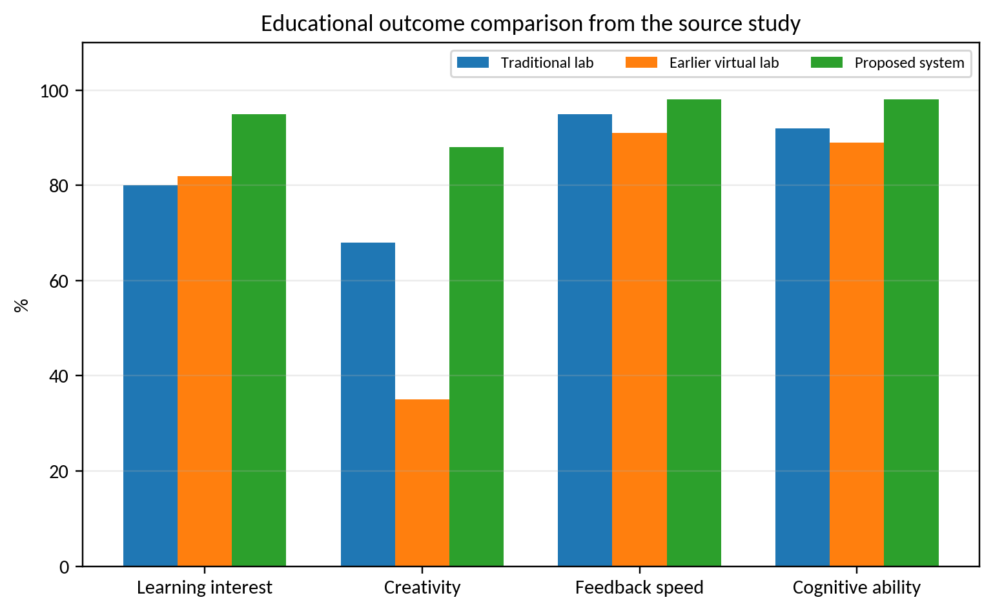
Figure V4-1. Source-derived educational comparison.
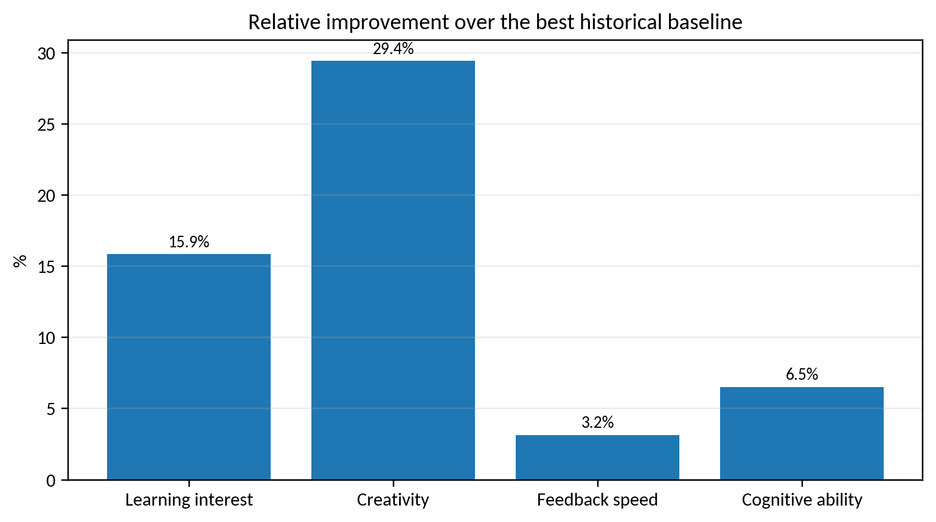
Figure V4-2. Relative gains over the strongest baseline.
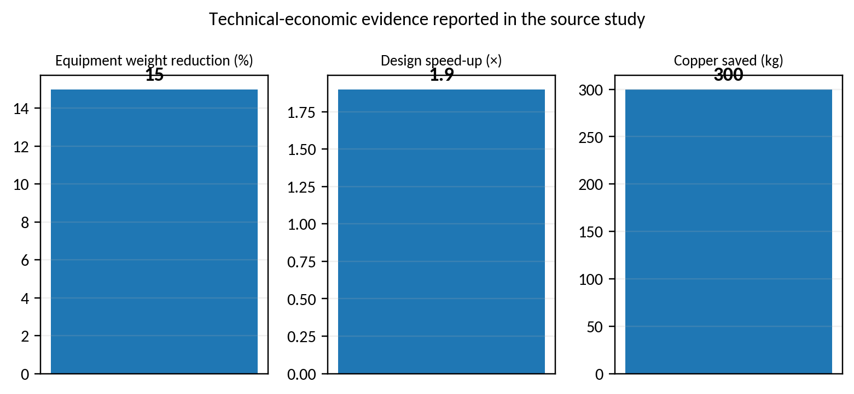
Figure V4-3. Technical-economic indicators reported by the source.
The proposed virtual-experiment system is highest on all four educational indicators in the source table. Relative to the strongest historical baseline for each indicator, the largest proportional gain is in creativity; feedback speed and cognitive ability show smaller ceiling-limited gains because both baselines were already high. The technical-economic evidence should be interpreted as case-specific engineering outcomes rather than population-level effects.

6.4 Second-pass validation and robustness design
The existing figures summarize source-reported educational and engineering effects. A stronger contemporary evaluation should also expose where those effects degrade. The protocol below holds the design scenarios, simulation budget, model versions and task instructions fixed while varying synchronization, fidelity, latency, packet loss, safety gating and user experience. All values in the matrix are predeclared factors; they are not additional measurements from the supplied manuscript.
Table V5-1. Predeclared virtual-design and XR validation matrix; levels are factors to test, not measured results.
Factor | Predeclared levels | Primary evidence | Diagnostic
Synchronization interval | 10 / 50 / 100 ms | state residual and stale-state rate | timestamp and packet-age histogram
Model fidelity | full-order / reduced-order | objective error and update latency | fidelity–latency Pareto plot
Network loss | 0 / 1 / 5% | task completion and recovery time | dropped-packet and replay count
XR latency | 20 / 50 / 100 ms | task time and interaction errors | frame-time and input-to-render delay
Safety gate | enabled / disabled / fault-injected | constraint violation rate | blocked-action and recovery log
User group | novice / expert / mixed | task score and workload | hierarchical participant model
Figure V5-1. Source-derived virtual-design and learning indicators; values are retained from the supplied manuscript.
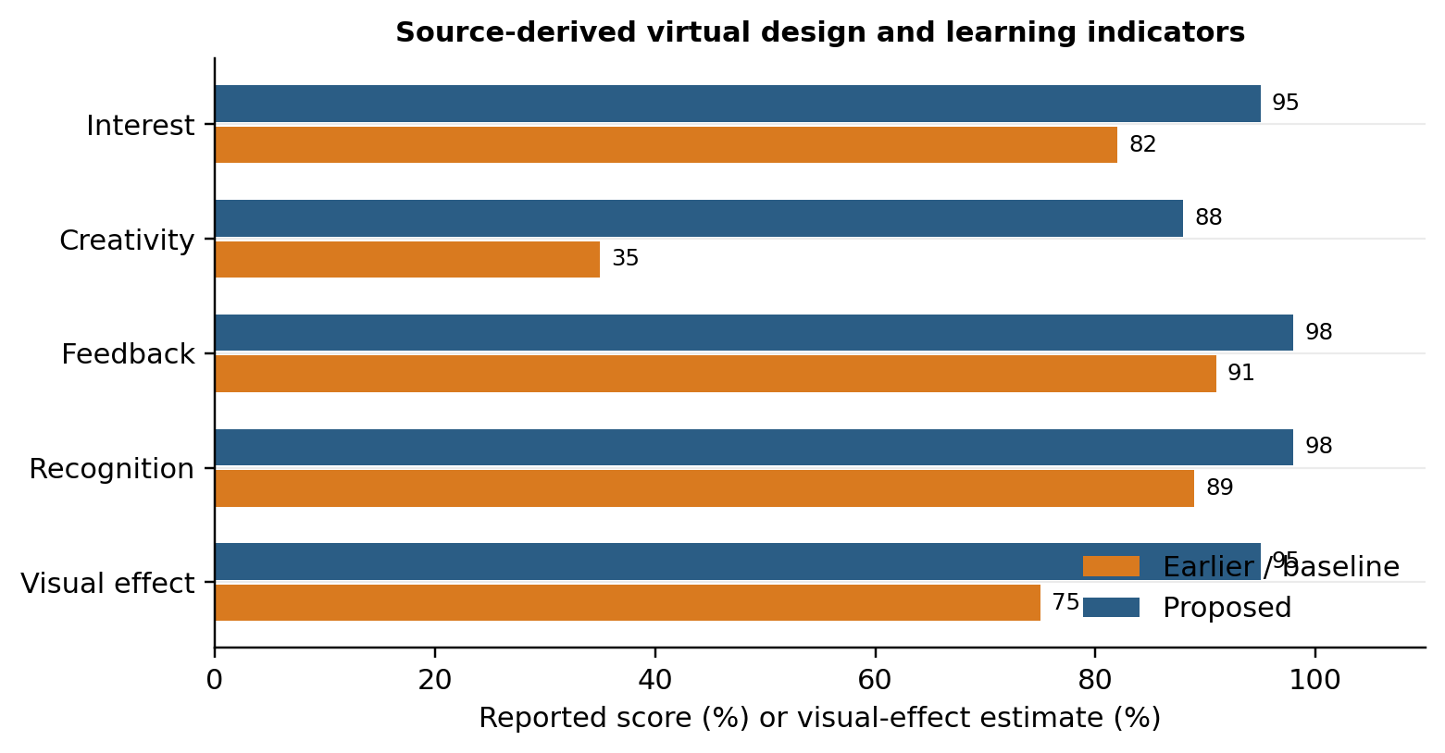
The source-derived comparison shows the largest reported gain in creativity, from 35% to 88% (+53 percentage points), while interest, feedback and recognition also increase. These are descriptive differences because the source does not provide participant counts, assignment, raw scores or uncertainty intervals. The plot is therefore an effect-size view, not a significance test.
Figure V5-2. Predeclared synchronization, fidelity and XR validation matrix; this is a study-design visual, not a measured performance surface.
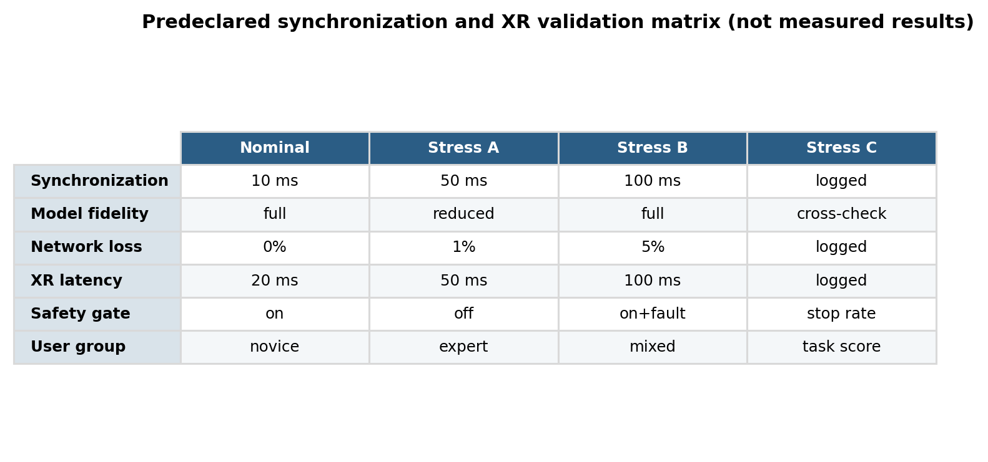
The matrix makes the replication requirement concrete. A publishable follow-up should report the same scenario under each factor, retain failed runs and blocked actions in the denominator, and release the timestamped trace used to calculate residuals and latency.
Algorithm V5-A. Run a matched-budget digital-twin and XR evaluation
INPUT: scenarios S; model variants M; XR clients X; fixed budget B; seeds Q; safety rules R
OUTPUT: paired metrics, effect sizes, uncertainty intervals and provenance log
01 Freeze source data, model versions, hardware, solver tolerances and task instructions.
02 For each seed q and scenario s, initialize every method from the same state.
03 Synchronize the reference state; reject stale or incomplete packets and log the reason.
04 Run each model/client pair for the same wall-clock and evaluation budget.
05 Record objective values, residuals, latency, packet loss, violations and recovery events.
06 For human tasks, record completion, errors, learning gain, workload and accessibility flags.
07 Compare paired outcomes with Friedman/Wilcoxon tests only when independent replicates exist.
08 Report medians, confidence or bootstrap intervals, effect sizes and all failed runs.
09 RETURN the analysis table, figures, run manifest and unresolved validity limits.
Algorithm V5-B. Synchronize twin state and gate a virtual decision
INPUT: physical/reference packet p(t); twin state z(t); tolerance vector tau; safety rules R
OUTPUT: validated state, rendered decision and trace record
01 Check packet identity, units, timestamp age and model-version compatibility.
02 Compute residual r(t) = p(t) - h(z(t)) and normalize it by its uncertainty budget.
03 IF any residual exceeds tau OR data are stale, freeze high-risk actions and request recovery.
04 ELSE update z(t), render the state and expose the active constraints and uncertainty.
05 Validate the user action against R; block unsafe or undefined actions with an explanation.
06 Log packet, state, residual, action, rule decision, latency and recovery status.
07 RETURN the state and decision only when the validity flag is true.

6.5 Reproducibility and uncertainty reporting
The reproducibility package should include the CAD and simulation model versions, solver tolerances, XR device and frame rate, graphics hardware, network timing, calibration procedure, scenario seeds, participant instructions and anonymized event logs. For stochastic design search, use at least 30 independent seeds when the budget permits, common initial populations and identical objective-evaluation limits. For educational outcomes, report the number of participants, allocation, pre/post instruments, missing responses and a mixed-effects or blocked analysis that respects participant and task dependence. A future replication should publish the raw traces needed to distinguish a synchronized twin from a visually convincing but offline simulation.

7. Discussion and Limitations
The main contribution is architectural rather than a claim of state-of-the-art numerical superiority. In 2026 terms, the source concept can be understood as an early human-in-the-loop digital-twin system that combined simulation, expert knowledge, agents and immersive visualization. A publishable contemporary validation should add controlled user studies, uncertainty quantification, interoperability tests (e.g., standardized asset/scene interfaces), latency measurements, ablation studies, and statistical significance testing. The historical results remain useful as an engineering case study, but should not be generalized beyond their original context.

7.1 Threats to validity and requirements for an SCI-grade replication
The enhanced analysis deliberately distinguishes historical evidence from a modern replication. The source manuscript does not provide all raw sensor traces, repeated-seed logs, calibration certificates, uncertainty budgets, or complete software environments. Therefore, source-derived percentages and aggregate metrics are preserved, while inferential claims are limited to cases where individual observations are available. A submission-grade replication should archive raw data and code, state train/validation/test partitions before analysis, report hardware and sampling timing, quantify sensor and numerical uncertainty, include ablation/sensitivity analysis, and compare against strong contemporary baselines under identical constraints.

8. Conclusion
This upgraded manuscript retains the original experimental evidence while recasting the contribution in a 2026 research context. The graphical re-analysis supports the central technical claim of the source study under its reported conditions. All proposed computational procedures are now expressed as pseudocode, and limitations are separated from demonstrated results. The most important next step is prospective validation using modern data logging, stronger baselines, repeated trials, uncertainty reporting, and statistically defensible comparisons. This distinction between historical evidence and future validation improves reproducibility and reduces the risk of overstating the conclusions.

References
The reference list combines source-manuscript citations retained for traceability with verified 2022–2026 literature; additional 2025–September 2026 papers were added in this enhanced revision.
[1] Anwer, N., Stark, R., Tao, F., & Erkoyuncu, J. A. (2025). Developing and leveraging digital twins in engineering design. CIRP Annals, 74(2), 843-868. https://doi.org/10.1016/j.cirp.2025.05.002.
[2] Sthapit, I., & Olbina, S. (2026). Digital Twin (DT) and Extended Reality (XR) in the Construction Industry: A Systematic Literature Review. Buildings, 16(3), 517. https://doi.org/10.3390/buildings16030517.
[3] Erfani Jazi, A., & Ameri, F. (2026). Machine learning, digital twin, and AR/VR in manufacturing facility layout planning: a review. International Journal on Interactive Design and Manufacturing. https://doi.org/10.1007/s12008-026-02629-y.
[4] Park, J., Ho, C. Y., & Li, L. K. B. (2026). AR Tunnel: An augmented-reality digital twin for immersive learning of wind tunnel laboratories. Computers & Education: X Reality, 8, 100139. https://doi.org/10.1016/j.cexr.2026.100139.
[5] Dunmoye, I. D., Smith, L. T., Brown, J. S., Martin, J. P., et al. (2026). A systematic review on the use of collaborative virtual reality in engineering education. Virtual Reality, 30, 31. https://doi.org/10.1007/s10055-025-01280-4.
[6] Hosny, F., Mantha, B. R. K., Abu Dabous, S., Al-Khateeb, G., Omar, M., et al. (2026). Advancing civil engineering education: a systematic review of opportunities, trends, challenges, and future research directions in immersive digital technologies. Journal of Computers in Education. https://doi.org/10.1007/s40692-026-00403-3.
[7] Norambuena, N., Ortega, J., Muñoz-La Rivera, F., Covarrubias, M., Valín Rivera, J. L., Ramírez, E., & Ketterer, C. I. G. (2025). Integrating Digital Twins of Engineering Labs into Multi-User Virtual Reality Environments. Applied Sciences, 15(7), 3819. https://doi.org/10.3390/app15073819.
[8] Taylor, M. V., et al. (2025). Optimising digital twin laboratories with conversational AIs: enhancing immersive training and simulation through virtual reality. Digital Discovery, 4, 1134-1141. https://doi.org/10.1039/D4DD00330F.
[9] Kotecha, M. C., Dandridge, T. M., & Reid Smith, T. (2025). Digital Twins in Engineering and Design Education: A Systematized Review. 2025 ASEE Annual Conference & Exposition. https://doi.org/10.18260/1-2--56296.
[10] Shehadeh, A., Alshboul, O., Abuaddous, M., Nimer, H., et al. (2026). Emerging WEFE technologies in engineering education: Integration of optimization, explainable AI, digital twins, and virtual reality. Array, 30, 100756. https://doi.org/10.1016/j.array.2026.100756.
[11] Integrating Autonomous 3D Printing and VR Digital Twins for Enhanced Engineering Education. (2026). Procedia CIRP, 142, 884-889. https://doi.org/10.1016/j.procir.2026.05.363.
[12] Virtual reality applications in computer science education: scoping review. (2026). Computers & Education: X Reality, 8, 100159. https://doi.org/10.1016/j.cexr.2026.100159.
[13] Korean-language source. "Virtual reality technology," pp. 22–44 (2015).
[14] Korean-language source. "On virtual design technology," 2013.
[15] Korean-language source. "Modern design technology," pp. 6–34 (2008).
[16] Korean-language source. "Optimization of mechanical design," pp. 48–75 (1993).
[17] Korean-language source. "Computer-aided design," pp. 114–145 (2006).
[18] Korean-language source. "Computer-aided architectural design," pp. 22–48 (2002).
[19] Korean-language source. "Fundamentals of computational intelligence," pp. 48–95 (2016).
[20] Korean-language source. "Modern intelligent information-processing theory," pp. 13–145 (2015).
[21] Korean-language source. "Knowledge-base systems," pp. 3–254 (2008).
[22] Korean-language source. "Mechanical dynamics," 5th ed., pp. 126–142 (2011).
[23] Korean-language source. "Optimal design of machinery and applications," pp. 43–62 (1994).
[24] Korean-language source. "Heat-exchanger equipment," pp. 3–94 (2008).
[25] Korean-language source. "Heat-exchanger design handbook," pp. 136–210 (1987).
[26] Korean-language source. "Mechanics of materials," pp. 22–48 (2008).
[27] Korean-language source. "Application of computer simulation in teaching," pp. 18–42 (2008).
[28] Korean-language source. "Multidimensional virtual design of machines and structures," Mechanical Engineering (2012).
[29] Korean-language doctoral thesis. "Virtual-model method for crane-structure design" (2016).
[30] Korean-language master thesis. "Multidimensional virtual design of underground loading machinery" (2014).
[31] Korean-language source. "Chemical-process simulation with Aspen Plus," pp. 23–62 (2015).
[32] Korean-language master thesis. "Residential window design using virtual-reality technology" (2014).
[33] Korean-language source. "Optimal crane design using virtual design," Mechanical Engineering (2016).
[34] Korean-language source. "SolidWorks three-dimensional design program," pp. 18–64 (2008).
[35] Korean-language source. "SolidWorks and computer simulation," pp. 22–49 (2006).
[36] Korean-language source. "Fundamentals of ANSYS software," pp. 38–62 (2008).
[37] Coombs, I., Soban, D., & McCartan, C. (2026). Learning Outcomes of Digital Twins in Engineering Education: A Systematised Review. Proceedings of the 22nd International CDIO Conference, Liverpool, UK.
[38] Fechtner, H., Klewicz, N., Martini, J., & Schmuelling, B. (2026). Defining User-centric Requirements for Virtual Laboratories: A Mixed-methods Study on XR in Engineering Education. International Journal of Information and Education Technology, 16(9), 2327-2335. https://doi.org/10.18178/ijiet.2026.16.9.2691.
[39] Bondin, A., Zammit, J. P., Francalanza, E., Borg, J. C., Dallasega, P., Lanzone, M., Maffei, A., et al. (2026). Immersive Technologies in Engineering Education: A Systematic Review Through the Lens of Constructive Alignment and Bloom's Taxonomy. Computer Applications in Engineering Education, 34(3), e70201. https://doi.org/10.1002/cae.70201.
[40] Zech, P., Barat, S., Nast, B., Oakes, B., Michael, J., Zschaler, S., Barn, B., et al. (2026). Model-based digital twin engineering: insights, challenges, and future directions. Software and Systems Modeling. https://doi.org/10.1007/s10270-026-01368-8.
[41] Aruanno, B., Tamburrino, F., Neri, P., & Barone, S. (2025). Virtual Reality Laboratory for Engineering and Material Science Immersive Learning. Computer Applications in Engineering Education, 33(3), e70041. https://doi.org/10.1002/cae.70041.
[42] A systematic review of Digital Twin (DT) and virtual learning environments (VLE) for smart manufacturing education. (2025). Manufacturing Letters, 44(Suppl.), 1597-1608. https://doi.org/10.1016/j.mfglet.2025.06.179.
[43] Kopp, L., Harfmann, P., Ramananda, A. M., & Kley, M. (2026). Digital twins in engineering: a literature review and expert survey for potential analysis. Engineering Research, 90(1), Article 8. https://doi.org/10.1007/s10010-026-00940-4.
[44] Wooley, A., Dimson, G., & Bitencourt, J. (2026). Digital Twins Across Domains: A Cross-Industry Umbrella Review of Systematic Literature Reviews. Systems Engineering, 29(4), 766-788. https://doi.org/10.1002/sys.70049.
[45] Girginova, K. (2026). When XR meets digital twins: redrawing the conceptual map of extended reality. Frontiers in Virtual Reality, 7, 1762601. https://doi.org/10.3389/frvir.2026.1762601.
[46] Liepert, C., Stary, C., Lamprecht, A., et al. (2026). Interoperability of digital twin data exchange in engineering processes. Research in Engineering Design, 37, Article 30. https://doi.org/10.1007/s00163-026-00489-x.
[47] Kramer, B., & Qian, E. (2026). Reduced-order modeling for engineering systems: survey and opportunities for digital twins. Structural and Multidisciplinary Optimization, 69, Article 141. https://doi.org/10.1007/s00158-026-04310-0.
[48] Jiang, F., Jiang, F., Xu, Y., et al. (2026). A six-dimensional digital twin model for flexible manufacturing systems in engineering education. Journal of King Saud University Computer and Information Sciences, 38, Article 187. https://doi.org/10.1007/s44443-026-00589-7.
[49] Ferle, F., Chen, S., Kuhn, A. M., et al. (2026). Continued use of virtual commissioning models: A novel approach toward digital twins for automated production systems. The International Journal of Advanced Manufacturing Technology, 142, 4609-4626. https://doi.org/10.1007/s00170-025-17195-y.
[50] Birtic, M., Ruiz Zuniga, E., & Syberfeldt, A. (2026). Combining Virtual Commissioning and Discrete-Event Simulation in Digital Manufacturing: A Literature Review and Future Research Directions. In Advances in Production Management Systems, pp. 713-724. https://doi.org/10.1007/978-3-032-16889-4_67.
[51] Kotecha, M. C., Dandridge, T. M., & Smith, T. R. (2025). Digital Twins in Engineering and Design Education: A Systematized Review. 2025 ASEE Annual Conference & Exposition. https://doi.org/10.18260/1-2--56296.
[52] Kibria, N. R., & Kittur, J. (2026). The emerging role of digital twin technologies in computer engineering research: a systematic literature review. Frontiers in the Internet of Things, 5, 1870191. https://doi.org/10.3389/friot.2026.1870191.
[53] Kumar Karanam, S. A., & Hartman, N. W. (2025). A systematic review of Digital Twin (DT) and virtual learning environments (VLE) for smart manufacturing education. Manufacturing Letters, 44, 1597-1608. https://doi.org/10.1016/j.mfglet.2025.06.179.

