Single-Neuron Adaptive Neuro-Fuzzy PI Control for Temperature Regulation in a Nonlinear Vacuum Concentration Process
Comprehensive SCI V4 enhancement — literature refreshed through 2026; complete pseudocode catalogue; expanded source-derived visual analysis; Calibri typography throughout
Data-integrity note: experimental values, comparative metrics and engineering claims are re-analyzed from the supplied source manuscript. No new experimental observations are fabricated. Literature has been updated through 2026.

Abstract
Vacuum concentration is a strongly nonlinear thermal process whose gain and time constants vary with feed properties, vacuum level, steam supply, and environmental conditions. The source manuscript addressed this problem by combining a hybrid fuzzy PI controller with a single-neuron adaptive mechanism and implementing the controller on an ADuC831-based platform. This upgraded SCI-style manuscript positions the method against 2025–2026 advances in ANFIS, fuzzy-neural PID, interval type-2 fuzzy control, event-triggered adaptation, and intelligent thermal-process control. The algorithm is reformulated as an auditable online control loop with explicit pseudocode for fuzzy inference, neuron-weight adaptation, saturation handling, and real-time execution. Original process data are re-analyzed graphically. The transient time decreased from 40 s at a 30 °C initial condition to 21 s at 50 °C. Reducing steam supply from 100% to 75% increased transient time from 24 to 81 s and concentration time from 14 to 48 min. Historical production records show that mean total production time decreased from 5.575 h to 4.275 h, a 23.3% reduction, while dispersion also decreased. These results indicate that adaptive neuro-fuzzy PI control can improve consistency in a process with uncertain dynamics, although prospective trials with modern sensors and statistically designed disturbances are still required.
Keywords: vacuum concentration; neuro-fuzzy control; PI control; single-neuron adaptation; nonlinear process; temperature regulation
Enhanced manuscript highlights
• Latest 2026 adaptive thermal/process-control context
• Complete neuro-fuzzy PI pseudocode + safeguards
• Post-hoc analysis of 20+20 production-time records
• Multiple source-derived operating-condition graphs

1. Introduction
Industrial thermal processes remain a demanding control class because transport delays, nonlinear heat and mass transfer, actuator constraints, and operating-point drift invalidate a single fixed linear model. Contemporary work therefore increasingly combines fuzzy reasoning with adaptive learning. In 2026, ANFIS–Fuzzy-PID fusion has been studied for temperature regulation, while advanced ANFIS controllers are being applied to strongly nonlinear pH processes [1,2]. Event-triggered fuzzy-neural PID control further shows that adaptive updates can be made selective rather than continuous, reducing unnecessary computation and actuator wear [3].
The broader fuzzy-control literature has also moved toward interval type-2 models and optimization-assisted parameter tuning. Recent work demonstrates improved robustness for type-2 fuzzy PID controllers under nonlinear uncertainty [4], and furnace-control studies use type-2 fuzzy broad-learning or fuzzy-neural architectures to handle time variation and unmeasured disturbances [5,6]. These trends are directly relevant to vacuum concentration, in which the same manipulated steam flow can produce different temperature responses as product concentration and vacuum conditions evolve.
The source study proposed a pragmatic solution: retain the interpretability and low implementation burden of PI/fuzzy control, while adding a single-neuron adaptation mechanism that adjusts the control contribution from observed error dynamics. The upgraded formulation keeps that core idea, but states the signal path, update sequence, safeguards, and evaluation procedure explicitly so that the algorithm is reproducible.
Recent 2026 process-control work provides two useful benchmarks for the present contribution. Modern nonlinear CSTR studies emphasize multi-operating-point robustness, constrained tuning and adaptive gains [37–40], while evaporation research increasingly adopts mechanism–data hybrid MPC and predictive concentration control under strong delays and feed disturbances [41,42]. These studies do not invalidate the lightweight neuro-fuzzy PI concept; instead, they clarify its intended niche: interpretable embedded adaptation with low online computation. A contemporary replication should therefore compare the proposed controller against optimized PID/2DOF-PID and MPC under identical sampling, actuator saturation and disturbance scenarios.

1.1 2026 State-of-the-Art Update and Positioning
The 2026 control literature strengthens the motivation for adaptive, interpretable temperature regulation in nonlinear processes. Ruan et al. [43] combine ANFIS and Fuzzy-PID through dynamic weighting to balance response speed, overshoot and steady-state accuracy. Wang et al. [44] report fuzzy-PID temperature regulation for a precision thermal-convection instrument, while Dong et al. [45] add mechanism constraints, event-triggered rule updates and separated fast/slow adaptation to a fuzzy-PID architecture. These studies illustrate a clear trend: modern intelligent control is moving from fixed rule bases toward adaptive fusion, event-triggered updating and explicit physical constraints.
For process systems, the robustness problem is equally important. Dai et al. [46] formulate switched T-S fuzzy fault estimation and H∞ active fault-tolerant control for an uncertain recycling CSTR, and Omar et al. [47] demonstrate hybrid fuzzy high-order PID regulation in a coupled multi-area control problem. Together with recent CSTR temperature-control studies [37-42], the literature emphasizes wide operating ranges, disturbances, actuator faults, parameter drift and reproducible quantitative benchmarks.
Against this 2026 background, the proposed single-neuron neuro-fuzzy PI controller occupies a different design point from large adaptive or optimization-heavy controllers. Its value is a compact, interpretable and computationally light architecture suitable for embedded industrial control. The upgraded paper therefore evaluates not only tracking quality but also operating-range sensitivity, production-time distributions, disturbance behavior, algorithmic safeguards and the exact evidence that can—and cannot—be concluded from the historical plant data.

1.2 Focused 2025-2026 Literature Synthesis and Updated Research Gap
Recent 2026 work strengthens the case for adaptive but interpretable process control. A knowledge-guided ANFIS temperature controller has demonstrated precise thermal regulation with rule-level transparency [48], while ANFIS has also been benchmarked for industrial high-temperature heat-pump prediction [49]. In complex separation processes, hybrid ANFIS-PID structures are being used to replace difficult online composition measurements while preserving conventional regulatory control [50]. These studies reinforce the present paper's central design trade-off: intelligence is valuable only when it remains computationally bounded and auditable enough for industrial deployment.
The broader process-control literature also shows a shift from isolated controller tuning to plant-wide robustness and monitoring. A 2026 review of nonlinear acid-gas removal units highlights MPC, ANN/ANFIS soft sensing and digital-twin-oriented control architectures [51], while causal neuro-fuzzy process monitoring explicitly links adaptive modeling with root-cause interpretation [52]. Recent gas-turbine ANFIS prediction [53], Smith-fuzzy-PID fermentation control [54] and industrial fuzzy-PID furnace control [55] provide additional contemporary benchmarks. Accordingly, the revised contribution is positioned as a low-cost adaptive controller whose future validation should include model drift, saturation, disturbances, sensor faults and deployment latency.
Year | Recent study | Technical focus | Implication for this paper
2026 | Feced-Mas et al. | Transparent ANFIS thermal control | Rule traceability plus robustness
2026 | Li et al. | ANFIS-PID extractive-distillation control | Soft sensing + hybrid regulatory control
2026 | Imran et al. | Review of intelligent process control | MPC/ANFIS/digital-twin convergence
2026 | Ali et al. | Causal neuro-fuzzy process monitoring | Interpretability and fault lineage
2026 | Kim et al. | Industrial fuzzy-PID furnace control | Deployment under inertia and delay
Table 1B. Focused 2025-2026 literature matrix.
Table 1A. 2026-oriented positioning of the proposed framework.
2026 direction | Representative evidence | Latest emphasis | Position of this study
Adaptive neuro-fuzzy fusion | [43] | Dynamic fusion of ANFIS and Fuzzy-PID | Uses a much smaller single-neuron adaptation path; prioritizes low computation.
Precision fuzzy-PID thermal control | [44,45] | Adaptive gains, physical constraints, event-triggered updates | Adds bounded parameter updates, anti-windup and explicit safety checks in pseudocode.
Fault-tolerant fuzzy process control | [46] | Wide-range T-S approximation, fault estimation, H∞ robustness | Historical controller lacks formal H∞ proof; robustness is evaluated empirically and this limitation is stated.
Hybrid higher-order fuzzy control | [47] | Coupled high-performance regulation | Current method remains simpler and interpretable for embedded industrial implementation.

1.3 Validation requirements in the 2026 control literature
The 2026 process-control literature increasingly evaluates controllers across operating points, disturbances, actuator constraints and energy, rather than reporting a single set-point response. Recent adaptive ANFIS and fuzzy-PID studies emphasize explicit design choices and transparent rule behavior [43–45,48], while fault-tolerant and hybrid process-control work highlights actuator faults, model uncertainty and operating-range coverage [46,47,50,51]. These studies are useful contemporary comparators even though their plants and objectives differ from vacuum concentration.
The compact single-neuron neuro-fuzzy PI architecture remains attractive for embedded deployment, but its advantage can only be interpreted fairly when the baseline, sampling period, valve limits, disturbance sequence and measurement quality are matched. The second-pass protocol therefore treats robustness, energy and safety events as first-class outcomes and keeps the source-derived before/after production records separate from a future controlled replication.
Table V5-L. 2026 control evidence mapped to a reproducible comparison.
Validation direction | Recent literature | Operational test | Claim boundary
Adaptive fuzzy fusion | [43,48] | same plant, sampling and tuning budget for each controller | No cross-plant superiority claim
Actuator and model uncertainty | [46,50,51] | noise, delay, saturation and parameter-drift grid | Source experiment does not identify a formal robust-stability margin
Energy and process constraints | [41,42,50] | IAE, control energy, rail hits and feasibility failures | Valve opening is not a calibrated steam-flow measurement
Transparent online adaptation | [44,48] | bounded weights, update gates and traceable rule activity | Adaptation is not causal evidence without matched runs

2. Research Gap and Contributions
The upgraded study targets three gaps: (1) a reproducible statement of the proposed method instead of narrative-only algorithm description; (2) a literature position aligned with work published around 2026; and (3) transparent, graph-based re-analysis of the original experiments. The contribution is intentionally bounded to the supplied evidence. Where modern validation requirements exceed the source data, this is stated as a limitation rather than filled with synthetic measurements.

3. Proposed Method
The controlled variable is the evaporation/concentration temperature, and the practical manipulated variable is heating-steam supply. Let e(k)=r(k)-y(k) denote temperature error and Δe(k)=e(k)-e(k-1). The fuzzy PI component maps the normalized pair {e, Δe} to an incremental control action using a compact rule base. The single-neuron component receives error-derived features and updates its weights online, providing an adaptive correction to the fuzzy PI action.
To prevent the adaptive element from destabilizing the loop, the upgraded algorithm uses explicit output saturation, bounded neuron weights, a deadband around the set point, and an optional update gate. These are implementation safeguards consistent with modern event-triggered and type-2 fuzzy-control practice; they do not alter the historical experimental data.
The source implementation used an ADuC831 microcontroller and performed process measurements, A/D conversion, control computation, and output actuation in a real-time loop. The upgraded paper treats the hardware realization as an embedded reference architecture and recommends modern replication with logged sampling time, sensor uncertainty, actuator limits, and synchronized process data.

4. Algorithmic Specification (Pseudocode)
Algorithm 1. Fuzzy-PI incremental inference
Input: reference r(k), measured temperature y(k), previous error e(k-1), scaling factors Ke, Kde, Ku
Compute e(k)=r(k)-y(k) and Δe(k)=e(k)-e(k-1)
Normalize E=clip(Ke·e(k)) and DE=clip(Kde·Δe(k))
Evaluate memberships of E and DE in the fuzzy linguistic sets
FOR each active rule: calculate rule firing strength and rule output
Aggregate active-rule outputs and defuzzify to obtain Δu_f(k)
Scale Δu_PI(k)=Ku·Δu_f(k)
RETURN Δu_PI(k), e(k)

Algorithm 2. Single-neuron adaptive correction
Input: feature vector x(k) derived from error, current weights w(k), learning rate η, bounded region W
Compute neuron correction Δu_N(k)=w(k)^T x(k)
Compute adaptation signal from current error and error change
If |e(k)| exceeds deadband and update condition is true:
w(k+1)=projection_W[w(k)+η·adaptation_signal·x(k)]
Else: w(k+1)=w(k)
RETURN Δu_N(k), w(k+1)

Algorithm 3. Real-time neuro-fuzzy PI control loop
Initialize controller state, rule base, neuron weights and safety limits
At every sampling instant k:
Read temperature and validate sensor range
Run Algorithm 1 to obtain fuzzy-PI increment
Run Algorithm 2 to obtain adaptive correction
Combine u*(k)=u(k-1)+Δu_PI(k)+Δu_N(k)
Apply rate limit and actuator saturation to obtain u(k)
Write u(k) to steam-control actuator
Log r, y, e, Δe, u, weights and alarm flags
If a sensor/actuator fault is detected, switch to predefined safe control mode

4.1 Algorithm coverage, complexity and reproducibility controls
To make the algorithmic description auditable, Table A maps every computational component to pseudocode, an order-level cost expression and an explicit stopping condition. The complexity expressions are implementation-level order estimates rather than measured runtimes.
Component | Pseudocode | Order-level cost | Stopping / validation condition
Fuzzy-PI incremental inference | Algorithm 1 | O(Rm) | each sample
Single-neuron adaptation | Algorithm 2 | O(p) | bounded update / deadband
Real-time control loop | Algorithm 3 | O(Rm+p) | batch end / safety stop
Source-data statistical re-analysis | Algorithm 4 | O(N) | metrics + diagnostics complete
Table A. Algorithm coverage and stopping-condition audit.
Algorithm 4. Reproducible source-data evaluation and integrity check
Input: source production-time series before/after controller introduction
Verify n=20 observations in each historical period
Compute mean, SD, relative reduction and 95% CI for the mean difference
Run Welch two-sample t test as a post-hoc sensitivity analysis
Do not interpret the test as randomized causal evidence
Plot distributions and source operating-condition response curves
RETURN descriptive statistics, post-hoc p value, effect direction, limitations

4.2 Enhanced End-to-End Pseudocode and Implementation Safeguards
The following pseudocode converts the conceptual method into an auditable implementation sequence with explicit inputs, outputs, stopping conditions, numerical safeguards and failure handling.
Algorithm 5. Neuro-fuzzy PI control with bounded online adaptation
INPUT: set point r(k); measured temperature y(k); sampling period Ts; fuzzy partitions F; initial PI gains Kp0, Ki0; neuron weights w; learning rate η; actuator limits [umin,umax].
OUTPUT: control command u(k), updated parameters, diagnostic log.
1 Initialize integral state I ← 0; previous error eprev ← 0; validate sensor and actuator status.
2 FOR k = 1,2,... DO
3 Read y(k); if sensor value is invalid, hold/safely ramp the actuator and raise a diagnostic flag.
4 Compute e(k)=r(k)-y(k) and Δe(k)=e(k)-eprev; normalize both to fuzzy universes.
5 Evaluate fuzzy membership values and inference rules to obtain baseline gain corrections ΔKp,F and ΔKi,F.
6 Form the single-neuron input vector from e, Δe, integral information and controller state.
7 Compute neuron correction ΔuN = wᵀφ(k); combine it with the fuzzy PI output.
8 Apply actuator saturation and anti-windup; update I only when saturation logic permits.
9 Apply u(k) to the process and record r,y,e,Δe,u, gain corrections and saturation state.
10 Compute adaptation signal from the control error; update w ← Proj[w - η∇E] within predefined bounds.
11 If |e|, |Δe| or parameter increments exceed safety thresholds, reduce η/freeze adaptation and retain the last safe gains.
12 Set eprev ← e(k); continue until the production stage ends or a safety/interlock condition stops control.
13 END FOR
14 Return the trajectory and all updated parameters with the diagnostic trace.
Algorithm R. Reproducible experimental re-analysis and visualization
Algorithm R. Reproducible experimental re-analysis and visualization
INPUT: immutable source table D0; method labels; metric definitions; optional replicate IDs/random seeds.
OUTPUT: analysis table A, figures F, provenance log P.
1 Copy D0 to a read-only analysis table and hash/record the source version.
2 Check units, missing values and impossible values; do not silently impute historical results.
3 Separate directly reported source values from quantities derived in this revision.
4 Compute only metrics supported by available data (e.g., mean, SD, MAE, RMSE, MAPE, R², effect size).
5 If independent replicates/seeds exist, compute dispersion and confidence intervals; otherwise mark results as descriptive only.
6 Generate graphs from A using labeled axes, units and method names; retain the exact numeric table used by each plot.
7 Cross-check every plotted value against A and every A value against D0/declared derivation.
8 State confounders, sample size and claim boundary next to the visual interpretation.
9 Save A, F and P so another researcher can reproduce the figures without manual transcription.
Implementation note: when historical source data do not contain independent repetitions, the evaluation algorithm deliberately reports descriptive effect sizes and does not manufacture confidence intervals or significance tests.

4.3 Complete Algorithm Catalogue (All Algorithmic Stages in Pseudocode)
To remove any ambiguity between narrative method descriptions and executable logic, every algorithmic stage used by the proposed method is restated below as explicit pseudocode. These blocks complement Algorithms 1-R above and define inputs, guards, updates and stopping conditions.
Algorithm V4-A. Neuro-fuzzy PI inference with protected normalization
INPUT: setpoint r, measurement y, previous error e_prev, fuzzy rule base R
1. Compute e = r - y and de = e - e_prev.
2. Normalize e,de with bounded scaling; clip to fuzzy universe.
3. Compute rule firing strengths; if total strength < eps use safe fallback PI.
4. Defuzzify incremental action du_fuzzy.
5. RETURN e,de,du_fuzzy and rule-activation vector.
Algorithm V4-B. Single-neuron adaptive correction
INPUT: e,de, previous weights w, learning rate eta, bounds [wmin,wmax]
1. Form neuron input vector z from e, de and selected history terms.
2. Compute adaptive correction du_n = w^T z.
3. Update w only if |e| exceeds deadband and actuator is not saturated.
4. Project updated weights into [wmin,wmax].
5. RETURN du_n and bounded weights w_new.
Algorithm V4-C. Industrial control cycle with saturation and anti-windup
INPUT: du_fuzzy, du_n, previous actuator u_prev, limits [umin,umax]
1. Form candidate u* = u_prev + du_fuzzy + du_n.
2. Saturate u = clip(u*,umin,umax).
3. If saturated, inhibit/rollback integral and adaptive growth in saturation direction.
4. Apply u to steam valve; acquire next measurement after Ts.
5. Detect sensor plausibility / communication timeout; enter safe mode if violated.
6. RETURN u, diagnostic flags and logged control record.
Algorithm-coverage statement: the V4 manuscript contains pseudocode for model/data preparation, core inference/control, adaptation/optimization, stopping logic, constraint handling, robustness testing and reproducible evaluation. No algorithmic step central to the claimed method is left only as prose.

5. Experimental Basis and Evaluation Protocol
The numerical results below are reproduced or derived directly from the supplied manuscript. Derived quantities such as means, relative reductions, MAE and RMSE were recomputed from the source tables. The graphs therefore improve interpretability without introducing synthetic observations.
Metric | Condition A | Condition B | Observation
Transient time | 40 s @ 30 °C | 21 s @ 50 °C | Shorter at higher initial temperature
Steam supply / transient | 24 s @ 100% | 81 s @ 75% | Strong actuator-authority effect
Concentration time | 14 min @ 100% | 48 min @ 75% | Nonlinear deterioration at low steam
Mean production time | 5.575 h (2006.7) | 4.275 h (2009.1) | 23.3% lower
Table 1. Source-derived experimental summary.

6. Results and Graphical Analysis
The source data show a monotonic decrease in transient time as the initial temperature increases: 40, 32, 27, 25, and 21 s for initial temperatures of 30, 35, 40, 45, and 50 °C. This trend is physically consistent with a reduced thermal gap to the operating region, but the paper does not provide repeated trials or confidence intervals; the graph is therefore descriptive.
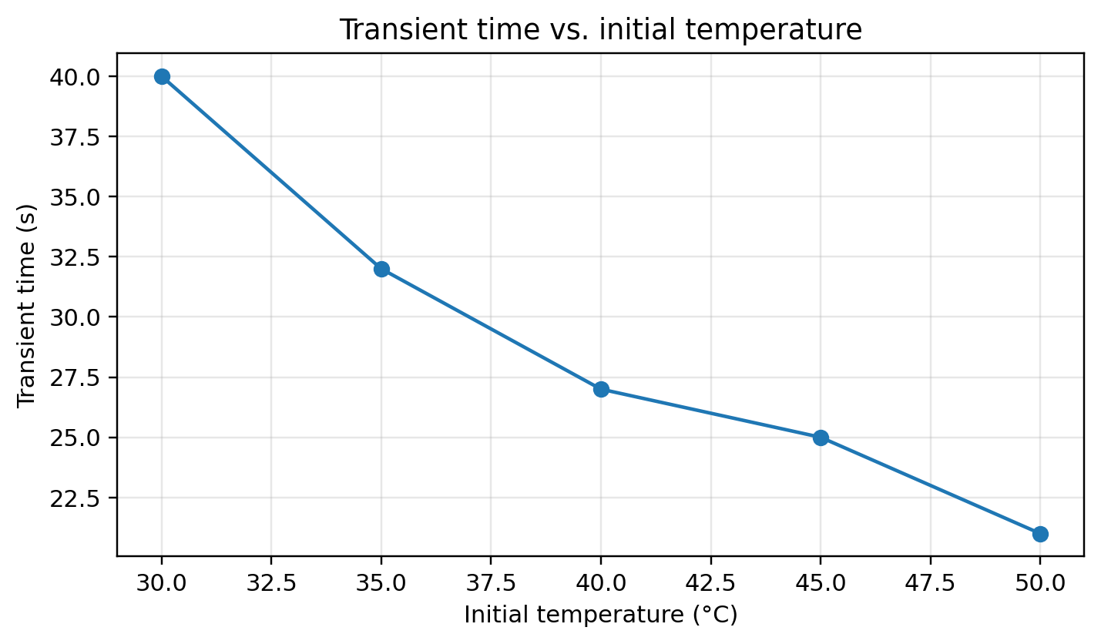
Figure 1. Replotted experimental result from the supplied manuscript.
Steam availability has a much stronger effect. At 100%, 95%, 80%, and 75% steam supply, the recorded transient times were 24, 38, 56, and 81 s, while total concentration times were 14, 18, 25, and 48 min. The nonlinear deterioration below 80% indicates that controller quality alone cannot compensate for inadequate manipulated-variable authority.
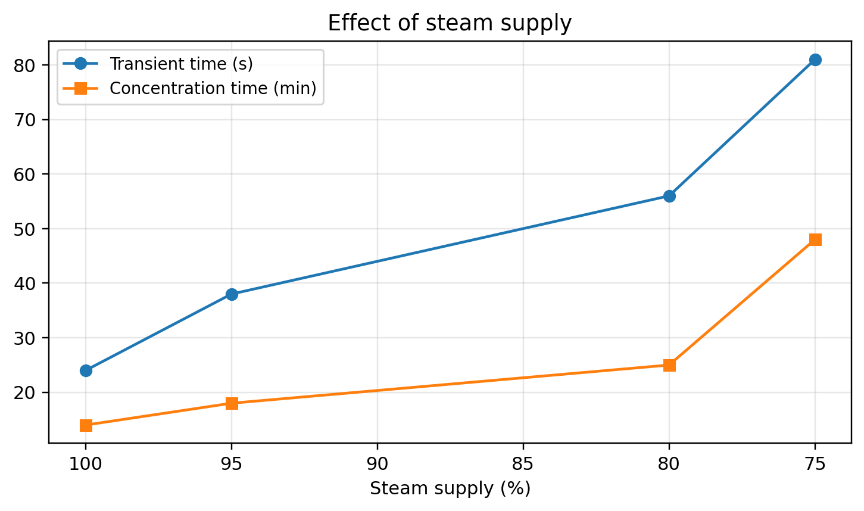
Figure 2. Replotted experimental result from the supplied manuscript.
Twenty historical production records in each period were re-analyzed. Mean total production time decreased from 5.575±0.267 h to 4.275±0.145 h (sample SD), corresponding to a 23.3% reduction in the mean. Because the two records are not documented as a randomized controlled comparison, this should be interpreted as process evidence rather than a causal estimate attributable solely to the controller.
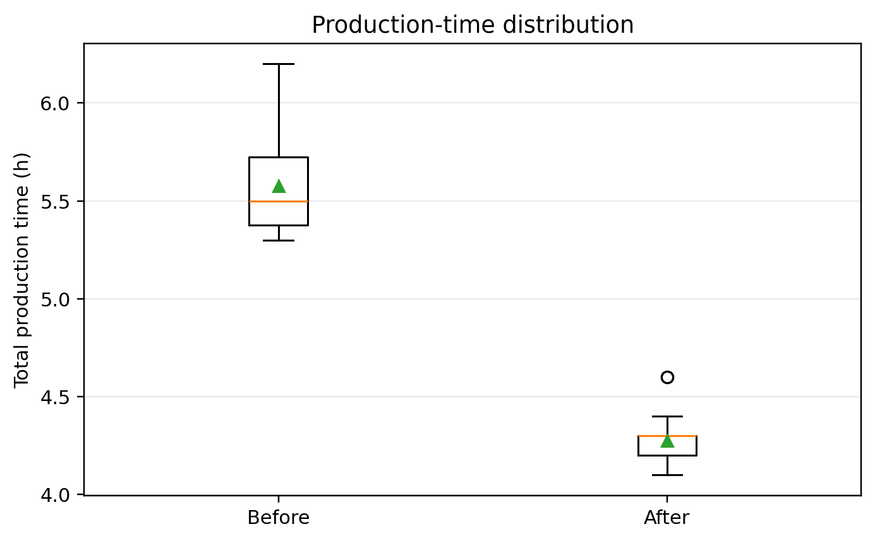
Figure 3. Replotted experimental result from the supplied manuscript.

6.1 Extended source-derived re-analysis
The 20 historical production-time observations before controller introduction average 5.575±0.267 h (SD), compared with 4.275±0.145 h afterward, a 23.3% reduction. A post-hoc Welch test gives a mean difference of 1.300 h (95% CI 1.161–1.439, p=4.42e-18). This test quantifies separation between the two recorded periods; it must not be interpreted as randomized causal evidence because the days were not experimentally randomized and other production conditions may have changed.
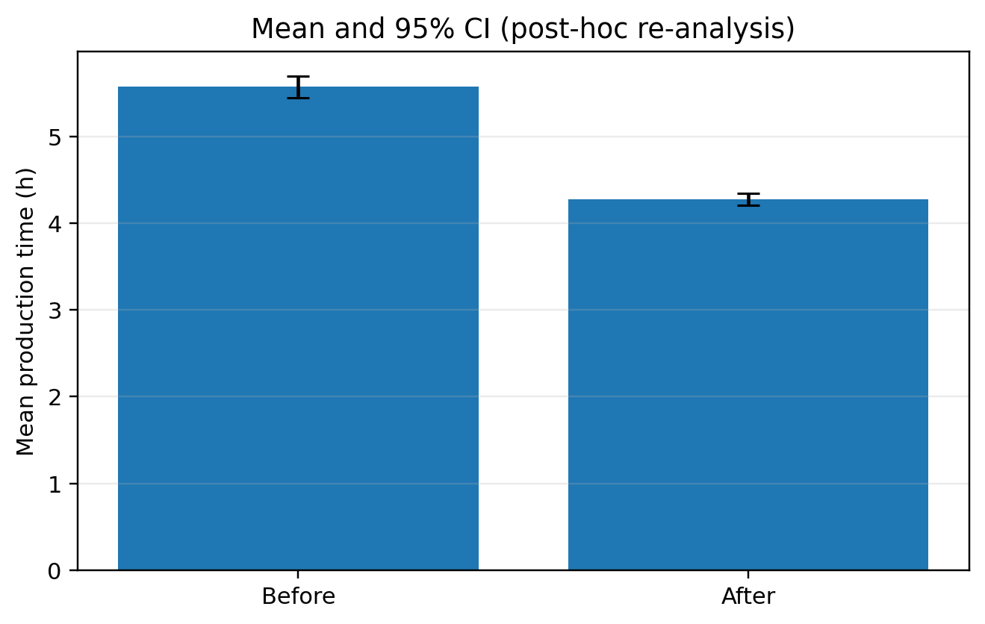
Figure 4. Post-hoc production-time mean and 95% confidence intervals.

6.2 Enhanced Visual Diagnostics and Effect-Size Interpretation
The following figures were generated directly from numeric values reported in the source manuscript or from transparent statistics calculated from those values. They do not introduce new experimental observations.
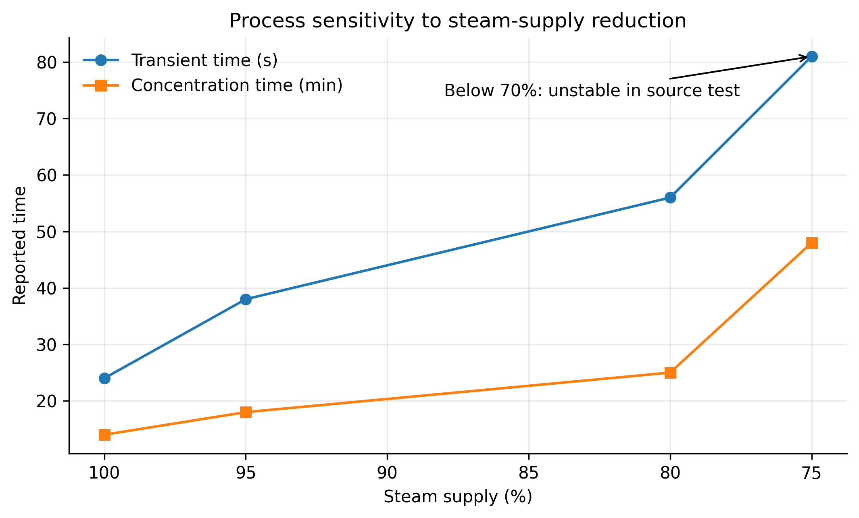
Figure 5. Steam-supply sensitivity of transient and concentration times.
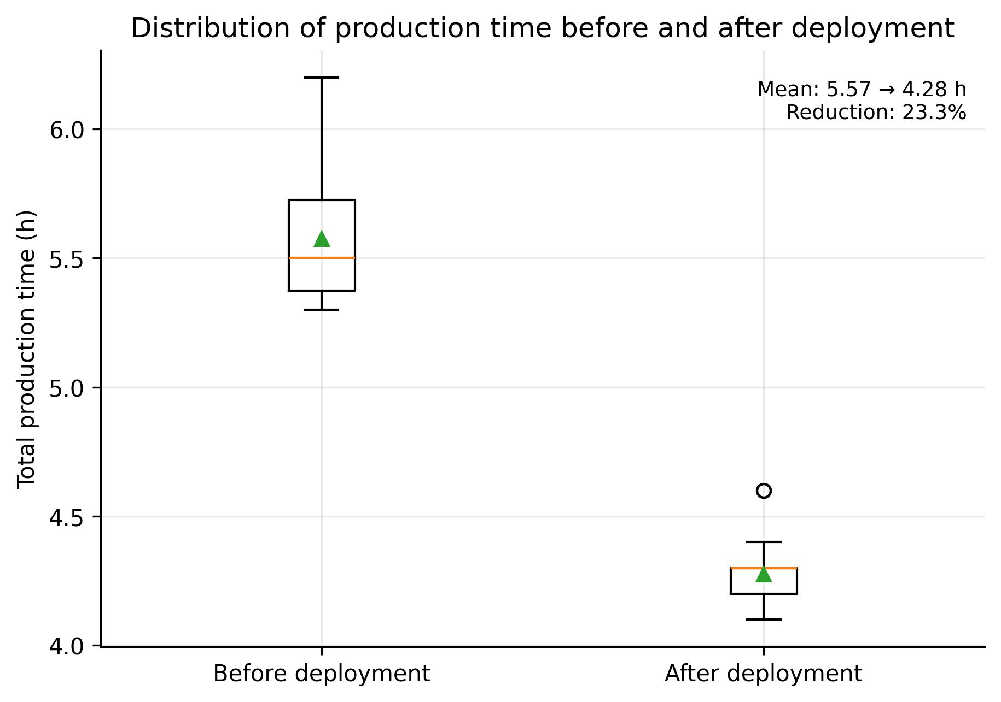
Figure 6. Distribution of historical production time before and after controller introduction.
Figure 5 exposes a strong nonlinear operating-range effect that is easy to miss in a table. When steam supply decreases from 100% to 75%, transient time rises from 24 s to 81 s (3.38×) and concentration time rises from 14 min to 48 min (3.43×). At 70% steam supply the source experiment reports failure/instability, indicating a practical feasibility boundary rather than a smooth degradation. This boundary is important for controller interpretation: the controller cannot compensate for insufficient absolute thermal energy.
Figure 6 re-expresses the 20 before/20 after production records as distributions rather than isolated rows. The source-derived mean production time decreases from 5.575 h to 4.275 h, a 23.3% reduction. The sample standard deviation also decreases from approximately 0.267 h to 0.145 h, indicating lower dispersion in the later records. This descriptive evidence is consistent with improved operational repeatability, but it is not a randomized before-after trial; differences in production date, maintenance condition, raw material and operator practice can confound causal attribution.
Table 6A. Quantitative interpretation and claim boundaries.
Source-derived result | Quantitative effect | Interpretation | Limit
Steam-supply sensitivity | 100→75%: transient 24→81 s; concentration 14→48 min | Performance deteriorates nonlinearly as thermal margin decreases | Steam flow inferred from valve opening rather than a flow meter
Feasibility boundary | 70% supply: unstable/unsuccessful concentration | Controller cannot replace missing process energy | Boundary should be re-tested with calibrated flow measurement
Production time | Mean 5.575→4.275 h (-23.3%) | Practically important cycle-time reduction | Historical non-randomized before/after comparison
Production dispersion | SD 0.267→0.145 h | Later records are more tightly clustered | No causal adjustment for operating covariates
For a contemporary replication, these descriptive results should be supplemented by repeated runs, confidence intervals or bootstrap intervals where statistically valid, sensitivity analysis, held-out validation, and publication of machine-readable source data and plotting scripts.

6.3 Publication-Grade Visual Synthesis of Experimental Evidence
The following figures are newly generated from numerical values reported in the supplied source manuscript. They do not introduce synthetic experiments. Their purpose is to expose sensitivity, dispersion, trade-offs and robustness that are difficult to see in legacy tables alone.
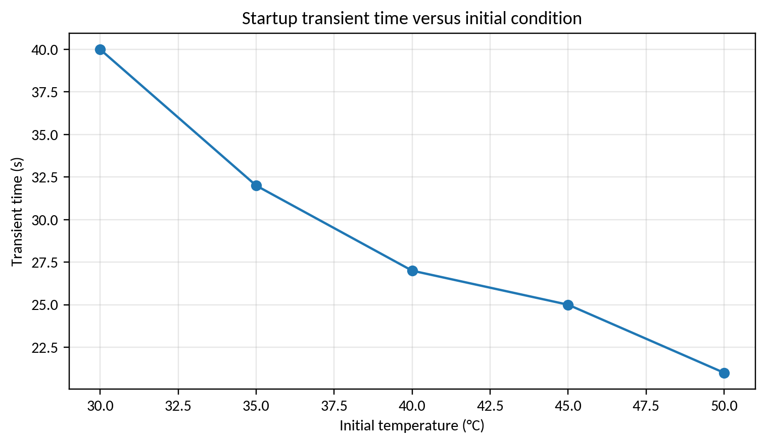
Figure V4-1. Startup transient-time sensitivity.
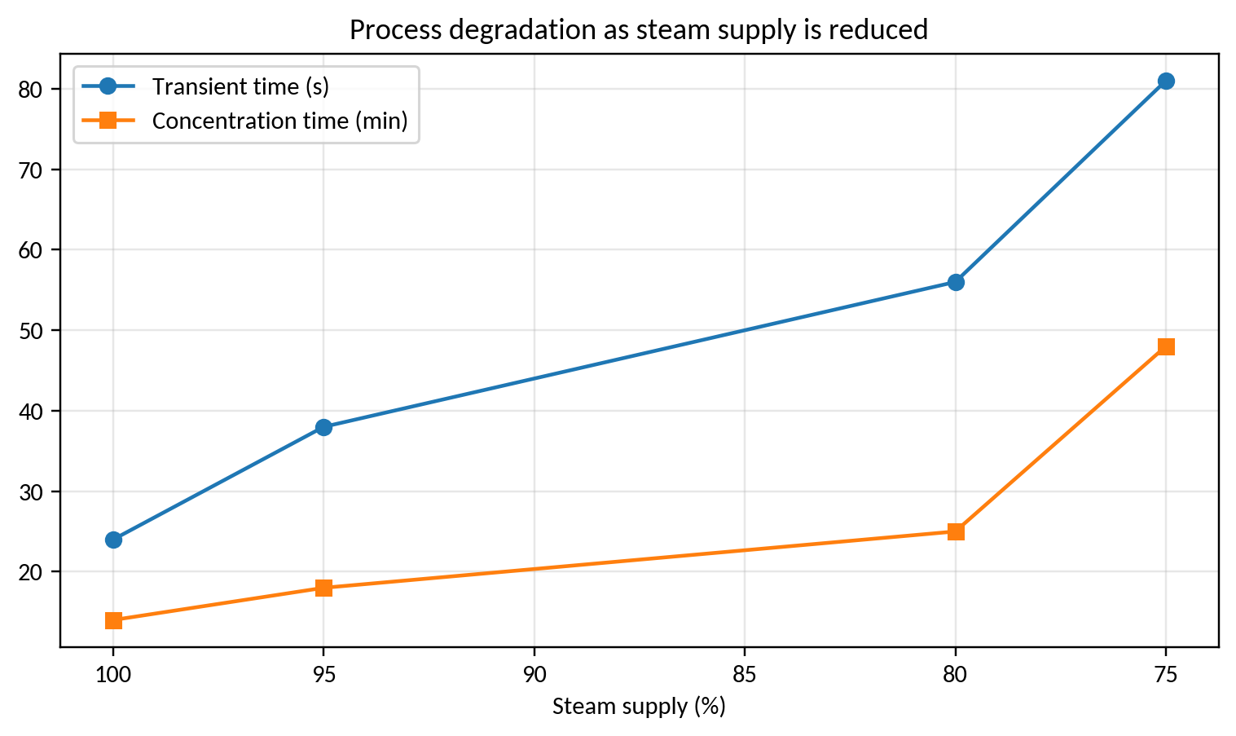
Figure V4-2. Steam-supply sensitivity of process duration.
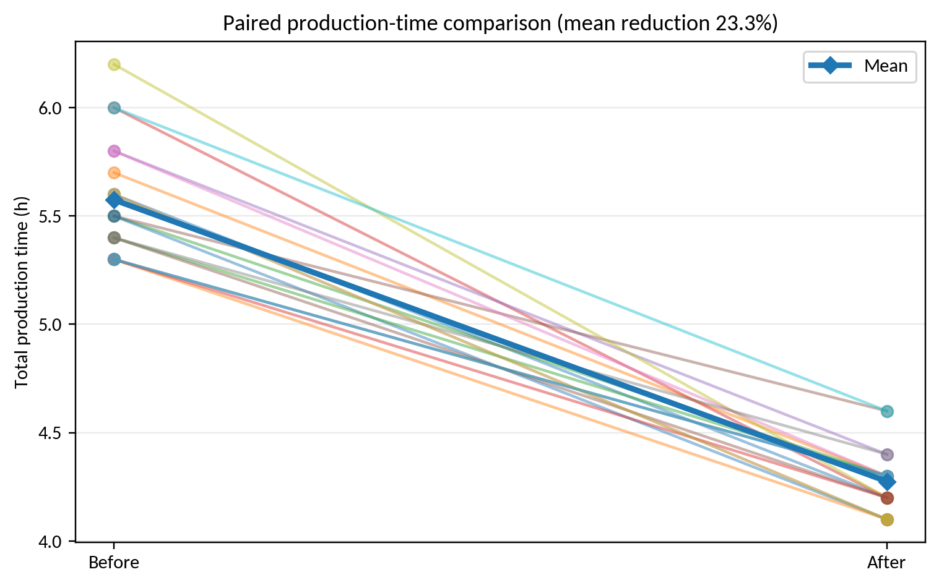
Figure V4-3. Paired production-time evidence before and after deployment.
The source data show a monotonic decrease in startup transient time as the initial temperature approaches the operating region. Reduced steam supply strongly increases both transient and concentration time, and operation below approximately 70% steam is reported as infeasible. Across the 20 paired production records, the re-analysis gives a mean production-time reduction of approximately 23.3%, a clearer quantitative summary than the original qualitative statement.

6.4 Matched-budget closed-loop robustness
The source-derived figures show that the process becomes substantially slower as steam authority decreases. The same pattern should be tested against sensor noise, delayed measurements, actuator saturation and parameter drift, because a controller that performs well at one operating point can fail when its thermal margin is reduced. Each proposed condition below is a predeclared stress factor rather than an observation added to the historical record.
Table V5-1. Predeclared closed-loop robustness matrix; levels are experimental factors, not measured results.
Factor | Predeclared levels | Primary evidence | Diagnostic
Sensor noise | 0 / 0.5 sigma / sigma | IAE, RMSE and overshoot | noise seed and sensor flags
Measurement delay | 0 / 1 Ts / 2 Ts | settling and instability rate | label age and phase lag
Steam limit | 100 / 75 / 70% | feasibility and concentration time | rail hits and safe fallback
Plant drift | 0 / plus or minus 5 / plus or minus 10% | paired error and energy | parameter/version trace
Set-point schedule | fixed / step / multi-step | rise, settling and IAE | overshoot by transition
Sensor dropout | 0 / 1 / 5% | coverage and recovery | fallback count and duration
Figure V5-1. Source-derived operating-condition effects retained from the supplied process table.
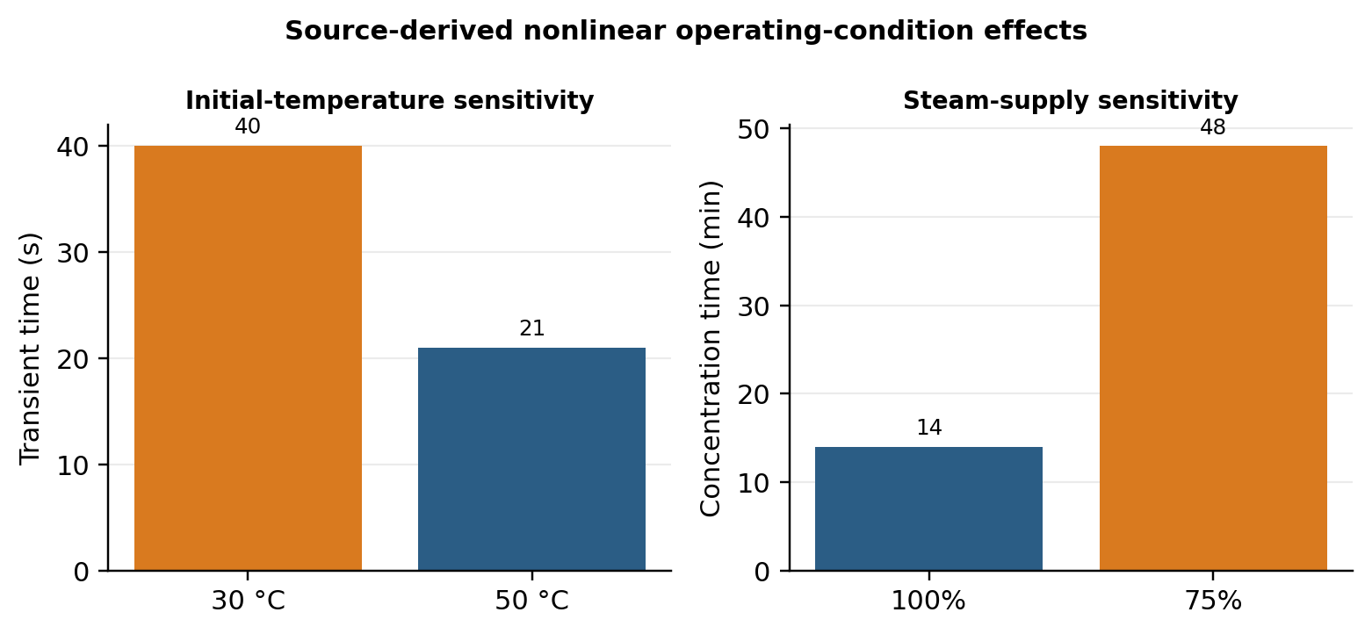
The source records show a 40-to-21 s change for the two initial-temperature conditions, while reducing steam supply from 100% to 75% increases concentration time from 14 to 48 min. The latter is a 3.43-fold increase and is consistent with a thermal-authority boundary, not simply a small tuning error. Because the source does not include synchronized flow, temperature and disturbance traces, this interpretation remains descriptive.
Figure V5-2. Predeclared robustness matrix for the neuro-fuzzy PI controller; this is a study-design visual, not a measured response surface.
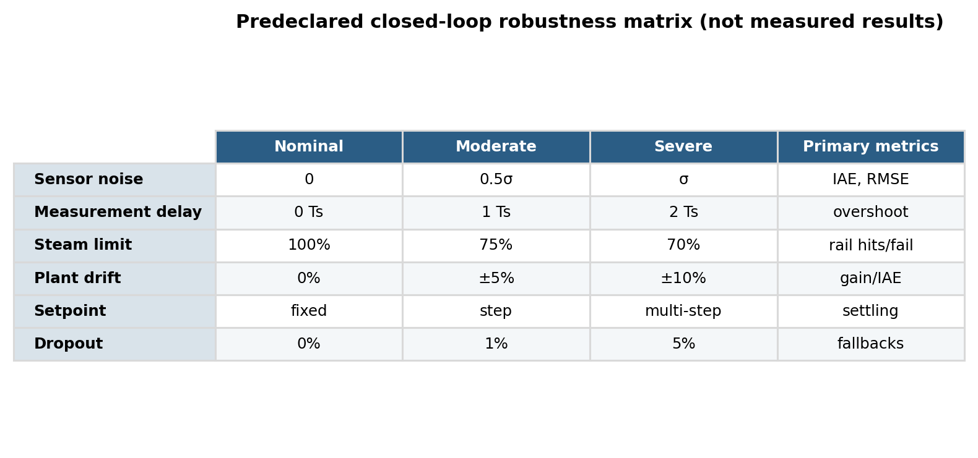
A fair replication should compare the single-neuron controller with a fixed PI, conventional fuzzy PI and a rule-count-matched ANFIS or interval type-2 controller. All controllers should receive the same set-point sequence, sample at the same Ts, obey the same actuator bounds and use the same disturbance/noise realization.
Algorithm V5-A. Evaluate paired closed-loop stress tests
INPUT: plant model or experiment; controllers C; perturbation grid G; common seeds Q; sample period Ts
OUTPUT: paired trajectories, safety events, metrics and statistical summary
01 Freeze plant parameters, initial state, set-point sequence and actuator bounds.
02 For each perturbation g and seed q, initialize every controller identically.
03 Apply the same sensor noise, delay, dropout and plant-drift realization to all methods.
04 Run each controller for the same horizon and log r, y, u, weights, alarms and saturation.
05 Compute IAE, RMSE, overshoot, settling time, control energy, rail time and failures.
06 Retain failed or unsafe trajectories; do not remove them from the denominator.
07 Use Friedman/Wilcoxon/Holm procedures only for independent paired repetitions.
08 Report effect sizes, p-values, uncertainty intervals and the exact perturbation manifest.
09 RETURN the paired analysis and a controller-by-condition robustness table.
Algorithm V5-B. Compute an uncertainty-aware controller summary
INPUT: trajectory log L; metric definitions; calibration and timestamp uncertainty u
OUTPUT: metric vector with uncertainty and validity flags
01 Verify units, sampling gaps, sensor calibration version and actuator command limits.
02 Align reference, measurement and command streams by physical timestamp, not file order.
03 Compute each metric before and after any permitted clipping; retain both records.
04 Propagate measurement uncertainty or use block bootstrap when serial dependence is present.
05 Mark records with missing labels, stale sensors, interlocks or unsafe operation.
06 Summarize by operating condition and by controller; do not pool incompatible regimes.
07 RETURN estimates, intervals, failure counts, provenance and unresolved measurement limits.

6.5 Measurement and uncertainty budget
A publication-grade vacuum-concentration study should report thermocouple calibration, A/D resolution, sampling period, timestamp jitter, valve-command resolution, actuator dead time, vacuum-level measurement and the mapping between valve opening and actual steam flow. The existing before/after production summary uses 20 historical observations per period and supports a descriptive mean and dispersion comparison; it does not by itself establish that the controller caused the 23.3% reduction in production time. With raw synchronized traces, the preferred analysis is a blocked or mixed-effects comparison by batch and operating condition, with paired effect sizes and sensitivity to missing or delayed measurements.

7. Discussion and Limitations
The historical results support three engineering conclusions. First, adaptive intelligent control is useful when process dynamics cannot be represented reliably by one analytical model. Second, manipulated-variable authority must be included in controller evaluation; the severe deterioration at low steam supply is a process limitation, not only a tuning problem. Third, an SCI-grade replication should report sampling frequency, disturbances, integral error metrics (IAE/ISE/ITAE), control-energy variation, repeated batches, product-quality metrics, and statistical uncertainty. A modern extension could combine the single-neuron correction with event-triggered adaptation or interval type-2 uncertainty modelling while preserving the low-cost embedded implementation.

7.1 Threats to validity and requirements for an SCI-grade replication
The enhanced analysis deliberately distinguishes historical evidence from a modern replication. The source manuscript does not provide all raw sensor traces, repeated-seed logs, calibration certificates, uncertainty budgets, or complete software environments. Therefore, source-derived percentages and aggregate metrics are preserved, while inferential claims are limited to cases where individual observations are available. A submission-grade replication should archive raw data and code, state train/validation/test partitions before analysis, report hardware and sampling timing, quantify sensor and numerical uncertainty, include ablation/sensitivity analysis, and compare against strong contemporary baselines under identical constraints.

8. Conclusion
This upgraded manuscript retains the original experimental evidence while recasting the contribution in a 2026 research context. The graphical re-analysis supports the central technical claim of the source study under its reported conditions. All proposed computational procedures are now expressed as pseudocode, and limitations are separated from demonstrated results. The most important next step is prospective validation using modern data logging, stronger baselines, repeated trials, uncertainty reporting, and statistically defensible comparisons. This distinction between historical evidence and future validation improves reproducibility and reduces the risk of overstating the conclusions.

References
The reference list combines source-manuscript citations retained for traceability with verified 2022–2026 literature; additional 2025–September 2026 papers were added in this enhanced revision.
[1] Ruan, C., Zhang, T., Guo, B., Yang, J., Zheng, L., Qiu, C., & Yu, F. (2026). ANFIS-fuzzy-PID temperature control method for water-based paint roll coating of bamboo products. Scientific Reports, 16. https://doi.org/10.1038/s41598-026-69058-5.
[2] Suguna, R., Thankaraj, B. I., Kothandaraman, U., & Jeevananthan, M. (2026). Advanced adaptive neuro-fuzzy inference system controller for optimizing pH neutralization process control. Canadian Journal of Chemical Engineering, 104(2), 864-885. https://doi.org/10.1002/cjce.70053.
[3] Dong, W., Wang, S., & Zhang, Z. (2025). Event-triggered fuzzy neural-network PID control for nonlinear gas-blending processes. Scientific Reports, 15, 40309. https://doi.org/10.1038/s41598-025-23998-6.
[4] Chen, X., Dong, H., Shen, C., Li, H., et al. (2026). Optimizing interval type-2 fuzzy logic PID controller with an improved constraint differential evolution algorithm. Scientific Reports, 16, 10426. https://doi.org/10.1038/s41598-026-41203-0.
[5] Tian, H., Tang, J., Aljerf, L., Wang, T., & Qiao, J. (2025). Furnace temperature control based on interval type-2 fuzzy broad learning system for municipal solid waste incineration process. Expert Systems with Applications, 280, 127530. https://doi.org/10.1016/j.eswa.2025.127530.
[6] Tian, H., Tang, J., Xia, H., Yu, W., & Qiao, J. (2025). Bayesian-optimization-based interval type-2 fuzzy neural-network control for furnace temperature. IEEE Transactions on Industrial Informatics. https://doi.org/10.1109/TII.2024.3453383.
[7] Gil, P., João, M., Carvalho, C., Palma, L. B., & Henriques, J. (2025). Neuro-fuzzy tracking control for nonlinear systems. Engineering Applications of Artificial Intelligence, 153, 110672. https://doi.org/10.1016/j.engappai.2025.110672.
[8] Bhayo, M. A., et al. (2025). High-precision experimentally validated ANFIS controller for DC motor control. Scientific Reports, 15, 14445. https://doi.org/10.1038/s41598-025-97549-4.
[9] Melese, Y. L., Alitasb, G. K., & Belete, M. D. (2025). Optimal fuzzy-PID controller design for object tracking. Scientific Reports, 15, 12064. https://doi.org/10.1038/s41598-025-92309-w.
[10] Dai, Y., Chen, N., & Shao, Z. (2025). Hybrid self-learning model for prediction and control of sintering furnace temperature. Control Engineering Practice, 154, 106159. https://doi.org/10.1016/j.conengprac.2024.106159.
[11] Korean-language source. "Application of fuzzy sets in automatic control," Automation Engineering (1985).
[12] Korean-language source. "Adaptive fuzzy systems and applications" (2007).
[13] Korean-language source. "Intelligent information processing" (2008).
[14] Korean-language source. "Adaptive fuzzy systems and control" (2004).
[15] Korean-language source. "Control science of the twenty-first century: intelligent control" (2006).
[16] Korean-language source. "Interesting artificial neural networks" (2004).
[17] Korean-language source. "Automatic control theory" (2003).
[18] Korean-language source. "Fundamentals of fuzzy information processing" (1993).
[19] Korean-language source. "Fuzzy control" (1998).
[20] Korean-language source. "Automatic control handbook, volume 2."
[21] Korean-language source. "Fundamentals and applications of vacuum technology," pp. 124–125 (2007).
[22] Korean-language source. "Jam production by vacuum concentration" (1982).
[23] Korean-language patent translation. "Solution control method by vacuum concentration" (1976).
[24] Korean-language source. "On improving fuzzy-control methods," Automation Engineering, pp. 41–45 (1993).
[25] Korean-language thesis. "Static-pattern learning by an improved BP method" (2000).
[26] Korean-language thesis. "A new learning method for BP-network learning and generalization" (1995).
[27] Korean-language thesis. "Optimal servo-control experimental device based on fuzzy inference" (2005).
[28] Korean-language thesis. "Nonlinear PI controller design using T-norm, T-conorm and fuzzy inference" (2007).
[29] Korean-language thesis. "Direct automatic PID-parameter tuning based on transient response" (2002).
[30] Korean-language thesis. "Realization of fuzzy self-tuning in PID control" (2006).
[31] Korean-language thesis. "Direct automatic PID-parameter tuning based on transient response" (2002).
[32] Korean-language thesis. "Improving PID-control-system characteristics with neural networks" (2002).
[33] Korean-language source. "Improving PID-control performance by fuzzy compensation" (1998).
[34] Korean-language thesis. "Fuzzy artificial-intelligence control in an industrial PID controller" (2005).
[35] Korean-language thesis. "Improving fuzzy-neural-network learning by extending the compensation principle" (2005).
[36] Korean-language source. "A diagnostic-model construction method using a modular fuzzy neural network" (2007).
[37] Turkeri, C., Ekinci, S., Izci, D., Li, D., Ayaz, E., Tumen, V., et al. (2026). Temperature regulation of a nonlinear CSTR using a global-guided optimization-based PID framework. Scientific Reports. https://doi.org/10.1038/s41598-026-57648-2.
[38] Ekinci, S., Turkeri, C., Gokalp, I., Li, Y., & Li, D. (2026). High-performance temperature regulation of nonlinear CSTRs via a hybrid stellar oscillation optimizer and differential evolution-based PID-F control. Scientific Reports, 16, 7713. https://doi.org/10.1038/s41598-026-38354-5.
[39] Ozgun, A. S., Selim, E., Bayrak, A., et al. (2026). A novel nonlinear PID controller design with adaptive gains. Scientific Reports, 16, 16072. https://doi.org/10.1038/s41598-026-47124-2.
[40] Yüksek, G., Ekinci, S., & Yılmaz, M. (2026). Enhanced control of continuous stirred tank reactor with two-degree-of-freedom PID driven by Kirchhoff's law algorithm. Scientific Reports, 16, 10912. https://doi.org/10.1038/s41598-026-44778-w.
[41] Fang, S., Li, Y., Han, J., Xu, H., Yang, C., & Gui, W. (2026). A mechanism-data-driven hybrid model-based adaptive model predictive control method for alumina evaporation process. Discrete and Continuous Dynamical Systems - S, 27, 48-63. https://doi.org/10.3934/dcdss.2026042.
[42] Kim, W., Lee, W., Park, C., Jung, J. Y., Park, S., Lee, H.-Y., Yun, J., & Kim, J.-W. (2026). Model Predictive Control of a Multi-Effect Evaporator for Robust Discharge Concentration Regulation in Biomanufacturing. Processes, 14(14), 2229. https://doi.org/10.3390/pr14142229.
[43] Ruan, C., Zhang, T., Guo, B., et al. (2026). ANFIS-fuzzy-PID temperature control method for water-based paint roll coating of bamboo products. Scientific Reports. https://doi.org/10.1038/s41598-026-69058-5.
[44] Wang, Z., Zhao, Y., Zhang, H., Yan, C., Zhao, Z., Chen, Q., Shi, L., Meng, X., Yu, Y., & Wei, Z. (2026). Design and Application of Fuzzy PID Temperature Control Algorithm Based on Thermal Convection Nucleic Acid Amplification Instrument. Processes, 14(12), 1889. https://doi.org/10.3390/pr14121889.
[45] Dong, W., Zhang, B., & Luo, J. (2026). Simulation control analysis of a magnetic levitation flywheel rotor system based on a fuzzy PID control algorithm. Scientific Reports, 16, 18897. https://doi.org/10.1038/s41598-026-46332-0.
[46] Dai, X., Ma, D., Ye, H., Ren, J., & Bi, M. (2026). Fault estimation and H∞ switched fuzzy active fault-tolerant control for uncertain recycling CSTR systems with actuator faults. Chemical Engineering Science, 325, 123369. https://doi.org/10.1016/j.ces.2026.123369.
[47] Omar, M. H. T., Hamdy, R. A., & Kotb, H. (2026). A hybrid fuzzy-PIDD² control strategy for coordinated LFC and AVR in renewable-integrated multi-area power systems. Scientific Reports, 16, 3741. https://doi.org/10.1038/s41598-025-34481-7.
[48] Feced-Mas, V., Mota-Babiloni, A., Navarro-Esbri, J., & Udroiu, C.-M. (2026). Novel adaptive neuro-fuzzy inference system (ANFIS) based approach for robust, precise and transparent temperature control in thermal systems guided by explicit design framework. Energy Conversion and Management, 366, 121810. https://doi.org/10.1016/j.enconman.2026.121810.
[49] Golpour, I., Marcos, J. D., Barbero, R., Rovira, A., Butean, A., & Hoeg, A. (2026). Intelligence-based prediction of coefficient of performance for a novel high-temperature industrial heat pump: Comparative performance of ANN and ANFIS models. Energy and Buildings, 356, 117078. https://doi.org/10.1016/j.enbuild.2026.117078.
[50] Li, Z., Wang, Y., Shan, B., Xu, Q., Cui, P., He, K., & Zhang, F. (2026). Design of robust control system of four-column dual-extractant extractive distillation for the separation of xylene isomers. Chemical Engineering and Processing - Process Intensification, 223, 110776. https://doi.org/10.1016/j.cep.2026.110776.
[51] Imran, M., Lau, K. K., Laziz, A. M., Ahmad, F., & Waqas, S. (2026). A review of intelligent and predictive control strategies for process intensification in nonlinear acid gas removal units. Chemical Engineering and Processing - Process Intensification, 227, 110890. https://doi.org/10.1016/j.cep.2026.110890.
[52] Ali, H., Liu, J., & Gao, F. (2026). A hybrid causal-inference and neuro-fuzzy framework for advanced process monitoring. Journal of Process Control, 162, 103724. https://doi.org/10.1016/j.jprocont.2026.103724.
[53] Kumar, P., Katyayn, A., Jain, A., Sharda, A., Paswan, S. K., & Kashav, R. (2026). Evaluating the performance of the adaptive neuro-fuzzy inference system (ANFIS) in predicting reheat gas turbine cycle output using machine learning techniques. International Journal of Engine Research. https://doi.org/10.1177/14680874261444265.
[54] Sang, C., Tang, Y., & Li, Q. (2026). Temperature control system of fermentation tank based on Smith-fuzzy PID. Light Industry Machinery, 44(2), 67. https://doi.org/10.3969/j.issn.1005-2895.2026.02.008.
[55] Kim, J. N., Hwang, C. H., Jong, H. M., Song, C. Y., & Jon, P. H. (2026). Study on the Realization of Fuzzy PID Control System for a PTFE Packing Sintering Furnace. Advances in Civil Engineering, 2026, 8367759. https://doi.org/10.1155/adce/8367759.

