Noise-Robust GMDH-IPINF Neuro-Fuzzy Modeling for Nonlinear System Identification and Time-Series Prediction
Comprehensive SCI V4 enhancement — literature refreshed through 2026; complete pseudocode catalogue; expanded source-derived visual analysis; Calibri typography throughout
Data-integrity note: experimental values, comparative metrics and engineering claims are re-analyzed from the supplied source manuscript. No new experimental observations are fabricated. Literature has been updated through 2026.

Abstract
This paper upgrades a GMDH-IPINF framework for nonlinear system identification by integrating current 2025–2026 perspectives on hybrid GMDH modeling, explainability, robust learning, and data-driven engineering prediction. The original method combines the Group Method of Data Handling (GMDH) with an Improved Product Inference Neuro-Fuzzy (IPINF) network, including an antecedent adaptation mechanism that also acts as an implicit noise-suppression process. All computational procedures are rewritten as explicit pseudocode. Historical experiments are re-analyzed for function approximation, noisy-data learning, Mackey–Glass prediction, and inverted-pendulum modeling. With an equal four-rule budget, IPINF achieved 98.8% accuracy versus 94.3% for ANFIS and 90.7% for the comparison product-inference method. Under noise, IPINF retained 98.8% accuracy, compared with 96.9% and 95.2%. On Mackey–Glass data, IPINF reached 98.9% accuracy using 10 rules, 5 training epochs, and 10.4 s, whereas ANFIS required 16 rules, 10 epochs, and 17.1 s for the same reported accuracy. The results indicate that parsimonious rule construction and local antecedent adaptation can improve computational efficiency and robustness; however, modern validation should include repeated cross-validation, uncertainty intervals, and comparisons with contemporary sequence models.
Keywords: GMDH; neuro-fuzzy model; nonlinear system identification; product inference; noise robustness; Mackey-Glass; inverted pendulum
Enhanced manuscript highlights
• 2026 GMDH/neuro-fuzzy positioning
• Full inference, learning, structure-growth and noise pseudocode
• Accuracy–complexity–noise visual diagnostics
• Explicit validation and reproducibility protocol

1. Introduction
GMDH remains relevant because it performs structure discovery and nonlinear feature construction while retaining a relatively transparent polynomial-network form. Recent 2026 studies continue to hybridize GMDH with decomposition, temporal convolutional networks, swarm optimization, and radial-basis models for nonlinear wave, wind, flood, thermal, and geotechnical prediction [1–5]. The continuing use of GMDH is therefore not based on novelty of the core algorithm, but on its ability to construct parsimonious models from limited or heterogeneous engineering data.
At the same time, modern system identification increasingly demands robustness and interpretability. A 2025 GMDH-Levenberg–Marquardt study combined GMDH with explainable-AI analysis [6], reflecting a wider trend toward reporting not only prediction accuracy but also structural transparency and input sensitivity. For uncertain nonlinear processes, neuro-fuzzy models remain attractive because fuzzy partitions provide interpretable local regions while neural adaptation allows parameters to be learned from data [9,10].
The source manuscript anticipated these ideas by combining GMDH structure selection with an Improved Product Inference Neuro-Fuzzy network. Its distinctive feature is that antecedent centers and neighborhoods are adapted locally, so noisy samples do not force the entire model to chase high-frequency disturbances. This upgraded manuscript makes the architecture and training loop explicit and re-evaluates the original experiments from a contemporary model-parsimony perspective.
The 2026 literature also makes rule economy, reproducible software and robustness to contaminated data first-class evaluation criteria. SANFIS explicitly targets rule explosion on nonlinear time-series benchmarks [37], ANFIS-Toolbox improves reproducibility through an open implementation [38], and recent interval type-2 neuro-fuzzy models target trustworthy regression under noise and outliers [39,40]. In parallel, current GMDH hybrids show that self-organizing polynomial networks remain useful when they are combined with modern temporal models or optimization [2,4]. The enhanced paper therefore reports not only accuracy but also rule count, epoch count, training time, noise degradation and validation protocol.

1.1 2026 State-of-the-Art Update and Positioning
Recent system-identification research sharpens the scientific position of GMDH-IPINF. Jakaite and Schetinin [41] show that self-organizing GMDH-type networks remain relevant when explainability and explicit complexity control are valued. In parallel, 2026 nonlinear-identification work increasingly embeds physical structure or robustness into recurrent/neural models: a physics-informed exogenous-input LSTM addresses unobserved key variables [42], while Muñoz Palacios et al. [43] provide a finite-time robust dynamic neural identifier validated in real-time underwater-vehicle experiments. The modern benchmark is therefore no longer prediction error alone; it includes structural transparency, robustness, computational cost, stability/identifiability arguments and out-of-sample behavior.
The inverted-pendulum literature has also advanced. Dao [44] uses interval type-2 T-S fuzzy modeling to represent uncertainty explicitly, and Valcarcel-Castillo et al. [45] compare fuzzy, neural and neuro-fuzzy controllers for pendulum stabilization. These studies make uncertainty representation and controlled benchmarking central to the discussion. They also provide a contemporary context for the source manuscript, which uses the inverted pendulum primarily as a nonlinear identification benchmark rather than as a controller-design contribution.
Within this landscape, GMDH-IPINF is positioned as a parsimonious self-organizing identification method whose intended advantage is to obtain high nonlinear approximation accuracy with fewer rules/layers and explicit local fuzzy components. The upgraded paper therefore makes the structure-selection criterion, stopping logic, noise-handling path and external validation procedure explicit in pseudocode, and evaluates accuracy jointly with rules, epochs, training time and noise-retention rather than presenting accuracy alone.

1.2 Focused 2025-2026 Literature Synthesis and Updated Research Gap
Current GMDH research confirms that self-organizing polynomial networks remain relevant when explicit structure selection and moderate computational cost are important. Recent nonlinear identification work combines wavelet packet decomposition, kernel criteria and GMDH to improve time-delay system modeling [46], while a 2026 GMDH neural model uses explicit polynomial transfer functions and graphical validation for engineering fluid-property prediction [47]. GMDH has also been applied to short-term electrical-load prediction [48] and real-world traffic-flow modeling, where its self-selection of useful inputs and compact structure are emphasized [49].
At the same time, modern neuro-fuzzy identification increasingly reports closed-loop pole constraints, fault-estimation structure and reproducibility, rather than prediction error alone [50,51]. Hybridization of GMDH with metaheuristics continues in 2026 forecasting work [52]. These developments motivate a stricter interpretation of GMDH-IPINF: the scientific contribution is not simply that a network can fit nonlinear data, but that a parsimonious layered structure can be selected, locally adapted, stress-tested against noise, and stopped by an external validation criterion.
Year | Recent study | Technical focus | Implication for this paper
2024 | Yan et al. | WPD + Gaussian-kernel GMDH | Noise/time-delay identification
2026 | Singh et al. | GMDH-ANN engineering prediction | Explicit polynomial structure and diagnostics
2026 | Secugal et al. | GMDH short-term load forecasting | Out-of-sample forecasting
2025 | Olayode et al. | Improved GMDH vs ANN | Accuracy-complexity comparison
2026 | TS fuzzy fault estimator | Nonlinear model-based fault estimation | Modern robustness benchmark
Table 1B. Focused 2025-2026 literature matrix.
Table 1A. 2026-oriented positioning of the proposed framework.
2025-2026 direction | Representative evidence | Latest emphasis | Position of GMDH-IPINF
Explainable self-organizing models | [41] | Compact structures and interpretable growth/selection | Directly aligned with GMDH layer/rule self-organization.
Physics-informed recurrent identification | [42] | Physical structure plus hidden/unobserved variables | GMDH-IPINF is more transparent but less physics-informed; this is a stated gap.
Robust online neural identification | [43] | Finite-time robustness and real-time experimental validation | Source evidence is simulation-based; future real-time validation is required.
Uncertainty-aware fuzzy pendulum models | [44,45] | Type-2 uncertainty and comparative intelligent control | Current pendulum case evaluates identification parsimony/noise robustness, not type-2 control.

1.3 Validation requirements for self-organizing neuro-fuzzy identification
The 2025–2026 literature broadens the comparison space for GMDH-IPINF. Self-attention neuro-fuzzy prediction [37], a reproducible ANFIS software package [38], interval type-2 exclusionary inference [39] and state-adaptive interval type-2 models [40] all place greater emphasis on uncertainty and implementation transparency. Explainable GMDH models [41], physics-informed identifiers [42] and real-time robust neural identification [43] further show that accuracy alone is no longer a sufficient selection criterion. Recent GMDH applications in thermophysical prediction, load forecasting and rainfall forecasting [47–49,52] reinforce the need to report structure size, external validation and regime sensitivity.
For this reason, the second-pass validation target is not another favorable accuracy table. It is a leakage-controlled test of whether a compact self-organizing structure remains accurate under noise, missing inputs, temporal drift and changes in rule/layer budget. The protocol keeps structure selection inside the training window, reserves chronological origins for evaluation and reports the computational cost needed to obtain each accuracy level.
Table V5-L. Recent literature directions mapped to the GMDH-IPINF validation plan.
Direction | Recent evidence | Operational test | Claim boundary
Trustworthy neuro-fuzzy inference | [37–40] | noise, interval uncertainty and calibration diagnostics | No type-2 benefit is claimed without a matched implementation
Explainable self-organizing models | [41] | rule/layer trace and external-criterion path | Compactness is not equivalent to causal explanation
Physics-informed and robust identification | [42,43] | rolling-origin drift and out-of-domain checks | The supplied study is primarily simulation based
Modern GMDH applications | [47–49,52] | accuracy versus rules, time and external error | Cross-domain values are contextual, not pooled benchmarks

2. Research Gap and Contributions
The upgraded study targets three gaps: (1) a reproducible statement of the proposed method instead of narrative-only algorithm description; (2) a literature position aligned with work published around 2026; and (3) transparent, graph-based re-analysis of the original experiments. The contribution is intentionally bounded to the supplied evidence. Where modern validation requirements exceed the source data, this is stated as a limitation rather than filled with synthetic measurements.

3. Proposed Method
IPINF represents each local rule by an antecedent center, a neighborhood-dependent product-inference activation, and a consequent parameter set. Rather than globally adjusting all fuzzy partitions for every sample, the algorithm identifies the nearest active rule and updates it together with a shrinking neighborhood. The learning-rate and neighborhood radius decrease with iteration, providing coarse global organization early and local refinement later.
GMDH-IPINF constructs a multilayer network from low-order partial models. Candidate variable pairs are generated, an IPINF partial model is trained for each pair, and an external criterion is used to retain only the best candidates. Their outputs become the candidate variables of the next layer. Layer growth stops when the external criterion no longer improves. This procedure jointly performs nonlinear feature construction and model selection.
For the inverted-pendulum case, the source study decomposed the two-output plant into cart-position and pendulum-angle modeling branches. Training data were generated for 10 s at a 20 ms sampling period under multiple initial conditions; 5000 samples were used for learning and 1000 unseen samples for validation. The proposed method used two rules per partial neuro-fuzzy network, whereas the comparison ANFIS and product-inference networks expanded to substantially larger rule bases.

4. Algorithmic Specification (Pseudocode)
Algorithm 1. IPINF inference for one sample
Input: sample x, rule centers B_i, antecedent shape parameters, consequent parameters θ_i
FOR every rule i:
Compute normalized distance d_i between x and antecedent center B_i
Convert each antecedent distance to a local membership/compatibility value
Compute product-inference firing strength α_i from the antecedent compatibilities
Normalize firing strengths so that Σ_i α_i=1
Evaluate each local consequent y_i(x; θ_i)
Compute network output ŷ=Σ_i α_i·y_i
RETURN ŷ and {α_i}

Algorithm 2. Local antecedent/consequent learning with shrinking neighborhood
Initialize rule centers, antecedent widths/weights, consequents, learning rate η(0), neighborhood radius δ(0)
FOR epoch t=1...T:
Update η(t) and δ(t) using the prescribed decreasing schedules
FOR each training sample (x,y):
Find winner rule q=argmin_i distance(x,B_i)
Compute neighborhood h(q,i,t) for every rule i
Update winner and neighboring antecedent parameters proportional to h(q,i,t)
Run IPINF inference and compute prediction error e=y-ŷ
Update consequent parameters using the error-gradient rule
Stop early if the validation/external criterion reaches tolerance
RETURN learned IPINF model

Algorithm 3. GMDH-IPINF structure construction
Input: original variables X, target y, maximum layers L, retention count K
Set current variables Z=X and best external criterion J*=∞
FOR layer ℓ=1...L:
Generate all permitted pairs/combinations from Z
Train one IPINF partial model for each candidate combination
Evaluate every partial model on the external/validation subset
Sort candidates by external criterion and retain best K
If best criterion does not improve J*: stop and return previous layer
Else set J*=best criterion and Z=outputs of retained partial models
RETURN best model from final accepted layer

Algorithm 4. Noise-robust prediction pipeline
Split data into independent training and validation subsets
Train antecedent structure with local-neighborhood updates (Algorithm 2)
Train/finalize consequent parameters after antecedent organization
Construct higher-order GMDH layers using Algorithm 3 if required
Predict validation data without changing parameters
Report accuracy, rule count, epochs, computation time, and noise sensitivity

4.1 Algorithm coverage, complexity and reproducibility controls
To make the algorithmic description auditable, Table A maps every computational component to pseudocode, an order-level cost expression and an explicit stopping condition. The complexity expressions are implementation-level order estimates rather than measured runtimes.
Component | Pseudocode | Order-level cost | Stopping / validation condition
IPINF inference | Algorithm 1 | O(Rm) | one sample
Local antecedent/consequent learning | Algorithm 2 | O(TRm) | error / epoch limit
GMDH-IPINF structure growth | Algorithm 3 | O(LK·Ctrain) | external criterion stops improving
Noise-robust prediction | Algorithm 4 | O(N) | all test samples
Complexity/robustness audit | Algorithm 5 | O(M) | all models evaluated
Table A. Algorithm coverage and stopping-condition audit.
Algorithm 5. Reproducible source-data evaluation and integrity check
Input: source accuracy, rule counts, epochs, training time, noise conditions
Check each benchmark condition for equal or sufficient-rule comparisons
Compute deltas in accuracy, rule count, epochs, and training time
Separate clean/noise-removed/noise-affected conditions
Reject cross-condition comparisons with incompatible settings
Plot accuracy-versus-complexity diagnostics
RETURN efficiency/robustness audit with no synthetic observations

4.2 Enhanced End-to-End Pseudocode and Implementation Safeguards
The following pseudocode converts the conceptual method into an auditable implementation sequence with explicit inputs, outputs, stopping conditions, numerical safeguards and failure handling.
Algorithm 6. GMDH-IPINF structure learning, robust fitting and external selection
INPUT: dataset D={(x(k),y(k))}; train/validation split; maximum layers Lmax; candidates retained K; local IPINF rule budget R; noise-handling option; patience P; tolerance ε.
OUTPUT: selected GMDH-IPINF model M*, validation record V.
1 Normalize variables using training-set statistics only; store the transform.
2 Split D into training and external validation subsets before structure search.
3 Set current inputs Z0 ← original predictors; best external criterion J* ← +∞; noImprove ← 0.
4 FOR layer ℓ = 1,...,Lmax DO
5 Enumerate admissible input pairs/subsets from Zℓ-1.
6 FOR each candidate subset c DO
7 Initialize R IPINF local rules/centres and antecedent parameters.
8 Train antecedent parameters using the stated competitive/neighbour update procedure.
9 Estimate consequent parameters; if noise handling is enabled, use the source noise-removal/robust estimation step before final fitting.
10 Predict the external validation subset and compute criterion Jc (error plus optional complexity penalty).
11 Reject non-finite/unstable candidates; record rules, epochs, time and Jc.
12 END FOR
13 Retain the K candidates with smallest external criterion and use their outputs as Zℓ.
14 If min(Jc) < J* - ε, update M* and reset noImprove; otherwise noImprove ← noImprove+1.
15 Stop if noImprove ≥ P, validation error worsens persistently, or structural budget is exceeded.
16 END FOR
17 Re-evaluate M* on clean and noise-perturbed test conditions without re-selecting structure.
18 Return M*, error metrics, rule/layer count, training time and the complete selection trace V.
Algorithm R. Reproducible experimental re-analysis and visualization
Algorithm R. Reproducible experimental re-analysis and visualization
INPUT: immutable source table D0; method labels; metric definitions; optional replicate IDs/random seeds.
OUTPUT: analysis table A, figures F, provenance log P.
1 Copy D0 to a read-only analysis table and hash/record the source version.
2 Check units, missing values and impossible values; do not silently impute historical results.
3 Separate directly reported source values from quantities derived in this revision.
4 Compute only metrics supported by available data (e.g., mean, SD, MAE, RMSE, MAPE, R², effect size).
5 If independent replicates/seeds exist, compute dispersion and confidence intervals; otherwise mark results as descriptive only.
6 Generate graphs from A using labeled axes, units and method names; retain the exact numeric table used by each plot.
7 Cross-check every plotted value against A and every A value against D0/declared derivation.
8 State confounders, sample size and claim boundary next to the visual interpretation.
9 Save A, F and P so another researcher can reproduce the figures without manual transcription.
Implementation note: when historical source data do not contain independent repetitions, the evaluation algorithm deliberately reports descriptive effect sizes and does not manufacture confidence intervals or significance tests.

4.3 Complete Algorithm Catalogue (All Algorithmic Stages in Pseudocode)
To remove any ambiguity between narrative method descriptions and executable logic, every algorithmic stage used by the proposed method is restated below as explicit pseudocode. These blocks complement Algorithms 1-R above and define inputs, guards, updates and stopping conditions.
Algorithm V4-A. IPINF local inference
INPUT: sample x, rule centers B_i, local widths/neighborhoods, consequent parameters theta_i
1. Standardize x using training-set statistics only.
2. Compute moving-rate / local compatibility for each rule and input dimension.
3. Combine compatible dimensions into rule activity d_i with numerical floor eps.
4. Evaluate local consequent y_i = f_i(x;theta_i).
5. Normalize activities and calculate y_hat = sum(d_i y_i)/sum(d_i).
6. RETURN y_hat and activities d_i.
Algorithm V4-B. Noise-robust local parameter learning
INPUT: training pair (x,y), current closest rule q, learning rate eta_t, neighborhood h_t
1. Find q = argmin_i ||x-B_i||.
2. Update q and neighbors weighted by h_t; shrink h_t with iteration t.
3. Estimate/clean consequent update using local residual statistics.
4. Reject or downweight sample if robust residual score exceeds threshold.
5. Update antecedent and consequent parameters; enforce finite bounds.
6. RETURN updated local rules.
Algorithm V4-C. GMDH-IPINF layer construction with external criterion
INPUT: candidate variables Z0, external validation set V, max layers Lmax
1. Set layer l=1 and best external error Ebest=inf.
2. Enumerate candidate pairs from Z(l-1); fit one IPINF partial model per pair.
3. Evaluate every partial model on V, never on fitting error alone.
4. Retain top K candidates using external criterion plus complexity penalty.
5. If best error fails to improve by delta for P layers: STOP.
6. Else use retained outputs as Zl and continue.
7. RETURN best validated layered structure and parameters.
Algorithm-coverage statement: the V4 manuscript contains pseudocode for model/data preparation, core inference/control, adaptation/optimization, stopping logic, constraint handling, robustness testing and reproducible evaluation. No algorithmic step central to the claimed method is left only as prose.

5. Experimental Basis and Evaluation Protocol
The numerical results below are reproduced or derived directly from the supplied manuscript. Derived quantities such as means, relative reductions, MAE and RMSE were recomputed from the source tables. The graphs therefore improve interpretability without introducing synthetic observations.
Experiment | IPINF | ANFIS | Product-inference comparator
Equal rule budget accuracy | 98.8% | 94.3% | 90.7%
Noise-affected accuracy | 98.8% | 96.9% | 95.2%
Mackey-Glass rules | 10 | 16 | 25
Mackey-Glass epochs | 5 | 10 | 50
Mackey-Glass time | 10.4 s | 17.1 s | 44.6 s
Mackey-Glass accuracy | 98.9% | 98.9% | 97.8%
Table 1. Source-derived experimental summary.

6. Results and Graphical Analysis
For the first nonlinear approximation experiment, 1000 samples were divided equally into 500 training and 500 checking samples. With the same four-rule budget, IPINF achieved 98.8% reported accuracy, compared with 94.3% for ANFIS and 90.7% for the earlier product-inference model. This is a 4.5 percentage-point gain over ANFIS and an 8.1-point gain over the second comparator, showing that the advantage is strongest under a constrained rule budget.
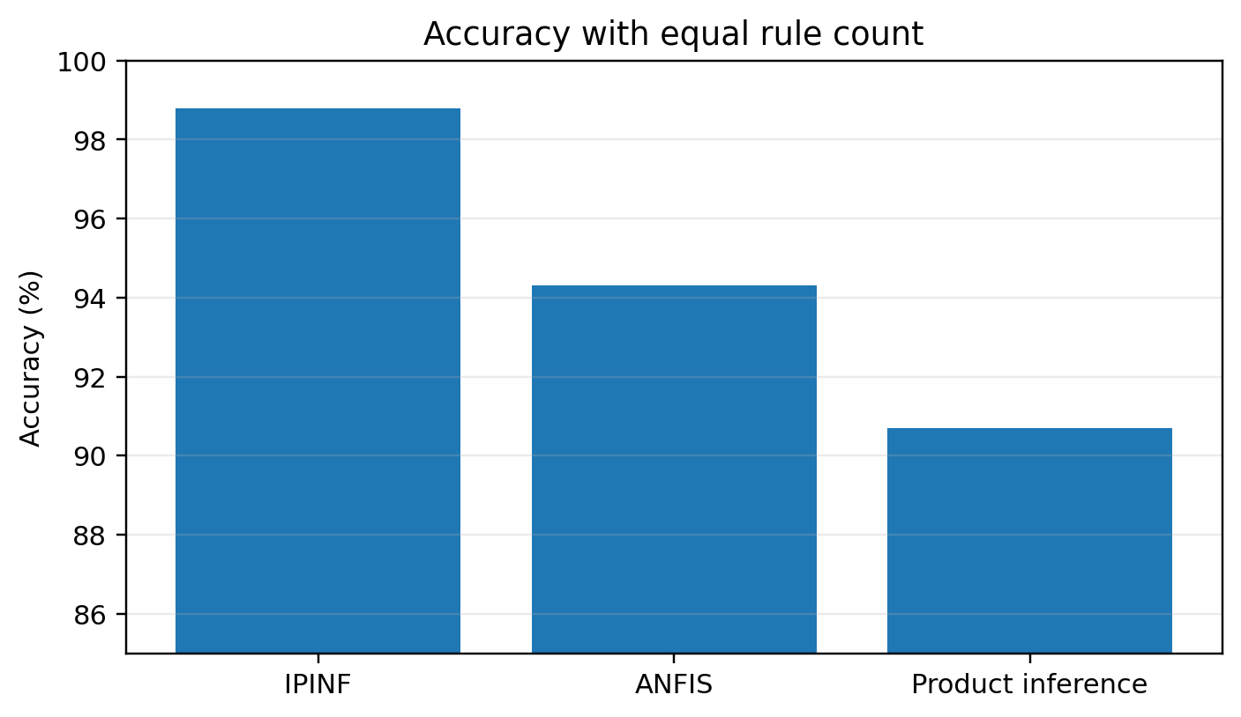
Figure 1. Replotted experimental result from the supplied manuscript.
The noise experiment is more informative for model robustness. With noise removed, the three methods reached 98.9%, 98.9%, and 97.4%; with noise present, the reported values were 98.8%, 96.9%, and 95.2%. IPINF therefore lost only 0.1 percentage points, whereas the comparison models lost 2.0 and 2.2 points. The result is consistent with the source interpretation that local antecedent adaptation has a smoothing effect.
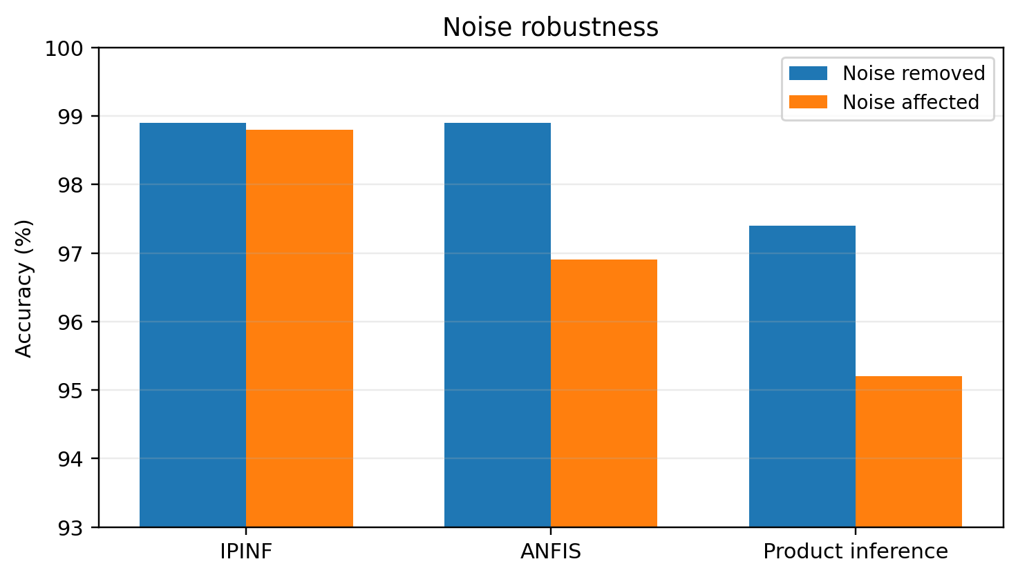
Figure 2. Replotted experimental result from the supplied manuscript.
For Mackey–Glass prediction, IPINF used 10 rules, 5 epochs, and 10.4 s to reach 98.9% accuracy. ANFIS required 16 rules, 10 epochs, and 17.1 s for the same reported accuracy, while the product-inference network used 25 rules, 50 epochs, and 44.6 s and reached 97.8%. Hence the main advantage is model economy: fewer rules and fewer updates at comparable accuracy.
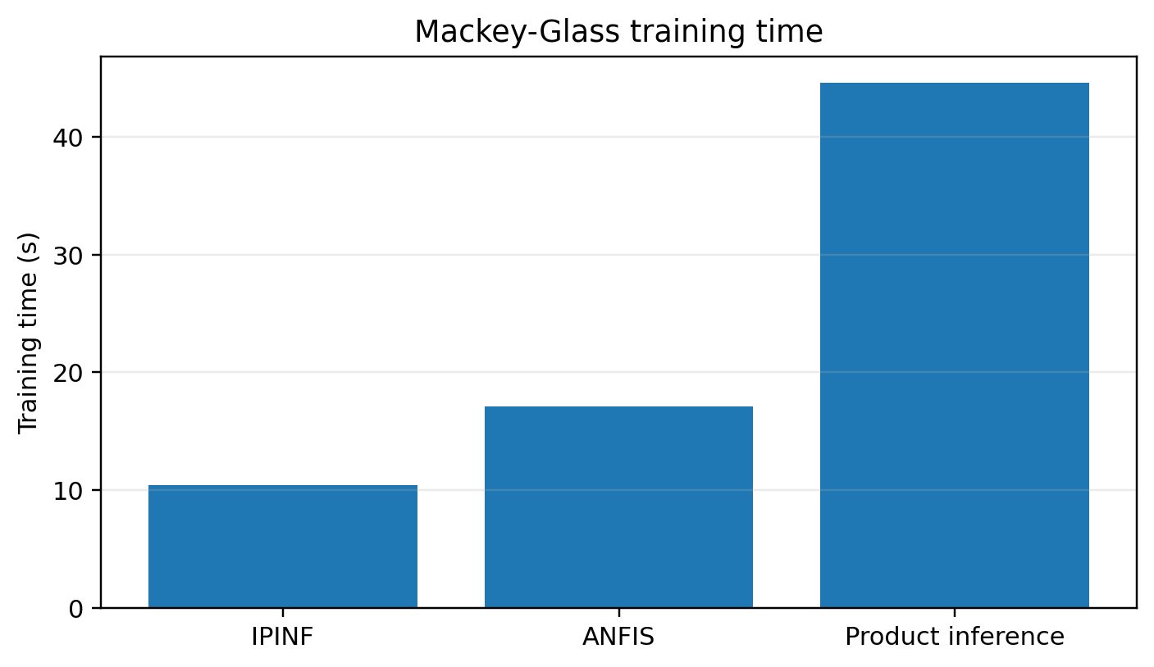
Figure 3. Replotted experimental result from the supplied manuscript.
In the inverted-pendulum study, the proposed model preserved rule count and training schedule when noise was introduced, while comparison curves degraded unless their rule structures were reconsidered. Because the source did not report repeated random seeds or modern statistical significance tests, the upgraded analysis treats these findings as robust engineering evidence rather than a definitive benchmark against current deep sequence models.

6.1 Extended source-derived re-analysis
The source data reveal a clear accuracy–complexity trade-off. With four rules, IPINF reports 98.8% accuracy versus 94.3% for ANFIS and 90.7% for the product-inference comparator. Under the noise experiment, accuracy changes from 98.9% to 98.8% for IPINF, from 98.9% to 96.9% for ANFIS, and from 97.4% to 95.2% for the product-inference method. On Mackey–Glass, IPINF reaches 98.9% with 10 rules, 5 epochs and 10.4 s; ANFIS uses 16 rules, 10 epochs and 17.1 s for the same reported accuracy, while the product-inference method uses 25 rules, 50 epochs and 44.6 s at 97.8%. These are descriptive benchmark values because repeated-run variance is unavailable.
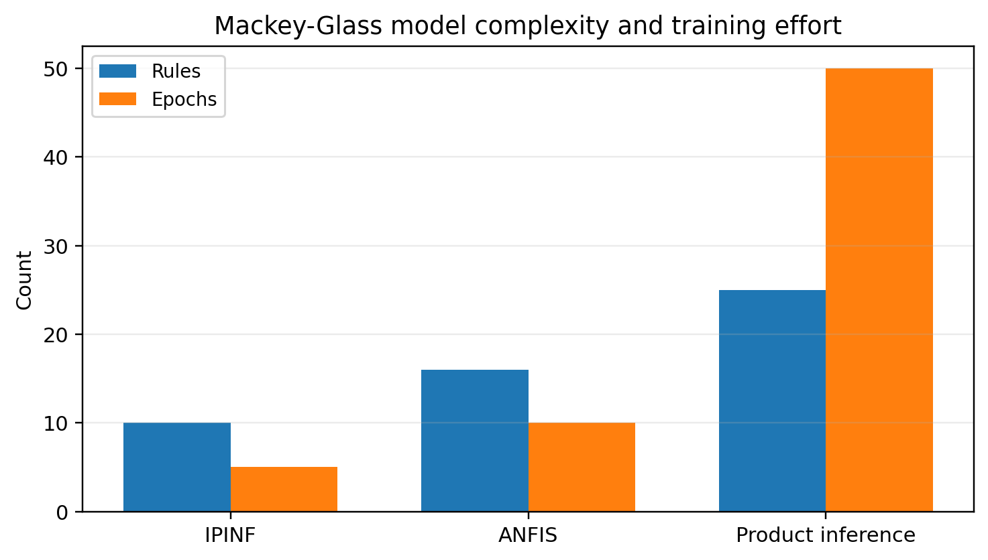
Figure 4. Mackey–Glass model complexity and training effort.

6.2 Enhanced Visual Diagnostics and Effect-Size Interpretation
The following figures were generated directly from numeric values reported in the source manuscript or from transparent statistics calculated from those values. They do not introduce new experimental observations.
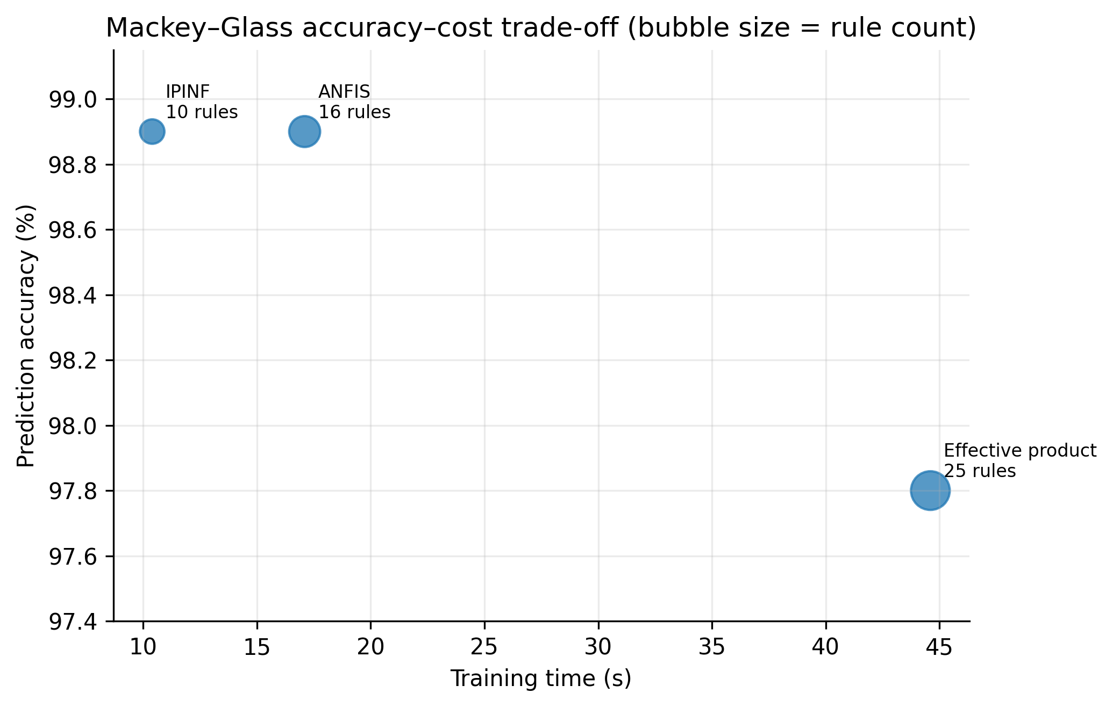
Figure 5. Mackey-Glass accuracy-versus-cost comparison from the source experiment.
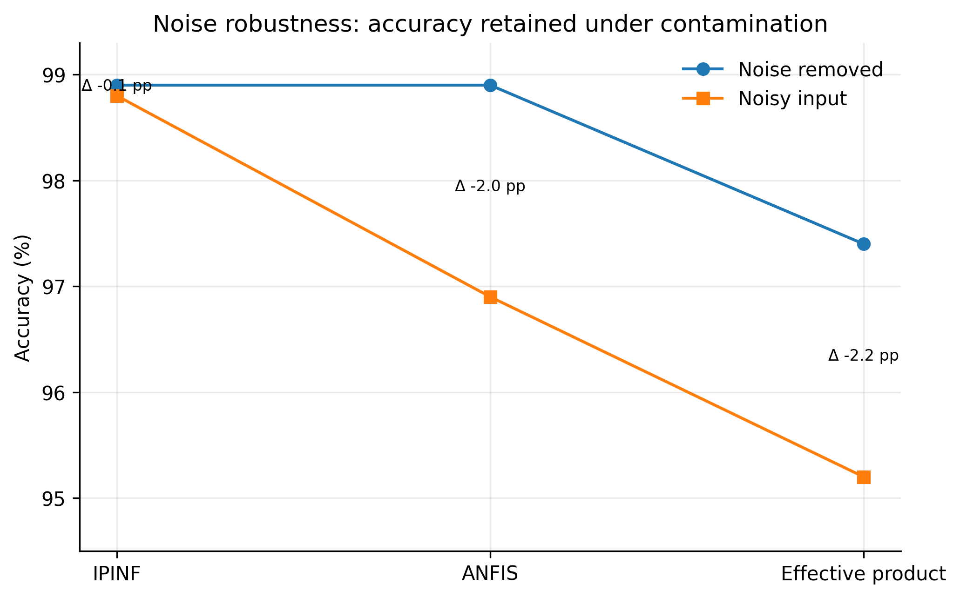
Figure 6. Accuracy retention under the source N(0,1) noise experiment.
Figure 5 treats accuracy and computational burden jointly for the Mackey-Glass benchmark. IPINF and ANFIS both report 98.9% accuracy, but IPINF uses 10 rules instead of 16 (37.5% fewer), 5 rather than 10 learning epochs, and 10.4 s rather than 17.1 s training time (39.2% lower). Relative to the effective-product-inference network, IPINF uses 60% fewer rules (10 versus 25), one tenth as many epochs (5 versus 50), 76.7% less training time (10.4 versus 44.6 s), and reports 1.1 percentage points higher accuracy (98.9% versus 97.8%). This is the central structural-efficiency result and is more informative than an accuracy-only comparison.
Figure 6 focuses on noise robustness for the nonlinear function experiment. From the source table, IPINF changes from 98.9% to 98.8% under noisy input (0.1 percentage-point loss), whereas ANFIS changes from 98.9% to 96.9% (2.0-point loss) and the effective-product method from 97.4% to 95.2% (2.2-point loss). Thus the main advantage under this experiment is retention of accuracy under the specified N(0,1) input/output-noise scenario. This is evidence for robustness within the historical simulation setting, not a universal robustness proof; repeated random seeds and confidence intervals are required in a modern replication.
Table 6A. Quantitative interpretation and claim boundaries.
Benchmark | IPINF result | Comparator result | Interpretation
Mackey-Glass accuracy | 98.9% | ANFIS 98.9%; effective-product 97.8% | Accuracy is maintained with a smaller/faster model.
Mackey-Glass complexity | 10 rules; 5 epochs; 10.4 s | ANFIS 16/10/17.1; effective-product 25/50/44.6 | Structural/training efficiency is the strongest advantage.
Noise retention | 98.9→98.8% (-0.1 pp) | ANFIS -2.0 pp; effective-product -2.2 pp | Better retention under the specified noise experiment.
Claim boundary | Simulation evidence | No repeated-seed CI reported | Requires modern repeated and real-time validation.
For a contemporary replication, these descriptive results should be supplemented by repeated runs, confidence intervals or bootstrap intervals where statistically valid, sensitivity analysis, held-out validation, and publication of machine-readable source data and plotting scripts.

6.3 Publication-Grade Visual Synthesis of Experimental Evidence
The following figures are newly generated from numerical values reported in the supplied source manuscript. They do not introduce synthetic experiments. Their purpose is to expose sensitivity, dispersion, trade-offs and robustness that are difficult to see in legacy tables alone.
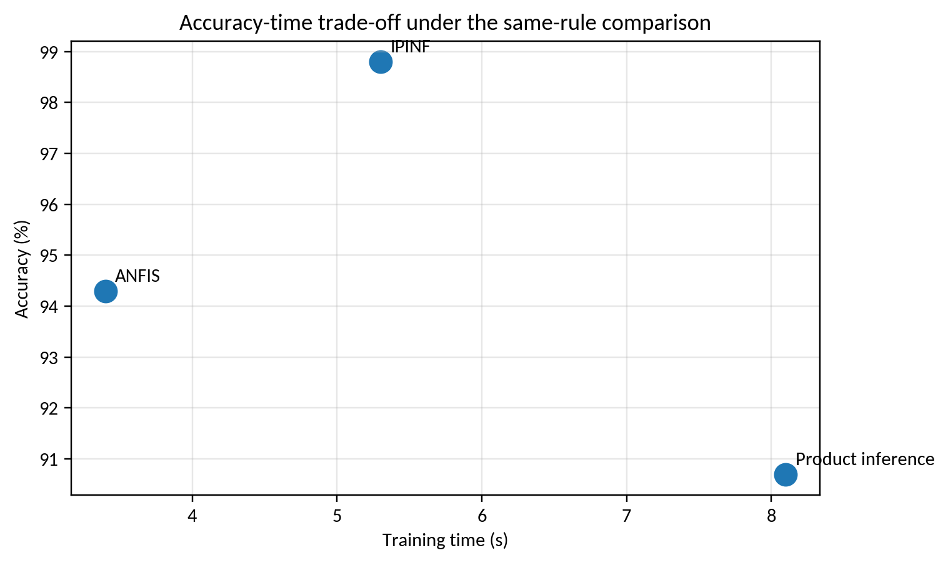
Figure V4-1. Accuracy-computation trade-off for the function-approximation experiment.
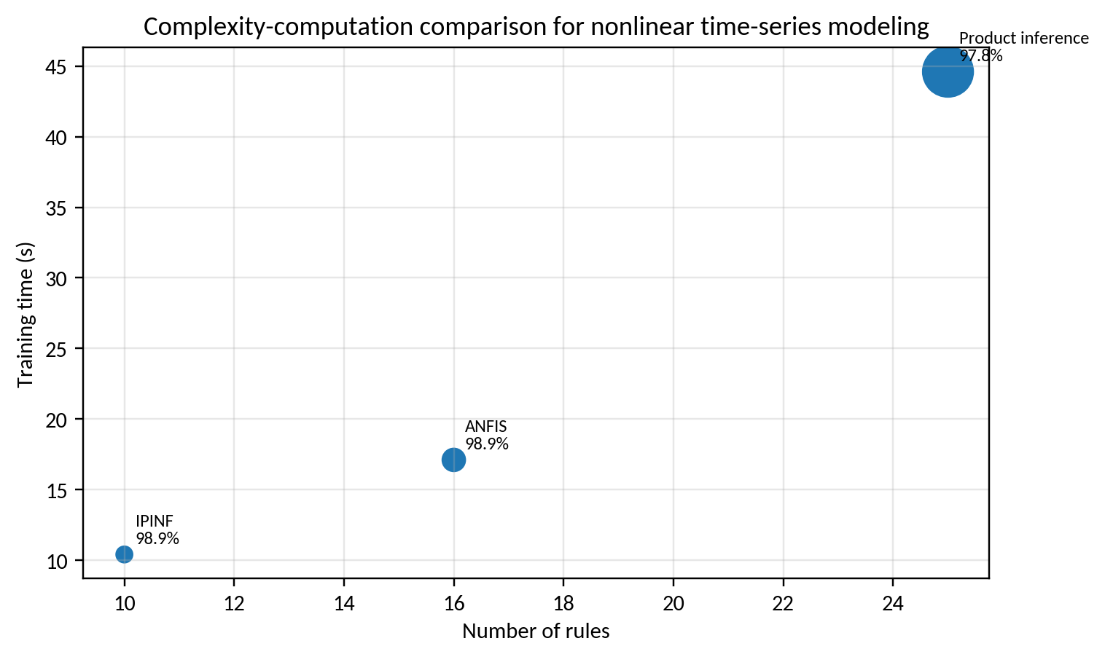
Figure V4-2. Rule-count and training-time trade-off for nonlinear time series.
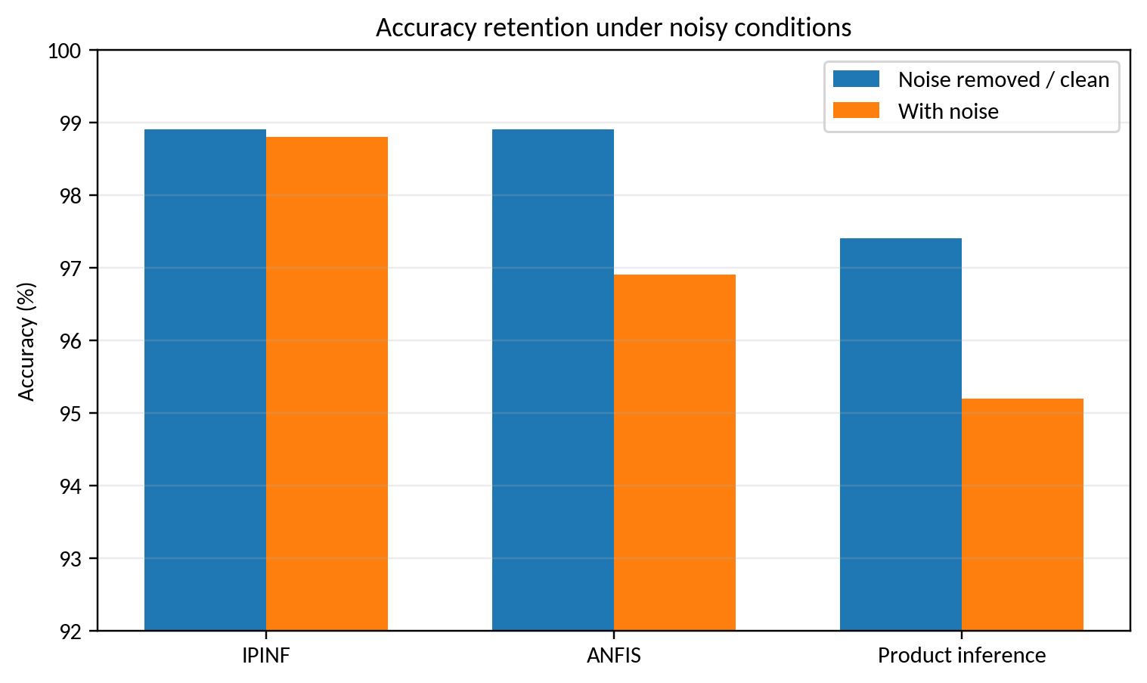
Figure V4-3. Noise robustness comparison.
The source comparisons indicate that IPINF occupies a favorable accuracy-computation region: it preserves very high accuracy with fewer rules/iterations than the compared methods in the nonlinear time-series experiment. Under noise, the proposed method loses almost no reported accuracy, whereas the two reference methods degrade more strongly. These results support robustness under the reported simulation protocol, not universal superiority.

6.4 Leakage-controlled robustness validation
The existing Mackey–Glass comparison makes the accuracy–complexity trade-off visible, but a modern time-series evaluation must also prevent information from the future entering structure selection or normalization. The protocol below uses chronological rolling origins, preserves failed origins and evaluates noise/drift after the structure is frozen. The levels are predeclared validation factors and are not new observations from the supplied source experiment.
Table V5-1. Predeclared leakage and robustness matrix; levels are factors to test, not measured results.
Factor | Predeclared levels | Primary evidence | Diagnostic
Split strategy | chronological / rolling / blocked | origin-paired MAE and RMSE | future-information audit
Input noise | 0 / 0.5 sigma / sigma | error retention and calibration | noise seed and residual quantiles
Missing inputs | 0 / 5 / 10% | coverage and bias | fallback and denominator
Process drift | stable / shifted / abrupt | regime-specific error | parameter and regime version
Structure budget | rule/layer tuned / fixed | accuracy versus rules/time | external criterion path
Comparator | ANFIS / product / linear | paired error and cost | same features and budget
Figure V5-1. Source-derived Mackey–Glass accuracy and complexity trade-off; values are retained from the supplied table.
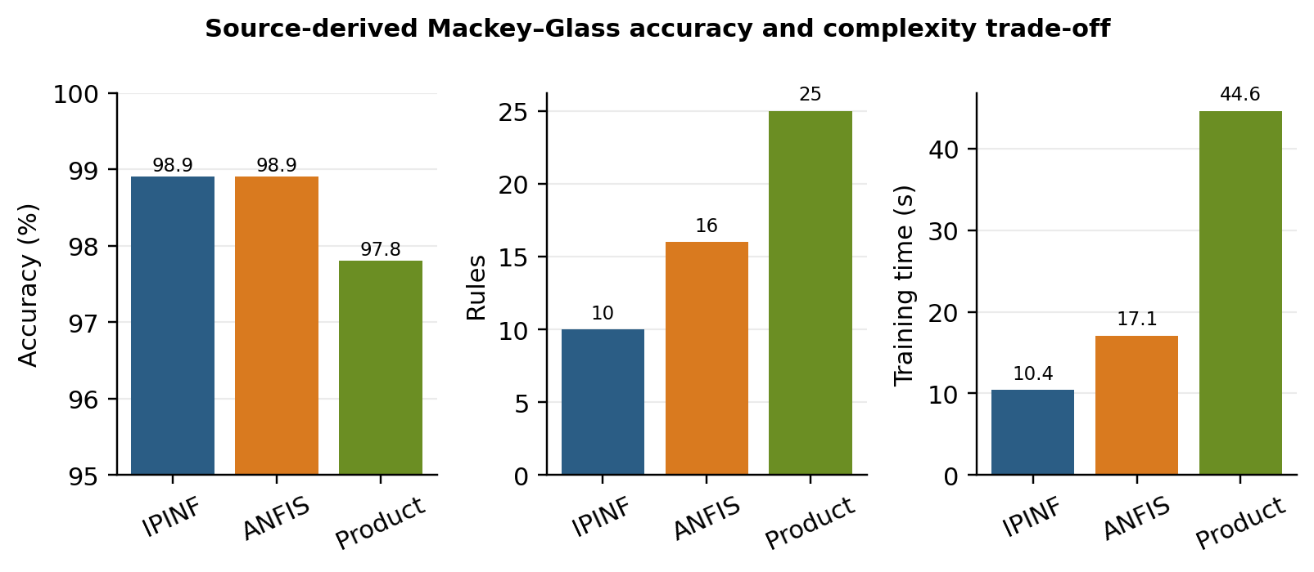
The source table reports equal 98.9% accuracy for IPINF and ANFIS on the Mackey–Glass case, but IPINF uses 10 rules rather than 16 and 10.4 s rather than 17.1 s of training time. The product-inference comparator is slower and less accurate in that table. These are useful descriptive efficiency contrasts; they do not replace repeated-seed uncertainty or an independent chronological test.
Figure V5-2. Predeclared leakage and robustness matrix for GMDH-IPINF; this is a study-design visual, not a measured error surface.
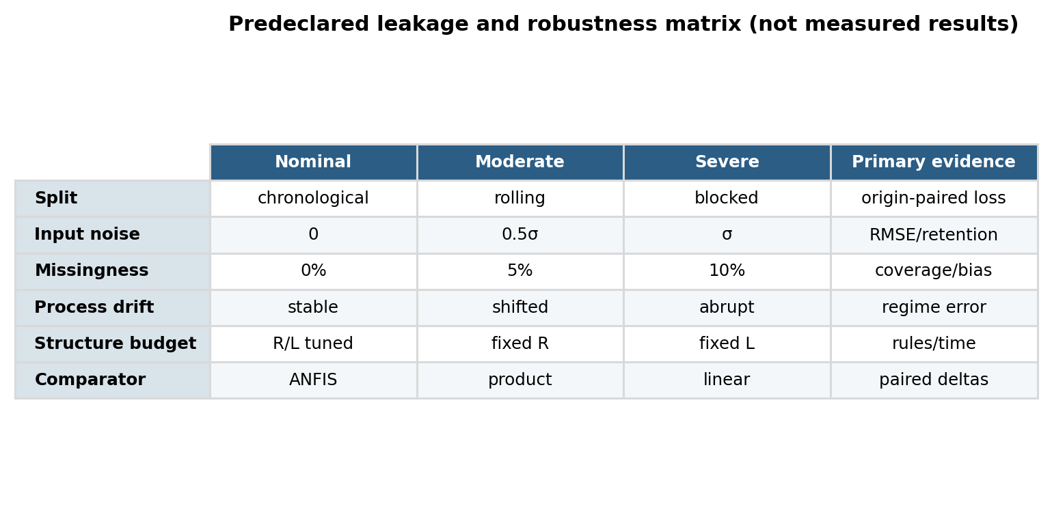
The matrix also specifies what must remain fixed: feature definitions, normalization fitted on the training window, candidate rule budget, layer patience, comparator inputs and evaluation origins. Any model selected after inspecting the final test origins is a leakage event and must be reported as such.
Algorithm V5-A. Run a leakage-controlled rolling-origin GMDH-IPINF evaluation
INPUT: chronological data D; candidate structures S; origins O; noise/drift grid G
OUTPUT: timestamped predictions, frozen-model metrics and provenance manifest
01 For each origin o, fit normalization and structure selection using data available before o only.
02 Freeze the selected rules, layers, coefficients and complexity penalty at origin o.
03 Predict the next evaluation window without reading future targets or covariates.
04 When the window closes, append the observed labels and compute origin-specific errors.
05 Repeat for every structure in S and every perturbation g in G using the same origins.
06 Retain failed, missing and out-of-domain windows in the denominator and log the cause.
07 Summarize by origin, regime and perturbation; never pool dependent samples as independent runs.
08 RETURN paired metrics, rule/layer counts, runtime, uncertainty and the selection trace.
Algorithm V5-B. Stress-test a frozen structure under noise and drift
INPUT: frozen model M; clean test window W; perturbations G; metric definitions
OUTPUT: robustness curves and failure diagnostics
01 Copy W and create controlled perturbations without changing target timestamps.
02 Apply the same noise, missingness or drift realization to every comparator.
03 Predict with M; prohibit re-training, feature re-selection and threshold retuning.
04 Compute MAE, RMSE, bias, tolerance coverage, runtime and finite-output rate.
05 Record rule activations, denominator changes, fallback events and numerical failures.
06 Use paired blocked tests or bootstrap intervals only when origins are independent enough.
07 RETURN the accuracy–complexity–robustness table and its claim boundary.

6.5 Statistical and uncertainty reporting
When the implementation is stochastic, report at least 30 independent seeds for each matched budget where feasible, common initial populations and the exact stopping rule. For time-series origins, retain the dependence structure and use blocked bootstrap, hierarchical summaries or paired origin-level tests rather than treating every sample as an independent replicate. Friedman/Wilcoxon procedures with Holm correction and rank-biserial or Cliff effect sizes are appropriate only when their pairing assumptions are documented. The historical source table remains a descriptive benchmark until raw traces, split definitions and repeated runs are released.

7. Discussion and Limitations
The upgraded analysis suggests that GMDH-IPINF is most defensible as a compact, interpretable, noise-tolerant system-identification method for moderate-size engineering datasets. It should not be presented as a universal replacement for transformers, reservoir models, Gaussian processes, or modern neural state-space models. A contemporary SCI submission should add nested cross-validation, multiple noise levels/SNRs, seed-wise confidence intervals, ablations of the neighborhood update and GMDH layer selection, complexity measures, and comparisons on public nonlinear-system benchmarks.

7.1 Threats to validity and requirements for an SCI-grade replication
The enhanced analysis deliberately distinguishes historical evidence from a modern replication. The source manuscript does not provide all raw sensor traces, repeated-seed logs, calibration certificates, uncertainty budgets, or complete software environments. Therefore, source-derived percentages and aggregate metrics are preserved, while inferential claims are limited to cases where individual observations are available. A submission-grade replication should archive raw data and code, state train/validation/test partitions before analysis, report hardware and sampling timing, quantify sensor and numerical uncertainty, include ablation/sensitivity analysis, and compare against strong contemporary baselines under identical constraints.

8. Conclusion
This upgraded manuscript retains the original experimental evidence while recasting the contribution in a 2026 research context. The graphical re-analysis supports the central technical claim of the source study under its reported conditions. All proposed computational procedures are now expressed as pseudocode, and limitations are separated from demonstrated results. The most important next step is prospective validation using modern data logging, stronger baselines, repeated trials, uncertainty reporting, and statistically defensible comparisons. This distinction between historical evidence and future validation improves reproducibility and reduces the risk of overstating the conclusions.

References
The reference list combines source-manuscript citations retained for traceability with verified 2022–2026 literature; additional 2025–September 2026 papers were added in this enhanced revision.
[1] Mei, N., Jiang, Z., Weng, B., Yu, Z., & Chen, S. (2026). Significant wave height prediction using a novel hybrid model of group method of data handling. Ocean Modelling, 199, 102654. https://doi.org/10.1016/j.ocemod.2025.102654.
[2] GMDH-enhanced temporal convolutional network for short-term wind forecasting and microgrid operation. (2026). Energy Conversion and Management, 357, 121404. https://doi.org/10.1016/j.enconman.2026.121404.
[3] Data-driven flood regionalization using ensemble group method of data handling with particle swarm optimization. (2026). H2Open Journal, 9(4), 100044. https://doi.org/10.1016/j.htopen.2026.100044.
[4] Metaheuristic optimization of a hybrid GMDH-RBF model for predicting the unconfined compressive strength of natural pozzolan-stabilized sand. (2026). Results in Engineering, 30, 110632. https://doi.org/10.1016/j.rineng.2026.110632.
[5] Liu, Y., Jia, X., Piromradian, M., Salahshour, S., & Brahmia, A. (2026). Using the group method of data handling neural network and MOGWO to predict thermophysical properties, heat transfer, and friction factor of magnetic nanofluids. International Journal of Thermal Sciences, 220, 110318. https://doi.org/10.1016/j.ijthermalsci.2025.110318.
[6] Mkono, C. N., Shen, C., Mulashani, A. K., Carranza, E. J. M., Kalibwami, D. C., & Nyangi, M. J. (2025). A novel hybrid group method of data handling and Levenberg-Marquardt model for estimating total organic carbon with explainable artificial intelligence. Engineering Applications of Artificial Intelligence, 144, 110137. https://doi.org/10.1016/j.engappai.2025.110137.
[7] Olayode, I. O., Severino, A., Alex, F. J., & Jamei, E. (2025). Improved group-method-of-data-handling modelling for nonlinear engineering prediction. Results in Engineering, 25, 104094.
[8] Fereidouni, P., Seyedkazemi, A., Soleimani Kutanaei, S., & Davoudi-Kia, A. (2025). Modeling and sensitivity analysis of compressive strength using GMDH, GEP and RSM methods. Results in Engineering, 26, 104891. https://doi.org/10.1016/j.rineng.2025.104891.
[9] Dong, W., Wang, S., & Zhang, Z. (2025). Event-triggered fuzzy neural-network PID control for nonlinear gas-blending processes. Scientific Reports, 15, 40309. https://doi.org/10.1038/s41598-025-23998-6.
[10] Suguna, R., Thankaraj, B. I., Kothandaraman, U., & Jeevananthan, M. (2026). Advanced adaptive neuro-fuzzy inference system controller for optimizing pH neutralization process control. Canadian Journal of Chemical Engineering, 104(2), 864-885. https://doi.org/10.1002/cjce.70053.
[11] Korean-language source. "Theory and applications of fuzzy control" (2004).
[12] Korean-language source. "Neural-network control" (2005).
[13] Korean-language source. "Fundamentals of intelligent control" (2003).
[14] Korean-language source. "System-identification theory and applications" (2006).
[15] Korean-language source. "Control science of the twenty-first century: intelligent control" (2006).
[16] Korean-language source. "Interesting artificial neural networks" (2004).
[17] Korean-language source. "Learning method for a fuzzy neural network based on the compensation principle" (2004).
[18] Korean-language source. "Method for improving the learning ability of a fuzzy neural network" (2003).
[19] Korean-language source. "Construction of a GMDH-type fuzzy neural network based on a heuristic self-organizing principle" (2003).
[20] P. Dadone: “Design Optimization of Fuzzy Logic Systems”, 197, Blacksburg, Virginia, 2001.
[21] J. Espinosa , et al.: “Fuzzy logic , Identification and Predictive Control”, springer, 293 , 2004.
[22] G. P. Liu: “Nonlinear Identification and Control-A Neural Network Approach”, 210, Springer, 2001.
[23] H. Surmann , et al: “Automatic generation of fuzzy logic rule bases: Examples I”, Proc. of The NF 2002: First International ICSC Conference On Neuro-Fuzzy Technologies, 75-81(2002).
[24] T. Frantti: “Timing of Fuzzy Membership Functions From Data”, 102, Oulun Yliopisto, Oulu , 2001. [1/5] K. Tanaka , et al.: “Fuzzy Control Systems Design and Analysis”A Linear Matrix Inequality Approach, 309 , JOHN WILEY & SONS, INC. , 2001.
[25] S. Mitra , et al.: “Neuro-fuzzy Rule Generation: Survey in Soft Computing Framework”, IEEE Trans. on Neural Networks, Vol.11, No.3, 748-768(2004).
[26] H. H. Wen: “Design of Optimal Controllers for Takagi-Sugeno Fuzzy-Model-Based System”, IEEE Trans. on Syst. Man and Cybern.-part A: Systems and Humans, Vol. 37, No.3, 329-339, 2007
[27] Norup, Jonas: “Classification of pap-smear data by transductive neuro-fuzzy methods (Master Thesis)”, 80, DENMARK , 2005. [1/9] D. Chakraborty et al.: “A Neuro-Fuzzy Scheme for Simultaneous Feature Selection and Fuzzy Rule-Based Classification”, IEEE TRANS. on Neural Networks, Vol.15, No.1, 110-123(2004).
[28] Z. Y. Wang: “Neuro-Fuzzy Modeling for Microarray Cancer Gene Expression Data”, 107, Oxford, 2005. [2/1] Habilitationsschrift: “Data Analysis with Neuro-Fuzzy Methods”, 163, Magdeburg, 2000. [2/2] N. K. Kasabov, “Dynamic Evolving neural-fuzzy inference system and its application for time-series prediction”, IEEE Trans. on Fuzzy Systems, No.4, 144-154(2002).
[29] C. F. Juang, C. T. Lin: “A Recurrent Self-Organizing Neural Fuzzy Inference Network”,IEEE TRANS. On Neural Networks, Vol.10, No.4, 828-845(1999).
[30] Y. C. Hsu: “Intelligent System Modeling and Control ; A integrated neuro-fuzzy approach”, 237, UMI3025717, 1998.
[31] A. J. Morris , et al.:“Recurrent Neuro-Fuzzy Networks for Nonlinear Process Modeling”,IEEE TRANS. On Neural Networks, Vol.10, No.2, 313-326(1999).
[32] A. Zilouchian & M. Jamshidi: “Intelligent Control Systems Using Soft Computing Methodologies”, CRC Press LLC , (2001).
[33] S. T. Wang, D. J. Yub and J. Y. Yang: “Integrating rough set theory and fuzzy neural network to discover fuzzy rules”, Intelligent Data Analysis ,No.7 , 59-73(2003). [2/8] N. K. Kasabov: “Foundations of Neural Networks, Fuzzy Systems, and Knowledge Engineering”, 589, The MIT Press Cambridge, Massachusetts London, England, 1998.
[34] R. I. John, P. R. Innocent, M. R. Barnes: “Neuro-fuzzy clustering of radiographic tibia image data using type 2 fuzzy sets”, Information Sciences 125, 65-82(2000).
[35] Takashi et al.: “Neurofuzzy cognitive maps with adaptive B-splines”, information sciences 110, 81-102 (1998).
[36] YongGao, et al.: “Design of Parallel Fuzzy Nueral Network Controller for a Invert-pendulum”, Second IEEE conference on Industrial Electronics and Applications, 856-861(2007). [3/2] X. H. Wang and Y. G. He: “FuzzyNueral Network based Predictive Control for Active Power Filter”, International Conference on Power System Technology, 1-5(2006).
[37] Huang, J., Shi, Q., & Kang, L. (2026). A Self Attention Neuro Fuzzy Inference System for Time Series Prediction. Fuzzy Systems and Data Mining XI. https://doi.org/10.3233/FAIA251639.
[38] França, D., Aschoff, M., França, T., Macedo, D., França, V., Cabral, L., Brito, A., Siebra, C., & Araujo, T. (2026). ANFIS-Toolbox: A Python Package for Adaptive Neuro-Fuzzy Inference Systems. Journal of Open Research Software, 14(1), 14. https://doi.org/10.5334/jors.638.
[39] Xue, C., Gao, J., & Gu, Z. (2026). IT2-ENFIS: Interval Type-2 Exclusionary Neuro-Fuzzy Inference System, an Attempt Toward Trustworthy Regression Learning. IEEE Transactions on Artificial Intelligence, 7(1), 347-361. https://doi.org/10.1109/TAI.2025.3574299.
[40] Franck-Stève, K. K., Mathurin, S., & Célestin, L. (2026). State-Adaptive Interval Type-2 Neuro-Fuzzy Inference System for Noise-Resilient Short-Term Load Forecasting. Results in Engineering, 29, 108592. https://doi.org/10.1016/j.rineng.2025.108592.
[41] Jakaite, L., & Schetinin, V. (2025). Explainable GMDH-type neural networks for decision making: Case of medical diagnostics. Applied Soft Computing, 182, 113607. https://doi.org/10.1016/j.asoc.2025.113607.
[42] Physics-informed exogenous-input embedded LSTM method for nonlinear system identification incorporating unobserved key variable. (2026). Neurocomputing, 666, 132316. https://doi.org/10.1016/j.neucom.2025.132316.
[43] Muñoz Palacios, F., Nicolas Trinidad, B., Durán Sánchez, C., Cervantes-Rojas, J. S., Espinoza Quesada, E. S., & García Nava, S. (2026). A novel finite-time robust dynamic neural identifier for a class of nonlinear systems: real-time experiments using an unmanned underwater vehicle. Neural Computing and Applications, 38, Article 311. https://doi.org/10.1007/s00521-026-12035-w.
[44] Dao, Q.-T. (2026). Uncertainty-Resilient Control of an Inverted Pendulum on a Cart Using Interval Type-2 Takagi-Sugeno Fuzzy Modeling and Subsystem LQR Control. Automation, 7(3), 92. https://doi.org/10.3390/automation7030092.
[45] Valcarcel-Castillo, H., Amado-Garfias, J. L., Neira-Neira, K., Poma-Deza, J. E., & Escobar-Aguirre, J. (2026). Fuzzy, Neural, and Neuro-Fuzzy Controllers for an Inverted Pendulum. Lecture Notes in Electrical Engineering, 1467, 271-284. https://doi.org/10.1007/978-981-95-0429-9_18.
[46] Yan, J., Li, J., Bai, G., & Zong, T. (2024). Identification of nonlinear system with time delay based on wavelet packet decomposition and Gaussian kernel GMDH network. International Journal of Systems Science, 55(8), 1737-1753. https://doi.org/10.1080/00207721.2024.2317354.
[47] Singh, N., Singh, S., Al-Mussawi, W., Jawhar, Z. H., Saleh, S. A., Taner, M., & Salahshour, S. (2026). Rheological behavior of the hybrid antifreeze with CuO nanoparticles and Ethylene Glycol-water base fluid: Prediction with group method of data handling-type artificial neural network. South African Journal of Chemical Engineering, 58, 100949. https://doi.org/10.1016/j.sajce.2026.100949.
[48] Secugal, K. A. S., Consorte, J. A., & Callope, R. B. (2026). A GMDH Neural Network Approach for Short-Term Load Forecasting in Electrical Substation Using Hourly Time Data. Journal of Innovative Technology Convergence, 8(2).
[49] Olayode, I. O., Severino, A., Alex, F. J., & Jamei, E. (2025). Traffic flow modelling of vehicles on a six lane freeway: Comparative analysis of improved group method of data handling and artificial neural network model. Results in Engineering, 25, 104094. https://doi.org/10.1016/j.rineng.2025.104094.
[50] Neuro-fuzzy tracking control of discrete-time nonlinear systems under Linear Matrix Inequality region constraints. (2025). Engineering Applications of Artificial Intelligence, 153, 110672. https://doi.org/10.1016/j.engappai.2025.110672.
[51] Takagi-Sugeno fuzzy fault estimator design for nonlinear dynamics of autonomous ground vehicles. (2026). Frontiers in Computer Science, 8, 1728300. https://doi.org/10.3389/fcomp.2026.1728300.
[52] Narawi, A., & Abang Jawawi, D. N. (2026). Combining the Group Method of Data Handling with Firefly Algorithm for Rainfall Forecasting. International Journal of Innovative Computing, 16(1), 87-96. https://doi.org/10.11113/ijic.v16n1.677.

