Improved Shark Smell Optimization for Fuzzy Controller Tuning of an Inverted Pendulum

Abstract
Shark Smell Optimization (SSO) combines directed movement with local search, but a useful modification must improve control performance under comparable computational and physical constraints. This paper clarifies an improved SSO method, denoted FSSO in the supplied benchmark, and reanalyzes its reported inverted-pendulum results. The literature review incorporates relevant work published in 2025 and 2026 while distinguishing SSO from the separate White Shark Optimizer. A mathematical problem statement, explicit evaluation budget, modular pseudocode, and failure-aware validation protocol make the computational requirements easier to inspect. In the six-trial comparison reported in the supplied manuscript, FSSO reduces mean total error from 13.157 to 10.725 and settling time from 4.525 to 3.905 s. Calculations from the rounded summaries give reductions of 18.5% in total error, 24.4% in angle error, 25.1% in position error, and 13.7% in settling time. A separate FACS comparison also favors FSSO on the four reported means. The supplied robustness plot reports SSO divergence beginning at the tested initial-velocity value of 5 m/s, whereas FSSO remains finite through 10 m/s. These observations support a benchmark-specific performance advantage, but do not establish a stability theorem or a statistically general advantage. The supplied file lacks the complete trial matrix, original coefficient-adaptation map, and simulation configuration. Consequently, new uncertainty estimates and significance tests are not asserted. A matched-budget replication and ablation protocol is specified to resolve those limitations.
Keywords: shark smell optimization; fuzzy control; inverted pendulum; constrained optimization; stochastic benchmarking; robustness

1 Introduction

1.1 Control tuning as a constrained search problem
A controller for an inverted pendulum must coordinate pendulum stabilization with cart-position regulation. Improving one quantity can worsen another: aggressive gains may shorten the initial transient while increasing actuator saturation, cart travel, or sensitivity to measurement noise. The meaningful optimization problem is therefore to find an admissible controller with a documented balance of tracking error, settling time, and control effort. Fuzzy sets provide a language for graded rules [1], and the early work of Mamdani established their use in feedback control [2, 3]. Takagi–Sugeno models and data-derived fuzzy rules subsequently connected linguistic descriptions with numerical system identification [4, 5].
Learning and optimization extend this framework in different ways. ANFIS learns a structured input–output mapping [6], whereas a population optimizer can tune scaling gains, membership parameters, or consequent coefficients against a closed-loop objective. Fuzzy-control tutorials emphasize that inference operators and scaling are part of the controller definition [7, 8]. The distinction matters here: the optimizer selects parameters, but the controller and plant together determine the resulting trajectory. A lower optimizer fitness cannot by itself establish closed-loop stability.

1.2 SSO and related research through 2026
The original SSO algorithm models odor-guided forward movement and rotational search [9]. Lin et al. extend SSO with information sharing and an escape mechanism for odor-source localization [10]. Their 2025 study is directly relevant to the search mechanism, although localization and pendulum regulation have different objective landscapes and failure conditions. Its results therefore motivate possible algorithmic components rather than supply a pendulum performance baseline.
White Shark Optimizer (WSO) is a separate algorithm introduced by Braik et al. [11]. The shared animal metaphor does not make FSSO an adaptive WSO variant. The recent review by Pathak and the systematic review by Awadallah et al. provide context for shark-inspired optimization and its evaluation [12, 13]. Chaos-enhanced WSO, hybrid-energy-system sizing, multi-strategy scheduling, and robot-controller optimization illustrate current application directions [14, 15, 16, 17]. These studies are useful comparators for experimental practice; their update equations should not be silently substituted for the SSO equations.
Current controller studies also expand the relevant benchmark set. Chen et al. investigate constrained differential evolution for interval type-2 fuzzy PID tuning, while Melese et al. study optimized fuzzy PID object tracking [18, 19]. For pendulum systems, recent research includes adaptive fuzzy sliding-mode control, optimized fuzzy/sliding-mode regulation of rotary pendula, interval type-2 fuzzy modeling with LQR, nonlinear optimal control, and fuzzy PID balancing of two-wheeled robots [20, 21, 22, 23, 24]. A 2026 comparison of fuzzy, neural, and neuro-fuzzy pendulum controllers further demonstrates the diversity of controller structures now available [25]. Since these plants, actuators, and tuning conditions differ, their published error values cannot be merged into a single numerical ranking.
Table 1. Recent literature and its specific relevance to this study.
Research direction | Representative work | Useful comparison | Transfer limitation
Modified SSO search | Lin et al., 2025 | Information sharing and escape behavior | Odor localization is not the present plant
Shark-optimizer evaluation | Pathak, 2026; Awadallah et al., 2026 | Variant definition and benchmarking | WSO and SSO are distinct algorithms
Constrained fuzzy tuning | Chen et al., 2026 | Feasible parameter search | Hydraulic-actuator dynamics differ
Robust pendulum control | Mohammed et al.; Dao, 2026 | Disturbance and uncertainty testing | Controller architecture differs
Nonlinear optimal control | Rigatos et al., 2026 | Model-based reference controller | Requires a compatible plant model
Robot balancing | Fahmizal et al., 2026 | Load and balancing constraints | Wheel dynamics differ from a cart

1.3 Research question and contribution
The research question is whether the reported FSSO modification improves the quality and feasibility of fuzzy-controller tuning for the supplied pendulum benchmark. The answer is evaluated at three levels: reported mean performance, behavior under a tested initial-condition sweep, and the reproducibility of the evidence. This paper provides a consistent mathematical notation, a readable algorithm specification, new comparisons calculated from supplied numerical summaries, and an explicit protocol for experiments that remain to be performed.
The contribution is not a new animal metaphor. Sörensen’s critique and the methodological guidelines of LaTorre et al. motivate an operator-level account of the modification and a fair evaluation of its cost [26, 27]. In particular, preservation of an elite, additional local candidates, and restart evaluations must all be counted. Otherwise, an apparent algorithmic gain may simply reflect a larger search budget. The literature assessment is current to 8 October 2026 and uses identifiable publisher records; foundational references are retained where they define the method or evaluation procedure.

2 Problem formulation and evidence scope

2.1 Plant state and controller parameters
Let $z\left(t\right)={\left[p\left(t\right),\dot{p}\left(t\right),θ\left(t\right),\dot{θ}\left(t\right)\right]}^{T}$ contain cart position, cart velocity, pendulum angle, and angular velocity. The generic simulation is written as
$$\dot{z}\left(t\right)=f\left(z\left(t\right),u\left(t\right);ψ\right), u\left(t\right)=π\left(z\left(t\right);ϑ\right), ϑ∈\left[ℓ,h\right]. \text{(1)}$$
Here, $ψ$ contains the physical plant parameters, $π$ is the fuzzy controller, and $ϑ$ is the candidate tuning vector. Each component of $ϑ$ must have a name, unit, lower bound, and upper bound. The plant model must state the angle convention, gravity, masses, pendulum length, friction, actuator dynamics, integration method, and sample interval. These values are not reconstructed from the outcome summaries. Supplying them is necessary before the historical experiment can be reproduced.
For numerical search, use a normalized vector $x∈{\left[0,1\right]}^{d}$ and decode it as $ϑ=ℓ+\left(h−ℓ\right)⊙x$. Normalization prevents parameters with large physical units from dominating distances or velocity bounds. It does not change the controller’s physical parameter limits. The rule base, membership-function shapes, inference operator, and output mapping must remain identical when the purpose is to compare optimizers.

2.2 Metrics and an explicit prospective objective
The supplied manuscript reports total error (TE), angle error (AE), position error (DE), and settling time (ST). It does not fully define their integration windows, normalizations, or tolerances. They are therefore retained as source labels. TE should not be reverse-engineered as an arbitrary sum of AE and DE. For a future replication, one transparent objective is
Jsϑ=q∈{θ,p,u}​wqIq,sbq+wTTsbT, wq,wT≥0. (2)
$I_{θ,s}$ and $I_{p,s}$ may be integrals of absolute angle and position error; $I_{u,s}$ may be the integral of squared control effort. The positive scales $b_{q}$ and $b_{T}$ are fixed before optimization, using engineering tolerances or a declared reference controller. Settling time must require the trajectory to remain inside specified angle and position bands for a declared dwell period. A run that never settles is assigned a failure flag or a right-censored settling time, rather than a favorable zero. Equation (2) is a proposed replication objective, not a claim about the unidentified historical TE formula.
Training scenarios and held-out robustness scenarios have separate roles. An optional robust search objective combines average and worst-case training cost:
Jrob=1−ρ1Strains∈Strain​Js+ρmaxs∈StrainJs, 0≤ρ≤1. (3)
The choice of $ρ$ must precede test evaluation. A larger value emphasizes the worst training scenario, but can sacrifice nominal performance. If failure penalties are used, they must exceed all admissible finite objective values or be replaced by feasibility-first comparison. Deb’s constraint-handling framework provides a useful basis for keeping feasibility separate from objective quality [28].

2.3 What the available evidence establishes
There are two separate reported comparisons. Comparison A contains six SSO–FSSO trials summarized by four means. Comparison B contrasts FACS with FSSO and has different FSSO means. The supplied figure for Comparison B describes 12 repeated cases, but its underlying case table is absent from the attached file. These two comparisons are not pooled. The acronym FACS is retained as the baseline label supplied by the manuscript; its exact implementation must be restored with the replication files.
Table 2. Available evidence and permissible analysis.
Evidence item | Available in the attachment | Analysis supported here
Comparison A | Four means and a six-trial TE plot | Descriptive differences; retained trial illustration
Comparison B | Four means and a distribution plot | Descriptive differences within that comparison
Initial-velocity sweep | Plotted trajectories and reported divergence onset | Tested feasibility boundary, not a probability of stability
Original random seeds and full trial matrix | Not supplied as numeric records | No new paired test, SD, or confidence interval
Exact coefficient policy and plant configuration | Incomplete | Algorithm interface and replication requirements

3 Search method and implementation requirements

3.1 Forward and rotational movement
For a minimization implementation, a general SSO-style forward step can be expressed as
$$v_{i}^{k+1}=clip​\left(ω_{k}r_{1}⊙v_{i}^{k}−α_{k}r_{2}⊙g_{i}^{k},−v_{max},v_{max}\right), y_{i}=Π_{{\left[0,1\right]}^{d}}\left(x_{i}^{k}+v_{i}^{k+1}\right). \text{(4)}$$
$r_{1}$ and $r_{2}$ are declared random vectors, $g_{i}^{k}$ is a search direction or gradient estimate, and $Π$ repairs parameter bounds. The negative sign is appropriate when $g$ estimates the gradient of a cost to be minimized. If odor concentration is defined as a maximization quantity, the direction must be changed consistently. A direction callback must declare whether it uses analytical gradients, finite differences, a surrogate, or population differences.
A rotational or local candidate can be represented by $y_{i}+δ_{ij}$, with the distribution, radius, and boundary repair of $δ_{ij}$ specified in the configuration. The best admissible member of the incumbent, forward point, and local candidates is retained. This form describes the data flow shared by the source narrative; it does not uniquely identify the historical FSSO modification. In particular, the supplied draft does not provide the complete fuzzy coefficient map. The coefficient policy is therefore an explicit input to the pseudocode, rather than an invented rule table attributed to the source.

3.2 Adaptation, diversity, and reproducibility
Useful diagnostics include normalized population diversity,
$$D_{k}=\sqrt{\frac{1}{Nd}\sum_{i=1}^{N}{∥}x_{i}^{k}−{\overline{x}}^{k}∥_{2}^{2}}, \text{(5)}$$
and the number of iterations since the last best-feasible improvement. A policy can use these quantities to adjust exploration or trigger a restart. Such diagnostics reveal whether faster apparent convergence arises from useful concentration or premature collapse. If a restart is enabled, the elite is preserved, the restarted subset is declared, and every reevaluation consumes budget. These are implementation safeguards for the replication; the historical outcome values are not evidence that each safeguard was originally present.
Use separate random streams for population initialization, local perturbations, and disturbances. A single seed reused across methods does not automatically create statistically paired trials, because methods consume random numbers differently. Explicitly shared scenario realizations or initial populations provide the relevant pairing. Differential evolution, particle swarm optimization, and CMA-ES are appropriate baseline optimizer families when they tune the same controller with the same evaluation budget [29, 30, 31]. Orthogonal simulated-annealing tuning of fuzzy neural PID controllers provides another historical optimization-based reference [32].

3.3 Computational cost and stopping
Let $B$ be the total allowed objective evaluations and $C_{sim}$ the cost of evaluating a candidate over the declared training scenarios. The principal cost is $O\left(BC_{sim}\right)$, with $O\left(Nd\right)$ population memory. Finite-difference direction estimation may require approximately $2d$ additional evaluations per candidate; these evaluations count against $B$. Local search with $m$ candidates also consumes $m$ evaluations, even when none improves the incumbent. Iteration count alone is therefore an unsuitable fairness measure.
Terminate when the evaluation budget is exhausted, a declared target is attained, or a predeclared stagnation rule is met. A time limit may be added, but must be identical across methods and reported separately from evaluation counts. COCO provides an established framework for evaluating optimization progress against function-evaluation cost [33]. For the control task, an analogous best-feasible-objective trace should use cumulative plant evaluations on the horizontal axis.

4 Algorithmic specification
The algorithms below use INPUT, OUTPUT, numbered steps, and named subroutines. POLICY, DIRECTION, and LOCAL_STEPS are configured functions whose equations and settings must accompany an executable release. They expose the missing historical details; they do not hide them behind an assertion of complete replication. A candidate is accepted only after its cost and failure status are known.
Algorithm 1. Evaluate one controller consistently.
INPUT: candidate x; bounds; plant; training scenarios; metric definitions
OUTPUT: feasible flag; objective; scenario metrics; failure reasons
01 Decode x into physical controller parameters.
02 For each training scenario s:
03 Reset plant, controller memory, solver and disturbance stream.
04 Simulate with the same horizon and actuator limits as all baselines.
05 If states become nonfinite or violate a declared stop limit:
06 Record failure and the stopping time; retain this scenario.
07 Else compute the declared errors, effort and settling status.
08 Rank infeasible candidates by the declared violation rule.
09 For feasible candidates, aggregate costs using Equation (3).
10 Return all metrics, including failures and saturation duration.
The reset in Step 3 prevents one candidate from inheriting a favorable controller state. The simulator must distinguish numerical failure from a physically unstable trajectory. Repeating a failed run with a smaller solver step is a diagnostic action that should be logged, not silently substituted into the comparison.
Algorithm 2. Run SSO or FSSO under an exact budget.
INPUT: population size N; dimension d; budget B; seed; method configuration
OUTPUT: best feasible controller; evaluation trace; complete configuration
01 Require B >= N. Initialize N bounded positions and valid velocities.
02 Evaluate the population with Algorithm 1; set used = N.
03 Save the best feasible candidate and initialize stagnation = 0.
04 While used < B and no declared stopping condition is met:
05 Measure population diversity and recent improvement.
06 Get coefficients from POLICY(iteration, diversity, stagnation).
07 For each shark i, while budget remains:
08 Get DIRECTION with remaining budget B-used; charge its calls.
09 If no budget remains, stop before evaluating another candidate.
10 Form and repair the forward point using Equation (4).
11 Evaluate it; increment used; compare with the incumbent.
12 For each configured local step, while used < B:
13 Repair, evaluate and compare the local candidate; used += 1.
14 Keep the best candidate under the same feasibility rule.
15 If POLICY requests a restart, consider allowed non-elites.
16 Evaluate each replacement only while used < B; increment used.
17 Update elite, stagnation counter and best-feasible trace.
18 Return the elite or an explicit no-feasible-controller outcome.
SSO and FSSO use the same outer loop. Their scientifically relevant difference lies in the configured movement or coefficient policy. An ablation changes one policy component at a time. Returning the best candidate only after all candidates in a generation have been evaluated would exceed the budget in some configurations; the within-loop checks prevent that error.
Algorithm 3. Freeze a controller and test robustness.
INPUT: selected controller; held-out scenario grid; fixed simulation setup
OUTPUT: performance surface; success/failure map; worst observed response
01 Freeze controller parameters and every tuning decision.
02 For each held-out scenario, reset all state and run the controller.
03 Record errors, settling, peak angle, cart travel and actuator activity.
04 Preserve unstable, nonfinite and non-settling runs as separate outcomes.
05 Summarize finite performance conditional on success.
06 Also report success counts with the full scenario denominator.
07 Plot tested points and failures; do not interpolate a stability proof.
Algorithm 4. Conduct a fair repeated-run and ablation study.
INPUT: methods; configurations; benchmark tasks; independent seed list; B
OUTPUT: run matrix; effect estimates; uncertainty; corrected comparisons
01 Fix the primary metric, budgets, tuning rules and failure treatment.
02 For each task and seed, give every method the same allowed resources.
03 Run Algorithm 2; retain the best controller and complete search trace.
04 Apply Algorithm 3 to untouched scenarios using shared disturbances.
05 Store every outcome, including unsuccessful searches.
06 Repeat for each single-component ablation under the same B.
07 Summarize the primary effect and uncertainty at the independent-run level.
08 Use paired tests only for genuine matched experimental units.
09 Adjust the declared family of comparisons and publish the run matrix.
Algorithm 5. Replot the supplied summary without inventing replicates.
INPUT: reported means; source figures; comparison identifiers
OUTPUT: descriptive figures; calculated reductions; evidence notes
01 Keep Comparison A and Comparison B as separate datasets.
02 Validate labels, units and baseline denominators.
03 For each reported metric, compute 100*(baseline - FSSO)/baseline.
04 Plot values and reductions; state that they use rounded source means.
05 Reproduce selected source trajectories with their provenance stated.
06 Do not estimate SD, confidence intervals or p values from means alone.
07 Record inconsistencies and the raw records needed to resolve them.

5 Experimental basis and validation design

5.1 Reported comparison data
Table 3. Numerical summaries transcribed from the supplied manuscript.
Comparison | Metric | Baseline | FSSO | Reduction from displayed means
A, SSO baseline | TE | 13.157 | 10.725 | 18.5%
A, SSO baseline | AE | 7.530 | 5.694 | 24.4%
A, SSO baseline | DE | 0.423 | 0.317 | 25.1%
A, SSO baseline | ST in s | 4.525 | 3.905 | 13.7%
B, FACS baseline | TE | 12.169 | 10.759 | 11.6%
B, FACS baseline | AE | 6.775 | 5.743 | 15.2%
B, FACS baseline | DE | 0.539 | 0.395 | 26.7%
B, FACS baseline | ST in s | 5.029 | 3.954 | 21.4%
The percentage calculation is $100\left(b−p\right)/b$, where $b>0$ is the baseline mean and $p$ is the FSSO mean. Small differences from percentages printed in earlier drafts can follow from rounding. For example, the displayed position-error means in Comparison A give 25.1%, whereas the source prose reports approximately 25.0%. Precision beyond the input summaries is not warranted.
Several original graphics encode quantities with different units on a common axis or disagree with the accompanying FACS summary. New numerical graphics in this revision consistently use Table 3 and separate the metrics into panels. The retained trial and robustness figures are identified as reproduced source visuals. No raw trial values have been reconstructed by reading pixels, and no new learning or convergence curve has been fabricated.

5.2 Proposed ablations and sensitivity experiments
Table 4. Prospective experiments; these are specifications, not completed results.
Question | Controlled comparison | Hold fixed | Outcome to report
Does adaptation help? | Fixed coefficients versus adaptive policy | Controller, population, evaluation budget | Objective distribution and failures
Does local search help? | Local search enabled versus disabled | Total evaluations, initialization | Improvement per evaluation
Does escape help? | Restart enabled versus disabled | Budget and elite preservation | Diversity and success probability
Is the solution weight-sensitive? | Predeclared objective-weight choices | Plant and test grid | Error–effort trade-off
Is tuning physically robust? | Nominal and perturbed masses, friction, delay | Frozen controller | Worst-case error and violations
Is the result solver-sensitive? | Finer integration steps and tolerances | Controller and scenarios | Metric change and failure agreement
Choose perturbation ranges from physically justified tolerances. An arbitrary numerical sweep is not equivalent to a realistic manufacturing distribution. Initial angles and cart velocities should be varied independently and jointly; a single initial-velocity sweep cannot characterize the entire region of attraction. Disturbance rejection and measurement-noise robustness should also be tested separately, since a controller can tolerate one and amplify the other.
For stochastic comparisons, a target such as 30 independent optimizer seeds is a practical starting design, not a theorem about sufficient sample size. Pilot dispersion, computational cost, and the smallest useful engineering improvement should determine the final replication count. Report median, interquartile range, mean, standard deviation, failure count, and run-level scatter when the raw matrix is available. Report convergence against evaluation count and measured wall time, including hardware and parallelism.

6 Results and visual interpretation

6.1 Performance within each comparison
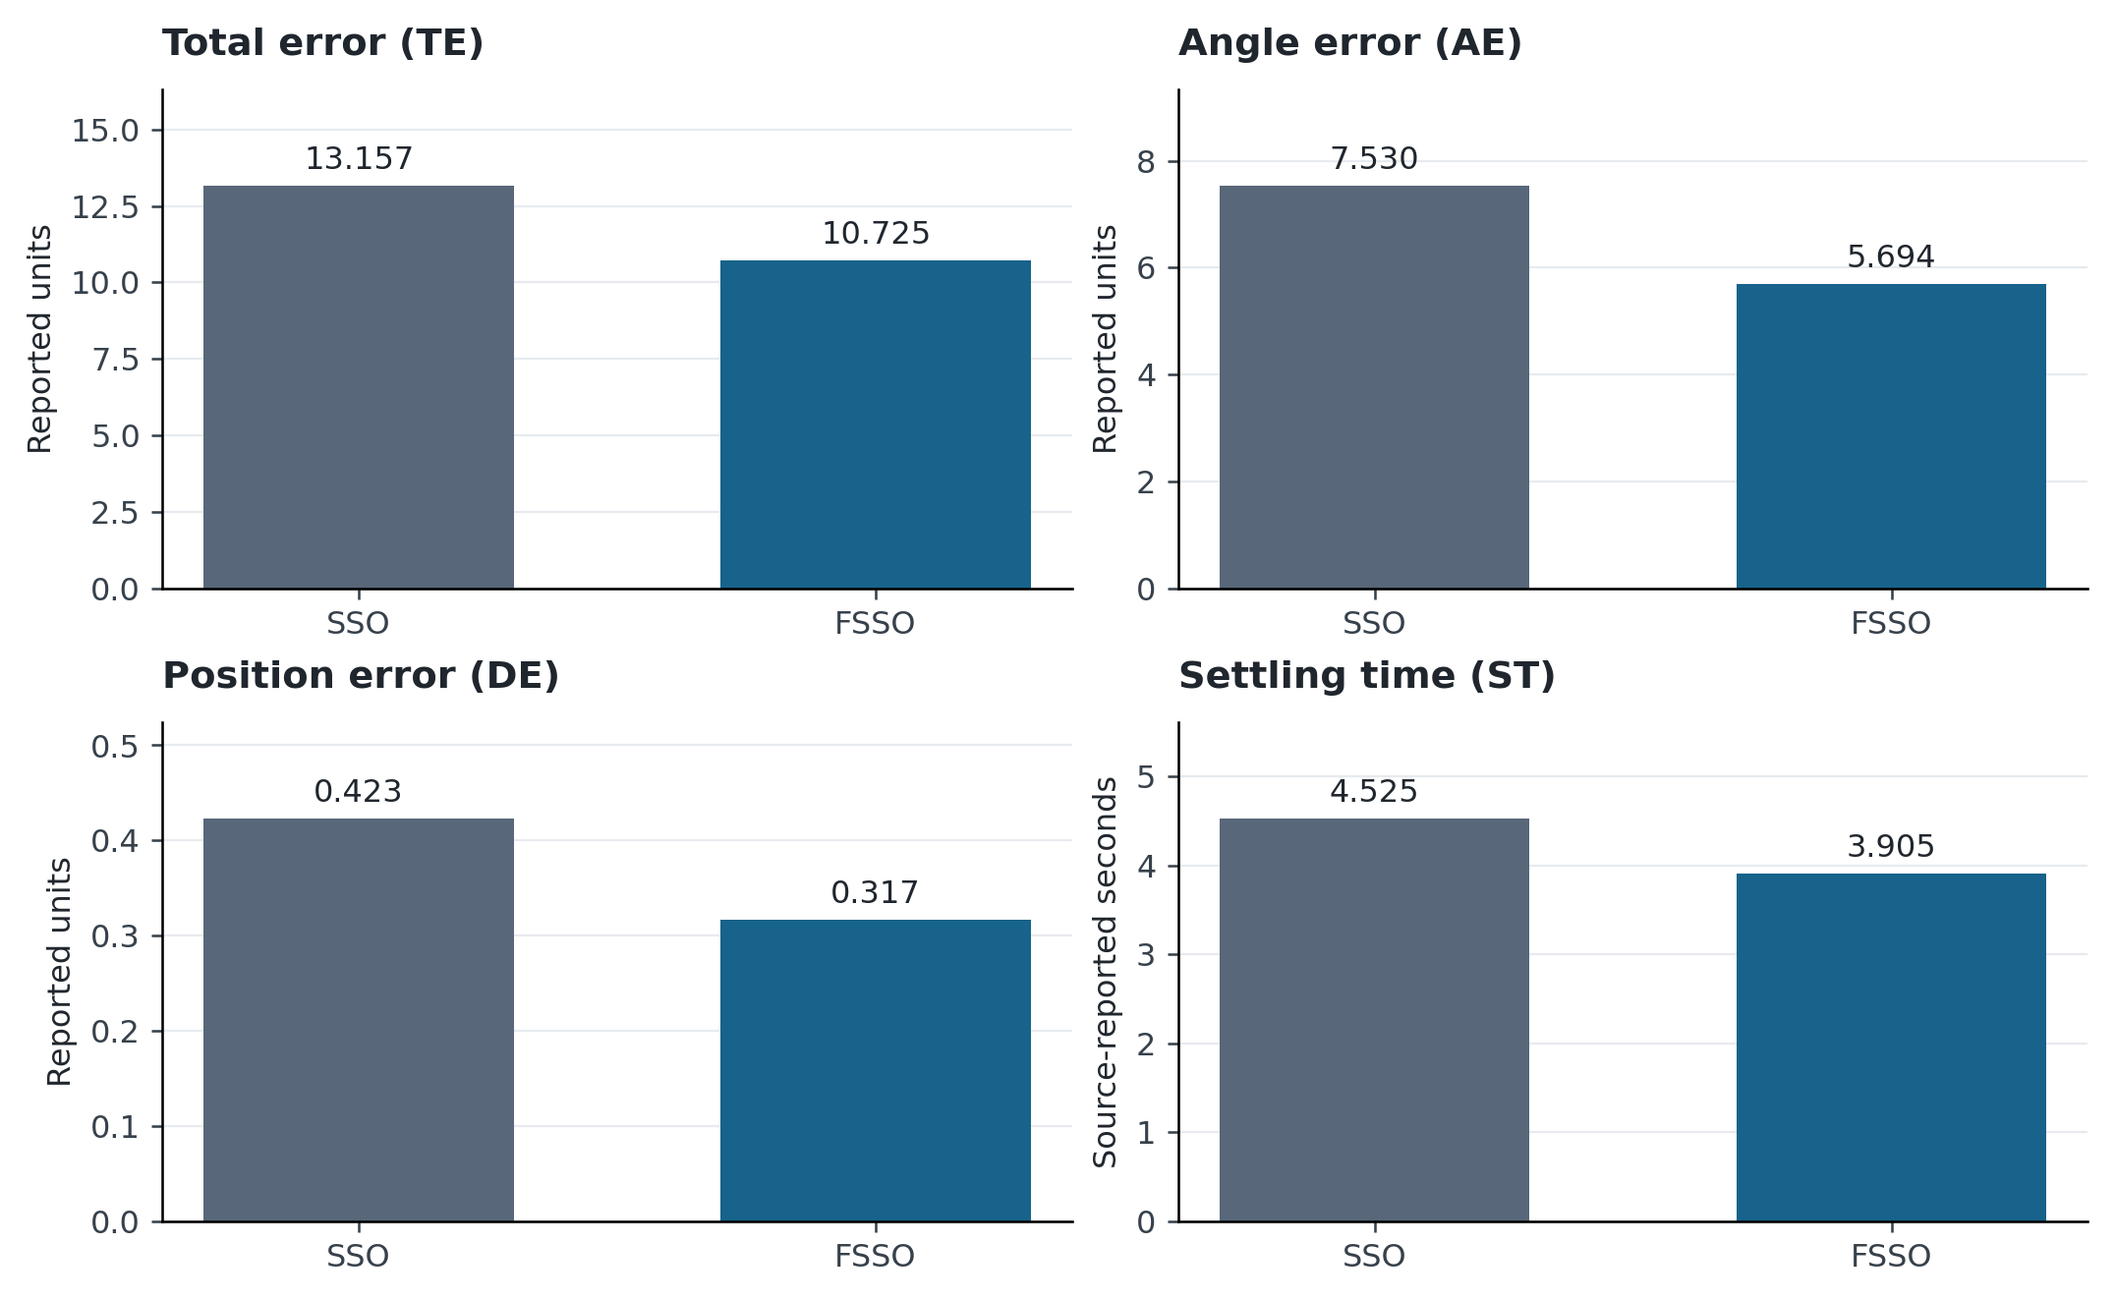
Figure 1. SSO and FSSO means in Comparison A. Each panel uses its own unit and starts at zero. Values are the supplied six-trial summaries; error bars are unavailable because the full trial matrix was not supplied.
FSSO has a lower reported mean for every metric in Comparison A. The largest proportional change is in position error, while the smallest is in settling time. This supports a multi-metric descriptive advantage rather than an improvement confined to TE. However, a reduction in a reported mean does not indicate how frequently a run fails or how variable its best controller is. The retained TE trajectory in Figure 2 adds some information about trial-to-trial behavior, but cannot replace the full four-metric matrix.
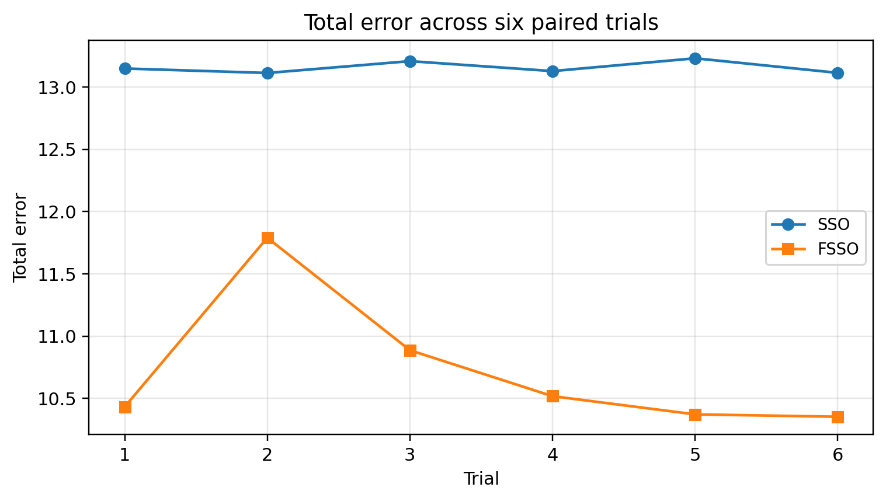
Figure 2. Six-trial TE trajectory reproduced from the supplied manuscript. The individual numerical records and seed identifiers are unavailable in the attachment. The visual is retained for context and is not the basis of a new inferential test.
The visible FSSO trajectory is less uniform than the SSO trajectory and includes a relatively larger second-trial value. This is precisely why a single best-run comparison would be misleading. Its lower reported mean is encouraging, but the stability of that advantage should be evaluated using independently repeated runs and the complete failure accounting described in Algorithm 4.
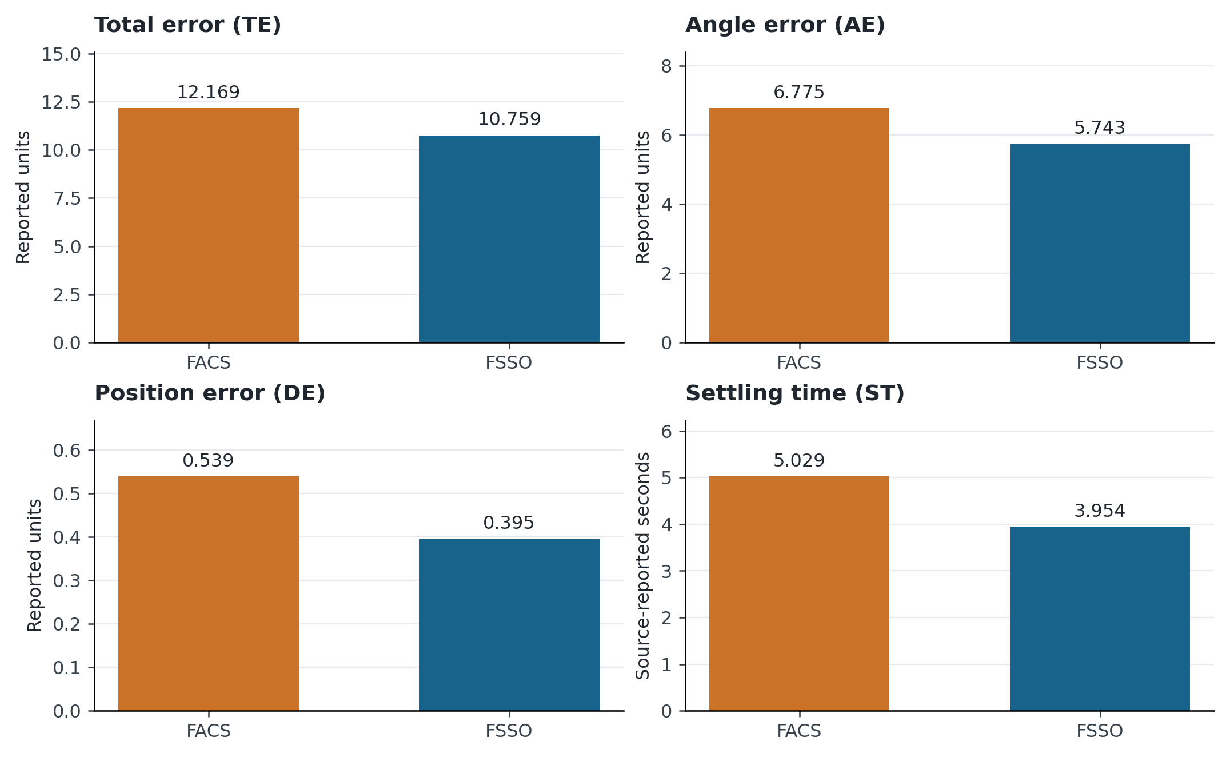
Figure 3. FACS and FSSO means in the separate Comparison B. The displayed numbers come from the supplied prose/table summaries. Comparison B is not pooled with Comparison A.
In Comparison B, the TE advantage is smaller than in Comparison A, whereas the settling-time advantage is larger. The FSSO mean position error also differs between the comparisons, from 0.317 to 0.395. This does not establish contradictory performance; it shows that the two comparison sets cannot be assumed to have identical trial realizations or conditions. A replication must state exactly which conditions were shared.

6.2 Practical effect sizes and trade-offs
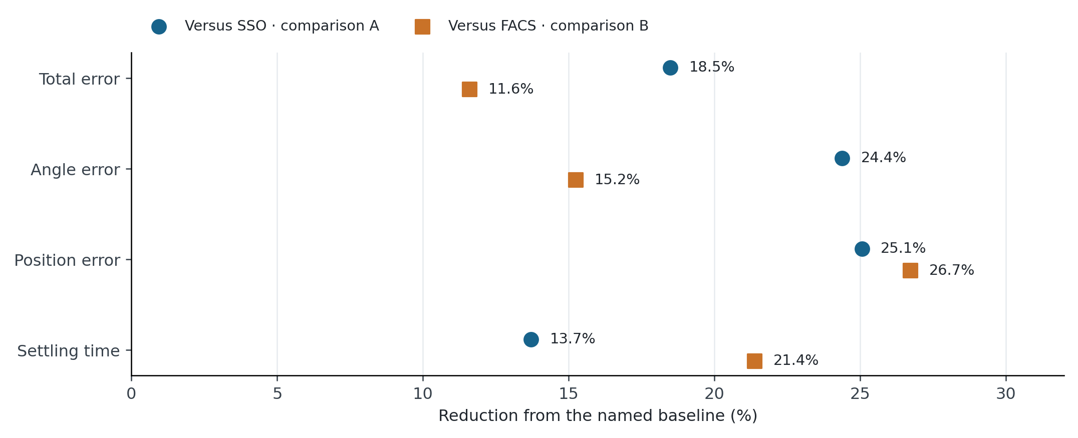
Figure 4. Relative reductions calculated from Table 3. Markers compare FSSO with each baseline within its own experiment. They are percentage changes in rounded means, not standardized statistical effect sizes.
Relative reductions make metrics with different scales easier to compare, but should accompany raw values. For instance, a roughly 25% decrease in DE corresponds to 0.106 reported units in Comparison A; its engineering importance depends on the position-error definition and allowable cart travel. Similarly, the settling-time reduction is 0.620 s. A useful acceptance criterion must say whether those absolute improvements matter for the intended apparatus and whether control effort increases.
The present evidence cannot quantify an accuracy–runtime trade-off for the optimizer, because equal objective budgets and measured runtimes are not documented in the attachment. Counting extra rotational or gradient evaluations is essential before attributing performance gains to the adaptive policy. Claims of faster optimization are therefore reserved for the planned matched-budget experiment.

6.3 Robustness and failure boundaries
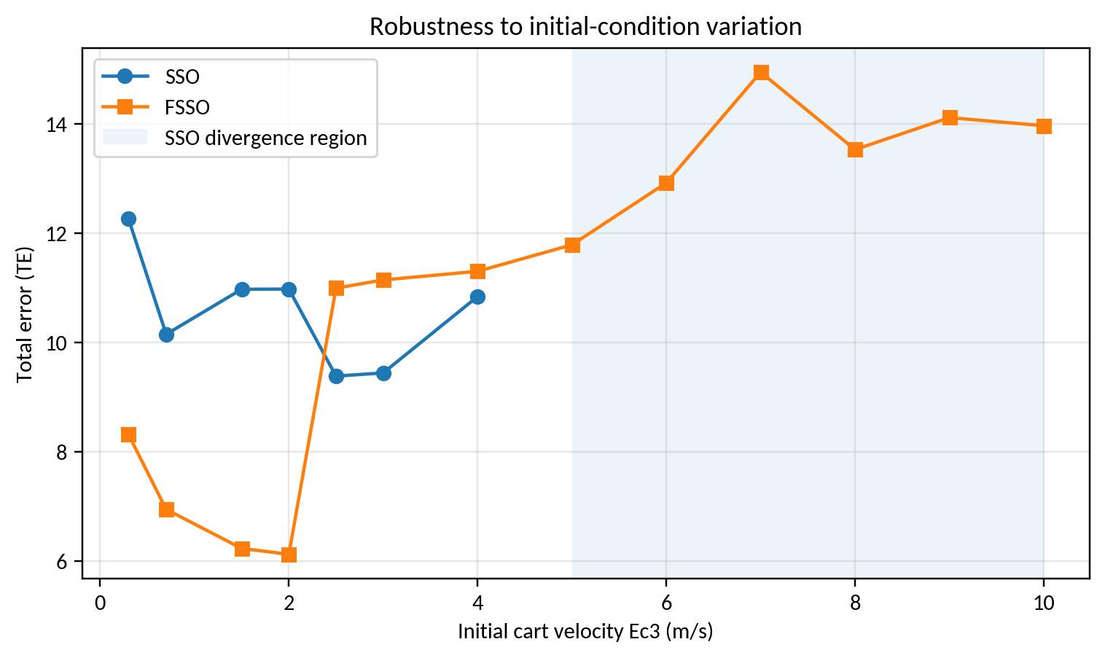
Figure 5. Initial-velocity sweep reproduced from the supplied manuscript. The source identifies SSO divergence from the tested 5 m/s case onward and finite FSSO outcomes through 10 m/s. The shaded region describes this tested sweep only.
The finite FSSO values at larger initial velocities show that its tuned controller tolerates the reported test conditions more broadly than the SSO controller. Performance is not invariant: its TE rises substantially at large perturbations. Thus, the useful observation is a wider tested feasibility range with increasing cost, rather than uniform error suppression. The boundary lies between discrete tested points and cannot be located more precisely from the supplied figure.
Neither a finite objective nor a bounded finite-horizon trajectory is a proof of asymptotic stability. Such a claim would require additional analysis, for example an appropriate Lyapunov certificate for a specified fuzzy closed-loop model [34]. A solver can also produce a finite trajectory that has not settled by the observation horizon. Failure, non-settling, constraint violation, and numerical breakdown should remain separate categories.

7 Statistical interpretation and limitations

7.1 Appropriate statistical units
The current document supports arithmetic comparisons of reported means. It does not support newly calculated paired p values or confidence intervals, because the complete paired observations and experimental design are unavailable. The prior statement that six trials are paired cannot be verified from ordering alone. Trials must share defined experimental blocks to justify a paired analysis.
With the missing data restored, choose the analysis to match the experiment. Wilcoxon signed-rank testing requires meaningful pairing and assumptions about the difference distribution [35]. Multi-task comparisons can use a Friedman-type framework with appropriate post-hoc testing, as discussed by Demšar and Derrac et al. [36, 37]. Do not use the four correlated performance metrics as though they were four independent benchmark tasks. Holm adjustment can control the declared family of pairwise comparisons [38].
Bootstrap intervals require actual sampling units [39]. Resample independent runs or physical batches, not every time sample within a trajectory. For dependent observations, a block approach such as that developed for stationary sequences is more appropriate when its assumptions are plausible [40]. Report an effect estimate and an uncertainty interval alongside any p value; a small p value does not by itself establish a practically important controller improvement.

7.2 Reproducibility and external validity
The release needed to support submission should include the exact FSSO coefficient map, original SSO and FACS configurations, fuzzy rule table, parameter bounds, objective definition, plant equations, solver configuration, seed list, and complete run matrix. Retain failed runs. Archive source data for each figure and distinguish direct observations from calculations on rounded summaries. The current manuscript provides the specification of these requirements, rather than claiming that unavailable files have been recovered.
Generalization remains limited to the supplied pendulum benchmark. Different controller structures, actuator limits, initial states, and disturbance distributions can change the ranking. Standard black-box benchmarks are useful for diagnosing search behavior, while held-out pendulum scenarios test control relevance; neither replaces the other. A hardware study is also needed before claiming practical real-time benefits, because simulated gains can disappear under sensor noise, computational delay, friction, and actuator saturation.

8 Conclusion
The reported FSSO controller-tuning results improve all four displayed mean metrics over SSO and over a separate FACS comparison. The initial-velocity sweep also reports a broader tested finite-response range. The most defensible conclusion is a promising benchmark-specific advantage, supported by transparent descriptive figures. The revised formulation distinguishes SSO from WSO, makes objective evaluation and budget accounting explicit, and supplies readable pseudocode for search, validation, ablation, and reanalysis. Independent replication still requires the original movement-policy details, simulation configuration, and complete trial records. Those records are necessary to quantify uncertainty, evaluate computational fairness, and determine whether the observed improvements extend to other plants and physical experiments.
Data and code availability. This revision uses the numerical summaries and figures contained in the supplied manuscript. It does not report a new optimization experiment or claim access to the original simulation code. Proposed validation procedures are identified in the relevant sections.

References
[1] Zadeh, L. A. (1965). Fuzzy sets. Information and Control, 8(3), 338–353. https://doi.org/10.1016/S0019-9958(65)90241-X
[2] Mamdani, E. H. (1974). Application of fuzzy algorithms for control of simple dynamic plant. Proceedings of the Institution of Electrical Engineers, 121(12), 1585. https://doi.org/10.1049/piee.1974.0328
[3] Mamdani, E. H., Assilian, S. (1975). An experiment in linguistic synthesis with a fuzzy logic controller. International Journal of Man-Machine Studies, 7(1), 1–13. https://doi.org/10.1016/S0020-7373(75)80002-2
[4] Takagi, T., Sugeno, M. (1985). Fuzzy identification of systems and its applications to modeling and control. IEEE Transactions on Systems, Man, and Cybernetics, SMC-15(1), 116–132. https://doi.org/10.1109/TSMC.1985.6313399
[5] Wang, L. X., Mendel, J. M. (1992). Generating fuzzy rules by learning from examples. IEEE Transactions on Systems, Man, and Cybernetics, 22(6), 1414–1427. https://doi.org/10.1109/21.199466
[6] Jang, J. S. R. (1993). ANFIS: adaptive-network-based fuzzy inference system. IEEE Transactions on Systems, Man, and Cybernetics, 23(3), 665–685. https://doi.org/10.1109/21.256541
[7] Lee, C. C. (1990). Fuzzy logic in control systems: fuzzy logic controller. I. IEEE Transactions on Systems, Man, and Cybernetics, 20(2), 404–418. https://doi.org/10.1109/21.52551
[8] Mendel, J. M. (1995). Fuzzy logic systems for engineering: a tutorial. Proceedings of the IEEE, 83(3), 345–377. https://doi.org/10.1109/5.364485
[9] Abedinia, O., Amjady, N., Ghasemi, A. (2016). A new metaheuristic algorithm based on shark smell optimization. Complexity, 21(5), 97–116. https://doi.org/10.1002/cplx.21634
[10] Lin, Q., Wu, S., Wu, S., Wang, H., Zhang, J. (2025). Development and simulation of two novel indoor odor source localization methods using a modified shark smell optimization algorithm. Measurement, 240, 115562. https://doi.org/10.1016/j.measurement.2024.115562
[11] Braik, M., Hammouri, A., Atwan, J., Al-Betar, M. A., Awadallah, M. A. (2022). White Shark Optimizer: A novel bio-inspired meta-heuristic algorithm for global optimization problems. Knowledge-Based Systems, 243, 108457. https://doi.org/10.1016/j.knosys.2022.108457
[12] Pathak, V. K. (2026). A comprehensive review on the white shark optimizer, its variants, statistical analysis and performance evaluation. Computer Science Review, 59, 100848. https://doi.org/10.1016/j.cosrev.2025.100848
[13] Awadallah, M. A., Braik, M., AlAkhras, L., Kassaymeh, S., Al-Betar, M. A. (2026). White Shark Optimizer and its Applications: A Systematic Review. Archives of Computational Methods in Engineering, 33(6), 7965–8033. https://doi.org/10.1007/s11831-025-10469-4
[14] El maloufy, A., Bencherqui, A., Tahiri, M. A., El Ghouate, N., Karmouni, H., Sayyouri, M., Askar, S. S., Abouhawwash, M. (2025). Chaos-enhanced white shark optimization algorithms CWSO for global optimization. Alexandria Engineering Journal, 122, 465–483. https://doi.org/10.1016/j.aej.2025.02.061
[15] El-Sattar, H. A., Kamel, S., Elseify, M. A. (2025). A modified white shark optimizer for optimizing photovoltaic, wind turbines, biomass, and hydrogen storage hybrid systems. Journal of Energy Storage, 113, 115655. https://doi.org/10.1016/j.est.2025.115655
[16] Cao, L., Li, M., Chen, K., Yue, Y., Qiu, Y., Cheng, Z. (2026). Multi-Strategy Enhanced White Shark Optimizer for Solving Job Shop Scheduling Problem. Biomimetics, 11(6), 372. https://doi.org/10.3390/biomimetics11060372
[17] García-Martínez, J. R., Rivera-Ruiz, J. R., Pérez-Juárez, J. G., Olmedo-García, L. F., Santos-Flores, Z. E. (2026). Performance comparison of Grey Wolf and white shark optimizers for the kinematic-dynamic control of differential drive mobile robots in a unity-based environment. Franklin Open, 16, 100734. https://doi.org/10.1016/j.fraope.2026.100734
[18] Chen, X., Dong, H., Shen, C., Li, H., Li, D. (2026). Optimizing interval type-2 fuzzy logic PID controller with an improved constraint differential evolution algorithm. Scientific Reports, 16(1), 10426. https://doi.org/10.1038/s41598-026-41203-0
[19] Melese, Y. L., Alitasb, G. K., Belete, M. D. (2025). Optimal fuzzy-PID controller design for object tracking. Scientific Reports, 15(1), 12064. https://doi.org/10.1038/s41598-025-92309-w
[20] Mohammed, T. K., Ezez, S. F., Siraj, A. Z., Abdissa, C. M. (2026). Adaptive fuzzy sliding mode control applied to inverted pendulum. Scientific Reports, 16(1), 14938. https://doi.org/10.1038/s41598-026-45197-7
[21] Nguyen, T. V. A., Dao, Q. T., Bui, N. T. (2024). Optimized fuzzy logic and sliding mode control for stability and disturbance rejection in rotary inverted pendulum. Scientific Reports, 14(1), 31116. https://doi.org/10.1038/s41598-024-82471-y
[22] Dao, Q. T. (2026). Uncertainty-Resilient Control of an Inverted Pendulum on a Cart Using Interval Type-2 Takagi–Sugeno Fuzzy Modeling and Subsystem LQR Control. Automation, 7(3), 92. https://doi.org/10.3390/automation7030092
[23] Rigatos, G., Cuccurullo, G., Siano, P., Abbaszadeh, M., Gao, Z., Zouari, F. (2026). Nonlinear optimal control of the planar inverted pendulum. Autonomous Intelligent Systems, 6(1), 11. https://doi.org/10.1007/s43684-026-00133-4
[24] Fahmizal, Mayub, A., Rafanah, L. F., Latifa, S. (2026). Fuzzy-PID Control for Balancing a Two-Wheeled Inverted Pendulum Robot. Journal of Fuzzy Systems and Control, 4(1), 58–64. https://doi.org/10.59247/jfsc.v4i1.390
[25] Valcarcel-Castillo, H., Amado-Garfias, J. L., Neira-Neira, K., Poma-Deza, J. E., Escobar-Aguirre, J. (2026). Fuzzy, Neural, and Neuro-Fuzzy Controllers for an Inverted Pendulum. Lecture Notes in Electrical Engineering, 271–284. https://doi.org/10.1007/978-981-95-0429-9_18
[26] Sörensen, K. (2015). Metaheuristics—the metaphor exposed. International Transactions in Operational Research, 22(1), 3–18. https://doi.org/10.1111/itor.12001
[27] LaTorre, A., Molina, D., Osaba, E., Poyatos, J., Del Ser, J., Herrera, F. (2021). A prescription of methodological guidelines for comparing bio-inspired optimization algorithms. Swarm and Evolutionary Computation, 67, 100973. https://doi.org/10.1016/j.swevo.2021.100973
[28] Deb, K. (2000). An efficient constraint handling method for genetic algorithms. Computer Methods in Applied Mechanics and Engineering, 186(2-4), 311–338. https://doi.org/10.1016/s0045-7825(99)00389-8
[29] Storn, R., Price, K. (1997). Differential Evolution – A Simple and Efficient Heuristic for global Optimization over Continuous Spaces. Journal of Global Optimization, 11(4), 341–359. https://doi.org/10.1023/a:1008202821328
[30] Kennedy, J., Eberhart, R. (1995). Particle swarm optimization. Proceedings of ICNN’95 - International Conference on Neural Networks, 4, 1942–1948. https://doi.org/10.1109/ICNN.1995.488968
[31] Hansen, N., Ostermeier, A. (2001). Completely Derandomized Self-Adaptation in Evolution Strategies. Evolutionary Computation, 9(2), 159–195. https://doi.org/10.1162/106365601750190398
[32] Ho, S. J., Li-Sun Shu, Shinn-Ying Ho (2006). Optimizing fuzzy neural networks for tuning PID controllers using an orthogonal simulated annealing algorithm OSA. IEEE Transactions on Fuzzy Systems, 14(3), 421–434. https://doi.org/10.1109/TFUZZ.2006.876985
[33] Hansen, N., Auger, A., Ros, R., Mersmann, O., Tušar, T., Brockhoff, D. (2021). COCO: a platform for comparing continuous optimizers in a black-box setting. Optimization Methods and Software, 36(1), 114–144. https://doi.org/10.1080/10556788.2020.1808977
[34] Tanaka, K., Sugeno, M. (1992). Stability analysis and design of fuzzy control systems. Fuzzy Sets and Systems, 45(2), 135–156. https://doi.org/10.1016/0165-0114(92)90113-I
[35] Wilcoxon, F. (1945). Individual comparisons by ranking methods. Biometrics Bulletin, 1(6), 80–83. https://doi.org/10.2307/3001968
[36] Demšar, J. (2006). Statistical comparisons of classifiers over multiple data sets. Journal of Machine Learning Research, 7, 1–30. https://jmlr.org/papers/v7/demsar06a.html
[37] Derrac, J., García, S., Molina, D., Herrera, F. (2011). A practical tutorial on the use of nonparametric statistical tests as a methodology for comparing evolutionary and swarm intelligence algorithms. Swarm and Evolutionary Computation, 1(1), 3–18. https://doi.org/10.1016/j.swevo.2011.02.002
[38] Holm, S. (1979). A simple sequentially rejective multiple test procedure. Scandinavian Journal of Statistics, 6(2), 65–70. https://www.jstor.org/stable/4615733
[39] Efron, B. (1979). Bootstrap Methods: Another Look at the Jackknife. The Annals of Statistics, 7(1). https://doi.org/10.1214/aos/1176344552
[40] Kunsch, H. R. (1989). The Jackknife and the Bootstrap for General Stationary Observations. The Annals of Statistics, 17(3). https://doi.org/10.1214/aos/1176347265

