Moving-Rate Fuzzy-Neural Learning for Rainfall Estimation: Method Specification and Historical Benchmark Analysis
Son-Il Kwak

Abstract
Compact fuzzy-neural models remain useful when rainfall records contain few explanatory variables and model interpretability is important. This study clarifies a moving-rate inference mechanism and examines the historical rainfall comparison reported in the source manuscript. The method represents each antecedent by a center and two widths, computes normalized input-to-center distances, and combines these distances into rule participation weights for local linear consequents. Equations, a worked example, and five algorithms specify inference, parameter learning, chronological validation, performance measurement, and evidence-aware visualization. A literature synthesis through October 2026 relates the approach to contemporary station-scale machine learning and probabilistic precipitation nowcasting without conflating their data regimes. Across 26 historical annual cases, the reported mean absolute error is 12.69 mm for moving-rate inference and 21.89 mm for the distance-type baseline; the corresponding root mean squared errors are 17.87 and 38.78 mm. These rounded summaries imply reductions of 42.0% and 53.9%, respectively. Reported computation times of 12.219 and 24.333 s imply a 1.99-fold ratio, although the timed phase and hardware are incompletely documented. New graphical comparisons expose the error–cost trade-off and explain the unusual activation geometry. Historical trajectory and parity figures are retained with their provenance. The findings establish a descriptive advantage within the reported comparison, not verified out-of-sample forecasting skill. Recovering dated predictors, original predictions, split definitions, and model settings is necessary for a reproducible forecast evaluation.
Keywords: rainfall estimation; fuzzy neural network; moving rate; Takagi–Sugeno inference; interpretable learning; temporal validation

1 Introduction

1.1 Rainfall prediction and the role of data scale
Rainfall prediction encompasses several different tasks: estimating a scalar seasonal or annual total, predicting daily station observations, and forecasting the spatial evolution of precipitation fields. These tasks differ in predictor availability, lead time, dimensionality, and the consequences of a missed extreme event. A method that fits a small annual record cannot be assumed to solve radar nowcasting, even when both studies report an error in millimeters. The prediction target and information available at forecast issue time must therefore be specified before comparing algorithms.
The recent literature emphasizes this distinction. An et al. organize precipitation nowcasting from a time-series forecasting perspective, while Li et al. review deep-learning quantitative precipitation nowcasting and its remaining challenges [1, 2]. Reviews of extreme-rainfall prediction and multimodal nowcasting further show why an evaluation must reflect rare events and the geometry of evolving precipitation fields [3, 4]. These studies provide the contemporary context for the present work, but their high-dimensional inputs and validation datasets differ substantially from the two-factor historical benchmark considered here.
Generative approaches address uncertainty and spatial plausibility. Deep generative radar nowcasting, diffusion-based nowcasting, uncertainty-aware diffusion, and conditional rectified-flow transformers offer different ways to represent precipitation evolution [5, 6, 7, 8]. At the global weather-model scale, Pangu-Weather, GraphCast, and GenCast demonstrate the importance of spatial context and, in the latter case, ensemble prediction [9, 10, 11]. Their numerical skill scores are not direct baselines for an annual scalar rainfall model. Their transferable lesson is to evaluate the correct lead time, spatial scale, and uncertainty representation.

1.2 Recent station-scale and interpretable learning research
Work published around 2026 also supports careful evaluation of smaller models. Talan studies rainfall prediction across temporal scales; Farman et al. compare machine and deep learning across climatic regimes using multiple seeds [12, 13]. Miri et al. combine feature engineering, random forests, attention-based recurrent learning, and probabilistic postprocessing, while Gandhi examines interpretable daily-precipitation forecasting [14, 15]. Together, these studies motivate explicit reporting of temporal aggregation, input information, regime dependence, and uncertainty. They do not imply that any one architecture is uniformly best.
Deployment requirements also matter. Infrastructure-oriented rainfall modeling and GMDH–firefly forecasting illustrate application-driven and compact hybrid approaches [16, 17]. Hybrid ANFIS rainfall models show the continuing relevance of fuzzy learning when antecedent structure and parameter optimization are appropriate to the available records [18]. For a small tabular dataset, useful comparisons include regularized regression, a conventional fuzzy model, random forests, and gradient-boosted trees [19, 20]. Recurrent networks such as LSTM are meaningful only when the sequence structure and amount of training information justify their complexity [21].
Table 1. Literature published around 2026 and the design questions it raises.
Direction | Representative studies | Question for this study
Temporal-scale benchmarking | Talan, 2026; Farman et al., 2026 | Is the target annual, seasonal, or daily, and are splits chronological?
Interpretable station prediction | Gandhi, 2026; Miri et al., 2026 | Which predictors are available at issue time, and how stable are their effects?
Generative nowcasting | Asperti et al., 2025; Liu et al.; Zhou et al., 2026 | Would probabilistic outputs be useful once a suitable dataset exists?
Compact hybrid learning | Pham et al., 2024; Narawi and Jawawi, 2026 | Does additional tuning improve error under an equal search budget?
Operational use | Alif et al., 2026 | Are latency, forecast horizon, and decision requirements documented?

1.3 Fuzzy reasoning and the research question
Fuzzy sets and Takagi–Sugeno rules provide a structured way to combine graded antecedents with local numerical models [22, 23]. Data-derived rules and ANFIS connect this structure to learning [24, 25]. Surveys and tutorials on fuzzy modeling emphasize that membership shapes, aggregation operators, and normalization determine the actual input–output map [26, 27]. Distance-based reasoning and the earlier moving-rate parameter-identification preprint are particularly relevant to the compatibility mechanism discussed here [28, 29]. The 2014 preprint is identified as a preprint; its rainfall experiment and baseline are not substituted for the different comparison in the attached manuscript.
This study asks whether the reported moving-rate model provides a useful error–computation trade-off on the historical comparison and whether its rule participation can be specified without ambiguity. The contribution consists of an explicit crisp-input formulation, a worked explanation of partial rule participation, a complete algorithm sequence, and a graphical analysis that separates supplied observations from calculations based on them. The literature review is current to 8 October 2026. The historical results are treated as a bounded methodological example because their forecast horizon and train–test provenance are incomplete.

2 Data, prediction target, and evidence scope

2.1 Historical annual benchmark
The supplied comparison covers 26 annual cases from 1952 to 1977 and describes two explanatory factors. It labels the comparator as Wang’s distance-type method. That label is retained as a historical baseline identifier; reproducing the baseline requires its actual equations, parameter settings, and implementation. The attachment contains aggregate metrics and raster plots, but no machine-readable table of the annual predictor values, targets, and both prediction vectors. The exact rainfall aggregation period, measurement station metadata, predictor units, and forecast issue dates must be restored from the original records.
The distinction between estimation and forecasting is central. If either explanatory factor is observed after the forecast issue date, the model is an explanatory or retrospective estimator for that target. A chronological split does not repair such information leakage. A future forecast experiment must attach an availability date to each predictor, lag any unavailable quantity, and define the horizon before model fitting. Until those details are established, the 26 cases are called historical evaluation cases rather than verified test forecasts.

2.2 Available information and unresolved details
Table 2. Evidence used in the present analysis.
Item | Status | Consequence
MAE, RMSE, MAPE, correlation, and reported accuracy | Numerical summaries supplied | Replotted and compared descriptively
Annual prediction, absolute-error, and parity plots | Supplied as images | Retained as historical visual evidence
Paired annual prediction vectors | Not supplied in reusable numerical form | No newly computed residual test or confidence interval
Train/validation/test membership and issue dates | Incomplete | Out-of-sample forecast skill is not established
Rule count, initialization, widths, and learning settings | Incomplete | Required in a replication configuration
Timing phase, machine, software, and repetitions | Incomplete | Historical time ratio only
The public moving-rate preprint discusses a related annual dataset, but reports a different baseline and different timing and accuracy values [29]. It is used to clarify the method, not to manufacture a paired data table for the present comparison. Similarly, digitizing a published plot would introduce approximation and would not recover the original data provenance. The new quantitative graphs therefore use only the explicitly reported summaries.

3 Mathematical formulation

3.1 Antecedents and local consequents
Let $x=\left(x_{1},…,x_{d}\right)$ be the normalized predictor vector and let the model contain $R$ rules. Rule $i$ has a center $b_{ij}$ and positive left and right widths $ℓ_{ij},r_{ij}$ for each input $j$. Its local consequent is
$$f_{i}\left(x\right)=c_{i0}+\sum_{j=1}^{d}{c_{ij}}x_{j}. \text{(1)}$$
The historical case has two explanatory variables, but the notation allows more. Centers and widths describe where a rule is locally relevant; consequent coefficients describe the local response. Inputs must be scaled using training-set quantities only. The fitted scaler, ordering of variables, handling of missing observations, and physical units must be stored with the model.
For crisp inputs, a bounded moving rate is specified as
$$d_{ij}\left(x_{j}\right)=\left\{\begin{matrix}min\{1,\left(b_{ij}−x_{j}\right)/ℓ_{ij}\}, & x_{j}≤b_{ij}, \\ min\{1,\left(x_{j}−b_{ij}\right)/r_{ij}\}, & x_{j}>b_{ij}.\end{matrix}\right. \text{(2)}$$
Thus $d_{ij}=0$ at the center and reaches 1 at or beyond the corresponding support boundary. Widths are constrained to remain strictly positive. Equation (2) gives an explicit triangular-support realization consistent with moving-rate reasoning; other shape families require their own declared distance formula. A fuzzy-input extension additionally needs the input fuzzy set’s center and widths and a precise compatibility kernel. That extension is not silently treated as equivalent to the crisp-input model used here.

3.2 Rule participation and normalization
Using the algebraic-product moving-rate construction, the unthresholded participation is
$$β_{i}=1−\prod_{j=1}^{d}{d_{ij}}, a_{i}=β_{i} 1\{β_{i}>τ\}, 0≤τ<1. \text{(3)}$$
$τ$ is a rule-activation threshold fixed using training/validation data. If the historical implementation used another aggregation operator, it must be recorded and evaluated as a separate variant. With S=i​ai>0, the normalized model is
$$w_{i}=\frac{a_{i}}{S}, \hat{y}=\sum_{i=1}^{R}{w_{i}}f_{i}\left(x\right). \text{(4)}$$
The weights sum to one. Adding an arbitrary constant to every positive denominator would change that property and bias the prediction toward zero. When $S$ is numerically indistinguishable from zero, the algorithm uses a declared fallback fitted on the training partition, such as a regularized linear model. The fallback rate must be reported. If nonnegative rainfall output is required, a nonnegative output mapping or truncation may be specified before validation; it must be applied consistently to all evaluations and identified as part of the model.

3.3 A worked example and an important semantic distinction
Consider two rules and two inputs. Suppose Rule 1 has moving rates $\left(0.2,1.0\right)$ and local output 100 mm, while Rule 2 has rates $\left(0.5,0.5\right)$ and local output 140 mm. With $τ=0$, their participation values are 0.80 and 0.75. Equation (4) gives $\left(0.80×100+0.75×140\right)/1.55=119.35$ mm. This is an illustrative calculation, not an observed rainfall prediction.
The same distances correspond to triangular memberships $1−d$. A conventional product conjunction would give Rule 1 the weight $\left(1−0.2\right)\left(1−1.0\right)=0$ and Rule 2 the weight 0.25. The moving-rate construction therefore permits a rule with a poor match on one variable to participate because another variable matches well. In the extreme case, one exact center match makes $β_{i}=1$ regardless of the other distances. This behavior can improve coverage, but it can also weaken the intended meaning of an “AND” antecedent. It should be tested through an ablation, not described as universally superior fuzzy reasoning.
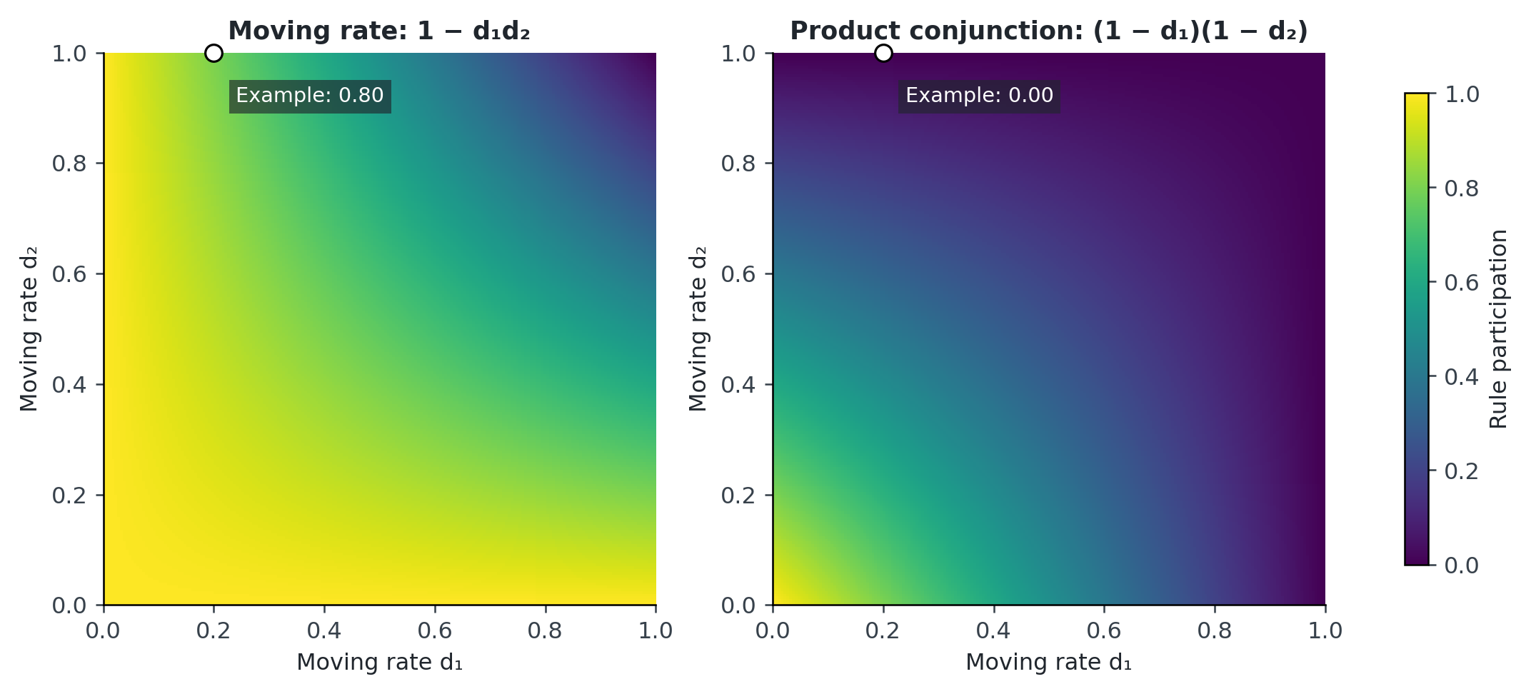
Figure 1. Analytical activation surfaces for two inputs. The left panel shows $1−d_{1}d_{2}$; the right shows $\left(1−d_{1}\right)\left(1−d_{2}\right)$. Both use the same color scale. These are mathematical illustrations, not experimental data. The moving-rate construction preserves high activation when either distance is small, whereas product conjunction requires both memberships to be appreciable.

3.4 Learning, constraints, and computational cost
For a training sample, define $e=\hat{y}−y$ and $L=e^{2}/2$. Away from activation boundaries, the consequent derivatives are
$$\frac{∂L}{∂c_{i0}}=ew_{i}, \frac{∂L}{∂c_{ij}}=ew_{i}x_{j}. \text{(5)}$$
For an active rule, the derivative through its unnormalized weight is
∂L∂βi=efi−yS, ∂βi∂dij=−q≠j​diq. (6)
The second expression should be computed as a product excluding $j$, rather than dividing the full product by $d_{ij}$, which would fail when a distance is zero. Prefix and suffix products compute these derivatives in linear time per rule. For the interior left branch, $∂d/∂b=1/ℓ$ and $∂d/∂ℓ=−\left(b−x\right)/ℓ^{2}$; for the interior right branch, $∂d/∂b=−1/r$ and $∂d/∂r=−\left(x−b\right)/r^{2}$. The clipped exterior has zero derivative almost everywhere. A fixed subgradient convention is required at the center and clipping boundaries. A hard activation threshold also creates a discontinuity at $β_{i}=τ$; gradients that ignore a threshold crossing are only piecewise valid. Training with $τ=0$ and tuning pruning afterward is one explicitly reportable option. Equations (5)–(6) describe the unconstrained output; if an output mapping is included during training, its derivative must also enter the chain rule.
Updates use the same pre-update parameter snapshot for all derivatives, then project widths to a positive lower bound and any declared upper bound. Gradient clipping, regularization, learning rates, sample order, and stopping patience are configuration parameters. A validation checkpoint protects against continuing to reduce training error while generalization worsens. Because many antecedents and consequents can fit a very short record, rule count and parameter count must be reported alongside error.
Inference takes $O\left(Rd\right)$ operations and $O\left(Rd\right)$ model storage. An epoch over $n_{train}$ observations costs $O\left(n_{train}Rd\right)$ for fixed-size rule evaluation and gradient computation; $E$ epochs cost $O\left(En_{train}Rd\right)$. This complexity estimate does not imply a fixed measured speedup over another implementation. Training time, batch prediction time, and per-sample latency require separate measurements.

4 Algorithms
The algorithms below define a reproducible crisp-input implementation and a future validation procedure. Missing historical settings remain inputs to be supplied; the pseudocode does not establish that these exact safeguards were used in the original run.
Algorithm 1. Moving-rate inference for one observation.
INPUT: x, centers b, widths left/right, coefficients c,
activation threshold tau, tolerance eps, fitted fallback
OUTPUT: prediction, rule weights, fallback flag
01 Check x is finite; apply the stored training-set scaler.
02 For each rule i:
03 For each input j:
04 Choose left width if x[j] <= b[i,j], else right width.
05 d[i,j] = min(1, abs(x[j]-b[i,j]) / chosen_width).
06 beta[i] = 1 - product over j of d[i,j].
07 a[i] = beta[i] if beta[i] > tau; otherwise a[i] = 0.
08 f[i] = c[i,0] + sum over j of c[i,j] * x[j].
09 S = sum of a[i].
10 fallback_used = (S <= eps).
11 If fallback_used:
12 prediction = fitted_fallback(x); set all rule weights to zero.
13 Else:
14 w[i] = a[i] / S for every rule.
15 prediction = sum over i of w[i] * f[i].
16 Apply the declared output constraint, if one was configured.
17 Return prediction, w, fallback_used.
Algorithm 2. Parameter learning with a retained validation checkpoint.
INPUT: chronological training and validation sets; rule count;
initialization seed; learning rates; epoch limit; patience
OUTPUT: best model, scaler, training trace, fallback model
01 Fit the scaler and fallback using training observations only.
02 Initialize antecedents and consequents within declared bounds.
03 Evaluate the initial validation loss; save this checkpoint.
04 Set epochs_without_improvement = 0.
05 For epoch = 1,...,epoch_limit:
06 For each training sample in the declared sample order:
07 Evaluate Algorithm 1 and cache the pre-update values.
08 If fallback was used: log the event; skip rule update.
09 Otherwise calculate loss and gradients, Eqs. (5)-(6).
10 Apply the specified boundary/subgradient convention.
11 Clip gradients; update all parameters from the cache.
12 Project widths and centers to their configured bounds.
13 Evaluate validation loss without changing any parameters.
14 If loss improves by the declared minimum amount:
15 Save checkpoint; reset epochs_without_improvement.
16 Else increment epochs_without_improvement.
17 Stop if patience is reached or parameters become nonfinite.
18 Restore the best finite checkpoint and return its full config.
Algorithm 3. Forecast evaluation using chronological outer splits.
INPUT: dated data, issue-time availability, forecast horizon,
predefined outer test blocks, candidate model settings
OUTPUT: locked out-of-sample predictions and evaluation manifest
01 Reject predictors unavailable at each forecast issue time.
02 For each predefined outer split in chronological order:
03 Separate past development data from the future test block.
04 Make chronological training/validation splits within past data.
05 Tune each model only on these inner splits, with equal budgets.
06 Freeze the chosen pipeline and its refitting rule.
07 Fit on permitted past data; never fit a scaler on the test block.
08 Predict the untouched test block at the declared horizon.
09 Store target, prediction, dates, split ID, and model version.
10 Check that no target is counted twice in the pooled score.
11 Compare all methods on identical eligible forecast cases.
Algorithm 4. Metrics and timing with explicit validity checks.
INPUT: targets y, predictions p, timestamps, timing protocol
OUTPUT: metrics, invalid-case report, phase-specific timing
01 Check equal lengths, aligned dates, units, and finite values.
02 residual = p - y; n = number of eligible paired cases.
03 MAE = mean(abs(residual)); RMSE = sqrt(mean(residual^2)).
04 Calculate MAPE only on the declared nonzero-target population.
05 Calculate R2 only if the target sum of squares is positive.
06 Calculate correlation only if both vectors have positive variance.
07 Report missing/excluded cases and their exclusion reasons.
08 Time training, warm-up, and prediction as separate phases.
09 Repeat timing under the same hardware/thread settings.
10 Report median timing and dispersion; retain individual timings.
Algorithm 5. Figure generation from available evidence.
INPUT: source summaries, optional paired prediction table,
supplied plot images, provenance labels
OUTPUT: figures, numeric plotting tables, claim boundaries
01 Verify every transcribed summary against its source location.
02 Plot reported means and compute relative changes from those means.
03 Label derived percentages as calculations from rounded values.
04 If the paired numeric table is available and validated:
05 Recompute annual errors, parity points, and eligible intervals.
06 Otherwise retain source plots with a reproduction caption.
07 Do not create residual values or confidence bars from summaries.
08 Save figure data, units, formulas, and source version together.

5 Evaluation design and metric definitions
For $n$ paired cases with residual $e_{t}={\hat{y}}_{t}−y_{t}$, the principal quantities are
MAE=1nt​et, RMSE=1nt​et2, R2=1−t​et2t​yt−y2. (7)
MAE represents typical absolute error in rainfall units. RMSE gives greater weight to large residuals. $R^{2}$ measures improvement relative to the evaluation-set mean in squared-error terms and can be negative. Pearson correlation measures co-variation and is insensitive to some systematic biases; it is therefore not interchangeable with $R^{2}$ or calibration. Hydrological model assessment benefits from separating correlation, variability, and bias effects [30].
MAPE is 100n−1t​et/yt only when all evaluated targets are nonzero and the averaging population is declared. Dry or near-dry periods can make percentage errors undefined or unstable. Forecast-accuracy literature therefore motivates reporting absolute-unit errors and a declared scaled error relative to an appropriate baseline as well [31]. The historical “accuracy” percentage is retained under that label because its defining equation is absent. It must not be relabeled as $100−MAPE$: the supplied values do not exactly satisfy that identity.
For future evaluation, chronological rolling-origin testing is preferable to an undocumented random division of annual records. Tashman, Bergmeir et al., and Cerqueira et al. discuss forecast evaluation and the conditions under which resampling choices are appropriate [32, 33, 34]. With only 26 annual cases, elaborate hyperparameter searches can consume most effective information. A small, predeclared search space and simple reference forecasts should precede larger model families. Comparisons must use the same available predictors and forecast horizon.
If probabilistic predictions are later added, interval coverage alone is insufficient: very wide intervals can attain high coverage without useful precision. Proper scoring rules and simultaneous reporting of calibration and sharpness provide a sounder assessment [35]. These probabilistic quantities cannot be reconstructed from the deterministic aggregate values in the current attachment.

6 Results and visual interpretation

6.1 Error levels and the size of the reported advantage
Table 3. Historical summary values and calculations from them.
Metric | Distance-type baseline | Moving-rate model | Derived comparison
MAE (mm) | 21.89 | 12.69 | 42.0% lower
RMSE (mm) | 38.78 | 17.87 | 53.9% lower
MAPE (%) | 4.77 | 2.62 | 45.1% lower
$R^{2}$ | 0.939 | 0.987 | +0.048
Pearson correlation | 0.9692 | 0.9938 | +0.0246
Reported accuracy (%) | 95.38 | 97.32 | +1.94 percentage points
Reported computation (s) | 24.333 | 12.219 | 49.8% lower; 1.99-fold ratio
The relative reduction is $100\left(M_{baseline}−M_{moving}\right)/M_{baseline}$. It is calculated separately for each metric, using rounded source values. The larger reduction in RMSE than in MAE is consistent with reduced influence of large residuals in the moving-rate summary. It does not identify which year caused the difference. The RMSE/MAE ratios are approximately 1.77 and 1.41 for the baseline and moving-rate model, respectively; these ratios describe how strongly large errors influence the aggregate squared-error measure, not a fitted residual distribution.
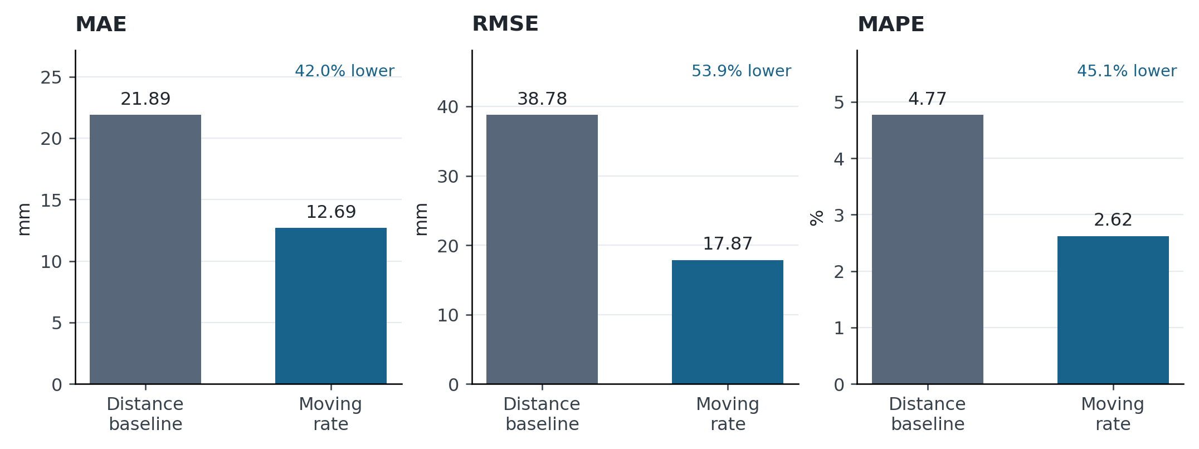
Figure 2. Reported MAE, RMSE, and MAPE with separate unit scales. Bars begin at zero and carry the supplied values. Percentage annotations are derived from the rounded summaries. No uncertainty bars are added because the paired numerical residuals are unavailable.

6.2 Temporal behavior and paired annual errors
The retained annual plot helps locate periods in which predictions track the observed historical pattern. It must be read together with an error plot: two curves can appear nearly coincident when the rainfall range is large even though their errors differ meaningfully. Neither plot supplies evidence of an independent forecast split when the split itself is undocumented.
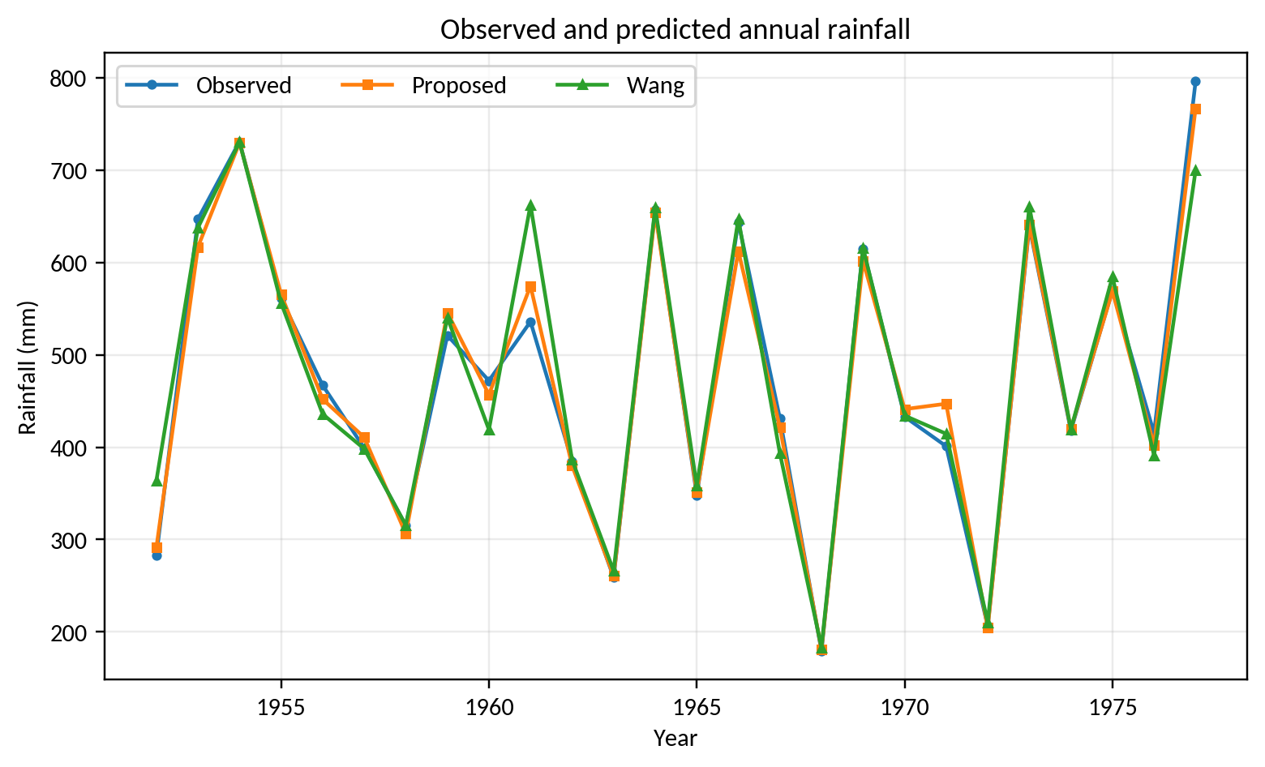
Figure 3. Historical annual observations and predictions, reproduced from the supplied manuscript. The graph covers the 26 annual cases. Its original plotted values are preserved; this revision does not reconstruct a numerical prediction vector from image pixels or certify the cases as out-of-sample forecasts.
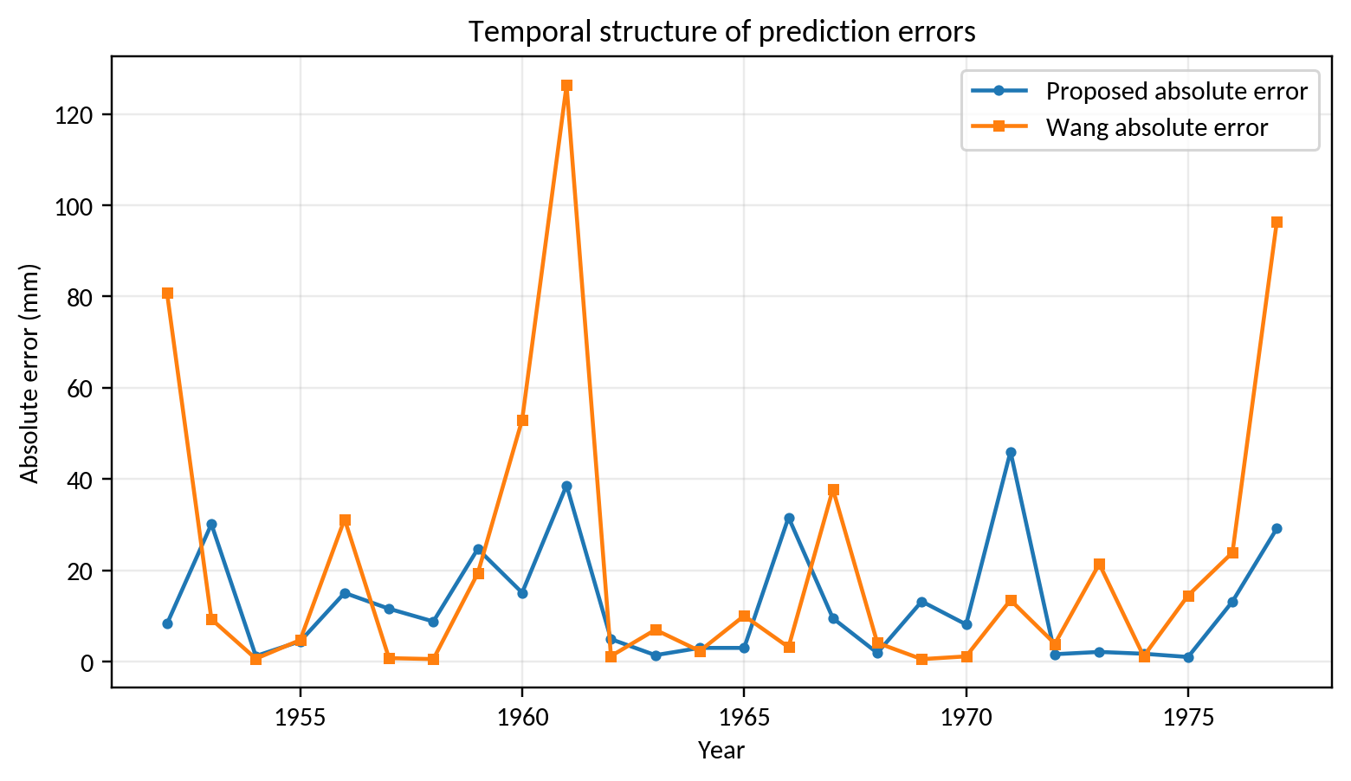
Figure 4. Annual absolute-error comparison reproduced from the supplied manuscript. The source reports lower moving-rate absolute error in 14 of 26 years. The remaining 12 cases are classified only as “not lower” because the available summary does not separate ties from baseline wins. A lower aggregate MAE can coexist with a modest case-wise win count if several large errors are reduced.

6.3 Agreement and computational cost
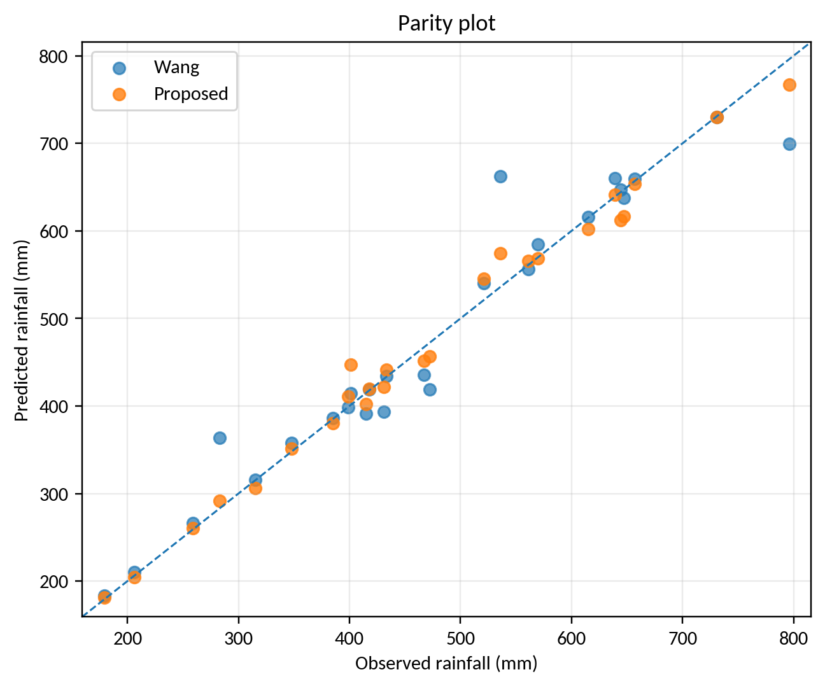
Figure 5. Observed-versus-predicted parity plot reproduced from the supplied manuscript. Proximity to the identity line supports visual agreement in this historical comparison. High correlation alone does not rule out bias, and the raster plot does not replace residual data for inference.
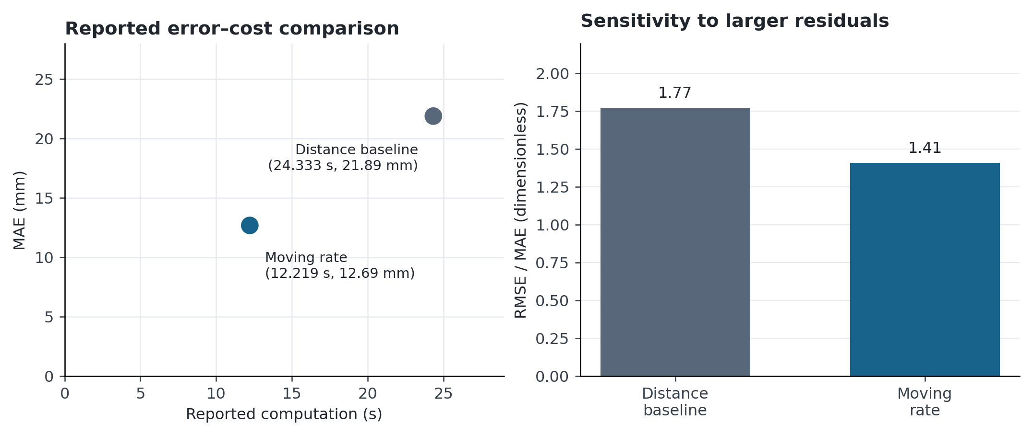
Figure 6. Reported computation versus MAE, with a complementary RMSE/MAE comparison. The left panel uses the reported aggregate time converted from milliseconds to seconds. It shows a descriptive lower-error, lower-time result for the moving-rate implementation. The right panel compares ratios calculated from the supplied errors. Neither panel establishes hardware-independent efficiency or uncertainty.
The time difference is 12.114 s, and $24.333/12.219≈1.99$. Calling this a training speedup, an inference speedup, or a real-time latency improvement would require knowing what was timed. A reproducible timing study should state processor, memory, language, library versions, thread count, initialization cost, warm-up, batch size, and repetitions. Optimization and hyperparameter-search costs must be included when comparing total model-development effort.

7 Discussion, ablation, and reproducibility

7.1 What the results support
The reported summary favors moving-rate inference in all three error measures and in its recorded computation time. The improvement is meaningful as a descriptive result for this comparison. Its practical interpretation remains conditional on predictor timing, baseline equivalence, and data separation. A high fitted correlation across 26 annual cases does not establish skill for a new station, a future climate regime, daily extremes, or short-horizon radar nowcasting.
The activation mechanism offers a plausible coverage advantage by preserving a rule when some antecedent distances are large. The same property is also a possible source of inappropriate rule participation. Interpretation should therefore show per-rule activations and local outputs for selected cases, including sparse or extreme regions of the predictor space. A rule with the highest weight is not necessarily the most important causal factor; local consequents and correlated predictors also affect the prediction.

7.2 Experiments required to isolate the mechanism
Table 4. Prospective experiments; no new outcomes are asserted.
Question | Controlled comparison | Quantities to report
Does moving-rate aggregation help? | Same antecedents and consequents; change only aggregation | MAE, RMSE, fallback frequency, rule participation
Does antecedent learning help? | Fixed versus learned centers/widths | Error, parameter count, stability across seeds
Does pruning save computation? | Predeclared thresholds with identical splits | Error, active-rule count, measured latency
Is the model forecasting? | Issue-time predictors and rolling-origin tests | Horizon-specific skill against simple references
Does it generalize by regime? | Additional stations and wet/dry regimes | Group errors and extreme-event performance
Is the time advantage repeatable? | Same machine and separately timed phases | Timing median, dispersion, search cost
For statistical comparisons, the unit of observation must be explicit. Repeated training seeds characterize optimization variability conditional on the dataset; they do not create additional independent rainfall years. A Wilcoxon signed-rank test requires the paired differences and assumptions about their distribution and independence [36]. Forecast-loss comparisons such as Diebold–Mariano require attention to serial dependence and horizon [37]. The earlier draft’s isolated test value is not carried forward as a verified result because its underlying paired residuals are unavailable.
Uncertainty estimation should respect time dependence. The bootstrap and block-bootstrap literature provides relevant starting points [38, 39], but a 26-year record may still yield unstable interval estimates. A permutation, bootstrap, or asymptotic test must specify its resampling unit and assumptions before use. Multiple planned comparisons can use Holm adjustment, while comparisons across independent datasets require an appropriate dataset-level analysis [40, 41]. No new significance claim is made from the present means.

7.3 Replication package
A complete release should include the dated raw predictor and rainfall table, metadata and units, target aggregation period, issue-time availability, chronological split indices, fitted normalization parameters, rule definitions, learned coefficients, thresholds, width constraints, seeds, and learning traces. It should also include the exact distance-type baseline implementation, every annual prediction, phase-specific timing logs, and scripts that regenerate all metrics and figures. An immutable source table and a separate derived table allow errors to be traced without changing the original observations.
The present figures have two provenance classes: new summary-based or analytical graphics, and retained historical plots. Analytical activation surfaces are explicitly identified as illustrations. The source annual images remain useful explanatory material, but numerical predictions are required before publication-quality redraws and independent statistical reanalysis can be completed.

8 Conclusion
Moving-rate fuzzy-neural inference provides a compact and interpretable mechanism for combining local rainfall models, provided its unusual rule-participation semantics are stated explicitly. On the historical summary, MAE decreases from 21.89 to 12.69 mm, RMSE from 38.78 to 17.87 mm, and recorded computation from 24.333 to 12.219 s. The revised equations, worked example, five algorithms, and six figures make these findings and their limitations easier to assess. The next scientific step is a documented, issue-time-correct temporal evaluation with recovered predictions and stronger matched baselines. The present evidence supports a promising historical comparison; it does not yet establish operational forecasting performance.
Data and code availability. The attached manuscript supplied the aggregate outcomes and reproduced plots used here. The original paired numerical predictions, learning code, and split definitions were not supplied for this revision. The prospective procedures and analytical illustrations are identified separately from historical outcomes.

References
[1] An, S., Oh, T. J., Sohn, E., Kim, D. (2025). Deep learning for precipitation nowcasting: A survey from the perspective of time series forecasting. Expert Systems with Applications, 268, 126301. https://doi.org/10.1016/j.eswa.2024.126301
[2] Li, D., Wang, J., Deng, K., Zhang, D., Zhao, C., Leng, H., et al. (2026). Review on deep learning quantitative precipitation nowcasting: Advances and challenges. Expert Systems with Applications, 305, 130775. https://doi.org/10.1016/j.eswa.2025.130775
[3] Mukhalela, B. U., Viriri, S., Ndzi, D., Gebreslasie, M., Zeeshan Shakir, M., Ramzan, N., et al. (2026). Deep learning techniques for extreme rainfall prediction: a review of state-of-the-art. Frontiers in Artificial Intelligence, 9, 1908848. https://doi.org/10.3389/frai.2026.1908848
[4] Fan, S., Fang, W., Wu, H., Li, Y. (2026). Multimodal Deep Learning in Precipitation Nowcasting: A Review from a Geometric Evolution. IETE Technical Review, 1–16. https://doi.org/10.1080/02564602.2026.2704967
[5] Ravuri, S., Lenc, K., Willson, M., Kangin, D., Lam, R., Mirowski, P., et al. (2021). Skilful precipitation nowcasting using deep generative models of radar. Nature, 597(7878), 672–677. https://doi.org/10.1038/s41586-021-03854-z
[6] Asperti, A., Merizzi, F., Paparella, A., Pedrazzi, G., Angelinelli, M., Colamonaco, S. (2025). Precipitation nowcasting with generative diffusion models. Applied Intelligence, 55(3), 187. https://doi.org/10.1007/s10489-024-06048-y
[7] Liu, J., Xu, C., Han, S., Song, L., Wang, P., Zhang, T. (2026). Uncertainty-aware precipitation nowcasting with diffusion model simulating precipitation evolution processes. Engineering Applications of Artificial Intelligence, 178, 115140. https://doi.org/10.1016/j.engappai.2026.115140
[8] Zhou, Y., Zhao, C., Ji, F., Hang, R., Liu, Q., Yuan, X. T. (2026). More realistic and accurate precipitation nowcasting with Conditional Rectified Flow Transformers. Engineering Applications of Artificial Intelligence, 165, 113402. https://doi.org/10.1016/j.engappai.2025.113402
[9] Bi, K., Xie, L., Zhang, H., Chen, X., Gu, X., Tian, Q. (2023). Accurate medium-range global weather forecasting with 3D neural networks. Nature, 619(7970), 533–538. https://doi.org/10.1038/s41586-023-06185-3
[10] Lam, R., Sanchez-Gonzalez, A., Willson, M., Wirnsberger, P., Fortunato, M., Alet, F., et al. (2023). Learning skillful medium-range global weather forecasting. Science, 382(6677), 1416–1421. https://doi.org/10.1126/science.adi2336
[11] Price, I., Sanchez-Gonzalez, A., Alet, F., Andersson, T. R., El-Kadi, A., Masters, D., et al. (2025). Probabilistic weather forecasting with machine learning. Nature, 637(8044), 84–90. https://doi.org/10.1038/s41586-024-08252-9
[12] Talan, T. (2026). Machine learning-based rainfall prediction across temporal scales: model benchmarking and explainability analysis. Stochastic Environmental Research and Risk Assessment, 40(5), 100. https://doi.org/10.1007/s00477-026-03245-8
[13] Farman, H., Hussain, M. A., Shaikh, S., Hassan, S., Hassan, S. R. (2026). Dual framework for rainfall prediction: a multi-seed machine and deep learning evaluation across Pakistan’s climatic regimes. Scientific Reports, 16(1), 20031. https://doi.org/10.1038/s41598-026-50979-0
[14] Miri, S. M., Kavianpour, M. R., Alizadeh, M. J. (2026). Delta feature and random forest–enhanced LSTM–attention forecasts with probabilistic postprocessing for rainfall forecasting. Scientific Reports, 16(1), 24208. https://doi.org/10.1038/s41598-026-54896-0
[15] Gandhi, F. (2026). Interpretable machine learning for daily precipitation forecasting: spatiotemporal dynamics and extreme event prediction in New Jersey. Hydrological Sciences Journal, 71(5), 883–902. https://doi.org/10.1080/02626667.2025.2609895
[16] Alif, H. A., Mashrafi, M. J., Haldar, U., Rahman, M. M., Miah, M. A., Uddin, M., Yousuf, S. B., Hasan, M. J. (2026). Machine learning-driven rainfall forecasting model for sustainable and adaptive infrastructure planning. Discover Sustainability, 7(1), 376. https://doi.org/10.1007/s43621-026-02699-8
[17] Narawi, A., N.A. Jawawi, D. (2026). Combining the Group Method of Data Handling with Firefly Algorithm for Rainfall Forecasting. International Journal of Innovative Computing, 16(1), 87–96. https://doi.org/10.11113/ijic.v16n1.677
[18] Pham, B. T., Bui, K. T. T., Prakash, I., Ly, H. B. (2024). Hybrid artificial intelligence models based on adaptive neuro fuzzy inference system and metaheuristic optimization algorithms for prediction of daily rainfall. Physics and Chemistry of the Earth, Parts A/B/C, 134, 103563. https://doi.org/10.1016/j.pce.2024.103563
[19] Breiman, L. (2001). Random Forests. Machine Learning, 45(1), 5–32. https://doi.org/10.1023/A:1010933404324
[20] Chen, T., Guestrin, C. (2016). XGBoost. Proceedings of the 22nd ACM SIGKDD International Conference on Knowledge Discovery and Data Mining, 785–794. https://doi.org/10.1145/2939672.2939785
[21] Hochreiter, S., Schmidhuber, J. (1997). Long Short-Term Memory. Neural Computation, 9(8), 1735–1780. https://doi.org/10.1162/neco.1997.9.8.1735
[22] Zadeh, L. A. (1965). Fuzzy sets. Information and Control, 8(3), 338–353. https://doi.org/10.1016/S0019-9958(65)90241-X
[23] Takagi, T., Sugeno, M. (1985). Fuzzy identification of systems and its applications to modeling and control. IEEE Transactions on Systems, Man, and Cybernetics, SMC-15(1), 116–132. https://doi.org/10.1109/TSMC.1985.6313399
[24] Wang, L. X., Mendel, J. M. (1992). Generating fuzzy rules by learning from examples. IEEE Transactions on Systems, Man, and Cybernetics, 22(6), 1414–1427. https://doi.org/10.1109/21.199466
[25] Jang, J. S. R. (1993). ANFIS: adaptive-network-based fuzzy inference system. IEEE Transactions on Systems, Man, and Cybernetics, 23(3), 665–685. https://doi.org/10.1109/21.256541
[26] Buckley, J. J., Hayashi, Y. (1994). Fuzzy neural networks: A survey. Fuzzy Sets and Systems, 66(1), 1–13. https://doi.org/10.1016/0165-0114(94)90297-6
[27] Mendel, J. M. (1995). Fuzzy logic systems for engineering: a tutorial. Proceedings of the IEEE, 83(3), 345–377. https://doi.org/10.1109/5.364485
[28] Kwak, S., Kim, U., Kim, K., Son, I., Ri, C. (2020). Fuzzy Reasoning Method Based on Distance Measure and Its Reductive Property. WSEAS TRANSACTIONS ON COMPUTER RESEARCH, 8, 73–89. https://doi.org/10.37394/232018.2020.8.10
[29] Ho, C. M., Gwak, S. I., Pak, S. H., & Ha, J. W. (2014). Improved parameter identification method based on moving rate. arXiv:1412.7774. Preprint. https://doi.org/10.48550/arXiv.1412.7774
[30] Gupta, H. V., Kling, H., Yilmaz, K. K., Martinez, G. F. (2009). Decomposition of the mean squared error and NSE performance criteria: Implications for improving hydrological modelling. Journal of Hydrology, 377(1-2), 80–91. https://doi.org/10.1016/j.jhydrol.2009.08.003
[31] Hyndman, R. J., Koehler, A. B. (2006). Another look at measures of forecast accuracy. International Journal of Forecasting, 22(4), 679–688. https://doi.org/10.1016/j.ijforecast.2006.03.001
[32] Tashman, L. J. (2000). Out-of-sample tests of forecasting accuracy: an analysis and review. International Journal of Forecasting, 16(4), 437–450. https://doi.org/10.1016/s0169-2070(00)00065-0
[33] Bergmeir, C., Hyndman, R. J., Koo, B. (2018). A note on the validity of cross-validation for evaluating autoregressive time series prediction. Computational Statistics & Data Analysis, 120, 70–83. https://doi.org/10.1016/j.csda.2017.11.003
[34] Cerqueira, V., Torgo, L., Mozetič, I. (2020). Evaluating time series forecasting models: an empirical study on performance estimation methods. Machine Learning, 109(11), 1997–2028. https://doi.org/10.1007/s10994-020-05910-7
[35] Gneiting, T., Raftery, A. E. (2007). Strictly Proper Scoring Rules, Prediction, and Estimation. Journal of the American Statistical Association, 102(477), 359–378. https://doi.org/10.1198/016214506000001437
[36] Wilcoxon, F. (1945). Individual comparisons by ranking methods. Biometrics Bulletin, 1(6), 80–83. https://doi.org/10.2307/3001968
[37] Diebold, F. X., Mariano, R. S. (1995). Comparing Predictive Accuracy. Journal of Business & Economic Statistics, 13(3), 253–263. https://doi.org/10.1080/07350015.1995.10524599
[38] Efron, B. (1979). Bootstrap Methods: Another Look at the Jackknife. The Annals of Statistics, 7(1). https://doi.org/10.1214/aos/1176344552
[39] Kunsch, H. R. (1989). The Jackknife and the Bootstrap for General Stationary Observations. The Annals of Statistics, 17(3). https://doi.org/10.1214/aos/1176347265
[40] Holm, S. (1979). A simple sequentially rejective multiple test procedure. Scandinavian Journal of Statistics, 6(2), 65–70. https://www.jstor.org/stable/4615733
[41] Demšar, J. (2006). Statistical comparisons of classifiers over multiple data sets. Journal of Machine Learning Research, 7, 1–30. https://jmlr.org/papers/v7/demsar06a.html

