Recursive-Factor Fuzzy Control of Vacuum Sintering Temperature: Controller Specification and Performance Trade-offs

Abstract
Vacuum sintering temperature control must accommodate thermal inertia, changing heat losses, actuator limits, and material-dependent processing requirements. This paper clarifies a recursive-factor fuzzy-control approach and reexamines its reported comparison with PID and conventional fuzzy control. The method uses a compact error–error-change rule table with repeated local refinement. A physical interpretation, dimensional scaling, explicit recursion interface, and five algorithms distinguish numerical refinement within a sampling instant from the subsequent physical furnace response. The literature review incorporates furnace modeling, adaptive fuzzy control, predictive control, and process monitoring published around 2026. Four new figures compare the supplied performance summaries and the documented recursion-depth values. Reported overshoot is 27.0% for recursive fuzzy control, compared with 52.3% for PID and 60.1% for conventional fuzzy control. The corresponding tracking-error variances are 0.49973, 0.71995, and 2.7748. Relative to PID, these summaries imply reductions of 48.4% in overshoot and 30.6% in tracking variance. The advantage is not uniform: PID has a reported steady-state error of zero and transition time of 22.34, whereas the recursive controller has an error of 0.03 and a transition time of approximately 23 in the source’s stated seconds. The reported recursion error falls to approximately 0.16 at degree 5 and 0.02 at degrees 8 and 10, with nonmonotonic behavior at low degrees. These are descriptive benchmark findings. Full controller tables, recursion maps, time-base verification, and repeated batch records remain necessary to establish reproducibility, statistical uncertainty, and production benefit.
Keywords: vacuum sintering; temperature regulation; recursive fuzzy control; scaling factors; thermal process; constrained actuation

1 Introduction

1.1 Temperature control in a spatial thermal process
Vacuum sintering quality depends on the complete temperature history experienced by a material: heating rate, dwell temperature, dwell duration, and cooling conditions. A sensor can follow a set point accurately while the load remains thermally nonuniform. Consequently, feedback tracking, spatial temperature uniformity, and final material quality are related but distinct quantities. A controller evaluation should state which quantity is measured and how it relates to the processing requirement.
Recent work makes the spatial nature of this problem explicit. Lin et al. study gradient heat shields and the temperature field of a vacuum sintering furnace, while Zhou et al. examine the influence of exhaust parameters on thermal–fluid coupling [1, 2]. Numerical studies of NdFeB vacuum sintering address gas-quenching temperature fields and temperature uniformity [3, 4]. These 2026 studies show why furnace geometry, radiation exchange, pressure, gas conditions, and load arrangement belong in the experimental description. A controller cannot compensate indefinitely for a poorly characterized thermal field or insufficient actuator authority.

1.2 Control methods and recent advances
Fuzzy control offers a compact representation of nonlinear operator knowledge. Fuzzy-set theory, early Mamdani control, and later tutorials establish the roles of linguistic partitions, inference, and scaling [5, 6, 7, 8, 9]. Takagi–Sugeno modeling, data-derived rules, and ANFIS provide complementary ways to connect fuzzy structure with numerical identification and learning [10, 11, 12]. These foundations remain relevant because a fuzzy controller is defined by its actual rule table and numerical mappings, rather than by its label alone.
Current furnace studies increasingly combine prediction, adaptation, and constraints. Dai et al. develop a hybrid self-learning model for sintering-furnace prediction and control [13]. Tian et al. and Wang et al. investigate interval type-2 fuzzy broad-learning control and predictive control for municipal-solid-waste incineration furnaces [14, 15]. Kim et al. examine fuzzy PID control for a PTFE packing sintering furnace, while Fang et al. study a recurrent fuzzy-neural controller with robust compensation for incineration temperature [16, 17]. These works are relevant to controller architecture, but their materials, heat sources, and operating conditions differ. Their reported errors should not be pooled as if they were measurements on the same plant.
Recent thermal and process-control studies also emphasize interpretable adaptation and selective updating. Feced-Más et al. describe an explicit ANFIS design framework for thermal control; Ruan et al. investigate ANFIS–fuzzy-PID temperature regulation in a coating process [18, 19]. Event-triggered fuzzy neural PID control, fuzzy adaptive PID for a lead-patenting furnace, and fractional-order PID temperature-control reviews offer additional approaches to computation and dynamics [20, 21, 22]. Earlier recurrent fuzzy predictive control and stable self-tuning industrial temperature regulation remain useful methodological references [23, 24].
Prediction and monitoring do not automatically establish closed-loop control performance. A 2026 causal variational network for rotary-kiln sintering-temperature forecasting and a causal neuro-fuzzy monitoring framework can inform diagnostics, but still require integration with a controller and validation of the resulting feedback system [25, 26]. Likewise, model-predictive-control literature emphasizes constraints, model error, and feasibility [27, 28]. These considerations apply to a lightweight table-based controller even when it avoids an online optimization problem.
Table 1. Recent literature and the corresponding validation requirement.
Research area | Representative work | Requirement for recursive fuzzy control
Vacuum thermal-field design | Lin et al.; Zhou et al.; Yang et al., 2026 | Record geometry, pressure, load, and sensor positions
Hybrid prediction and control | Dai et al., 2025 | Separate model prediction error from closed-loop tracking
Adaptive fuzzy furnace control | Tian et al.; Wang et al., 2025; Fang et al., 2026 | Report uncertainty range, disturbances, and computation
Sintering-furnace fuzzy PID | Kim et al., 2026 | Match operating requirements before comparing controllers
Transparent thermal learning | Feced-Más et al.; Ruan et al., 2026 | Publish rules, scaling, and adaptation settings
Forecasting and monitoring | Wang et al.; Ali et al., 2026 | Validate any diagnostic inside the complete feedback loop

1.3 Aim and scope
The present method pursues a narrower engineering objective: improve the resolution of a compact fuzzy lookup controller through recursive factor refinement. The useful question is whether this refinement improves the specified tracking and disturbance measures at acceptable computation and actuator cost. It is not sufficient to report a single smaller error while omitting overshoot, saturation, latency, or steady-state behavior.
This paper contributes a consistent notation for scaling and recursion, explicit pseudocode for implementation and validation, and a visual comparison of the historical metrics. The literature review is current to 8 October 2026. The numerical analysis is limited to the source summaries; no new furnace runs or material tests are asserted. Where the earlier narrative leaves the refinement map unspecified, the missing configuration is identified rather than replaced by an invented historical rule.

2 Process model and measurement definitions

2.1 Physical interpretation
A lumped heat balance provides an interpretable starting point:
$$C_{eff}\left(T\right)\frac{dT}{dt}=η\left(T\right)P\left(u\right)−Q_{rad}−Q_{cond}−Q_{gas}−Q_{load}. \text{(1)}$$
$C_{eff}$ is effective heat capacity, $P\left(u\right)$ is heater power, and the heat-loss terms represent radiation, conduction, gas-mediated transfer, and energy absorbed by the load. Equation (1) is a conceptual balance, not a fitted model of the reported apparatus. Vacuum reduces some gas-mediated transfer, but does not make radiation, structural conduction, residual gas, or deliberate gas cooling irrelevant. Temperature-dependent emissivity and changing load conditions can alter the effective dynamics during a batch.
A measured furnace temperature is also not necessarily the material-core temperature. Sensor location, calibration, response delay, and shielding must be documented. A spatial uniformity metric such as $ΔT_{space}=\max_{m}T_{m}−\min_{m}T_{m}$ across declared sensor locations should be reported separately from the feedback error at the control sensor. This distinction prevents a low control error from being interpreted automatically as uniform sintering.

2.2 Error, sampling, and normalized coordinates
At sample $k$, let $r_{k}$ be the set point, $T_{k}$ the valid control measurement, and $Δt$ the sampling interval. Define
$$e_{k}=r_{k}−T_{k}, Δe_{k}=e_{k}−e_{k−1}, E_{k}=K_{e}e_{k}, EC_{k}=K_{ec}Δe_{k}. \text{(2)}$$
Equation (2) uses a sample-to-sample difference, as in the source narrative. If an implementation uses the rate $\left(e_{k}−e_{k−1}\right)/Δt$, its scaling factor has different units and must be identified accordingly. Changing the sample interval without changing a difference-based gain can alter controller behavior. Set-point changes also appear in $Δe_{k}$; an alternative derivative-on-measurement formulation must be treated as a documented controller variant.
The linguistic labels NB, NM, Z, PM, and PB denote negative big, negative medium, zero, positive medium, and positive big. The membership breakpoints, overlap, rule outputs, interpolation or defuzzification method, and clipping range complete the numerical controller definition. The source does not provide the complete numerical table and all refinement coefficients in reusable form. They remain required replication inputs.

2.3 Incremental actuation and physical limits
Let $U_{k}$ be the final dimensionless output of the recursive inference procedure. Apply the physical output gain once:
$$Δu_{k}^{req}=K_{u}U_{k}, u_{k}^{req}=u_{k−1}^{applied}+Δu_{k}^{req}, u_{k}^{applied}=L\left(u_{k}^{req}\right). \text{(3)}$$
$L$ enforces the configured actuator range, slew limit, and plant interlocks. The next increment is referenced to the applied command, not an unattainable unsaturated request. If additional integral or adaptation states exist, they require an explicit anti-windup or state-correction mechanism. Standard anti-windup and bumpless-transfer studies provide the relevant principles [29, 30]. Double application of $K_{u}$ would change the effective controller gain and is excluded from Equation (3).
The controller’s normal output limits and the furnace’s protective functions are separate. A process engineer must define actions for invalid sensors, loss of vacuum, overtemperature, heater faults, and communication failure. A universal “hold last output” rule is inappropriate because the correct action depends on the thermal and equipment state. Independent equipment protection must remain authoritative over the numerical refinement routine.

3 Recursive-factor inference

3.1 Refinement within one control sample
The purpose of recursion is to refine a control estimate using the current information. During one sampling instant, the measured pair $\left(E_{k},EC_{k}\right)$ is held fixed. A numerical iteration does not cause a new furnace temperature measurement or demonstrate that the physical error has already decreased. Any prediction of a future error requires an explicit plant model, its time horizon, and its uncertainty.
Let $ξ_{1}$ denote the initial local coordinate representation and let $T$ be the configured table evaluator. One consistent interface is
$$U_{j}=T\left(ξ_{j};C\right), ξ_{j+1}=R\left(ξ_{j},E_{k},EC_{k},U_{j};λ_{j},C\right), \text{(4)}$$
where $C$ contains the numerical rule table and coordinate conventions, and $R$ is the local refinement map. The map must state which interval is contracted, the contraction factor, the coordinate origin, how out-of-range inputs are handled, and how the output estimate is expressed in a common normalized unit. Merely stating “shrink the universe” does not uniquely define these operations.
The interface in Equation (4) returns complete normalized output estimates $U_{j}$, so the applied estimate is the final accepted one. A different implementation may return residual corrections $q_{j}$ with explicit scales $a_{j}$, in which case U=j​ajqj. These conventions cannot be mixed: summing complete estimates would repeatedly count the same command. The source narrative contains both refinement and accumulated-correction language without a complete numerical mapping. Reproduction therefore requires the original author to identify the intended convention and provide its map. Algorithms 1–3 use the complete-estimate convention as a clearly stated implementation interface, not as a recovered historical implementation.

3.2 Stopping, deadbands, and runtime
Three different conditions can stop refinement: a maximum depth, a computation deadline, and a numerical convergence tolerance. A typical numerical test is
$$\left|U_{j}−U_{j−1}\right|≤ϵ_{U}\left(1+\left|U_{j−1}\right|\right). \text{(5)}$$
Equation (5) measures change in the numerical control estimate; it is not a test of physical closed-loop convergence. A physical error deadband must instead be selected with reference to sensor resolution, process tolerance, and acceptable steady-state behavior. Its treatment should be specified separately, including whether the command is held, reduced, or recalculated within that region.
If one table evaluation has bounded cost $C_{T}$ and maximum recursion depth is $R$, inference costs $O\left(RC_{T}\right)$ per sample with constant-size local state. For a fixed compact lookup table, this is effectively linear in depth. Initialization cost depends on the number of calibration experiments and candidate configurations; it cannot be reduced to $O\left(R\right)$ without describing those experiments. Worst-case execution time and scheduling jitter are more relevant than mean inference time when the sampling deadline is strict.

3.3 Stability and controller comparison
Smaller simulated error and a convergent internal recursion do not constitute a stability proof for the sampled furnace. A formal claim would require a plant model, operating region, disturbance bounds, actuator constraints, and an appropriate stability argument. Takagi–Sugeno stability analysis illustrates the additional structure needed for such claims [31]. The present historical summary supports empirical comparisons only.
PID should be tuned against the same engineering requirements and actuator limits as the fuzzy controllers. Model-based PID tuning principles and optimization-assisted fuzzy-neural PID design provide useful reference procedures [32, 33]. Equal requirements do not mean forcing equal energy use: energy should be measured as an outcome when efficiency is a study objective. Controller tuning must use development batches, while performance claims should use separate evaluation batches.

4 Algorithms
Algorithm 1. Configure the table, scaling, and recursion interface.
INPUT: calibrated measurements; operating ranges; sampling interval;
rule table; explicit refinement map; actuator/interlock limits
OUTPUT: versioned controller configuration C
01 Record sensor units, delays, sample interval, and signal filters.
02 Declare whether EC uses a difference or a derivative.
03 Set Ke and Kec from the declared physical and normalized ranges.
04 Load membership breakpoints, rule outputs, and table evaluator.
05 Load REFINE with coordinate origin, bounds, and contraction factors.
06 Declare its output convention: complete estimate or residual.
07 For Algorithms 2-3, require the complete-estimate convention.
08 Set Ku once at the physical actuator interface.
09 Set depth limit, numeric tolerance, deadline, and physical deadband.
10 Specify saturation, slew limits, interlock actions, and state recovery.
11 Check table boundary continuity and units before equipment use.
12 Verify direction and limits in the approved commissioning procedure.
13 Freeze C for evaluation; retain any subsequent version changes.
Algorithm 2. Recursive inference at a frozen measurement.
INPUT: fixed E, EC; complete-estimate table evaluator; REFINE;
configuration C; remaining computation time
OUTPUT: final normalized estimate U, depth, diagnostic status
01 Check that the numerical table and REFINE are fully specified.
02 xi = initial_coordinates(E, EC, C).
03 U = TABLE(xi, C); depth = 1.
04 If U is invalid: return configured failure status.
05 While depth < C.maximum_depth:
06 If the next iteration may exceed the deadline: stop.
07 xi_next = REFINE(xi, E, EC, U, C.factor[depth], C).
08 U_next = TABLE(xi_next, C), expressed in the same output unit.
09 If xi_next or U_next is invalid: stop with diagnostic flag.
10 converged = abs(U_next-U) <= C.epsU * (1+abs(U)).
11 xi = xi_next; U = U_next; depth = depth + 1.
12 If converged: stop.
13 Return U, depth, status; do not sum complete output estimates.
Algorithm 3. One closed-loop sampling cycle.
INPUT: set point r, measurement T, previous valid error,
previous applied command, configuration C
OUTPUT: applied command, updated state, cycle log
01 Validate timestamp, sensor status, vacuum, and equipment interlocks.
02 If invalid: apply the protective action; log it; end this cycle.
03 Otherwise compute e = r-T and ec = e-previous_error.
04 Apply the configured filtering and physical deadband policy.
05 Form E = Ke*e and EC = Kec*ec with declared input limits.
06 Run Algorithm 2 using the remaining time in this sample.
07 If inference fails: apply recovery action; log it; end this cycle.
08 Else request = previous_applied_command + Ku*U.
09 applied = enforce_range_slew_and_interlocks(request, C).
10 Update internal states from the applied command; prevent windup.
11 Send applied to the actuator and record acknowledgement.
12 Log r, T, e, ec, U, request, applied, depth, duration, and flags.
13 Store the current valid error for the next sampling instant.
Algorithm 4. Select recursion depth on development data.
INPUT: predefined candidate depths; development batches/scenarios;
process-error tolerance; latency limit; fixed other settings
OUTPUT: selected depth or a documented failure to meet requirements
01 For each candidate depth, use the same development scenarios.
02 Measure tracking, overshoot, settling, saturation, and cycle time.
03 Check all required tolerances and constraints for every scenario.
04 Retain depths satisfying both process and computation limits.
05 Choose the smallest acceptable depth under the declared rule.
06 If none qualifies, revise the design using development data only.
07 Freeze the selected depth before independent evaluation.
08 Do not assume error decreases monotonically with depth.
Algorithm 5. Matched comparison and traceable visualization.
INPUT: controllers, matched batch protocol, raw logs if available,
historical summary table, metric definitions
OUTPUT: performance tables, figures, uncertainty where supported
01 Match material, load, recipe, initial condition, and plant limits.
02 Tune controllers only on designated development runs.
03 Randomize or balance evaluation order when operationally feasible.
04 Record all completed, failed, interrupted, and excluded batches.
05 Compute metrics over identical declared windows and time units.
06 Use batches, not high-frequency samples, as independent replicates.
07 If raw repeats exist, estimate paired effects and valid uncertainty.
08 If only historical summaries exist, report descriptive changes only.
09 Plot separate unit scales; mark missing values instead of using zero.
10 Save numeric figure inputs and preserve the provenance of each value.

5 Experiments and metric definitions

5.1 Available benchmark
The source compares PID, conventional fuzzy control, and recursive-factor fuzzy control in step-response, tracking, and disturbance cases. It also reports error at selected recursion degrees and a production yield exceeding 98%. The attachment does not provide complete synchronized traces, batch identifiers, replicate counts, disturbance amplitudes, sampling intervals, furnace geometry, heater rating, or the full controller configuration. Consequently, the analysis below is descriptive and does not create confidence intervals from single summary values.
The transition-time unit needs particular attention. The source labels the values as seconds, including 22.34 for PID and approximately 23 for recursive fuzzy control. Without the simulator time base, sampling interval, or apparatus logs, these values should not be interpreted as demonstrated full-scale furnace heat-up durations. They are retained as source-reported benchmark times, pending author verification.

5.2 Definitions for replication
For an upward step from $r_{0}$ to $r_{1}$, percentage overshoot may be defined as $100max\left(0,T_{max}−r_{1}\right)/\left|r_{1}−r_{0}\right|$. A different normalization changes the number and must be stated. Settling or transition time requires a tolerance band and a dwell rule. A response that does not settle within the observation horizon is censored or labeled nonsettling, rather than assigned zero time.
For errors $e_{1},…,e_{N}$ within a declared phase, separate the mean error and variance:
e=1Nk​ek, se2=1N−1k​ek−e2, RMSE=1Nk​ek2. (6)
Variance measures dispersion around the mean, so a constant temperature offset can have low variance. It must therefore be interpreted with steady-state bias or RMSE. The source uses the label “error variance,” but does not fully document its centering, denominator, or physical units. Those values are preserved as reported; they are not relabeled as squared degrees Celsius or converted to RMSE. A replication should additionally report integrated absolute error, control effort, actuator saturation duration, and phase-specific energy consumption.

6 Results and graphical analysis

6.1 Raw performance levels
Table 2. Source-reported benchmark values. Variance and error units require confirmation.
Metric | PID | Conventional fuzzy | Recursive fuzzy
Overshoot (%) | 52.3 | 60.1 | 27.0
Step-response error variance | 22.8 | 22.2 | 15.6
Tracking error variance | 0.71995 | 2.7748 | 0.49973
Disturbance error variance | 30.0035 | 33.3794 | 27.5194
Steady-state error | 0 | Oscillatory: +27/−5 | 0.03
Transition time, source-reported s | 22.34 | Not reported as a settled value | Approximately 23
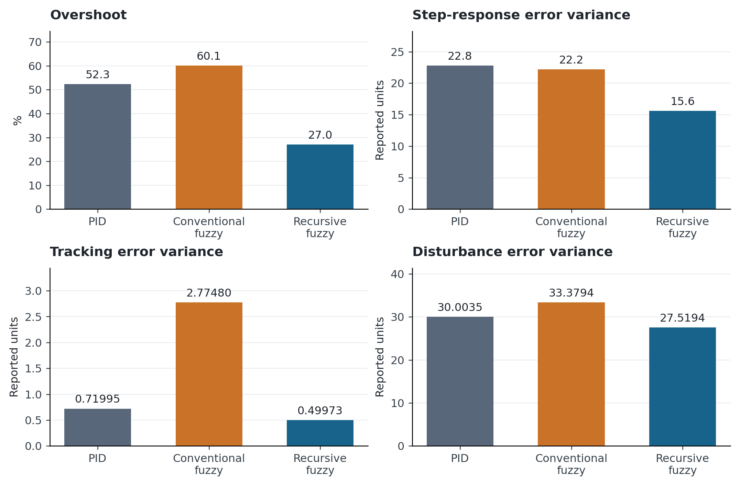
Figure 1. Four reported performance measures on separate scales. All bars begin at zero. Separating panels avoids combining percentage overshoot and three differently scaled variance quantities on one arbitrary axis. Values are source summaries; error bars are unavailable because repeated numerical runs were not supplied.
The recursive controller has the smallest reported overshoot and each of the three variance summaries. The conventional fuzzy controller’s tracking variance is markedly larger than the other two values. This suggests that the recursive modification addresses a weakness of that particular baseline configuration. It does not establish that all conventional fuzzy controllers would perform similarly, because gains, rule tables, and tuning effort influence the comparison.

6.2 Relative effects depend on the comparator
For a positive lower-is-better metric, define reduction as $100\left(M_{B}−M_{R}\right)/M_{B}$, where $B$ is the named baseline and $R$ is recursive control. The baseline must always be stated: the same recursive result produces different percentages against PID and conventional fuzzy control.
Table 3. Relative reductions calculated from the rounded summaries.
Metric | Versus PID | Versus conventional fuzzy
Overshoot | 48.4% | 55.1%
Step-response error variance | 31.6% | 29.7%
Tracking error variance | 30.6% | 82.0%
Disturbance error variance | 8.3% | 17.6%
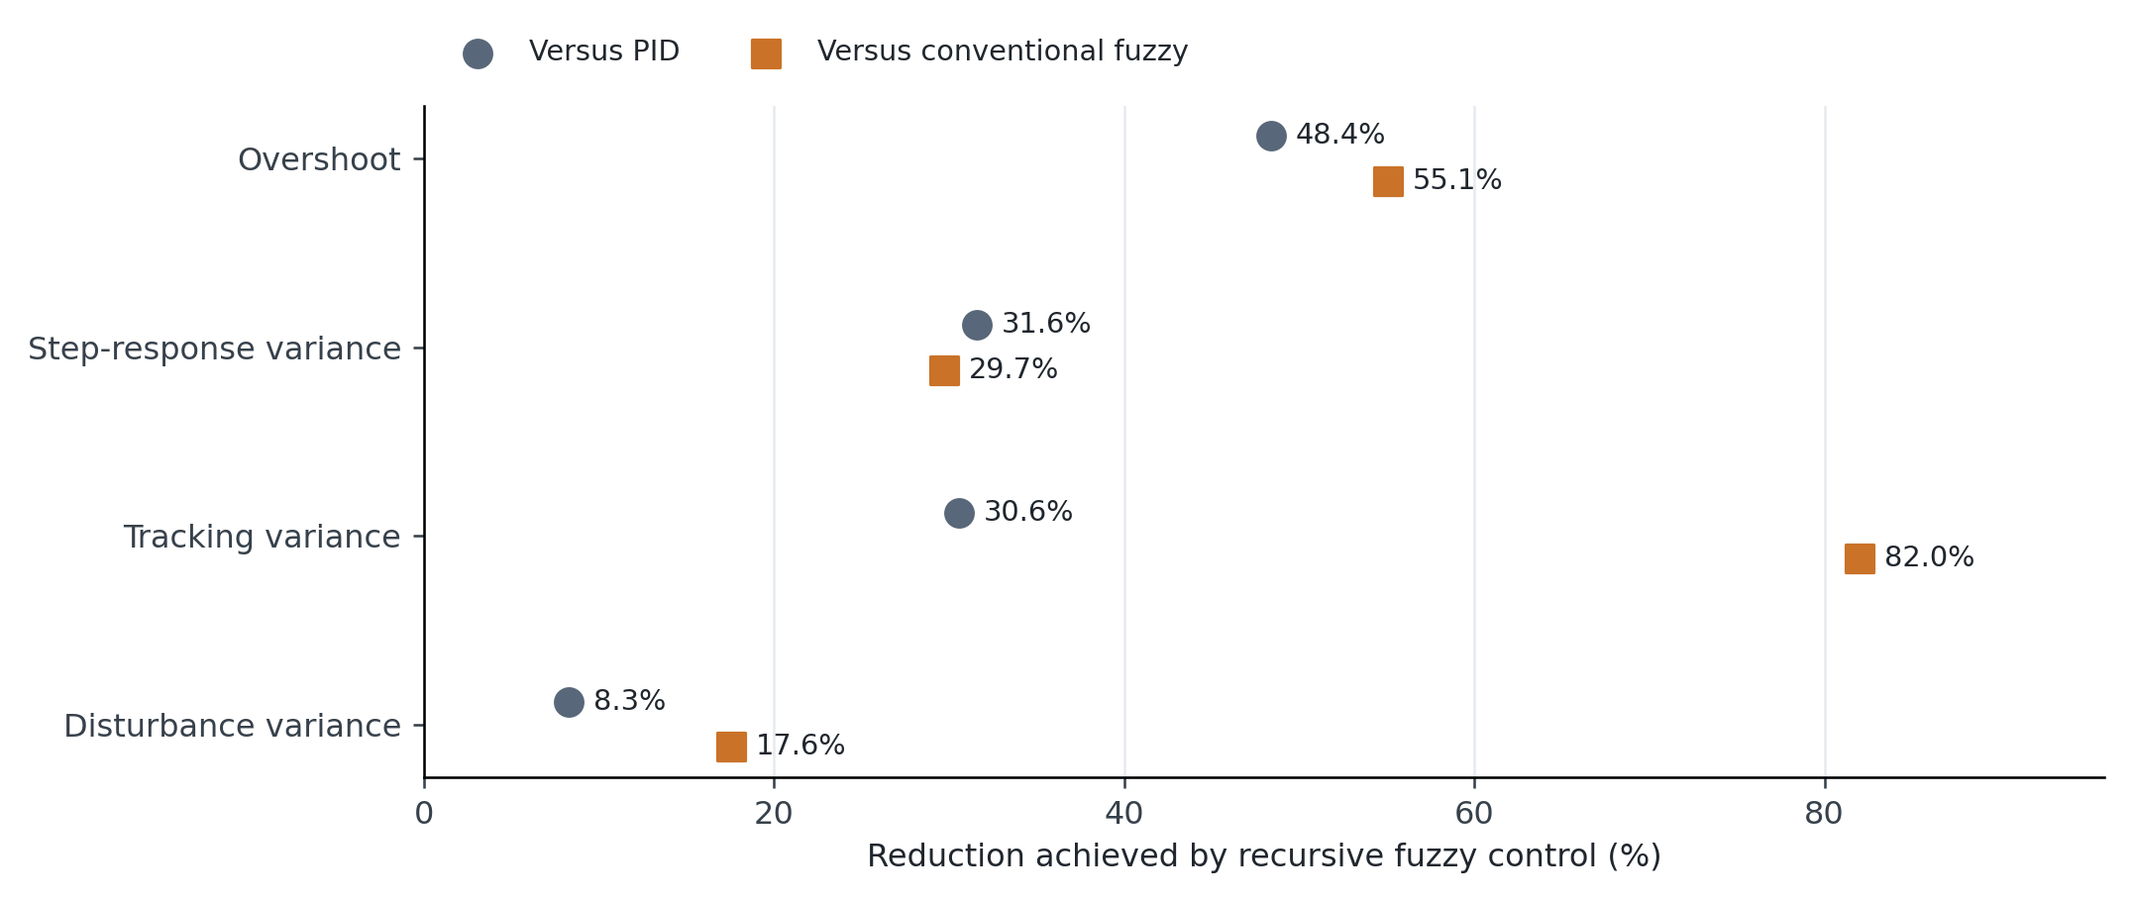
Figure 2. Descriptive reductions relative to each baseline. The modest 8.3% disturbance-variance reduction against PID contrasts with the 82.0% tracking-variance reduction against conventional fuzzy control. This graph makes the dependence on test case and comparator explicit; it is not a significance plot.
The disturbance comparison deserves a restrained interpretation. It favors the recursive summary, but the practical benefit depends on the disturbance amplitude, duration, timing, and process tolerance. A small absolute change may matter near a material-processing limit, while a larger percentage change may be irrelevant if all controllers already satisfy requirements. Those operating thresholds are absent from the historical summary.

6.3 Overshoot, transition time, and steady-state trade-offs
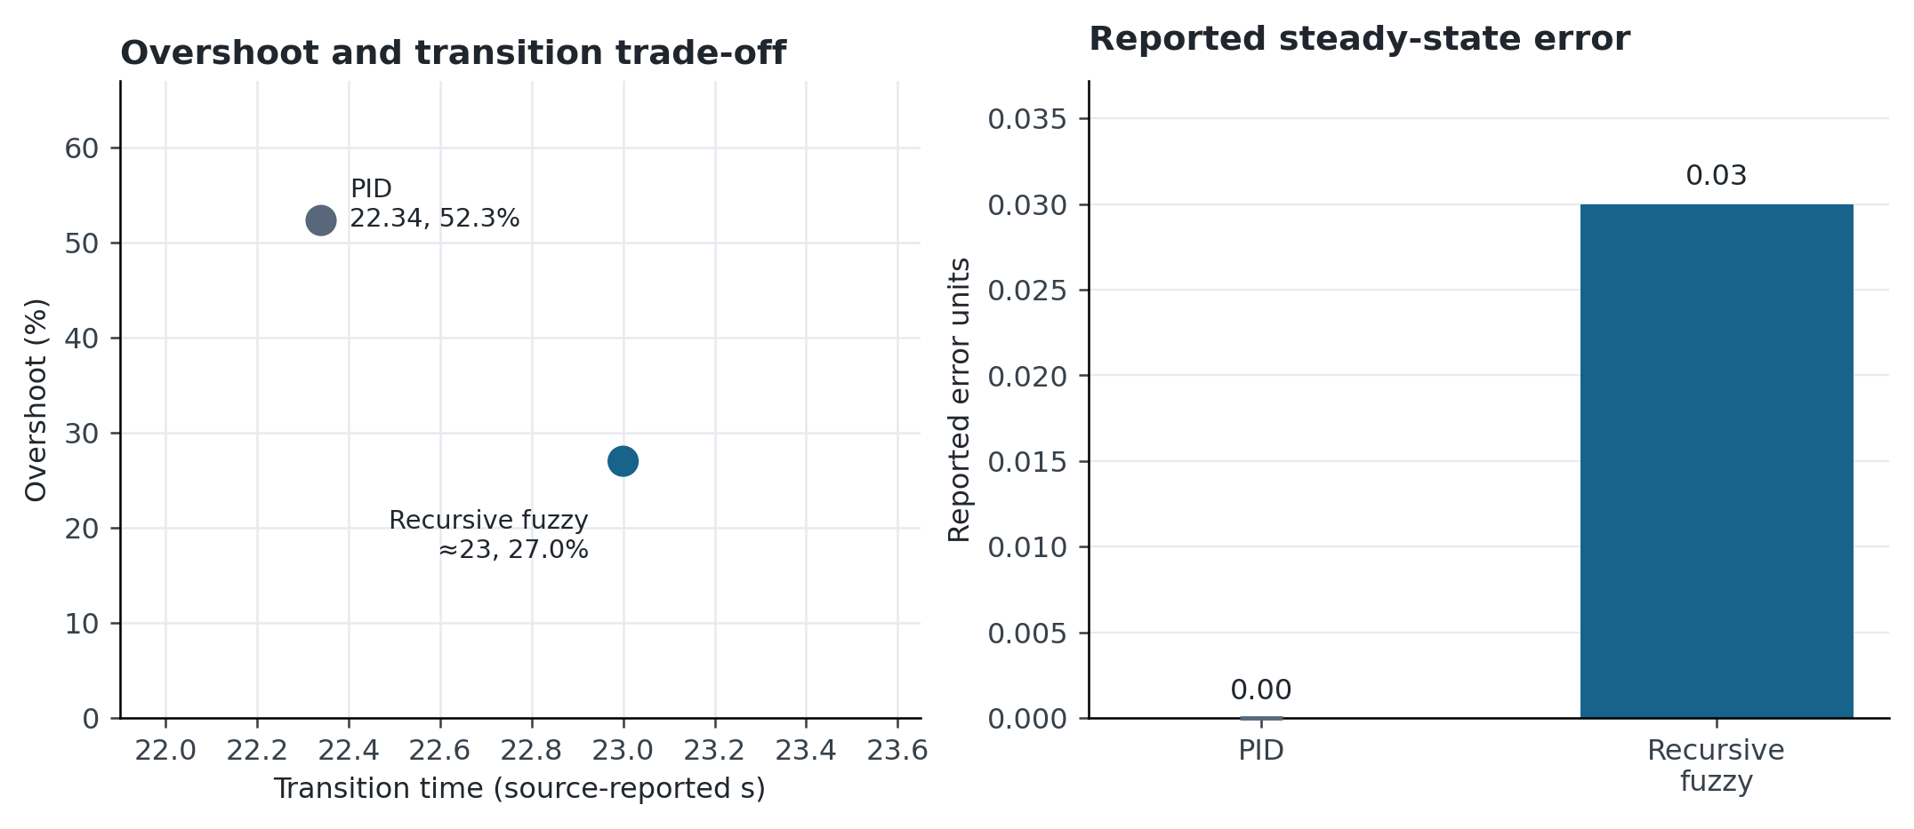
Figure 3. The recursive controller’s advantage is not uniform. The left panel plots reported overshoot against transition time for PID and recursive control; the approximate recursive time is marked accordingly. Conventional fuzzy control is omitted from that panel because a comparable settled time was not supplied. The right panel preserves the reported zero PID error and 0.03 recursive error. The source time base and error units require verification.
Using the approximate value 23, the recursive transition is about 0.66 source-reported seconds, or 3.0%, longer than PID. The source’s zero PID steady-state error is also better than 0.03 under a strict absolute-error criterion. These details qualify any claim that recursive control dominates every metric. The engineering choice depends on the acceptable overshoot, steady-state tolerance, and time requirement. Measurement resolution and rounding may affect the significance of a reported 0.03 error, but cannot be inferred from the summary alone.

6.4 Recursion depth and diminishing returns
Table 4. Recursion errors explicitly documented in the source narrative.
Degree | Reported signed error, when specified | Absolute error used in Figure 4
1 | −10 | 10
2 | +12.5 | 12.5
3 | −4.4 | 4.4
4 | +1.25 | 1.25
5 | Approximately −0.16 | Approximately 0.16
8 | Sign not specified | 0.02
10 | Sign not specified | 0.02
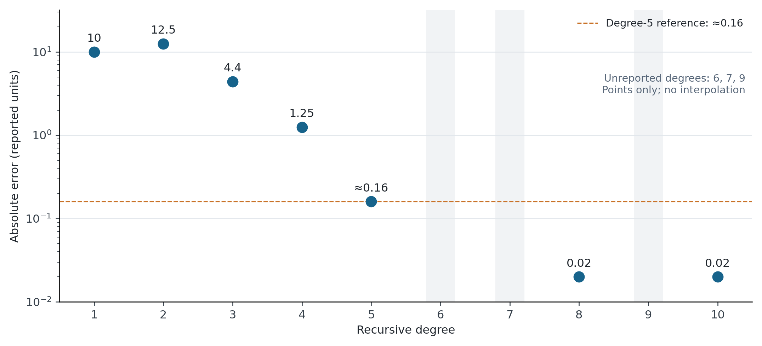
Figure 4. Documented absolute error versus recursion degree on a logarithmic vertical axis. Only the explicitly available values are plotted. Degrees 6, 7, and 9 are not interpolated or assigned synthetic observations. Error first increases from degree 1 to 2, then falls across the documented later values. The dashed 0.16 line is the source’s degree-5 reference, not an independently selected process tolerance.
Degree 5 provides a large reduction relative to the low-degree values, but it is not automatically optimal. The change from approximately 0.16 to 0.02 is an eightfold reduction in absolute error, which could matter for a sufficiently precise process. Conversely, it could be smaller than sensor noise or unnecessary under the process tolerance. Depth selection therefore requires both an accuracy threshold and a measured computation budget. The nonmonotonic initial behavior also rules out a blanket claim that every additional recursion improves the physical result.

7 Discussion and validation requirements

7.1 Production quality and external validity
The source reports a product yield above 98% after implementation. Without the number of batches, denominator definition, material specification, baseline yield, exclusion rules, and changes to the process, this is an uncontrolled production observation. It cannot establish a causal percentage-point improvement attributable to the controller. A future quality study should predefine acceptable density, porosity, dimensional change, magnetic or mechanical properties where relevant, and the inspection method. Controller performance and material acceptance should be linked at the batch level.
The reported controller comparison also cannot be generalized directly to different furnaces, load masses, pressure regimes, or temperature ranges. Radiation-dominated high-temperature operation may have different gains and delays from a lower-temperature calibration. The relevant operating envelope should be mapped using planned load and recipe variations. Sensor faults and actuator limits should be tested through appropriate simulation or controlled validation before any production trial, using the equipment’s established commissioning process.

7.2 Prospective validation matrix
Table 5. Experiments needed to strengthen the evidence. These are proposed, not completed.
Objective | Controlled design | Primary outputs
Isolate recursive refinement | Same base table and scaling; vary recursion only | Tracking, overshoot, settling, bias
Establish an operating envelope | Predefined load, recipe, and initial-condition blocks | Constraint violations and phase-specific error
Quantify real-time cost | Measure each control-cycle duration on deployment hardware | Worst-case time, jitter, deadline misses
Test actuator behavior | Same range and slew limits across controllers | Saturation duration, command variation, energy
Verify spatial quality | Calibrated multipoint sensors and matched load positions | Spatial spread and material outcomes
Estimate production benefit | Matched, independently recorded evaluation batches | Yield with denominator and uncertainty
Independent batches are the relevant replication unit for production claims. Thousands of adjacent temperature samples from one batch do not constitute thousands of independent experiments. Paired batch differences, when matching is credible, can improve interpretability. Bootstrap intervals can be useful when the resampling unit reflects the study design, while time-dependent traces require an appropriate block or model-based treatment [34, 35]. If multiple primary metrics or controller contrasts are tested, their multiplicity should be addressed with a declared procedure such as Holm adjustment [36]. No such interval or test is reconstructed from the available summaries.

7.3 Reproducibility package and remaining limitations
A reproducible release requires the full numerical rule table, membership definitions, recursive map and factors, output convention, all gains and units, sample interval, filtering, stopping criteria, controller state updates, and actuator interface. It also requires the furnace and sensor description, calibration records, set-point recipes, pressure and load histories, disturbance schedule, time-aligned raw logs, controller versions, and unsuccessful runs. The time base and definition of each reported variance must be resolved before interpreting the historical values physically.
The new figures use supplied numerical summaries or explicit arithmetic derived from them. They do not assert new experimental performance, stability, energy savings, or material improvements. This boundary preserves the useful reported comparison while making the information needed for a stronger study concrete.

8 Conclusion
Recursive-factor fuzzy control offers a potentially economical way to refine a compact fuzzy temperature controller. In the historical comparison, it reduces overshoot and three error-variance summaries, with the largest relative tracking improvement occurring against the conventional fuzzy baseline. PID retains the better reported steady-state error and slightly shorter transition time. The recursion study suggests substantial benefit by degree 5 but does not establish a universal optimum or monotonic convergence. The clarified equations, five algorithms, and four new figures expose these trade-offs and define the implementation and validation details needed for replication. Full configuration recovery, verified time units, and repeated matched batch measurements are the next requirements for a defensible production-performance claim.
Data and code availability. The numerical summaries used here come from the supplied manuscript. Complete apparatus logs, independent batch records, and the original numerical recursion implementation were not supplied for this revision. All prospective tests are identified as future work.

References
[1] Lin, M., Wang, Y. H., Zhou, M. X., Li, J. C. (2026). Effect of gradient heat shield on temperature field in vacuum sintering furnace: numerical simulations and theory. Applied Physics A, 132(8), 701. https://doi.org/10.1007/s00339-026-09867-7
[2] Zhou, M. X., Jing, L. X., Li, J. C. (2026). Effect of exhaust parameters on thermal-fluid coupling properties of large-scale vacuum sintering furnaces. International Communications in Heat and Mass Transfer, 178, 111720. https://doi.org/10.1016/j.icheatmasstransfer.2026.111720
[3] Yang, S., Zhou, L., Bi, X., Shi, X., He, D. (2026). Numerical simulation and optimization of gas quenching cooling temperature field of sintered NdFeB vacuum sintering furnace. High Temperature Materials and Processes, 45(1), 20250106. https://doi.org/10.1515/htmp-2025-0106
[4] Yang, S., Gao, T., Shi, X., He, D. (2026). Numerical simulation and analysis of temperature uniformity in vacuum sintering furnace for NdFeB sintered magnets. Modelling and Simulation in Materials Science and Engineering, 34(3), 035026. https://doi.org/10.1088/1361-651X/ae5c27
[5] Zadeh, L. A. (1965). Fuzzy sets. Information and Control, 8(3), 338–353. https://doi.org/10.1016/S0019-9958(65)90241-X
[6] Mamdani, E. H. (1974). Application of fuzzy algorithms for control of simple dynamic plant. Proceedings of the Institution of Electrical Engineers, 121(12), 1585. https://doi.org/10.1049/piee.1974.0328
[7] Mamdani, E. H., Assilian, S. (1975). An experiment in linguistic synthesis with a fuzzy logic controller. International Journal of Man-Machine Studies, 7(1), 1–13. https://doi.org/10.1016/S0020-7373(75)80002-2
[8] Lee, C. C. (1990). Fuzzy logic in control systems: fuzzy logic controller. I. IEEE Transactions on Systems, Man, and Cybernetics, 20(2), 404–418. https://doi.org/10.1109/21.52551
[9] Mendel, J. M. (1995). Fuzzy logic systems for engineering: a tutorial. Proceedings of the IEEE, 83(3), 345–377. https://doi.org/10.1109/5.364485
[10] Takagi, T., Sugeno, M. (1985). Fuzzy identification of systems and its applications to modeling and control. IEEE Transactions on Systems, Man, and Cybernetics, SMC-15(1), 116–132. https://doi.org/10.1109/TSMC.1985.6313399
[11] Wang, L. X., Mendel, J. M. (1992). Generating fuzzy rules by learning from examples. IEEE Transactions on Systems, Man, and Cybernetics, 22(6), 1414–1427. https://doi.org/10.1109/21.199466
[12] Jang, J. S. R. (1993). ANFIS: adaptive-network-based fuzzy inference system. IEEE Transactions on Systems, Man, and Cybernetics, 23(3), 665–685. https://doi.org/10.1109/21.256541
[13] Dai, Y., Chen, N., Shao, Z. (2025). Hybrid self-learning model for the prediction and control of sintering furnace temperature. Control Engineering Practice, 154, 106159. https://doi.org/10.1016/j.conengprac.2024.106159
[14] Tian, H., Tang, J., Aljerf, L., Wang, T., Qiao, J. (2025). Furnace temperature control based on interval type-2 fuzzy broad learning system for municipal solid waste incineration process. Expert Systems with Applications, 280, 127530. https://doi.org/10.1016/j.eswa.2025.127530
[15] Wang, B., Tang, J., Tian, H., Yu, W., Qiao, J. (2025). Improved Interval Type-II Fuzzy Broad MPC Method for Furnace Temperature of Municipal Solid Waste Incineration Process. IEEE Transactions on Fuzzy Systems, 33(10), 3420–3432. https://doi.org/10.1109/TFUZZ.2025.3590654
[16] Kim, J. N., Hwang, C. H., Jong, H. M., Song, C. Y., Jon, P. H. (2026). Study on the Realization of Fuzzy PID Control System for a PTFE Packing Sintering Furnace. Advances in Civil Engineering, 2026(1), 8367759. https://doi.org/10.1155/adce/8367759
[17] Fang, X., Ding, H., Qiao, J. (2026). Self-Organizing Recurrent Fuzzy Neural Network With Robust Compensation for Furnace Temperature Control in MSWI Process. IEEE Transactions on Industrial Informatics, Early access. https://doi.org/10.1109/TII.2026.3720405
[18] Feced-Más, V., Mota-Babiloni, A., Navarro-Esbrí, J., Udroiu, C. M. (2026). Novel adaptive neuro-fuzzy inference system (ANFIS) based approach for robust, precise and transparent temperature control in thermal systems guided by explicit design framework. Energy Conversion and Management, 366, 121810. https://doi.org/10.1016/j.enconman.2026.121810
[19] Ruan, C., Zhang, T., Guo, B., Yang, J., Wu, J., Zheng, L., Qiu, C., Yu, F. (2026). ANFIS-fuzzy-PID temperature control method for water-based paint roll coating of bamboo products. Scientific Reports. https://doi.org/10.1038/s41598-026-69058-5
[20] Dong, W., Wang, S., Zhang, Z. (2025). Event-triggered fuzzy neural-network PID control for nonlinear gas-blending processes. Scientific Reports, 15(1), 40309. https://doi.org/10.1038/s41598-025-23998-6
[21] Huang, J., Huang, F., Liang, J., Chen, J., Li, P. (2024). Fuzzy Adaptive PID Algorithm in Temperature Control System of Lead Patenting Furnace. Advances in Civil Engineering, 2024(1), 4519537. https://doi.org/10.1155/2024/4519537
[22] Jamil, A. A., Tu, W. F., Ali, S. W., Terriche, Y., Guerrero, J. M. (2022). Fractional-Order PID Controllers for Temperature Control: A Review. Energies, 15(10), 3800. https://doi.org/10.3390/en15103800
[23] Lu, C. H., Tsai, C. C. (2007). Generalized predictive control using recurrent fuzzy neural networks for industrial processes. Journal of Process Control, 17(1), 83–92. https://doi.org/10.1016/j.jprocont.2006.08.003
[24] Zhiqiang Gao, Trautzsch, T. A., Dawson, J. G. (2002). A stable self-tuning fuzzy logic control system for industrial temperature regulation. IEEE Transactions on Industry Applications, 38(2), 414–424. https://doi.org/10.1109/28.993163
[25] Wang, K., Chen, H., Zhang, X., Chen, Q., Cai, Y., Zhang, L. (2026). A Temporal-spatial Causal Variational Network for accurate sintering temperature forecasting in rotary kilns. Engineering Applications of Artificial Intelligence, 175, 114600. https://doi.org/10.1016/j.engappai.2026.114600
[26] Ali, H., Liu, J., Gao, F. (2026). A hybrid causal-inference and neuro-fuzzy framework for advanced process monitoring. Journal of Process Control, 162, 103724. https://doi.org/10.1016/j.jprocont.2026.103724
[27] Qin, S. J., Badgwell, T. A. (2003). A survey of industrial model predictive control technology. Control Engineering Practice, 11(7), 733–764. https://doi.org/10.1016/S0967-0661(02)00186-7
[28] Mayne, D. Q., Rawlings, J. B., Rao, C. V., Scokaert, P. O. M. (2000). Constrained model predictive control: Stability and optimality. Automatica, 36(6), 789–814. https://doi.org/10.1016/S0005-1098(99)00214-9
[29] Astrom, K. J., Rundqwist, L. (1989). Integrator Windup and How to Avoid It. 1989 American Control Conference, 1693–1698. https://doi.org/10.23919/acc.1989.4790464
[30] Kothare, M. V., Campo, P. J., Morari, M., Nett, C. N. (1994). A unified framework for the study of anti-windup designs. Automatica, 30(12), 1869–1883. https://doi.org/10.1016/0005-1098(94)90048-5
[31] Tanaka, K., Sugeno, M. (1992). Stability analysis and design of fuzzy control systems. Fuzzy Sets and Systems, 45(2), 135–156. https://doi.org/10.1016/0165-0114(92)90113-I
[32] Skogestad, S. (2003). Simple analytic rules for model reduction and PID controller tuning. Journal of Process Control, 13(4), 291–309. https://doi.org/10.1016/S0959-1524(02)00062-8
[33] Ho, S. J., Li-Sun Shu, Shinn-Ying Ho (2006). Optimizing fuzzy neural networks for tuning PID controllers using an orthogonal simulated annealing algorithm OSA. IEEE Transactions on Fuzzy Systems, 14(3), 421–434. https://doi.org/10.1109/TFUZZ.2006.876985
[34] Efron, B. (1979). Bootstrap Methods: Another Look at the Jackknife. The Annals of Statistics, 7(1). https://doi.org/10.1214/aos/1176344552
[35] Kunsch, H. R. (1989). The Jackknife and the Bootstrap for General Stationary Observations. The Annals of Statistics, 17(3). https://doi.org/10.1214/aos/1176347265
[36] Holm, S. (1979). A simple sequentially rejective multiple test procedure. Scandinavian Journal of Statistics, 6(2), 65–70. https://www.jstor.org/stable/4615733

