Movement Based Fuzzy Inference and Neuro Fuzzy Learning for Rainfall Regression

Abstract
Movement based fuzzy inference converts the displacement between an observation and a rule antecedent into normalized rule weights. Its value for rainfall modeling depends on the exact aggregation operator, the learned parameter capacity, and the separation between fitting and forecasting. This study develops the mathematical structure, learning derivatives, computational workflow, and validation requirements of a two predictor neuro fuzzy model with thirty six first order rules. The analysis makes explicit the difference between minimum and product displacement aggregation, the mapping needed to connect Gaussian memberships with finite reference widths, and the rank limitation of fitting 108 consequent coefficients from twenty six observations. Six algorithms describe inference, alternating regularized learning, distance based comparisons, temporal evaluation, residual analysis, and rule reduction. Recalculation of the reported 1952–1977 fitted values gives MAE of 12.688 mm and RMSE of 17.874 mm, compared with 21.889 and 38.784 mm for the source labeled baseline. The movement method has lower absolute error in fourteen observations and higher error in twelve. Two observations account for 64.58% of the baseline squared error, explaining much of the aggregate RMSE difference. Reported training time decreases from 24.333 to 12.219 s, while the source accuracy increases by 1.94 percentage points. These are fitted sample and reported timing results, rather than independently verified forecast skill. The expanded formulation provides a reproducible basis for investigating the inference mechanism while identifying the data definitions and temporal tests required for a defensible rainfall forecasting study.
Keywords: rainfall regression; neuro fuzzy learning; movement based inference; model identifiability; temporal validation; residual analysis

1 Introduction
Rainfall modeling supports water management and weather related decisions, but its statistical task depends on the target definition. Predicting a rainfall accumulation at a station differs from generating a spatial radar field, and a nowcast differs from a seasonal or subseasonal forecast. Location, accumulation interval, lead time, and information available at forecast issue time determine which models and evaluation procedures are appropriate.
Recent developments include generative radar nowcasting, NowcastNet, neural global weather prediction, GraphCast, probabilistic forecasting, and machine learning for subseasonal prediction [1–6]. Extreme weather modeling and climate oriented learning further emphasize uncertainty, rare outcomes, and physically meaningful evaluation [7,8]. These advances provide a contemporary context for methodological standards. They do not make a small tabular rainfall experiment directly comparable with a global or radar based forecasting system.
Fuzzy models remain relevant when a study seeks an explicit mapping between a limited number of predictors and a response. Their rules can organize nonlinear behavior into interpretable components, while learning adjusts memberships and consequent coefficients. However, linguistic labels do not guarantee interpretability when predictor meanings are unknown, and a large rule base can fit a small sample without providing useful generalization.
The method studied here uses a normalized displacement, called a movement rate in the source, to determine rule activation. The quantity is a dimensionless location relationship rather than a temporal rate or physical velocity. Each rule supplies an affine consequent, and the final output is a normalized weighted average. The stated objective is to simplify inference and learning while retaining useful nonlinear approximation.
This paper develops that mechanism in detail and reassesses its rainfall application. The theoretical contributions are an explicit operator analysis, learning derivatives, and a linear algebra account of consequent identifiability. The empirical contribution is a graphical reanalysis of the reported fitted values, including observation level reversals and the concentration of squared error. The resulting argument distinguishes the mathematical promise of the inference scheme from the evidence required to establish future rainfall prediction skill.

2 Related work and appropriate comparison tasks

2.1 Modern precipitation modeling
Multiscale feature fusion, adaptive ensemble designs, and training strategy research address the spatial and temporal organization of precipitation [9–11]. Optical flow based methods, meteorological feature integration, heterogeneous observations, and higher resolution input data illustrate how information quality affects nowcasting performance [12–15]. Attention, displacement representations, hybrid physical models, larger training domains, and three dimensional cloud information provide further architectural and data choices [16–21].
These studies share a dependence on a clearly defined target and evaluation setting. An improvement measured over a radar domain cannot be interpreted as a numerical baseline for an unidentified two factor station record. Early warning research also shows that predictive error should be connected to user requirements when the intended application is operational decision support [22].
Neuro fuzzy rainfall runoff modeling and hybrid daily rainfall prediction are closer to the tabular setting examined here [23,24]. Even so, runoff and rainfall are different targets. Reviews of precipitation nowcasting and machine learning for weather provide useful task classifications [25,26]. The present study therefore uses modern weather literature to motivate validation standards and task definition, without claiming direct superiority over those forecasting systems.

2.2 Fuzzy model structure and learning
Data informed membership initialization, fuzzy regression trees, multihead fuzzy systems, monotonic constraints, and adaptive Dombi norms provide current alternatives for controlling fuzzy representation and capacity [27–31]. Neuro fuzzy rainfall runoff work also illustrates the interaction between model structure and optimization [32]. Classical Takagi Sugeno identification, ANFIS, and example based rule learning supply the foundational model and learning context [33–35].
Movement and distance based reasoning are particularly relevant to the present inference mechanism [36,37]. They motivate deriving a rule response from an observation’s displacement relative to antecedent reference points. The details matter: complementing a minimum of displacements, complementing their product, and multiplying memberships define different functions.
The methodological question is consequently specific. Does one fully specified movement operator provide a useful error, complexity, or timing tradeoff when compared with equally specified alternatives under a common capacity and data protocol? The historical fitted table supplies preliminary evidence, while the following formulation identifies what must be fixed for that question to be answered reproducibly.

3 Rule structure and movement based inference

3.1 Affine consequents and normalized averaging
For $p$ inputs and $R$ rules, rule $i$ has the form
$$R_{i}: x_{1}\text{ is }A_{i1},…,x_{p}\text{ is }A_{ip} ⇒ f_{i}\left(x\right)=c_{i0}+\sum_{j=1}^{p}{c_{ij}}x_{j}.\text{ (1)}$$
Let $a_{i}\left(x\right)≥0$ be the rule activation and Ax=i​aix. For positive coverage,
$$ω_{i}\left(x\right)=\frac{a_{i}\left(x\right)}{A\left(x\right)}, \hat{y}\left(x\right)=\sum_{i=1}^{R}{ω_{i}}\left(x\right)f_{i}\left(x\right).\text{ (2)}$$
The output is a convex combination of the consequent values at the current input. It therefore lies between their minimum and maximum at that input. Since affine consequents can become negative or grow outside the training domain, this property does not guarantee nonnegative or physically plausible rainfall.
Input standardization should be fitted on training observations and saved with the model. Consequent coefficients depend on the chosen scale, so coefficients from differently scaled predictors should not be compared directly as measures of physical influence.

3.2 Normalized displacement
Let an antecedent have center $m_{ij}$ and positive left and right widths $w_{ij}^{L}$ and $w_{ij}^{R}$. A finite reference displacement is
$$δ_{ij}\left(x_{j}\right)=\left\{\begin{matrix}min\{1,\left(m_{ij}−x_{j}\right)/w_{ij}^{L}\}, & x_{j}<m_{ij}, \\ min\{1,\left(x_{j}−m_{ij}\right)/w_{ij}^{R}\}, & x_{j}≥m_{ij}.\end{matrix}\right.\text{ (3)}$$
The center has zero displacement, while points at or beyond either reference boundary have displacement one. Asymmetry permits different left and right spread. The widths must use the same units and scaling as the predictor.
The source writes activation in the form
$$a_{i}=1−T\left(δ_{i1},…,δ_{ip}\right).\text{ (4)}$$
The conjunction symbol does not uniquely identify $T$. Two relevant interpretations are
aimin=1−minjδij, aiprod=1−j​δij. (5)
For two displacements of 0.2 and 0.8, these activations are 0.8 and 0.84, respectively. Conventional product conjunction on complementary memberships would give $\left(1−0.2\right)\left(1−0.8\right)=0.16$. Thus, the movement variants allow a strong partial coordinate match to sustain substantial activation.
This property can broaden coverage, but can also reduce the specificity of a rule’s linguistic description. For example, a rule whose first antecedent matches exactly can be fully active even when the second antecedent is far outside its reference width. The interpretation of a rule must follow the actual operator rather than the wording of a conventional AND statement.
Algorithm 1. Evaluate movement based inference.
Inputs: scaled x, centers, positive widths, coefficients, T
For each rule:
Calculate clipped displacement in every input dimension
Apply the explicitly selected displacement operator T
Set activation to one minus the operator result
Calculate the affine consequent
If total activation is below the coverage tolerance:
Return the configured no-coverage result
Otherwise normalize activations and average consequents
Return the prediction and rule activation diagnostics
No historical prediction is regenerated by arbitrarily selecting one convention. The exact operator used in the original implementation remains a replication requirement.

3.3 Gaussian memberships and reference width mapping
The rainfall application also specifies Gaussian memberships,
$$μ_{ij}\left(x_{j}\right)=exp\left[−{\left(x_{j}−a_{ij}\right)}^{2}/b_{ij}\right], b_{ij}>0.\text{ (6)}$$
A Gaussian has no finite support endpoint. A reproducible relationship to Equation (3) therefore needs an additional convention. One possible extension selects a membership level $ϵ_{μ}∈\left(0,1\right)$ and sets
$$m_{ij}=a_{ij}, w_{ij}^{L}=w_{ij}^{R}=\sqrt{b_{ij}ln\left(1/ϵ_{μ}\right)}.\text{ (7)}$$
The reference boundaries then correspond to the chosen Gaussian level. Different levels yield different movement functions, even with identical Gaussian parameters. Equation (7) is a proposed operational mapping, not a recovered historical setting.
An alternative is to define displacement directly as $1−μ_{ij}$. This gives a different shape from clipped linear movement and should be named as a separate model. Substituting it silently would change the inference mechanism and invalidate a claim of exact reproduction.
For fuzzy input observations, the source proposes a representative input location. Its selection and the effect of input spread must be specified. Because the rainfall table contains crisp numerical factors, the present empirical conclusions do not establish performance for uncertain fuzzy inputs.

4 Learning derivatives and capacity control

4.1 Normalization derivatives
For a fixed input, normalized averaging gives
$$\frac{∂\hat{y}}{∂a_{i}}=\frac{f_{i}−\hat{y}}{A}, \frac{∂\hat{y}}{∂c_{ij}}=ω_{i}x_{j}, x_{0}=1.\text{ (8)}$$
The first derivative shows that changing one activation matters according to how its consequent differs from the current average. A large activation derivative does not necessarily imply a large prediction change when the consequents agree.
For the product displacement variant,
∂ai∂δij=−ℓ≠j​δiℓ. (9)
For the minimum variant, the derivative is minus one for the unique minimum displacement and zero for the others. At ties, a declared subgradient or smooth approximation is required. A smooth approximation changes the model and introduces another setting to validate.
Within an unclipped left branch of Equation (3),
$$\frac{∂δ}{∂m}=\frac{1}{w^{L}}, \frac{∂δ}{∂w^{L}}=−\frac{m−x}{{\left(w^{L}\right)}^{2}}.\text{ (10)}$$
Within the right branch, the center derivative is $−1/w^{R}$ and the width derivative is $−\left(x−m\right)/{\left(w^{R}\right)}^{2}$. Outside a clipped reference interval, the derivative is zero away from its boundary. Center and clipping boundaries require explicit nonsmooth conventions.
The Gaussian derivatives are
$$\frac{∂μ}{∂a}=\frac{2\left(x−a\right)}{b}μ, \frac{∂μ}{∂b}=\frac{{\left(x−a\right)}^{2}}{b^{2}}μ.\text{ (11)}$$
When Equation (7) is used, the learning chain must pass through that width mapping. Using Equation (11) alone while evaluating clipped movement in the forward pass would not differentiate the actual prediction function.

4.2 Squared loss and positive widths
For target values $y_{k}$, an explicit regularized loss is
J=12Nk​yk−yk2+λ2∥c∥22. (12)
The original record does not document a penalty, so $λ=0$ represents the historical unregularized objective. Positive $λ$ is a proposed capacity control extension requiring a separate experiment. Predictor standardization is important because a coefficient penalty depends on scale.
A log width parameterization $b=exp\left(ρ\right)$ or $w=exp\left(ρ_{w}\right)$ preserves positivity. The derivative includes the corresponding multiplicative chain factor. Numerical limits and a minimum meaningful width should be declared to prevent extremely narrow regions from producing unstable gradients.

4.3 Consequent design matrix and identifiability
For fixed antecedents, define the augmented predictor ${\tilde{x}}_{k}={\left[1,x_{k1},x_{k2}\right]}^{T}$. The design row is
$$Φ_{k}=\left[ω_{1}\left(x_{k}\right){\tilde{x}}_{k}^{T},…,ω_{R}\left(x_{k}\right){\tilde{x}}_{k}^{T}\right], \hat{y}=Φc.\text{ (13)}$$
With thirty six two input rules, $c$ contains $36\left(2+1\right)=108$ coefficients. The available rainfall table has twenty six rows, so
$$rank\left(Φ\right)≤26, dimnull\left(Φ\right)≥108−26=82.\text{ (14)}$$
This is an exact dimensional limitation conditional on fixed antecedents. Any coefficient change in the null space leaves fitted values unchanged. Hence a low fitted error cannot identify a unique set of 108 coefficients from these observations without additional restrictions.
Learning antecedents adds flexibility rather than resolving this limitation. If the six Gaussian sets on each predictor share one center and one width per set, they add twenty four stored parameters. Independent per-rule antecedents would add more. The source’s precise sharing pattern is needed for an exact effective capacity count.
For a positive penalty on all consequent coefficients, the regularized normal equations are
$$\left(Φ^{T}Φ+NλI\right)c=Φ^{T}y.\text{ (15)}$$
The matrix is positive definite for $λ>0$, giving a unique solution for the fixed antecedent problem. A numerical linear solve should be used rather than explicitly forming an inverse. The penalty can reduce variance, but its choice must be evaluated on later observations.

4.4 Alternating learning
Algorithm 2. Fit a fully specified neuro fuzzy model.
Declare the operator, width mapping and parameter sharing
Separate training, model-selection and final temporal data
Fit predictor scales using training observations
Initialize centers and positive widths
For each learning epoch:
Calculate training activations and the design matrix
Fit consequent coefficients with the declared penalty
Calculate antecedent gradients through the full forward model
Update antecedent parameters within their numerical bounds
Evaluate later model-selection observations without updating
Save the best configuration and apply a patience rule
Return the selected model and every inference convention
The alternating regularized form is a proposed reproducible implementation, rather than an assertion that it generated the reported historical values. The original learning scripts are required to determine the exact optimizer, initialization, stopping criterion, and operator convention.

4.5 Reducing rules and reporting effective complexity
A rule with very small activation mass over training data may contribute little to supported predictions. However, deleting it can affect extrapolation or a small but important region. Pruning should therefore evaluate both validation error and coverage.
Algorithm 3. Reduce a rule base under a declared capacity budget.
Fit a candidate model using training observations only
Calculate each rule's training activation mass
Rank possible removals or merges by a declared criterion
For each proposed reduction:
Refit the affected coefficients on training observations
Check coverage and model-selection error
Accept only if the declared error and capacity limits hold
Stop at the chosen budget or when no reduction is acceptable
Freeze the final structure before test evaluation
Rule count, stored parameters, design matrix rank, and effective degrees of freedom describe different aspects of complexity. For fixed antecedents and a full ridge penalty, a useful effective dimension is the trace of the fitted linear smoother. It cannot exceed the rank of $Φ$. Reporting this quantity alongside the nominal 108 coefficients would clarify how strongly a regularized fit actually uses its capacity.

5 Distance based comparisons and computational cost

5.1 Distance weighting
A generic distance based predictor assigns a positive distance $D_{i}$ to each antecedent. Some formulations use products of all distances except the current one:
qi=ℓ≠i​Dℓ, qij​qj=Di−1j​Dj−1 when every Di>0. (16)
The equivalence follows by dividing numerator and denominator by the common product of all distances. A nested product implementation is therefore not necessary. Zero distances require a special exact-match policy, such as averaging the consequents of all zero-distance rules.
Algorithm 4. Evaluate distance and set-distance comparators.
Calculate the declared antecedent distance for every rule
If any distances are zero:
Average the consequents of the exact-match rules
Otherwise normalize inverse distances and average consequents
For a finite point-set Hausdorff comparison:
Find each point's nearest distance to the other set
Take the largest directed distance in each direction
Return the larger of those two directed distances
Record the support grid, scaling and set representation
Hausdorff distance depends on the embedding of a fuzzy set, the support discretization, and the underlying point distance. A direct comparison of two grids can be much more costly than evaluating a center and width, but the cost depends on implementation and any available structure.

5.2 Fair timing interpretation
Movement inference with $R$ rules and $p$ inputs requires work proportional to $Rp$, apart from interval or membership evaluation details. An efficient inverse-distance implementation can have the same order. Training adds gradient calculations, epochs, matrix solves, or optimization steps. Lower training time in one experiment therefore does not establish an asymptotic inference advantage.
A timing comparison should report processor, software, numeric precision, initialization, stopping tolerance, objective calls, and repeated elapsed times. Preprocessing and data transfer should either be included for all methods or reported separately. Training time and per-observation inference latency answer different implementation questions.
The source calls its comparator Wang’s method, but its bibliography combines example based rule generation with distance based inference. The empirical results are therefore retained under the label “source baseline.” Its exact published identity and implementation must be resolved before a direct algorithm superiority claim is made.

6 Data and evaluation protocol

6.1 Available observations
The data consist of twenty six year indexed observations from 1952 through 1977. Each row contains two numerical factors and a rainfall quantity in millimeters. The location, measurement source, accumulation interval, predictor meanings, forecast issue time, and lead time are not provided. The years are valid row identifiers, but they do not prove that the target is an annual total.
The observed rainfall values range from 179 to 796 mm, with sample mean 474.154 mm. This describes the available table only. The unidentified target interval prevents assigning these values to a particular meteorological accumulation scale.
The source labels the observations as training data and subsequently reports fitted values for the same years. An independent chronological test is not documented. All metrics calculated from those values are consequently treated as fitted sample metrics.

6.2 Temporal evaluation for a new experiment
A forecast must use information available before the target is observed. A predictor that summarizes conditions occurring during or after the target interval can create leakage even if the model is evaluated on different rows. Data availability times are therefore as important as the chronological order.
Algorithm 5. Conduct a temporal forecasting evaluation.
Define location, target interval, lead time and issue time
Verify that every predictor is available at issue time
Reserve a final chronological test period before tuning
Within earlier observations, create rolling-origin splits
For each candidate model and each split:
Fit scaling, rules and coefficients using earlier data only
Predict the later validation observations
Record errors, coverage, complexity and measured runtime
Select settings using only rolling validation performance
Evaluate the frozen model once on the final test period
Compare with climatology, persistence and regularized regression
This protocol requires new fitting. Existing fitted values cannot be relabeled as test predictions by placing their rows in a later year group after training has already used them.
With only twenty six observations, any temporal split leaves little information for both fitting and evaluation. Expanding the observation record and establishing predictor provenance are therefore more valuable than adding many model variants to the same small validation set. Uncertainty estimates must reflect serial dependence and the small number of independent forecast cases.

7 Fitted sample results and visual diagnostics

7.1 Observed values and fitted series
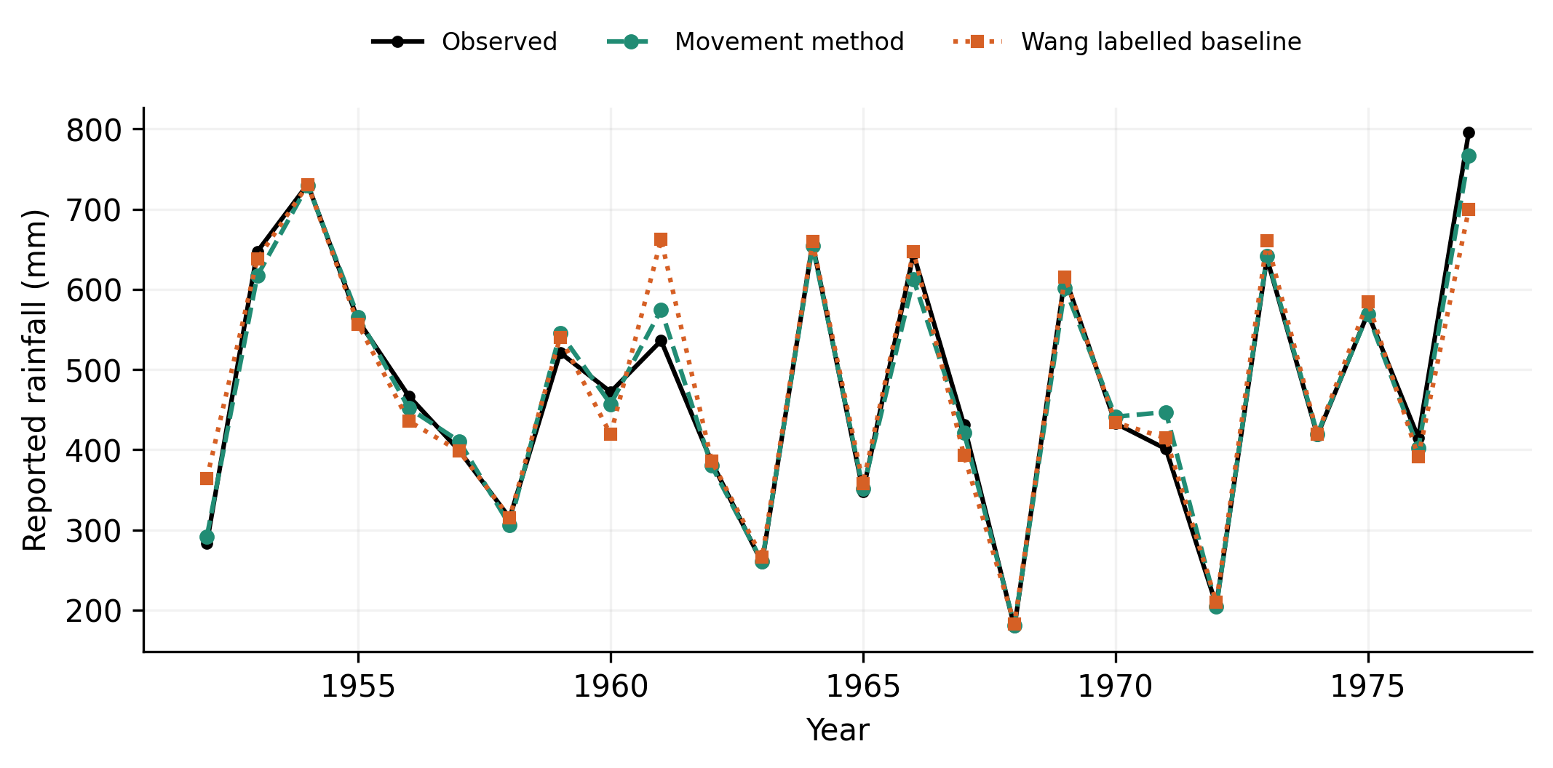
Figure 1. Rainfall observations and source fitted values for 1952–1977. The lines connect year indexed records; they are not independently held out forecast trajectories.
Both models reproduce much of the variation in the table. The movement model appears closer at several large baseline deviations, but visual agreement over twenty six fitted points must be interpreted alongside the 108 consequent coefficients. A flexible model’s ability to represent the data is different from its ability to forecast a later observation.
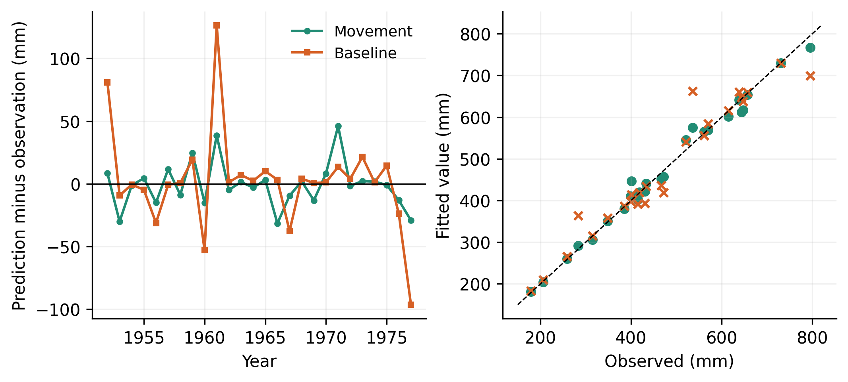
Figure 2. Signed residuals and observed versus fitted values. The residual is fitted value minus observation. Exact agreement lies on the diagonal in the scatter panels.
The movement method has smaller absolute error in fourteen rows; the baseline has smaller error in twelve, with no ties. Thus, the improvement in aggregate error does not mean that the method wins on nearly every observation. In 1953, for example, the movement residual is −30.15 mm and the baseline residual is −9.31 mm.

7.2 Metric definitions and recalculation
For residual $e_{k}={\hat{y}}_{k}−y_{k}$,
MAE=1Nk​ek, RMSE=1Nk​ek2, Bias=1Nk​ek. (17)
The percentage and variance based measures are
MAPE=100Nk​ekyk, R2=1−k​ek2k​yk−y2. (18)
All observed targets are positive in this table, so MAPE is calculable. A broader rainfall dataset with zero or near-zero accumulations would require careful treatment because percentage errors can become undefined or dominated by small denominators.
Table 1. Recomputed fitted sample metrics.
Metric | Source baseline | Movement method
MAE mm | 21.889 | 12.688
RMSE mm | 38.784 | 17.874
Bias mm | 2.052 | −0.983
MAPE percent | 4.770 | 2.618
Centered R squared | 0.93925 | 0.98710
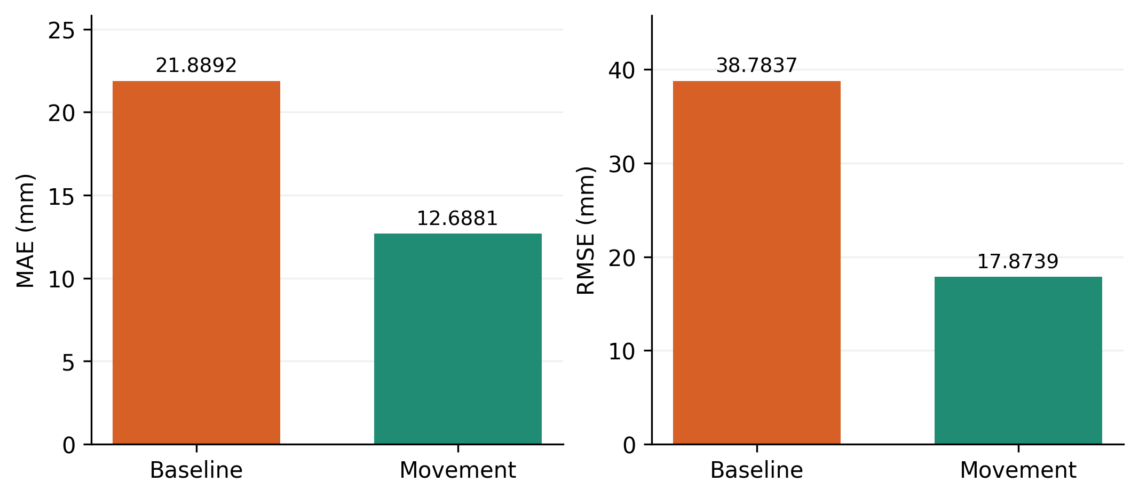
Figure 3. Recomputed MAE and RMSE from the tabulated values. The relative reductions are approximately 42.0% and 53.9%, respectively.
RMSE exceeds MAE for both methods, indicating that larger errors contribute more strongly under the squared loss. The movement model’s small negative mean residual does not establish an absence of bias across rainfall regimes because positive and negative errors can cancel.
For context, a constant fitted mean of 474.154 mm gives MAE of approximately 130.870 mm and RMSE of 157.356 mm on these same observations. Both fuzzy models represent the fitted variation much better than that constant. This is an in-sample descriptive comparison, since the constant itself uses the full sample mean.

7.3 Concentration of squared error
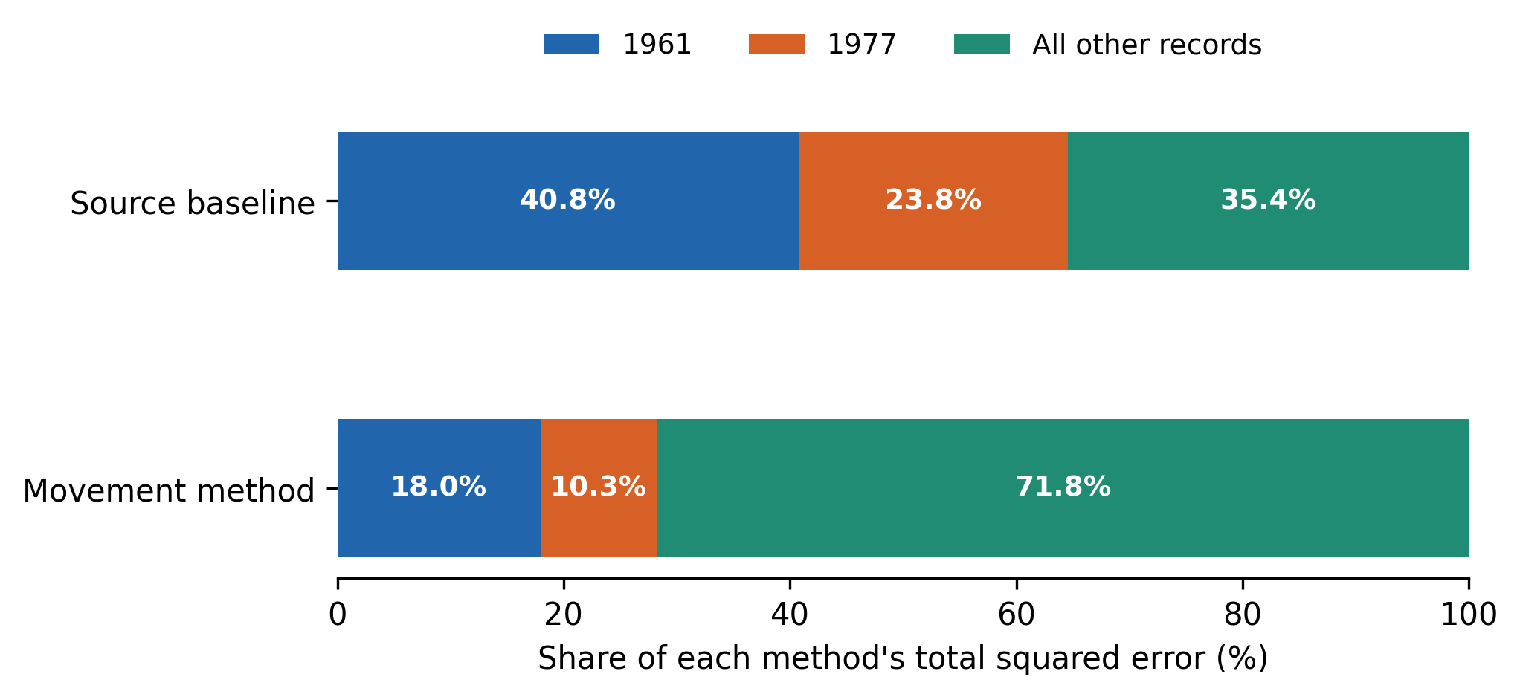
Figure 4. Shares of each method’s total fitted squared error attributable to 1961, 1977, and all other observations. These shares are calculated from the reported fitted values without refitting either model.
The baseline residuals in 1961 and 1977 are 126.29 and −96.47 mm. Their squared errors account for approximately 40.78% and 23.80% of the baseline total, or 64.58% together. The movement residuals for those rows are 38.64 and −29.20 mm.
This concentration explains how a method that wins in fourteen of twenty six rows can achieve a much larger RMSE reduction. Much of the advantage comes from reducing a few particularly large baseline deviations. That can be valuable, but its interpretation differs from a uniform improvement across the sample.
These calculations are influence diagnostics for the reported error summary. They are not leave-one-out cross validation because neither model is refitted after deleting a row. Removing difficult observations from the main metric would also conceal a material part of model behavior.
Algorithm 6. Audit the complete set of fitted residuals.
Read observations and both reported fitted series
Calculate signed, absolute and squared residuals
Recompute aggregate metrics from the same complete rows
Count wins, losses and ties in absolute error
Calculate each observation's share of total squared error
Inspect large errors alongside original predictor values
Retain all rows in the primary comparison
Label any deletion analysis as a diagnostic without refitting

7.4 Reported training time and source accuracy
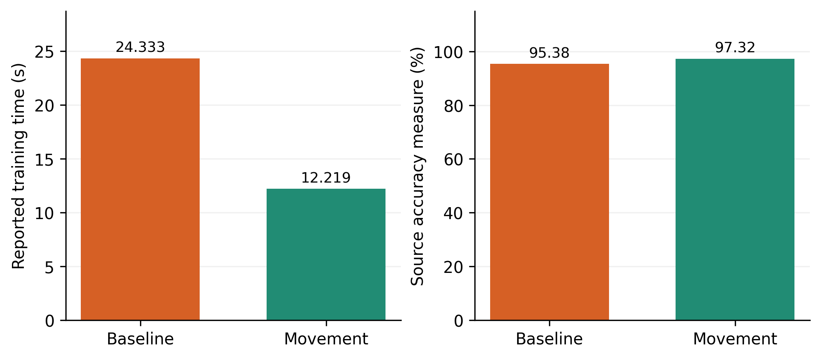
Figure 5. Historical training duration and source defined accuracy. Repeated timing, hardware, software, and stopping criteria are not supplied.
The times are 24,333 ms for the source baseline and 12,219 ms for movement learning. Their relative change is
$$R_{time}=\frac{24333−12219}{24333}×100=49.784\%, \frac{24333}{12219}=1.991.\text{ (19)}$$
The source accuracy increases from 95.38% to 97.32%, a gain of 1.94 percentage points. This is not a 1.94 fold accuracy improvement. The reported percentages also do not equal one hundred minus the MAPE recalculated from the table, so they remain a separate source metric.
The original gain column has an unclear definition and contains values that cannot be consistently recovered, including the 1977 entry. It is preserved in the underlying transcription but excluded from the conclusions. The timing table supports one reported training comparison; it does not establish inference latency or general computational superiority.

8 Discussion

8.1 What the movement mechanism contributes
The method provides an explicit route from normalized input displacement to rule activation and affine output averaging. Its computation can be simple, and its derivatives can be written directly once the operator and width convention are fixed. Partial match activation may help a limited rule base avoid complete loss of coverage.
The same behavior can make rules less local. A rule can remain strongly active despite a poor match in one predictor. When the predictors have known physical meanings, this behavior should be examined against the intended interpretation of the linguistic antecedents. In the present dataset, undefined factor names prevent that interpretation from being validated.

8.2 Capacity and generalization
The rank result is central to the empirical interpretation. The fixed antecedent model has at least eighty two unconstrained consequent directions with twenty six observations. This does not prove that every learned model overfits, but it shows that training fit alone cannot identify a stable coefficient representation.
Regularization, shared coefficients, fewer rules, or a larger dataset can address different parts of the problem. A positive ridge penalty makes the fixed antecedent fit unique, but the chosen penalty and antecedent structure still need temporal validation. Pruning can reduce storage, but should preserve useful coverage and later-observation performance.
A fair study should compare a mean or climatological baseline, persistence when the target sequence supports it, regularized linear regression, a matched capacity fuzzy model, and a modern alternative appropriate to the available data. Large weather networks are not a meaningful numerical baseline for twenty six undefined tabular observations.

8.3 Uncertainty and operational interpretation
Operational rainfall claims require a known accumulation interval, forecast lead, and observation source. They also require evaluation across conditions relevant to the intended user. Aggregate fitted RMSE does not establish heavy rainfall detection, spatial transfer, calibrated predictive uncertainty, or skill relative to an issued forecast.
Prediction intervals would require an explicit residual or probabilistic model. Exchangeability or dependence assumptions should match the data. The current fitted table is too limited to justify a precise uncertainty claim for rare events. No synthetic confidence bands are added to its graphs.
The strongest empirical conclusion is therefore limited but concrete: the movement model better fits the reported sample in aggregate and has a shorter reported training time, while individual reversals and a few large errors explain much of the comparison. Resolving the inference and data definitions would allow that observation to be tested as a forecasting hypothesis.

9 Conclusions
Movement based fuzzy rainfall regression has been expanded into a detailed inference, learning, and validation formulation. The analysis distinguishes aggregation operators, derives normalization and width gradients, and establishes the rank limitation of fitting 108 consequent coefficients from twenty six observations. Six algorithms make the principal operations explicit.
The reported fitted values give MAE of 12.688 mm and RMSE of 17.874 mm for the movement method, with lower aggregate error than the source baseline. Fourteen observation level wins and twelve losses, together with concentrated baseline squared error, provide a more informative interpretation than one accuracy percentage. The reported training comparison favors the method, but forecast skill remains unverified. Data provenance, fully specified inference, capacity control, and independent temporal evaluation are the essential next requirements.

Data and code availability
The research package includes the twenty six input and rainfall records, both fitted series, thirty six consequent coefficient rows, timing data, and graph generation code. The squared error concentration diagnostic is derived from those fitted series. Original training code, predictor definitions, observation provenance, and issue-time metadata are required for historical replication and a new forecasting evaluation.

References
[1] Ravuri, S.; Lenc, K.; Willson, M.; Kangin, D.; Lam, R.; Mirowski, P.; et al. (2021). Skilful precipitation nowcasting using deep generative models of radar. Nature, 597(7878), 672-677. https://doi.org/10.1038/s41586-021-03854-z
[2] Zhang, Y.; Long, M.; Chen, K.; Xing, L.; Jin, R.; Jordan, M.I.; et al. (2023). Skilful nowcasting of extreme precipitation with NowcastNet. Nature, 619(7970), 526-532. https://doi.org/10.1038/s41586-023-06184-4
[3] Bi, K.; Xie, L.; Zhang, H.; Chen, X.; Gu, X.; Tian, Q. (2023). Accurate medium-range global weather forecasting with 3D neural networks. Nature, 619(7970), 533-538. https://doi.org/10.1038/s41586-023-06185-3
[4] Lam, R.; Sanchez-Gonzalez, A.; Willson, M.; Wirnsberger, P.; Fortunato, M.; Alet, F.; et al. (2023). Learning skillful medium-range global weather forecasting. Science, 382(6677), 1416-1421. https://doi.org/10.1126/science.adi2336
[5] Price, I.; Sanchez-Gonzalez, A.; Alet, F.; Andersson, T.R.; El-Kadi, A.; Masters, D.; et al. (2025). Probabilistic weather forecasting with machine learning. Nature, 637(8044), 84-90. https://doi.org/10.1038/s41586-024-08252-9
[6] Guan, H.; Mouatadid, S.; Orenstein, P.; Cohen, J.; Dong, H.; Ni, Z.; et al. (2026). Advancing subseasonal forecasting with machine learning. Nature. https://doi.org/10.1038/s41586-026-11126-x
[7] Camps-Valls, G.; Fernández-Torres, M.Á.; Cohrs, K.H.; Höhl, A.; Castelletti, A.; Pacal, A.; et al. (2025). Artificial intelligence for modeling and understanding extreme weather and climate events. Nature Communications, 16(1), 1919. https://doi.org/10.1038/s41467-025-56573-8
[8] Bracco, A.; Brajard, J.; Dijkstra, H.A.; Hassanzadeh, P.; Lessig, C.; Monteleoni, C. (2024). Machine learning for the physics of climate. Nature Reviews Physics, 7(1), 6-20. https://doi.org/10.1038/s42254-024-00776-3
[9] Tan, J.; Huang, Q.; Chen, S. (2024). Deep learning model based on multi-scale feature fusion for precipitation nowcasting. Geoscientific Model Development, 17(1), 53-69. https://doi.org/10.5194/gmd-17-53-2024
[10] Amini, A.; Dolatshahi, M.; Kerachian, R. (2022). Adaptive precipitation nowcasting using deep learning and ensemble modeling. Journal of Hydrology, 612, 128197. https://doi.org/10.1016/j.jhydrol.2022.128197
[11] Ko, J.; Lee, K.; Hwang, H.; Oh, S.G.; Son, S.W.; Shin, K. (2022). Effective training strategies for deep-learning-based precipitation nowcasting and estimation. Computers & Geosciences, 161, 105072. https://doi.org/10.1016/j.cageo.2022.105072
[12] Ha, J.H.; Lee, H. (2024). A Deep Learning Model for Precipitation Nowcasting Using Multiple Optical Flow Algorithms. Weather and Forecasting, 39(1), 41-53. https://doi.org/10.1175/waf-d-23-0104.1
[13] Hu, J.; Yin, B.; Guo, C. (2024). METEO-DLNet: Quantitative Precipitation Nowcasting Net Based on Meteorological Features and Deep Learning. Remote Sensing, 16(6), 1063. https://doi.org/10.3390/rs16061063
[14] Chen, D.Y.; Chang, C.T.; Chen, B.F.; Huang, T.S. (2025). Integrating Heterogeneous Data for Deep Learning Precipitation Nowcasting. Weather and Forecasting, 40(10), 1977-2001. https://doi.org/10.1175/waf-d-24-0095.1
[15] Gong, A.; Li, B.; Zhou, R.; Tian, F.; Ni, G. (2025). Higher-resolution data improves deep learning-based precipitation nowcasting. Atmospheric Research, 319, 108010. https://doi.org/10.1016/j.atmosres.2025.108010
[16] Li, L.; Zhang, X.; Han, L. (2025). SCECA-Net: A Deep Learning-Based Model for Precipitation Nowcasting. IEEE Transactions on Geoscience and Remote Sensing, 63, 1-11. https://doi.org/10.1109/tgrs.2025.3534278
[17] Zhang, Z.; Song, Q.; Duan, M.; Liu, H.; Huo, J.; Han, C. (2025). Deep Learning Model for Precipitation Nowcasting Based on Residual and Attention Mechanisms. Remote Sensing, 17(7), 1123. https://doi.org/10.3390/rs17071123
[18] Pan, Z.; Ji, F.; Zhou, Y.; Hang, R.; Liu, Q.; Yuan, X.T. (2024). Deep Precipitation Nowcasting With Dual Regions Displacement Information and Global Spatiotemporal Representations Learning. IEEE Geoscience and Remote Sensing Letters, 21, 1-5. https://doi.org/10.1109/lgrs.2024.3384772
[19] Kim, H.J.; Yoon, S.S.; Gu, Y.H.; Kim, S.H.; Choi, Y.D.; Kwon, H.H. (2025). A Hybrid Approach to Physical and Deep Learning Models for Radar-Based Precipitation Nowcasting. IEEE Transactions on Geoscience and Remote Sensing, 63, 1-16. https://doi.org/10.1109/tgrs.2025.3560454
[20] Inoue, T.; Misumi, R. (2022). Learning from Precipitation Events in the Wider Domain to Improve the Performance of a Deep Learning–Based Precipitation Nowcasting Model. Weather and Forecasting, 37(6), 1013-1026. https://doi.org/10.1175/waf-d-21-0078.1
[21] Ye, Y.; Gao, F.; Cheng, W.; Liu, C.; Zhang, S.; Wang, S. (2024). Improved Precipitation Nowcasting Through a Deep Learning Model Based on Three-Dimensional Cloud Structures. IEEE Transactions on Geoscience and Remote Sensing, 62, 1-14. https://doi.org/10.1109/tgrs.2024.3404062
[22] Ayzel, G.; Heistermann, M. (2025). Brief communication: Training of AI-based nowcasting models for rainfall early warning should take into account user requirements. Natural Hazards and Earth System Sciences, 25(1), 41-47. https://doi.org/10.5194/nhess-25-41-2025
[23] Kantharia, V.; Mehta, D.; Kumar, V.; Shaikh, M.P.; Jha, S. (2024). Rainfall–runoff modeling using an Adaptive Neuro-Fuzzy Inference System considering soil moisture for the Damanganga basin. Journal of Water and Climate Change, 15(5), 2518-2531. https://doi.org/10.2166/wcc.2024.143
[24] Pham, B.T.; Bui, K.T.T.; Prakash, I.; Ly, H.B. (2024). Hybrid artificial intelligence models based on adaptive neuro fuzzy inference system and metaheuristic optimization algorithms for prediction of daily rainfall. Physics and Chemistry of the Earth, Parts A/B/C, 134, 103563. https://doi.org/10.1016/j.pce.2024.103563
[25] Li, D.; Wang, J.; Deng, K.; Zhang, D.; Zhao, C.; Leng, H.; et al. (2026). Review on deep learning quantitative precipitation nowcasting: Advances and challenges. Expert Systems with Applications, 305, 130775. https://doi.org/10.1016/j.eswa.2025.130775
[26] Zhang, H.; Liu, Y.; Zhang, C.; Li, N. (2025). Machine Learning Methods for Weather Forecasting: A Survey. Atmosphere, 16(1), 82. https://doi.org/10.3390/atmos16010082
[27] Wang, T.; Gault, R.; Greer, D. (2026). Data Informed Initialization of Fuzzy Membership Functions. International Journal of Fuzzy Systems, 28(2), 597-608. https://doi.org/10.1007/s40815-024-01971-1
[28] Xia, H.; Tang, J.; Yu, W.; Cui, C.; Qiao, J. (2023). Takagi–Sugeno Fuzzy Regression Trees With Application to Complex Industrial Modeling. IEEE Transactions on Fuzzy Systems, 31(7), 2210-2224. https://doi.org/10.1109/tfuzz.2022.3221790
[29] Bian, Z.; Chang, Q.; Wang, J.; Pal, N.R. (2025). Multihead Takagi–Sugeno–Kang Fuzzy System. IEEE Transactions on Fuzzy Systems, 33(8), 2561-2573. https://doi.org/10.1109/tfuzz.2025.3569227
[30] Deng, Z.; Cao, Y.; Lou, Q.; Choi, K.S.; Wang, S. (2022). Monotonic relation-constrained Takagi-Sugeno-Kang fuzzy system. Information Sciences, 582, 243-257. https://doi.org/10.1016/j.ins.2021.09.015
[31] Xue, G.; Hu, L.; Wang, J.; Ablameyko, S. (2025). ADMTSK: A High-Dimensional Takagi–Sugeno–Kang Fuzzy System Based on Adaptive Dombi T-Norm. IEEE Transactions on Fuzzy Systems, 33(6), 1767-1780. https://doi.org/10.1109/tfuzz.2025.3535640
[32] Vakili, S.; Mousavi, S.M. (2022). Rainfall–runoff modeling using adaptive neuro-fuzzy inference system (ANFIS) and genetic algorithm (GA). Water Supply, 22(10), 7460-7475. https://doi.org/10.2166/ws.2022.318
[33] Takagi, T.; Sugeno, M. (1985). Fuzzy identification of systems and its applications to modeling and control. IEEE Transactions on Systems, Man, and Cybernetics, SMC-15(1), 116-132. https://doi.org/10.1109/tsmc.1985.6313399
[34] Jang, J.S.R. (1993). ANFIS: adaptive-network-based fuzzy inference system. IEEE Transactions on Systems, Man, and Cybernetics, 23(3), 665-685. https://doi.org/10.1109/21.256541
[35] Wang, L.X.; Mendel, J.M. (1992). Generating fuzzy rules by learning from examples. IEEE Transactions on Systems, Man, and Cybernetics, 22(6), 1414-1427. https://doi.org/10.1109/21.199466
[36] Kwak, C.J.; Ri, K.C.; Kwak, S.I.; Kim, K.J.; Ryu, U.S.; Kwon, O.C.; et al. (2021). Fuzzy Modus Ponens and Tollens based on Moving Distance in SISO Fuzzy System. Romanian Journal of Information Science and Technology, 24(3), 257-283. https://www.romjist.ro/full-texts/paper693.pdf
[37] Kwak, S.; Kim, U.; Kim, K.; Son, I.; Ri, C. (2020). Fuzzy Reasoning Method Based on Distance Measure and Its Reductive Property. WSEAS TRANSACTIONS ON COMPUTER RESEARCH, 8, 73-89. https://doi.org/10.37394/232018.2020.8.10

