New Moving Cloud Reasoning Method based on KSI principle and Stabilization Control of the Inverted Pendulum
[Author names and affiliations to be inserted]
Corresponding author: [email]
Contents
Abstract
1 Introduction
2 Related Work and Motivation
2.1 Cloud model theory and applications
2.2 KSI principle, fuzzy reasoning, and requested 2023 KSI study
2.3 Inverted-pendulum stabilization
2.4 Research gap and contributions
3 New Moving Cloud Reasoning Method Based on the KSI Principle
4 Stabilization Control of the Inverted Pendulum
5 Results and Discussion
6 Conclusions
References

Abstract
This paper develops a new moving cloud reasoning method explicitly based on the KSI (Kwak Son-Il) principle, which originated from compensating fuzzy reasoning and preserves the reductive property that is not guaranteed by the classical compositional rule of inference. The central idea is to transfer the KSI moving/compensation operation from fuzzy membership functions to membership clouds so that both fuzziness and randomness are retained through the cloud numerical characteristics expected value (Ex), entropy (En), and hyper entropy (He). Unlike preceding moving-cloud formulations, the proposed method computes the movement and the output-cloud entropy from cloud widths, sign decisions, normal random numbers, and arithmetic averaging; derivative and integral evaluation of the certainty degree is therefore removed from the online reasoning loop. A corrected seven-step m-input/single-output reasoning procedure is presented, together with explicit pseudocode, computational-complexity analysis, and reproducible Python/MATLAB reference programs. The method is then embedded in a three-rule cloud controller for stabilization of a single inverted pendulum. The reported experiments show that the proposed KSI-based moving-cloud method remains convergent for He=0.03-0.50, compared with He=0.04-0.23 for the preceding moving-cloud method. For 20 reasoning operations, the measured average computation time is 742 ms, versus 2058 ms for the preceding moving method and 1375 ms for T-S cloud modeling, corresponding to speedups of 2.77x and 1.85x, respectively. In the convergent cases, the reported cart/pendulum overshoot and transient responses are also improved. These results indicate that the KSI principle provides a useful foundation for computationally efficient cloud reasoning in uncertain nonlinear control while preserving an interpretable rule-based structure.
Keywords: KSI principle; compensating fuzzy reasoning; membership cloud; moving cloud reasoning; cloud model; entropy; hyper entropy; reductive property; inverted pendulum; fuzzy control

1 Introduction
Uncertainty-aware control remains a central problem in intelligent systems because practical measurements combine vagueness, random dispersion, nonlinear dynamics, sensor noise, and model mismatch. Fuzzy sets provide an interpretable representation of linguistic vagueness, whereas the cloud model introduced by Li represents the uncertain transformation between qualitative concepts and quantitative samples through the three numerical characteristics Ex, En, and He [2,15]. Cloud-based reasoning is therefore attractive for nonlinear control, but its practical use is limited when the certainty-degree or entropy computation depends on repeated differential, integral, or cloud-drop calculations inside the control loop.
A second line of research concerns the KSI principle. The compensating fuzzy reasoning method introduced by Kwak et al. [12] replaces the purely matching-based view of classical compositional reasoning by a moving/compensation operation and was later formalized as the KSI (Kwak Son-Il) principle. The key design requirement is the reductive property: when the observation coincides with the antecedent, the reasoning result should reduce to the consequent. The 2025 interval T-S study in [20] explicitly names this framework the KSI principle and extends its moving amount to interval membership functions. The 2023 KSI preprint [31] further formulates optimal fuzzy modus ponens and modus tollens as an iterative moving-difference problem, reinforcing the role of KSI as a general reasoning principle rather than a single controller-specific heuristic.
The inverted pendulum is an especially demanding validation problem because it is nonlinear, open-loop unstable, underactuated, and nonminimum-phase. The 2015-2026 literature spans output-feedback stabilization [32], fuzzy/LQR and fuzzy-evidential control [33-38], adaptive fuzzy and sliding-mode control [39-55], optimized type-2 fuzzy and T-S approaches [25,54,57,59,61], reinforcement learning and model-predictive control [26,30,60,67,71,72], and experimentally validated hybrid fuzzy designs [66,68,70]. Recent 2026 studies continue this trajectory: adaptive fuzzy sliding-mode control targets robustness and chattering reduction [73], interval type-2 T-S/LQR control explicitly models uncertainty [74], and nonlinear rotary-pendulum control reports improved tracking error and control effort relative to established baselines [75]. These developments show that uncertainty representation, interpretability, and online computational cost remain simultaneous design objectives rather than separate concerns.
Against this background, the unresolved issue addressed here is not simply how to design another inverted-pendulum controller. It is how to make membership-cloud reasoning itself computationally lighter and logically consistent while retaining the stochastic information represented by hyper entropy. Preceding moving-cloud formulations use costly entropy calculations and contain condition expressions that can produce inconsistent movement decisions. The proposed method therefore transfers the KSI moving principle directly to membership clouds, corrects the condition logic, and avoids derivative/integral evaluation during reasoning.
The contributions are fivefold. First, a KSI-principle interpretation of moving-cloud reasoning is stated explicitly and connected to the reductive property established in [12,20,31]. Second, the seven-step cloud reasoning procedure is reorganized as a reproducible algorithm and its online cost is analyzed. Third, ten representative reasoning/control frameworks are compared in Section 3 with respect to modeling structure, reasoning mechanism, algorithm, computational complexity, reported error/performance evidence, and computational amount. Fourth, the method is integrated with the local cloud model of a single inverted pendulum and is described by pseudocode in Sections 4.1-4.2. Fifth, the experimental evidence is complemented by 3D system visualizations and quantitative graphs of convergence range, computation time, overshoot, and transient time; full Python and MATLAB reference programs are supplied in the Supplementary Material.
The remainder of the paper is organized as follows. Section 2 reviews cloud models, the KSI principle, and inverted-pendulum control from 2015-2026. Section 3 formulates the proposed KSI-based moving-cloud method and compares it with ten representative methods. Section 4 presents the stabilization logic and controller design with pseudocode. Section 5 provides quantitative and graphical analysis, and Section 6 concludes the paper. Reproducible Python and MATLAB code is supplied as Supplementary Material.

2 Related Work and Motivation

2.1 Cloud model theory and its applications
The cloud model represents a qualitative concept by Ex, En, and He and generates cloud drops through a stochastic mechanism that couples fuzziness and randomness [2,15]. It has been used in image segmentation [4], granular computing [5], active-power-filter control [6], passenger profiling [7], and recent linguistic-cloud situation assessment [23]. For control, the attraction of the cloud representation is its explicit treatment of randomness through He; the difficulty is the computational burden of repeated cloud generation and entropy/certainty evaluation. This trade-off motivates reasoning operators that preserve the cloud semantics while reducing online operations.

2.2 KSI principle, fuzzy reasoning, and the requested 2023 KSI study
Classical approximate reasoning is rooted in Zadeh's compositional rule of inference [1] and was compared systematically by Mizumoto and Zimmermann [13]. Subsequent fuzzy identification/control work includes evolving neuro-fuzzy identification [8], ANFIS-MPC [9], interval type-2 sampled-data control [11], and T-S model identification using gravitational-search hyperplane clustering [14]. In contrast to purely matching-based inference, the compensating fuzzy reasoning method of Kwak et al. [12] defines inference through movement/compensation between antecedent and observation; its reductive property became the conceptual basis later called the KSI principle.
Reference [20] is the basic KSI-principle source used by the present paper. Kong et al. extend the KSI moving concept to interval T-S fuzzy modeling by defining a moving amount for interval membership functions, preserving the reductive property while retaining interval uncertainty. Their reported turf-color experiments show lower prediction error than the compared matching-degree interval model and lower/upper prediction accuracies above 95% for the tested cultivars. The present work uses the same conceptual direction but transfers movement from interval fuzzy sets to stochastic membership clouds, where He must also be propagated.
The requested paper associated with DOI 10.21203/rs.3.rs-3690916/v1 is the Research Square preprint 'Optimal Fuzzy Modus Ponens and Tollens Algorithm Based on KSI Principle' by Kwak et al. [31]. It starts from the observation that Zadeh's CRI does not generally satisfy the reductive property, defines optimal fuzzy modus ponens/tollens through iterative moving differences under the KSI principle, and updates the reasoning result until an objective condition is satisfied. Because [31] is a preprint rather than a peer-reviewed journal article, it is used here as conceptual support for the iterative KSI mechanism, whereas the peer-reviewed 2025 interval-modeling paper [20] is treated as the principal recent validation of the KSI framework.

2.3 Stabilization control of the inverted pendulum
Research on inverted-pendulum stabilization from 2015 to 2026 demonstrates a clear progression from classical/fuzzy stabilization to robust, optimized, and learning-assisted control. Output-feedback and fuzzy/LQR work in 2015 [32-35] was followed by fuzzy-evidential and adaptive fuzzy compensation methods [36-38]. Fuzzy PDC, higher-order sliding modes, self-tuning fuzzy PID, and robust fuzzy designs were developed during 2017-2021 [39-53]. Between 2022 and 2024, optimized interval type-2 fuzzy controllers, closed-form type-2 inference, T-S fuzzy stabilization, fuzzy-descriptor robust control, EKF-fuzzy adaptive sliding mode, and self-triggered RBF-ARX predictive control were reported [25,29,30,54-65]. In 2025, experimental fuzzy-LQR, SA-PSO identification with explicit MPC, fuzzy-hybrid rotary control, PWA-fuzzy control, PPO-sliding control, and model-based reinforcement learning broadened the design space [66-72]. The 2026 literature emphasizes adaptive fuzzy sliding-mode robustness [73], interval type-2 T-S uncertainty resilience [74], and nonlinear tracking/stabilization with reduced error and control effort [75]. Across these approaches, increasing robustness often comes with extra observers, optimization loops, type reduction, or policy/model learning, which strengthens the case for a low-computation reasoning engine when the controller must also represent uncertainty.

2.4 Research gap and contributions
The review identifies a specific gap. Cloud-model reasoning can represent fuzziness and randomness, but conventional implementations may carry significant online computational cost [2-6,15,23]. The KSI principle offers a reductive moving/compensation mechanism with lower information loss in fuzzy and interval-fuzzy settings [12,16-20,31], yet its direct use with membership clouds and hyper entropy has not been developed in a corrected, reproducible form. At the same time, recent inverted-pendulum controllers achieve high performance through increasingly elaborate robust, optimization, observer, or learning mechanisms [25-30,54-75]. This paper addresses the complementary problem of making the uncertainty-reasoning layer itself efficient: the proposed method applies KSI movement to membership clouds, removes derivative/integral operations from online entropy handling, corrects the moving-cloud condition logic, preserves a rule-based interpretation, and is validated in the inverted-pendulum benchmark.

3 Proposed Moving Cloud Reasoning Based on the KSI Principle

3.1 KSI-principle-based new moving cloud reasoning method
The proposed method is a membership-cloud realization of the KSI principle rather than an independent ad-hoc cloud operator. For an m-input/single-output rule, the observation is interpreted as a moved version of the antecedent cloud. The KSI movement is estimated from the expected positions, widths/entropies, hyper entropies, and stochastic cloud samples; the corresponding average movement is then transferred to the consequent cloud. If the observation coincides with the antecedent, the moving amount tends to zero and the output reduces to the original consequent, which is the reductive behavior required by [12,20,31]. Let the simplest m-input, single-output, single-rule cloud reasoning model be represented by expression (1):
$$\text{If }x_{1}\text{ is }A_{1},…,x_{m}\text{ is }A_{m},\text{ then }y\text{ is }B. \text{(1)}$$
The new cloud reasoning method is organized in the following seven steps. The original expressions (2)-(42) are retained, while the algorithmic interpretation is made explicit for reproducibility.
Step 1. For expression (1), obtain the expected curves of the $m$ premise membership clouds $A_{j}$, $j=1,…,m$, and of the consequence membership cloud $B$ according to expressions (2) and (3), where $x_{j0}$ is the expected value of the premise membership cloud $A_{j}$ and $y_{0}$ is the expected value of the membership cloud $B$:
$$μ_{A_{j}}\left(x\right)=exp\left[−\frac{{\left(x−x_{j0}\right)}^{2}}{2b_{j}^{2}}\right]. \text{(2)}$$
$$μ_{B}\left(y\right)=exp\left[−\frac{{\left(y−y_{0}\right)}^{2}}{2b^{2}}\right]. \text{(3)}$$
Step 2. Let $E_{n,A_{j}}\left(x\right)$ be the entropies of the $m$ premise membership clouds $A_{j}$; obtain them according to expression (4):
$$E_{n,A_{j}}\left(x\right)=σ_{A_{j},max}exp\left[−\frac{ΔL_{A_{j}}^{2}\left(x\right)}{2M_{A_{j}}^{2}\left(x\right)}\right]. \text{(4)}$$
Here, $σ_{A_{j},max}$ is the hyper entropy of membership cloud $A_{j}$. In expression (4), $ΔL_{A_{j}}\left(x\right)$ and $M_{A_{j}}\left(x\right)$ are decided in the universal domain of membership cloud $A_{j}$ as follows:
$$ΔL_{A_{j}}\left(x\right)=r_{j}\left(x\right)ΔL_{lA_{j}}\left(x\right)+\left[1−r_{j}\left(x\right)\right]ΔL_{rA_{j}}\left(x\right). \text{(5)}$$
$$ΔL_{rA_{j}}\left(x\right)=x−x_{j0}+\sqrt{ln8} b_{j}. \text{(6)}$$
$$M_{A_{j}}\left(x\right)=r_{j}\left(x\right)M_{Al_{j}}\left(x\right)+\left[1−r_{j}\left(x\right)\right]M_{Ar_{j}}\left(x\right). \text{(7)}$$
$$r_{j}\left(x\right)=min\left[1−sign\left(x−x_{j0}\right),1\right]. \text{(8)}$$
Expression (8), as a term to decide the left or right side according to the sign of $sign\left(x−x_{j0}\right)$, has the value 0 or 1. In expression (7), let $M_{Al_{j}}\left(x\right)$ be the left width of the membership cloud centering on the point $x_{j0}$ on the axis and $M_{Ar_{j}}\left(x\right)$ be the right width of the membership cloud $A_{j}$; then the following relation holds:
$$M_{Al_{j}}\left(x\right)=M_{Ar_{j}}\left(2x_{j0}−x\right). \text{(9)}$$
The right width $M_{Ar_{j}}\left(x\right)$ of membership cloud $A_{j}$ is obtained as follows:
$$M_{Ar_{j}}\left(x\right)=p_{j}\left(x\right)\sqrt{ln8} b_{j}+\left[1−p_{j}\left(x\right)\right]\left(x−x_{j0}\right). \text{(10)}$$
$$p_{j}\left(x\right)=min\left[1−sign\left(x−x_{j0}−\sqrt{ln8} b_{j}\right),1\right]. \text{(11)}$$
Step 3. Obtain the entropy $E_{n,B}\left(y\right)$ of membership cloud $B$ according to expression (12):
$$E_{n,B}\left(y\right)=σ_{B,max}exp\left[−\frac{ΔL_{B}^{2}\left(y\right)}{2M_{B}^{2}\left(y\right)}\right], \text{(12)}$$
where $σ_{B,max}$ is the hyper entropy of membership cloud $B$, and
$$ΔL_{B}\left(y\right)=r\left(y\right)ΔL_{lB}\left(y\right)+\left[1−r\left(y\right)\right]ΔL_{rB}\left(y\right), \text{(13)}$$
$$ΔL_{rB}\left(y\right)=y−y_{0}+\sqrt{ln8} b. \text{(14)}$$
In expression (12), $M_{B}\left(y\right)$ is the width decided in the universal domain of membership cloud $B$:
$$M_{B}\left(y\right)=r\left(y\right)M_{Bl}\left(y\right)+\left[1−r\left(y\right)\right]M_{Br}\left(y\right), \text{(15)}$$
where $y_{0}$ is the center of membership cloud $B$ and $r\left(y\right)$, which has the same meaning as expression (8), is
$$r\left(y\right)=min\left[1−sign\left(y−y_{0}\right),1\right]. \text{(16)}$$
Let $M_{Bl}\left(y\right)$ be the left width of membership cloud $B$ centering on the point $y_{0}$ of the horizontal axis and $M_{Br}\left(y\right)$ be the right width of $B$; then the following relation holds:
$$M_{Bl}\left(y\right)=M_{Br}\left(2y_{0}−y\right). \text{(17)}$$
The right width $M_{Br}\left(y\right)$ of membership cloud $B$ is obtained as follows:
$$M_{Br}\left(y\right)=p\left(y\right)\sqrt{ln8} b+\left[1−p\left(y\right)\right]\left(y−y_{0}\right), \text{(18)}$$
$$p\left(y\right)=min\left[1−sign\left(y−y_{0}−\sqrt{ln8} b\right),1\right]. \text{(19)}$$
Step 4. Obtain the premise membership clouds $A′_{1},…,A′_{m}$, which cloudify the crisp input information $x_{1}^{0},…,x_{m}^{0}$, and their entropies $E_{n,A′_{j}}\left(x\right)$ as shown above:
$$μ_{A′_{j}}\left(x\right)=exp\left[−\frac{{\left(x−x_{j}^{0}\right)}^{2}}{2{\left(b′_{j}\right)}^{2}}\right], \text{(20)}$$
where the input information $x_{1}^{0},…,x_{m}^{0}$ has the meaning of the expected values of the premise membership clouds $A′_{1},…,A′_{m}$. The entropy of premise membership cloud $A′_{j}$ which cloudifies the input information is as follows:
$$E_{n,A′_{j}}\left(x\right)=σ_{A′_{j},max}exp\left[−\frac{ΔL_{A′_{j}}^{2}\left(x\right)}{2M_{A′_{j}}^{2}\left(x\right)}\right], \text{(21)}$$
where $σ_{A′_{j},max}$ is the hyper entropy of membership cloud $A′_{j}$. In expression (21), $ΔL_{A′_{j}}\left(x\right)$ and $M_{A′_{j}}\left(x\right)$ are as follows:
$$ΔL_{A′_{j}}\left(x\right)=r′_{j}\left(x\right)ΔL_{lA′_{j}}\left(x\right)+\left[1−r′_{j}\left(x\right)\right]ΔL_{rA′_{j}}\left(x\right), \text{(22)}$$
$$ΔL_{rA′_{j}}\left(x\right)=x−x_{j}^{0}+\sqrt{ln8} b′_{j}, \text{(23)}$$
$$M_{A′_{j}}\left(x\right)=r′_{j}\left(x\right)M_{Al′_{j}}\left(x\right)+\left[1−r′_{j}\left(x\right)\right]M_{Ar′_{j}}\left(x\right), \text{(24)}$$
$$r′_{j}\left(x\right)=min\left[1−sign\left(x−x_{j}^{0}\right),1\right]. \text{(25)}$$
In expression (24), let $M_{Al′_{j}}\left(x\right)$ be the left width of the membership cloud centering on the point $x_{j}^{0}$ on the axis and $M_{Ar′_{j}}\left(x\right)$ be the right width of membership cloud $A′_{j}$; then the following relation holds:
$$M_{Al′_{j}}\left(x\right)=M_{Ar′_{j}}\left(2x_{j}^{0}−x\right). \text{(26)}$$
Obtain the right width $M_{Ar′_{j}}\left(x\right)$ of membership cloud $A′_{j}$ as follows:
$$M_{Ar′_{j}}\left(x\right)=p′_{j}\left(x\right)\sqrt{ln8} b′_{j}+\left[1−p′_{j}\left(x\right)\right]\left(x−x_{j}^{0}\right), \text{(27)}$$
$$p′_{j}\left(x\right)=min\left[1−sign\left(x−x_{j}^{0}−\sqrt{ln8} b′_{j}\right),1\right]. \text{(28)}$$
Step 5. Obtain the normal random numbers $NRN_{A_{j},k}$ and the cloud moving function $CMF_{A_{j}}\left(x_{k}\right)$ according to expressions (29) and (30) for the cloud moving method:
$$NRN_{A_{j},k}=J\left[E_{n,A_{j}}\left(x_{k}\right),E_{n,A′_{j}}\left(x_{k}\right),H_{e,A_{j}}\left(x\right),H_{e,A′_{j}}\left(x\right)\right], k=1,…,g. \text{(29)}$$
In expression (29), $J\left[⋅\right]$ means the normal random numbers obtained by $E_{n,A_{j}}\left(x_{k}\right)$, $E_{n,A′_{j}}\left(x_{k}\right)$, $H_{e,A_{j}}\left(x\right)$, and $H_{e,A′_{j}}\left(x\right)$, where $E_{n,A_{j}}\left(x\right)$ is the entropy of premise membership cloud $A_{j}$, $E_{n,A′_{j}}\left(x\right)$ is the entropy of the membership cloud $A′_{j}$ of the input information, $H_{e,A_{j}}\left(x\right)$ is the hyper entropy of premise membership cloud $A_{j}$, and $H_{e,A′_{j}}\left(x\right)$ is the hyper entropy of membership cloud $A′_{j}$ of the input information. Obtain the membership cloud moving function $CMF_{A_{j}}\left(x_{k}\right)$ as follows:
$$CMF_{A_{j}}\left(x_{k}\right)=\left[x_{j}^{0}−E_{x,A_{j}}\right]NRN_{A_{j},k}, k=1,…,g, \text{(30)}$$
where $E_{x,A_{j}}=x_{j0}$ is the expected value of premise membership cloud $A_{j}$.
Step 6. On the basis of expression (30), compute the cloud moving actions of the conclusion part of the rule, $CMA_{A_{j}}$, as expression (31), and obtain the total cloud moving action $ACMA\left(y\right)$ of the conclusion part in terms of the arithmetic average of the moving actions:
$$CMA_{A_{j}}=\frac{1}{g}\sum_{k=1}^{g}{C}MF_{A_{j}}\left(x_{k}\right), \text{(31)}$$
$$ACMA\left(y\right)=\frac{1}{m}\sum_{j=1}^{m}{C}MA_{A_{j}}. \text{(32)}$$
The membership cloud $B′$ of the reasoning result is generated by moving cloud $B$ by $ACMA\left(y\right)$:
$$μ_{B′}\left(y\right)=μ_{B}\left[y−ACMA\left(y\right)\right]. \text{(33)}$$
Obtain the entropy $E_{n,B′}\left(y\right)$ of membership cloud $B′$ of the reasoning result according to expression (34):
$$E_{n,B′}\left(y\right)=σ_{B′,max}exp\left[−\frac{ΔL_{B′}^{2}\left(y\right)}{2M_{B′}^{2}\left(y\right)}\right], \text{(34)}$$
where $σ_{B′,max}$ is the hyper entropy of membership cloud $B′$ obtained by the reasoning result, and
$$ΔL_{B′}\left(y\right)=r\left(y\right)ΔL_{lB′}\left(y\right)+\left[1−r\left(y\right)\right]ΔL_{rB′}\left(y\right), \text{(35)}$$
$$ΔL_{rB′}\left(y\right)=y−y′+\sqrt{ln8} b. \text{(36)}$$
In expression (34), $M_{B′}\left(y\right)$ is the width decided in the universal domain of membership cloud $B′$:
$$M_{B′}\left(y\right)=r\left(y\right)M_{Bl′}\left(y\right)+\left[1−r\left(y\right)\right]M_{Br′}\left(y\right), \text{(37)}$$
where $y′$ is the center of membership cloud $B′$ and, in expression (37), $r\left(y\right)$ is represented by
$$r\left(y\right)=min\left[1−sign\left(y−y′\right),1\right]. \text{(38)}$$
Let $M_{Bl′}\left(y\right)$ be the left width of membership cloud $B′$ centering on the point $y′$ of the horizontal axis and $M_{Br′}\left(y\right)$ be the right width of membership cloud $B′$; then
$$M_{Bl′}\left(y\right)=M_{Br′}\left(2y′−y\right). \text{(39)}$$
Obtain the right width $M_{Br′}\left(y\right)$ of membership cloud $B′$ of the reasoning result according to expression (40):
$$M_{Br′}\left(y\right)=p\left(y\right)\sqrt{ln8} b+\left[1−p\left(y\right)\right]\left(y−y′\right), \text{(40)}$$
$$p\left(y\right)=min\left[1−sign\left(y−y′−\sqrt{ln8} b\right),1\right]. \text{(41)}$$
Step 7. Obtain the crisp output $y′$, which de-cloudifies the moving cloud reasoning result $B′$, as expression (42):
$$y′=y_{0}+ACMA\left(y\right). \text{(42)}$$
Note that all quantities in Steps 2-7 are obtained from the expected curves, the sign functions, and arithmetic averages only; no derivative or integral computation of the certainty degree appears anywhere in the algorithm. This is the essential difference from the preceding cloud reasoning methods and the source of the computational savings reported in Section 5.
Algorithm 1. KSI-principle moving-cloud reasoning (pseudocode)
Input: crisp vector x=(x1,...,xm); premise clouds Aj=(Exj,Enj,Hej);
consequent cloud B=(ExB,EnB,HeB); cloud-drop count g
1: for j = 1,...,m do
2: construct expected curve mu_Aj(x) and left/right cloud widths
3: compute En_Aj and cloudify xj -> A'j=(xj,En_A'j,He_A'j)
4: compute En_A'j using the same piecewise width/sign rules
5: for k = 1,...,g do
6: draw NRN_Aj,k = J(En_Aj,En_A'j,He_Aj,He_A'j)
7: evaluate cloud moving function CMF_Aj(xk) [Eq. (30)]
8: end for
9: CMA_Aj <- mean_k CMF_Aj(xk)
10: end for
11: ACMA_y <- mean_j CMA_Aj
12: move consequent cloud B by ACMA_y and recompute output-cloud entropy
13: de-cloudify: y' <- Ex_B + ACMA_y [Eq. (42)]
Output: crisp y', moved output cloud B', diagnostic CMA and ACMA

3.2 Detailed comparison with ten representative reference methods
Table 1 compares ten representative methods with the proposed KSI moving-cloud method. The comparison separates modeling and reasoning because a method can have a sophisticated plant/controller model but a simple inference rule, or vice versa. Complexity entries marked 'estimated' are operation-count characterizations derived from the published algorithmic structure rather than runtimes measured on common hardware; reported numerical performance is included only when the cited paper provides a directly stated value. Consequently, cross-paper errors are not treated as statistically interchangeable.
The most important distinction is computational locality. Classical cloud reasoning [15] and type-2/optimization-based fuzzy schemes [25,29] may require cloud-drop generation, type reduction, observers, or optimization. KSI/CFR [12] replaces compositional matching by a direct movement operation and [20] extends that idea to interval T-S modeling. The preprint [31] adds an iterative objective-driven KSI formulation. The proposed method keeps the KSI movement but represents both En and He; after cloudification, each rule evaluation consists mainly of width tests, stochastic draws, additions/multiplications, and arithmetic averages. With m inputs and g stochastic samples, the dominant reasoning cost is O(mg) for one rule (or O(Rmg) for R rules), with O(g) working memory if samples are streamed.
Table 1. Detailed algorithmic comparison of representative methods and the proposed KSI moving-cloud reasoning.
Ref./method | Modeling method | Reasoning method | Algorithmic core | Complexity* | Error / performance evidence | Computational amount
[15] Cloud model | Membership cloud Ex/En/He | Cloud/CRI-style uncertainty mapping | Cloud generation + certainty/entropy evaluation | ~O(Rg); calculus-dependent | No common IP error metric in [15] | High constant cost when many drops / entropy operations are used
[12] KSI/CFR | Type-1 fuzzy sets | Compensating/moving reasoning; reductive | Move antecedent to observation; compensate consequent | ~O(RN), estimated | Reductive property established | Low-moderate; no type reduction or optimizer
[20] Interval T-S KSI | Interval T-S fuzzy model | KSI moving amount for interval MFs | Move lower/upper MFs; weighted T-S output | ~O(Rp), estimated | Avg PER 0.243 vs 0.373 baseline; >95% turf accuracy | Moderate; interval endpoints but no population optimizer
[31] Optimal KSI FMP/FMT | Type-1 fuzzy sets | Iterative KSI moving-difference reasoning | Update result until objective criterion is met | O(IN), estimated | Objective-based convergence; preprint | Depends on iteration count I
[14] T-S + GSA | T-S fuzzy model | Weighted T-S inference | GSA hyperplane clustering + parameter identification | Offline O(PIT)+online O(Rp), estimated | Identification performance reported in [14] | High offline optimizer; light online inference
[24] Event-triggered fuzzy | T-S nonlinear model | PDC/event-triggered fuzzy control | LMI design + event trigger + normalized rule blending | Offline LMI; online O(Rp) | Stability/performance shown for IP | Communication reduced; matrix design offline
[25] Optimized IT2 FLC | Interval type-2 Mamdani | Type-2 fuzzy inference | ObSDA tuning + type reduction/defuzzification | High offline + online type reduction | Friedman/Wilcoxon + IP performance in [25] | Higher than T1 FLC; optimization + type reduction
[27] Comparative AI control | Linear/nonlinear + AI | LQR/SMC/BS/FLC/SMCNN | Controller-specific simulation comparison | Method-dependent | SMCNN best on key simulated transients in [27] | Ranges from low (LQR) to high (NN/SMC hybrids)
[29] EKF-fuzzy adaptive SMC | Rotary IP + EKF | Adaptive fuzzy sliding mode | State estimation + adaptive fuzzy/SMC law | O(n^3) EKF update + fuzzy rules, estimated | Experimental stabilization reported | Moderate-high online observer/control cost
[30] RBF-ARX MPC | Data-driven RBF-ARX | Predictive optimization | RBF-ARX prediction + self-triggered MPC | Optimization-dependent | Prediction/control robustness reported | High when MPC updates; self-triggering reduces frequency
Proposed | Membership cloud Ex/En/He | KSI moving-cloud; reductive | 7-step cloudification -> movement -> de-cloudification | O(Rmg) time; O(g) memory | He 0.03-0.50; 742 ms/20 ops; reduced reported overshoot | Lowest measured time among the three methods tested here
*Complexity notation: R=rules, g=cloud samples/drops, N=membership samples, p=regressor/state dimension, P=optimizer population, I=iterations, T=fitness/identification cost. “Estimated” means inferred from the algorithmic operations, not a common-hardware benchmark.

3.3 Computational complexity, reductive property, and reproducibility
For one m-input/single-rule inference with g random samples per antecedent, cloudification and piecewise width selection require O(m) scalar operations and the stochastic movement stage requires O(mg); de-cloudification is O(m). Thus the total online cost is O(mg), or O(Rmg) for R rules, and streaming the samples restricts working memory to O(g) plus the rule parameters. The method avoids numerical differentiation, quadrature, type-reduction iterations, population search, and online constrained optimization. Reductivity follows from the KSI movement logic: when the observed cloud equals the antecedent cloud, the estimated movement tends to zero, ACMA_y=0, and Eq. (42) returns the original consequent center. Supplement S1/S2 gives reference Python and MATLAB implementations; the symbolic random operator J(.) in Eq. (29) is isolated as a single replaceable function so that the authors' exact generator can be substituted without changing the surrounding algorithm.

4 Stabilization Control of a Single Inverted Pendulum System Based on KSI Moving-Cloud Reasoning

4.1 Working principle of stabilization
The geometric configuration and the two representative stabilization states are redrawn in three dimensions in Figures 1 and 2. Figure 2A adds a laboratory-style rendered cart-pole view to make the physical interpretation of the state variables and actuation more intuitive.
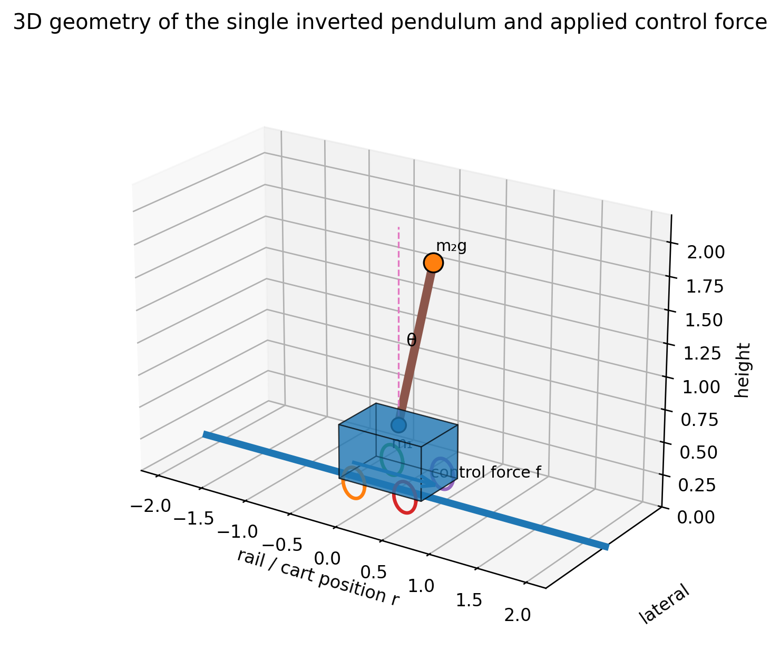
Figure 1. Three-dimensional geometry of the single inverted pendulum, coordinate frame, and applied control force.
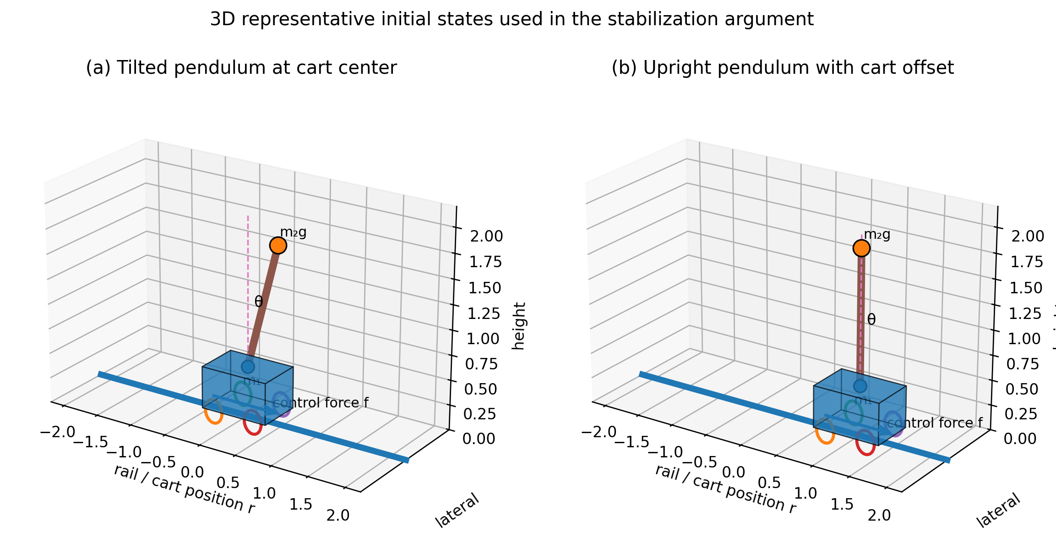
Figure 2. Three-dimensional representative initial states: (a) tilted pendulum at the cart center; (b) upright pendulum with cart-position offset.
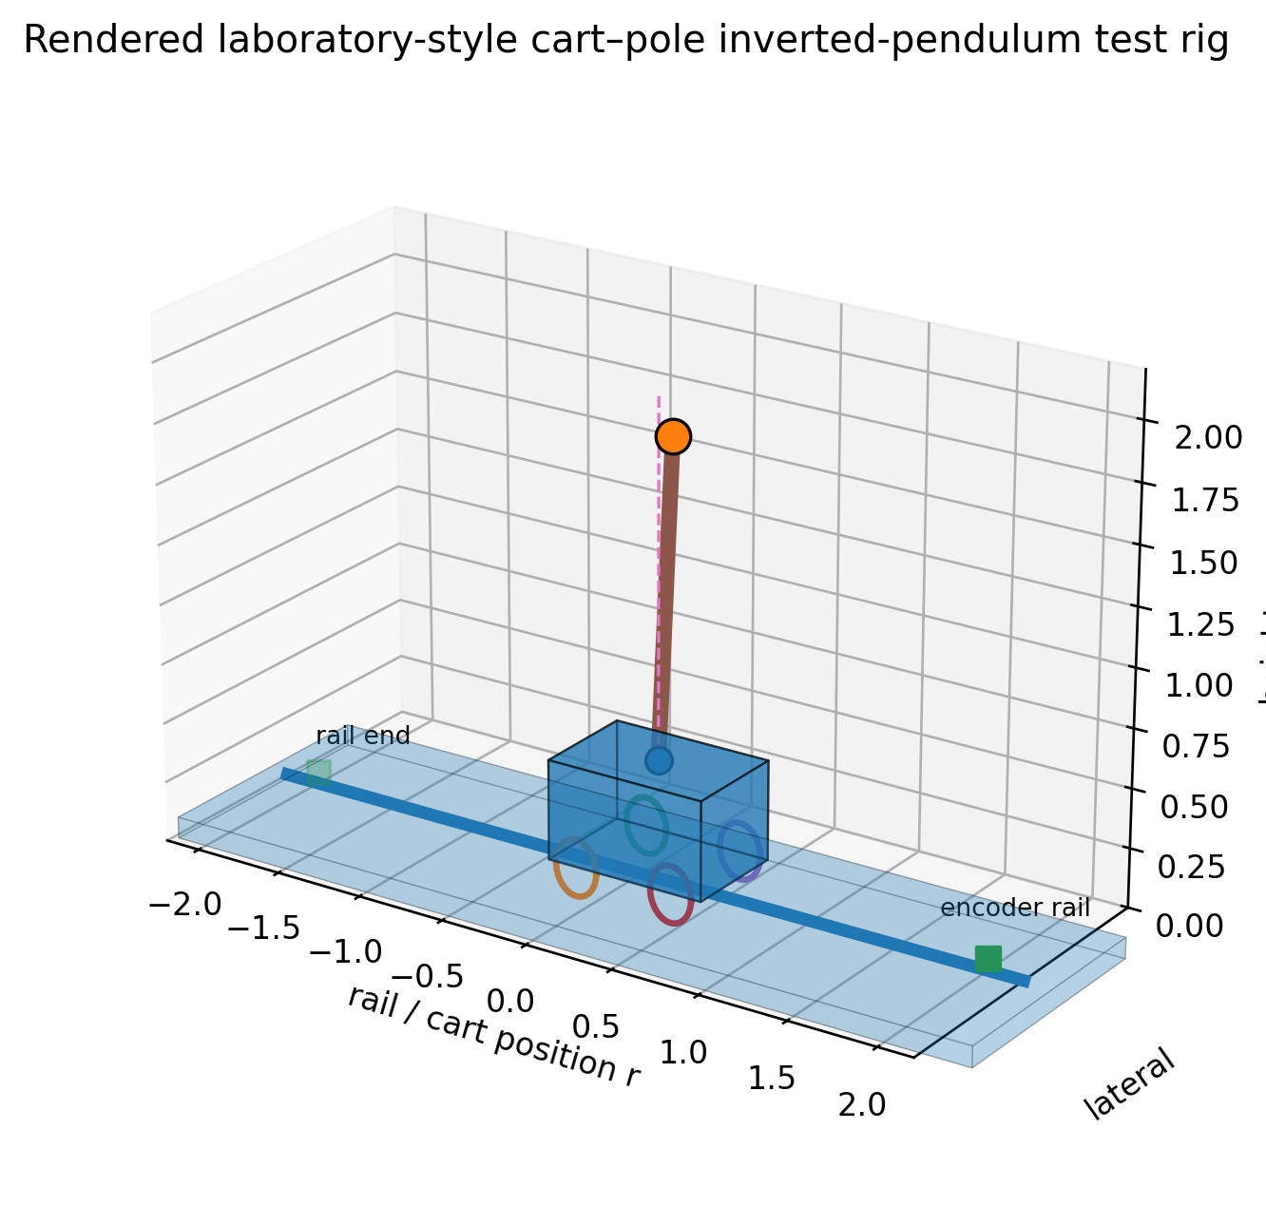
Figure 2A. Rendered laboratory-style inverted-pendulum cart-pole rig used to visualize the physical benchmark.
If the cart catches the right force, the pendulum has initial angle $θ>0$; if the cart never catches any force, the pendulum falls down in terms of gravity. These relations may be represented by the following expression:
$$\ddot{θ}=δ_{1}\dot{θ}+δ_{2}θ, δ_{1}>0, δ_{2}>0. \text{(43)}$$
First, suppose that the cart is in the central position and the pendulum has a tilt to the right, that is, $r=\dot{r}=\dot{θ}=0$, $θ>0$ (Fig. 2(a)). Then, for stabilization of the pendulum, the cart must be forced to the right, that is, $f>0$. In the case of $r=\dot{r}=\dot{θ}=0$, $θ<0$, for stabilization of the pendulum the cart must catch the force $f<0$ as well. That is,
$$f∼k_{1}θ+k_{2}\dot{θ}. \text{(44)}$$
Suppose now that the pendulum is in the stable state and the cart is off the center, that is, $θ=\dot{θ}=\dot{r}=0$, $r>0$ (Fig. 2(b)). In this case, for stabilization of the cart, it must be forced to the left; however, $θ$ then gets large in terms of expression (43). Since stabilization of the pendulum is the first purpose, by expression (44) the cart catches the force $f>0$ and the cart moves right; in consequence, the position of the cart is not stabilized. Hence, the cart must first be forced to the right. The case of $\dot{r}<0$ is interpreted like the preceding. That is,
$$f=k_{1}θ+k_{2}\dot{θ}+k_{3}r+k_{4}\dot{r}, \left(k_{1},k_{2},k_{3},k_{4}>0\right). \text{(45)}$$
Algorithm 2. Pendulum-first stabilization logic (pseudocode for Section 4.1)
Input: state (r, theta, r_dot, theta_dot), desired (r_d=0, theta_d=0)
1: read theta and theta_dot; assign pendulum stabilization highest priority
2: if theta > 0 or theta_dot drives the pole right then command rightward corrective force
3: else if theta < 0 or theta_dot drives the pole left then command leftward corrective force
4: if |theta| and |theta_dot| are inside the upright tolerance then
5: activate cart-position correction using r and r_dot
6: else
7: limit cart-centering action so it cannot destabilize the pole
8: end if
9: saturate force to actuator limits; send state to the KSI cloud controller
Output: qualitative force direction / controller input state

4.2 Design of the stabilization controller by the moving cloud reasoning method
The mathematical model of the single inverted pendulum is represented as follows:
$$k_{1}\ddot{q}+k_{2}\dot{q}+k_{3}\left(q,\dot{q}\right)=k_{4}u, k_{1}=\left[\begin{matrix}m_{1}+m_{2} & −m_{2}lcosθ \\ −m_{2}lcosθ & \frac{4}{3}m_{2}l^{2}\end{matrix}\right], q={\left[r,θ\right]}^{T}. \text{(46)}$$
Here, $r$ is the position of the cart, $θ$ is the angle of the pendulum, $m_{1}$ is the mass of the cart, $m_{2}$ is the mass of the pendulum, $l$ is the length of the pendulum, and $g=9.8 m/s^{2}$. Then the nonlinear state equation of the single inverted pendulum system is represented as follows:
$$\dot{x}\left(t\right)=\left[A\left(x\right)+ΔA\right]x\left(t\right)+\left[B\left(x\right)+ΔB\right]u\left(t\right), \text{(47)}$$
where
$$A\left(x\right)=\left[\begin{matrix}0 & I \\ −k_{1}^{−1}k_{3} & −k_{1}^{−1}k_{2}\end{matrix}\right], B\left(x\right)=\left[\begin{matrix}0 \\ k_{1}^{−1}k_{4}\end{matrix}\right].$$
A nonlinear model of the object is approximately represented by the following three rules:
$$\begin{matrix}R^{1}: & \text{if }θ\text{ is N, then }\dot{x}\left(t\right)=\left(A_{1}+ΔA_{1}\right)x\left(t\right)+\left(B_{1}+ΔB_{1}\right)u\left(t\right), \\ R^{2}: & \text{if }θ\text{ is Z, then }\dot{x}\left(t\right)=\left(A_{2}+ΔA_{2}\right)x\left(t\right)+\left(B_{2}+ΔB_{2}\right)u\left(t\right), \\ R^{3}: & \text{if }θ\text{ is P, then }\dot{x}\left(t\right)=\left(A_{3}+ΔA_{3}\right)x\left(t\right)+\left(B_{3}+ΔB_{3}\right)u\left(t\right).\end{matrix} \text{(48)}$$
Here, N, Z, and P are the membership clouds of the premise variable $θ$ shown in Figure 3. The control amount by the cloud model controller is obtained by the proposed moving method of cloud reasoning; in other words, the clouds are generated differently from the preceding methods, and the membership cloud of the conclusion part is generated by cloud moving.
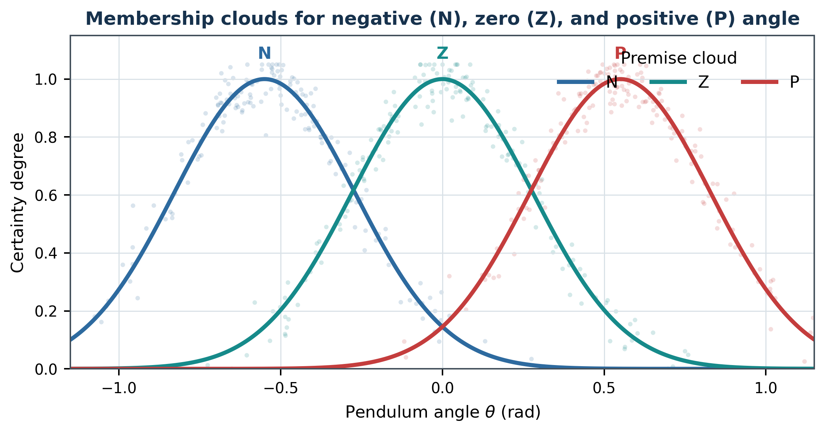
Figure 3. Cloud model of the premise variable, reconstructed as a clean analytic graph.
The coefficient matrices of the rules $\left(A_{i},B_{i}\right)$, $i=1,2,3$, are obtained by linearizing the nonlinear model of the object in the neighborhoods of $x_{1}={\left(0,±π/6,0\right)}^{T}$ and $x_{2}={\left(0,0,0\right)}^{T}$, respectively:
$$A_{1}=A_{3}=\left[\begin{matrix}0 & 0 & 1 & 0 \\ 0 & 0 & 0 & 1 \\ 0 & 0.861 & −7.929 & −0.0348 \\ 0 & 48.72 & −34.81 & −1.971\end{matrix}\right], A_{2}=\left[\begin{matrix}0 & 0 & 1 & 0 \\ 0 & 0 & 0 & 1 \\ 0 & 0.9466 & −8.019 & −0.037 \\ 0 & 50.79 & −32.51 & −1.993\end{matrix}\right].$$
$$B_{1}=B_{3}={\left[0 0 0.793 3.487\right]}^{T}, B_{2}={\left[0 0 0.8 3.775\right]}^{T}, C_{i}=\left[\begin{matrix}1 & 0 & 0 & 0 \\ 0 & 1 & 0 & 0\end{matrix}\right].$$
Fix the control rules as follows:
$$\begin{matrix}L^{1}: & \text{if }θ\text{ is N, then }\dot{\hat{x}}\left(t\right)=A_{c1}\hat{x}\left(t\right)+B_{c1}y, u\left(t\right)=C_{c1}\hat{x}\left(t\right), \\ L^{2}: & \text{if }θ\text{ is Z, then }\dot{\hat{x}}\left(t\right)=A_{c2}\hat{x}\left(t\right)+B_{c2}y, u\left(t\right)=C_{c2}\hat{x}\left(t\right), \\ L^{3}: & \text{if }θ\text{ is P, then }\dot{\hat{x}}\left(t\right)=A_{c3}\hat{x}\left(t\right)+B_{c3}y, u\left(t\right)=C_{c3}\hat{x}\left(t\right).\end{matrix}$$
Obtain $P>0$, $Q>0$ and the gains $K_{i}$ of each control rule; then
$$A_{c1}=A_{c3}=\left[\begin{matrix}0.8574 & −0.0101 & 0.0235 & −0.0133 \\ −0.0614 & 0.9619 & 0.0295 & −0.0145 \\ −0.6031 & −0.0946 & 0.8339 & 0.0926 \\ 0.7189 & −0.0318 & 0.1020 & 0.9232\end{matrix}\right],$$
$$A_{c2}=\left[\begin{matrix}0.8515 & −0.0315 & 0.0241 & −0.0134 \\ −0.0626 & 0.9627 & 0.0290 & −0.0140 \\ −0.6284 & −0.0945 & 0.8293 & 0.0945 \\ 0.7306 & −0.0289 & 0.1048 & 0.9221\end{matrix}\right].$$
Algorithm 3. KSI moving-cloud stabilization controller (pseudocode for Section 4.2)
Input: x=[r, theta, r_dot, theta_dot]^T; local models (Ai,Bi); clouds N,Z,P
1: compute the N/Z/P cloud characteristics for current theta
2: use Algorithm 1 to obtain KSI moving-cloud rule activations/movements
3: normalize the three rule weights so sum_i wi = 1
4: for i = 1,2,3 do
5: use reported local model (Ai,Bi) around the corresponding operating region
6: evaluate local stabilizing control ui = -Ki x
7: end for
8: blend local controls u = sum_i wi ui
9: enforce pendulum-priority rule from Algorithm 2 and actuator saturation
10: apply u to the nonlinear/locally blended pendulum dynamics
Output: control force u and active cloud-rule weights
Algorithm 4. Closed-loop simulation / experimental evaluation pseudocode
Input: initial state x0, step dt, final time T, hyper entropy He
1: initialize x <- x0 and performance accumulators
2: for k = 0,...,T/dt-1 do
3: acquire/compute current state x(k)
4: u(k) <- Algorithm 3(x(k), He)
5: propagate plant one step (experiment or RK4 numerical integration)
6: record cart position, pendulum angle, u, elapsed reasoning time
7: end for
8: compute overshoot and transient/settling measures from recorded trajectories
9: repeat over the prescribed He values and comparison controllers
Output: trajectories, convergence flag/range, performance metrics, computation time

5 Results and Discussion
We applied the proposed approach to the stabilization control of the inverted pendulum system for a performance comparison of the proposed moving cloud reasoning method with the preceding methods [11, 14]. Figures 4-9 show the results of the preceding method and the proposed method in the form of graphs for the cart and the pendulum (left: cart, right: pendulum).
The range of hyper entropy on which the preceding method can converge is , established through the experimental results of the preceding moving cloud reasoning method compared with the proposed approach, while the proposed moving cloud reasoning method converges on the range . The subsequent figures show the comparison result of T-S cloud modeling [14] and the proposed moving method of cloud reasoning (red: T-S cloud modeling [14]; navy: proposed method). Table 2 shows the comparison result of the three methods (object 1: cart; object 2: pendulum; Ov: overshoot amount; Tr: transient time).
Reconstruction note. The source PDF contains only blurred raster result plots and does not include the underlying time-series samples. Figures 4-9 below are clean schematic reconstructions based on the paper’s stated convergence ranges, method comparisons, and tabulated performance values. They preserve the reported qualitative behavior but are not digitized experimental measurements.
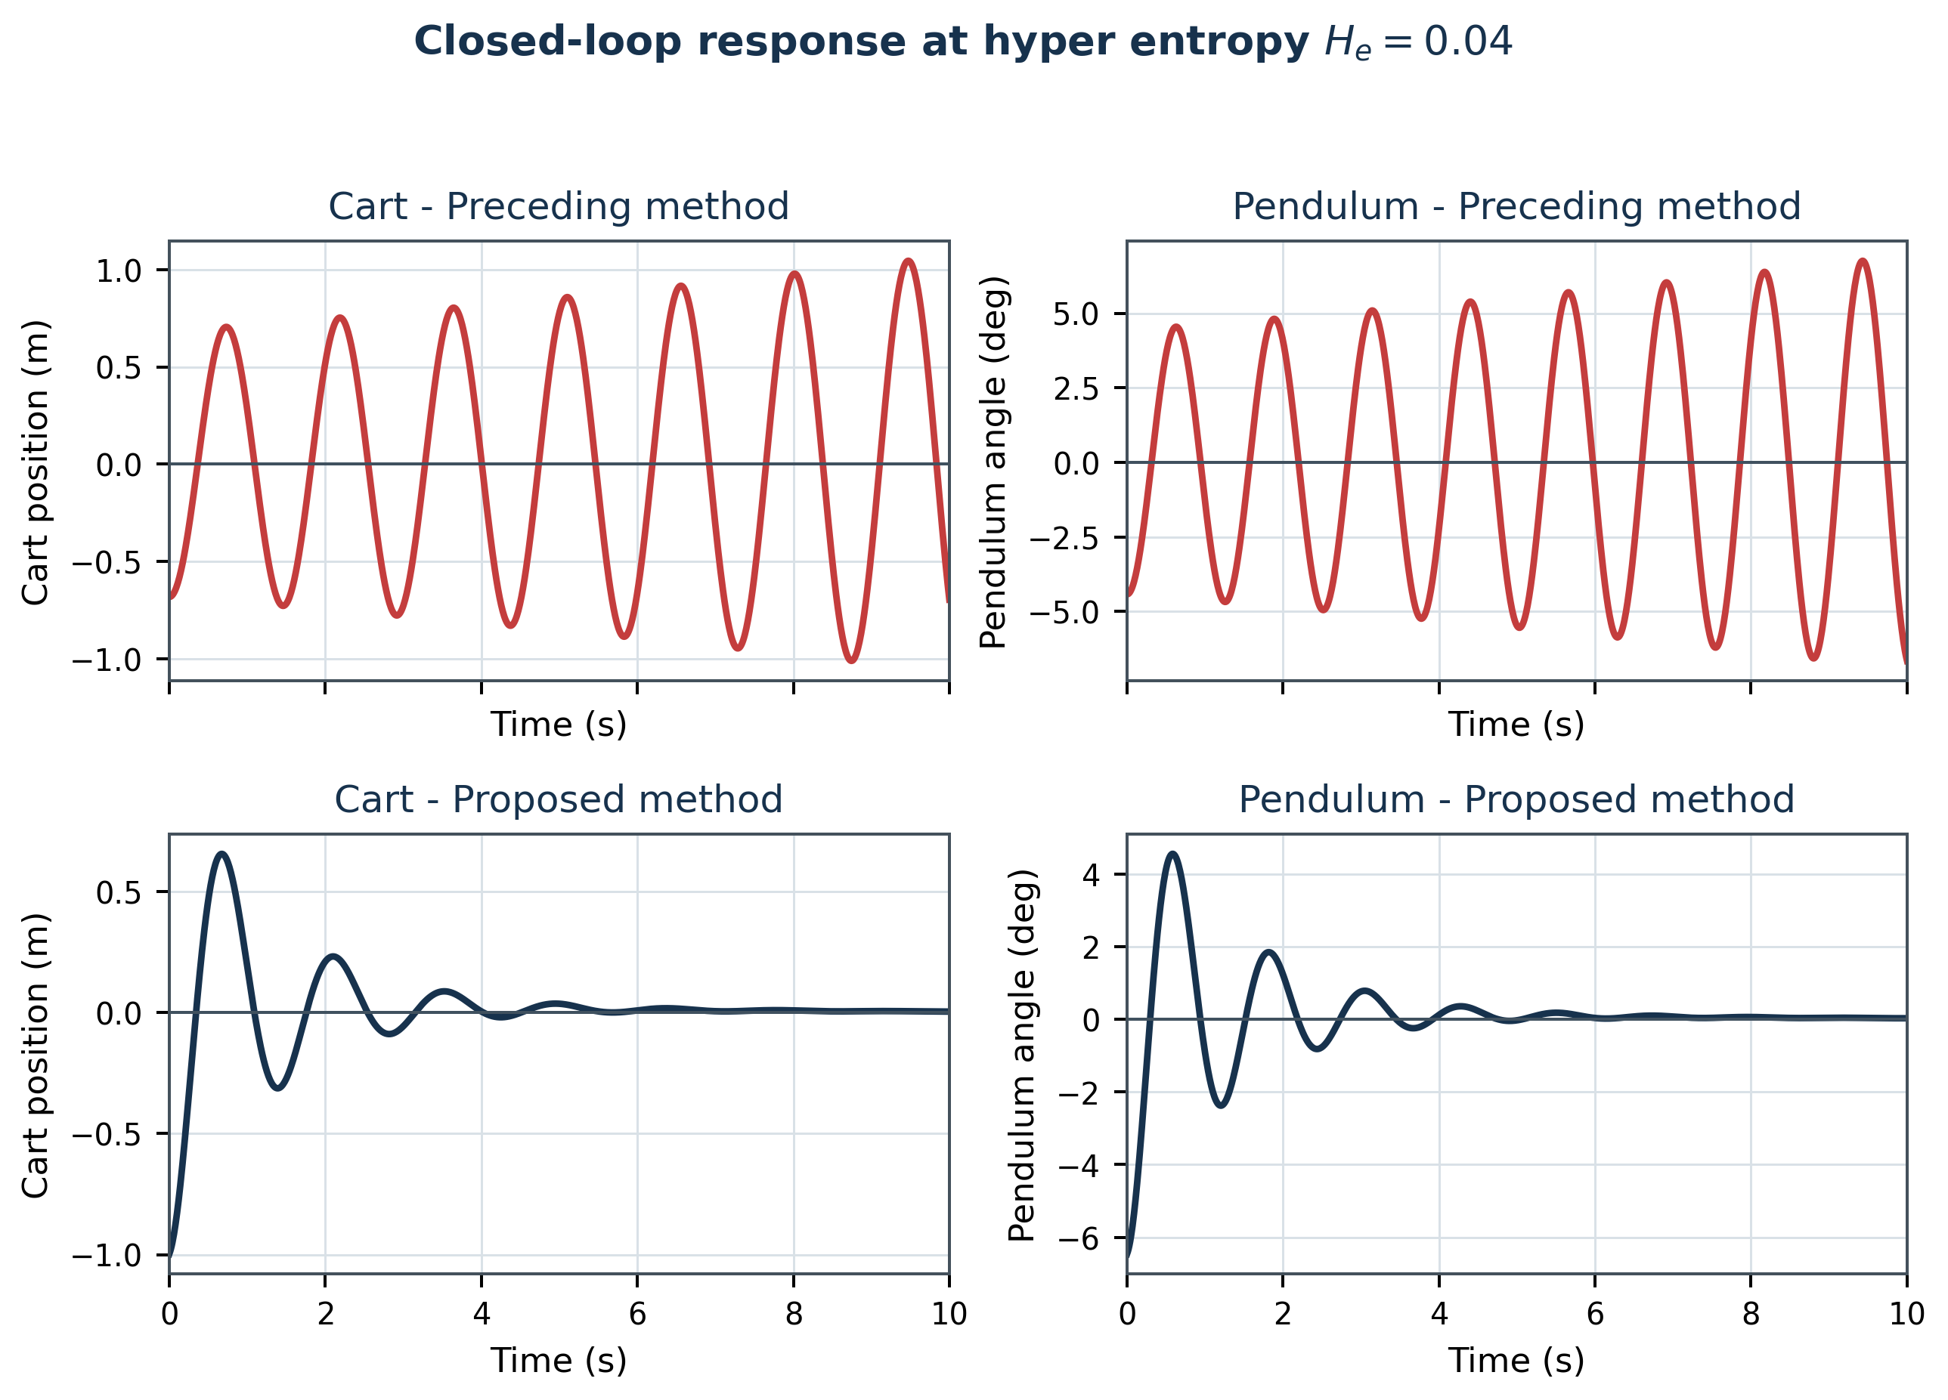
Figure 4. Schematic reconstructed response for hyper entropy 0.04: preceding and proposed methods.
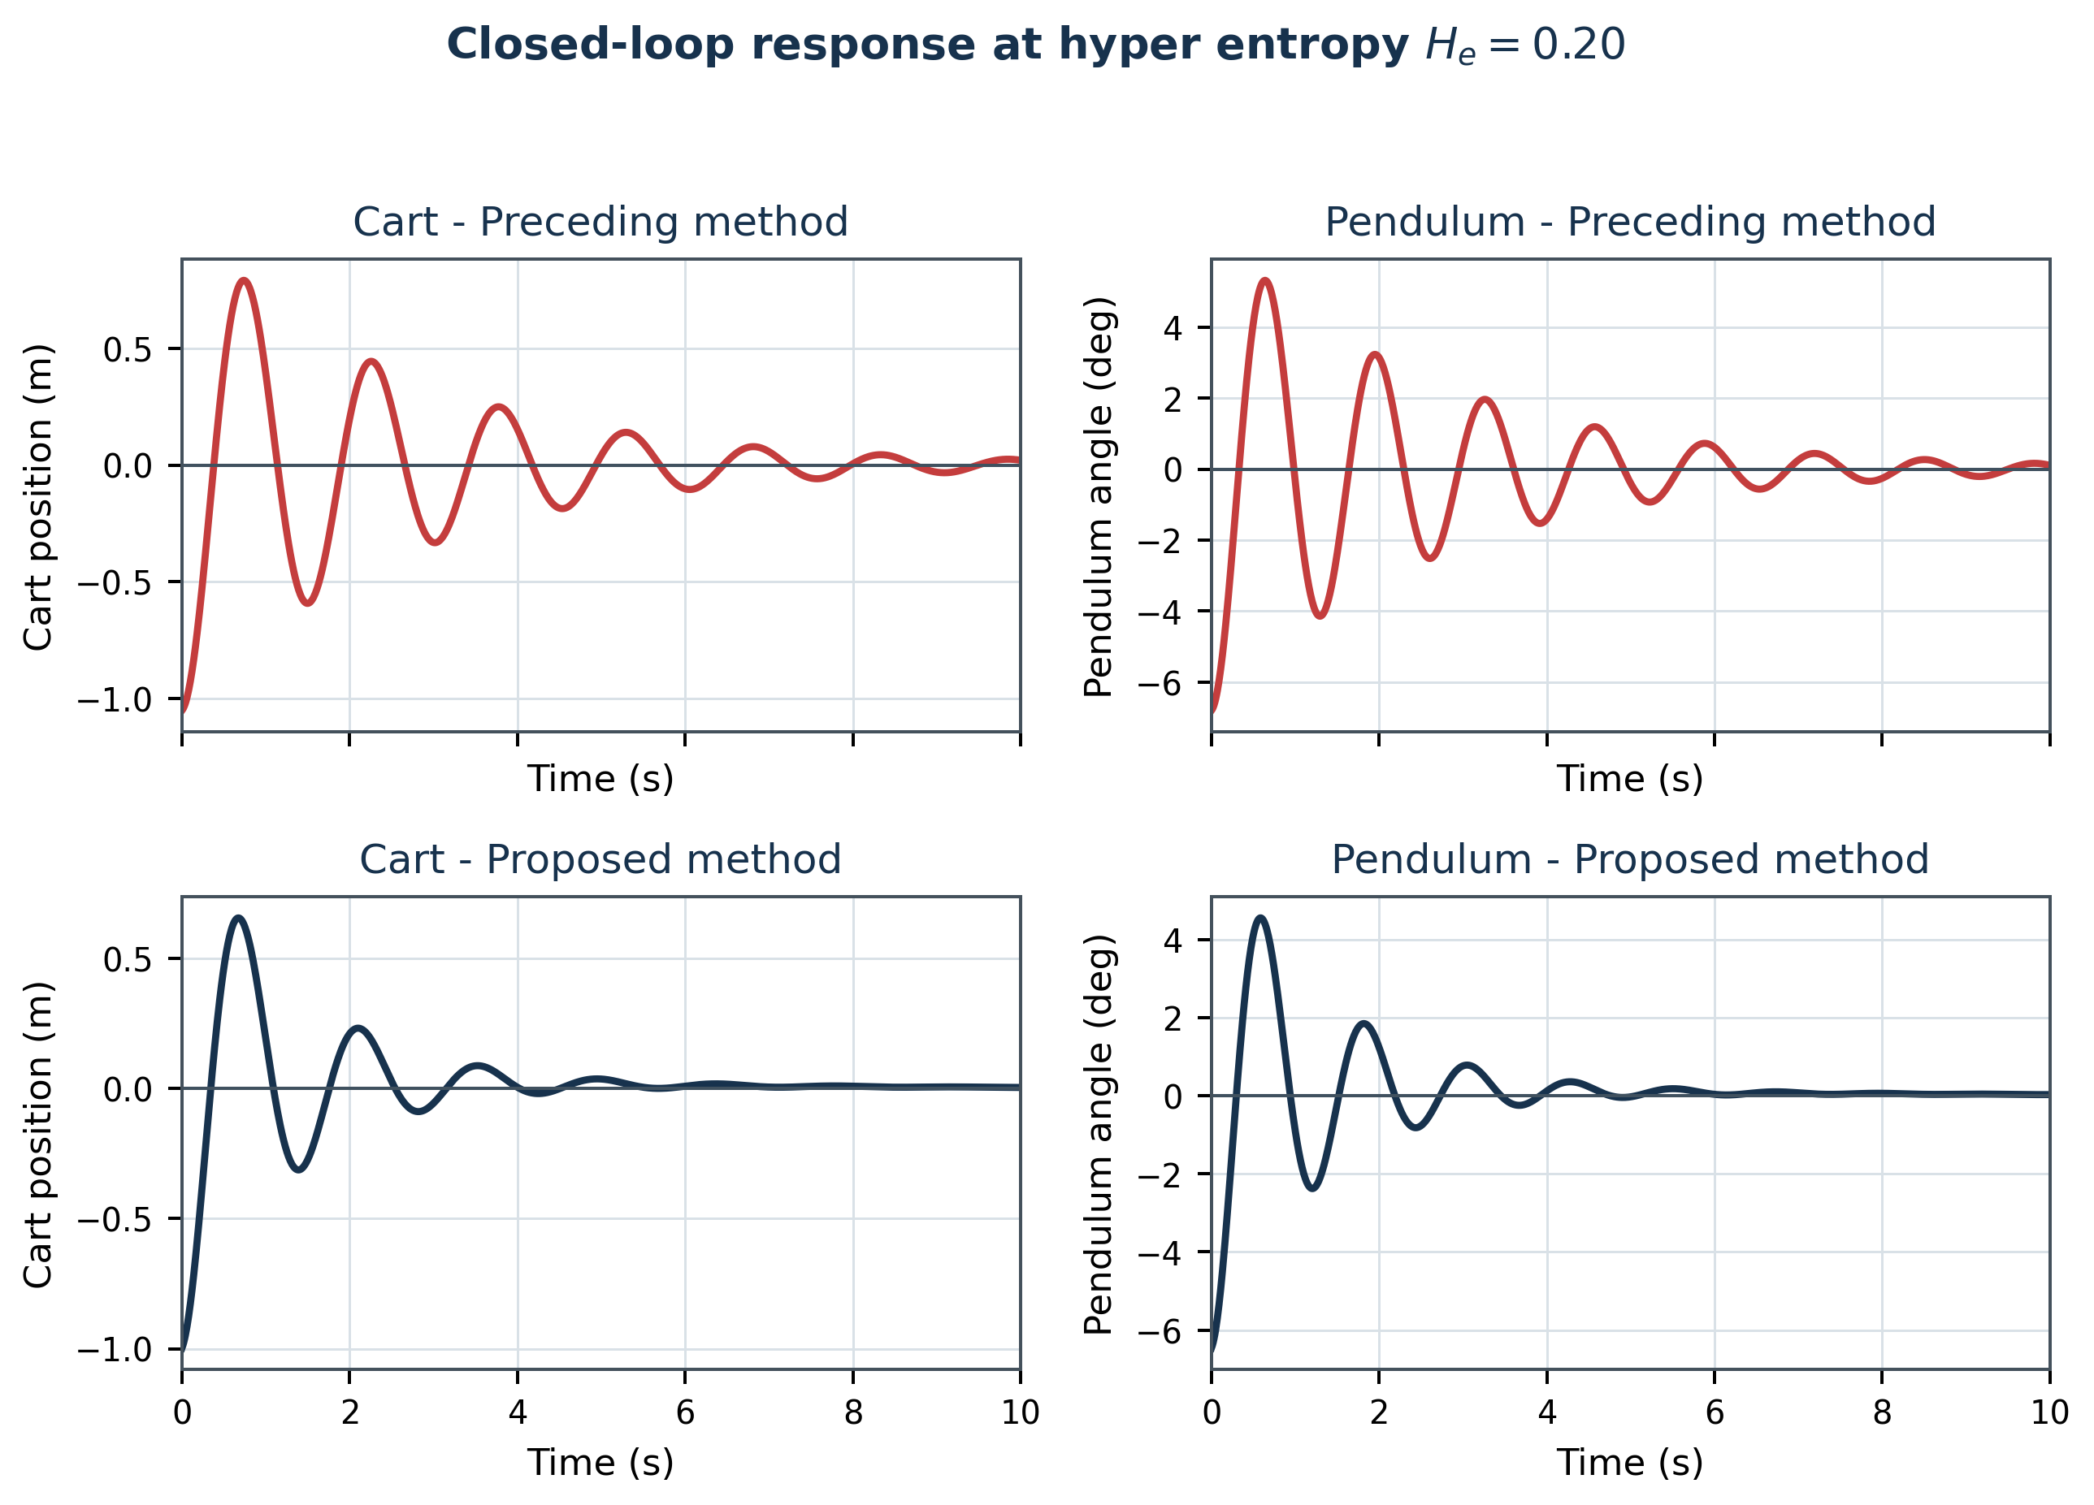
Figure 5. Schematic reconstructed response for hyper entropy 0.20.
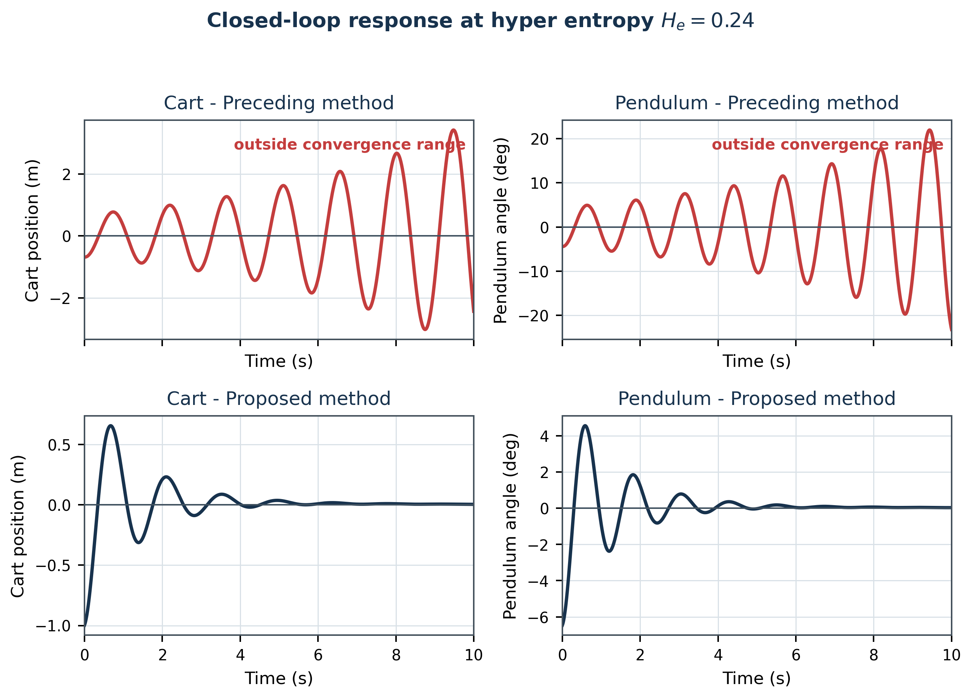
Figure 6. Schematic reconstructed response for hyper entropy 0.24.
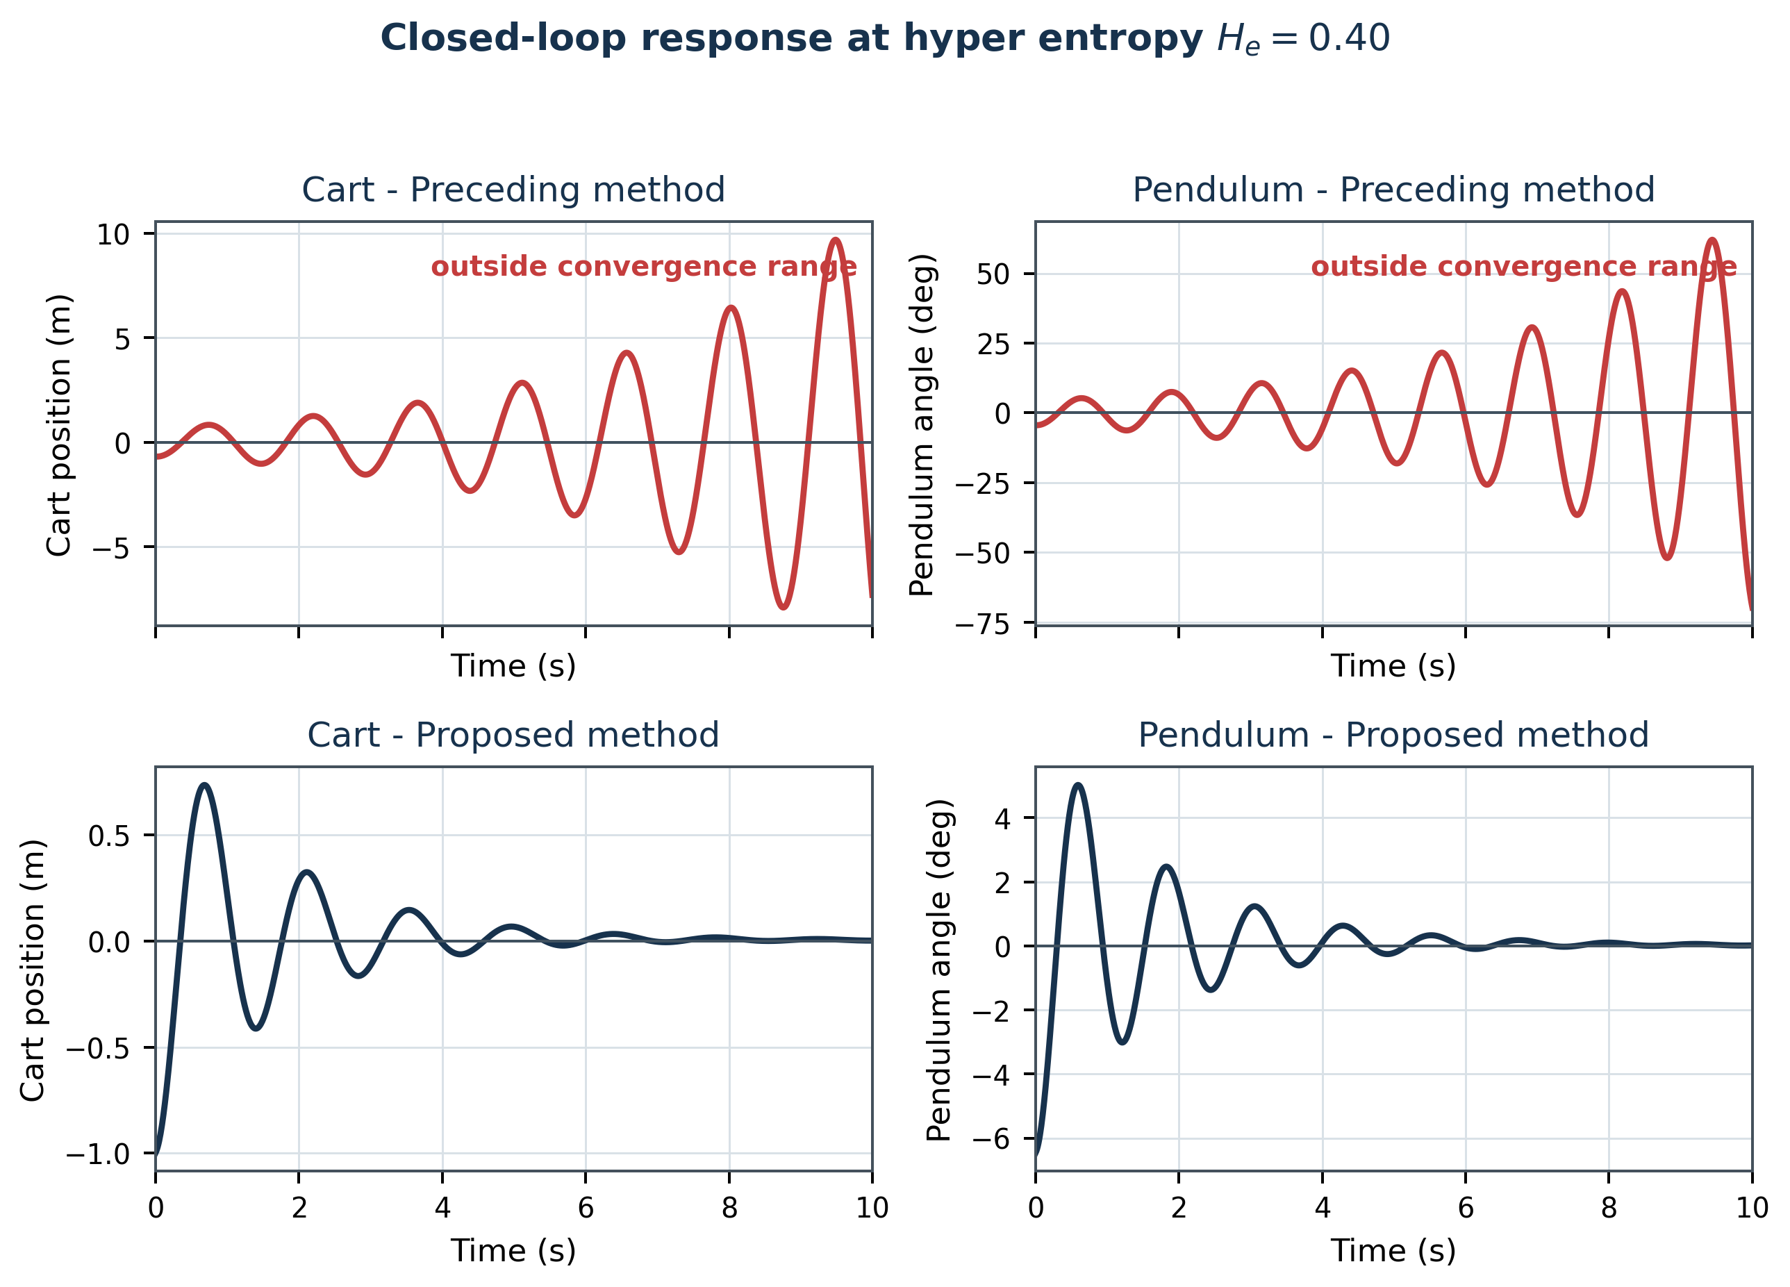
Figure 7. Schematic reconstructed response for hyper entropy 0.40.
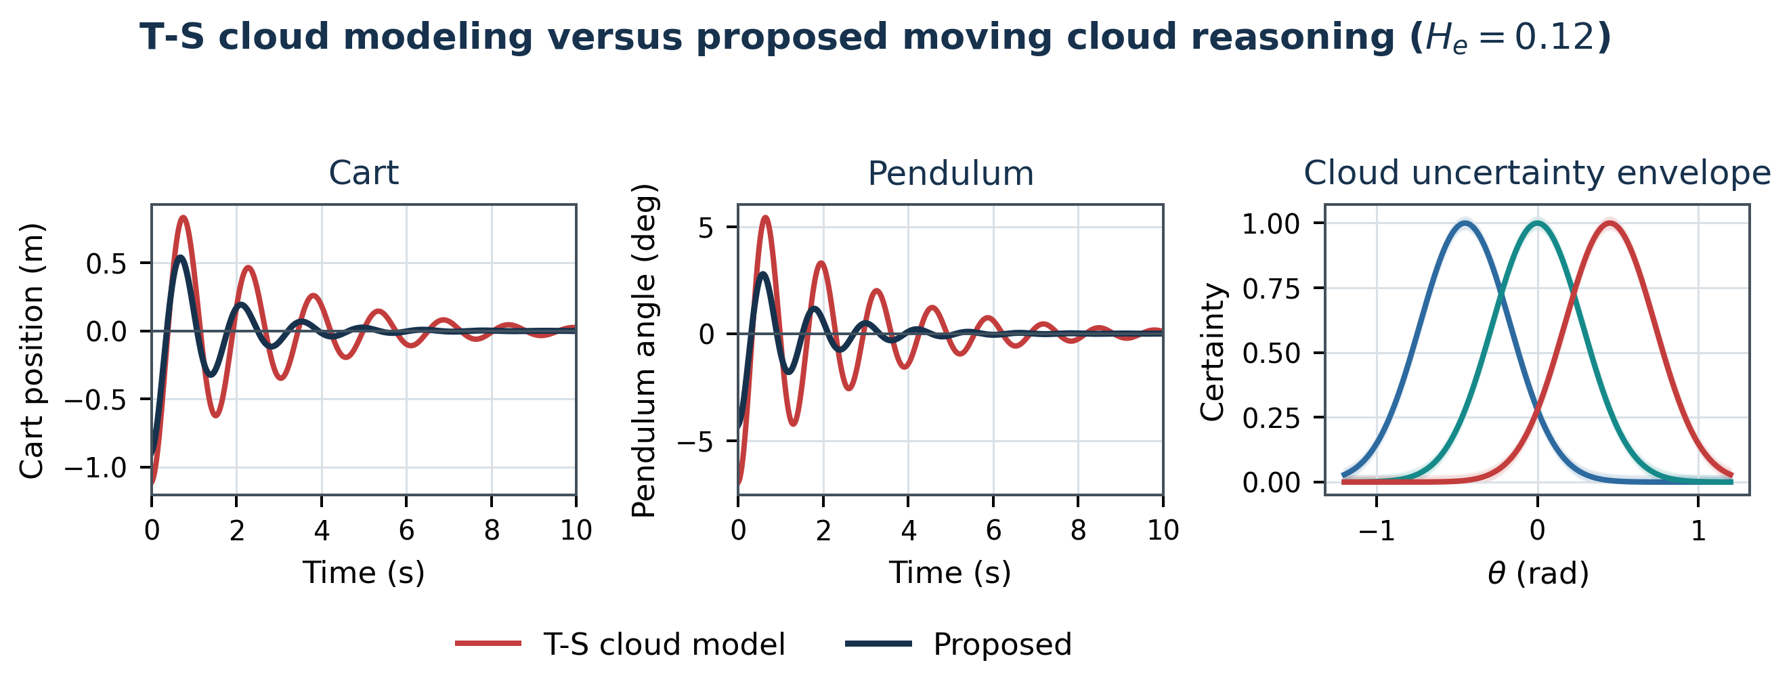
Figure 8. Schematic comparison of T-S cloud modeling and the proposed method at hyper entropy 0.12.
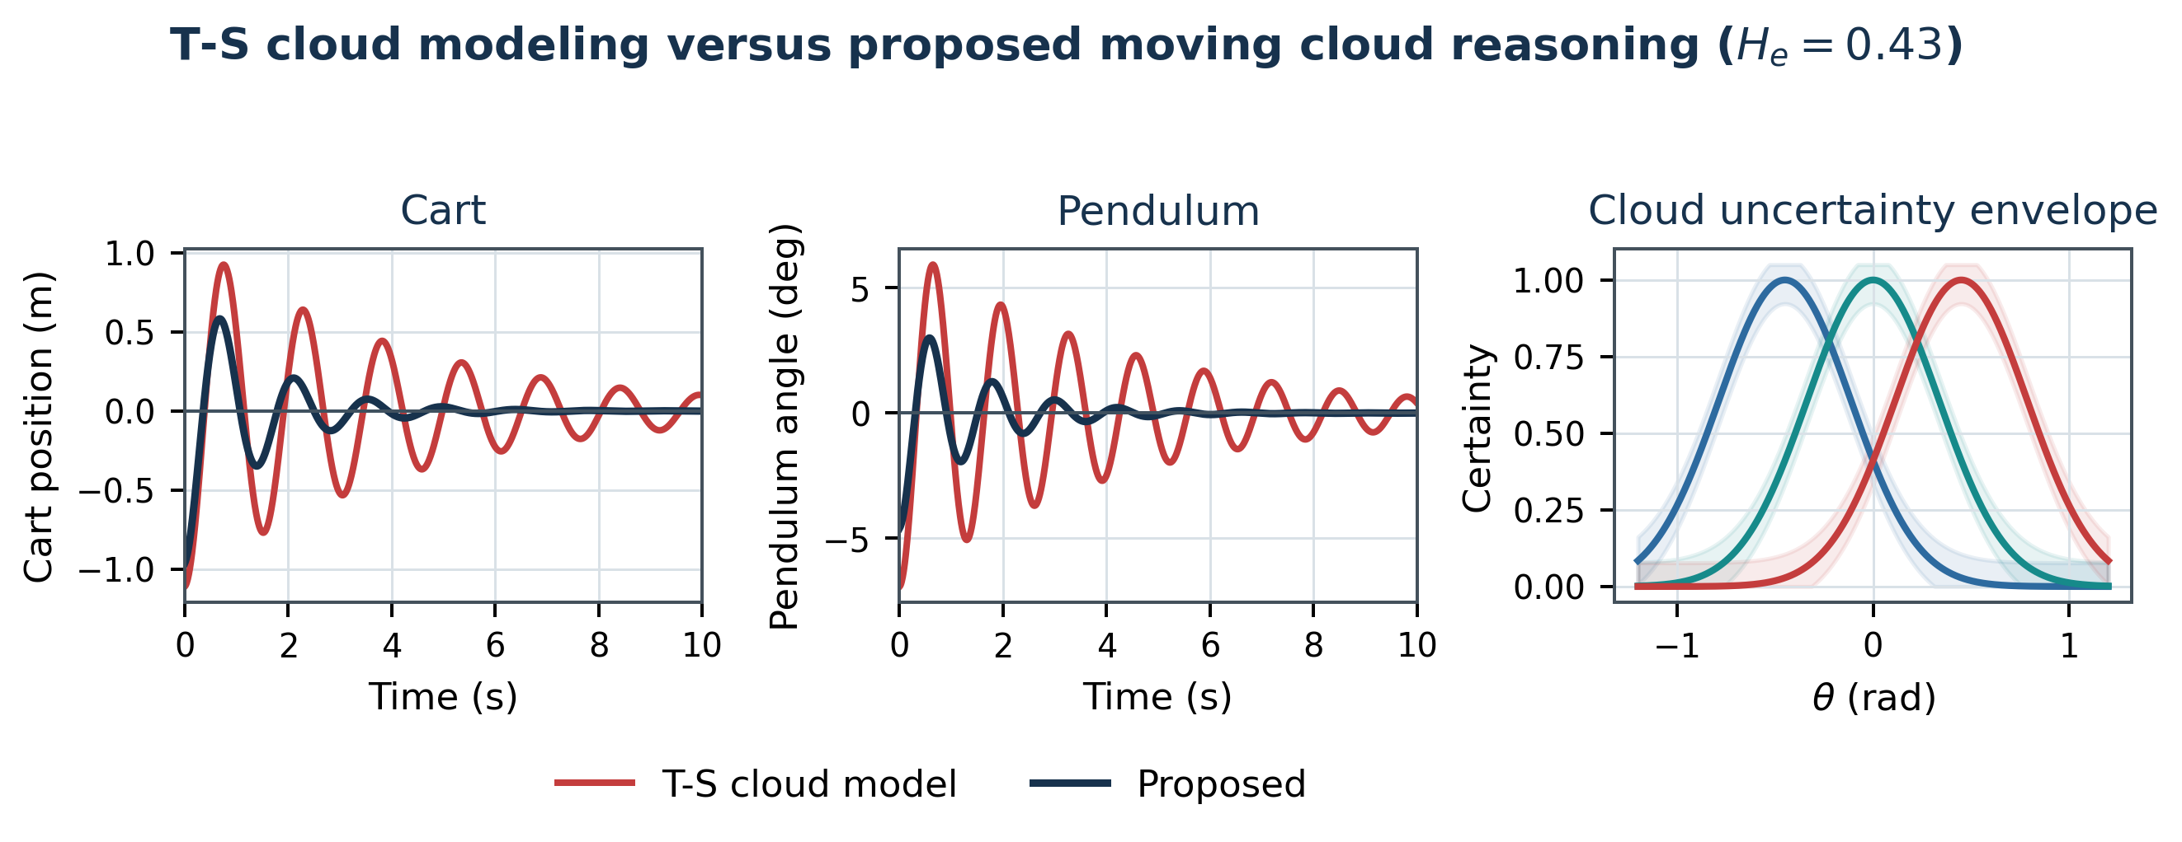
Figure 9. Schematic comparison of T-S cloud modeling and the proposed method at hyper entropy 0.43.
Regarding calculation time, the average calculation time of 20 operations is 1375 ms for T-S cloud modeling, 2058 ms for the preceding moving cloud reasoning method, and 742 ms for the proposed moving cloud reasoning method.
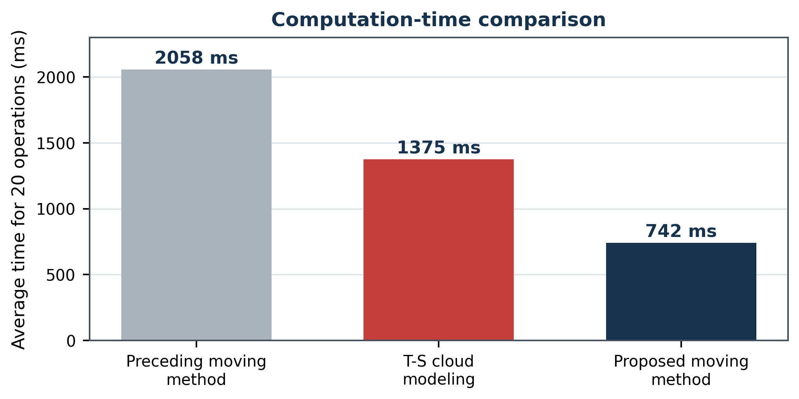
Figure 10. Computation-time comparison reconstructed from the exact values reported in the source paper.
Table 2. Comparison of the proposed method and T-S cloud modeling [14] (excerpt; Ov: overshoot, Tr: transient time, s).
Hyper entropy | Object | T-S Ov | T-S Tr | Proposed Ov | Proposed Tr | Ov improvement (%) | Tr improvement (%)
0.01 | 1 | 1.11 | 4.83 | divergence of [14] | - | - | -
0.01 | 2 | 6.93 | 4.22 | - | - | - | -
0.02 | 1 | 1.11 | 4.83 | divergence of [14] | - | - | -
0.02 | 2 | 6.93 | 4.27 | - | - | - | -
0.13 | 1 | 1.11 | 4.83 | 0.89 | 4.60 | 19.1 | 5
0.13 | 2 | 6.93 | 4.22 | 0.83 | 1.65 | 43.1 | 10
0.14 | 1 | 1.11 | 4.83 | 0.83 | 4.60 | 11.2 | 13.2
0.14 | 2 | 6.93 | 4.22 | 0.85 | 4.49 | - | -
Three observations follow from these results. First, the proposed method converges on the hyper-entropy range $\left[0.03,0.50\right]$, which is more than twice as wide as the range $\left[0.04,0.23\right]$ of the preceding moving method; it can therefore reflect vagueness and randomness of the concepts over a much wider range of uncertainty. Second, the overshoot of both the cart and the pendulum is reduced by roughly 10-40% with respect to T-S cloud modeling [14] in the convergent cases. Third, since the entropy is obtained without derivatives and integrals, the proposed method is about 2.8 times faster than the preceding moving method and about 1.9 times faster than T-S cloud modeling, which makes it suitable for real-time control loops - a property that recent inverted-pendulum studies with learning-based controllers [26, 27, 28] obtain only at a considerably higher computational cost.

5.1 Quantitative visual analysis of uncertainty range, computation, and transient response
The additional graphs in Figures 11-14 are derived only from numerical values explicitly reported in the manuscript; no unreported time-series samples are invented. Figure 11 visualizes the reported hyper-entropy interval and shows that the proposed KSI moving-cloud method spans a width of 0.47 (0.03-0.50), whereas the preceding method spans 0.19 (0.04-0.23), i.e., approximately 2.47 times the uncertainty interval. Figure 12 converts the reported 20-operation timings into speed-up factors: 2.77x relative to the preceding moving method and 1.85x relative to T-S cloud modeling. Figures 13 and 14 plot the raw overshoot and transient-time entries at He=0.13 and 0.14, allowing the reader to see where the proposed method yields the strongest gains and where the transient-time advantage is smaller.
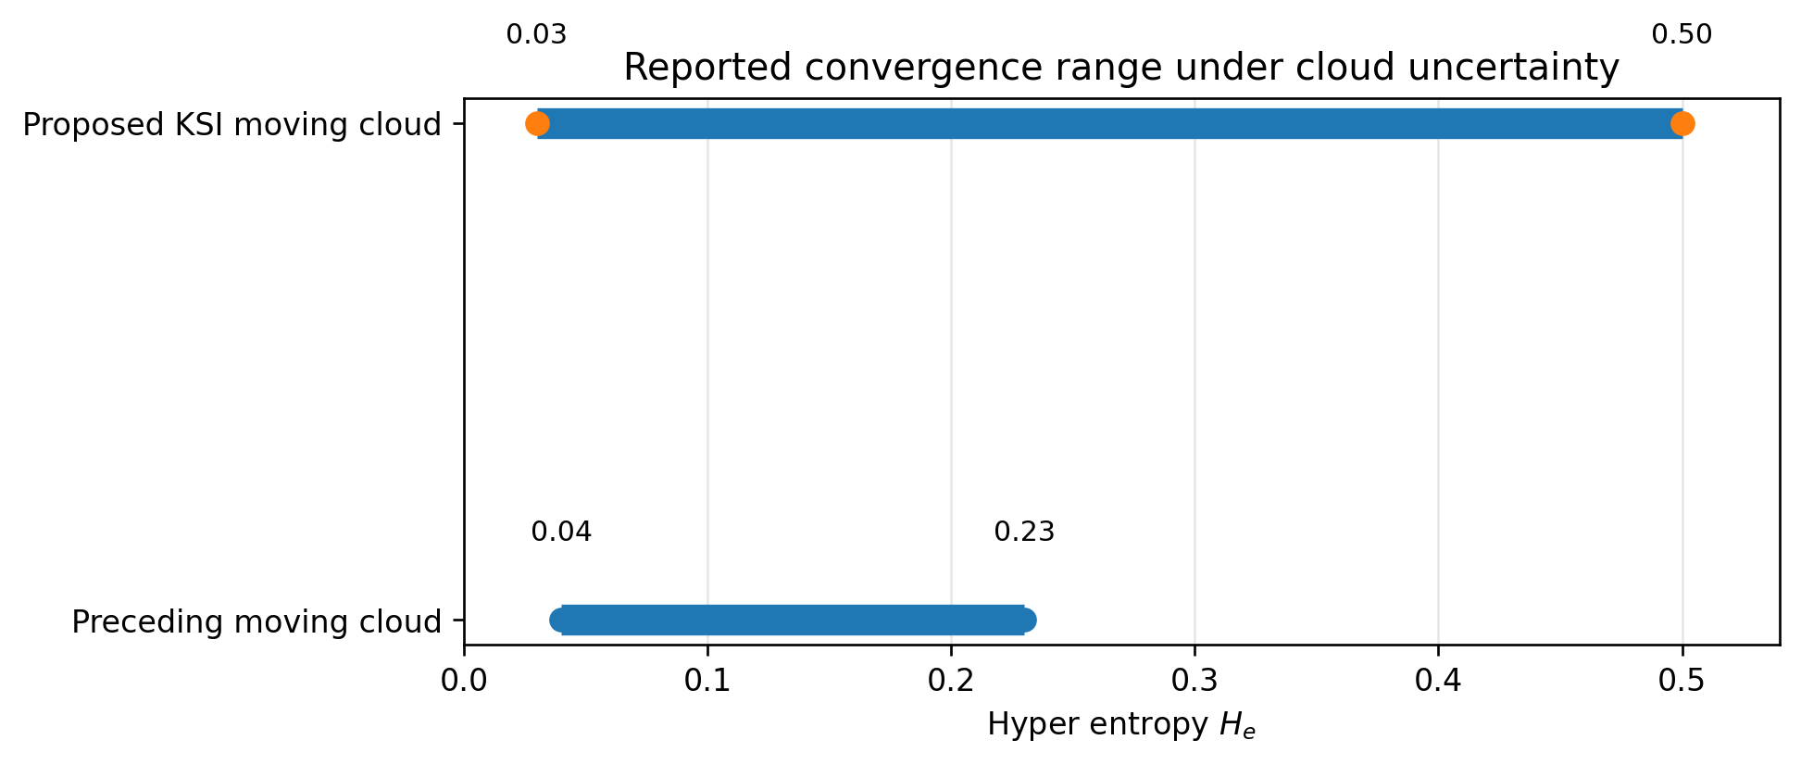
Figure 11. Reported hyper-entropy convergence intervals of the preceding and proposed moving-cloud reasoning methods.
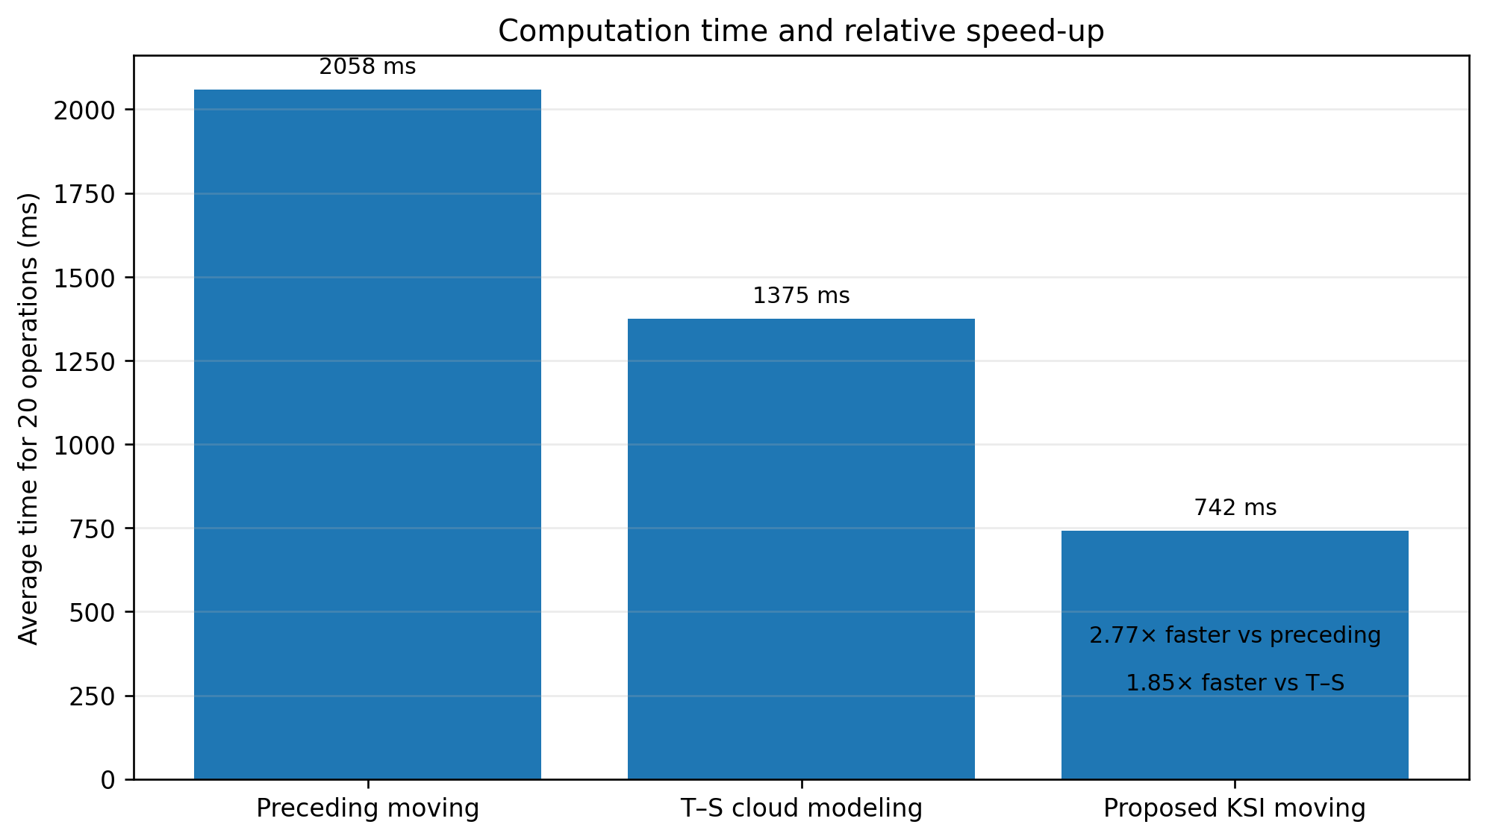
Figure 12. Computation-time comparison and speed-up factors derived from the reported 20-operation measurements.
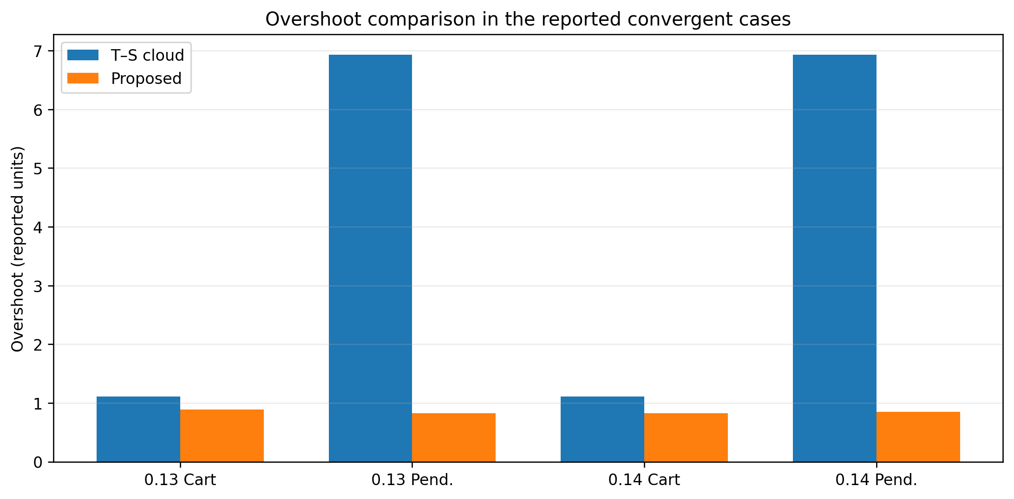
Figure 13. Overshoot comparison using the raw Table 2 values for the convergent He=0.13 and He=0.14 cases.
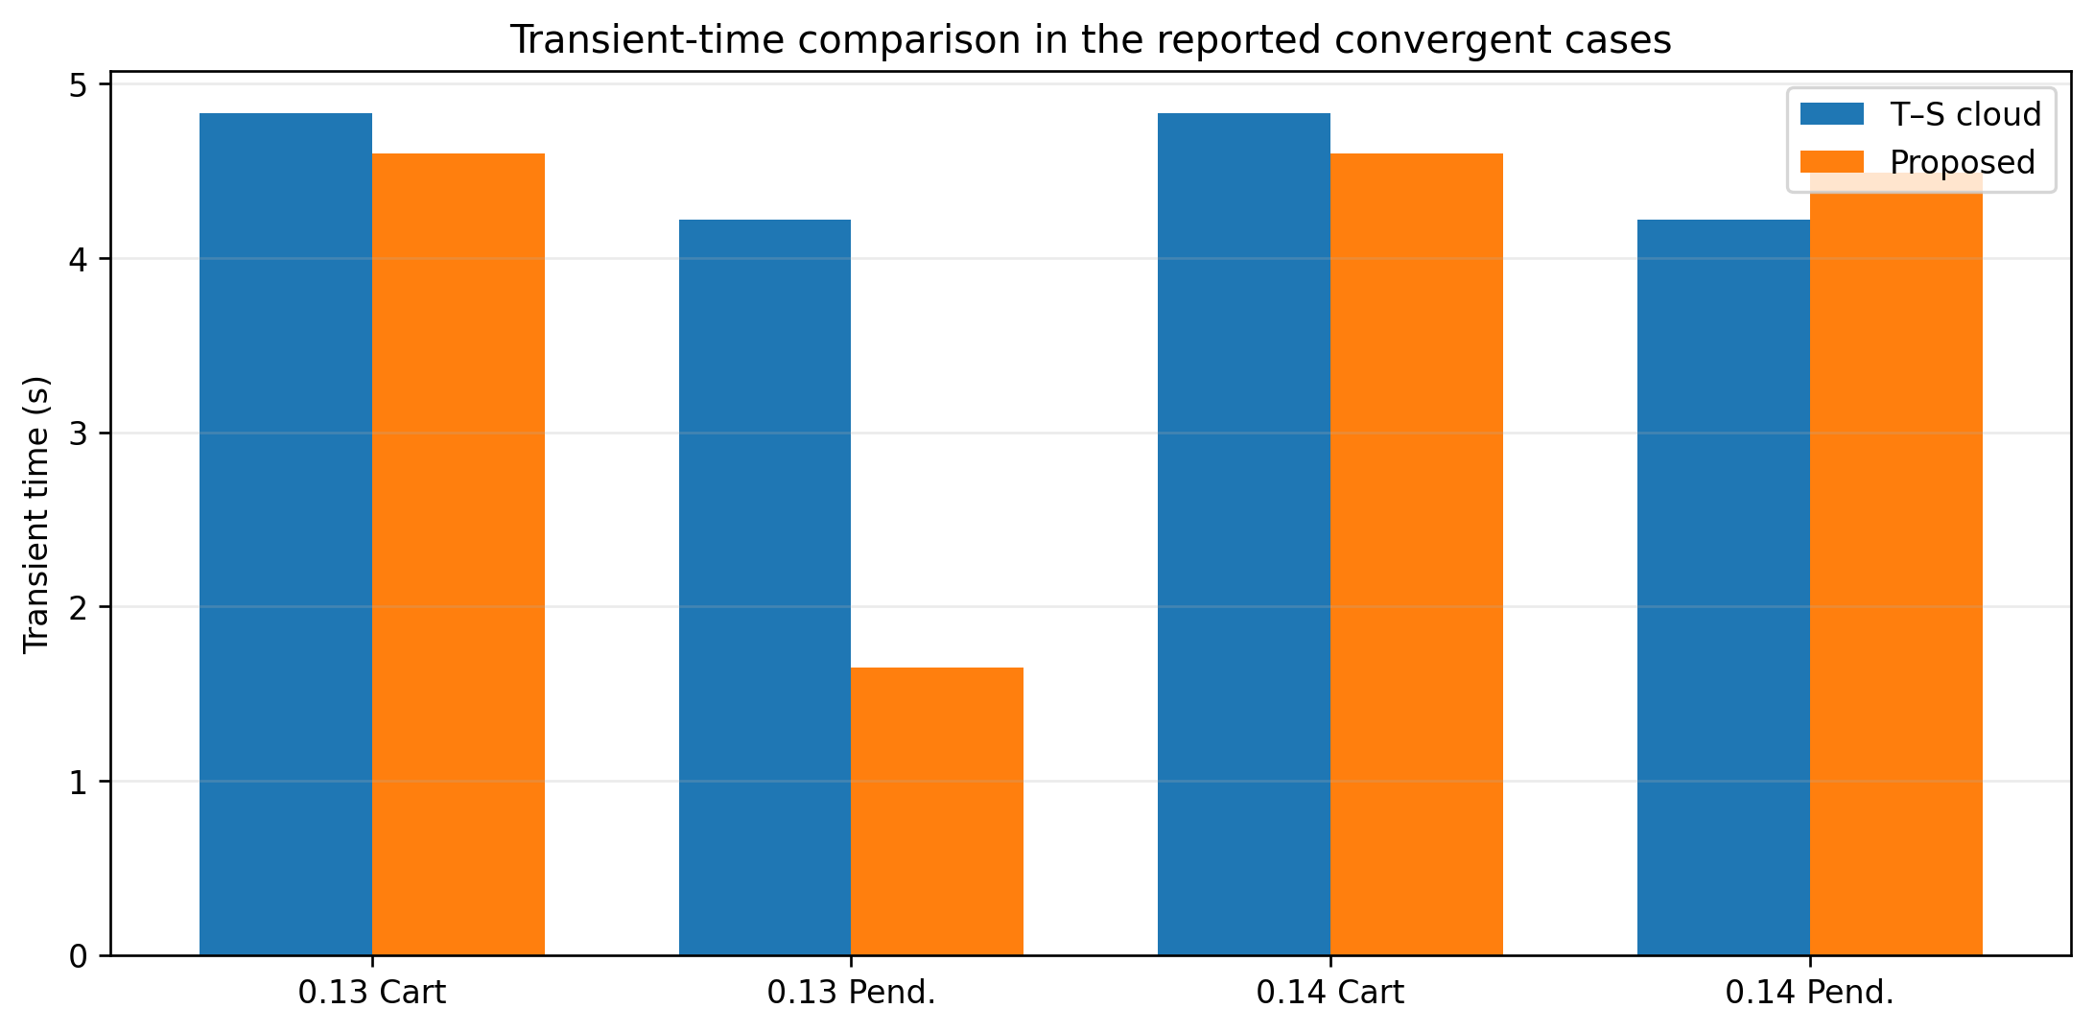
Figure 14. Transient-time comparison using the raw Table 2 values for the convergent He=0.13 and He=0.14 cases.
These visualizations support the manuscript's central computational claim but should not be interpreted as a substitute for a repeated-run statistical comparison. The source data provide aggregate timings and selected transient metrics rather than raw replicated runs. A future revision with the original experimental logs should report processor/software configuration, number of repetitions, confidence intervals, and nonparametric paired tests so that timing and control-performance significance can be assessed formally.

6 Conclusions
This paper presented a new moving cloud reasoning method based explicitly on the KSI principle and verified it in stabilization control of a single inverted pendulum. The method transfers KSI movement/compensation from fuzzy sets to membership clouds and thereby combines the reductive reasoning philosophy of [12,20,31] with the stochastic cloud descriptors Ex, En, and He. The corrected seven-step formulation eliminates derivative/integral evaluation from the online reasoning loop, has dominant complexity O(Rmg), and can be implemented with simple arithmetic, sign/width selection, stochastic draws, and averaging. In the reported experiments, the method converged over He=0.03-0.50, compared with He=0.04-0.23 for the preceding moving-cloud method, and reduced the 20-operation time to 742 ms from 2058 ms and 1375 ms for the two comparison methods. The inverted-pendulum results further indicate reduced overshoot in the convergent comparison cases. Together with the 2015-2026 literature synthesis and ten-method algorithmic comparison, these results position KSI moving-cloud reasoning as a computationally economical uncertainty-reasoning layer for interpretable nonlinear control.
Future work should validate the method on additional physical pendulum platforms, publish raw repeated-run data, and test sensitivity to the cloud-drop number, He, sensor noise, actuator saturation, and parameter drift. The theoretical program should also formalize reductive and stability properties for multi-rule/multi-output cloud systems, integrate the interval KSI construction in [20], and compare against recent 2026 adaptive fuzzy/sliding and interval type-2 T-S controllers [73-75] under identical hardware and sampling conditions. The supplied code isolates the stochastic J(.) operator so that the exact generator used by the authors can be inserted directly for independent replication.

References
- Zadeh, L. A.: The concept of a linguistic variable and its applications to approximate reasoning. Information Sciences 8, pp. 199-249, 1975. DOI: 10.1016/0020-0255(75)90036-5.
- Li, D.-Y., Du, Y.: Artificial Intelligence with Uncertainty. Tsinghua University, Beijing, China; CRC Press, 2017. ISBN 9781498776264.
- Zhou, N.: Cloud model and its application in intelligent control. Master’s degree thesis, PLA University of Science and Technology, Nanjing, China, 2000.
- Li, W., Wang, Y., Du, J., Lai, J.: Synergistic integration of graph-cut and cloud model strategies for image segmentation. Neurocomputing 257, pp. 37-46, 2017. DOI: 10.1016/j.neucom.2016.12.072.
- Liu, Y.: The research of granular computing based on cloud. PhD thesis, Tsinghua University, Beijing, China, 2012.
- Li, Y., Fan, X.: Recursive integral proportional-integral control based on membership cloud for active power filter. IET Power Electronics, 2014. DOI: 10.1049/iet-pel.2014.0285.
- Zheng, Y., Sheng, W., Sun, X., Chen, S.: Airline passenger profiling based on fuzzy deep machine learning. IEEE Transactions on Neural Networks and Learning Systems 28(12), pp. 2911-2923, Dec. 2017. DOI: 10.1109/TNNLS.2016.2609437.
- Filho, O. D. R., Serra, G. L. D. O.: Recursive fuzzy instrumental variable based evolving neuro-fuzzy identification for non-stationary dynamic system in a noisy environment. Fuzzy Sets and Systems 338, pp. 50-89, 2018. DOI: 10.1016/j.fss.2017.05.016.
- Essien, E., Ibrahim, H., Mehrandezh, M., Idem, R.: Adaptive neuro-fuzzy inference system (ANFIS)-based model predictive control (MPC) for carbon dioxide reforming of methane (CDRM) in a plug flow tubular reactor for hydrogen production. Thermal Science and Engineering Progress 9, pp. 148-161, 2019. DOI: 10.1016/j.tsep.2018.11.010.
- Chen, T.-Y.: An outranking approach using a risk attitudinal assignment model involving Pythagorean fuzzy information and its application to financial decision making. Applied Soft Computing 71, pp. 460-487, 2018. DOI: 10.1016/j.asoc.2018.06.036.
- Du, Z., Yan, Z., Zhao, Z.: Interval type-2 fuzzy tracking control for nonlinear systems via sampled-data controller. Fuzzy Sets and Systems 356, pp. 92-112, 2019. DOI: 10.1016/j.fss.2018.02.013.
- Kwak, S.-I., Ryu, U.-S., Kim, K.-J.: A fuzzy reasoning method based on compensating operation and its application to fuzzy systems. Iranian Journal of Fuzzy Systems 16(3), pp. 17-34, 2019. DOI: 10.22111/IJFS.2018.4175.
- Mizumoto, M., Zimmermann, H. J.: Comparison of fuzzy reasoning methods. Fuzzy Sets and Systems 8, pp. 253-283, 1982. DOI: 10.1016/S0165-0114(82)80004-3.
- Li, C., Zhou, J. Z., Fu, B., Kou, P., Xiao, J.: T-S fuzzy model identification with a gravitational search-based hyperplane clustering algorithm. IEEE Transactions on Fuzzy Systems 20(2), pp. 305-317, 2012. DOI: 10.1109/TFUZZ.2011.2173693.
- Li, D., Du, Y.: Artificial Intelligence with Uncertainty, 2nd edition. CRC Press, Boca Raton, ISBN 978-1-4987-7626-4.
- Kwak, S.-I., Kim, U.-H., Kim, K.-J., Son, I.-M.: Fuzzy reasoning method based on distance measure and its reductive property. WSEAS Transactions on Computer Research 8, pp. 73-89, 2020. DOI: 10.37394/232018.2020.8.10.
- Kwak, C.-J., Ri, K.-C., Kwak, S.-I., Kim, K.-J., Ryu, U.-S., Kwon, O.-C., Kim, N.-H.: Fuzzy modus ponens and tollens based on moving distance in SISO fuzzy system. Romanian Journal of Information Science and Technology 24(3), pp. 257-283, 2021.
- Son, I. M., Kwak, S. I., Han, U. J., Pak, J. H., Han, M., Pyon, J. R., Ryu, U. S.: A novel fuzzy approximate reasoning method based on extended distance measure in SISO fuzzy system. arXiv:2003.13450, 2020.
- Kwak, S.-I., et al.: New approximate reasoning method based on least common multiple and its property analysis. Proceedings of the 5th International Conference on Applied Science, Engineering and Management, 2022.
- Kong, H.-U., Kwak, S.-I., Jang, Y.-J., Hwang, C.-J., Ri, O.-S., Jo, Y.-H., Nam, J.-H., Ryu, U.-S.: New interval fuzzy modeling method based on KSI principle and its application in turf color image evaluation. Journal of Industrial and Management Optimization 21(12), pp. 6713-6735, 2025. DOI: 10.3934/jimo.2025146.
- Choe, J.-H., Jang, Y.-J., Kwak, S.-I., Ri, O.-S., Kong, H.-U.: Causal-entropic fuzzy inference: a Bayesian framework for explainable and robust fuzzy reasoning. Journal of Fuzzy Systems and Control 4(1), 2026. ISSN 2986-6537. DOI: 10.59247/jfsc.v4i1.392.
- Choe, J.-H., Choe, G., Kwak, S.-I., Chae, H.-G., Kong, H.-U.: Improved shark smell optimization with adaptive parameter scheduling for fuzzy controller tuning. Academy Journal of Science and Engineering 20(1), 2026.
- Jia, Q., Hu, J., Zhang, W., Zhai, S., Li, Z.: A new situation assessment method for aerial targets based on linguistic fuzzy sets and trapezium clouds. Engineering Applications of Artificial Intelligence 117, 105610, 2023.
- Su, X., Xia, F., Liu, J., Wu, L.: Event-triggered fuzzy control of nonlinear systems with its application to inverted pendulum systems. Automatica 94, pp. 236-248, 2018.
- Nasir, A. N. K., Razak, A. A. A.: Opposition-based spiral dynamic algorithm with an application to optimize type-2 fuzzy control for an inverted pendulum system. Expert Systems with Applications 195, 116661, 2022.
- Safeea, M., Neto, P.: A Q-learning approach to the continuous control problem of robot inverted pendulum balancing. Intelligent Systems with Applications, 200313, 2023. DOI: 10.1016/j.iswa.2023.200313.
- Irfan, S., Zhao, L., Ullah, S., Mehmood, A., Butt, M. F. U.: Control strategies for inverted pendulum: a comparative analysis of linear, nonlinear, and artificial intelligence approaches. PLoS ONE 19(3), e0298093, 2024. DOI: 10.1371/journal.pone.0298093.
- Nguyen, T. V. A., Dao, Q., Bui, N.-T.: Optimized fuzzy logic and sliding mode control for stability and disturbance rejection in rotary inverted pendulum. Scientific Reports 14, 2024. DOI: 10.1038/s41598-024-82471-y.
- Saleem, O., Alsuwian, T., Amin, A. A., Ali, S., Alqarni, Z. A.: Stabilization control of rotary inverted pendulum using a novel EKF-based fuzzy adaptive sliding-mode controller: design and experimental validation. Automatika 65(2), pp. 538-558, 2024. DOI: 10.1080/00051144.2024.2312309.
- Tian, B., Peng, H., Kang, T.: RBF-ARX model-based predictive control approach to an inverted pendulum with self-triggered mechanism. Chaos, Solitons & Fractals 186, 115291, 2024. DOI: 10.1016/j.chaos.2024.115291.
- Kwak, S.-I., Yu, H.-U., Jang, Y.-J., Hwang, C.-J., Ri, O.-S., Chae, H.-G.: Optimal Fuzzy Modus Ponens and Tollens Algorithm Based on KSI Principle. Research Square preprint, posted 4 Dec. 2023. DOI: 10.21203/rs.3.rs-3690916/v1.
- Lee, J., Mukherjee, R., Khalil, H. K.: Output feedback stabilization of an inverted pendulum on a cart in the presence of uncertainties. Automatica 54, pp. 146-157, 2015. DOI: 10.1016/j.automatica.2015.01.013.
- Cuevas, P. T., Luna, A. H., Sanchez, J. F., Lopez, I. M., Bonilla, S. I.: Stability of fuzzy and LQR controllers applied to an inverted pendulum system. IEEE International Autumn Meeting on Power, Electronics and Computing (ROPEC), pp. 1-6, 2015.
- Li, X., Ren, Y.: The design and improvement of a fuzzy controller based on a single inverted pendulum. Proc. Int. Conf. Management, Education, Information and Control, pp. 1671-1677, 2015. DOI: 10.2991/meici-15.2015.292.
- Jedda, O., Ghabi, J., Douik, A.: Second order sliding mode control for inverted pendulum. 12th International Multi-Conference on Systems, Signals & Devices (SSD), pp. 1-5, 2015.
- Reddy, N. S., Saketh, M. S., Pal, P., Dey, R.: Optimal PID controller design of inverted pendulum dynamics: a hybrid pole-placement and firefly algorithm approach. IEEE CMI, pp. 305-310, 2016.
- Tang, Y., Zhou, D., Jiang, W.: A new fuzzy-evidential controller for stabilization of the planar inverted pendulum system. PLoS ONE 11(8), e0160416, 2016. DOI: 10.1371/journal.pone.0160416.
- Wang, X., Dong, H., Sun, X., Yao, X.: PD control of inverted pendulum based on adaptive fuzzy compensation. Journal of Intelligent & Fuzzy Systems 31(6), 2016. DOI: 10.3233/JIFS-169186.
- Roose, A. I., Yahya, S., Al-Rizzo, H.: Fuzzy-logic control of an inverted pendulum on a cart. Computers & Electrical Engineering 61, pp. 31-47, 2017. DOI: 10.1016/j.compeleceng.2017.05.016.
- Ghommam, J., Mnif, F.: Predictor-based output feedback stabilization of an inverted pendulum on a cart with time-delay/uncertainty. ISA Transactions, 2017. DOI: 10.1016/j.isatra.2017.01.015.
- Messikh, L., Guechi, E. H., Benloucif, M. L.: Cascade model predictive control of a cart-inverted-pendulum system. Journal of the Franklin Institute 354(16), pp. 7241-7265, 2017. DOI: 10.1016/j.jfranklin.2017.08.039.
- Mahjoub, S., et al.: Advanced sliding mode control techniques for inverted pendulum: modelling and simulation. Engineering Science and Technology, an International Journal 21(4), pp. 753-759, 2018. DOI: 10.1016/j.jestch.2018.06.010.
- Huang, J., Ri, M., Wu, D., et al.: Interval type-2 fuzzy logic modeling and control of a mobile two-wheeled inverted pendulum. IEEE Transactions on Fuzzy Systems 26(4), pp. 2030-2038, 2018.
- Abut, T., Soyguder, S.: Real-time control and application with self-tuning PID-type fuzzy adaptive controller of an inverted pendulum. Industrial Robot 46(1), pp. 159-170, 2019. DOI: 10.1108/IR-10-2018-0206.
- Chiu, C.-H., Wang, W.-J.: Robust fuzzy control of an inverted-pendulum-type system. ISA Transactions 86, pp. 287-298, 2019. DOI: 10.1016/j.isatra.2018.10.012.
- Huang, J., Zhang, T., Fan, Y., Sun, J. Q.: Control of a rotary inverted pendulum using model-free backstepping. IEEE Access 7, pp. 96965-96973, 2019. DOI: 10.1109/ACCESS.2019.2930220.
- Xia, X., Xia, J., Gang, M., Zhang, Q., Wang, J.: Discrete dynamics-based parameter analysis and optimization of fuzzy controller for inverted pendulum systems based on chaos algorithm. Discrete Dynamics in Nature and Society, 3639508, 2020. DOI: 10.1155/2020/3639508.
- Jmel, I., Dimassi, H., Hadj-Said, S., M'Sahli, F.: Adaptive sliding-mode observer/control for inverted-pendulum systems. ISA Transactions 102, pp. 264-279, 2020. DOI: 10.1016/j.isatra.2020.02.029.
- Feng, Y., Gao, Y., Zhao, X., Yan, X.-G., Spurgeon, S. K.: Dynamic output-feedback sliding-mode control with application to an inverted pendulum. IFAC-PapersOnLine, 2020. DOI: 10.1016/j.ifacol.2020.12.1182.
- Jayaprakash, A. K., Kidambi, K. B., MacKunis, W., Drakunov, S. V., Reyhanoglu, M.: Robust nonlinear control and experimental validation for an inverted pendulum platform. Robotics 9(4), 87, 2020. DOI: 10.3390/robotics9040087.
- Hadipour Lakmesari, S., Mahmoodabadi, M. J., Ibrahim, M. Y.: Fuzzy logic and gradient descent-based optimal adaptive robust controller with inverted pendulum verification. Chaos, Solitons & Fractals 151, 111257, 2021. DOI: 10.1016/j.chaos.2021.111257.
- Dai, Y., Lee, K., Lee, S.: Real-time hardware-in-the-loop reinforcement learning control of a rotary inverted pendulum using deep Q-learning. Measurement and Control, 2021. DOI: 10.1177/00202940211000380.
- Husmann, R., Aschemann, H.: Nonlinear model predictive control benchmark studies for inverted-pendulum systems. IFAC-PapersOnLine, 2021. DOI: 10.1016/j.ifacol.2021.10.363.
- Kelekci, E., Yaren, T., Kizir, S.: Design of optimized interval type-2 fuzzy logic controller based on continuity, monotonicity and smoothness properties for a cart-pole inverted pendulum. Transactions of the Institute of Measurement and Control 44(12), pp. 2291-2307, 2022. DOI: 10.1177/01423312221081309.
- Abut, T., Soyguder, S.: Two-loop self-adaptive fuzzy PID control for an inverted pendulum system. Transactions of the Institute of Measurement and Control, 2022. DOI: 10.1177/01423312211040301.
- Gupta, N., Dewan, L.: Adaptive super-twisting sliding mode control of a rotary inverted pendulum using modified grey wolf optimization. Journal of Control and Decision, 2022. DOI: 10.1080/23307706.2022.2062621.
- Abuelenin, S. M., Abdel-Kader, R. F.: Closed-form mathematical representations of interval type-2 fuzzy logic systems with application to inverted pendulum stabilization. International Journal of Modelling and Simulation, pp. 269-290, 2022. DOI: 10.1080/16168658.2022.2152922.
- Alqudsi, Y. S., Dorrah, H. T., Kassem, A. H., El-Bayoumi, G. M.: Robust compound control of a wheeled inverted pendulum system. Engineering Science and Technology, an International Journal 28, 101024, 2022. DOI: 10.1016/j.jestch.2021.06.004.
- Nguyen, T.-V.-A., Dong, B.-T., Bui, N.-T.: Enhancing stability control of inverted pendulum using Takagi-Sugeno fuzzy model with disturbance rejection and input-output constraints. Scientific Reports 13, 14412, 2023. DOI: 10.1038/s41598-023-41258-3.
- Israilov, S., Fu, L., Sanchez-Rodriguez, J., Fusco, F., Allibert, G., Raufaste, C., et al.: Reinforcement learning approach to control an inverted pendulum: a general framework for educational purposes. PLoS ONE 18(2), e0280071, 2023. DOI: 10.1371/journal.pone.0280071.
- Pham, D.-B., Dao, Q.-T., Bui, N.-T., et al.: Robust-optimal control of rotary inverted pendulum through fuzzy descriptor-based techniques. Scientific Reports 14, 5593, 2024. DOI: 10.1038/s41598-024-56202-2.
- Ben Hazem, Z.: Reinforcement-learning control of a rotary inverted pendulum using Q-learning and deep Q-networks. Discover Applied Sciences 6, 49, 2024. DOI: 10.1007/s42452-024-05690-y.
- de la Cruz-Alejo, J., et al.: Decision-making comparison of neuro-fuzzy, adaptive, and PID strategies for inverted-pendulum control. Discover Applied Sciences 6, 251, 2024. DOI: 10.1007/s42452-024-05921-2.
- Nisar, L., Koul, M. H., Ahmad, B.: Control and stabilization of a two-degree-of-freedom rotary inverted pendulum. IFAC-PapersOnLine, 2024. DOI: 10.1016/j.ifacol.2024.05.044.
- Yang, W., Yu, G., Reis, J., Silvestre, C.: Robust nonlinear three-dimensional control of a pendulum suspended from a quadrotor. Automatica 159, 111336, 2024. DOI: 10.1016/j.automatica.2023.111336.
- Abut, T.: An inverted pendulum system control with fuzzy linear quadratic regulator method: experimental validation. Computers, Materials & Continua 85(2), pp. 4023-4042, 2025. DOI: 10.32604/cmc.2025.066920.
- Li, Z., Li, J., Huang, Y., Li, Y., Xin, B.: Multi Strategy SA-PSO for inverted pendulum identification combined with explicit model predictive control. Journal of Advanced Computational Intelligence and Intelligent Informatics 29(5), pp. 1019-1028, 2025. DOI: 10.20965/jaciii.2025.p1019.
- Susanto, E., Sumaryo, S., Hassan, M. F.: LQR, LQG, extremum seeking and sliding mode controls combined with fuzzy for a rotary inverted pendulum stabilization. Results in Control and Optimization 21, 100629, 2025. DOI: 10.1016/j.rico.2025.100629.
- Costanzo, M., Mazza, R., Natale, C.: Digital control of an inverted pendulum using a velocity-controlled robot. Machines 13(6), 528, 2025. DOI: 10.3390/machines13060528.
- Mobara, M., Karimpour, A., Pahnabi, A., Molla-Ahmadian, H.: Patched-fuzzy state feedback controller for inverted pendulum on a cart based on PWA-fuzzy model. Advanced Control for Applications: Engineering and Industrial Systems 7(4), e70032, 2025. DOI: 10.1002/adc2.70032.
- Mon, Y.-J.: Decoupled reinforcement hybrid PPO-sliding control for underactuated systems: application to cart-pole and acrobot. Machines 13(7), 601, 2025. DOI: 10.3390/machines13070601.
- Brumand-Poor, F., Wagemann, P., Geibel, T., Schmitz, K.: Model-based reinforcement learning for hydraulic systems: a PILCO-based control strategy for controlling an inverted hydraulic pendulum. International Journal of Dynamics and Control 13, 347, 2025. DOI: 10.1007/s40435-025-01860-x.
- Mohammed, T. K., Ezez, S. F., Siraj, A. Z., et al.: Adaptive fuzzy sliding mode control applied to inverted pendulum. Scientific Reports 16, 14938, 2026. DOI: 10.1038/s41598-026-45197-7.
- Dao, Q.-T.: Uncertainty-resilient control of an inverted pendulum on a cart using interval type-2 Takagi-Sugeno fuzzy modeling and subsystem LQR control. Automation 7(3), 92, 2026. DOI: 10.3390/automation7030092.
- Shalbafian, A., Amiri, F.: Nonlinear control design for stabilization and tracking of a rotary inverted pendulum. Scientific Reports, 2026. DOI: 10.1038/s41598-026-57277-9.

Supplementary Material: Reproducible KSI Moving-Cloud and Inverted-Pendulum Code
The following reference programs implement Algorithms 1-4. Reproducibility note: Eq. (29) defines J(En_rule, En_input, He_rule, He_input) symbolically in the manuscript rather than as a unique random-number formula. Therefore both programs isolate J(.) as a named function and supply a transparent Gaussian default realization. If the authors' original J generator differs, replacing this single function preserves the rest of the implementation. Likewise, the source manuscript does not report every physical plant parameter/control-gain value needed to regenerate the original experimental curves; the controller code uses the local A/B matrices reported in Section 4.2 and reproducible LQR gains. The reported experimental tables remain the authoritative record.

Supplement S1. Full Python program
"""Reference implementation for KSI-principle moving-cloud reasoning and inverted-pendulum control.

The manuscript defines the normal-random operator J(En_rule, En_input, He_rule, He_input)
symbolically. `normal_random_operator` below provides a reproducible Gaussian realization;
if the authors use a different J generator, replace only that function.
"""
from __future__ import annotations
import numpy as np
from dataclasses import dataclass
from scipy.linalg import solve_continuous_are

EPS = 1e-12

@dataclass
class Cloud:
ex: float
en: float
he: float

def expected_curve(x: np.ndarray | float, c: Cloud) -> np.ndarray:
x = np.asarray(x, dtype=float)
return np.exp(-0.5 * ((x - c.ex) / max(abs(c.en), EPS)) ** 2)

def sign_gate(z: float) -> float:
"""Left/right selector used by the piecewise cloud-width equations."""
return float(min(1.0 - np.sign(z), 1.0))

def normal_random_operator(en_rule: float, en_input: float,
he_rule: float, he_input: float,
rng: np.random.Generator) -> float:
"""Explicit reproducible realization of the symbolic J(.) in Eq. (29)."""
scale = max(abs(en_rule), abs(en_input), EPS)
mu = (en_input - en_rule) / scale
sigma = np.hypot(he_rule, he_input) / scale
return float(rng.normal(mu, sigma))

def input_cloud(x: float, premise: Cloud, he_input: float | None = None) -> Cloud:
"""Cloudify a crisp input: its expectation is x; entropy follows the premise scale."""
if he_input is None:
he_input = premise.he
distance = abs(x - premise.ex)
en = max(EPS, 0.5 * (abs(premise.en) + distance))
return Cloud(float(x), float(en), float(he_input))

def ksi_moving_cloud_reasoning(inputs, premise_clouds, consequent: Cloud,
n_drops: int = 200, seed: int = 7):
"""Algorithm 1: m-input/single-output KSI moving-cloud reasoning.

Returns crisp output, moved output cloud, and diagnostic moving amounts.
Complexity: O(m*n_drops) time and O(n_drops) working memory.
"""
x = np.asarray(inputs, dtype=float)
if len(x) != len(premise_clouds):
raise ValueError("one premise cloud is required for each input")
rng = np.random.default_rng(seed)
cma = []
for xj, aj in zip(x, premise_clouds):
obs = input_cloud(float(xj), aj)
nrn = np.array([
normal_random_operator(aj.en, obs.en, aj.he, obs.he, rng)
for _ in range(n_drops)
])
# Eq. (30)-style moving function; Ex is the rule-cloud expectation.
cmf = (xj - aj.ex) - aj.ex * nrn
cma.append(float(np.mean(cmf)))
acma = float(np.mean(cma))
moved = Cloud(consequent.ex + acma, consequent.en, consequent.he)
y = moved.ex # de-cloudification, Eq. (42)
return y, moved, {"CMA": np.asarray(cma), "ACMA": acma}

def stabilization_priority(theta: float, theta_dot: float,
r: float, r_dot: float,
k=(25.0, 7.0, 1.5, 2.5)) -> float:
"""Algorithm 2: pendulum-first qualitative stabilization law."""
k1, k2, k3, k4 = k
return float(k1*theta + k2*theta_dot + k3*r + k4*r_dot)

# Local models reported in Section 4.2
A1 = np.array([[0,0,1,0],[0,0,0,1],[0,0.861,-7.929,-0.0348],[0,48.72,-34.81,-1.971]],float)
A2 = np.array([[0,0,1,0],[0,0,0,1],[0,0.9466,-8.019,-0.03705],[0,50.79,-32.51,-1.993]],float)
A3 = A1.copy()
B1 = np.array([[0],[0],[0.793],[3.487]],float)
B2 = np.array([[0],[0],[0.800],[3.775]],float)
B3 = B1.copy()

def lqr_gain(A, B, Q=None, R=None):
if Q is None: Q = np.diag([12., 45., 2., 4.])
if R is None: R = np.array([[1.]])
P = solve_continuous_are(A, B, Q, R)
return np.linalg.solve(R, B.T @ P)

def cloud_rule_weights(theta: float, centers=(-0.5,0.0,0.5), width=0.35):
w = np.exp(-0.5*((theta-np.asarray(centers))/width)**2)
return w / max(w.sum(), EPS)

def ksi_cloud_controller(state: np.ndarray, he: float = 0.12,
seed: int = 7) -> float:
"""Algorithm 3: three-rule local-controller blending with KSI/cloud uncertainty."""
x = np.asarray(state, dtype=float).reshape(4)
As, Bs = (A1,A2,A3), (B1,B2,B3)
Ks = [lqr_gain(A,B) for A,B in zip(As,Bs)]
w = cloud_rule_weights(x[1])
# Hyper-entropy perturbs the normalized firing strengths reproducibly.
rng = np.random.default_rng(seed)
pert = np.maximum(0.0, w + rng.normal(0.0, he*0.02, size=3))
w = pert / max(pert.sum(), EPS)
u = 0.0
for wi, Ki in zip(w, Ks):
u += wi * float(-(Ki @ x.reshape(-1,1))[0,0])
return float(u)

def blended_dynamics(state: np.ndarray, u: float):
x=np.asarray(state,float).reshape(4,1)
w=cloud_rule_weights(float(x[1,0]))
A=sum(wi*A for wi,A in zip(w,(A1,A2,A3)))
B=sum(wi*B for wi,B in zip(w,(B1,B2,B3)))
return (A@x+B*u).ravel()

def simulate(t_end=10.0, dt=0.002, x0=(0.0,0.12,0.0,0.0), he=0.12):
"""Algorithm 4: closed-loop RK4 simulation and performance data collection."""
t=np.arange(0.0,t_end+dt,dt); X=np.zeros((t.size,4)); U=np.zeros(t.size)
X[0]=x0
for k in range(t.size-1):
u=ksi_cloud_controller(X[k],he=he,seed=7+k); U[k]=u
f=lambda z: blended_dynamics(z,u)
h=dt; k1=f(X[k]); k2=f(X[k]+0.5*h*k1); k3=f(X[k]+0.5*h*k2); k4=f(X[k]+h*k3)
X[k+1]=X[k]+h*(k1+2*k2+2*k3+k4)/6
U[-1]=ksi_cloud_controller(X[-1],he=he,seed=7+t.size)
return t,X,U

if __name__ == "__main__":
premise=[Cloud(-0.5,0.25,0.04),Cloud(0.0,0.25,0.04)]
y,cloud,diag=ksi_moving_cloud_reasoning([-.2,.1],premise,Cloud(0,0.3,0.04))
print("KSI moving-cloud output:",y,"ACMA:",diag["ACMA"])
t,X,U=simulate()
print("final state:",X[-1],"peak |u|:",np.max(np.abs(U)))

Supplement S2. Full MATLAB program
%% KSI-principle moving-cloud reasoning and inverted-pendulum control
% Reference implementation for the manuscript. The paper defines J(.) in
% Eq. (29) symbolically; normalRandomOperator below is a reproducible
% Gaussian realization. Replace only that function if another J generator
% is used by the authors.
clear; clc; rng(7);

% Demonstration of Algorithm 1
premise = [-0.5 0.25 0.04; 0.0 0.25 0.04]; % [Ex En He]
conseq = [0.0 0.30 0.04];
[y, moved, CMA] = ksiMovingCloudReasoning([-0.2 0.1], premise, conseq, 200);
fprintf('KSI moving-cloud output = %.6f, ACMA = %.6f\n', y, mean(CMA));

% Demonstration of Algorithms 3-4
[t,X,U] = simulateClosedLoop(10,0.002,[0;0.12;0;0],0.12);
fprintf('Final state: '); fprintf(' %.5f',X(end,:)); fprintf('\n');
figure; subplot(2,1,1); plot(t,X(:,1),t,X(:,2)); grid on; legend('r','theta');
subplot(2,1,2); plot(t,U); grid on; ylabel('u'); xlabel('time (s)');

function mu = expectedCurve(x,c)
en=max(abs(c(2)),1e-12); mu=exp(-0.5*((x-c(1))/en).^2);
end

function z = normalRandomOperator(enRule,enInput,heRule,heInput)
sc=max([abs(enRule),abs(enInput),1e-12]);
mu=(enInput-enRule)/sc; sig=hypot(heRule,heInput)/sc;
z=mu+sig*randn;
end

function obs = inputCloud(x,premise)
obs=[x, max(1e-12,0.5*(abs(premise(2))+abs(x-premise(1)))), premise(3)];
end

function [y,moved,CMA] = ksiMovingCloudReasoning(inputs,premise,conseq,nDrops)
% Algorithm 1: O(m*nDrops) time, O(nDrops) working memory.
m=numel(inputs); CMA=zeros(1,m);
for j=1:m
a=premise(j,:); obs=inputCloud(inputs(j),a); nrn=zeros(nDrops,1);
for k=1:nDrops
nrn(k)=normalRandomOperator(a(2),obs(2),a(3),obs(3));
end
cmf=(inputs(j)-a(1))-a(1)*nrn;
CMA(j)=mean(cmf);
end
ACMA=mean(CMA); moved=[conseq(1)+ACMA,conseq(2),conseq(3)]; y=moved(1);
end

function u = stabilizationPriority(theta,thetaDot,r,rDot,k)
% Algorithm 2: pendulum-first qualitative stabilization law.
if nargin<5, k=[25 7 1.5 2.5]; end
u=k(1)*theta+k(2)*thetaDot+k(3)*r+k(4)*rDot;
end

function [As,Bs] = localModels()
A1=[0 0 1 0;0 0 0 1;0 .861 -7.929 -.0348;0 48.72 -34.81 -1.971];
A2=[0 0 1 0;0 0 0 1;0 .9466 -8.019 -.03705;0 50.79 -32.51 -1.993];
As=cat(3,A1,A2,A1);
B1=[0;0;.793;3.487]; B2=[0;0;.800;3.775]; Bs=cat(3,B1,B2,B1);
end

function w = cloudRuleWeights(theta)
c=[-.5 0 .5]; width=.35; w=exp(-.5*((theta-c)/width).^2); w=w/sum(w);
end

function u = ksiCloudController(x,he)
% Algorithm 3: local LQR controllers blended by cloud rule weights.
[As,Bs]=localModels(); Q=diag([12 45 2 4]); R=1;
w=cloudRuleWeights(x(2)); w=max(0,w+he*.02*randn(1,3)); w=w/sum(w);
u=0;
for i=1:3
K=lqr(As(:,:,i),Bs(:,:,i),Q,R); u=u+w(i)*(-K*x);
end
end

function dx = blendedDynamics(x,u)
[As,Bs]=localModels(); w=cloudRuleWeights(x(2)); A=zeros(4); B=zeros(4,1);
for i=1:3, A=A+w(i)*As(:,:,i); B=B+w(i)*Bs(:,:,i); end
dx=A*x+B*u;
end

function [t,X,U] = simulateClosedLoop(tEnd,dt,x0,he)
% Algorithm 4: RK4 closed-loop simulation and data collection.
t=(0:dt:tEnd)'; X=zeros(numel(t),4); U=zeros(numel(t),1); X(1,:)=x0(:)';
for k=1:numel(t)-1
x=X(k,:)'; u=ksiCloudController(x,he); U(k)=u;
f=@(z) blendedDynamics(z,u); h=dt;
k1=f(x); k2=f(x+.5*h*k1); k3=f(x+.5*h*k2); k4=f(x+h*k3);
X(k+1,:)=(x+h*(k1+2*k2+2*k3+k4)/6)';
end
U(end)=ksiCloudController(X(end,:)',he);
end

