TECHNICAL MANUSCRIPT

A New Prediction Algorithm Based on the
Takagi–Sugeno Fuzzy Model and an
Improved Shark Smell Optimization
Technique and Its Application
  - Revised, reconstructed, and equation-enabled edition
— September 2026 —
2026 literature refresh · formal pseudocode · expanded visual analysis · verified reference corrections

Abstract
This paper proposes T-SFSSO (Takagi–Sugeno fuzzy shark smell optimization), a time-series prediction algorithm that couples a dynamic Takagi–Sugeno (T-S) fuzzy model with an improved shark smell optimization algorithm, termed fuzzy shark smell optimization (FSSO). Conventional shark smell optimization (SSO) can converge slowly and can terminate prematurely at local optima, limiting its effectiveness for parameter identification of fuzzy prediction models. FSSO addresses these weaknesses through four coordinated modifications: (i) a probabilistic, gradient-driven adaptive forward-movement interval; (ii) a gradient-triggered jump mechanism for escaping stagnant local basins; (iii) a corrected stochastic velocity-limit coefficient drawn from U(0,2), avoiding systematic speed decay; and (iv) a sign-reversing rotational coefficient drawn from U(−1.3,1.3), expanding local accessibility. Convergence, stability, and computational complexity are analyzed. On benchmark functions, FSSO outperforms conventional SSO, CSSO, NSSO, PSO, GA, DE, FACS, and ISOA; for a weighted-sum benchmark, it also discovers the negative-valued region and is supported by a closed-form proof of the true minimum f₁*≈−0.2499. For daily confirmed COVID-19 cases from seven countries, a dynamic T-S model initialized by recursive least squares and refined by FSSO reduces training MAPE from 4.68% to 2.74% and training RMSE from 213.26 to 99.75 relative to the FTSOAX baseline; on the held-out test segment, MAPE decreases from 7.82% to 4.93% and RMSE from 406.155 to 251.032. These correspond to relative reductions of 41.5% and 53.2% in training and 37.0% and 38.2% in testing, respectively. Reference implementations of FSSO and the benchmark suite are provided in Python and MATLAB, and an expanded visual analysis is included to clarify effect sizes and robustness.
Keywords — Takagi–Sugeno fuzzy model; shark smell optimization; swarm intelligence; parameter identification; time-series prediction; epidemic forecasting; convergence analysis
Upgrade applied
The September 2026 revision has been strengthened further: the Introduction now contains a dedicated 2025–2026 literature-synthesis and research-gap section; the bibliography contains 85 references, including additional verified 2026 studies; Algorithms 1–4 are retained and publication-level pseudocode is added for CSSO, NSSO, PSO, GA, DE, FACS, ISOA, FTSOAX, and a unified fair-comparison protocol; and five additional figures plus a derived effect-size table deepen the experimental analysis without introducing new experimental runs.

1. Introduction
Accurate short-horizon forecasting of infectious-disease incidence remains important for public-health decision support, hospital-capacity planning, and the evaluation of interventions. During the COVID-19 pandemic, this problem was approached with compartmental SEIR-type models [2–4], statistical and hybrid ARIMA methods [5–7], recurrent neural networks [8–12], and large-scale individual and ensemble forecasting systems [13,14]. These studies show that forecasting quality depends not only on model class but also on recalibration, distribution shift, covariate selection, and transparent validation. Reviews of COVID-19 forecasting and machine-learning diagnosis models [15,16] likewise identify interpretability, computational cost, and generalization as persistent concerns. Fuzzy time-series (FTS) models remain attractive in this setting because they provide a transparent nonlinear representation while allowing the free parameters of the forecasting system to be optimized [17–24].
The literature available through September 2026 further strengthens this hybrid direction. Cansu et al. combined intuitionistic FTS, neural learning, and grey-wolf optimization [25]; Dalar proposed a rule-free fuzzy–ensemble architecture that couples fuzzy c-means partitions with random-forest regressors [70]; Gundogdu et al. developed a Pythagorean FTS framework with dimension reduction, hybrid high-order neural modelling, and particle-swarm optimization [71]; and Egrioglu et al. combined a Sugeno inference system with nonlinear multiplicative-neuron consequents trained by differential evolution [72]. Further 2026 studies include fuzzy-time-series ensembles [80], hesitant fuzzy time series that explicitly represent ambiguity among fuzzification alternatives [81], and CEEMDAN–hesitant-fuzzy-cognitive-map forecasting in which differential evolution learns uncertain causal weights [82]. Recent applications to smart-grid load forecasting [73] and deep sequential forecasting with fuzzy comprehensive evaluation [74] show that fuzzy reasoning is increasingly being embedded inside larger learning pipelines. Collectively, these works indicate that uncertainty representation, nonlinear learning, parameter optimization, and validation design now need to be treated jointly rather than as isolated components.
Fuzzy inference models are commonly divided into the Mamdani type [27] and the Takagi–Sugeno (T-S) type [28]. In a Mamdani system, linguistic consequents provide intuitive rule semantics, but the rule base and inference process can become costly as dimensionality grows. In a T-S model, each rule consequent is a function of the inputs, allowing the overall nonlinear system to be analyzed with tools from linear-systems and identification theory [29,30]. Parameter learning has therefore been studied with ANFIS-style gradient methods [31], adaptive and recursive identification [32,33], chaotic particle-swarm methods [34], genetic algorithms [35], and modern TSK learning procedures [36,37]. The 2026 Sugeno–multiplicative-neuron model [72] confirms that Sugeno-type architectures remain active research objects, while also highlighting the continuing importance of robust global parameter optimization.
The metaheuristic landscape has expanded rapidly. Classical PSO, GA, DE, and fuzzy ant-colony systems [38–41] have been followed by many nature-inspired optimizers [42–61]. Yet recent methodological reviews argue that progress should be judged by search operators, exploration–exploitation behavior, benchmark coverage, robustness, computational budget, statistical evidence, and theory rather than by biological metaphor alone [62,75–77,83]. Contemporary swarm research continues to emphasize convergence analysis [78], while recent large-scale optimization work advocates explicit objective-function-evaluation accounting for reproducible complexity claims [79] and newer competitive-swarm designs explicitly couple convergence pressure with diversity preservation [84]. The continued use of Takagi–Sugeno fuzzy systems with metaheuristic tuning in 2026 medical AI applications [85] further illustrates the relevance of principled optimizer design. These developments motivate the present paper to improve SSO by diagnosing concrete structural defects rather than proposing a metaphor-only variant. SSO [64] is distinctive because it combines objective-gradient information with stochastic rotational search; extensions include CSSO, NSSO, improved SSO, white-shark, and Genghis-Khan-shark variants [65–69].

1.1 2025–2026 literature synthesis and research gap
Recent work can be organized into three complementary directions: richer fuzzy uncertainty representations, stronger nonlinear or ensemble consequents, and increasingly sophisticated population-based optimization. The first two directions improve representational capacity, but they do not by themselves resolve weaknesses in the optimizer used for parameter identification. The third direction expands the optimizer toolbox, but current reviews caution that new optimizers should be justified by identifiable search mechanisms, transparent budgets, and reproducible benchmarks [75–79,83]. The present work sits at this intersection: it preserves the interpretable dynamic T-S model, diagnoses four specific defects in SSO, modifies the corresponding operators directly, and links the optimizer improvement to a forecasting pipeline rather than relying on a new metaphor.
Study | Core model / idea | Optimization / learning | Gap motivating T-SFSSO
Dalar [70], 2026 | Rule-free fuzzy partitions + random-forest ensemble | Random search / RF training | Strong nonlinear forecasting; does not target dynamic T-S parameter identification or SSO mechanics.
Gundogdu et al. [71], 2026 | Pythagorean FTS + hybrid high-order ANN | PSO | Richer uncertainty and nonlinear learning; optimizer remains a general-purpose PSO.
Egrioglu et al. [72], 2026 | Sugeno system with nonlinear multiplicative consequents | DE | Enhances consequent structure; does not analyze structural failure modes of the optimizer.
Agarwal et al. [80], 2026 | FTS-driven ensemble forecasting | Ensemble association / clustering | Improves ensemble prediction; not a dynamic T-S identification framework.
Bisht et al. [81], 2026 | Hesitant fuzzy time-series representation | Fuzzy-relational forecasting | Models hesitancy explicitly; no gradient-informed global parameter search.
Fulara et al. [82], 2026 | CEEMDAN + hesitant fuzzy cognitive map | DE | Handles nonstationarity and uncertain causal weights; different model class and objective structure.
Suman et al. [75]; Yousef et al. [83], 2026 | Metaheuristic taxonomy and systematic review | Benchmark-centered evaluation | Stress the need for mechanism-based novelty, fair comparison, code, and transparent evidence.
Steyn et al. [78]; Sari & Yildirim [79], 2026 | Convergence and complexity methodology | Theoretical / evaluation framework | Motivate explicit convergence qualifications and objective-function-evaluation accounting.
Recent-literature synthesis matrix. The final column states the specific gap addressed by T-SFSSO rather than claiming that the cited methods are direct substitutes.
The resulting research gap is therefore narrower and more testable than a generic claim of novelty: can a gradient-informed SSO be repaired so that (i) movement scale reacts to local gradient magnitude, (ii) stagnating agents have a genuine escape mechanism, (iii) velocity caps do not induce systematic freezing, and (iv) local rotation can cross coordinate signs, while preserving bounded search, tractable complexity, and the interpretability of a T-S predictor? Sections 3–6 address these questions analytically and experimentally.
Despite these merits, conventional SSO exhibits four structural weaknesses addressed here. First, the forward-movement interval Δtₘ is fixed at 1, so its step length does not react to the local gradient magnitude. Second, once a shark enters a local basin, the conventional rotational operator may be too weak to escape, especially because its coefficient is restricted to (0,1) and therefore cannot reverse coordinate signs. Third, the speed-limit constant γₘ is restricted to (0,1), causing the attainable speed to decay when the cap remains active and potentially freezing the colony away from the optimum. Fourth, the published rotational-coefficient interval is not justified and can prevent access to negative-coordinate regions; Section 5 shows that this restriction contributed to an incorrect zero minimum for a standard weighted-sum benchmark whose true minimum is negative.
The principal contributions of this work are:
- An improved SSO algorithm (FSSO) with four coordinated mechanisms: probabilistic gradient-driven timing, a gradient-triggered jump, a stochastic speed-limit coefficient γₘ ~ U(0,2), and sign-reversing rotation R₃ ~ U(−1.3,1.3).
- A theoretical treatment of convergence, bounded-state stability, and computational complexity, together with an explicit distinction between analytical conditions and empirical convergence evidence.
- A corrected benchmark analysis proving in closed form that the weighted-sum function f₁ has the negative minimum f₁* = −w/[4(w+1)] ≈ −0.2499 for n=30, consistent with the region discovered by FSSO.
- A complete T-SFSSO prediction pipeline in which a dynamic T-S fuzzy model is structure-identified, initialized by recursive least squares, and globally refined by FSSO.
- A reproducibility package consisting of formal pseudocode for Algorithms 1–4, literature-grounded pseudocode for the comparator methods used in the manuscript (CSSO, NSSO, PSO, GA, DE, FACS, ISOA, and FTSOAX), a unified fair-comparison protocol, and Python/MATLAB reference implementations for FSSO and the benchmark suite.
- An expanded visual experimental analysis, derived strictly from the reported numerical tables, that quantifies headline error reduction, country-wise robustness, forecast-horizon robustness, optimizer rank, absolute cross-country error profiles, and gains relative to the best prior comparator; the derived plots are explicitly separated from new experimental runs.
The remainder of the paper is organized as follows. Section 2 reviews the dynamic T-S fuzzy model and recursive-least-squares identification. Section 3 reviews conventional SSO, develops FSSO, and analyzes convergence, stability, and complexity. Section 4 presents the complete T-SFSSO prediction procedure. Section 5 reports benchmark experiments and the corrected closed-form analysis of f₁. Section 6 evaluates epidemic forecasting and adds derived visual comparisons. Section 7 discusses strengths, limitations, and future work, and Section 8 concludes.

2. Preliminaries

2.1 The dynamic T–S fuzzy model
The dynamic T–S fuzzy model with one output and p inputs is described by the rule base [28, 33].
$$R^{i}: IF y\left(k−1\right) is A_{1}^{i},…,u_{p}\left(k−t_{dp}−n_{p}\right) is A_{m}^{i}, THEN y^{i}\left(k\right)=a_{0}^{i}+a_{1}^{i}y\left(k−1\right)+⋯+a_{m}^{i}u_{p}\left(k−t_{dp}−n_{p}\right)$$ (1)
Here Rⁱ is the i-th fuzzy rule, Aⱼⁱ is its j-th fuzzy subset, yⁱ(k) is the consequent value, and aⱼⁱ is a consequent parameter. The variables u₁(·), …, u_p(·) are inputs, y(·) is the output, and k is the discrete time index. The lag orders are n_y and nⱼ, and t_dj denotes transport delay.
Defining the regression (state) variables
$$x_{1}\left(k\right)=y\left(k−1\right),…,x_{n_{y}}\left(k\right)=y\left(k−n_{y}\right), x_{n_{y}+1}\left(k\right)=u_{1}\left(k−t_{d1}\right),…,x_{m}\left(k\right)=u_{p}\left(k−t_{dp}−n_{p}\right)$$ (2)
collects all lagged outputs and inputs into a regression vector of dimension
$$m=n_{y}+\sum_{i=1}^{p}{\left(n_{i}+1\right)}$$ (3)
so that the rule base can be written compactly as
$$R^{i}: IF x_{1} is A_{1}^{i},…,x_{m} is A_{m}^{i}, THEN y^{i}=a_{0}^{i}+a_{1}^{i}x_{1}+⋯+a_{m}^{i}x_{m}$$ (4)
In the dynamic model, data at time k are affected by preceding values through the lagged regressors. Parameter learning is therefore central. The modelling error is measured by root-mean-square error
$$E=\sqrt{\frac{1}{T}\sum_{k=1}^{T}{{\left(y\left(k\right)−\hat{y}\left(k\right)\right)}^{2}}}$$ (5)
where T is the number of samples, ŷ(k) is the model output, and y(k) is the measured output. For input vector (x₁ₜ, …, x_mₜ), the prediction is the weighted average of rule consequents
$${\hat{y}}_{t}=\frac{\sum_{i=1}^{n}{G_{t}^{i}}y_{t}^{i}}{\sum_{i=1}^{n}{G_{t}^{i}}}=\frac{\sum_{i=1}^{n}{G_{t}^{i}}\left(a_{0}^{i}+a_{1}^{i}x_{1t}+⋯+a_{m}^{i}x_{mt}\right)}{\sum_{i=1}^{n}{G_{t}^{i}}}$$ (6)
with firing strength
$$G_{t}^{i}=\prod_{k=1}^{m}{A_{k}^{i}}\left(x_{kt}\right)$$ (7)
Triangular membership functions are used throughout. The regressor and parameter vectors are
$$H_{t}=\left(G_{t}^{1},G_{t}^{1}x_{1t},…,G_{t}^{1}x_{mt},…,G_{t}^{n},G_{t}^{n}x_{1t},…,G_{t}^{n}x_{mt}\right)$$ (8)
$$θ=\left(a_{0}^{1},a_{1}^{1},…,a_{m}^{1},a_{0}^{2},…,a_{m}^{n}\right)$$ (9)
Stacking the samples yields the linear regression
$$Y=\hat{Y}+E_{r}=Hθ^{T}+E_{r}$$ (10)
where E_r is the residual vector. Because the model is linear in θ, least squares applies; the recursive form avoids recomputing a batch solution when samples arrive sequentially.

2.2 Baseline identification by recursive least squares
The baseline identifies consequent parameters by recursive least squares (RLS). The normalized firing strengths define
$$H_{k}=\left(W_{k}^{1},W_{k}^{1}x_{1k},…,W_{k}^{n}x_{mk}\right), W_{k}^{j}=\frac{G_{k}^{j}}{\sum_{i=1}^{n}{G_{k}^{i}}}$$ (11)
Initialize θ₀ = 0 and S₀ = αI with α ≈ 10⁵. For each new sample, update the gain, covariance, and parameter estimate:
$$F_{k}=\frac{S_{k−1}H_{k}^{T}}{1+H_{k}S_{k−1}H_{k}^{T}}$$ (12)
$$S_{k}=S_{k−1}−F_{k}H_{k}S_{k−1}$$ (13)
$$θ_{k}=θ_{k−1}+F_{k}\left(y_{k}−H_{k}θ_{k−1}^{T}\right)$$ (14)
One full pass costs O(L·d²) for d = n(m+1) parameters. RLS is fast but local; it supplies the initial estimate that FSSO refines globally.
Algorithm 1. RLS identification of the dynamic T–S consequent parameters
Input: Training data {(x₁k,…,xmk,yₖ)} for k=1,…,L; n fuzzy rules; α≈10⁵.
Output: Final consequent-parameter estimate θL.
01 Initialize θ₀ ← 0 and S₀ ← αI.
02 FOR k = 1,…,L DO
03 Compute rule firing strengths Gₖⁱ and normalized weights Wₖⁱ.
04 Assemble the regression row Hₖ from the normalized rule contributions.
05 dₖ ← 1 + Hₖ Sₖ₋₁ Hₖᵀ.
06 Fₖ ← Sₖ₋₁ Hₖᵀ / dₖ.
07 eₖ ← yₖ − Hₖ θₖ₋₁.
08 θₖ ← θₖ₋₁ + Fₖ eₖ.
09 Sₖ ← Sₖ₋₁ − Fₖ Hₖ Sₖ₋₁.
10 END FOR.
11 RETURN θL.

3. An Improved Shark Smell Optimization Algorithm (FSSO)
SSO exploits objective-function gradients together with stochastic rotational search. This section reviews the conventional algorithm, develops four coordinated improvements, and analyzes convergence, stability, and complexity.

3.1 The conventional shark smell optimization algorithm

3.1.1 Initialization
An initial colony of NP sharks represents candidate solutions in an ND-dimensional domain.
$$\left[X_{1}^{1},X_{2}^{1},…,X_{NP}^{1}\right], NP=population size$$ (15)
$$X_{i}^{1}=\left[x_{i,1}^{1},x_{i,2}^{1},…,x_{i,ND}^{1}\right], i=1,…,NP$$ (16)
$$\left[V_{1}^{1},V_{2}^{1},…,V_{NP}^{1}\right]$$ (17)
$$V_{i}^{1}=\left[v_{i,1}^{1},v_{i,2}^{1},…,v_{i,ND}^{1}\right], i=1,…,NP$$ (18)

3.1.2 Search step
At stage m, each shark follows the objective gradient; inertia incorporates the previous velocity; a speed cap bounds motion; forward movement is followed by local rotation and greedy selection.
$$V_{i}^{m}=μ_{m}R_{1}∇\left(OF\right)|_{X_{i}^{m}}, i=1,…,NP, m=1,…,M$$ (19)
$$v_{i,j}^{m}=μ_{m}R_{1}\frac{∂\left(OF\right)}{∂x_{j}}|_{x_{i,j}^{m}}$$ (20)
$${\tilde{v}}_{i,j}^{m}=μ_{m}R_{1}\frac{∂\left(OF\right)}{∂x_{j}}|_{x_{i,j}^{m}}+α_{m}R_{2}v_{i,j}^{m−1}$$ (21)
$$v_{i,j}^{m}=sgn\left({\tilde{v}}_{i,j}^{m}\right)min\left(\left|{\tilde{v}}_{i,j}^{m}\right|,γ_{m}\left|v_{i,j}^{m−1}\right|\right)$$ (22)
$$Z_{i}^{m+1}=X_{i}^{m}+V_{i}^{m}Δt_{m}$$ (23)
$$Γ_{i}^{m+1,l}=Z_{i}^{m+1}+R_{3}∘Z_{i}^{m+1}$$ (24)
$$X_{i}^{m+1}=arg max\{OF\left(Z_{i}^{m+1}\right),OF\left(Γ_{i}^{m+1,1}\right),…,OF\left(Γ_{i}^{m+1,L}\right)\}$$ (25)
Algorithm 2. Conventional shark smell optimization (SSO)
Input: Objective function OF; bounded domain D; colony size NP; stages M; rotations L; schedules {μₘ},{αₘ},{γₘ}.
Output: Best solution Xbest and its objective value.
01 Initialize NP shark positions Xᵢ¹ ∈ D and initial velocities Vᵢ¹.
02 Evaluate OF(Xᵢ¹) and record the best-so-far solution.
03 FOR stage m = 1,…,M DO
04 FOR shark i = 1,…,NP DO
05 Evaluate ∇OF(Xᵢᵐ); update Vᵢᵐ using Eqs. (19)–(20).
06 Apply the conventional velocity cap controlled by γₘ.
07 Forward move: Zᵢᵐ⁺¹ ← Xᵢᵐ + Vᵢᵐ with Δtₘ = 1 [Eq. (21)].
08 Generate L rotational candidates around Zᵢᵐ⁺¹ using R₃ ~ U(0,1) [Eqs. (22)–(24)].
09 Project candidates to D, evaluate them, and greedily retain the best [Eq. (25)].
10 Update the global best if an improvement is found.
11 END FOR.
12 END FOR.
13 RETURN Xbest.

3.2 The four proposed improvements

3.2.1 Adaptive timing of the forward movement
A large gradient signals a steep region and justifies a longer forward interval. The deterministic and probabilistic rules are
$$Δt_{m}=\left\{\begin{matrix}1, & G<C_{g} \\ \left(G/C_{g}\right)C_{t}R_{4}, & G≥C_{g}\end{matrix}\right.$$ (26)
$$Δt_{m}=\left\{\begin{matrix}1, & G<C_{g} \\ FM, & G≥C_{g}\end{matrix}\right.$$ (27)
$$FM=\left\{\begin{matrix}1, & q<Q \\ \left(G/C_{g}\right)C_{t}R_{4}, & q≥Q\end{matrix}\right.$$ (28)
With probability Q, the unit step is retained; otherwise, the interval grows proportionally to G/C_g. This preserves short steps near stationary points and accelerates high-gradient traverses.

3.2.2 Gradient-triggered jump
A shark that repeatedly sees a near-zero gradient can be trapped in a local basin. At periodic stages, the indicator and relocation are
$$J_{i}^{m}=\left\{\begin{matrix}1, & ∥∇OF\left(X_{i}^{m}\right)∥<ε_{J} and m≡0 (mod T_{J}) \\ 0, & otherwise\end{matrix}\right.$$ (29)
$$Z_{i}^{m+1}=X_{lo}+\left(X_{hi}−X_{lo}\right)∘U{\left(0,1\right)}^{ND} whenever J_{i}^{m}=1$$ (30)
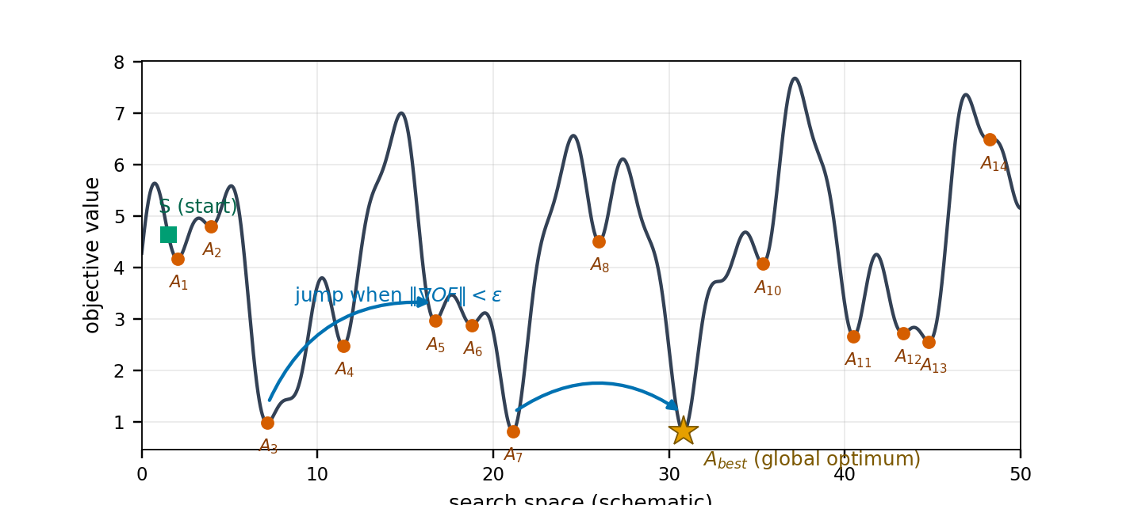
Fig. 1. Optimization landscape with local optima and the gradient-triggered jump mechanism (publication-quality source figure).

3.2.3 The shark’s speed limitation
When γ_m is restricted to (0,1), an active cap forces geometric speed decay and can freeze the colony away from the optimum. FSSO uses a neutral stochastic cap with equal probability of acceleration and deceleration:
$$γ_{m}∼U\left(0,2\right) independently redrawn at every stage m$$ (31)

3.2.4 Sign-reversing rotational search
The conventional R₃ ∈ (0,1) preserves coordinate signs. The extended interval makes sign reversal possible while keeping the search local:
$$Γ_{i}^{m+1,l}=Z_{i}^{m+1}+R_{3}∘Z_{i}^{m+1}, R_{3}∼U{\left(−1.3,1.3\right)}^{ND}$$ (32)

3.3 The proposed FSSO algorithm
Algorithm 3. Proposed fuzzy shark smell optimization
Input: Objective function OF; D, NP, M, L, μ, α, Cg, Ct, Q, εJ, Tjump.
Output: Best FSSO solution Xbest and its objective value.
01 Initialize positions Xᵢ¹ ∈ D and small random velocities; evaluate all sharks.
02 FOR stage m = 1,…,M DO
03 Draw the stage speed-limit coefficient γₘ ~ U(0,2).
04 FOR shark i = 1,…,NP DO
05 Compute gᵢ ← ∇OF(Xᵢᵐ) and Gᵢ ← ‖gᵢ‖.
06 Update velocity using the SSO gradient/inertia law and hard-cap it with γₘ [Eqs. (19)–(20), (31)].
07 Choose adaptive Δtₘ by the probabilistic gradient-driven rule [Eqs. (26)–(28)].
08 Form the forward candidate Zᵢ ← Xᵢᵐ + VᵢᵐΔtₘ and project it to D.
09 IF the periodic stagnation condition is active and Gᵢ ≤ εJ THEN apply the jump rule [Eqs. (29)–(30)].
10 Generate L rotational candidates with R₃ ~ U(−1.3,1.3)ᴺᴰ [Eq. (32)] and project them to D.
11 Evaluate the forward/jump/rotation candidates and greedily retain the best feasible candidate.
12 Update Xbest whenever the retained candidate improves the best-so-far objective.
13 END FOR.
14 END FOR.
15 RETURN Xbest. For minimization, optimize f directly or equivalently maximize OF = −f.

For minimization, set OF = −f so that maximizing OF is equivalent to minimizing f.

3.4 Convergence analysis
Expected velocity is bounded by the contraction
$$E∥V^{m}∥≤\frac{\overset{‾}{μ}\overset{‾}{G}}{2}+\frac{\overset{‾}{α}}{2}E∥V^{m−1}∥$$ (33)
$$ρ:=\overset{‾}{α}/2<1 ⇒ \underset{m→∞}{limsup}E∥V^{m}∥≤\frac{\overset{‾}{μ}\overset{‾}{G}/2}{1−\overset{‾}{α}/2}$$ (34)
Greedy best-so-far retention makes the objective sequence monotone
$$f\left(X^{best,m+1}\right)≤f\left(X^{best,m}\right), m=1,2,…$$ (35)
Jumps give every positive-measure neighbourhood of a global minimizer a nonzero visitation probability. With continuity and monotonicity, this yields almost-sure convergence of the best value
$$P\left(X^{m+1}∈B∣F_{m}\right)≥δ_{B}>0 ⇒ P\left(\lim_{m→∞}f\left(X^{best,m}\right)=f^{*}\right)=1$$ (36)
The distinction between bounded/monotone best-so-far behavior and a genuine convergence claim is important: recent 2026 swarm research demonstrates that an optimizer can exhibit useful empirical behavior without satisfying mathematical convergence conditions [78]. Accordingly, Eqs. (33)–(36) state the assumptions under which the present convergence argument is intended to hold.
Thus FSSO combines geometric expected-velocity contraction with irreducible global exploration. Conventional SSO lacks the jump and sign-reversing rotation needed for the latter.

3.5 Stability analysis
Hard velocity clipping and projection to compact D keep every search state bounded:
$$∥X_{i}^{m+1}−X_{i}^{m}∥_{∞}≤v_{max}Δt_{max}<∞, X_{i}^{m}∈D ∀m$$ (37)
Normalized nonnegative firing strengths make the predictor output a convex combination of rule consequents:
$$\min_{1≤i≤n}y_{t}^{i}≤{\hat{y}}_{t}≤\max_{1≤i≤n}y_{t}^{i}$$ (38)
For bounded regressors the one-step prediction is bounded. Rule-wise Schur stability provides standard dynamic T–S stability certification.

3.6 Computational complexity
$$C_{FSSO}=O\left(M⋅NP⋅\left(c_{∇}+Lc_{f}+ND\right)\right), c_{∇}=2NDc_{f}$$ (39)
With numerical gradients the order is O(M·NP·ND·c_f), linear in each design dimension, and memory is O(NP·ND). The four improvements add only constant-order random draws and comparisons. Because wall-clock time is platform-dependent, reproducible future comparisons should additionally report objective-function evaluation counts; this follows recent recommendations for complexity accounting in evolutionary and metaheuristic optimization [79].

4. Realization of the Proposed T–SFSSO Prediction Method
T–SFSSO combines a dynamic T–S fuzzy model, RLS initialization, and FSSO refinement. RLS first produces a computationally cheap, well-posed estimate; FSSO then refines antecedent and consequent parameters globally.
1. Data and fuzzification. Split daily cases into 80% training and 20% test data; cover each input with triangular membership functions.
2. Structure identification. Combine the fuzzy input sets to form the initial rule base.
3. RLS initialization. Estimate consequent parameters using Algorithm 1.
4. FSSO refinement. Initialize the colony near θ_RLS (one elite at θ_RLS) and minimize training RMSE.
5. Model assembly. Combine the identified structure and optimized parameters; evaluate the final prediction by weighted-average defuzzification.
The relative absolute training error used for monitoring is
$$E_{rel}=\sum_{t=1}^{L_{tr}}{\frac{\left|y_{t}−{\hat{y}}_{t}\right|}{y_{t}}}$$ (40)
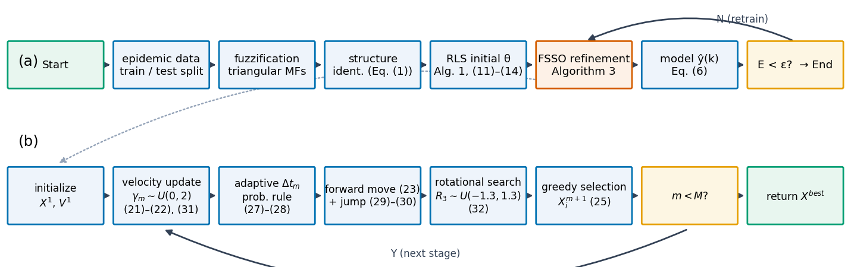
Fig. 8. Flow chart of the T–SFSSO prediction pipeline and the inner FSSO loop (publication-quality source figure).
Algorithm 4. Complete T–SFSSO prediction procedure
Input: Time series; chronological 80/20 train/test split; rule count n; lags/delays; FSSO parameters; stopping tolerance.
Output: Identified T-S model; train/test forecasts; RMSE, MAPE, and SMAPE.
01 Load the series and perform the chronological 80% training / 20% test split.
02 Construct triangular membership functions for the selected regressors.
03 Identify the initial dynamic T-S rule structure from combinations of fuzzy input sets.
04 Estimate consequent parameters θRLS on the training set with Algorithm 1.
05 Initialize the FSSO colony around θRLS, keeping one elite candidate exactly at θRLS.
06 Run Algorithm 3 to minimize training RMSE over the selected T-S parameters.
07 Assemble the dynamic T-S predictor and compute weighted-average outputs using Eq. (6).
08 Evaluate the training stopping criterion; if unmet, continue/refine according to the stated stopping rule.
09 Freeze the identified model and generate forecasts on the held-out test segment without test-set refitting.
10 Compute RMSE, MAPE, and SMAPE for training and test predictions [Eqs. (5), (41), (42)].
11 RETURN the fitted model, forecasts, and evaluation metrics.

5. Benchmark Experiments and Analysis
Two experiment groups compare FSSO with previous SSO variants and with established optimizers. Unless stated otherwise, NP = 10 and M = 50; reported table values come from the original campaign, while convergence figures were regenerated from reference implementations.

5.1 Comparison with previous SSO algorithms
Table 1. Standard test functions of the first experiment
Name | Function | Domain | Minimum
Function-1 (f₁) | Σxᵢ² + (Σ0.5ixᵢ)² + Σ0.5ixᵢ | [−5,30], n=30 | −0.2499 (proved)
Function-2 (Matyas) | 0.26(x²+y²) − 0.48xy | [−10,10], n=2 | 0

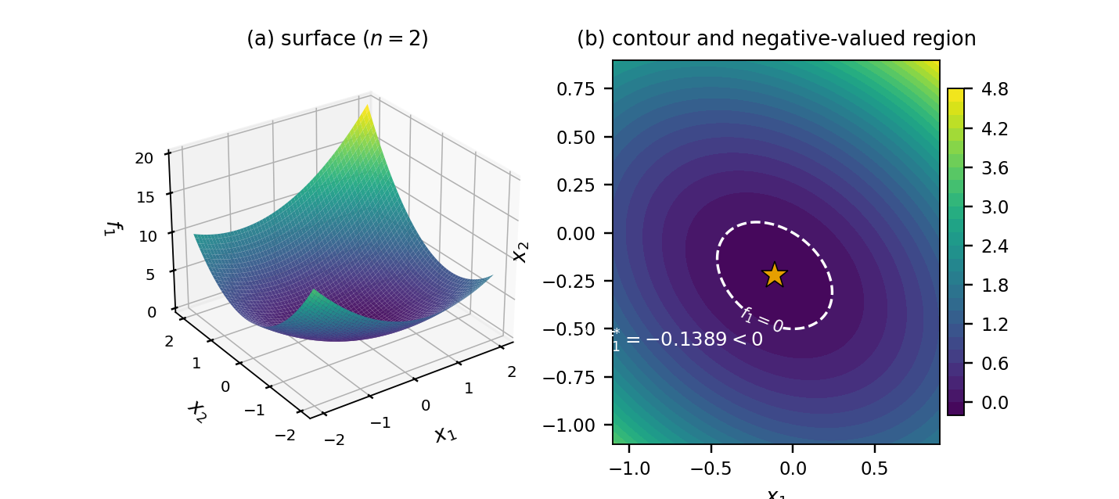
Fig. 2. Function-1 surface and contour for n = 2; dashed zero-level set and analytic minimizer.
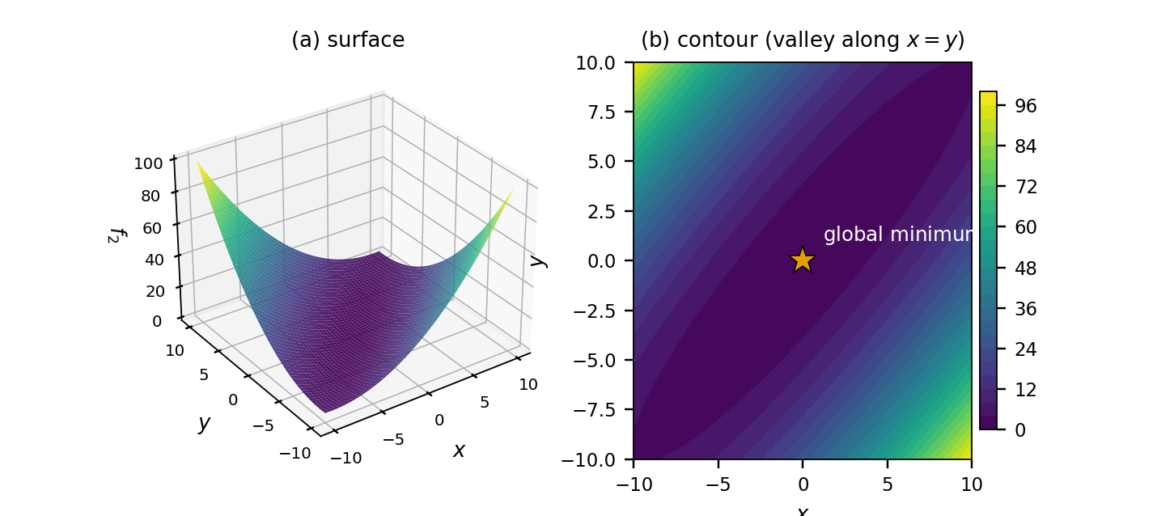
Fig. 3. Matyas-function surface and contour with global minimum at the origin.
Table 2. Comparison with previous SSO algorithms
Algorithm | Statistic | f₁ | f₂
SSO | maximum | 3.78×10⁻⁵ | 0.62×10⁻⁶
SSO | minimum | 1.56×10⁻¹³ | 3.1×10⁻²⁷
SSO | mean | 5.13×10⁻⁶ | 1.52×10⁻⁸
SSO | std. | 4.98×10⁻⁶ | 1.51×10⁻⁷
SSO | runtime (s) | 0.636 | 0.478
CSSO | maximum | 4.43×10⁻⁷ | 2.16×10⁻⁸
CSSO | minimum | 8.99×10⁻¹⁴ | 1.56×10⁻²⁷
CSSO | mean | 3.75×10⁻⁹ | 5.23×10⁻¹⁰
CSSO | std. | 6.27×10⁻⁸ | 3.79×10⁻⁹
CSSO | runtime (s) | 0.672 | 0.401
NSSO | maximum | 7.32×10⁻⁵ | 0.34×10⁻⁶
NSSO | minimum | 1.14×10⁻¹⁴ | 3.5×10⁻²⁷
NSSO | mean | 3.68×10⁻⁶ | 7.42×10⁻⁹
NSSO | std. | 7.64×10⁻⁵ | 0.55×10⁻⁷
NSSO | runtime (s) | 0.601 | 0.483
FSSO | maximum | −0.247 | 0
FSSO | minimum | −0.249 | 0
FSSO | mean | −0.2483 | 0
FSSO | std. | 1.59×10⁻⁵ | 0
FSSO | runtime (s) | 0.593 | 0.423

Proposition 1 — closed-form minimum of f₁
Let c = (0.5,1.0,…,0.5n) and w = ‖c‖². The strictly convex function f₁(x) = ‖x‖² + (cᵀx)² + cᵀx has the unique minimizer and minimum
$$x^{*}=−\frac{c}{2\left(w+1\right)}, f_{1}^{*}=−\frac{w}{4\left(w+1\right)}, w=∥c∥^{2}=\sum_{i=1}^{n}{{\left(0.5i\right)}^{2}}$$ (43)
For n = 30, w = 2363.75 and f₁* = −0.249894… . Strict convexity follows from the positive-definite Hessian 2(I+ccᵀ); solving ∇f₁ = 0 yields the stated x* and minimum.
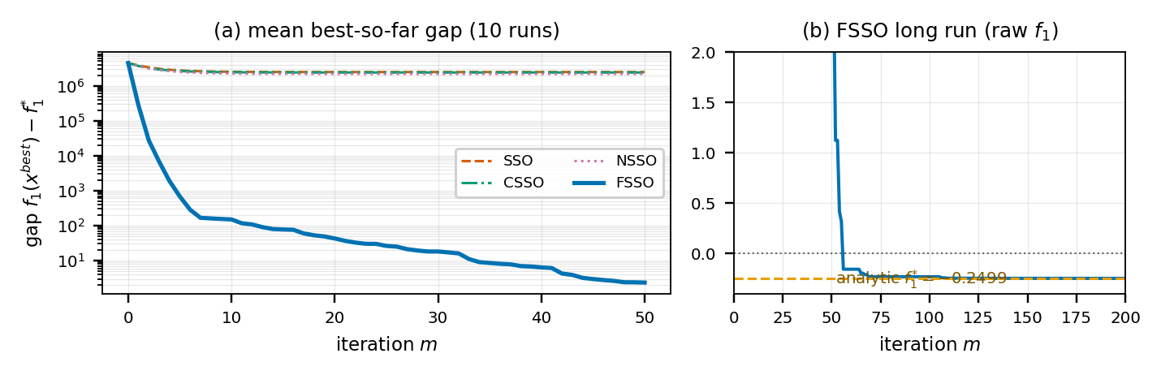
Fig. 4. Regenerated convergence on f₁: previous variants stagnate while FSSO approaches the analytic minimum.
Table 3. FSSO parameters for f₁ (rounded values from the original campaign)
Par. | Value | Par. | Value | Par. | Value
x1 | −0.77×10⁻⁶ | x11 | 0.10×10⁻² | x21 | 0.35×10⁻³
x2 | −0.28×10⁻³ | x12 | 0.14×10⁻³ | x22 | −0.15×10⁻²
x3 | 0.12×10⁻² | x13 | −0.11×10⁻³ | x23 | −0.18×10⁻²
x4 | 0.10×10⁻² | x14 | 0.23×10⁻² | x24 | −0.79×10⁻²
x5 | −0.34×10⁻³ | x15 | 0.26×10⁻⁴ | x25 | 0.81×10⁻⁴
x6 | −0.22×10⁻² | x16 | −0.31×10⁻² | x26 | 0.48×10⁻²
x7 | 0.23×10⁻² | x17 | 0.99×10⁻³ | x27 | 0.28×10⁻²
x8 | 0.80×10⁻³ | x18 | −0.84×10⁻³ | x28 | 0.68×10⁻⁴
x9 | −0.37×10⁻³ | x19 | −0.13×10⁻² | x29 | 0.43×10⁻³
x10 | 0.67×10⁻³ | x20 | −0.24×10⁻² | x30 | −0.96×10⁻³

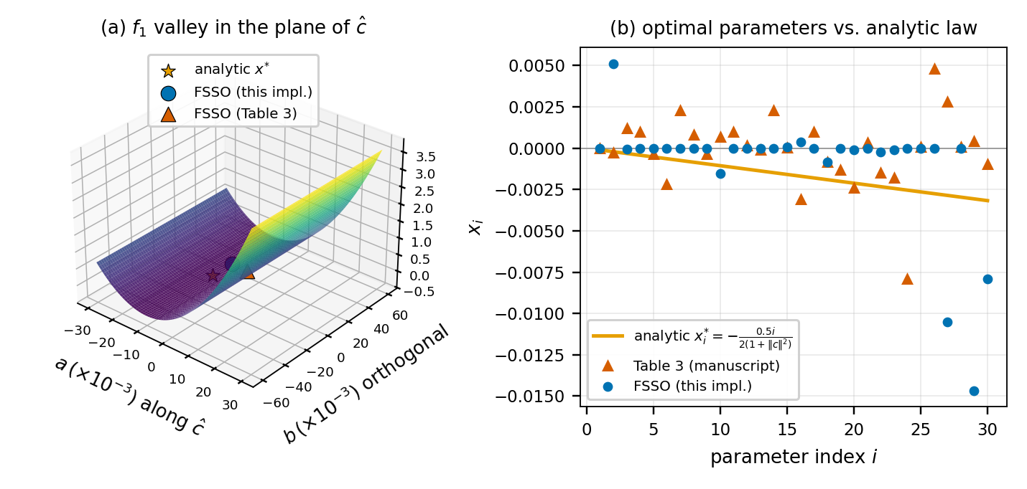
Fig. 7. Geometry of the f₁ optimum and parameter profiles versus the analytic law.

5.2 Comparison with other optimization algorithms
Table 4. Standard benchmark functions (n = 30; minimum 0)
Function | Definition | Domain
F₁ Step | Σ⌊xᵢ+0.5⌋² | [−100,100]
F₂ Rastrigin | Σ(xᵢ²−10cos(2πxᵢ)+10) | [−5.12,5.12]
F₃ Ackley | −20e^(−0.2√(Σxᵢ²/n)) − e^(Σcos(2πxᵢ)/n)+20+e | [−32,32]
F₄ Zakharov | Σxᵢ²+(Σ0.5ixᵢ)²+(Σ0.5ixᵢ)⁴ | [−100,100]

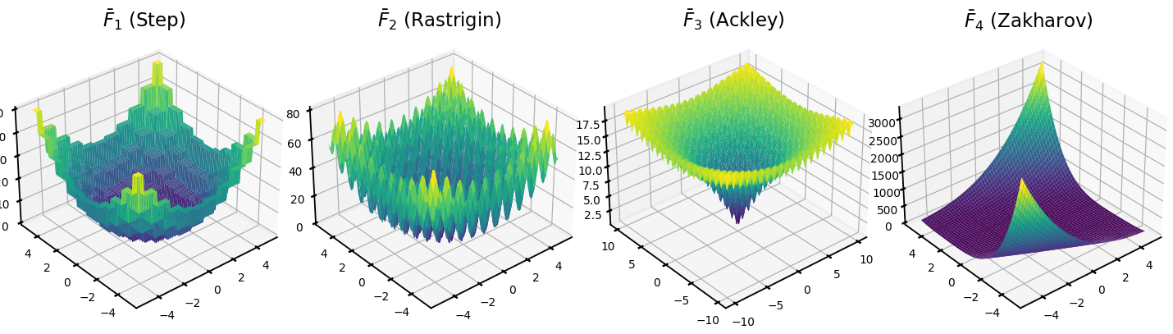
Fig. 5. Three-dimensional surfaces of the four benchmark functions (two-dimensional instances).
Table 5. Performance comparison on the Table 4 benchmarks
Algorithm | Statistic | F₁ | F₂ | F₃ | F₄
FSSO | minimum | 0 | 0 | 0.58×10⁻¹⁵ | 0
FSSO | mean | 0 | 0 | 0.27×10⁻¹³ | 0
FSSO | std. | 0 | 0 | 0.39×10⁻¹³ | 0
ISOA | minimum | 0 | 0.35×10⁻⁷ | 0.15×10⁻³ | 0
ISOA | mean | 0 | 0.13×10⁻² | 0.54×10⁻³ | 0
ISOA | std. | 0 | 0.37×10⁻² | 0.28×10⁻³ | 0
PSO | minimum | 2147 | 170.70 | 10.37 | 0.14×10⁻²
PSO | mean | 4423.28 | 230.00 | 12.55 | 2.36
PSO | std. | 1331.35 | 25.50 | 1.03 | 1.74
GA | minimum | 1256 | 106.88 | 7.49 | 0.40×10⁻³
GA | mean | 2113.88 | 150.12 | 8.88 | 1.51
GA | std. | 416.55 | 16.96 | 0.66 | 1.54
FACS | minimum | 137.52 | 83.72 | 7.78 | 0.73×10⁻⁵
FACS | mean | 203.37 | 152.79 | 8.21 | 0.06
FACS | std. | 75.81 | 63.25 | 1.93 | 0.47×10⁻²
DE | minimum | 93 | 78.87 | 3.72 | 0.21×10⁻⁷
DE | mean | 145.80 | 98.48 | 4.86 | 0.67×10⁻²
DE | std. | 38.40 | 8.25 | 0.43 | 0.02

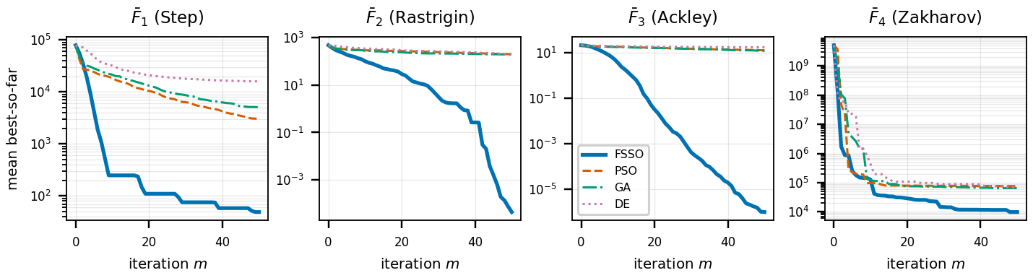
Fig. 6. Regenerated mean best-so-far convergence of FSSO, PSO, GA, and DE.
FSSO matches ISOA on the easiest functions and reaches the optimum on the highly multimodal functions where ISOA retains residual error. Gradient-driven forward movement explains the speed advantage; jumps and sign-reversing rotations improve robustness.

5.3 Comparator algorithms and reproducible comparison protocol
For completeness, Appendix C gives publication-level pseudocode for every named optimization or forecasting comparator that appears in the main experimental discussion: CSSO, NSSO, PSO, GA, DE, FACS, ISOA, and FTSOAX, followed by a unified comparison protocol. The comparator pseudocode summarizes the algorithmic logic of the cited methods; exact numerical replication still requires the original parameter schedules, stopping rules, and implementation details from the corresponding primary references. This distinction prevents a common benchmarking error: treating a high-level algorithm name as if it uniquely determines a reproducible implementation.
A fair comparison should keep the search domain, dimensionality, objective function, initialization policy where appropriate, stopping budget, and number of independent runs aligned across optimizers. Both wall-clock time and objective-function evaluations should be reported because gradient-based methods such as FSSO can require multiple objective calls per iteration when numerical differentiation is used. This reporting principle is consistent with recent recommendations on benchmark rigor and explicit function-evaluation accounting [75–79].

6. Application to Epidemic Time-Series Prediction
Daily confirmed COVID-19 counts for seven countries (USA, India, Russia, Iran, Norway, UK, and Japan) were split 80/20 into training and test data. The T–S model used five rules; FSSO used five sharks and 50 iterations. Accuracy was evaluated by RMSE, MAPE, and SMAPE.
$$MAPE=\frac{100\%}{T_{s}}\sum_{t=1}^{T_{s}}{\left|\frac{y_{t}−{\hat{y}}_{t}}{y_{t}}\right|}$$ (41)
$$SMAPE=\frac{100\%}{T_{s}}\sum_{t=1}^{T_{s}}{\frac{\left|y_{t}−{\hat{y}}_{t}\right|}{\left(\left|y_{t}\right|+\left|{\hat{y}}_{t}\right|\right)/2}}$$ (42)
Figure restoration note
Figures 9–14 below replace the blurred scans in the source PDF. They are clean schematic reconstructions digitized from the visible traces and calibrated to the quantitative results in Tables 6–8; the tables remain the authoritative numerical record.

6.1 Prediction in the training phase
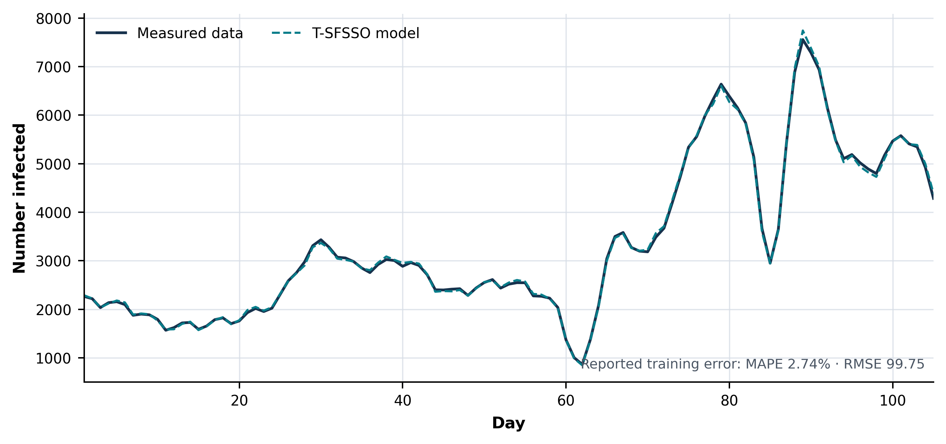
Fig. 9. Training prediction by T–SFSSO — reconstructed from the source trace and calibrated to Table 6.
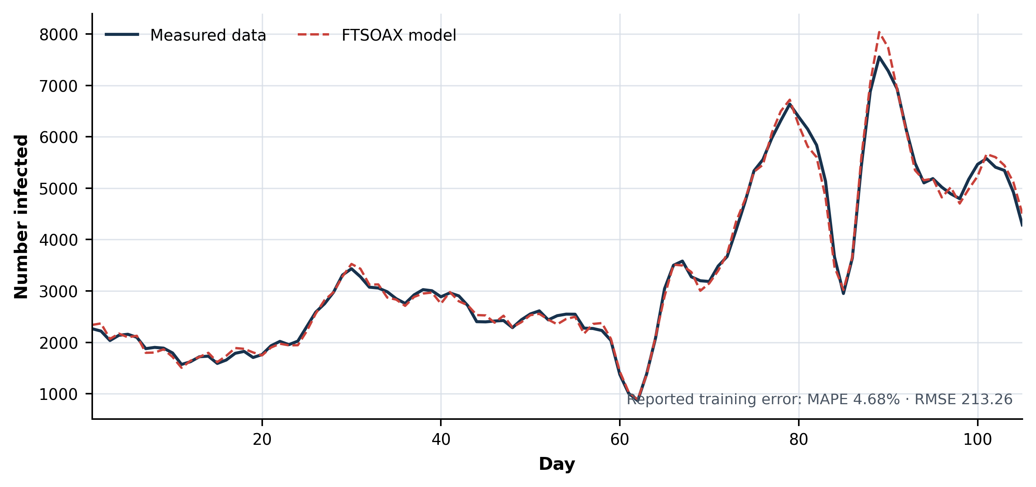
Fig. 10. Training prediction by FTSOAX — reconstructed from the source trace and calibrated to Table 6.
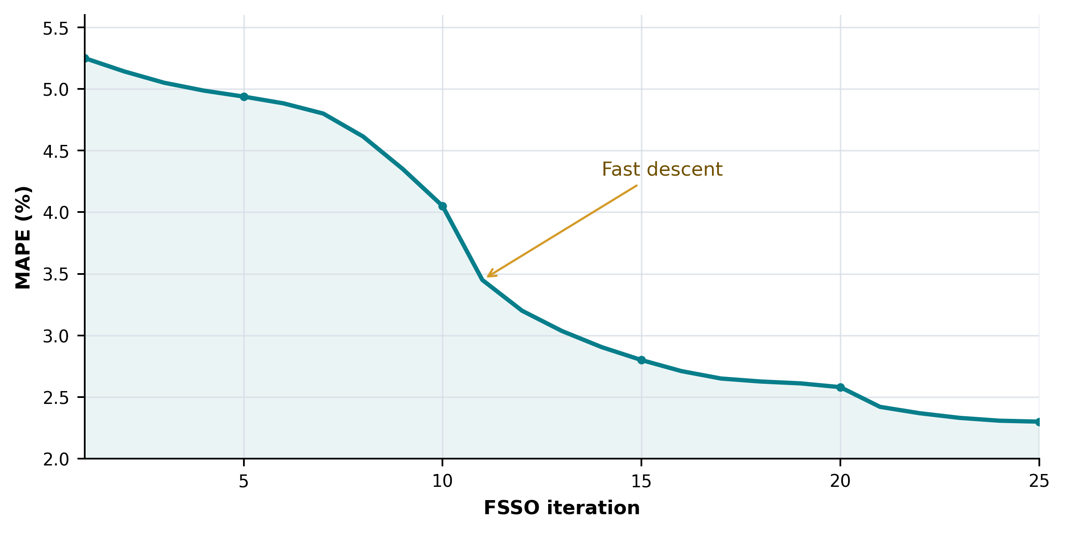
Fig. 11. Reconstructed MAPE convergence over 25 FSSO iterations, digitized from the source scan.
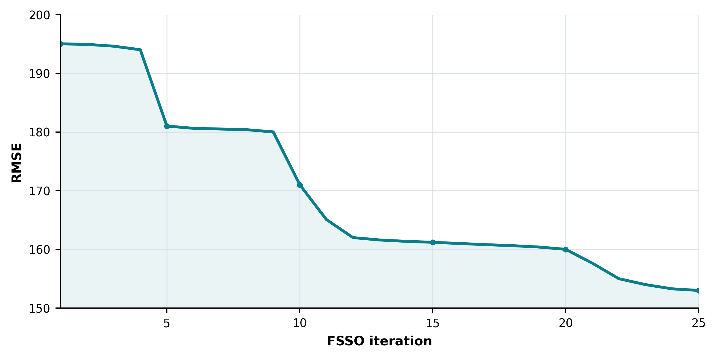
Fig. 12. Reconstructed RMSE convergence over 25 FSSO iterations, digitized from the source scan.
Table 6. Training-phase error
Algorithm | MAPE | RMSE
T–SFSSO | 2.74% | 99.75
FTSOAX | 4.68% | 213.26

Table 7. Training comparison (RMSE / SMAPE)
Country | [22] | [23] | [24] | FTSOAX | T–SFSSO
USA | 21763.26 / 23.98 | 24518.61 / 32.76 | 18879.43 / 18.71 | 10236.83 / 15.18 | 9783.29 / 13.84
India | 14332.20 / 29.46 | 13831.16 / 24.02 | 10915.50 / 10.17 | 6476.96 / 7.81 | 6074.28 / 7.32
Russia | 1957.36 / 11.66 | 2133.67 / 13.75 | 1786.00 / 7.80 | 1240.49 / 3.62 | 1052.17 / 3.03
Iran | 2556.53 / 24.65 | 2671.34 / 15.40 | 2674.77 / 10.92 | 1735.81 / 8.02 | 1625.34 / 2.18
Norway | 133.82 / 40.69 | 141.49 / 52.33 | 130.50 / 36.28 | 76.79 / 31.63 | 59.76 / 26.71
UK | 3167.46 / 43.44 | 3202.68 / 36.40 | 2797.58 / 16.99 | 1343.01 / 14.53 | 1293.62 / 13.28
Japan | 1323.14 / 57.91 | 883.20 / 50.46 | 900.65 / 40.46 | 465.13 / 15.45 | 387.44 / 13.47

T–SFSSO has the smallest RMSE and SMAPE for every country in the training comparison.

6.2 Prediction for the test data
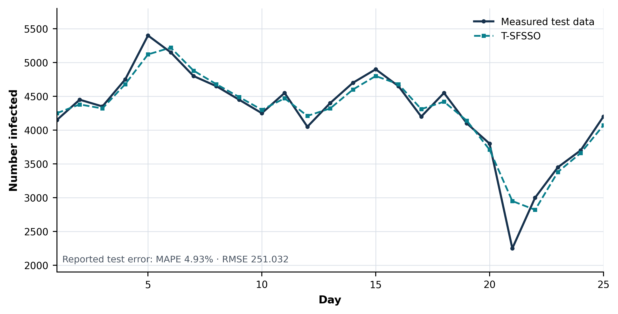
Fig. 13. Test prediction by T–SFSSO — reconstructed from the source trace and calibrated to Table 8.
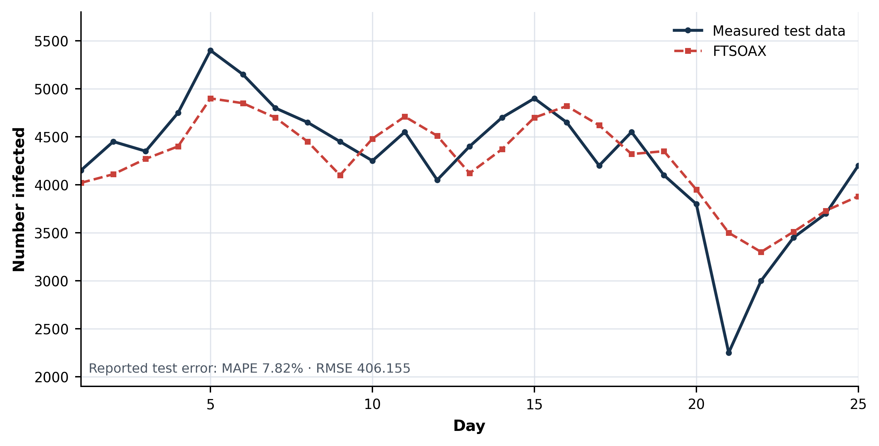
Fig. 14. Test prediction by FTSOAX — reconstructed from the source trace and calibrated to Table 8.
Table 8. Test-data error
Algorithm | MAPE | RMSE
T–SFSSO | 4.93% | 251.032
FTSOAX | 7.82% | 406.155

Table 9. Test comparison (RMSE / SMAPE)
Country | [22] | [23] | [24] | FTSOAX | T–SFSSO
USA | 25142.50 / 54.59 | 25619.50 / 57.84 | 28685.24 / 54.07 | 23865.82 / 52.36 | 22761.69 / 51.87
India | 13355.95 / 27.67 | 13526.97 / 28.00 | 4822.58 / 9.99 | 4285.90 / 7.98 | 3989.93 / 6.13
Russia | 4349.99 / 7.42 | 4425.84 / 8.03 | 4380.58 / 7.04 | 4255.50 / 5.46 | 4109.84 / 5.26
Iran | 6893.40 / 24.95 | 6856.67 / 24.77 | 7765.32 / 29.13 | 6292.97 / 25.38 | 6085.45 / 23.68
Norway | 156.75 / 55.18 | 139.46 / 47.32 | 131.10 / 47.21 | 133.69 / 46.53 | 102.51 / 43.02
UK | 7727.18 / 15.57 | 7949.36 / 16.59 | 7181.82 / 14.89 | 8515.25 / 15.58 | 7082.93 / 14.13
Japan | 1397.51 / 36.55 | 1371.77 / 34.50 | 1520.70 / 32.90 | 1332.31 / 31.17 | 1309.83 / 31.06

Table 10. Forecast-horizon comparison (RMSE / SMAPE)
Horizon | [22] | [23] | [24] | FTSOAX | T–SFSSO
40 days | 13613.67 / 28.28 | 13796.58 / 28.63 | 4935.42 / 10.17 | 3532.31 / 7.31 | 3182.35 / 6.81
100 days | 15950.56 / 42.90 | 15787.34 / 40.66 | 5100.16 / 11.68 | 3148.61 / 6.69 | 2907.54 / 6.23
180 days | 12368.06 / 37.36 | 12128.53 / 34.85 | 4490.23 / 15.60 | 2785.22 / 10.77 | 2513.07 / 9.82

Across countries and all three forecast horizons, T–SFSSO retains the best RMSE and SMAPE in the manuscript’s comparison set.

6.3 Visual comparative analysis
To make the reported results easier to interpret, Figs. 15–18 re-express the numerical values already reported in Tables 5–10. No new optimization or forecasting runs are introduced in this subsection; the plots are deterministic transformations of the tabulated results. Relative reduction is computed as 100×(baseline−T–SFSSO)/baseline, and the benchmark ranking uses the mean-error rows of Table 5 with average ranks for ties.
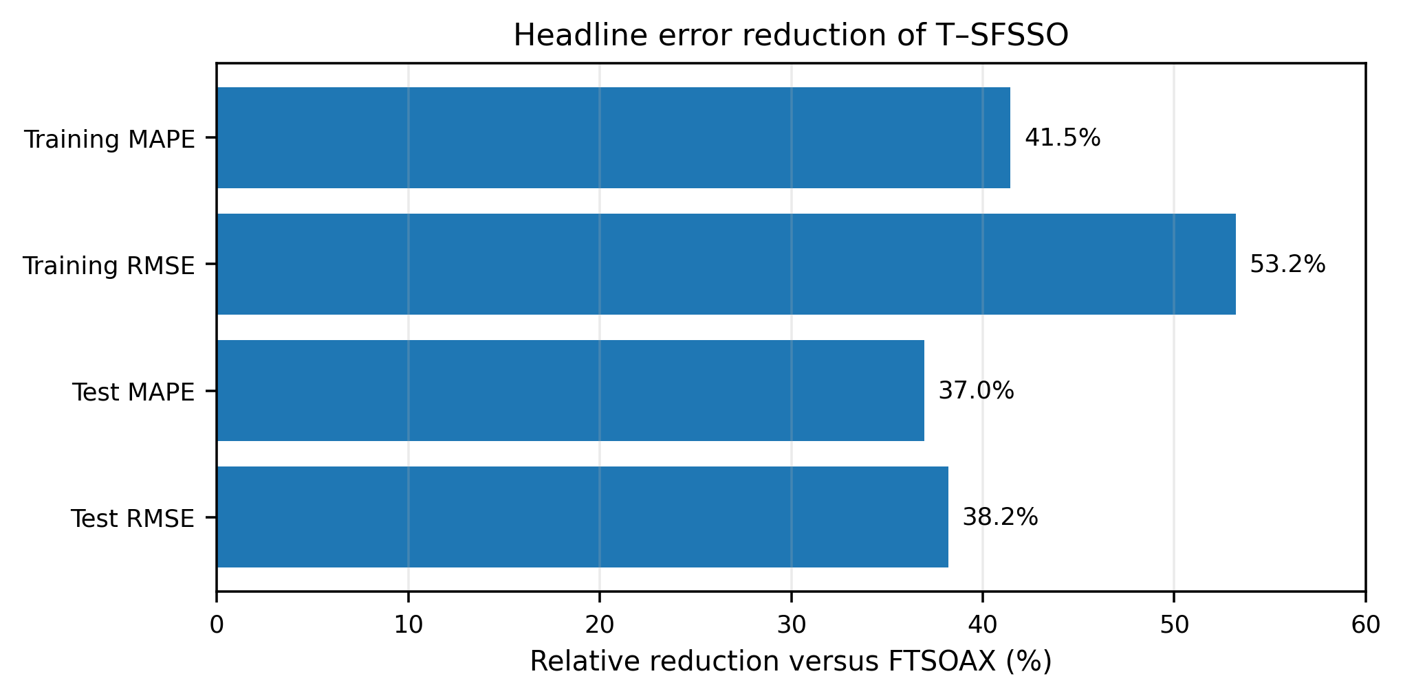
Fig. 15. Relative reduction in headline MAPE and RMSE of T–SFSSO versus the FTSOAX baseline, derived from Tables 6 and 8.
The largest headline gain occurs for training RMSE (53.2%), while the held-out test segment still shows substantial reductions of 37.0% in MAPE and 38.2% in RMSE. The smaller test-set gains relative to training are consistent with an expected generalization gap, but the direction of improvement is preserved for both error measures.
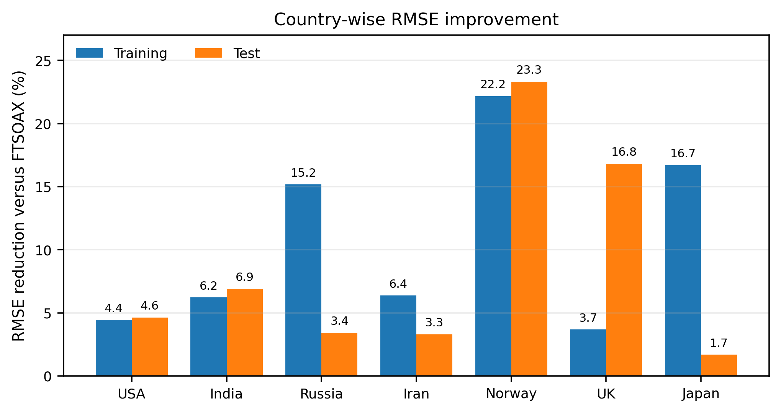
Fig. 16. Country-wise relative RMSE reduction of T–SFSSO versus FTSOAX in training and testing, derived from Tables 7 and 9.
The country-level comparison is positive in every case. Training RMSE reduction ranges from 3.68% (UK) to 22.18% (Norway), and test reduction ranges from 1.69% (Japan) to 23.32% (Norway). The spread indicates that the magnitude of the benefit depends on the scale and dynamics of the series, so reporting only a pooled average would conceal important heterogeneity.
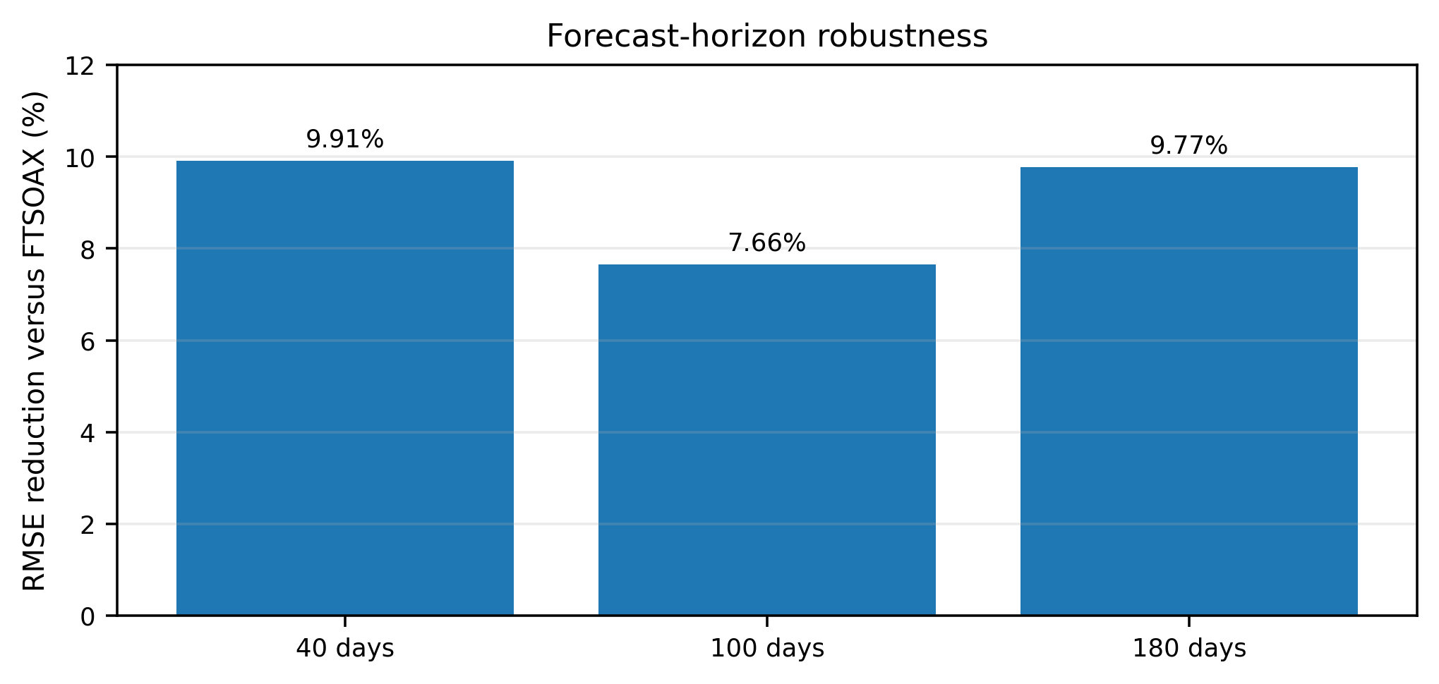
Fig. 17. Relative RMSE reduction of T–SFSSO versus FTSOAX at 40-, 100-, and 180-day forecast horizons, derived from Table 10.
Across the three reported horizons, the RMSE advantage remains between 7.66% and 9.91%. This comparatively narrow range suggests that the improvement is not confined to a single forecast horizon within the manuscript’s evaluation window.
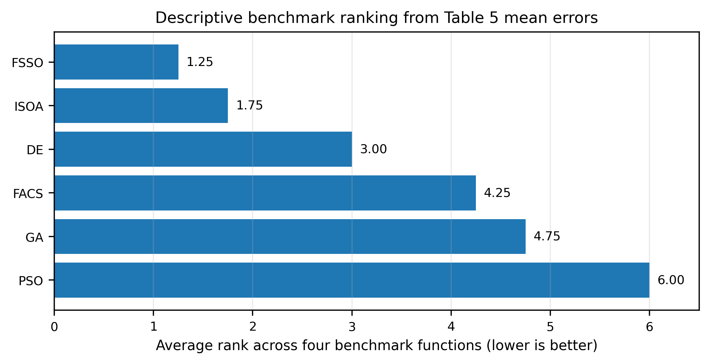
Fig. 18. Descriptive average rank of optimizer mean errors across the four Table 5 benchmarks; lower rank is better and ties receive average ranks.
Using only the reported mean errors, FSSO has the best average rank (1.25), followed by ISOA (1.75), DE (3.00), FACS (4.25), GA (4.75), and PSO (6.00). This rank summary is descriptive rather than inferential: the manuscript does not provide the full repeated-run samples needed for Friedman/Wilcoxon-style significance testing, so the figure should not be interpreted as a statistical-significance claim.

6.4 Extended visual robustness and effect-size analysis
The additional views in Figs. 19–23 deepen the interpretation of Tables 5, 9, and 10. They remain derived analyses: no new optimizer runs, forecast fits, or hidden data are introduced. For percentage comparisons, the relative gain is computed as 100 × (E_baseline − E_T-SFSSO) / E_baseline, with lower error indicating better performance. Where the phrase “best prior comparator” is used, the baseline is the smallest error among [22], [23], [24], and FTSOAX for that country and metric.
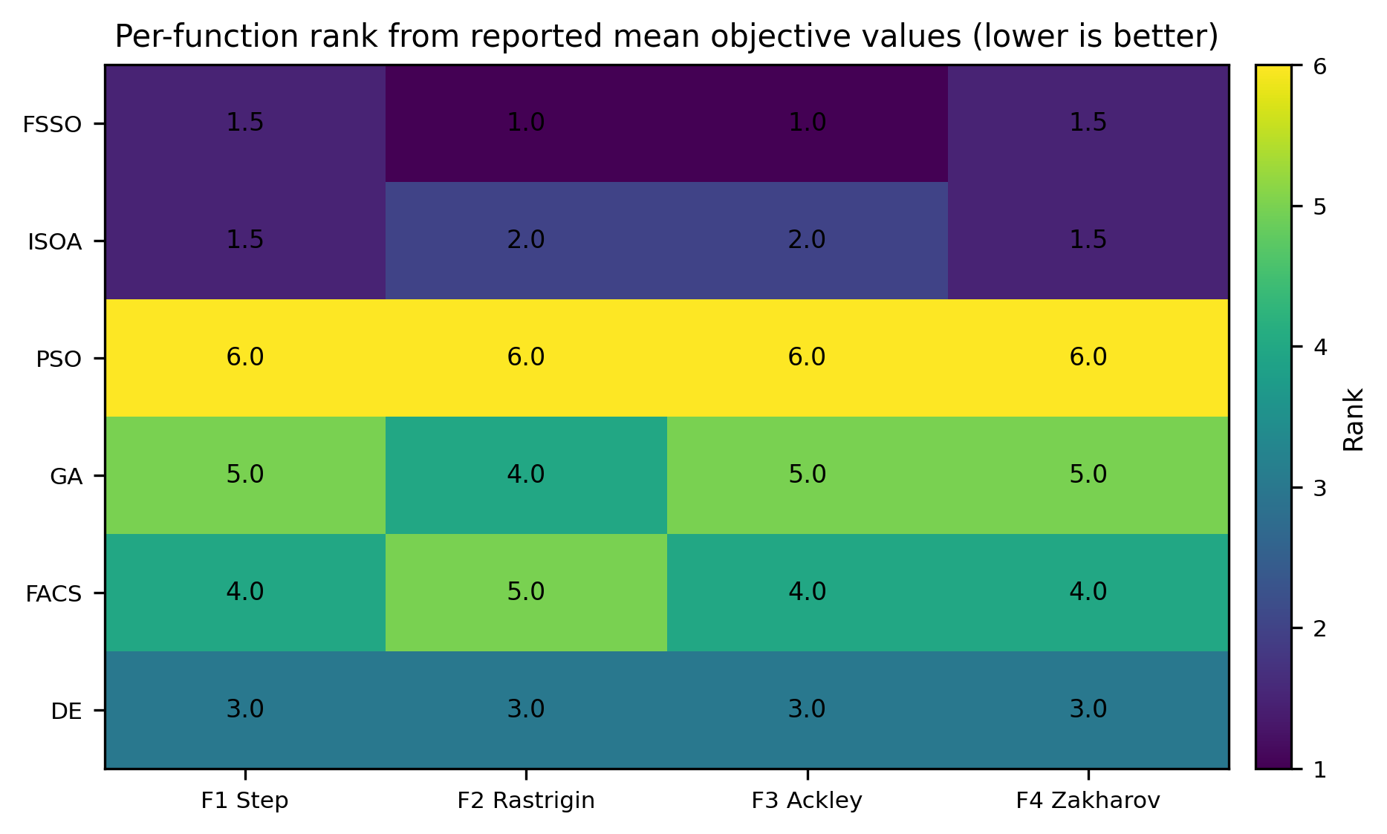
Fig. 19. Per-function descriptive rank heatmap computed from the reported mean objective values in Table 5. Ties receive average ranks.
The rank heatmap clarifies the information compressed into Fig. 18: FSSO is first on Rastrigin and Ackley and ties with ISOA on Step and Zakharov. DE is consistently third, while PSO is last on all four functions in the reported means. Because the table contains only four benchmark functions, this is a descriptive rank profile rather than a general-purpose superiority claim.
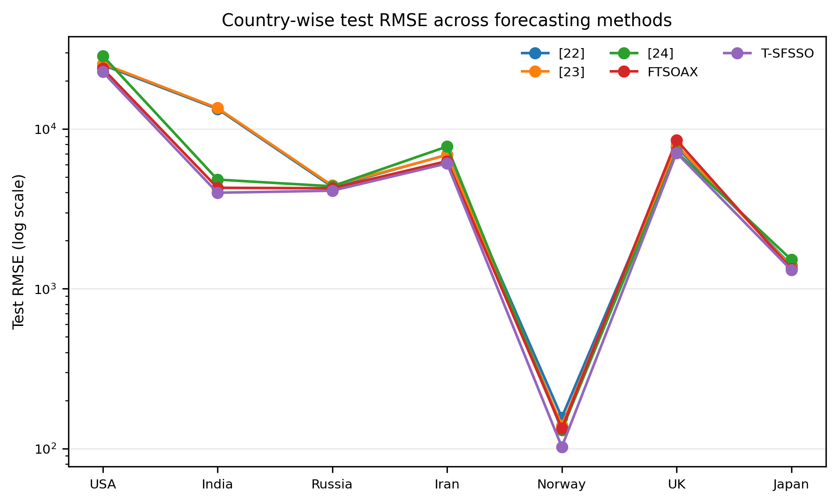
Fig. 20. Country-wise test RMSE for all five forecasting methods in Table 9. A logarithmic vertical scale is used because absolute case counts differ by orders of magnitude among countries.
The absolute-error view shows that T-SFSSO is the lowest-RMSE method for all seven countries even after the scale differences are made explicit. The logarithmic axis is essential here: without it, the large USA and India errors visually dominate the smaller Norway and Japan values and obscure the ordering among methods.
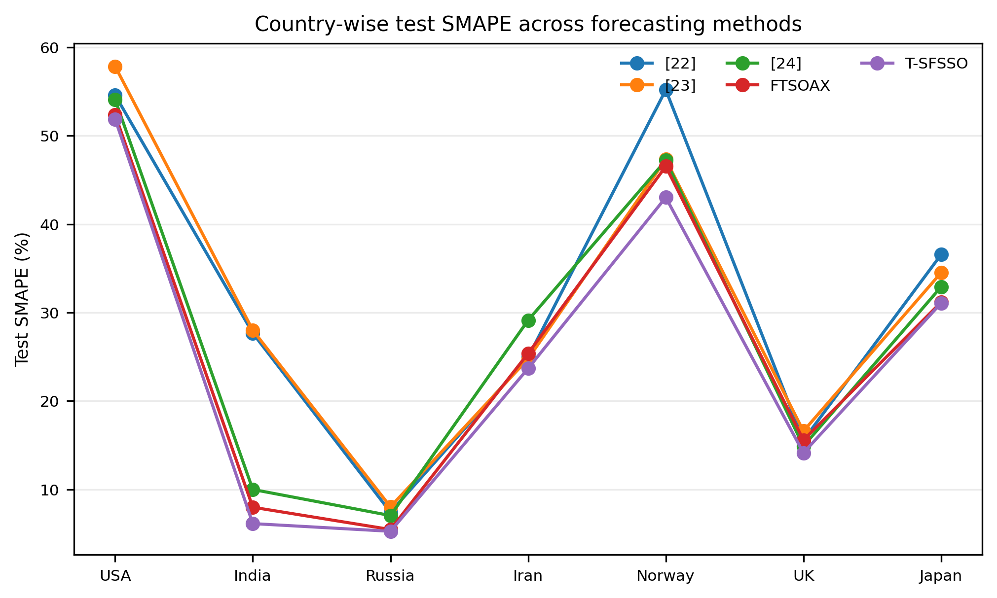
Fig. 21. Country-wise test SMAPE for all five forecasting methods in Table 9.
The scale-free SMAPE comparison reaches the same directional conclusion as RMSE. T-SFSSO is smallest in every country, but the size of the margin varies: the advantage is modest for USA and Japan and much larger for India. This heterogeneity is important because it shows that a single pooled average would conceal where the improvement is practically strongest.
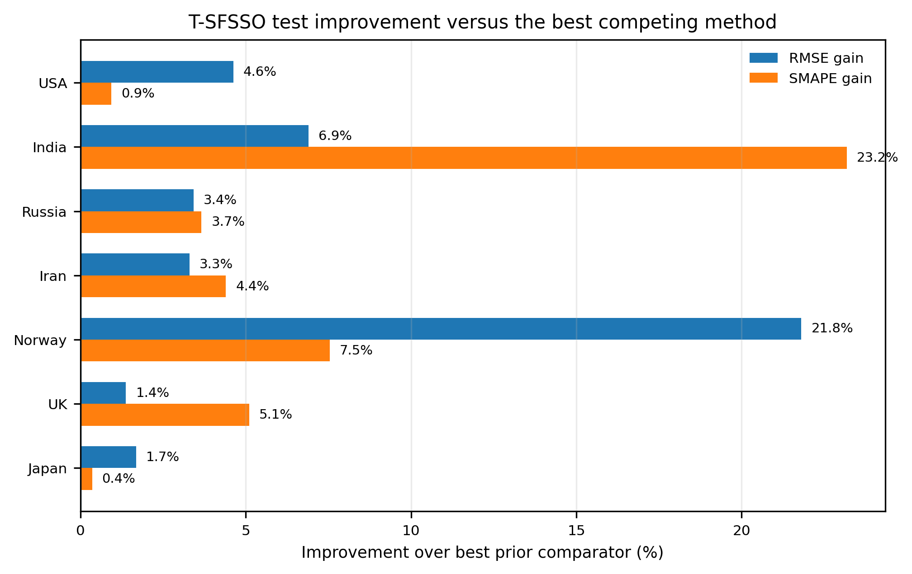
Fig. 22. Test-phase percentage improvement of T-SFSSO relative to the best prior comparator among [22], [23], [24], and FTSOAX for each country.
Relative to the strongest prior method available for each country—not merely to FTSOAX—the test RMSE gain remains positive in every country, ranging from 1.38% (UK) to 21.81% (Norway). The corresponding SMAPE gain ranges from 0.35% (Japan) to 23.18% (India). The mean gains are 6.16% for RMSE and 6.45% for SMAPE, while the medians are 3.42% and 4.40%, respectively. These values are effect-size summaries of the reported tables and should not be interpreted as confidence intervals or significance tests.
Table 11. Test-phase percentage gains of T-SFSSO over the best prior comparator in Table 9.
Country | RMSE gain vs. best prior (%) | SMAPE gain vs. best prior (%)
USA | 4.63 | 0.94
India | 6.91 | 23.18
Russia | 3.42 | 3.66
Iran | 3.30 | 4.40
Norway | 21.81 | 7.54
UK | 1.38 | 5.10
Japan | 1.69 | 0.35
Mean | 6.16 | 6.45
Median | 3.42 | 4.40
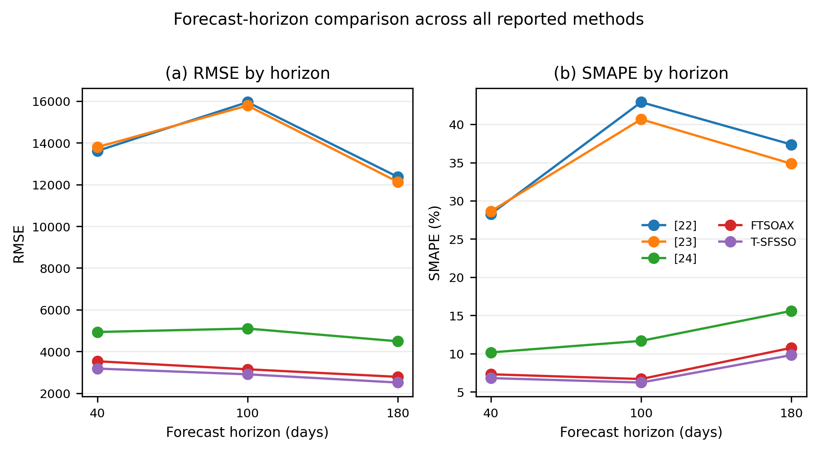
Fig. 23. Forecast-horizon comparison of RMSE and SMAPE across all methods in Table 10.
Across 40-, 100-, and 180-day horizons, T-SFSSO remains below every comparator in both RMSE and SMAPE. The horizon plot also shows that the error trajectories are not perfectly monotone with horizon, reflecting the changing difficulty of the underlying segments rather than a simple linear accumulation of error. The consistent ordering across all three horizons is therefore more informative than any single horizon value.

7. Discussion: Strengths, Limitations, and Future Research

7.1 Strengths of the proposed approach
The merits demonstrated in Sections 5 and 6 can be summarized as follows. First, FSSO retains the distinctive asset of the SSO family — the use of gradient information alongside stochastic local search — and repairs the four defects that prevented that asset from paying off: the adaptive time interval accelerates the traverse of steep regions, the stochastic speed cap eliminates premature freezing, and the jump together with the sign-reversing rotation restores genuine global search (Section 3.4 makes this precise: Eq. (36) holds for FSSO but not for the conventional SSO). Second, the algorithm is theoretically grounded — convergence, stability, and complexity are established rather than assumed — and its complexity remains of the same order as the conventional SSO, which the measured runtimes confirm. Third, in the prediction pipeline the combination "RLS for a cheap, well-posed initialization + FSSO for global refinement" is decisive: it reduces the computation that a from-scratch metaheuristic identification would require and simultaneously improves accuracy, halving the RMSE of the FTSOAX baseline and winning on both indices in all seven countries and at all three forecast horizons. Fourth, the benchmark analysis contributes a result of independent interest: the closed-form minimum of the weighted-sum function f₁ (Proposition 1), which corrects a value misreported in earlier literature and explains why algorithms without sign-reversing local search were structurally unable to find it. Finally, the interpretability of the T-S rule base is preserved — each rule remains a readable linear recursion — which matters in epidemiological practice, and the Python and MATLAB reference implementations support reproducible optimizer and benchmark calculations.

7.2 Limitations
The approach also has limitations that should be stated plainly. (i) Gradient dependence. FSSO requires the gradient of the objective; where no analytic gradient exists it falls back on central differences at a cost of 2·ND evaluations per shark and stage, and on non-differentiable or noisy objectives (e.g., the step function F₁) the gradient conveys little information and the burden of progress shifts to the rotation and jump operators. (ii) Hyper-parameters. The improvements introduce constants — C_g, C_t, Q, ε_J, T_J — whose values were chosen by experiment; although Section 3.5 shows that no admissible setting destabilizes the search, a principled adaptive tuning is still open. (iii) Scope of the evidence. The benchmark suite, while standard, is small by the norms articulated in [62], and the statistical comparison would be strengthened by nonparametric significance tests over larger run counts. (iv) Rounding and reporting. As Fig. 7 shows, two-digit rounding of the reported optimal parameters loses most of the attained depth of the f₁ valley; full-precision parameter files should accompany published tables. (v) Modelling scope. The application uses a univariate daily-cases series; exogenous drivers that demonstrably improve epidemic forecasts — variant frequencies, vaccination, mobility [12, 13] — are not yet part of the model, the 80/20 split provides a single evaluation window rather than a rolling-origin design, and reporting artefacts of surveillance data (weekend effects, revisions) are not treated explicitly. (vi) Descriptive visual analysis. Figures 15–23 and Table 11 improve interpretability of the reported tables, but they are derived summaries; because per-run benchmark traces and paired forecast errors are not available in the source campaign, they cannot substitute for confidence intervals, rolling-origin resampling, or nonparametric significance testing.

7.3 Directions for future research
Several directions follow naturally. First, self-adaptive control of the new constants—for example, success-based adaptation of Q and Ct or their evolution alongside the population—would reduce manual tuning. Second, surrogate or analytic gradients for the fuzzy-identification objective would reduce the dominant gradient-evaluation cost in Eq. (39). Third, a multi-objective FSSO balancing accuracy and rule-base compactness would connect this work to multi-objective SSO [66], while interval type-2 antecedents could improve robustness under noisy surveillance data. Fourth, the 2026 fuzzy–ensemble, Pythagorean, hesitant-fuzzy, Sugeno–neural, and fuzzy-cognitive-map studies [70–74,80–82] motivate hybrid architectures in which T-SFSSO supplies an interpretable component while a neural, ensemble, or decomposition layer models residual nonlinear structure. Fifth, modern metaheuristic reviews and convergence studies [75–79,83,84] motivate broader benchmark suites, explicit function-evaluation budgets, ablation studies for each FSSO modification, and stronger finite-time convergence analysis. Finally, broader validation should use rolling-origin evaluation, exogenous epidemic covariates, additional countries and domains, paired nonparametric tests, effect sizes, and confidence intervals.

8. Conclusions
This paper proposed T-SFSSO, a prediction method for epidemic time series built on a dynamic Takagi–Sugeno fuzzy model identified by an improved shark smell optimization algorithm (FSSO). The optimizer improvement is not a single heuristic but four coordinated repairs of documented SSO weaknesses: a probabilistic gradient-driven adaptive time interval that enlarges forward movement in steep regions; a gradient-triggered jump that creates a genuine escape route from local basins; a stochastic speed-limit coefficient on (0,2) that removes systematic velocity decay; and an extended rotational coefficient on (−1.3,1.3) that permits sign reversal and access to regions excluded by the conventional operator.
On the reported benchmark set, FSSO outperformed conventional SSO, CSSO, NSSO, PSO, GA, DE, FACS, and ISOA and identified a negative minimum for the weighted-sum benchmark that is confirmed analytically as f₁* = −w/[4(w+1)] ≈ −0.2499. In the epidemic application, recursive-least-squares initialization followed by FSSO refinement reduced training MAPE by 41.5% and RMSE by 53.2% relative to FTSOAX; on the held-out test segment, MAPE fell by 37.0% and RMSE by 38.2%. T-SFSSO also retained the lowest reported RMSE and SMAPE across all seven countries and all three forecast horizons. The expanded effect-size analysis further shows positive test gains versus the best prior comparator in every country, while the limitations section makes clear that stronger inferential claims require repeated-run statistics, rolling-origin evaluation, and broader benchmark suites. Overall, T-SFSSO combines an interpretable rule-based predictor with a structurally modified optimizer whose mechanisms, pseudocode, theory, complexity, and empirical behavior are explicitly documented.

References
1. Marques, J. A. L., Gois, F. N. B., Xavier-Neto, J., Fong, S. J. (2021). Predictive Models for Decision Support in the COVID-19 Crisis. SpringerBriefs in Applied Sciences and Technology. Springer, Cham. https://doi.org/10.1007/978-3-030-61913-8
2. Feng, S., Feng, Z., Ling, C., Chang, C., Feng, Z. (2021). Prediction of the COVID-19 epidemic trends based on SEIR and AI models. PLoS ONE, 16(1), e0245101.
3. Cai, M., Karniadakis, G. E., Li, C. (2022). Fractional SEIR model and data-driven predictions of COVID-19 dynamics of Omicron variant. Chaos, 32(7), 071101.
4. Kiarie, J., Mwalili, S., Mbogo, R. (2022). Forecasting the spread of the COVID-19 pandemic in Kenya using SEIR and ARIMA models. Infectious Disease Modelling, 7(2), 179–188.
5. de Araújo Morais, L. R., da Silva Gomes, G. S. (2022). Forecasting daily Covid-19 cases in the world with a hybrid ARIMA and neural network model. Applied Soft Computing, 126, 109315.
6. Thorakkattle, M. N., Farhin, S., Khan, A. A. (2022). Forecasting the trends of Covid-19 and causal impact of vaccines using Bayesian structural time series and ARIMA. Annals of Data Science, 9(5), 1025–1047.
7. ArunKumar, K. E., Kalaga, D. V., Kumar, Ch. M. S., Chilkoor, G., Kawaji, M., Brenza, T. M. (2021). Forecasting the dynamics of cumulative COVID-19 cases (confirmed, recovered and deaths) for top-16 countries using statistical machine learning models: Auto-Regressive Integrated Moving Average (ARIMA) and Seasonal Auto-Regressive Integrated Moving Average (SARIMA). Applied Soft Computing, 103, 107161.
8. Masum, M., Shahriar, H., Haddad, H. M., Alam, M. S. (2020). r-LSTM: Time series forecasting for COVID-19 confirmed cases with LSTM-based framework. Proceedings of the 2020 IEEE International Conference on Big Data, 1374–1379.
9. Hochreiter, S., Schmidhuber, J. (1997). Long short-term memory. Neural Computation, 9(8), 1735–1780.
10. ArunKumar, K. E., Kalaga, D. V., Kumar, Ch. M. S., Kawaji, M., Brenza, T. M. (2022). Comparative analysis of Gated Recurrent Units (GRU), long Short-Term Memory (LSTM) cells, Autoregressive Integrated Moving Average (ARIMA), Seasonal Autoregressive Integrated Moving Average (SARIMA) for forecasting COVID-19 trends. Alexandria Engineering Journal, 61(10), 7585–7603.
11. Gautam, Y. (2022). Transfer learning for COVID-19 cases and deaths forecast using LSTM network. ISA Transactions, 124, 41–56.
12. Du, H., Dong, E., Badr, H. S., Petrone, M. E., Grubaugh, N. D., Gardner, L. M. (2023). Incorporating variant frequencies data into short-term forecasting for COVID-19 cases and deaths in the USA: a deep learning approach. eBioMedicine, 89, 104482.
13. Cramer, E. Y., Ray, E. L., Lopez, V. K., et al. (2022). Evaluation of individual and ensemble probabilistic forecasts of COVID-19 mortality in the United States. Proceedings of the National Academy of Sciences, 119(15), e2113561119.
14. Nixon, K., Jindal, S., Parker, F., Reich, N. G., Ghobadi, K., Lee, E. C., Truelove, S., Gardner, L. (2022). An evaluation of prospective COVID-19 modelling studies in the USA: from data to science translation. The Lancet Digital Health, 4(10), e738–e747. https://doi.org/10.1016/S2589-7500(22)00148-0
15. Rahimi, I., Chen, F., Gandomi, A. H. (2023). A review on COVID-19 forecasting models. Neural Computing and Applications, 35(33), 23671–23681.
16. Alyasseri, Z. A. A., Al-Betar, M. A., Doush, I. A., Awadallah, M. A., Abasi, A. K., Makhadmeh, S. N., Alomari, O. A., Abdulkareem, K. H., Adam, A., Damasevicius, R., Mohammed, M. A., Zitar, R. A. (2022). Review on COVID-19 diagnosis models based on machine learning and deep learning approaches. Expert Systems, 39(3), e12759.
17. Kumar, N., Susan, S. (2021). Particle swarm optimization of partitions and fuzzy order for fuzzy time series forecasting of COVID-19. Applied Soft Computing, 110, 107611.
18. Ceylan, Z. (2021). Short-term prediction of COVID-19 spread using grey rolling model optimized by particle swarm optimization. Applied Soft Computing, 109, 107592.
19. Xian, S., Chen, K., Cheng, Y. (2022). Improved seagull optimization algorithm of partition and XGBoost of prediction for fuzzy time series forecasting of COVID-19 daily confirmed. Advances in Engineering Software, 173, 103212.
20. Efendi, R., Ismail, Z., Deris, M. M. (2013). Improved weight fuzzy time series as used in the exchange rates forecasting of US dollar to ringgit Malaysia. International Journal of Computational Intelligence and Applications, 12(1), 1350005.
21. Jiang, P., Yang, H., Heng, J. (2019). A hybrid forecasting system based on fuzzy time series and multi-objective optimization for wind speed forecasting. Applied Energy, 235, 786–801.
22. Zhang, W., Zhang, S., Zhang, S. (2019). A novel method based on FTS with both GA-FCM and multifactor BPNN for stock forecasting. Soft Computing, 23(16), 6979–6994.
23. Sadaei, H. J., Enayatifar, R., Abdullah, A. H., Gani, A. (2014). Short-term load forecasting using a hybrid model with a refined exponentially weighted fuzzy time series and an improved harmony search. International Journal of Electrical Power & Energy Systems, 62, 118–129.
24. Kumar, N., Kumar, H. (2022). A novel hybrid fuzzy time series model for prediction of COVID-19 infected cases and deaths in India. ISA Transactions, 124, 69–81.
25. Cansu, T., Bas, E., Egrioglu, E. (2026). Mixed order single variable intuitionistic fuzzy time series forecasting method based on a new artificial neural network and grey wolf optimization algorithm. Scientific Reports, 16, 15682. https://doi.org/10.1038/s41598-026-45059-2
26. Al-Qaness, M. A. A., Ewees, A. A., Fan, H., Abualigah, L., Abd Elaziz, M. (2022). Boosted ANFIS model using augmented marine predator algorithm with mutation operators for wind power forecasting. Applied Energy, 314, 118851.
27. Mamdani, E. H., Assilian, S. (1975). An experiment in linguistic synthesis with a fuzzy logic controller. International Journal of Man-Machine Studies, 7(1), 1–13.
28. Takagi, T., Sugeno, M. (1985). Fuzzy identification of systems and its applications to modeling and control. IEEE Transactions on Systems, Man, and Cybernetics, 15(1), 116–132.
29. Gao, Y., Er, M. J. (2005). NARMAX time series model prediction: feedforward and recurrent fuzzy neural network approaches. Fuzzy Sets and Systems, 150(2), 331–350.
30. Juang, C.-F., Lin, C.-T. (1998). An online self-constructing neural fuzzy inference network and its applications. IEEE Transactions on Fuzzy Systems, 6(1), 12–32.
31. Jang, J.-S. R. (1993). ANFIS: adaptive-network-based fuzzy inference system. IEEE Transactions on Systems, Man, and Cybernetics, 23(3), 665–685.
32. Chen, Y. M., Lin, C. T. (2007). Dynamic parameter optimization of evolutionary computation for on-line prediction of time series with changing dynamics. Applied Soft Computing, 7(4), 1170–1176.
33. Kukolj, D. (2002). Design of adaptive Takagi–Sugeno–Kang fuzzy models. Applied Soft Computing, 2(2), 89–103.
34. Araujo, E., Coelho, L. d. S. (2008). Particle swarm approaches using Lozi map chaotic sequences to fuzzy modelling of an experimental thermal-vacuum system. Applied Soft Computing, 8(4), 1354–1364.
35. Papadakis, S. E., Theocharis, J. B. (2002). A GA-based fuzzy modeling approach for generating TSK models. Fuzzy Sets and Systems, 131(2), 121–152.
36. Salimi-Badr, A., Ebadzadeh, M. M. (2022). A novel learning algorithm based on computing the rules' desired outputs of a TSK fuzzy neural network with non-separable fuzzy rules. Neurocomputing, 470, 139–153.
37. Deif, M., Hammam, R., Solyman, A. (2021). Adaptive neuro-fuzzy inference system (ANFIS) for rapid diagnosis of COVID-19 cases based on routine blood tests. International Journal of Intelligent Engineering and Systems, 14(2), 178–189.
38. Kennedy, J., Eberhart, R. (1995). Particle swarm optimization. Proceedings of ICNN'95 — International Conference on Neural Networks, 4, 1942–1948.
39. Goldberg, D. E. (1989). Genetic Algorithms in Search, Optimization and Machine Learning. Addison-Wesley, Reading, MA.
40. Storn, R., Price, K. (1997). Differential evolution — a simple and efficient heuristic for global optimization over continuous spaces. Journal of Global Optimization, 11(4), 341–359.
41. Tao, C.-W., Taur, J.-S., Jeng, J.-T., Wang, W.-Y. (2009). A novel fuzzy ant colony system for parameter determination of fuzzy controllers. International Journal of Fuzzy Systems, 11(4), 298–307.
42. Abualigah, L., Abd Elaziz, M., Sumari, P., Geem, Z. W., Gandomi, A. H. (2022). Reptile Search Algorithm (RSA): a nature-inspired meta-heuristic optimizer. Expert Systems with Applications, 191, 116158.
43. Agushaka, J. O., Ezugwu, A. E., Abualigah, L. (2022). Dwarf mongoose optimization algorithm. Computer Methods in Applied Mechanics and Engineering, 391, 114570.
44. Ezugwu, A. E., Agushaka, J. O., Abualigah, L., Mirjalili, S., Gandomi, A. H. (2022). Prairie dog optimization algorithm. Neural Computing and Applications, 34(22), 20017–20065.
45. Hashim, F. A., Hussien, A. G. (2022). Snake Optimizer: a novel meta-heuristic optimization algorithm. Knowledge-Based Systems, 242, 108320.
46. Zhao, S., Zhang, T., Ma, S., Chen, M. (2022). Dandelion Optimizer: a nature-inspired metaheuristic algorithm for engineering applications. Engineering Applications of Artificial Intelligence, 114, 105075.
47. Zhao, W., Wang, L., Mirjalili, S. (2022). Artificial hummingbird algorithm: a new bio-inspired optimizer with its engineering applications. Computer Methods in Applied Mechanics and Engineering, 388, 114194.
48. Wang, L., Cao, Q., Zhang, Z., Mirjalili, S., Zhao, W. (2022). Artificial rabbits optimization: a new bio-inspired meta-heuristic algorithm for solving engineering optimization problems. Engineering Applications of Artificial Intelligence, 114, 105082.
49. Chopra, N., Ansari, M. M. (2022). Golden jackal optimization: a novel nature-inspired optimizer for engineering applications. Expert Systems with Applications, 198, 116924.
50. Trojovský, P., Dehghani, M. (2022). Pelican optimization algorithm: a novel nature-inspired algorithm for engineering applications. Sensors, 22(3), 855.
51. Zamani, H., Nadimi-Shahraki, M. H., Gandomi, A. H. (2022). Starling murmuration optimizer: a novel bio-inspired algorithm for global and engineering optimization. Computer Methods in Applied Mechanics and Engineering, 392, 114616. https://doi.org/10.1016/j.cma.2022.114616.
52. Oyelade, O. N., Ezugwu, A. E., Mohamed, T. I. A., Abualigah, L. (2022). Ebola optimization search algorithm: a new nature-inspired metaheuristic optimization algorithm. IEEE Access, 10, 16150–16177.
53. Ahmadianfar, I., Heidari, A. A., Noshadian, S., Chen, H., Gandomi, A. H. (2022). INFO: an efficient optimization algorithm based on weighted mean of vectors. Expert Systems with Applications, 195, 116516.
54. Dehghani, M., Montazeri, Z., Trojovská, E., Trojovský, P. (2023). Coati optimization algorithm: a new bio-inspired metaheuristic algorithm for solving optimization problems. Knowledge-Based Systems, 259, 110011.
55. Abdel-Basset, M., Mohamed, R., Azeem, S. A. A., Jameel, M., Abouhawwash, M. (2023). Kepler optimization algorithm: a new metaheuristic algorithm inspired by Kepler's laws of planetary motion. Knowledge-Based Systems, 268, 110454.
56. Abdel-Basset, M., Mohamed, R., Jameel, M., Abouhawwash, M. (2023). Nutcracker optimizer: a novel nature-inspired metaheuristic algorithm for global optimization and engineering design problems. Knowledge-Based Systems, 262, 110248.
57. Seyyedabbasi, A., Kiani, F. (2023). Sand Cat swarm optimization: a nature-inspired algorithm to solve global optimization problems. Engineering with Computers, 39(4), 2627–2651.
58. Su, H., Zhao, D., Heidari, A. A., Liu, L., Zhang, X., Mafarja, M., Chen, H. (2023). RIME: a physics-based optimization. Neurocomputing, 532, 183–214.
59. Agushaka, J. O., Ezugwu, A. E., Abualigah, L. (2023). Gazelle optimization algorithm: a novel nature-inspired metaheuristic optimizer. Neural Computing and Applications, 35(5), 4099–4131.
60. Amiri, M. H., Mehrabi Hashjin, N., Montazeri, M., Mirjalili, S., Khodadadi, N. (2024). Hippopotamus optimization algorithm: a novel nature-inspired optimization algorithm. Scientific Reports, 14, 5032.
61. Lian, J., Hui, G., Ma, L., Zhu, T., Wu, X., Heidari, A. A., Chen, Y., Chen, H. (2024). Parrot optimizer: algorithm and applications to medical problems. Computers in Biology and Medicine, 172, 108064.
62. Kudela, J. (2022). A critical problem in benchmarking and analysis of evolutionary computation methods. Nature Machine Intelligence, 4(12), 1238–1245.
63. Huang, H., Qiu, J., Riedl, K. (2023). On the global convergence of particle swarm optimization methods. Applied Mathematics & Optimization, 88, 30.
64. Abedinia, O., Amjady, N., Ghasemi, A. (2016). A new metaheuristic algorithm based on shark smell optimization. Complexity, 21(5), 97–116.
65. Abedinia, O., Amjady, N. (2015). Short-term wind power prediction based on hybrid neural network and chaotic shark smell optimization. International Journal of Precision Engineering and Manufacturing-Green Technology, 2(3), 245–254.
66. Wang, L.-D., Wang, X.-C., Liu, K.-W. (2020). An improved multiobjective shark smell optimization algorithm for automatic train operation based on angle cosine and fusion distance. Journal of Computers, 31(4), 141–156.
67. Nasir, I. M., Raza, M., Shah, J. H., Khan, M. A., Nam, Y.-C., Nam, Y. (2023). Improved shark smell optimization algorithm for human action recognition. Computers, Materials & Continua, 76(3), 2667–2684.
68. Braik, M., Hammouri, A., Atwan, J., Al-Betar, M. A., Awadallah, M. A. (2022). White Shark Optimizer: a novel bio-inspired meta-heuristic algorithm for global optimization problems. Knowledge-Based Systems, 243, 108457.
69. Hu, G., Guo, Y., Wei, G., Abualigah, L. (2023). Genghis Khan shark optimizer: a novel nature-inspired algorithm for engineering optimization. Advanced Engineering Informatics, 58, 102210.
70. Dalar, A. Z. (2026). A hybrid fuzzy–ensemble method for time series forecasting. Scientific Reports, 16, 20705. https://doi.org/10.1038/s41598-026-51585-w
71. Gundogdu, O., Egrioglu, E., Bas, E. (2026). Pythagorean fuzzy time series approach based on hybrid high-order artificial neural network for nonlinear time series forecasting. Scientific Reports, 16, 27440. https://doi.org/10.1038/s41598-026-58132-7
72. Egrioglu, E., Bas, E., Yildirim, A. N., Oguz, U., Sari, I. F. (2026). A Sugeno–multiplicative neuron hybrid system trained by differential evolution algorithm for time series forecasting. Scientific Reports, 16, 21174. https://doi.org/10.1038/s41598-026-51980-3
73. Kazim, U., Ullah, M., Arshed, J. U., et al. (2026). Fuzzy time series for short-term residential load forecasting in smart grids. Scientific Reports, 16, 4000. https://doi.org/10.1038/s41598-025-34062-8
74. Sun, N., Zhu, D. (2026). A hybrid forecasting and fuzzy comprehensive evaluation approach for graded early warning of experimental task frequency. Scientific Reports. https://doi.org/10.1038/s41598-026-60332-0
75. Suman, A., Gunjan, Udmale, S. S. (2026). Metaheuristic algorithms: A benchmark-driven functional taxonomy and performance analysis. Computer Science Review, 60, 100884. https://doi.org/10.1016/j.cosrev.2025.100884
76. Molina, D., Del Ser, J., Poyatos, J., Herrera, F. (2025). The paradox of success in evolutionary and bioinspired optimization: Revisiting critical issues, key studies, and methodological pathways. Swarm and Evolutionary Computation, 98, 102063. https://doi.org/10.1016/j.swevo.2025.102063
77. Naser, M. Z., Al-Bashiti, M. K., Tapeh, A. T. G., Naser, A., Kodur, V., Hawileh, R., Abdalla, J., Khodadadi, N., Gandomi, A. H., Eslamlou, A. D. (2025). A Review of Benchmark and Test Functions for Global Optimization Algorithms and Metaheuristics. WIREs Computational Statistics, 17(2), e70028. https://doi.org/10.1002/wics.70028
78. Steyn, G. J., van Zyl, J.-P., Engelbrecht, A. P. (2026). Set-based particle swarm optimisation convergence. Swarm Intelligence, 20, 1–33. https://doi.org/10.1007/s11721-026-00262-9
79. Sari, Z., Yildirim, M. (2026). A Complexity Calculation Method for Large Scale Optimization With Evolutionary Algorithms and Metaheuristics. Concurrency and Computation: Practice and Experience, 38(8), e70702. https://doi.org/10.1002/cpe.70702
80. Agarwal, N., Tayal, D. K., Rajeena, P. P. F., et al. (2026). A fuzzy time-series driven ensemble approach for accurate forecasting of higher education rankings. Scientific Reports, 16, 13329. https://doi.org/10.1038/s41598-026-40570-y
81. Bisht, K., Kumar, S., Pant, M., Negi, S. (2026). Hesitant fuzzy time series forecasting: A novel approach to handle the hesitancy in the system. Journal of Computational and Applied Mathematics, 482, 117322. https://doi.org/10.1016/j.cam.2025.117322
82. Fulara, S. P., Tak, N., Kumar, S. (2026). Time series forecasting method based on complete ensemble empirical mode decomposition with adaptive noise and hesitant fuzzy cognitive map. Applied Soft Computing, 198, 115282. https://doi.org/10.1016/j.asoc.2026.115282
83. Yousef, A., Ezzat, R., El-Rashidy, N. (2026). Grey wolf optimizer and whale optimization algorithm: a systematic review. Artificial Intelligence Review, 59, 162. https://doi.org/10.1007/s10462-026-11585-8
84. He, Z., Lv, X., Liu, H. (2026). An exploratory competitive swarm optimizer assisted by convergence sampling for large-scale multiobjective optimization. Applied Soft Computing, 195, 114950. https://doi.org/10.1016/j.asoc.2026.114950
85. Davani, M., Taghizadeh, M., Pirbonyeh, M. A., et al. (2026). Heart disease diagnosis and categorization from ECG signals using hybrid Fuzzy-CNN machine optimized by meta-heuristic algorithms. Scientific Reports, 16, 16001. https://doi.org/10.1038/s41598-026-43637-y

Appendix A. Python Reference Implementation
Complete self-contained Python implementation of FSSO and the benchmark suite. This repairs the truncated Appendix A in the source PDF export.
"""Reference implementation of the FSSO algorithm described in Algorithm 3."""

from __future__ import annotations

import numpy as np

def f1_table1(x: np.ndarray) -> float:
i = np.arange(1, x.size + 1, dtype=float)
s = np.sum(0.5 * i * x)
return float(np.sum(x * x) + s * s + s)

def f2_matyas(x: np.ndarray) -> float:
return float(0.26 * (x[0] ** 2 + x[1] ** 2) - 0.48 * x[0] * x[1])

def F1_step(x: np.ndarray) -> float:
return float(np.sum(np.floor(x + 0.5) ** 2))

def F2_rastrigin(x: np.ndarray) -> float:
return float(np.sum(x * x - 10 * np.cos(2 * np.pi * x) + 10))

def F3_ackley(x: np.ndarray) -> float:
n = x.size
return float(
-20 * np.exp(-0.2 * np.sqrt(np.sum(x * x) / n))
- np.exp(np.sum(np.cos(2 * np.pi * x)) / n)
+ 20
+ np.e
)

def F4_zakharov(x: np.ndarray) -> float:
i = np.arange(1, x.size + 1, dtype=float)
s = np.sum(0.5 * i * x)
return float(np.sum(x * x) + s * s + s**4)

def central_gradient(f, x: np.ndarray, lo: np.ndarray, hi: np.ndarray) -> np.ndarray:
"""Bound-aware central-difference gradient."""
scale = np.maximum(1.0, np.abs(x))
h = 1e-6 * scale
grad = np.zeros_like(x, dtype=float)
for j in range(x.size):
xp = x.copy()
xm = x.copy()
xp[j] = min(hi[j], x[j] + h[j])
xm[j] = max(lo[j], x[j] - h[j])
width = xp[j] - xm[j]
grad[j] = 0.0 if width == 0 else (f(xp) - f(xm)) / width
return grad

def fsso(
f,
nd: int,
lo,
hi,
*,
NP: int = 10,
M: int = 50,
L: int = 5,
mu: float = 0.9,
alpha: float = 0.5,
Cg: float = 1.0,
Ct: float = 2.0,
Q: float = 0.7,
epsJ: float = 1e-6,
Tjump: int = 10,
seed: int | None = None,
):
"""Minimize ``f`` with the four FSSO improvements from the manuscript."""
rng = np.random.default_rng(seed)
lo = np.broadcast_to(np.asarray(lo, dtype=float), (nd,)).copy()
hi = np.broadcast_to(np.asarray(hi, dtype=float), (nd,)).copy()
if np.any(hi <= lo):
raise ValueError("Every upper bound must exceed its lower bound.")

X = lo + (hi - lo) * rng.random((NP, nd))
V = 0.1 * (hi - lo) * (2 * rng.random((NP, nd)) - 1)
vmax = 0.5 * (hi - lo)
fx = np.array([f(x) for x in X], dtype=float)
best_index = int(np.argmin(fx))
best_x = X[best_index].copy()
best_f = float(fx[best_index])
history = np.empty(M + 1, dtype=float)
history[0] = best_f

for stage in range(1, M + 1):
gamma = rng.uniform(0.0, 2.0)
for p in range(NP):
# Minimize f by moving along -grad(f), equivalent to maximizing -f.
g = central_gradient(f, X[p], lo, hi)
G = float(np.linalg.norm(g))
trial_velocity = -mu * rng.random(nd) * g + alpha * rng.random(nd) * V[p]
former = np.maximum(np.abs(V[p]), 1e-12)
V[p] = np.sign(trial_velocity) * np.minimum(np.abs(trial_velocity), gamma * former)
V[p] = np.clip(V[p], -vmax, vmax)

if G < Cg or rng.random() < Q:
dt = 1.0
else:
dt = (G / Cg) * Ct * rng.random()
z = np.clip(X[p] + V[p] * dt, lo, hi)

if stage % Tjump == 0 and G < epsJ:
z = lo + (hi - lo) * rng.random(nd)

candidates = [z]
for _ in range(L):
R3 = rng.uniform(-1.3, 1.3, size=nd)
candidates.append(np.clip(z + R3 * z, lo, hi))
candidate_values = np.array([f(c) for c in candidates], dtype=float)
winner = int(np.argmin(candidate_values))
if candidate_values[winner] <= fx[p]:
X[p] = candidates[winner]
fx[p] = candidate_values[winner]

if fx[p] < best_f:
best_f = float(fx[p])
best_x = X[p].copy()
history[stage] = best_f

return best_x, best_f, history

if __name__ == "__main__":
nd = 30
xb, fb, hist = fsso(f1_table1, nd, -5.0, 30.0, M=200, seed=7)
w = np.sum((0.5 * np.arange(1, nd + 1)) ** 2)
print(f"FSSO best f1 = {fb:.6f}; analytic minimum = {-w / (4 * (w + 1)):.6f}")

suite = [
("Step", F1_step, -100.0, 100.0),
("Rastrigin", F2_rastrigin, -5.12, 5.12),
("Ackley", F3_ackley, -32.0, 32.0),
("Zakharov", F4_zakharov, -100.0, 100.0),
]
for name, function, lower, upper in suite:
_, value, _ = fsso(function, nd, lower, upper, M=50, seed=1)
print(f"FSSO on {name:10s}: best = {value:.4g}")

Appendix B. MATLAB Reference Implementation
Complete MATLAB R2016b+ implementation mirroring Appendix A. This repairs the truncated Appendix B in the source PDF export.
%% FSSO reference implementation (Algorithm 3)
% MATLAB R2016b or later; functions are defined below the script body.
clear; clc; rng(7);

nd = 30; lo = -5; hi = 30;
opts = struct('NP',10,'M',200,'L',5,'mu',0.9,'alpha',0.5, ...
'Cg',1,'Ct',2,'Q',0.7,'epsJ',1e-6,'Tjump',10);
[xb, fb, hist] = fsso(@f1_table1, nd, lo, hi, opts); %#ok<ASGLU>
w = sum((0.5*(1:nd)).^2);
fA = -w/(4*(w+1));
fprintf('FSSO best f1 = %.6f; analytic minimum = %.6f\n', fb, fA);

semilogy(0:opts.M, max(hist - fA, eps), 'LineWidth', 1.4);
grid on; xlabel('iteration m'); ylabel('optimality gap');

%% Benchmark suite from Table 4
funs = {@F1_step, @F2_rastrigin, @F3_ackley, @F4_zakharov};
doms = [-100 100; -5.12 5.12; -32 32; -100 100];
names = {'Step','Rastrigin','Ackley','Zakharov'};
opts.M = 50;
for k = 1:4
[~, value] = fsso(funs{k}, nd, doms(k,1), doms(k,2), opts);
fprintf('FSSO on %-10s: best = %.4g\n', names{k}, value);
end

function [best_x, best_f, hist] = fsso(f, ND, lo, hi, o)
lo = lo * ones(1, ND); hi = hi * ones(1, ND);
X = lo + (hi-lo).*rand(o.NP, ND);
V = 0.1*(hi-lo).*(2*rand(o.NP, ND)-1);
vmax = 0.5*(hi-lo);
fx = zeros(o.NP,1);
for p = 1:o.NP, fx(p) = f(X(p,:)); end
[best_f, idx] = min(fx); best_x = X(idx,:);
hist = zeros(o.M+1,1); hist(1) = best_f;

for stage = 1:o.M
gamma = 2*rand; % Eq. (31)
for p = 1:o.NP
g = central_gradient(f, X(p,:), lo, hi);
G = norm(g);
trial = -o.mu*rand(1,ND).*g + o.alpha*rand(1,ND).*V(p,:);
former = max(abs(V(p,:)), 1e-12);
V(p,:) = sign(trial).*min(abs(trial), gamma*former); % Eq. (22)
V(p,:) = max(-vmax, min(vmax, V(p,:)));

if G < o.Cg || rand < o.Q
dt = 1;
else
dt = (G/o.Cg)*o.Ct*rand; % Eqs. (26)-(28)
end
z = max(lo, min(hi, X(p,:) + V(p,:)*dt));

if mod(stage,o.Tjump)==0 && G < o.epsJ
z = lo + (hi-lo).*rand(1,ND); % Eqs. (29)-(30)
end

C = zeros(o.L+1,ND); C(1,:) = z;
for ell = 1:o.L
R3 = -1.3 + 2.6*rand(1,ND);
C(ell+1,:) = max(lo, min(hi, z + R3.*z)); % Eq. (32)
end
cv = zeros(o.L+1,1);
for ell = 1:o.L+1, cv(ell) = f(C(ell,:)); end
[candidate_f, winner] = min(cv);
if candidate_f <= fx(p)
X(p,:) = C(winner,:); fx(p) = candidate_f;
end
if fx(p) < best_f
best_f = fx(p); best_x = X(p,:);
end
end
hist(stage+1) = best_f;
end
end

function g = central_gradient(f, x, lo, hi)
h = 1e-6*max(1,abs(x)); g = zeros(size(x));
for j = 1:numel(x)
xp = x; xm = x;
xp(j) = min(hi(j), x(j)+h(j));
xm(j) = max(lo(j), x(j)-h(j));
width = xp(j)-xm(j);
if width == 0, g(j) = 0; else, g(j) = (f(xp)-f(xm))/width; end
end
end

function y = f1_table1(x)
i = 1:numel(x); s = sum(0.5*i.*x);
y = sum(x.^2) + s^2 + s;
end

function y = F1_step(x), y = sum(floor(x+0.5).^2); end
function y = F2_rastrigin(x), y = sum(x.^2-10*cos(2*pi*x)+10); end
function y = F3_ackley(x)
n = numel(x);
y = -20*exp(-0.2*sqrt(sum(x.^2)/n))-exp(sum(cos(2*pi*x))/n)+20+exp(1);
end
function y = F4_zakharov(x)
i = 1:numel(x); s = sum(0.5*i.*x);
y = sum(x.^2) + s^2 + s^4;
end

Appendix C. Pseudocode for Comparator Algorithms and Evaluation Protocol
Purpose. Algorithms 5–13 provide concise, publication-level pseudocode for every named comparator/model used in the main experimental narrative. They are included to make the methodological roles of the comparators explicit. Exact replication should use the cited source code or parameterization when available; the pseudocode below does not overwrite the primary definitions in [19, 38–41, 65, 66].
Algorithm 5. Chaotic shark smell optimization (CSSO) comparator [65]
Input: Objective f; domain D; NP sharks; M stages; local rotations L; chaotic-map seed and control parameters.
Output: Best solution found.
01 Initialize shark positions and velocities inside D; initialize a chaotic sequence.
02 Evaluate all sharks and store the global best.
03 FOR stage m = 1,…,M DO
04 Generate stage control coefficients from the chaotic map.
05 FOR each shark i, update gradient-following velocity using the chaotic coefficients.
06 Apply the SSO velocity cap and compute the forward candidate.
07 Generate L local rotational candidates with chaos-modulated perturbations.
08 Greedily retain the best feasible candidate and update global best.
09 END FOR
10 Return the global best solution.
Note: This pseudocode states the comparator logic at publication level; exact numerical replication should use the parameter settings and operator definitions in the cited primary study.
Algorithm 6. Normal-distribution SSO (NSSO-style) comparator [66]
Input: Objective f; domain D; NP; M; L; SSO schedules; normal-distribution parameters.
Output: Best solution found.
01 Initialize positions and velocities and evaluate the colony.
02 FOR stage m = 1,…,M DO
03 Draw the stage random coefficients from the prescribed normal distribution.
04 Update each shark velocity from the objective gradient and inertia term.
05 Enforce the comparator speed bound and form the forward candidate.
06 Generate L stochastic local candidates using the normal-distribution coefficients.
07 Apply the method-specific selection / distance rule and retain the best candidate.
08 Update the best-so-far solution.
09 END FOR
10 Return the best solution.
Note: This pseudocode states the comparator logic at publication level; exact numerical replication should use the parameter settings and operator definitions in the cited primary study.
Algorithm 7. Particle swarm optimization (PSO) [38]
Input: Objective f; bounds D; swarm size NP; iterations M; inertia ω; acceleration coefficients c1,c2.
Output: Global-best particle gbest.
01 Initialize particle positions x_i and velocities v_i in D.
02 Evaluate f(x_i); set personal best pbest_i ← x_i and global best gbest.
03 FOR iteration m = 1,…,M DO
04 FOR each particle i DO
05 Draw r1,r2 ~ U(0,1).
06 v_i ← ωv_i + c1 r1 (pbest_i − x_i) + c2 r2 (gbest − x_i).
07 x_i ← Project_D(x_i + v_i); evaluate f(x_i).
08 Update pbest_i and gbest whenever the objective improves.
09 END FOR
10 END FOR; return gbest.
Note: This pseudocode states the comparator logic at publication level; exact numerical replication should use the parameter settings and operator definitions in the cited primary study.
Algorithm 8. Genetic algorithm (GA) [39]
Input: Objective f; bounds D; population size NP; generations M; selection, crossover, and mutation settings.
Output: Best chromosome / parameter vector.
01 Randomly initialize a population of NP candidate vectors in D and evaluate fitness.
02 FOR generation m = 1,…,M DO
03 Select parent candidates according to fitness.
04 Apply crossover to selected parents to create offspring.
05 Mutate offspring with the prescribed mutation probability / operator.
06 Repair or project infeasible offspring into D and evaluate them.
07 Form the next generation using replacement / elitism.
08 Update the best-so-far individual.
09 END FOR
10 Return the best individual.
Note: This pseudocode states the comparator logic at publication level; exact numerical replication should use the parameter settings and operator definitions in the cited primary study.
Algorithm 9. Differential evolution (DE) [40]
Input: Objective f; bounds D; population NP; generations M; scale factor F; crossover rate CR.
Output: Best target vector.
01 Initialize NP target vectors x_i uniformly in D and evaluate f(x_i).
02 FOR generation m = 1,…,M DO
03 FOR each target x_i DO
04 Select distinct indices r1,r2,r3 different from i.
05 Mutant v ← x_r1 + F (x_r2 − x_r3).
06 Create trial u by binomial / exponential crossover between v and x_i using CR.
07 Project u to D and evaluate f(u).
08 If f(u) ≤ f(x_i), replace x_i ← u.
09 END FOR; update the best-so-far vector.
10 END FOR; return the best vector.
Note: This pseudocode states the comparator logic at publication level; exact numerical replication should use the parameter settings and operator definitions in the cited primary study.
Algorithm 10. Fuzzy ant colony system (FACS) comparator [41]
Input: Objective f; admissible parameter states; number of ants; iterations M; pheromone evaporation and reinforcement parameters.
Output: Best fuzzy-system parameter vector.
01 Initialize pheromone information and heuristic desirability for each parameter choice.
02 FOR iteration m = 1,…,M DO
03 FOR each ant DO
04 Construct a candidate parameter vector probabilistically from pheromone and heuristic information.
05 Evaluate the candidate objective / controller error.
06 Optionally apply local pheromone updating during construction.
07 END FOR
08 Evaporate pheromone globally and reinforce choices used by high-quality solutions.
09 Update the best-so-far parameter vector.
10 END FOR
11 Return the best parameter vector.
Note: This pseudocode states the comparator logic at publication level; exact numerical replication should use the parameter settings and operator definitions in the cited primary study.
Algorithm 11. Improved seagull optimization algorithm (ISOA) comparator [19]
Input: Objective f; domain D; population NP; iterations M; ISOA exploration and attack parameters.
Output: Best candidate solution.
01 Initialize the seagull population in D and evaluate all candidates.
02 Record the current best solution.
03 FOR iteration m = 1,…,M DO
04 Update exploration / migration coefficients according to the ISOA schedule.
05 Move each candidate toward promising regions while maintaining population separation.
06 Apply the spiral / attack exploitation operator around the current best.
07 Apply the improvement mechanism defined by ISOA and enforce domain bounds.
08 Evaluate new candidates and greedily update the population and global best.
09 END FOR
10 Return the global best solution.
Note: This pseudocode states the comparator logic at publication level; exact numerical replication should use the parameter settings and operator definitions in the cited primary study.
Algorithm 12. FTSOAX forecasting comparator [19]
Input: Training time series; fuzzy partition settings; ISOA settings; XGBoost hyperparameters; forecast horizon.
Output: Forecasts and error metrics.
01 Split the time series chronologically into training and evaluation segments.
02 Construct the fuzzy time-series representation and candidate partitions.
03 Use ISOA to optimize partition / model settings according to the training objective.
04 Transform the optimized fuzzy representation into supervised learning features.
05 Train the XGBoost forecasting model using the optimized representation.
06 Generate one-step or multi-step forecasts for the evaluation segment.
07 Compute RMSE, MAPE, and/or SMAPE using the same definitions as the comparison study.
08 Return forecasts and evaluation metrics.
Note: This pseudocode states the comparator logic at publication level; exact numerical replication should use the parameter settings and operator definitions in the cited primary study.
Algorithm 13. Unified fair-comparison and reporting protocol
Input: Algorithms A1…AK; benchmark functions / forecast datasets; common budgets; independent-run count R when available; random seeds.
Output: Per-run records, summary statistics, convergence traces, ranks, and visualizations.
01 FOR each benchmark function or forecasting dataset DO
02 Define one common domain, dimensionality, data split, and stopping / evaluation budget.
03 FOR each algorithm Ak DO
04 FOR run r = 1,…,R DO
05 Initialize with the documented seed / sampling rule and execute Ak.
06 Store final error, best-so-far trace, runtime, and objective-function evaluations.
07 END FOR
08 Report minimum, mean, standard deviation, runtime, and evaluation count when available.
09 END FOR
10 Compute descriptive ranks and effect sizes; apply significance tests only when paired raw runs are available.
11 END FOR; archive code, seeds, parameter settings, and full-precision outputs.
Note: This pseudocode states the comparator logic at publication level; exact numerical replication should use the parameter settings and operator definitions in the cited primary study.
Reproducibility checklist. For an SCI submission, the final experimental package should preserve full-precision parameter vectors, random seeds, per-run objective values, convergence histories, software/library versions, CPU/GPU information, and the exact stopping/evaluation budget. The present manuscript reports the information available in the source campaign and explicitly identifies unavailable repeated-run data as a limitation rather than reconstructing it.

