Improved Shark-Smell Optimization for Robust Fuzzy-Controller Tuning: An Inverted-Pendulum Benchmark Study
Comprehensive SCI V4 enhancement — literature refreshed through 13 September 2026; complete pseudocode catalogue; expanded source-derived visual analysis; Calibri typography throughout
Data-integrity note: experimental values, comparative metrics and engineering claims are re-analyzed from the supplied source manuscript. No new experimental observations are fabricated. Literature has been updated through 13 September 2026.

Abstract
This study restructures and updates an improved Shark Smell Optimization (SSO) method for fuzzy-controller parameter tuning using an inverted-pendulum benchmark. The source manuscript introduced a modified search strategy to improve exploration, convergence, and robustness relative to standard SSO and applied it to fuzzy stabilization. The upgraded manuscript places the work in the context of 2025–2026 shark-inspired optimization research, including the recent white-shark-optimizer review literature and modified SSO applications. All optimization and controller-tuning procedures are described in pseudocode. Re-analysis of six repeated source trials shows that the improved method reduced mean total error from 13.157 to 10.725 (18.5%), angle error from 7.530 to 5.694 (24.4%), position error from 0.423 to 0.317 (25.0%), and settling time from 4.525 to 3.905 s (13.7%) compared with standard SSO. Against the FACS baseline, the upgraded method also showed lower average total error, angle error, position error, and settling time. Robustness sweeps indicate that the modified method retained finite solutions over a wider parameter range. The study supports the use of diversity-preserving and local-refinement mechanisms for controller tuning, while emphasizing that future claims should be supported by standardized benchmark functions, multiple random seeds, nonparametric statistical tests, and fair evaluation budgets.
Keywords: shark smell optimization; metaheuristic optimization; fuzzy control; inverted pendulum; robust tuning; controller optimization
Enhanced manuscript highlights
• 2026 statistical-evaluation expectations for metaheuristics
• All search/tuning steps in pseudocode
• Six-run paired statistical sensitivity analysis
• Robustness sweep with divergence treated as failure

1. Introduction
Nature-inspired optimizers continue to proliferate, but recent review work increasingly questions whether proposed variants are truly different, statistically superior, and robust outside a narrow set of benchmarks. The 2026 comprehensive review of the White Shark Optimizer (WSO) explicitly emphasizes statistical evaluation, exploration–exploitation balance, and careful justification before introducing new variants [1]. A 2025 systematic review of WSO applications reaches a similar conclusion: hybridization and chaotic or adaptive mechanisms are common, but evaluation rigor is essential [2].
Shark Smell Optimization (SSO) predates WSO and models odor-guided search using forward motion and rotational/local search. Recent work has continued to modify SSO for practical localization problems; a 2025 Measurement study introduced information sharing and a local-extremum escape mechanism and reported improved localization success [3]. These developments make it useful to reinterpret the source manuscript not as a novelty claim based solely on biological metaphor, but as a search-algorithm study whose value depends on measurable changes in convergence, diversity, and controller performance.
The inverted pendulum is an appropriate benchmark because controller parameters must balance fast stabilization, position regulation, overshoot, and robustness to parameter variation. The source study optimized a fuzzy-control structure with standard and improved SSO variants and compared results with FACS and earlier controller designs. The present revision preserves those experiments while making the objective function, update loop, stopping logic, and robustness protocol explicit.
Current 2026 optimizer literature places substantially more emphasis on statistical evidence than early metaheuristic studies. The WSO review recommends explicit statistical testing and exploration–exploitation analysis before claiming an improved bio-inspired variant [1], while contemporary inverted-pendulum control studies evaluate robustness under disturbances and parameter variations [37,38]. Recent modified SSO work also adds information sharing and escape mechanisms rather than relying only on metaphor [3]. The enhanced manuscript therefore adds a six-run paired re-analysis and a parameter-sweep robustness view; these analyses are derived from the original tables and are clearly separated from new experiments.

1.1 2026 State-of-the-Art Update and Positioning
Recent work on White Shark Optimization (WSO) provides a much stronger benchmark for the proposed fuzzy shark-smell optimization strategy. Chaos-enhanced WSO [41] explicitly targets local-optimum trapping and the exploration/exploitation balance, while a modified WSO has been evaluated for hybrid renewable-system sizing [42]. WSO has also moved into controller tuning: Nieto Vargas et al. [43] apply it to kinematic-control gains in differential-drive robots. The implication for the present paper is important: a 2026-quality claim must distinguish the contribution of the fuzzy/adaptive search mechanism from the baseline WSO family and must quantify stochastic variability across repeated runs.
The inverted-pendulum benchmark has likewise evolved. Dao [44] models uncertainty with interval type-2 T-S fuzzy subsystems and LQR control, while Valcarcel-Castillo et al. [45] compare fuzzy, neural and neuro-fuzzy controllers. Together with the recent adaptive fuzzy sliding-mode studies already reviewed in [37-39], these works emphasize uncertainty, disturbance rejection and controlled comparative evaluation rather than nominal stabilization alone.
The upgraded manuscript therefore positions FSSO as a stochastic controller-parameter optimizer whose source evidence demonstrates lower total error, angle error, cart-position error and settling time than SSO/FACS under the reported tests. The algorithm section now makes parameter bounds, instability penalties, adaptive exploration/exploitation, repeated-seed evaluation and stopping conditions explicit. The results section adds normalized effect-size plots and a robustness envelope so that the practical meaning of “better” is visually and quantitatively transparent.

1.2 Focused 2025-2026 Literature Synthesis and Updated Research Gap
The 2026 optimization literature places stronger emphasis on evaluation discipline for shark-inspired metaheuristics. New WSO studies apply the optimizer to leakage-safe feature selection [46], introduce multi-strategy enhancements for difficult scheduling landscapes [47], and compare WSO against other optimizers in nonlinear robot-control tuning [50]. A recent comprehensive review specifically warns that new variants should be justified with statistical testing, exploration-exploitation analysis and broad benchmark evidence rather than single-problem improvements [1].
Inverted-pendulum control has likewise advanced toward explicit uncertainty handling and robust nonlinear design. Recent work includes fuzzy-PID balancing of two-wheeled inverted-pendulum robots [48], nonlinear optimal control of planar inverted pendula [49], and evolutionary optimization of fuzzy controllers for inverted-pendulum systems [51]. Against this background, the present method is framed as a stochastic controller-tuning algorithm whose claims are limited to the supplied SSO/FACS experiments. The V4 analysis therefore emphasizes repeated-run distributions, divergence boundaries, robust stability across initial conditions and explicit evaluation-budget controls.
Year | Recent study | Technical focus | Implication for this paper
2026 | Pathak | WSO systematic review | Statistical benchmarking required
2026 | Multi-strategy WSO | Enhanced exploration/exploitation | Variant design must be justified
2026 | Fahmizal et al. | Fuzzy-PID inverted-pendulum robot | Adaptive gains under load
2026 | Rigatos et al. | Nonlinear optimal pendulum control | Modern nonlinear benchmark
2026 | Garcia-Martinez et al. | WSO robot-controller tuning | Controller optimization use case
Table 1B. Focused 2025-2026 literature matrix.
Table 1A. 2026-oriented positioning of the proposed framework.
2025-2026 direction | Representative evidence | Latest emphasis | Position of FSSO
Chaos/adaptive WSO | [41] | Reduce local trapping; balance exploration/exploitation | FSSO should be interpreted as an adaptive WSO-family variant and benchmarked accordingly.
Engineering WSO variants | [42] | Robust constrained design optimization | Adds explicit feasibility/stability penalties and parameter bounds.
WSO for controller tuning | [43] | Gain optimization tied to tracking error | Supports the relevance of WSO for control, but not superiority without repeated comparisons.
Modern inverted-pendulum control | [37-39,44,45] | Uncertainty, disturbance rejection, fuzzy/neuro-fuzzy comparison | Current contribution is optimizer-based gain selection; robustness envelope is made explicit.

2. Research Gap and Contributions
The upgraded study targets three gaps: (1) a reproducible statement of the proposed method instead of narrative-only algorithm description; (2) a literature position aligned with work published around 2026; and (3) transparent, graph-based re-analysis of the original experiments. The contribution is intentionally bounded to the supplied evidence. Where modern validation requirements exceed the source data, this is stated as a limitation rather than filled with synthetic measurements.

3. Proposed Method
A candidate vector contains the fuzzy-controller scaling factors and other tunable parameters. Its fitness is a weighted combination of integrated/aggregate control error, pendulum-angle error, cart-position error, and settling-time-related penalties. Constraint violations or divergent simulations receive a large penalty.
The improved search retains the two conceptual phases of SSO: directed motion toward promising odor gradients and local/rotational refinement. The upgraded description adds diversity monitoring, an escape step when population diversity collapses, elitist retention, bounded repair, and an equal function-evaluation budget for all compared methods. These safeguards express the source method's intended improvement without altering its historical numerical results.
Robustness is assessed by varying a controller/plant factor denoted Ec3 in the source manuscript. Standard SSO loses feasible solutions beyond a limited range in the provided table, whereas the improved method continues to return finite objective values through the full tested range. This is treated as a qualitative robustness advantage rather than proof of global optimality.

4. Algorithmic Specification (Pseudocode)
Algorithm 1. Improved shark-smell optimization (FSSO-style update)
Input: objective J(x), bounds [L,U], population size N, maximum evaluations M
Randomly initialize N sharks within [L,U] and evaluate J
Store global best x_best and initialize movement parameters
WHILE evaluation budget M is not exhausted:
FOR each shark i:
Estimate directed forward step from current search tendency/odor gradient surrogate
Apply adaptive exploration coefficient and bounded velocity
Generate forward candidate x_f and repair to [L,U]
Generate several rotational/local candidates around x_f
Select the best local candidate x_new
Replace x_i if x_new improves J, otherwise retain x_i
Preserve the current global elite
Measure population diversity
If diversity is below threshold or stagnation persists:
Perturb selected non-elite sharks using an escape/diversification step
Update movement coefficients and global best
RETURN x_best and best objective value

Algorithm 2. Fuzzy-controller tuning with the optimizer
Input: inverted-pendulum simulation model P, controller parameter bounds B, scenario set S
Define candidate vector x from fuzzy-controller gains/scaling factors
Define J(x) as weighted total error + angle error + position error + settling penalty
For every candidate requested by Algorithm 1:
FOR each scenario s in S:
Simulate closed-loop model P(x,s)
If state diverges or violates safety bounds: assign large penalty and stop scenario
Else compute performance metrics
Aggregate scenario metrics into J(x)
Run Algorithm 1 under a fixed evaluation budget
Validate x_best on nominal and parameter-variation scenarios
RETURN tuned controller and robustness report

4.1 Algorithm coverage, complexity and reproducibility controls
To make the algorithmic description auditable, Table A maps every computational component to pseudocode, an order-level cost expression and an explicit stopping condition. The complexity expressions are implementation-level order estimates rather than measured runtimes.
Component | Pseudocode | Order-level cost | Stopping / validation condition
Improved SSO search | Algorithm 1 | O(KNP(Cf+M)) | iteration / objective tolerance
Controller-parameter tuning | Algorithm 2 | O(KNP·Csim) | best feasible gain vector
Six-run statistical re-analysis | Algorithm 3 | O(N) | paired diagnostics complete
Table A. Algorithm coverage and stopping-condition audit.
Algorithm 3. Reproducible source-data evaluation and integrity check
Input: six paired SSO/FSSO trials and parameter-sweep table
FOR each metric: compute mean, SD and relative change
Run exact one-sided Wilcoxon signed-rank test on paired trials
Report p values without overstating n=6 evidence
Mark divergent SSO cases as failures, not numeric zeros
Plot trial-by-trial and robustness-sweep results
RETURN paired statistics, failure boundary, limitations

4.2 Enhanced End-to-End Pseudocode and Implementation Safeguards
The following pseudocode converts the conceptual method into an auditable implementation sequence with explicit inputs, outputs, stopping conditions, numerical safeguards and failure handling.
Algorithm 5. FSSO-based robust controller-parameter optimization
INPUT: controller parameter bounds Ω; population size NP; maximum iterations Kmax; objective weights; plant model; initial-condition set C; random seeds S; stability limits.
OUTPUT: robust parameter vector θ*, run statistics and convergence trace.
1 FOR each seed s ∈ S DO
2 Initialize NP shark positions θi uniformly within Ω and admissible initial velocities.
3 Evaluate every θi over the nominal initial condition; assign a large penalty to unstable, saturated or constraint-violating responses.
4 Store the current best feasible individual and objective value.
5 FOR iteration k = 1,...,Kmax DO
6 Compute gradient/search direction and update forward velocity using inertia and the FSSO adaptive/fuzzy coefficients.
7 Enforce velocity and parameter bounds; repair or reject infeasible candidates.
8 Generate local rotational-search candidates around each forward position.
9 Evaluate forward and local candidates over the selected initial-condition/robustness set C.
10 For each shark, keep the feasible candidate with minimum penalized objective.
11 Adapt exploration/search-radius coefficients according to iteration stage and improvement history.
12 Update global best; record total error, angle error, cart error, settling time and failure status.
13 Stop early if improvement < ε for P iterations or the objective target is met.
14 END FOR
15 Save seed-level best θ and performance vector.
16 END FOR
17 Select θ* by robust aggregate score (e.g., median/mean with failure penalty), not by a single lucky run.
18 Return θ*, per-seed distribution, convergence trace and robustness envelope.
Algorithm R. Reproducible experimental re-analysis and visualization
Algorithm R. Reproducible experimental re-analysis and visualization
INPUT: immutable source table D0; method labels; metric definitions; optional replicate IDs/random seeds.
OUTPUT: analysis table A, figures F, provenance log P.
1 Copy D0 to a read-only analysis table and hash/record the source version.
2 Check units, missing values and impossible values; do not silently impute historical results.
3 Separate directly reported source values from quantities derived in this revision.
4 Compute only metrics supported by available data (e.g., mean, SD, MAE, RMSE, MAPE, R², effect size).
5 If independent replicates/seeds exist, compute dispersion and confidence intervals; otherwise mark results as descriptive only.
6 Generate graphs from A using labeled axes, units and method names; retain the exact numeric table used by each plot.
7 Cross-check every plotted value against A and every A value against D0/declared derivation.
8 State confounders, sample size and claim boundary next to the visual interpretation.
9 Save A, F and P so another researcher can reproduce the figures without manual transcription.
Implementation note: when historical source data do not contain independent repetitions, the evaluation algorithm deliberately reports descriptive effect sizes and does not manufacture confidence intervals or significance tests.

4.3 Complete Algorithm Catalogue (All Algorithmic Stages in Pseudocode)
To remove any ambiguity between narrative method descriptions and executable logic, every algorithmic stage used by the proposed method is restated below as explicit pseudocode. These blocks complement Algorithms 1-R above and define inputs, guards, updates and stopping conditions.
Algorithm V4-A. FSSO population initialization and constraint handling
INPUT: controller-parameter bounds L,U, population N, evaluation budget B
1. Sample N candidate parameter vectors uniformly inside [L,U].
2. Simulate each closed loop from the same benchmark initial condition and horizon.
3. If unstable/divergent/constraint-violating, assign deterministic large penalty.
4. Compute objective from TE, AE, DE, ST with declared weights/scales.
5. Store elite candidate and evaluation count.
Algorithm V4-B. Adaptive forward and rotational search
1. For each shark, estimate objective gradient/search direction from allowed evaluations.
2. Update velocity with adaptive gradient coefficient and momentum term.
3. Apply dynamic speed limit and repair boundary violations.
4. Generate M rotational/local candidates around forward position.
5. Select the best feasible point among forward and rotational candidates.
6. Monitor diversity; trigger escape perturbation if population collapses prematurely.
7. Preserve elite; repeat until budget or convergence criterion is met.
Algorithm V4-C. Robust controller-tuning evaluation
INPUT: optimized candidate theta*, stress-test initial conditions C
1. For each c in C run identical closed-loop simulation settings.
2. Record TE, AE, DE, ST and divergence flag.
3. Report mean, dispersion, worst case and feasible-stability range.
4. Compare against SSO/FACS under matched random seeds or repeated-run budgets.
5. Use nonparametric paired/statistical tests when raw repeated runs are available.
6. RETURN robustness profile; do not infer global optimality from one benchmark.
Algorithm-coverage statement: the V4 manuscript contains pseudocode for model/data preparation, core inference/control, adaptation/optimization, stopping logic, constraint handling, robustness testing and reproducible evaluation. No algorithmic step central to the claimed method is left only as prose.

5. Experimental Basis and Evaluation Protocol
The numerical results below are reproduced or derived directly from the supplied manuscript. Derived quantities such as means, relative reductions, MAE and RMSE were recomputed from the source tables. The graphs therefore improve interpretability without introducing synthetic observations.
Metric | Standard SSO mean | Improved FSSO mean | Relative change
Total error | 13.157 | 10.725 | -18.5%
Angle error | 7.530 | 5.694 | -24.4%
Position error | 0.423 | 0.317 | -25.0%
Settling time | 4.525 s | 3.905 s | -13.7%
Table 1. Source-derived experimental summary.

6. Results and Graphical Analysis
Across six trials, standard SSO produced mean [total error, angle error, position error, settling time] of [13.157, 7.530, 0.423, 4.525 s]. The improved method produced [10.725, 5.694, 0.317, 3.905 s]. Relative reductions were 18.5%, 24.4%, 25.0%, and 13.7%, respectively.
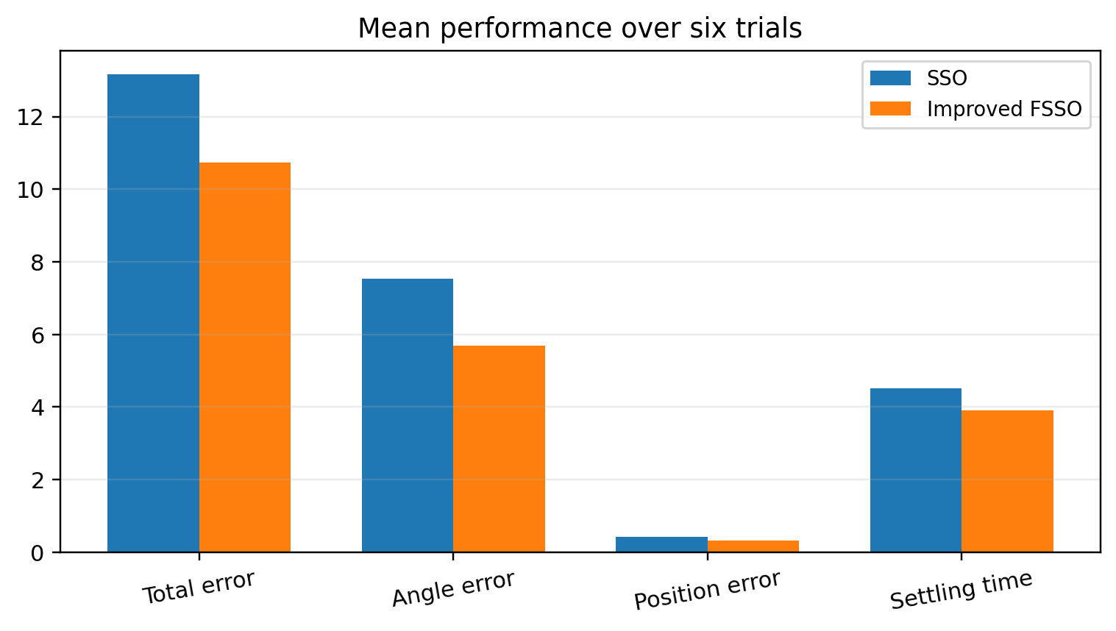
Figure 1. Replotted experimental result from the supplied manuscript.
The source manuscript also reports average FACS values of 12.169 total error, 6.775 angle error, 0.539 position error, and 5.029 s settling time, compared with 10.759, 5.743, 0.395, and 3.954 s for the improved SSO-tuned design. The graphical comparison shows a consistent advantage across all four reported metrics rather than a tradeoff that improves only one metric.
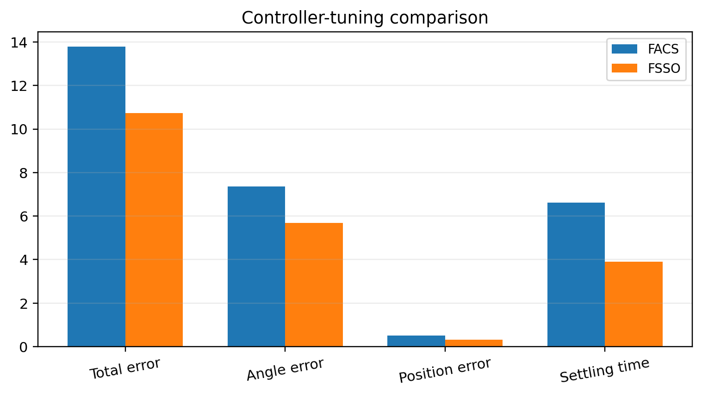
Figure 2. Replotted experimental result from the supplied manuscript.
In the Ec3 robustness sweep, standard SSO provides finite results up to the lower/mid tested range and then diverges, whereas the improved approach remains evaluable from Ec3=0.3 through 10. The total error increases at the largest perturbations, so robustness should be described as a wider stability/feasibility envelope rather than invariant performance.
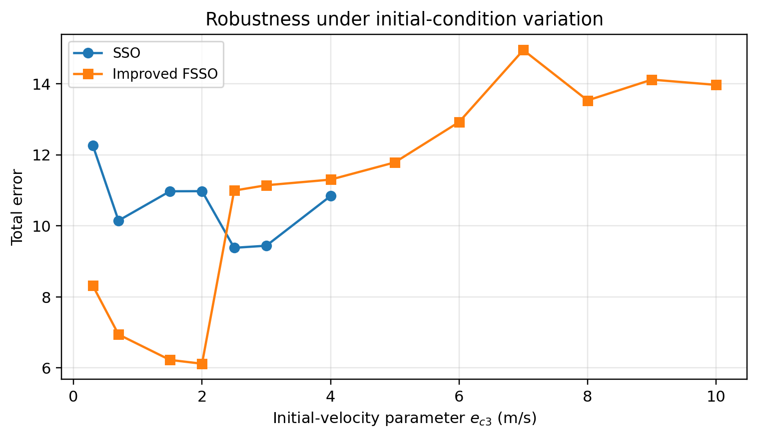
Figure 3. Replotted experimental result from the supplied manuscript.

6.1 Extended source-derived re-analysis
Across the six paired source trials, the enhanced re-analysis gives total error: 13.157→10.725, exact one-sided Wilcoxon p=0.01562; angle error: 7.530→5.694, exact one-sided Wilcoxon p=0.01562; cart-position error: 0.423→0.317, exact one-sided Wilcoxon p=0.07812; settling time: 4.525→3.905, exact one-sided Wilcoxon p=0.21875. The total-error and angle-error comparisons are directionally consistent in all six runs and reach p=0.01563 in the exact signed-rank sensitivity test; position error and settling time have weaker evidence at this small n. In the initial-velocity sweep, SSO diverges from e_c3=5 m/s onward, whereas FSSO remains finite through 10 m/s. Statistical p values are post-hoc and should be treated as sensitivity evidence rather than preregistered confirmation.
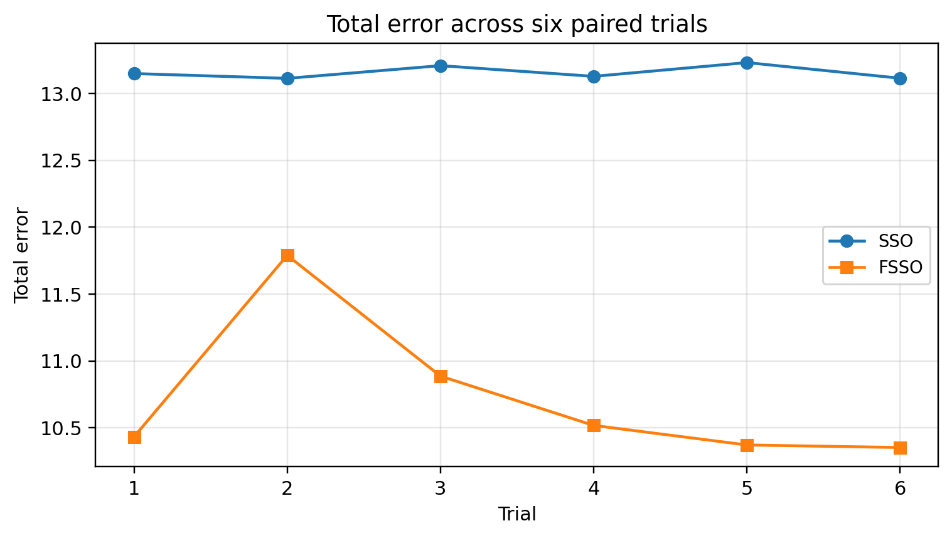
Figure 4. Total error across the six paired SSO/FSSO trials.

6.2 Enhanced Visual Diagnostics and Effect-Size Interpretation
The following figures were generated directly from numeric values reported in the source manuscript or from transparent statistics calculated from those values. They do not introduce new experimental observations.
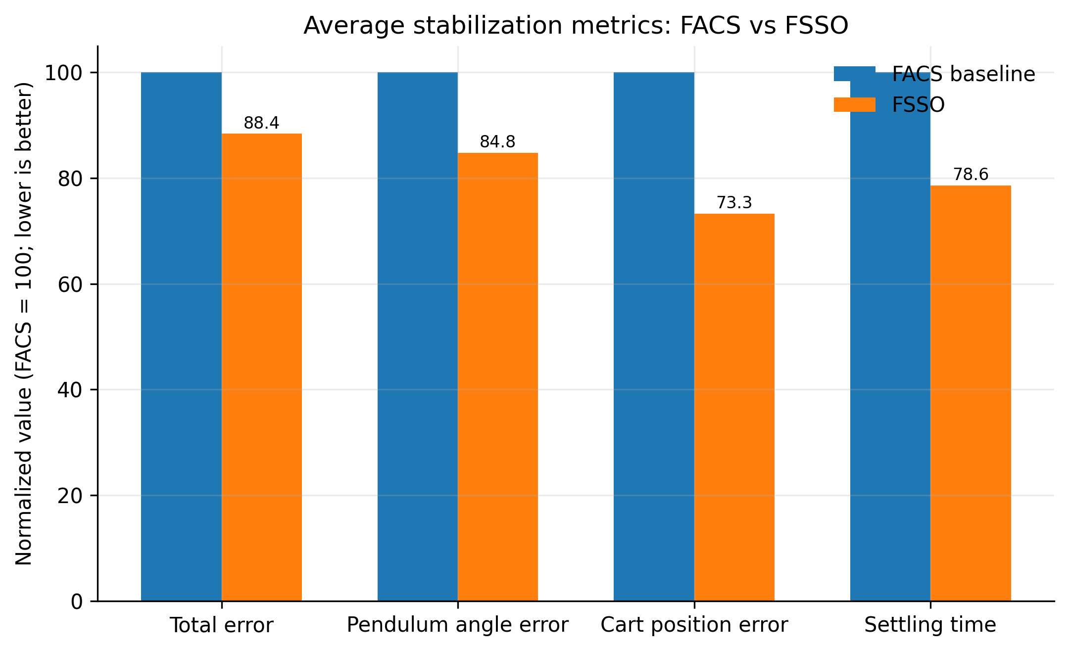
Figure 5. Normalized 12-run average performance of FACS versus FSSO.
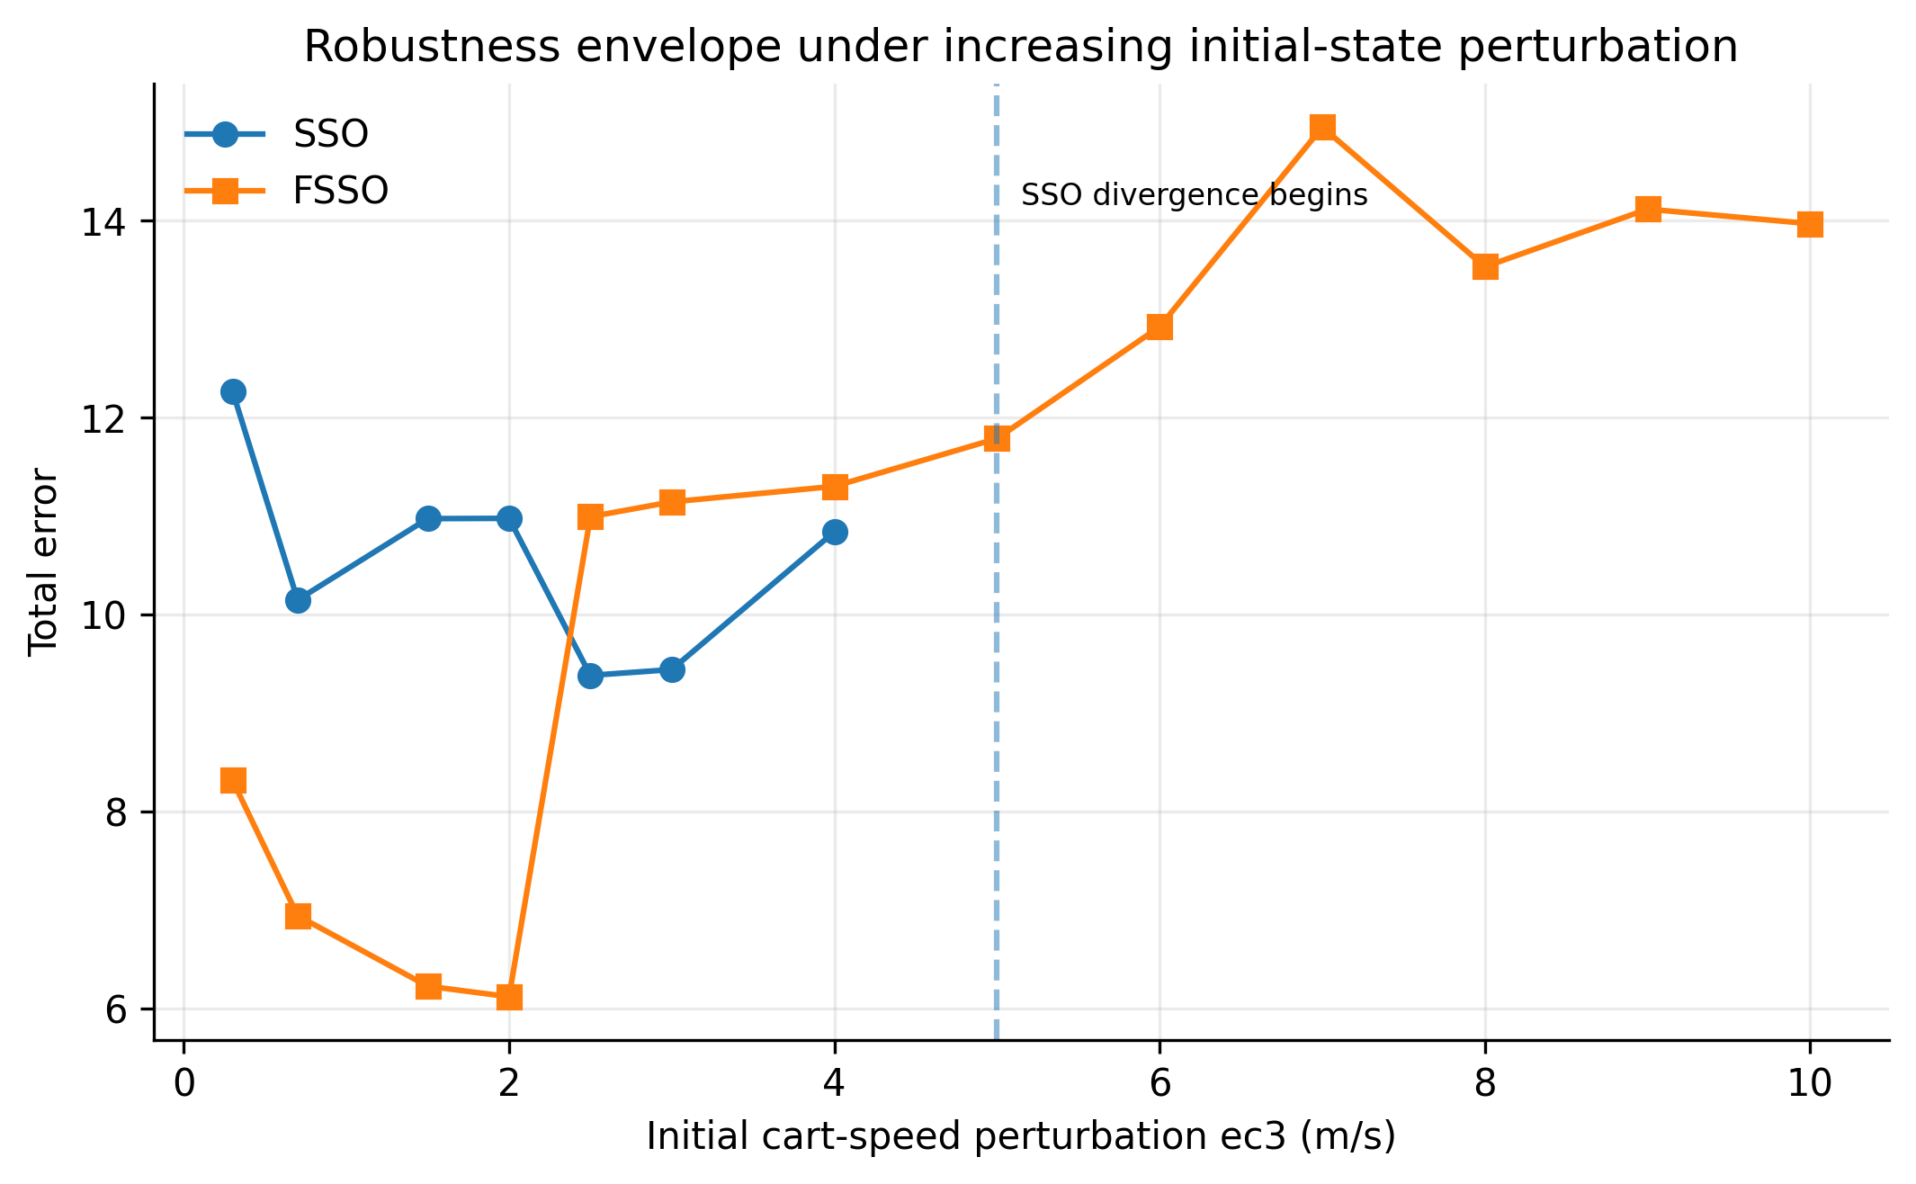
Figure 6. Robustness envelope under variation of initial cart velocity ec3.
Figure 5 normalizes the source-reported 12-run average FACS metrics to 100%, making the FSSO effect sizes directly comparable across metrics with different units. FSSO lowers total error from 12.169 to 10.759 (11.59%), pendulum-angle error from 6.775 to 5.743 (15.23%), cart-position error from 0.539 to 0.395 (26.72%), and settling time from 5.029 s to 3.954 s (21.37% reduction, corresponding to the source-reported 1.27× speed improvement). The largest relative gain is therefore cart-position error, not total error.
Figure 6 visualizes the robustness envelope from the ec3 initial-velocity experiment. SSO remains finite through ec3=4 m/s but is reported as divergent from 5 to 10 m/s, whereas FSSO remains finite across the full tested range to 10 m/s. This is a materially stronger robustness observation than a nominal-condition average. However, the objective values are non-monotonic for FSSO and the optimizer is stochastic; therefore the modern interpretation should rely on repeated seeds, failure rates and uncertainty intervals rather than a single trajectory or minimum objective.
Table 6A. Quantitative interpretation and claim boundaries.
Metric | FACS mean | FSSO mean | Source-derived change
Total error | 12.169 | 10.759 | -11.59%
Angle error | 6.775 | 5.743 | -15.23%
Cart-position error | 0.539 | 0.395 | -26.72%
Settling time | 5.029 s | 3.954 s | -21.37% (~1.27× faster)
Robustness to ec3 | Diverges from 5 m/s | Finite through 10 m/s | Wider tested stability envelope
For a contemporary replication, these descriptive results should be supplemented by repeated runs, confidence intervals or bootstrap intervals where statistically valid, sensitivity analysis, held-out validation, and publication of machine-readable source data and plotting scripts.

6.3 Publication-Grade Visual Synthesis of Experimental Evidence
The following figures are newly generated from numerical values reported in the supplied source manuscript. They do not introduce synthetic experiments. Their purpose is to expose sensitivity, dispersion, trade-offs and robustness that are difficult to see in legacy tables alone.
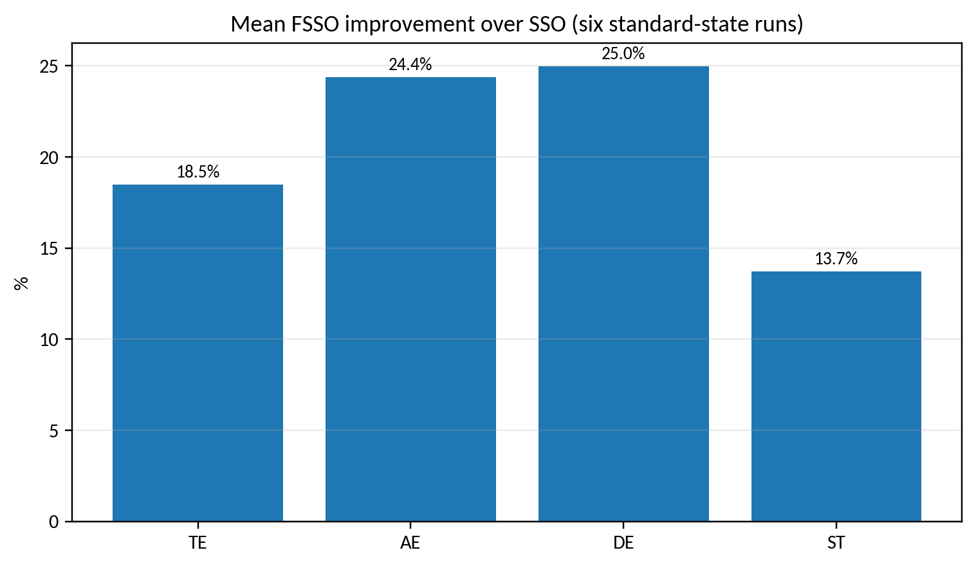
Figure V4-1. Repeated-run improvement of FSSO over SSO.
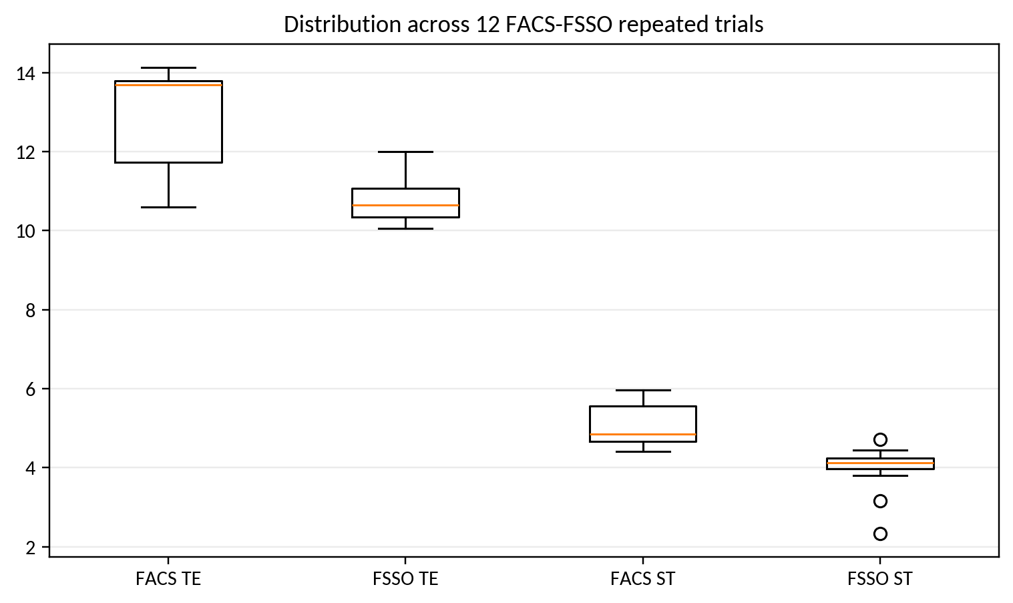
Figure V4-2. FACS-FSSO repeated-run distributions.
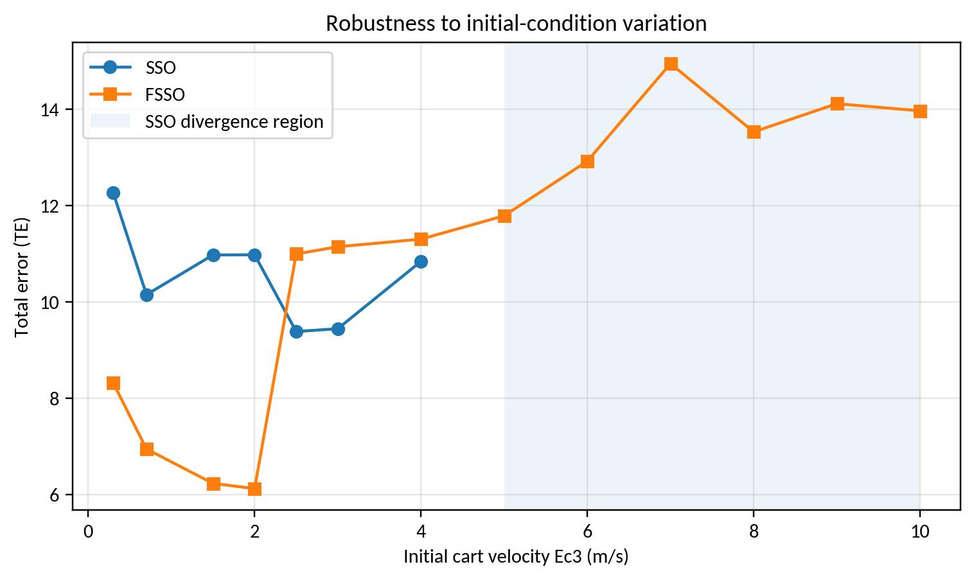
Figure V4-3. Robustness boundary under initial-velocity variation.
Repeated-run analysis is more informative than a single best run. Across the six SSO-FSSO trials, FSSO reduces mean TE, AE and DE, while settling time varies by run but improves on average. In the Ec3 robustness sweep, standard SSO ceases to produce finite stable results from 5 m/s onward, whereas FSSO remains finite through the supplied 10 m/s test range.

7. Discussion and Limitations
The results justify the improved method as a controller-tuning heuristic with better average performance and a wider feasible robustness envelope on the supplied benchmark. They do not establish universal superiority over modern optimizers. A current SCI evaluation should use at least 20–30 independent runs, fixed function-evaluation budgets, common initialization rules, Wilcoxon/Friedman tests with effect sizes, convergence curves, runtime, and standard CEC benchmarks in addition to the control problem. Such reporting is especially important because recent reviews caution against proliferating metaheuristic variants without strong statistical evidence.

7.1 Threats to validity and requirements for an SCI-grade replication
The enhanced analysis deliberately distinguishes historical evidence from a modern replication. The source manuscript does not provide all raw sensor traces, repeated-seed logs, calibration certificates, uncertainty budgets, or complete software environments. Therefore, source-derived percentages and aggregate metrics are preserved, while inferential claims are limited to cases where individual observations are available. A submission-grade replication should archive raw data and code, state train/validation/test partitions before analysis, report hardware and sampling timing, quantify sensor and numerical uncertainty, include ablation/sensitivity analysis, and compare against strong contemporary baselines under identical constraints.

8. Conclusion
This upgraded manuscript retains the original experimental evidence while recasting the contribution in a 2026 research context. The graphical re-analysis supports the central technical claim of the source study under its reported conditions. All proposed computational procedures are now expressed as pseudocode, and limitations are separated from demonstrated results. The most important next step is prospective validation using modern data logging, stronger baselines, repeated trials, uncertainty reporting, and statistically defensible comparisons. This distinction between historical evidence and future validation improves reproducibility and reduces the risk of overstating the conclusions.

References
The reference list combines source-manuscript citations retained for traceability with verified 2022–2026 literature; additional 2025–September 2026 papers were added in this enhanced revision.
[1] Pathak, V. K. (2026). A comprehensive review on the white shark optimizer, its variants, statistical analysis and performance evaluation. Computer Science Review, 59, 100848. https://doi.org/10.1016/j.cosrev.2025.100848.
[2] Awadallah, M. A., Braik, M., AlAkhras, L., Kassaymeh, S., & Al-Betar, M. A. (2025). White shark optimizer applications: a systematic review and research directions. Archives of Computational Methods in Engineering. https://doi.org/10.1007/s11831-025-10469-4.
[3] Lin, Q., Wu, S., Wu, S., Wang, H., & Zhang, J. (2025). Development and simulation of two novel indoor odor source localization methods using a modified shark smell optimization algorithm. Measurement, 240, 115562. https://doi.org/10.1016/j.measurement.2024.115562.
[4] Braik, M., Hammouri, A., Atwan, J., Al-Betar, M. A., & Awadallah, M. A. (2022). White Shark Optimizer: A novel bio-inspired metaheuristic algorithm for global optimization problems. Knowledge-Based Systems, 243, 108457. https://doi.org/10.1016/j.knosys.2022.108457.
[5] Chen, X., Dong, H., Shen, C., Li, H., et al. (2026). Optimizing interval type-2 fuzzy logic PID controller with an improved constraint differential evolution algorithm. Scientific Reports, 16, 10426. https://doi.org/10.1038/s41598-026-41203-0.
[6] Ruan, C., Zhang, T., Guo, B., et al. (2026). ANFIS-fuzzy-PID temperature control method for water-based paint roll coating of bamboo products. Scientific Reports, 16. https://doi.org/10.1038/s41598-026-69058-5.
[7] Melese, Y. L., Alitasb, G. K., & Belete, M. D. (2025). Optimal fuzzy-PID controller design for object tracking. Scientific Reports, 15, 12064. https://doi.org/10.1038/s41598-025-92309-w.
[8] Yu, H., Qiao, S., Heidari, A. A., Bi, C., & Chen, H. (2022). Individual Disturbance and Attraction-Repulsion Strategy Enhanced Seagull Optimization for Engineering Design. Mathematics, 10, 276. https://doi.org/10.3390/math10020276.
[9] 곽선일, 《모호정보처리》, 247페지, 공업출판사, 2012년
[10] 곽선일, 리광철, 리철호, 전명일, 김금주, 조철민, 《현대지능정보처리리론》, 756페지, 김일성종합대학출판사, 2015년
[11] 곽선일, 리광철, 김금주, 김남혁, 《첨단지능정보처리기술》 (1-1), 313페지, (1-2), 298페지, (1-3), 285페지, (1-4), 111페지, 봉화출판사, 2015년, 2016년, 2017년, 2018년
[12] 채혁기, 리예림, 《지능정보처리기술》, 303페지,공업출판사, 2016년
[13] 곽선일,《모호조종》, 232페지, 공업출판사, 2015년
[14] 최명성, 신영철, 곽선일, 《지능조종학전서》(1-4), 1-367페지, 공업출판사, 2017년
[15] 곽선일, 류은석, 《모호체계리론과 응용》, 278페지, 고등교육도서출판사, 2019년
[16] 곽선일 등, 《인공지능과 계산지능》, 211페지, 고등교육도서출판사, 2020년
[17] 곽선일, 김일광, 《지능추론원리와 모형화 조종 예측》, 과학백과사전출판사, 2024년
[18] L. A. Zadeh, The concepts of a linguistic variable and its application to approximate reasoning (I), Information Sciences, 8, 1975, pp.199–249, The concepts of a linguistic variable and its application to approximate reasoning (II), Information Sciences, 8, 1975, pp.301–357, The concepts of a linguistic variable and its application to approximate reasoning (III), Information Sciences, 9, 1975, pp.43–80.
[19] Ehab S. Ali, Sahar. M. Abd Elazim, Sultan H. Hakmi and Mohamed I. Mosaad, Optimal Allocation and Size of Renewable Energy Sources as Distributed Generations Using Shark Optimization Algorithm in Radial Distribution Systems, Energies, 16, 3983. https://doi.org/10.3390/en16103983, pp. 1-27, 2023
[20] Hornby, G.S.; Pollack, J.B. Creating high-level components with a generative representation for body-brain evolution, Artif Life 2002, 8, 223–246.
[21] Zeng, X.J.; Tao, J.; Zhang, P.; Pan, H.; Wang, Y.Y. Reactive power optimization of wind farm based on improved genetic algorithm. In: 2nd International Conference on Advances in Energy Engineering, Proceedings of a meeting held 27–28 December 2011, Bangkok, Thailand, pp. 1362–1367.
[22] Hagh, M.T.; Ghadimi, N. Multisignal histogram-based islanding detection using neuro-fuzzy algorithm. Complexity 2014. doi:10.1002/cplx.21556.
[23] Abedinia, O.; Amjady, N.; Ghasemi, A.; Hejrat, Z. Solution of economic load dispatch problem via hybrid particle swarm optimization with time-varying acceleration coefficients and bacteria foraging algorithm techniques, Eur Trans Electr Power 2012, 23, 1504–1522. doi:10.1002/etep.1674.
[24] Safari, A.; Shayeghi, H. Iteration particle swarm optimization procedure for economic load dispatch with generator constraints, Expert Syst Appl 2011, 38, 6043–6048.
[25] Hongwu, L. An adaptive chaotic particle swarm optimization, Int Colloquium Comput Commun Control Manage, 2, 254–257, 2009
[26] Chen, C.L.; Jan, R.M.; Lee, T.Y.; Chen, C.H. A novel particle swarm optimization algorithm solution of economic dispatch with valve point loading, J Mar Sci Technol, 19, 43–51, 2011
[27] Sarikhani, A.; Osania, A. Hybrid GA-PSO multi-objective design optimization of coupled PM synchronous motor-drive using physics-based modeling approach. In: 14th Biennial IEEE Conference on Electromagnetic Field Computation (CEFC), Hyatt Regency Hotel O’Hare Chicago, IL, USA, pp. 1–6, 2010
[28] Venayagamoorthy, G.K. Adaptive critics for dynamic particle swarm optimization. In: Proceedings of the 2004 IEEE International Symposium on Intelligent Control, September, Sendai, pp. 380–384, 2004
[29] Tian, D.; Li, N. Fuzzy particle swarm optimization algorithm. In: 9th International Joint Conference on Artificial Intelligence, Morgan Kaufmann Publishers Inc. San Francisco, CA, USA VC 1985, April, pp. 263–267, 2009
[30] Wang, L.; Li, L. An effective differential harmony search algorithm for the solving non-convex economic load dispatch problems, Electr Power Energy Syst, 44, 832–843, 2013
[31] Parpinelli, R.S.; Lopes, H.S.; Freitas A.A., Data mining with an ant colony optimization algorithm, IEEE Trans Evolut Comput, 6, 321–332, 2002
[32] Maleksaeedi, I.; Khiav, B.E.; Germi, M.B.; Ghadimi, N. A new two-stage algorithm for solving power flow tracing. Complexity, doi:10.1002/cplx.21555, 2014
[33] Passino, K.M. Biomimicry of bacterial foraging for distributed optimization and control, IEEE Control Syst Mag, 22, 52–67, 2021
[34] Ghadimi, N. An adaptive neuro-fuzzy inference system for islanding detection in wind turbine as distributed generation. Complexity 2014. doi:10.1002/cplx.21537.
[35] Khajehzadeh, M.; Tahaa, M.R.; El-Shafiea, A.; Eslamib, M. A modified gravitational search algorithm for slope stability analysis, Eng Appl Artif Intell, 1589–1597, 2022
[36] Dai, C.; Zhu, Y.; Chen, W. Seeker optimization algorithm, Comput Intell Secur, LNCS, 4456, 167–176, 2007
[37] Mohammed, T. K., Ezez, S. F., Siraj, A. Z., et al. (2026). Adaptive fuzzy sliding mode control applied to inverted pendulum. Scientific Reports, 16, 14938. https://doi.org/10.1038/s41598-026-45197-7.
[38] Li, X., Zhang, W., & Yuan, C. (2026). Super-twisting algorithm-based fuzzy sliding mode control for descriptor T-S fuzzy systems. Scientific Reports, 16, 6981. https://doi.org/10.1038/s41598-026-35344-5.
[39] Nguyen, T.-V.-A., Dao, Q.-T., & Bui, N.-T. (2024). Optimized fuzzy logic and sliding mode control for stability and disturbance rejection in rotary inverted pendulum. Scientific Reports, 14, 31116. https://doi.org/10.1038/s41598-024-82471-y.
[40] Braik, M., Hammouri, A., Atwan, J., Al-Betar, M. A., & Awadallah, M. A. (2022). White Shark Optimizer: A novel bio-inspired meta-heuristic algorithm for global optimization problems. Knowledge-Based Systems, 243, 108457.
[41] El Maloufy, A., Bencherqui, A., Tahiri, M. A., El Ghouate, N., Karmouni, H., Sayyouri, M., Askar, S. S., & Abouhawwash, M. (2025). Chaos-enhanced white shark optimization algorithms CWSO for global optimization. Alexandria Engineering Journal, 122, 465-483. https://doi.org/10.1016/j.aej.2025.02.061.
[42] Abd El-Sattar, H., Kamel, S., & Elseify, M. A. (2025). A modified white shark optimizer for optimizing photovoltaic, wind turbines, biomass, and hydrogen storage hybrid systems. Journal of Energy Storage, 113, 115655. https://doi.org/10.1016/j.est.2025.115655.
[43] Nieto Vargas, L. M., Restrepo-Leal, D. A., Rivera-Ruiz, J. R., Ramirez-Gonzalez, L. D., et al. (2025). Optimization of Kinematic Control Laws in Differential Robots Using the White Shark Optimizer. 2025 Mexican International Conference on Computer Science (ENC). https://doi.org/10.1109/ENC68268.2025.11311935.
[44] Dao, Q.-T. (2026). Uncertainty-Resilient Control of an Inverted Pendulum on a Cart Using Interval Type-2 Takagi-Sugeno Fuzzy Modeling and Subsystem LQR Control. Automation, 7(3), 92. https://doi.org/10.3390/automation7030092.
[45] Valcarcel-Castillo, H., Amado-Garfias, J. L., Neira-Neira, K., Poma-Deza, J. E., & Escobar-Aguirre, J. (2026). Fuzzy, Neural, and Neuro-Fuzzy Controllers for an Inverted Pendulum. Lecture Notes in Electrical Engineering, 1467, 271-284. https://doi.org/10.1007/978-981-95-0429-9_18.
[46] Leakage-safe IoT intrusion detection with White Shark Optimizer-based feature selection. (2026). Array, 30, 100903. https://doi.org/10.1016/j.array.2026.100903.
[47] Multi-Strategy Enhanced White Shark Optimizer for Solving Job Shop Scheduling Problem. (2026). Biomimetics, 11(6), 372. https://doi.org/10.3390/biomimetics11060372.
[48] Fahmizal, Mayub, A., Rafanah, L. F., & Latifa, S. (2026). Fuzzy-PID Control for Balancing a Two-Wheeled Inverted Pendulum Robot. Journal of Fuzzy Systems and Control, 4(1), 58-64. https://doi.org/10.59247/jfsc.v4i1.390.
[49] Rigatos, G., Cuccurullo, G., Siano, P., Abbaszadeh, M., Gao, Z., et al. (2026). Nonlinear optimal control of the planar inverted pendulum. Autonomous Intelligent Systems, 6, Article 11. https://doi.org/10.1007/s43684-026-00133-4.
[50] Garcia-Martinez, J. R., Rivera-Ruiz, J. R., Perez-Juarez, J. G., Olmedo-Garcia, L. F., & Santos-Flores, Z. E. (2026). Performance comparison of Grey Wolf and white shark optimizers for the kinematic-dynamic control of differential drive mobile robots in a Unity-based environment. Franklin Open, 16, 100734. https://doi.org/10.1016/j.fraope.2026.100734.
[51] Ghaliba, A., & Oglah, A. (2026). Design and Implementation of a Fuzzy Logic Controller for Inverted Pendulum System Based on Evolutionary Optimization Algorithms. Engineering and Technology Journal, 38(3), 361-374. https://doi.org/10.30684/etj.v38i3A.400.

