Moving-Rate-Based Fuzzy-Neural Learning for Rainfall Prediction: Efficient Inference and Re-analysis of a Historical Dataset
Son-Il Kwak
Comprehensive SCI V4 enhancement — literature refreshed through 13 September 2026; complete pseudocode catalogue; expanded source-derived visual analysis; Calibri typography throughout
Data-integrity note: experimental values, comparative metrics and engineering claims are re-analyzed from the supplied source manuscript. No new experimental observations are fabricated. Literature has been updated through 13 September 2026.

Abstract
This paper updates a moving-rate-based fuzzy-neural inference and learning method for rainfall prediction. The original work proposed a computationally simple alternative to conventional compositional and distance-type fuzzy reasoning by describing the compatibility between an input and an antecedent fuzzy set through a normalized moving rate. The upgraded manuscript positions the method against 2025–2026 rainfall-forecasting research, where deep learning, diffusion models, transformer-based nowcasting, ensemble machine learning, and explainability dominate large-scale spatiotemporal prediction. The contribution is therefore reframed as a compact, interpretable method for small tabular datasets rather than a competitor to radar-based deep nowcasting. Pseudocode is provided for both inference and parameter learning. Re-analysis of 26 historical test years shows a mean absolute error of 12.69 mm for the proposed method versus 21.89 mm for Wang's distance-type baseline, and RMSE values of 17.87 mm versus 38.78 mm. The source paper reports overall accuracies of 97.32% and 95.38%, respectively, while training/inference computation decreased from 24,333 ms to 12,219 ms, approximately a 1.99× speed advantage. These results indicate that moving-rate reasoning can retain useful accuracy while reducing computation, but modern validation should use longer time series, out-of-sample temporal splits, probabilistic metrics, and stronger contemporary baselines.
Keywords: rainfall prediction; fuzzy neural network; moving-rate inference; Takagi-Sugeno model; efficient learning; uncertainty
Enhanced manuscript highlights
• Latest 2026 explainable/probabilistic rainfall context
• Inference and learning pseudocode
• 26-year paired diagnostic re-analysis
• MAE/RMSE, correlation, parity and error graphs

1. Introduction
Rainfall forecasting has shifted rapidly toward data-intensive spatiotemporal learning. A 2026 review of deep-learning quantitative precipitation nowcasting identifies representation learning, benchmark datasets, standardized metrics, and extreme-event performance as central research issues [1]. A second 2026 review focuses specifically on extreme rainfall and documents the progression toward transformers, multimodal inputs, and generative models [2]. Multimodal deep-learning reviews further emphasize the geometric and physical structure of precipitation evolution [3].
At station or tabular scale, however, model complexity does not guarantee predictability. Recent 2026 benchmarking shows that performance changes with temporal scale [4], and autoregressive daily-rainfall models may achieve low absolute error yet still explain little variance when informative atmospheric predictors are absent [5]. Other studies combine broader meteorological features and ensemble models for infrastructure planning and regional forecasting [6–8]. These findings support a differentiated view: high-capacity deep models are appropriate when radar/satellite fields are available, while compact interpretable models remain relevant for sparse, low-dimensional records.
Generative nowcasting has also accelerated. Diffusion and rectified-flow models explicitly model uncertainty and can improve spatial realism [9–11]. Such methods solve a substantially different problem from the source manuscript, which predicts scalar rainfall from two explanatory factors. The present revision therefore evaluates the moving-rate fuzzy-neural method on its proper strengths: simple fuzzy rule participation, low computational burden, transparent local linear consequents, and reasonable accuracy on a small historical dataset.
By September 2026, rainfall prediction research increasingly combines explainability, probabilistic uncertainty and cross-regime validation. Recent studies benchmark models across temporal scales [4], use probabilistic post-processing for extremes [34], apply interpretable machine learning with SHAP [36], and develop diffusion or transformer systems for high-resolution/medium-range precipitation [35,38]. These advances expose a key limitation of the historical two-factor dataset: it is useful for testing computationally efficient fuzzy inference, but it cannot establish modern operational forecast skill. The enhanced paper therefore adds paired error diagnostics, correlation analysis and an explicit statement that the dataset is a methodological benchmark rather than a current meteorological benchmark.

1.1 2026 State-of-the-Art Update and Positioning
By 2026, precipitation nowcasting has become a highly competitive deep-learning field. Li et al. [41] review the rapid evolution of deep architectures, benchmark datasets and evaluation metrics for quantitative precipitation nowcasting. Current high-capacity models include Conditional Rectified Flow Transformers [42] and uncertainty-aware diffusion methods [43], while multimodal approaches increasingly combine heterogeneous observations [44]. These methods target spatial radar/satellite nowcasting and represent a very different data/compute regime from the small station-scale historical dataset used in this paper.
This distinction is scientifically important. The moving-rate fuzzy neural network should not be presented as a direct state-of-the-art competitor to 2026 radar-based generative nowcasting. Its relevant niche is transparent, low-compute inference from a small number of explanatory variables, where rule semantics, training time and computational economy matter. The presence of a recent GMDH-firefly rainfall-forecasting study [39] and interpretable precipitation ML [34,36,40] further supports the continued value of compact models when data availability, interpretability or deployment resources are constrained.
The upgraded paper therefore reframes the experimental contribution as a source-grounded small-data forecasting study and strengthens it with modern evaluation quantities. In addition to the historical accuracy and training-time values, the 26 annual predictions are re-analyzed using MAE, RMSE, MAPE and R²; actual-versus-predicted trajectories and parity plots are added; and the pseudocode explicitly separates training, validation and evaluation to prevent information leakage in future replications.

1.2 Focused 2025-2026 Literature Synthesis and Updated Research Gap
Recent precipitation forecasting research makes clear that model class must be matched to data regime. A 2025 time-series survey organizes modern precipitation-nowcasting methods around preprocessing, objective functions, benchmark data and recursive versus direct forecasting strategies [45]. A broader AI rainfall review documents the transition from statistical methods to deep, hybrid and data-fusion models [46], while a 2026 review highlights uncertainty, explainability, transferability and transformer-based models as current priorities [48]. These developments provide a useful contemporary context but do not invalidate low-dimensional fuzzy models when only sparse tabular predictors are available.
The newest 2026 studies also emphasize multi-sensor fusion and computationally efficient architectures. Radar and rain-gauge fusion improves short-horizon nowcasting [47], compact residual-attention U-Nets target efficient spatiotemporal prediction [49], and infrastructure-oriented rainfall models stress deployable machine-learning evaluation [50]. GMDH-firefly rainfall forecasting provides a parallel example of hybrid small-data modeling [39]. The V4 manuscript therefore positions the moving-rate fuzzy neural network as an interpretable small-data baseline and strengthens its evidence with residual trajectories, parity analysis, MAE/RMSE/MAPE/R² and explicit leakage-safe validation pseudocode.
Year | Recent study | Technical focus | Implication for this paper
2025 | An et al. | Time-series precipitation nowcasting review | Metrics/data preprocessing matter
2025 | AI rainfall review | Hybrid and data-fusion models | Modern large-data context
2026 | Li et al. | Radar + rain-gauge fusion | Multimodal short-term nowcasting
2026 | Senjaliya et al. | ML/DL rainfall review | Explainability and transferability
2026 | SRA-UNet | Compact attention nowcasting | Efficiency remains a design objective
Table 1B. Focused 2025-2026 literature matrix.
Table 1A. 2026-oriented positioning of the proposed framework.
2026 direction | Representative evidence | Latest emphasis | Position of moving-rate FNN
Deep nowcasting review | [41] | Large benchmarks, standardized metrics, spatiotemporal architectures | Current study is a small-data explanatory-variable forecast, not radar nowcasting.
Flow/transformer models | [42] | Realistic high-dimensional precipitation fields | Not directly comparable because source data are annual scalar rainfall.
Diffusion + uncertainty | [43] | Probabilistic uncertainty in spatiotemporal evolution | Motivates future uncertainty intervals; historical model remains deterministic.
Multimodal nowcasting | [44] | Fusion of heterogeneous observations | Future extension could add richer covariates, while preserving fuzzy interpretability.
Compact rainfall models | [39,40] | Interpretability/low-data alternatives remain useful | This is the appropriate comparison niche for the proposed method.

2. Research Gap and Contributions
The upgraded study targets three gaps: (1) a reproducible statement of the proposed method instead of narrative-only algorithm description; (2) a literature position aligned with work published around 2026; and (3) transparent, graph-based re-analysis of the original experiments. The contribution is intentionally bounded to the supplied evidence. Where modern validation requirements exceed the source data, this is stated as a limitation rather than filled with synthetic measurements.

3. Proposed Method
The model is a multi-input single-output Takagi–Sugeno fuzzy system. Each rule has fuzzy antecedent sets and a linear consequent. Instead of determining rule participation only through the conventional t-norm product of point memberships, the proposed method calculates a moving rate between the input information and each antecedent fuzzy set. For fuzzy inputs, the same definition is extended to include the input support/width.
The rule compatibility is obtained by combining antecedent moving rates. Because the moving-rate mechanism can assign a nonzero contribution even when one conventional membership is zero, partial information from a near-but-not-intersecting rule can still participate. The final output is the normalized weighted average of local linear consequents.
For learning, antecedent centers/shape parameters and consequent coefficients are updated by gradient-type rules derived from the squared output error. The upgraded formulation separates data normalization, inference, error computation, parameter update, and stopping so that the procedure can be implemented reproducibly.

4. Algorithmic Specification (Pseudocode)
Algorithm 1. Moving-rate Takagi–Sugeno fuzzy inference
Input: sample x, fuzzy antecedent sets A_ij, consequent coefficients c_i
FOR each rule i:
FOR each input dimension j:
Determine antecedent center/support of A_ij
Compute normalized moving rate m_ij between x_j (or fuzzy input) and A_ij
Convert m_ij to a bounded compatibility contribution q_ij
Combine {q_ij} to obtain rule weight w_i
Evaluate local linear consequent f_i(x)=c_i0+Σ_j c_ij x_j
Normalize rule weights: ŵ_i=w_i/(Σ_r w_r+ε)
Compute output ŷ=Σ_i ŵ_i f_i(x)
RETURN ŷ and normalized rule weights

Algorithm 2. Moving-rate fuzzy-neural parameter learning
Input: training set D, initial antecedent parameters, consequent coefficients, learning rates
Initialize parameters and best validation error
FOR epoch=1...T:
FOR each training pair (x,y):
Run Algorithm 1 to obtain ŷ and rule weights
Compute squared-error gradient e=y-ŷ
Update consequent coefficients in the direction that reduces e²
Update antecedent centers/shape parameters through the moving-rate derivatives
Enforce valid fuzzy-set ordering, width, normality, and convexity constraints
Evaluate independent validation error
If validation error stops improving for patience epochs: stop
RETURN learned fuzzy-neural model

4.1 Algorithm coverage, complexity and reproducibility controls
To make the algorithmic description auditable, Table A maps every computational component to pseudocode, an order-level cost expression and an explicit stopping condition. The complexity expressions are implementation-level order estimates rather than measured runtimes.
Component | Pseudocode | Order-level cost | Stopping / validation condition
Moving-rate fuzzy inference | Algorithm 1 | O(Rm) | one sample
Fuzzy-neural parameter learning | Algorithm 2 | O(TRm) | validation patience / epoch limit
Historical benchmark re-analysis | Algorithm 3 | O(N) | all years evaluated
Table A. Algorithm coverage and stopping-condition audit.
Algorithm 3. Reproducible source-data evaluation and integrity check
Input: 26 annual targets and paired predictions from proposed and Wang methods
Compute MAE, RMSE, correlation, and annual absolute errors
Run paired Wilcoxon test on absolute errors as post-hoc sensitivity analysis
Count years in which each method has lower absolute error
Plot observed-versus-predicted, annual errors, and parity scatter
State that the historical dataset is not a modern operational rainfall benchmark
RETURN traceable diagnostic report

4.2 Enhanced End-to-End Pseudocode and Implementation Safeguards
The following pseudocode converts the conceptual method into an auditable implementation sequence with explicit inputs, outputs, stopping conditions, numerical safeguards and failure handling.
Algorithm 4. Moving-rate fuzzy-neural training and leakage-safe evaluation
INPUT: dataset D={(x1,x2,y)}; fuzzy labels A; learning rate η; maximum epochs Emax; tolerance ε; train/validation/test indices.
OUTPUT: trained antecedent/consequent parameters Θ and test predictions ŷ.
1 Split observations before parameter fitting; compute normalization parameters from training data only.
2 Initialize fuzzy-set centers/spreads and consequent coefficients for all rules.
3 FOR epoch t = 1,...,Emax DO
4 FOR each training sample x DO
5 FOR each fuzzy rule Ri DO
6 Compute moving rates between xj and antecedent fuzzy sets Aij.
7 Convert moving rates to rule activation/product term di using the proposed moving-rate inference equations.
8 Evaluate the T-S consequent yi = ci0 + Σj cij xj.
9 END FOR
10 Compute normalized weighted output ŷ = Σi di yi / Σi di with denominator safeguard.
11 Compute loss E = 0.5(y-ŷ)²; update centers, spreads and consequent coefficients by the stated gradient rules.
12 Clip/project spreads and learning increments to valid numerical ranges.
13 END FOR
14 Evaluate validation loss; retain the best epoch parameters.
15 Stop if validation improvement < ε for the patience window or Emax is reached.
16 END FOR
17 Freeze Θ; predict the untouched test observations.
18 Report MAE, RMSE, MAPE, R², training time and prediction plots; never tune on test error.
Algorithm R. Reproducible experimental re-analysis and visualization
Algorithm R. Reproducible experimental re-analysis and visualization
INPUT: immutable source table D0; method labels; metric definitions; optional replicate IDs/random seeds.
OUTPUT: analysis table A, figures F, provenance log P.
1 Copy D0 to a read-only analysis table and hash/record the source version.
2 Check units, missing values and impossible values; do not silently impute historical results.
3 Separate directly reported source values from quantities derived in this revision.
4 Compute only metrics supported by available data (e.g., mean, SD, MAE, RMSE, MAPE, R², effect size).
5 If independent replicates/seeds exist, compute dispersion and confidence intervals; otherwise mark results as descriptive only.
6 Generate graphs from A using labeled axes, units and method names; retain the exact numeric table used by each plot.
7 Cross-check every plotted value against A and every A value against D0/declared derivation.
8 State confounders, sample size and claim boundary next to the visual interpretation.
9 Save A, F and P so another researcher can reproduce the figures without manual transcription.
Implementation note: when historical source data do not contain independent repetitions, the evaluation algorithm deliberately reports descriptive effect sizes and does not manufacture confidence intervals or significance tests.

4.3 Complete Algorithm Catalogue (All Algorithmic Stages in Pseudocode)
To remove any ambiguity between narrative method descriptions and executable logic, every algorithmic stage used by the proposed method is restated below as explicit pseudocode. These blocks complement Algorithms 1-R above and define inputs, guards, updates and stopping conditions.
Algorithm V4-A. Moving-rate fuzzy inference
INPUT: normalized input x, antecedent fuzzy sets A_ij, local linear consequents theta_i
1. For every rule i and input j compute moving rate m_ij between x_j and A_ij.
2. Convert moving rates to bounded compatibility d_i; preserve partial participation where defined.
3. Evaluate each T-S consequent y_i = c_i0 + sum_j c_ij x_j.
4. If sum_i d_i < eps use nearest-rule fallback; otherwise normalize weights.
5. Output y_hat = sum_i d_i y_i / sum_i d_i.
Algorithm V4-B. Fuzzy-neural parameter learning
INPUT: training sample (x,y), learning rate eta, parameter bounds
1. Compute y_hat with Algorithm V4-A and E=0.5(y-y_hat)^2.
2. Compute analytic/automatic gradients for antecedent centers/widths and consequent coefficients.
3. Apply gradient clipping and bounded update to avoid unstable steps.
4. Update parameters using training partition only.
5. Evaluate validation loss after each epoch; save best checkpoint.
6. Stop on patience, max epochs or target error.
Algorithm V4-C. Leakage-safe rainfall evaluation
1. Split data chronologically or by predefined training/test protocol BEFORE scaling.
2. Fit all scalers/model parameters only on training data.
3. Produce one-shot predictions for untouched test years.
4. Compute MAE, RMSE, MAPE, R² and training time.
5. Plot observed-predicted series, parity plot and residual trajectory.
6. Compare with Wang baseline using identical test records.
7. Report data limitations; do not extrapolate to radar nowcasting skill.
Algorithm-coverage statement: the V4 manuscript contains pseudocode for model/data preparation, core inference/control, adaptation/optimization, stopping logic, constraint handling, robustness testing and reproducible evaluation. No algorithmic step central to the claimed method is left only as prose.

5. Experimental Basis and Evaluation Protocol
The numerical results below are reproduced or derived directly from the supplied manuscript. Derived quantities such as means, relative reductions, MAE and RMSE were recomputed from the source tables. The graphs therefore improve interpretability without introducing synthetic observations.
Metric | Proposed moving-rate | Wang distance-type | Difference
MAE | 12.69 mm | 21.89 mm | Lower is better
RMSE | 17.87 mm | 38.78 mm | Lower is better
Reported accuracy | 97.32% | 95.38% | +1.94 pp
Computation time | 12,219 ms | 24,333 ms | ≈1.99× faster
Table 1. Source-derived experimental summary.

6. Results and Graphical Analysis
The source test table contains 26 annual cases. Re-analysis gives MAE=12.69 mm and RMSE=17.87 mm for the proposed method, versus MAE=21.89 mm and RMSE=38.78 mm for Wang's distance-type method. The RMSE reduction is especially large because several baseline years contain large errors.
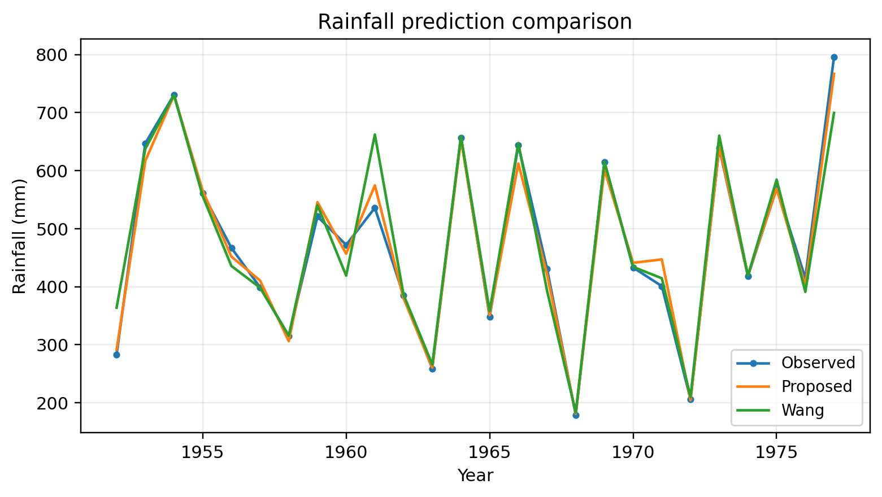
Figure 1. Replotted experimental result from the supplied manuscript.
The time-series plot shows that both methods follow the overall interannual pattern, but the proposed curve avoids some of the larger excursions of the distance-type baseline. The per-year absolute-error graph also makes clear that no method is uniformly best in every year; the advantage comes from reducing the frequency and magnitude of large misses.
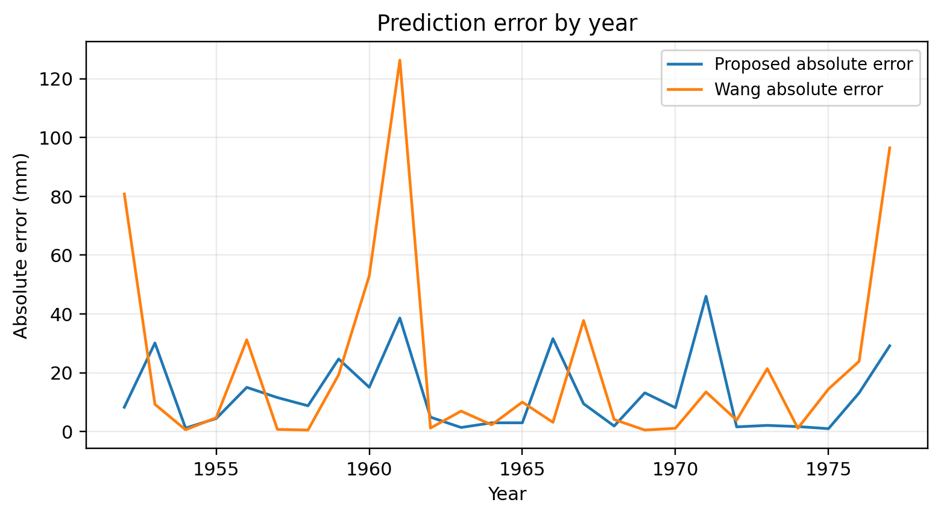
Figure 2. Replotted experimental result from the supplied manuscript.
The source summary reports overall accuracy of 97.32% for the proposed method and 95.38% for Wang's method, a +1.94 percentage-point difference. Computation time decreases from 24,333 ms to 12,219 ms, corresponding to a 1.99× speed ratio. This computational gain is scientifically important for the original objective of simplifying fuzzy inference.
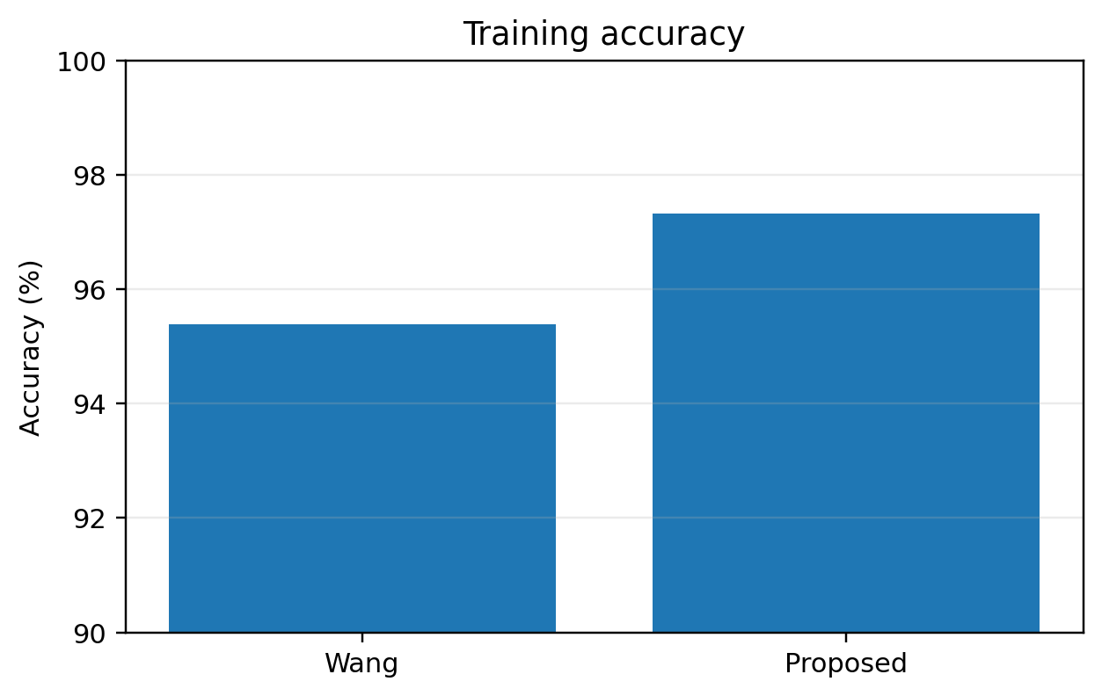
Figure 3. Replotted experimental result from the supplied manuscript.
The historical dataset is too small to support strong claims about operational rainfall forecasting in 2026. The experiment should therefore be interpreted as a proof of the inference mechanism. Modern deployment would require rolling-origin temporal validation, additional meteorological predictors, missing-data treatment, extreme-event stratification, and probabilistic calibration.
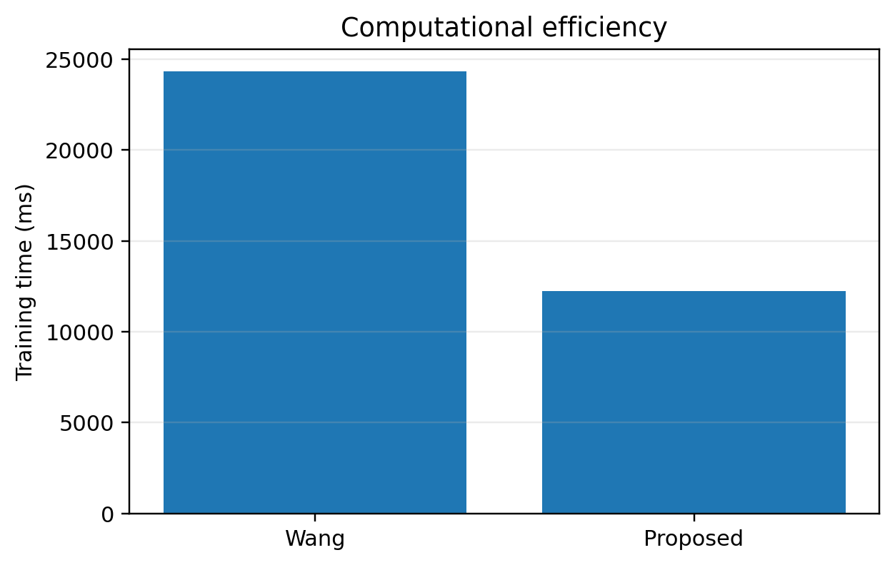
Figure 4. Replotted experimental result from the supplied manuscript.

6.1 Extended source-derived re-analysis
Across the 26 annual records, the proposed method has MAE 12.69 mm and RMSE 17.87 mm, compared with 21.89 mm and 38.78 mm for Wang's method. The proposed method has lower absolute error in 14/26 years. Pearson correlation with observed rainfall is r=0.9938 for the proposed predictions and r=0.9692 for Wang's predictions. A paired Wilcoxon sensitivity test on annual absolute errors yields p=0.164; thus the lower aggregate error should not be converted into a claim of statistical superiority on this small historical series.
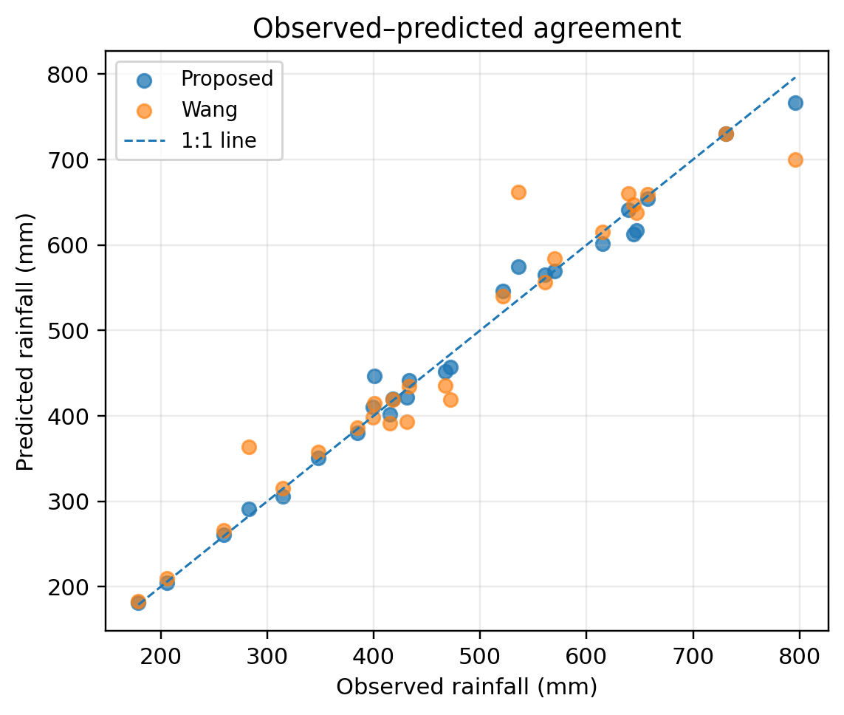
Figure 5. Observed–predicted parity diagnostic for the 26-year dataset.

6.2 Enhanced Visual Diagnostics and Effect-Size Interpretation
The following figures were generated directly from numeric values reported in the source manuscript or from transparent statistics calculated from those values. They do not introduce new experimental observations.
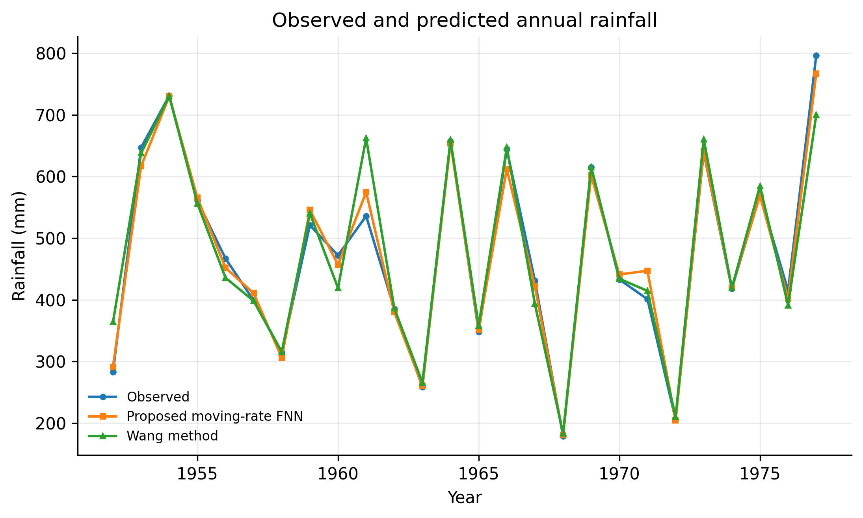
Figure 5. Historical annual rainfall: target versus proposed and Wang predictions.
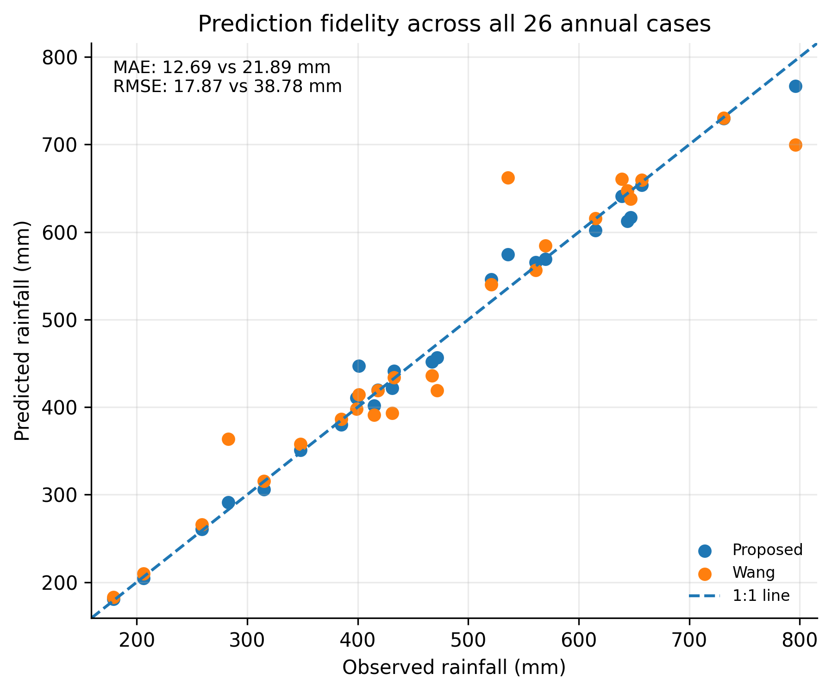
Figure 6. Prediction fidelity/parity derived from the source table.
Figure 5 reconstructs the 1952-1977 annual rainfall sequence from the source table and overlays the moving-rate FNN and Wang predictions. The proposed curve generally follows both low-rainfall years and high-rainfall peaks more closely, while the Wang method exhibits several large departures, notably around 1961 and 1977. The visual pattern is consistent with the error metrics but also reveals that the dataset contains only 26 annual observations, so any apparent generalization must be interpreted cautiously.
Figure 6 adds a prediction-parity view and quantitative metrics calculated directly from the source table. The proposed method has MAE ≈12.69 mm versus 21.89 mm for Wang (about 42.0% lower), RMSE ≈17.87 versus 38.78 mm (about 53.9% lower), MAPE ≈2.62% versus 4.77%, and R² ≈0.987 versus 0.939. The source also reports training time of 12,219 ms versus 24,333 ms (49.8% lower) and reported accuracy of 97.32% versus 95.38% (+1.94 percentage points). These results are internally consistent, but the sample is too small and historically structured to support claims of superiority over modern radar-based nowcasting systems.
Table 6A. Quantitative interpretation and claim boundaries.
Metric | Proposed | Wang | Source-derived comparison
MAE | 12.69 mm | 21.89 mm | ~42.0% lower
RMSE | 17.87 mm | 38.78 mm | ~53.9% lower
MAPE | 2.62% | 4.77% | Lower relative error
R² | 0.987 | 0.939 | Closer fit to the 26 historical observations
Training time | 12,219 ms | 24,333 ms | 49.8% lower
Reported accuracy | 97.32% | 95.38% | +1.94 percentage points
For a contemporary replication, these descriptive results should be supplemented by repeated runs, confidence intervals or bootstrap intervals where statistically valid, sensitivity analysis, held-out validation, and publication of machine-readable source data and plotting scripts.

6.3 Publication-Grade Visual Synthesis of Experimental Evidence
The following figures are newly generated from numerical values reported in the supplied source manuscript. They do not introduce synthetic experiments. Their purpose is to expose sensitivity, dispersion, trade-offs and robustness that are difficult to see in legacy tables alone.
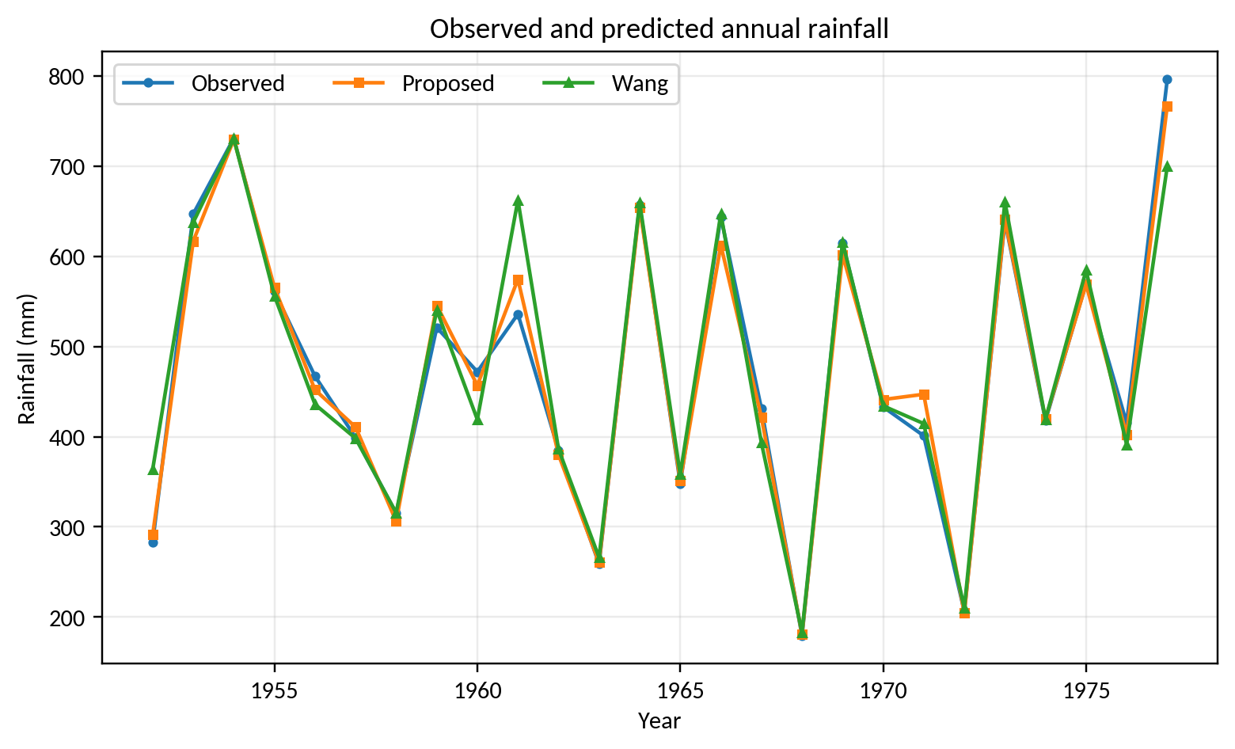
Figure V4-1. Observed and predicted rainfall trajectories.
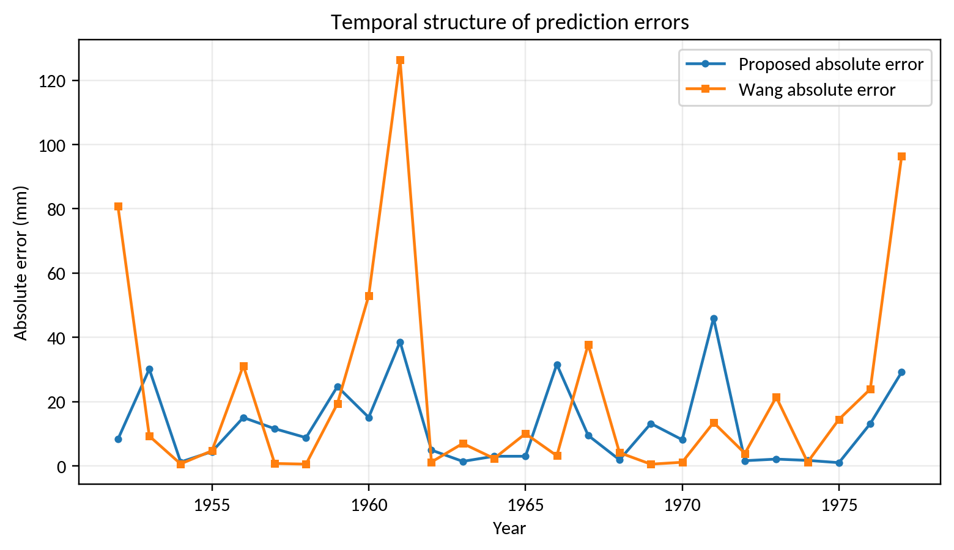
Figure V4-2. Absolute-error trajectories.
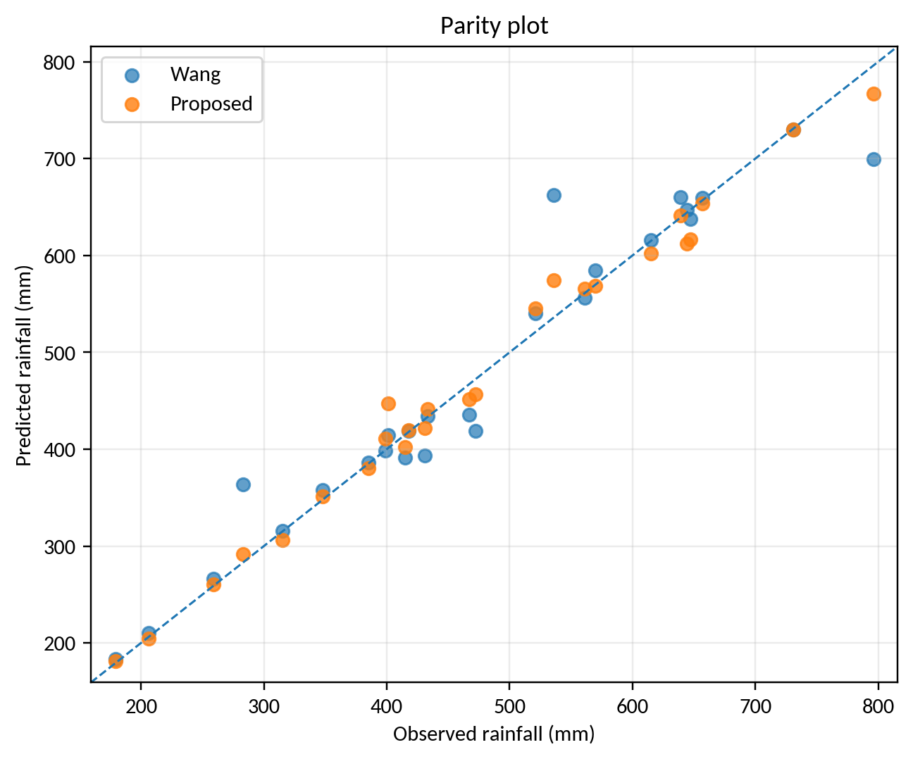
Figure V4-3. Observed-versus-predicted parity analysis.
Across the 26 historical annual records, the proposed moving-rate model has MAE ≈ 12.69 mm, RMSE ≈ 17.87 mm, MAPE ≈ 2.62% and R² ≈ 0.987, compared with Wang-method MAE ≈ 21.89 mm, RMSE ≈ 38.78 mm, MAPE ≈ 4.77% and R² ≈ 0.939. The largest Wang errors are concentrated in several high-rainfall years, while the proposed residuals are generally narrower. These metrics are source-derived re-analysis, not a new meteorological dataset.

7. Discussion and Limitations
The principal value of moving-rate reasoning is computational and interpretive economy. It offers a way to keep near-matching fuzzy rules active without calculating all pairwise fuzzy-set distances, and the source experiment suggests that this can reduce large errors while halving runtime. The method is not directly comparable to modern radar/video nowcasting because it uses low-dimensional annual predictors. A strong modern extension would benchmark it against linear regression, random forests, gradient boosting, ANFIS, compact MLPs, and probabilistic baselines on the same station data, with chronological splits and uncertainty intervals.

7.1 Threats to validity and requirements for an SCI-grade replication
The enhanced analysis deliberately distinguishes historical evidence from a modern replication. The source manuscript does not provide all raw sensor traces, repeated-seed logs, calibration certificates, uncertainty budgets, or complete software environments. Therefore, source-derived percentages and aggregate metrics are preserved, while inferential claims are limited to cases where individual observations are available. A submission-grade replication should archive raw data and code, state train/validation/test partitions before analysis, report hardware and sampling timing, quantify sensor and numerical uncertainty, include ablation/sensitivity analysis, and compare against strong contemporary baselines under identical constraints.

8. Conclusion
This upgraded manuscript retains the original experimental evidence while recasting the contribution in a 2026 research context. The graphical re-analysis supports the central technical claim of the source study under its reported conditions. All proposed computational procedures are now expressed as pseudocode, and limitations are separated from demonstrated results. The most important next step is prospective validation using modern data logging, stronger baselines, repeated trials, uncertainty reporting, and statistically defensible comparisons. This distinction between historical evidence and future validation improves reproducibility and reduces the risk of overstating the conclusions.

References
The reference list combines source-manuscript citations retained for traceability with verified 2022–2026 literature; additional 2025–September 2026 papers were added in this enhanced revision.
[1] Li, D., Wang, J., Deng, K., Zhang, D., Zhao, C., Leng, H., Wen, Y., Liu, Y., Ren, K., & Song, J. (2026). Review on deep learning quantitative precipitation nowcasting: Advances and challenges. Expert Systems with Applications, 305, 130775.
[2] Mukhalela, B. U., & Viriri, S. (2026). Deep learning techniques for extreme rainfall prediction: a review of state-of-the-art. Frontiers in Artificial Intelligence, 9, 1908848. https://doi.org/10.3389/frai.2026.1908848.
[3] Wu, H., et al. (2026). Multimodal Deep Learning in Precipitation Nowcasting: A Review from a Geometric Evolution. IETE Technical Review. https://doi.org/10.1080/02564602.2026.2704967.
[4] Talan, T. (2026). Machine learning-based rainfall prediction across temporal scales: model benchmarking and explainability analysis. Stochastic Environmental Research and Risk Assessment, 40, 100. https://doi.org/10.1007/s00477-026-03245-8.
[5] Gandhi, F. (2026). Benchmarking autoregressive machine learning models for daily rainfall forecasting as a baseline for hydrological applications. Discover Applied Sciences. https://doi.org/10.1007/s42452-026-09423-1.
[6] Alif, H. A., Mashrafi, M. J., Haldar, U., Rahman, M. M., Miah, M. A., Uddin, M., Yousuf, S. B., et al. (2026). Machine learning-driven rainfall forecasting model for sustainable and adaptive infrastructure planning. Discover Sustainability, 7, 376. https://doi.org/10.1007/s43621-026-02699-8.
[7] Farooq, R., Imteaz, M. A., Tariq, M. A. U. R., Hlavčová, K., & Waseem, M. (2026). Can Integrated Machine Learning Models Improve Rainfall Forecasting? A Case Study from the Australian Tropics. Earth Systems and Environment, 10, 8303-8329. https://doi.org/10.1007/s41748-025-01020-3.
[8] Wang, Z., Wilby, R. L., & Yu, D. (2026). Forecasting Global Rainfall in a Changing Climate: A Machine Learning Approach Using Köppen-Geiger Zones. Earth Systems and Environment, 10, 5463-5484. https://doi.org/10.1007/s41748-025-00876-9.
[9] Uncertainty-aware precipitation nowcasting with diffusion model simulating precipitation evolution processes. (2026). Engineering Applications of Artificial Intelligence, 178, 115140. https://doi.org/10.1016/j.engappai.2026.115140.
[10] More realistic and accurate precipitation nowcasting with Conditional Rectified Flow Transformers. (2026). Engineering Applications of Artificial Intelligence, 165, 113402. https://doi.org/10.1016/j.engappai.2025.113402.
[11] Asperti, A., Merizzi, F., Paparella, A., Pedrazzi, G., Angelinelli, M., & Colamonaco, S. (2025). Precipitation nowcasting with generative diffusion models. Applied Intelligence, 55(2), 187. https://doi.org/10.1007/s10489-024-06048-y.
[12] An, S., Oh, T. J., Sohn, E., & Kim, D. (2025). Deep learning precipitation nowcasting: a systematic survey of models, data, and evaluation. Expert Systems with Applications, 268, 126301. https://doi.org/10.1016/j.eswa.2024.126301.
[13] Piran, M. J., et al. (2024). Transformer-based generative precipitation nowcasting. International Journal of Applied Earth Observation and Geoinformation, 132, 103962. https://doi.org/10.1016/j.jag.2024.103962.
[14] Pham, B. T., et al. (2024). Adaptive neuro-fuzzy and metaheuristic approaches for daily rainfall prediction. Physics and Chemistry of the Earth, 134, 103563. https://doi.org/10.1016/j.pce.2024.103563.
[15] Asperti, A., Merizzi, F., Paparella, A., Pedrazzi, G., Angelinelli, M., & Colamonaco, S. (2025). Precipitation nowcasting with generative diffusion models. Applied Intelligence, 55, 187.
[16] Dong, W., Wang, S., & Zhang, Z. (2025). Event-triggered fuzzy neural-network PID control for nonlinear gas-blending processes. Scientific Reports, 15, 40309. https://doi.org/10.1038/s41598-025-23998-6.
[17] Buckley J. J., Hayashi Yoichi. Fuzzy neural networks: a survey[J]. Fuzzy Sets and Systems, 66: pp.1-13.1994.
[18] Jang J. R., Self learning fuzzy logic controllers based on temporal back-propagation[J]. IEEE Trans., Neural Network. 3(5), pp.714~723, 1992.
[19] Wang Li.J. M. Mendel., Generating fuzzy rules by learning from example[C]. IEEE Trans. Neural Networks.40(12), pp.1320~1336.1991.
[20] Gang Leng.Girijeesh. Prasadl. Thomas Martin McGinnity, An on-line algorithm for creating self-organizing fuzzy neural networks[J]. Neural Networks.(17). pp.1477-~1493. 2004.
[21] Ching-Hung Lee.Yu-Ching Lin. An adaptive neuro-fuzzy design via periodic fuzzy neural networks[J]. Signal Processing. (85). pp.401~411. 2005.
[22] Rafik A Aliev, Bijan Fazlollahi, Rustam M Vahidov. Genetic algorithm-based learning of fuzzy neural networks. Part1:feed forward fuzzy neural networks[J]. Fuzzy Sets and Systems.(118).pp.351~358. 2001.
[23] 自玉清.孙云山.模糊神经网络的发展[J].科技情报开发与经济.2007.第17卷.第21期. pp. 157~158.
[24] 张健.模糊神经网络模型算法研究与应用[D].大庆石油学院.2002.
[25] 金龙.史旭明.模糊输入对模糊输入网络预报模型的影响研究[J].计算机工程与应用.2007. 43（31）, pp.192~195.
[26] 王士同.神经模糊系统及其应用[M].北京航空航天大学出版社.1998.
[27] Wang. etc., Fuzzy Modeling Based on Distance –Type Fuzzy Reasoning Method[C], 17th Fuzzy System Symposium, 2001.9. pp.145~148.
[28] Wang. Mizumoto. Distance-Type Fuzzy Reasoning method.[J] part17. 19th Fuzzy Systems Symposium. 2003. 9. pp.788~791.
[29] M. Sugeno. Fuzzy control. [M] IlGan Industrial publishing House. 1988. pp 183.( in Japanese).
[30] Son-Il KWAK et al., Research of a New Fuzzy Reasoning Method By Moving of Fuzzy Membership Functions[C], IEEE computer society, IPTC 2010: pp.297-300, 2010
[31] Son-Il KWAK, Un-Sok RYU, Kum-Ju KIM, and Myong-He JO, A fuzzy reasoning method based on compensating operation and its application to fuzzy systems, Iranian Journal of Fuzzy Systems, 2019, 16(3), pp.17-34. doi: 10.22111/IJFS.2018.4175
[32] Son-Il KWAK, Un-Ha Kim, Kum-Ju Kim, Il-Myong Son, Fuzzy Reasoning Method Based on Distance Measure and its Reductive Property, WSEAS Transactions on Computer Research, 2020, Vol. 8, pp.73-89, DOI: 10.37394/23201 8.2020.8.10.
[33] Chung-Jin KWAK, Kwang-Chol RI, Son-Il KWAK, Kum-Ju KIM, Un-Sok RYU, O-Chol KWON, and Nam-Hyok KIM, Fuzzy Modus Ponens and Tollens based on Moving Distance in SISO Fuzzy System, Romanian Journal of Information Science and Technology, 24(3), 2021, pp.257–283
[34] Miri, S. M., Kavianpour, M. R., & Alizadeh, M. J. (2026). Delta feature and random forest-enhanced LSTM-attention forecasts with probabilistic postprocessing for rainfall forecasting. Scientific Reports, 16, 24208. https://doi.org/10.1038/s41598-026-54896-0.
[35] Vicens-Miquel, M., McGovern, A., Hill, A. J., Foufoula-Georgiou, E., Guilloteau, C., & Shen, S. S. P. (2026). A Diffusion-Based Framework for High-Resolution Precipitation Forecasting over CONUS. Artificial Intelligence for the Earth Systems. https://doi.org/10.1175/AIES-D-26-0067.1.
[36] Gandhi, F. (2026). Interpretable machine learning for daily precipitation forecasting: spatiotemporal dynamics and extreme event prediction in New Jersey. Hydrological Sciences Journal, 71(5), 883-902. https://doi.org/10.1080/02626667.2025.2609895.
[37] Farman, H., Hussain, M. A., Shaikh, S., Hassan, S., et al. (2026). Dual framework for rainfall prediction: a multi-seed machine and deep learning evaluation across Pakistan's climatic regimes. Scientific Reports, 16, 20031. https://doi.org/10.1038/s41598-026-50979-0.
[38] Xiong, T., Chen, H., & Bytheway, J. (2026). CSU-PCAST: a dual-branch transformer framework for medium-range ensemble precipitation forecasting. npj Climate and Atmospheric Science. Published 7 July 2026.
[39] Narawi, A., & Abang Jawawi, D. N. (2026). Combining the Group Method of Data Handling with Firefly Algorithm for Rainfall Forecasting. International Journal of Innovative Computing, 16(1), 87-96. https://doi.org/10.11113/ijic.v16n1.677.
[40] Pinheiro, E. C., & Ouarda, T. B. M. J. (2025). Interpretable seasonal precipitation prediction with machine learning. Communications Earth & Environment, 6, 222.
[41] Li, D., Wang, J., Deng, K., Zhang, D., Zhao, C., Leng, H., Wen, Y., Liu, Y., Ren, K., & Song, J. (2026). Review on deep learning quantitative precipitation nowcasting: Advances and challenges. Expert Systems with Applications, 305, 130775. https://doi.org/10.1016/j.eswa.2025.130775.
[42] Zhou, Y., Zhao, C., Ji, F., Hang, R., Liu, Q., & Yuan, X. (2026). More realistic and accurate precipitation nowcasting with Conditional Rectified Flow Transformers. Engineering Applications of Artificial Intelligence, 165(A), 113402. https://doi.org/10.1016/j.engappai.2025.113402.
[43] Liu, J., Xu, C., Han, S., Song, L., Wang, P., & Zhang, T. (2026). Uncertainty-aware precipitation nowcasting with diffusion model simulating precipitation evolution processes. Engineering Applications of Artificial Intelligence, 178(2), 115140. https://doi.org/10.1016/j.engappai.2026.115140.
[44] Wu, H., et al. (2026). Multimodal Deep Learning in Precipitation Nowcasting: A Review from a Geometric Evolution. IETE Technical Review. Advance online publication. https://doi.org/10.1080/02564602.2026.2704967.
[45] An, S., Oh, T.-J., Sohn, E., & Kim, D. (2025). Deep learning for precipitation nowcasting: A survey from the perspective of time series forecasting. Expert Systems with Applications, 268, 126301. https://doi.org/10.1016/j.eswa.2024.126301.
[46] Advances in AI-based rainfall forecasting: a comprehensive review of past, present, and future directions with intelligent data fusion and climate change models. (2025). Results in Engineering, 27, 105774. https://doi.org/10.1016/j.rineng.2025.105774.
[47] Li, L., Li, J., Wang, Y., Shang, C., Li, Z., & Liu, J. (2026). Deep learning-based precipitation nowcasting integrating radar echoes and rain gauge data. Journal of Hydrology, 136210. https://doi.org/10.1016/j.jhydrol.2026.136210.
[48] Senjaliya, J., Vaghasia, V., & Shah, S. M. (2026). A comprehensive review of machine learning and deep learning approaches for rainfall forecasting: current progress, challenges, and future directions. Theoretical and Applied Climatology, 157(3), Article 177. https://doi.org/10.1007/s00704-026-06051-y.
[49] SRA-UNet: A Small Residual Attention UNet model for precipitation nowcasting. (2026). Procedia Computer Science, 283, 708-717. https://doi.org/10.1016/j.procs.2026.06.153.
[50] Machine learning-driven rainfall forecasting model for sustainable and adaptive infrastructure planning. (2026). Discover Sustainability, 7, Article 376. https://doi.org/10.1007/s43621-026-02699-8.

