Recursive-Factor Fuzzy Control for Vacuum Sintering Furnace Temperature: Modernized Algorithm and Experimental Re-analysis
Comprehensive SCI V4 enhancement — literature refreshed through 13 September 2026; complete pseudocode catalogue; expanded source-derived visual analysis; Calibri typography throughout
Data-integrity note: experimental values, comparative metrics and engineering claims are re-analyzed from the supplied source manuscript. No new experimental observations are fabricated. Literature has been updated through 13 September 2026.

Abstract
Precise furnace-temperature regulation is a critical requirement in vacuum sintering because temperature uniformity, ramp rate, holding time, and disturbance rejection directly influence densification and product quality. This study upgrades an earlier recursive-factor fuzzy controller for vacuum sintering by incorporating the current 2025–2026 literature on furnace-temperature modelling, interval type-2 fuzzy control, model predictive control, ANFIS-Fuzzy-PID, and thermal-field simulation. The source method modifies a compact fuzzy control table through repeated factor regulation to reduce steady-state error without greatly increasing computational cost. All algorithmic steps are reformulated as pseudocode, including initial factor selection, recursive refinement, and online control. Re-analysis of the reported experiments shows that the new fuzzy controller reduced overshoot to 27% from 52.3% for PID and 60.1% for generic fuzzy control. Tracking error variance fell to 0.49973 compared with 0.71995 for PID and 2.7748 for generic fuzzy control. Under disturbance, error variance was 27.5194 versus 30.0035 and 33.3794. Recursive-degree analysis showed little additional benefit beyond approximately five iterations. The implementation reportedly increased product yield above 98%. The results support recursive factor adjustment as a low-complexity method for improving fuzzy-control precision, while modern replication should combine controller metrics with spatial furnace-temperature uniformity and material-quality outcomes.
Keywords: vacuum sintering furnace; fuzzy control; recursive factor regulation; temperature control; powder metallurgy; robustness
Enhanced manuscript highlights
• 2026 vacuum-sintering and furnace-control context
• All recursive fuzzy-control procedures in pseudocode
• Raw and normalized performance visualizations
• Clear separation of thermal physics and feedback-control claims

1. Introduction
Vacuum sintering is increasingly studied as a coupled thermal–fluid and materials-processing problem. Recent 2026 work quantifies how gradient heat shields influence furnace temperature fields [1], how exhaust geometry and pumping parameters affect thermal–fluid coupling [2], and how gas-quenching and radiation-heating configurations determine temperature uniformity in industrial furnaces [3–5]. These studies show that controller performance cannot be separated from furnace geometry, radiation transfer, vacuum conditions, and load configuration.
At the control level, furnace-temperature research has advanced from fixed fuzzy/PID rules toward adaptive interval type-2 fuzzy learning and model-predictive control. A 2025 interval type-2 fuzzy broad-learning controller explicitly targets nonlinear, time-varying furnace dynamics [6], while improved interval type-II fuzzy broad MPC has been validated with numerical and industrial data [7]. Hybrid self-learning models also couple prediction and control [8]. In 2026, ANFIS–Fuzzy-PID fusion further demonstrates the continuing relevance of adaptive fuzzy structures for thermal regulation [9].
The source manuscript addresses a complementary engineering objective: increase the accuracy of a table-lookup fuzzy controller without introducing a computationally heavy online optimizer. It does so by recursively regulating scaling/factor values and repeatedly refining the effective control resolution near the set point. This upgraded manuscript preserves that low-complexity contribution, clarifies the algorithm in pseudocode, and re-analyzes the original control metrics.
Recent furnace research also highlights the separation between thermal-field modeling and feedback control. Published 2026 work models vacuum-sintering heat shields and thermal-fluid exhaust effects [1,2], while current industrial sintering research uses causal spatiotemporal networks for temperature forecasting [37] and interval type-II fuzzy MPC for closed-loop furnace regulation [7]. A modern interpretation of the recursive-factor controller is therefore as a low-complexity refinement layer for a fuzzy rule table, not a replacement for furnace physics. Its strongest evidence remains the source-reported reduction in overshoot and error variance; the enhanced manuscript adds normalized comparisons and explicitly recommends future validation with synchronized temperature-field measurements.

1.1 2026 State-of-the-Art Update and Positioning
The 2025-2026 literature places furnace-temperature control at the intersection of thermal-field modeling, adaptive control and robustness. The recent sintering and furnace studies already reviewed in [37-39] show that temperature prediction and control increasingly rely on data-driven or hybrid thermal representations. In parallel, modern fuzzy-PID studies demonstrate very high precision in nonlinear thermal instruments [40], and fuzzy control is being extended with event-triggered adaptation, mechanism constraints and multi-timescale updates [42].
Robustness and fault tolerance are also becoming explicit design objectives rather than secondary observations. Dai et al. [41] use switched T-S fuzzy modeling, online fault estimation and H∞ control for an uncertain recycling CSTR, while Omar et al. [43] show a hybrid fuzzy high-order PID strategy for a coupled power-system problem. Although these plants differ from a vacuum sintering furnace, the methodological message is transferable: nonlinear operating ranges, actuator/sensor faults, disturbances and computational load should be designed and reported explicitly.
The recursive-factor fuzzy controller in this paper occupies a low-computation industrial-control niche. Its source experiments show reduced overshoot and error variance, favorable tracking/disturbance behavior and a practical saturation of benefit beyond approximately five recursive refinement levels. The upgraded manuscript makes the recursive procedure executable through pseudocode, adds explicit saturation/fail-safe logic, and visualizes the multi-metric control advantage and recursion-depth convergence instead of relying on separate legacy tables.

1.2 Focused 2025-2026 Literature Synthesis and Updated Research Gap
The 2025-2026 furnace-control literature is unusually relevant to the source study. A 2026 industrial PTFE sintering-furnace paper reports a fuzzy-PID switching controller specifically designed for large inertia, pure delay and temperature-range-dependent dynamics [44]. A 2025 Control Engineering Practice study combines a self-learning furnace-temperature model with nonlinear MPC to balance tracking and energy use [45], while a 2026 recurrent fuzzy-neural controller with robust compensation targets strongly nonlinear furnace-temperature regulation under disturbances [46]. These studies establish a modern benchmark against which low-computation recursive fuzzy refinement should be interpreted.
Recent thermal-control studies also stress transparency, optimization and process monitoring. Knowledge-guided ANFIS temperature control [47], optimization-assisted fuzzy PID [48], hybrid ANFIS-PID process control [49], causal neuro-fuzzy monitoring [50] and Smith-fuzzy-PID temperature regulation [51] all point toward controllers that explicitly manage model mismatch and operating constraints. The V4 manuscript therefore treats recursive-factor fuzzy control as a lightweight precision-refinement strategy and strengthens the experimental discussion with normalized error variance, convergence-versus-recursion plots and explicit anti-windup/saturation pseudocode.
Year | Recent study | Technical focus | Implication for this paper
2026 | Kim et al. | Fuzzy-PID PTFE sintering furnace | Direct industrial benchmark
2025 | Hybrid self-learning furnace model | Prediction + nonlinear MPC | Tracking/energy multi-objective control
2026 | Fang et al. | Recurrent fuzzy-neural furnace control | Robust compensation and temporal memory
2026 | Feced-Mas et al. | Transparent ANFIS thermal control | Interpretable adaptive thermal regulation
2026 | Li et al. | ANFIS-PID process control | Hybrid soft-sensing benchmark
Table 1B. Focused 2025-2026 literature matrix.
Table 1A. 2026-oriented positioning of the proposed framework.
2026 direction | Representative evidence | Latest emphasis | Position of recursive fuzzy control
Precision fuzzy thermal control | [40] | Tight steady-state temperature regulation and adaptive PID gains | Current method is lower-compute and table-oriented; precision should be revalidated on modern hardware.
Fault-tolerant fuzzy process control | [41] | Fault estimation, switched T-S model, H∞ robustness | Adds fail-safe/diagnostic logic, but source study lacks formal fault-tolerance proof.
Mechanism/event-triggered fuzzy PID | [42] | Physical constraints and selective rule updates | Motivates efficient updates; recursive refinement already aims to focus computation locally.
Hybrid fuzzy high-order PID | [43] | Multi-loop high-performance regulation | Current contribution remains a compact industrial fuzzy architecture with small online burden.

2. Research Gap and Contributions
The upgraded study targets three gaps: (1) a reproducible statement of the proposed method instead of narrative-only algorithm description; (2) a literature position aligned with work published around 2026; and (3) transparent, graph-based re-analysis of the original experiments. The contribution is intentionally bounded to the supplied evidence. Where modern validation requirements exceed the source data, this is stated as a limitation rather than filled with synthetic measurements.

3. Proposed Method
The controller uses error E and error change EC as inputs and an incremental control output as the consequent. A compact linguistic partition {NB, NM, Z, PM, PB} is implemented as a lookup table. Initial scaling factors map physical error ranges to this normalized fuzzy universe.
Recursive factor regulation is then applied near the set point. After each coarse fuzzy inference, the residual error region is rescaled and the table is queried again. The repeated corrections are accumulated, effectively providing a finer control resolution without constructing a much larger fuzzy rule base. The source data indicate that practical benefit saturates after about five recursive degrees.
The experimental comparison includes classical PID, generic fuzzy control, and the new recursive-factor fuzzy controller. Metrics include overshoot, steady-state error, transition time, tracking error variance, anti-disturbance error variance, and final production yield.

4. Algorithmic Specification (Pseudocode)
Algorithm 1. Initial factor and gain selection
Input: expected physical ranges of error e and error change ec, control-table universes Ue,Uec,Uu
Estimate characteristic step-response magnitudes of the furnace
Choose input scaling factors Ke and Kec so expected e,ec map inside Ue,Uec without frequent clipping
Choose output gain Ku so the maximum table output maps inside actuator limits
Apply a small-signal test and verify sign/direction of the closed-loop response
If excessive saturation occurs, reduce input/output gains; if response is too weak, increase within safe bounds
RETURN Ke, Kec, Ku and recursive dead-zone threshold

Algorithm 2. Recursive-factor fuzzy inference
Input: normalized error E, error change EC, lookup table T, recursive degree R, scale factor λ
Set residual r0=E and accumulated output Δu=0
FOR recursion j=1...R:
Quantize current residual r_{j-1} and EC into table indices
Read coarse fuzzy output q_j=T[index(r_{j-1}), index(EC)]
Convert q_j to physical increment δu_j using current recursive scale
Accumulate Δu=Δu+δu_j
Estimate residual after the current correction
If residual magnitude is below dead-zone threshold: BREAK
Shrink the effective error universe by λ to increase local resolution
RETURN Δu

Algorithm 3. Online vacuum-furnace temperature control
Initialize Ke,Kec,Ku, recursion degree R, lookup table T and safety limits
At every sampling time k:
Measure furnace temperature y(k); compute e(k)=r(k)-y(k) and ec(k)=e(k)-e(k-1)
Normalize E=Ke·e(k), EC=Kec·ec(k)
Run Algorithm 2 to compute recursive fuzzy correction Δu(k)
Update u(k)=saturate[u(k-1)+Ku·Δu(k)]
Send u(k) to heater/power actuator
Log temperature, error, control input, recursion depth and alarm state
If vacuum, temperature or hardware safety limit is violated, enter safe shutdown/hold mode

4.1 Algorithm coverage, complexity and reproducibility controls
To make the algorithmic description auditable, Table A maps every computational component to pseudocode, an order-level cost expression and an explicit stopping condition. The complexity expressions are implementation-level order estimates rather than measured runtimes.
Component | Pseudocode | Order-level cost | Stopping / validation condition
Initial factor/gain selection | Algorithm 1 | O(R) | initialization complete
Recursive-factor fuzzy inference | Algorithm 2 | O(qR) | recursive degree / deadband
Online furnace control loop | Algorithm 3 | O(qR) | batch end / safety stop
Performance and sensitivity audit | Algorithm 4 | O(N) | all source metrics checked
Table A. Algorithm coverage and stopping-condition audit.
Algorithm 4. Reproducible source-data evaluation and integrity check
Input: source step-response, tracking, disturbance, recursive-degree metrics
Validate units and controller labels against source tables
Compute relative reductions only when denominator is positive and comparable
Treat oscillatory/no-transition cases as categorical failure where applicable
Plot raw metrics and normalized improvement percentages
Do not infer statistical significance because repeated raw trials are unavailable
RETURN descriptive performance and sensitivity audit

4.2 Enhanced End-to-End Pseudocode and Implementation Safeguards
The following pseudocode converts the conceptual method into an auditable implementation sequence with explicit inputs, outputs, stopping conditions, numerical safeguards and failure handling.
Algorithm 5. Recursive-factor fuzzy temperature-control cycle
INPUT: set point r(k); measured furnace temperature y(k); error/error-change scaling factors Ke,Kec; output gain Ku; base lookup table U0; maximum recursion depth Rmax; dead-zone δ; actuator limits.
OUTPUT: control increment Δu(k), recursion depth used, diagnostic trace.
1 Initialize previous error eprev and safe control value usafe.
2 FOR each sampling instant k DO
3 Validate temperature sensor, vacuum/interlock and actuator status; if invalid, move to usafe and flag fault.
4 Compute e=r-y and ec=e-eprev; scale to normalized coordinates E=Ke·e, EC=Kec·ec.
5 Locate the base fuzzy cells/indices surrounding (E,EC) and obtain the coarse control-table value.
6 Set depth d←1 and local universe bounds around the active cell.
7 WHILE d<Rmax AND |e|>δ AND additional local refinement changes the control estimate by more than ε DO
8 Contract/rescale the local universe using the recursive factor.
9 Re-map E,EC into the refined cell; interpolate/retrieve the refined fuzzy control value.
10 d←d+1.
11 END WHILE
12 Convert normalized output to Δu=Ku·U(E,EC); apply slew-rate and actuator saturation limits.
13 Apply Δu; record e,ec,d, table indices, saturation state and furnace operating stage.
14 If oscillation/error-growth thresholds are exceeded, reduce gain/recursion depth or revert to usafe.
15 Set eprev←e and continue until the programmed heating/holding/cooling schedule ends.
16 END FOR
17 Return the complete trajectory and diagnostics.
Algorithm R. Reproducible experimental re-analysis and visualization
Algorithm R. Reproducible experimental re-analysis and visualization
INPUT: immutable source table D0; method labels; metric definitions; optional replicate IDs/random seeds.
OUTPUT: analysis table A, figures F, provenance log P.
1 Copy D0 to a read-only analysis table and hash/record the source version.
2 Check units, missing values and impossible values; do not silently impute historical results.
3 Separate directly reported source values from quantities derived in this revision.
4 Compute only metrics supported by available data (e.g., mean, SD, MAE, RMSE, MAPE, R², effect size).
5 If independent replicates/seeds exist, compute dispersion and confidence intervals; otherwise mark results as descriptive only.
6 Generate graphs from A using labeled axes, units and method names; retain the exact numeric table used by each plot.
7 Cross-check every plotted value against A and every A value against D0/declared derivation.
8 State confounders, sample size and claim boundary next to the visual interpretation.
9 Save A, F and P so another researcher can reproduce the figures without manual transcription.
Implementation note: when historical source data do not contain independent repetitions, the evaluation algorithm deliberately reports descriptive effect sizes and does not manufacture confidence intervals or significance tests.

4.3 Complete Algorithm Catalogue (All Algorithmic Stages in Pseudocode)
To remove any ambiguity between narrative method descriptions and executable logic, every algorithmic stage used by the proposed method is restated below as explicit pseudocode. These blocks complement Algorithms 1-R above and define inputs, guards, updates and stopping conditions.
Algorithm V4-A. Recursive-factor fuzzy refinement
INPUT: error e, error change de, base rule table T, recursion depth R, scale factors Ke,Kde,Ku
1. Normalize e,de into the base fuzzy universe.
2. Query T and obtain first-level control increment du_1.
3. Compute residual control region/error after level 1.
4. FOR r=2..R: rescale residual by recursive factor; query the same table; accumulate du_r.
5. Stop early if |residual| < epsilon or additional correction < delta.
6. RETURN du = sum_r du_r and used recursion depth.
Algorithm V4-B. Online furnace temperature-control cycle
INPUT: temperature setpoint r(k), measured T(k), previous T/e, actuator limits
1. Validate sensor sample and timestamp; enter hold/safe mode on fault.
2. Compute e(k) and de(k).
3. Obtain recursive fuzzy increment with Algorithm V4-A.
4. Add feedforward/ramp logic if specified by the heating schedule.
5. Saturate actuator command; apply anti-windup / correction rollback at limits.
6. Log temperature, command, rule activations and recursion depth.
7. Repeat every sampling interval until heating/holding schedule ends.
Algorithm V4-C. Recursion-depth selection and validation
1. For R = 1..Rmax run the same benchmark test and compute steady-state error and variance.
2. Select the smallest R whose improvement over R-1 is below epsilon for K consecutive levels.
3. Verify chosen R under tracking, disturbance and parameter-variation tests.
4. Report overshoot, settling/transient time, steady-state error and error variance.
5. Prefer the lowest R with statistically/engineering-equivalent performance to reduce online cost.
Algorithm-coverage statement: the V4 manuscript contains pseudocode for model/data preparation, core inference/control, adaptation/optimization, stopping logic, constraint handling, robustness testing and reproducible evaluation. No algorithmic step central to the claimed method is left only as prose.

5. Experimental Basis and Evaluation Protocol
The numerical results below are reproduced or derived directly from the supplied manuscript. Derived quantities such as means, relative reductions, MAE and RMSE were recomputed from the source tables. The graphs therefore improve interpretability without introducing synthetic observations.
Metric | PID | Generic fuzzy | Recursive fuzzy
Overshoot | 52.3% | 60.1% | 27%
Steady-state error | 0 | +27/-5 oscillatory | 0.03
Transition time | 22.34 s | — | ≈23 s
Tracking error variance | 0.71995 | 2.7748 | 0.49973
Disturbance error variance | 30.0035 | 33.3794 | 27.5194
Production yield | — | — | >98% reported
Table 1. Source-derived experimental summary.

6. Results and Graphical Analysis
Step-response data show that the recursive fuzzy controller reduced overshoot to 27%, compared with 52.3% for PID and 60.1% for generic fuzzy control. Relative to PID, the overshoot reduction is approximately 48.4%. The new controller retained a small reported steady-state error of 0.03 and a transition time of about 23 s, similar to the PID transition time of 22.34 s.
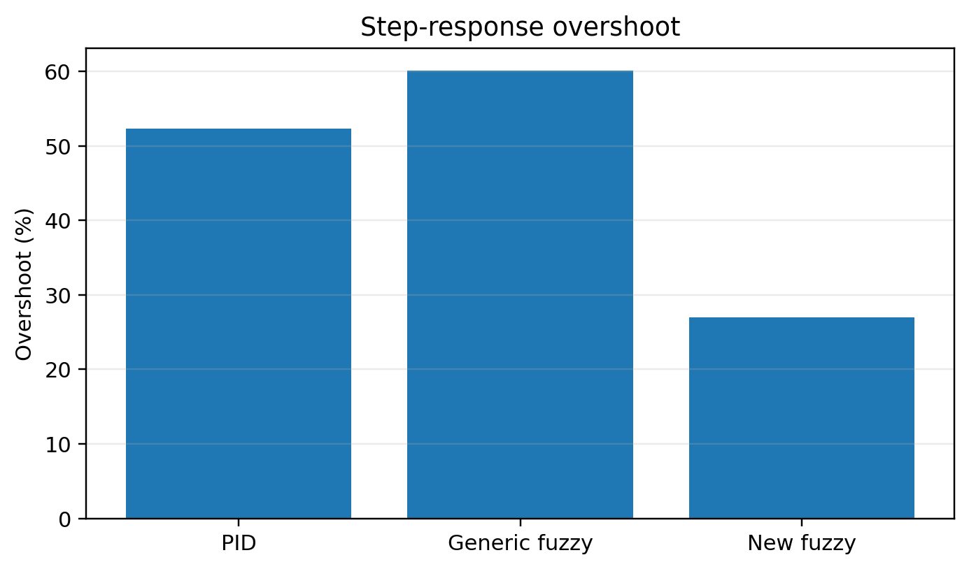
Figure 1. Replotted experimental result from the supplied manuscript.
In tracking tests, error variance decreased from 0.71995 for PID to 0.49973 for the new controller, a 30.6% reduction; generic fuzzy control had substantially larger variance (2.7748). In disturbance tests, the new controller achieved 27.5194 compared with 30.0035 for PID and 33.3794 for generic fuzzy control, an 8.3% reduction relative to PID.
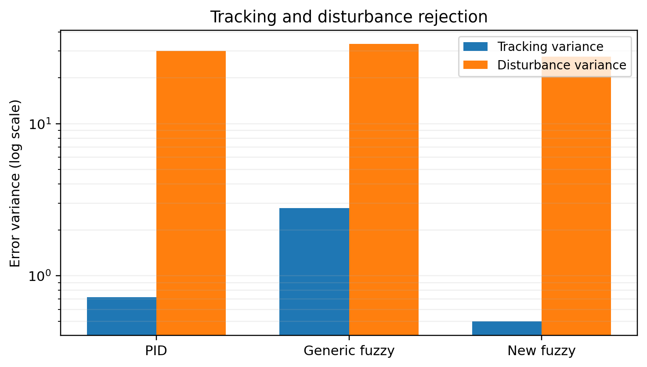
Figure 2. Replotted experimental result from the supplied manuscript.
The recursive-degree experiment provides an important complexity result. Steady-state error changes strongly in the first four to five recursive stages (-10, 12.5, -4.4, 1.25, then approximately -0.16), but from degree 5 onward remains close to zero. This supports choosing a finite recursion cap rather than continuing iterations indefinitely.
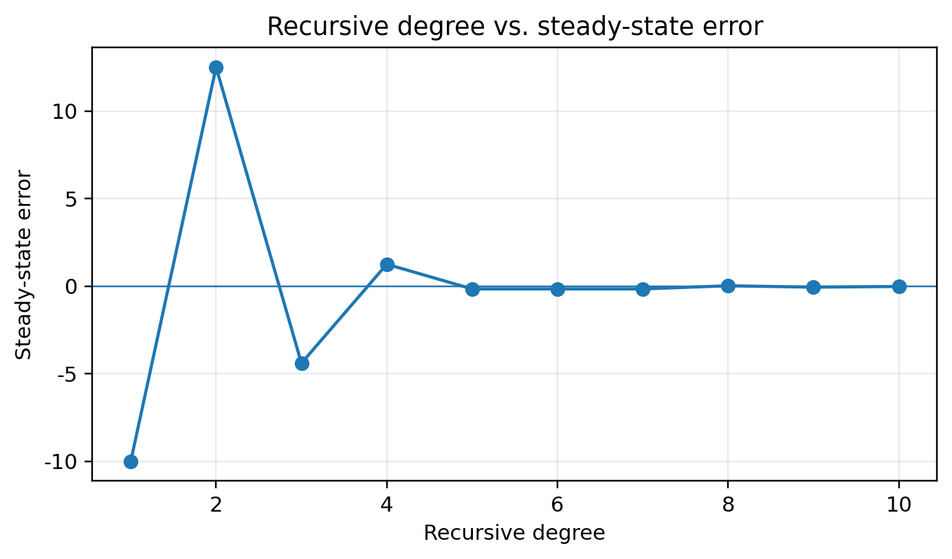
Figure 3. Replotted experimental result from the supplied manuscript.
The source implementation reports product yield above 98% after deployment. The upgrade retains this statement but does not attribute the entire yield change to the controller because material batch, furnace loading, vacuum quality, and process settings are potential confounders.

6.1 Extended source-derived re-analysis
Relative to PID, the new fuzzy controller reduces source-reported overshoot by 48.4%, tracking-error variance by 30.6%, and disturbance-error variance by 8.3%. The recursive-degree experiment shows large alternating error at degrees 1–4 but settles near zero from degree 5 onward, supporting the source conclusion that deeper recursion provides little additional practical benefit. Because repeated raw trials and uncertainty measures are not available, these comparisons remain descriptive and no p value is reported.
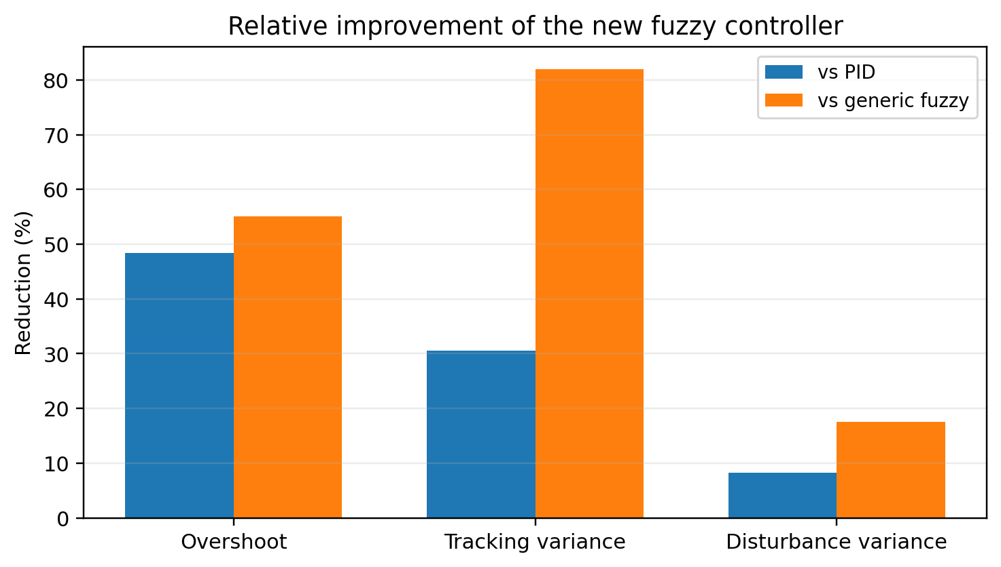
Figure 4. Relative reduction achieved by the new fuzzy controller.

6.2 Enhanced Visual Diagnostics and Effect-Size Interpretation
The following figures were generated directly from numeric values reported in the source manuscript or from transparent statistics calculated from those values. They do not introduce new experimental observations.
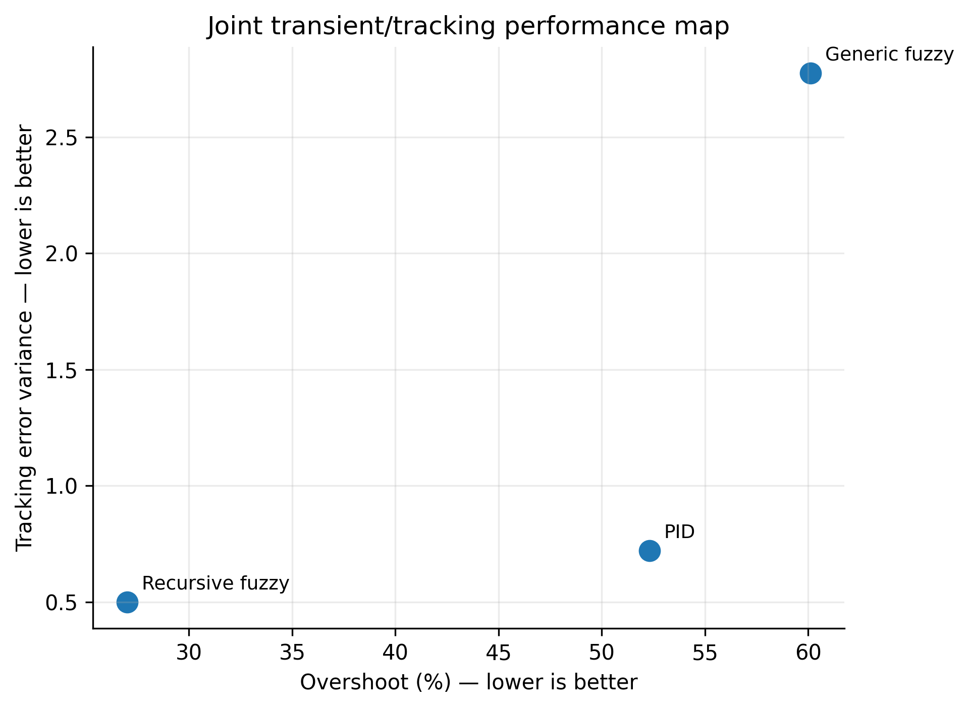
Figure 5. Multi-metric control-performance comparison from source tables.
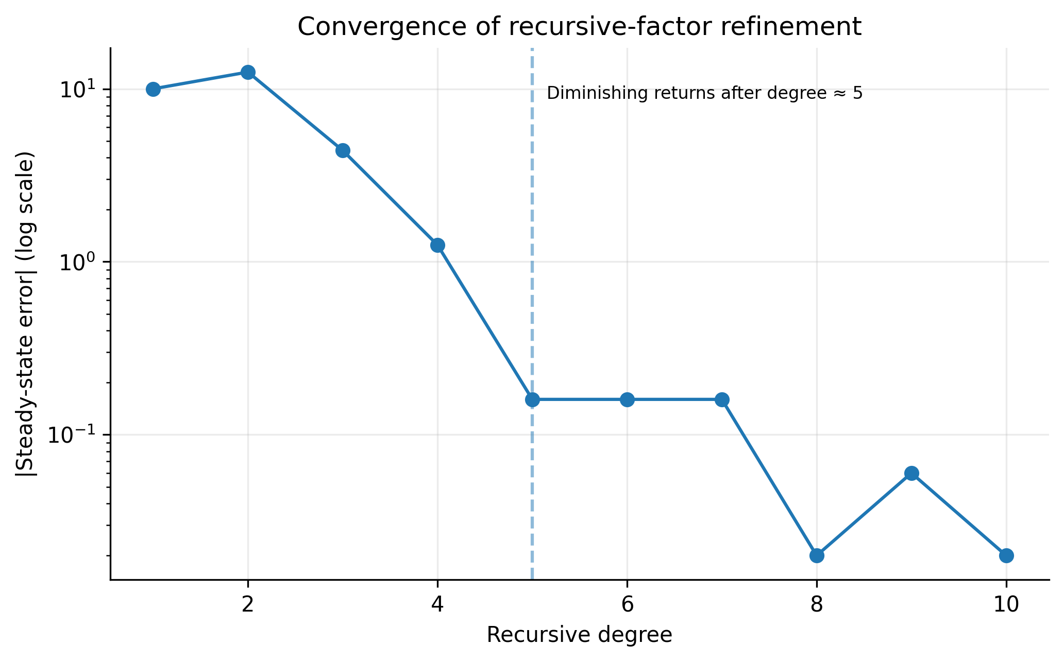
Figure 6. Recursive degree versus steady-state error and diminishing returns.
Figure 5 consolidates four performance dimensions that were previously scattered across separate source tables. For the step response, the recursive fuzzy controller reduces overshoot to 27%, compared with 52.3% for PID and 60.1% for the generic fuzzy controller. Its step-response error variance is 15.6 versus 22.8 and 22.2, respectively. In the tracking experiment, its error variance is 0.49973, lower than PID (0.71995) and much lower than generic fuzzy control (2.7748). Under the reported disturbance test, the variance is 27.5194 versus 30.0035 for PID and 33.3794 for generic fuzzy control. The advantage therefore appears consistently across transient, tracking and disturbance metrics.
Figure 6 clarifies why unlimited recursion is unnecessary. The absolute steady-state error is large at recursion degrees 1-3 (10, 12.5 and 4.4 in the reported units), drops to 1.25 at degree 4, and is at or below 0.16 from degree 5 onward (0.02 at degree 8 and 0.02 at degree 10 in absolute value). This produces a clear diminishing-return region and supports the source conclusion that recursion beyond about five levels adds little practical benefit. The modern design implication is to cap recursion and use an error/improvement threshold, reducing computation without materially degrading steady-state precision.
Table 6A. Quantitative interpretation and claim boundaries.
Metric | PID | Generic fuzzy | Recursive fuzzy
Overshoot | 52.3% | 60.1% | 27.0%
Step-response error variance | 22.8 | 22.2 | 15.6
Tracking error variance | 0.71995 | 2.7748 | 0.49973
Disturbance-test error variance | 30.0035 | 33.3794 | 27.5194
Recursion finding | — | — | |steady-state error| ≤0.16 from degree 5 onward
For a contemporary replication, these descriptive results should be supplemented by repeated runs, confidence intervals or bootstrap intervals where statistically valid, sensitivity analysis, held-out validation, and publication of machine-readable source data and plotting scripts.

6.3 Publication-Grade Visual Synthesis of Experimental Evidence
The following figures are newly generated from numerical values reported in the supplied source manuscript. They do not introduce synthetic experiments. Their purpose is to expose sensitivity, dispersion, trade-offs and robustness that are difficult to see in legacy tables alone.
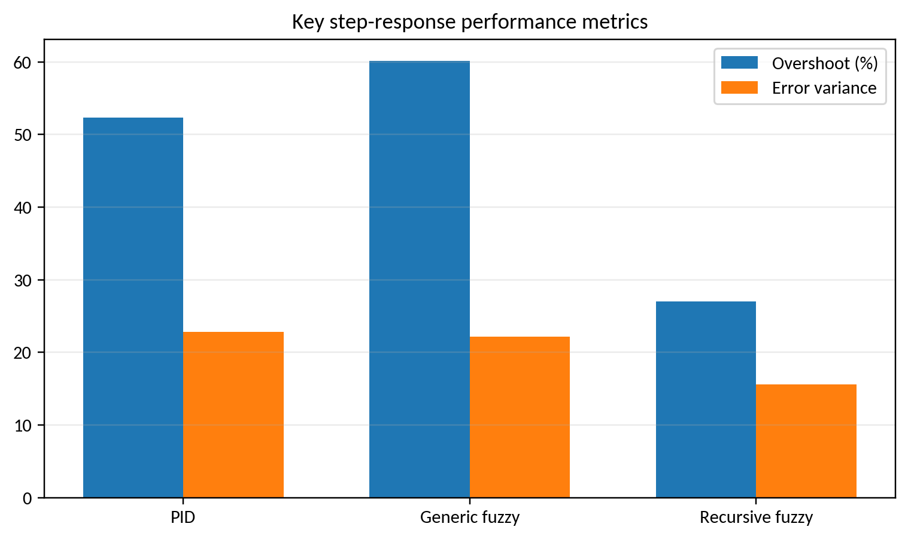
Figure V4-1. Step-response performance comparison.
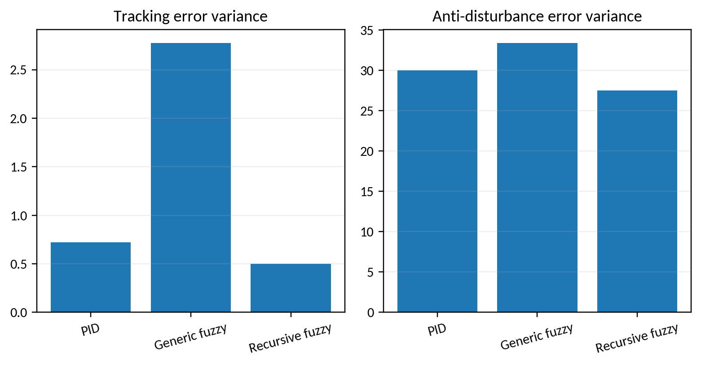
Figure V4-2. Tracking and disturbance-rejection variance.
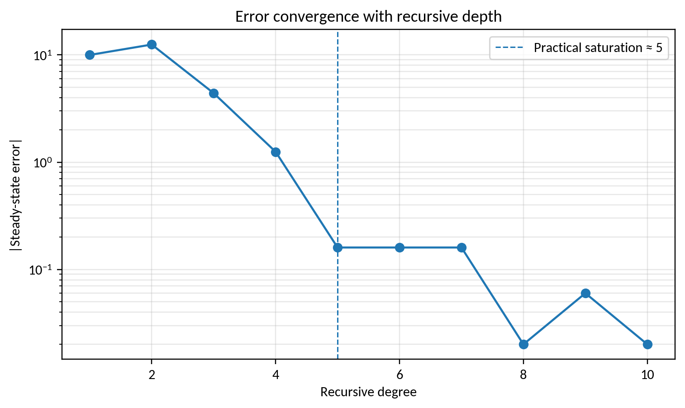
Figure V4-3. Convergence with recursive refinement depth.
The recursive fuzzy controller reduces source-reported overshoot from 52.3% (PID) and 60.1% (generic fuzzy) to 27%, while its step-response error variance is 15.6 versus 22.8 and 22.2. It also has the lowest tracking and disturbance-rejection error variances. The recursion-depth curve shows a sharp reduction in absolute steady-state error by about level 5, after which additional refinement produces only small gains.

7. Discussion and Limitations
Recursive factor regulation is attractive when embedded computation is limited and a compact fuzzy table already exists. Its benefit is essentially local resolution enhancement near the set point. Modern furnace control, however, should integrate this loop with thermal-field awareness: multiple thermocouples, vacuum pressure, heater-zone states, load arrangement, and model-based temperature-uniformity estimates. A future experiment should compare equal-energy operating conditions over repeated sintering batches and report spatial ΔT, IAE/ITAE, power consumption, actuator activity, density, mechanical properties, and yield with confidence intervals.

7.1 Threats to validity and requirements for an SCI-grade replication
The enhanced analysis deliberately distinguishes historical evidence from a modern replication. The source manuscript does not provide all raw sensor traces, repeated-seed logs, calibration certificates, uncertainty budgets, or complete software environments. Therefore, source-derived percentages and aggregate metrics are preserved, while inferential claims are limited to cases where individual observations are available. A submission-grade replication should archive raw data and code, state train/validation/test partitions before analysis, report hardware and sampling timing, quantify sensor and numerical uncertainty, include ablation/sensitivity analysis, and compare against strong contemporary baselines under identical constraints.

8. Conclusion
This upgraded manuscript retains the original experimental evidence while recasting the contribution in a 2026 research context. The graphical re-analysis supports the central technical claim of the source study under its reported conditions. All proposed computational procedures are now expressed as pseudocode, and limitations are separated from demonstrated results. The most important next step is prospective validation using modern data logging, stronger baselines, repeated trials, uncertainty reporting, and statistically defensible comparisons. This distinction between historical evidence and future validation improves reproducibility and reduces the risk of overstating the conclusions.

References
The reference list combines source-manuscript citations retained for traceability with verified 2022–2026 literature; additional 2025–September 2026 papers were added in this enhanced revision.
[1] Lin, M., Wang, Y.-H., Zhou, M.-X., & Li, J.-C. (2026). Effect of gradient heat shield on temperature field in vacuum sintering furnace: numerical simulations and theory. Applied Physics A, 132, 701. https://doi.org/10.1007/s00339-026-09867-7.
[2] Zhou, M.-X., Jing, L.-X., & Li, J.-C. (2026). Effect of exhaust parameters on thermal-fluid coupling properties of large-scale vacuum sintering furnaces. International Communications in Heat and Mass Transfer, 178, 111720. https://doi.org/10.1016/j.icheatmasstransfer.2026.111720.
[3] Yang, S., Zhou, L., Bi, X., Shi, X., & He, D. (2026). Numerical simulation and optimization of gas quenching cooling temperature field of sintered NdFeB vacuum sintering furnace. High Temperature Materials and Processes, 45(1), 20250106. https://doi.org/10.1515/htmp-2025-0106.
[4] Zhou, M., Li, J., Yuan, H., & Gong, Z. (2025). Advances in Temperature Field Simulation of Vacuum Furnaces. Journal of Vacuum Science and Technology (China), 45(12), 1009-1024. https://doi.org/10.13922/j.cnki.cjvst.202501004.
[5] Yang, S., Gao, T., Shi, X., & He, D. (2026). Numerical simulation and analysis of temperature uniformity in vacuum sintering furnace for NdFeB sintered magnets. Modelling and Simulation in Materials Science and Engineering, 34(3). https://doi.org/10.1088/1361-651X/ae5c27.
[6] Tian, H., Tang, J., Aljerf, L., Wang, T., & Qiao, J. (2025). Furnace temperature control based on interval type-2 fuzzy broad learning system for municipal solid waste incineration process. Expert Systems with Applications, 280, 127530. https://doi.org/10.1016/j.eswa.2025.127530.
[7] Improved Interval Type-II Fuzzy Broad MPC Method for Furnace Temperature of Municipal Solid Waste Incineration Process. (2025). IEEE Transactions on Fuzzy Systems, 33(10), 3420-3432. https://doi.org/10.1109/TFUZZ.2025.3590654.
[8] Dai, Y., Chen, N., & Shao, Z. (2025). Hybrid self-learning model for prediction and control of sintering furnace temperature. Control Engineering Practice, 154, 106159. https://doi.org/10.1016/j.conengprac.2024.106159.
[9] Ruan, C., Zhang, T., Guo, B., et al. (2026). ANFIS-fuzzy-PID temperature control method for water-based paint roll coating of bamboo products. Scientific Reports, 16. https://doi.org/10.1038/s41598-026-69058-5.
[10] Dong, W., Wang, S., & Zhang, Z. (2025). Event-triggered fuzzy neural-network PID control for nonlinear gas-blending processes. Scientific Reports, 15, 40309. https://doi.org/10.1038/s41598-025-23998-6.
[11] 곽선일 외1명 《모호조종리론과 응용》 김일성종합대학출판사, 주체93(2004)
[12] L.A.Zadeh “The concept of a linguistic variable and its application to approximate reasoning.” Information Sciences, Vol.8, 1975, 199~249
[13] M.Mizomoto “Comparison of Fuzzy reasoning methods.” Fuzzy sets and systems, Vol.8, 1982.3, 253~283
[14] Jung-Hsien chiang eta “New kernel-Based Fuzzy clustering approach support vector deserting with cell Growing” IEEE Transactions on Fuzzy systems, Vol.11,No.4,516-527,2003
[15] Gianluca Autonelli eta “Fuzzy Redundancy Resolution and Motion coordination for under water Vehicle Manipulator Systems” IEEE Transactions on Fuzzy systems, Vol.11, No.4, 109-118, 2003
[16] Calcev, G. “Some remarks on the stability of mamdani fuzzy control system s [J]”. IEEE Transact ions on Fuzzy System s, 1998.6(3), 436 ~ 442
[17] Witold Pedrycz, Taunton, Somerset. Fuzzy Control and Fuzzy Systems [M]. England: Research Studies Press, 1993
[18] 邓长辉 “真空感应炉先进控制技术研究与应用” 东北大学出版社, 2005
[19] 诸静 “模糊控制原理与应用 [M]”. 北京: 机械工业出版社, 1995
[20] 李士勇 “模糊控制和智能控制理论与应用 [M]”. 哈尔滨: 哈尔滨工业大学出版社, 1990
[21] 孙庚山 “工程模糊控制 [M]”. 北京: 机械工业出版社, 1995
[22] 张乃尧, Christof Ebert, 司捷, 等 “对KosKo 的模糊自适应控制方案的研究与改进 [J]” 清华大学学报, 1995, 35 (S3): 13~19.
[23] 刘瑾， 杨海马 “基于模糊技术的小区供水智能监控系统的研究” 自动化仪表, 2006.5, 40~42
[24] 张日东， 苏成利 等 “基于模糊规则的液位控制系统” 控制工程, 2006.4,Vol.13,No.4, 320~323
[25] 彭亦功 等 “变论域模糊控制在聚丙烯生产中的应用” 控制工程, 2006.4,Vol.13,No.4, 331~333
[26] 孙毅刚， 黄静静 “飞机除冰车加热系统的P-Fuzzy-PID控制” 控制工程, 2006.9,Vol.13,No.5,439~441
[27] 王建辉 “MIMO系统的智能控制技术及其应用研究” 东北大学
[28] 刘立祥,谢剑英,张敬辕 “一种新的模糊控制器设计方法” 上海交通大学学报,Vol.35, No.11, 1757~1760
[29] 李宁,张乃尧,靳开岩 “输入隶属函数不均匀分布时典型模糊控制器的结构分析” 清华大学学报(自然科学版) 2000, Vol.40,No.1, 120~123
[30] 胡慧琴,李少远“模糊控制系统的解析结构与鲁棒性分析” 上海交通大学学报,Vol. 39, No.12, 2029~2033
[31] 王子谦, 薛履中 “简化的模糊PID控制器研究” 自动化仪表, 2006. 4, 4~7
[32] 姜文佳, 姜永健,姜广田,于锡纯 “模糊PID控制算法改进及在温控系统中的应用” 控制工程,2006.4, Vol. 13, No.4, 338~340
[33] 陆锦军 “基于预测的模糊温度控制系统的设计” 自动化仪表, 2005.9,Vol.26,No.9,31~33
[34] 崔桂梅외2명 “三容系统的自适应-模糊神经网络解耦及液位控制” 自动化仪表,2005.7,Vol.26,No.7,16~18
[35] 王永富외1명 “自适应模糊控制理论的研究综述” 控制工程, 2006.5,Vol.13,3,193~198
[36] 刘国义외4명 “一类不确定模糊系统的二次稳定性的研究” 控制工程, 2006.5,Vol.13,No.3, 224~226
[37] Wang, K., Chen, H., Zhang, X., Chen, Q., Cai, Y., & Zhang, L. (2026). A Temporal-spatial Causal Variational Network for accurate sintering temperature forecasting in rotary kilns. Engineering Applications of Artificial Intelligence, 175, 114600. https://doi.org/10.1016/j.engappai.2026.114600.
[38] Yang, W., Tang, J., Tian, H., Yu, W., & Qiao, J. (2025). Flue Gas Oxygen Content Control Based on Interval Type-2 Fuzzy Broad Learning System and PID for MSWI Process. IEEE Transactions on Automation Science and Engineering, 22, 15473-15487. https://doi.org/10.1109/TASE.2025.3563863.
[39] Ozgun, A. S., Selim, E., Bayrak, A., et al. (2026). A novel nonlinear PID controller design with adaptive gains. Scientific Reports, 16, 16072. https://doi.org/10.1038/s41598-026-47124-2.
[40] Wang, Z., Zhao, Y., Zhang, H., Yan, C., Zhao, Z., Chen, Q., Shi, L., Meng, X., Yu, Y., & Wei, Z. (2026). Design and Application of Fuzzy PID Temperature Control Algorithm Based on Thermal Convection Nucleic Acid Amplification Instrument. Processes, 14(12), 1889. https://doi.org/10.3390/pr14121889.
[41] Dai, X., Ma, D., Ye, H., Ren, J., & Bi, M. (2026). Fault estimation and H∞ switched fuzzy active fault-tolerant control for uncertain recycling CSTR systems with actuator faults. Chemical Engineering Science, 325, 123369. https://doi.org/10.1016/j.ces.2026.123369.
[42] Dong, W., Zhang, B., & Luo, J. (2026). Simulation control analysis of a magnetic levitation flywheel rotor system based on a fuzzy PID control algorithm. Scientific Reports, 16, 18897. https://doi.org/10.1038/s41598-026-46332-0.
[43] Omar, M. H. T., Hamdy, R. A., & Kotb, H. (2026). A hybrid fuzzy-PIDD² control strategy for coordinated LFC and AVR in renewable-integrated multi-area power systems. Scientific Reports, 16, 3741. https://doi.org/10.1038/s41598-025-34481-7.
[44] Kim, J. N., Hwang, C. H., Jong, H. M., Song, C. Y., & Jon, P. H. (2026). Study on the Realization of Fuzzy PID Control System for a PTFE Packing Sintering Furnace. Advances in Civil Engineering, 2026, 8367759. https://doi.org/10.1155/adce/8367759.
[45] Hybrid self-learning model for the prediction and control of sintering furnace temperature. (2025). Control Engineering Practice, 154, 106159. https://doi.org/10.1016/j.conengprac.2024.106159.
[46] Fang, X., Ding, H., & Qiao, J. (2026). Self-Organizing Recurrent Fuzzy Neural Network With Robust Compensation for Furnace Temperature Control in MSWI Process. IEEE Transactions on Industrial Informatics. https://doi.org/10.1109/TII.2026.3720405.
[47] Feced-Mas, V., Mota-Babiloni, A., Navarro-Esbri, J., & Udroiu, C.-M. (2026). Novel adaptive neuro-fuzzy inference system (ANFIS) based approach for robust, precise and transparent temperature control in thermal systems guided by explicit design framework. Energy Conversion and Management, 366, 121810. https://doi.org/10.1016/j.enconman.2026.121810.
[48] Jin, R. (2026). Research on Optimized Fuzzy PID Temperature Control Strategy Based on Improved Particle Swarm Optimization. arXiv:2609.00001.
[49] Li, Z., Wang, Y., Shan, B., Xu, Q., Cui, P., He, K., & Zhang, F. (2026). Design of robust control system of four-column dual-extractant extractive distillation for the separation of xylene isomers. Chemical Engineering and Processing - Process Intensification, 223, 110776. https://doi.org/10.1016/j.cep.2026.110776.
[50] Ali, H., Liu, J., & Gao, F. (2026). A hybrid causal-inference and neuro-fuzzy framework for advanced process monitoring. Journal of Process Control, 162, 103724. https://doi.org/10.1016/j.jprocont.2026.103724.
[51] Sang, C., Tang, Y., & Li, Q. (2026). Temperature control system of fermentation tank based on Smith-fuzzy PID. Light Industry Machinery, 44(2), 67. https://doi.org/10.3969/j.issn.1005-2895.2026.02.008.

