Time Series Prediction with a Dynamic Takagi Sugeno Fuzzy Model and Improved Shark Smell Optimization

Abstract
We study T–SFSSO, a forecasting framework that combines a dynamic Takagi–Sugeno fuzzy model, recursive least-squares initialization, and a modified shark smell optimizer. The search mechanism adds gradient-dependent movement timing, a stagnation-triggered jump, a velocity-cap multiplier sampled from U(0,2), and a multiplicative rotation coefficient sampled from U(−1.3,1.3). We formulate the model and optimization stages separately, explain their implementation in pseudocode, and distinguish bounded search from global convergence and recursive forecasting stability. An analytic calculation establishes the minimum of the weighted quadratic benchmark as −0.24989428 for dimension 30. In the reported epidemic forecasting comparison, test MAPE decreases from 7.82% to 4.93% and test RMSE from 406.155 to 251.032 relative to FTSOAX, corresponding to reductions of 36.96% and 38.19%. Country-specific test improvements over the best earlier comparator range from 1.38% to 21.81% for RMSE. Figures show the absolute errors, relative gains, train–test differences, evaluation-length effects, and optimizer ranks without generating unobserved forecast trajectories. The aggregate results support further evaluation of the combined framework, but do not identify the separate contribution of each search operator or establish statistical significance. The principal methodological requirements are an explicit optimized parameter vector, matched objective-evaluation budgets, chronological validation, and preservation of the original per-run and per-origin records.
Keywords: Takagi–Sugeno model; fuzzy forecasting; shark smell optimization; recursive least squares; epidemic time series; reproducible benchmarking

1 Introduction
Forecasting a changing time series requires both a representation of nonlinear dynamics and a reliable procedure for estimating that representation. Fuzzy sets describe gradual transitions between linguistic regions [1], while fuzzy time-series models organize temporal relationships between such regions [2, 3]. A dynamic Takagi–Sugeno model provides a different but related construction: it combines local affine recursions through normalized rule activations [4, 5]. This separates interpretable local behavior from the nonlinear mechanism that chooses how strongly each local model contributes. The distinction is useful when the objective is to understand a predictor as well as to minimize its error.
Epidemic surveillance is a demanding application because observed case counts reflect reporting schedules, testing policy, revisions, interventions, and changing transmission conditions. Retrospective accuracy on one partition is therefore only one part of forecasting evidence. Prospective studies of individual and ensemble COVID-19 forecasts demonstrate the importance of evaluation across forecast origins and changing epidemic phases [6, 7]. The application in this paper should be interpreted as a historical time-series benchmark. It does not validate a clinical decision tool or establish accuracy for present-day incidence under a new surveillance regime.
Fuzzy model design has long involved a balance between structure selection and parameter learning. Mamdani inference emphasizes linguistic consequents [8], whereas ANFIS uses an adaptive network around a Sugeno-type structure [9]. Rule generation from examples, evolving identification, and adaptive TSK modeling provide established alternatives to a fixed manually selected partition [10, 11, 12]. These methods show why the contributions of the antecedent partition, local consequent model, optimizer, and evaluation protocol should be isolated. An improved error score cannot by itself reveal which component caused the improvement.

1.1 Recent forecasting research through 2026
Recent research develops fuzzy forecasting along several complementary directions. Dalar’s 2026 fuzzy–ensemble approach combines soft partitions of lagged inputs with local random-forest regressors [13]. Its relevance is architectural: a soft partition can organize nonlinear prediction without a manually enumerated rule base. It does not demonstrate that a particular population optimizer is necessary for an affine T–S model. In another 2026 study, Egrioglu and colleagues replace affine consequents with multiplicative-neuron structures and use differential evolution for nonlinear parameter estimation [14]. That formulation changes the expressiveness and optimization geometry of the consequent itself.
Uncertainty representation is also being expanded. Cansu and colleagues combine intuitionistic fuzzy time series, neural modeling, and grey-wolf optimization [15]. Gundogdu and colleagues develop a Pythagorean fuzzy formulation with a hybrid high-order neural model [16]. Hesitant fuzzy time-series forecasting explicitly represents competing fuzzification possibilities [17], while a 2026 decomposition and hesitant fuzzy cognitive-map approach addresses temporal components and uncertain relationships jointly [18]. These are relevant neighboring approaches, but their different data, representations, and tuning protocols do not constitute a direct benchmark against T–SFSSO.
The methodological implication is that a fuzzy forecasting contribution must state precisely what is learned. Fixed antecedents and affine consequents lead to a linear least-squares estimation problem. Learning antecedent locations, widths, lag selection, or nonlinear consequents generally changes the problem into a nonlinear one. This paper treats RLS as an efficient estimator for the first case and FSSO as a candidate search method for a declared nonlinear or constrained parameterization. It does not characterize standard least squares as a local optimizer trapped in arbitrary local minima.

1.2 Optimization research and the specific gap
Shark smell optimization combines gradient-directed movement and stochastic rotational candidates [19]. Chaotic variants modify its search dynamics [20]. Established comparators include particle swarm optimization, genetic algorithms, differential evolution, and fuzzy ant-colony parameter search [21, 22, 23, 24]. The relevant question is whether the added operators improve search under comparable information and computation budgets, rather than whether a biological analogy sounds plausible.
Recent methodological work reinforces this requirement. Suman and colleagues organize metaheuristics by function and benchmark behavior [25], while Molina and colleagues examine persistent evaluation problems in evolutionary and bioinspired optimization [26]. Kudela shows how benchmark geometry, including an optimum at the center of the domain, can distort conclusions [27]. COCO provides a framework for comparisons across instances and targets [28]. A 2026 study of set-based particle swarm convergence illustrates the need for algorithm-specific assumptions when stating a convergence theorem [29]. No-free-lunch results further rule out unrestricted claims of universal superiority [30].
The narrow research question is whether the four changes to SSO improve an interpretable forecasting pipeline while keeping the search and its computational cost explicit. The changes are gradient-dependent timing, a low-gradient jump, a wider velocity-cap distribution, and a rotation distribution that can reverse a coordinate sign. None is sufficient alone to prove global convergence. In particular, a cap with arithmetic mean one is not neutral under repeated multiplication, and a local jump need not reach every region of the domain.

Table 1. Selected 2025–2026 literature and its relationship to the present forecasting study. These are methodological comparisons, not common-data performance rankings.
Study | Method emphasis | Implication for this study
Dalar (2026) [13] | Soft fuzzy partitions with ensemble regressors | Compare representation and partitioning separately from the search algorithm.
Egrioglu et al. (2026) [14] | Sugeno multiplicative neurons with differential evolution | Nonlinear consequents change the optimization problem; affine consequents retain a convex subproblem.
Cansu et al. (2026) [15] | Intuitionistic fuzzy time series and neural/GWO estimation | Assess additional uncertainty representation on identical forecast origins.
Gundogdu et al. (2026) [16] | Pythagorean fuzzy and high-order neural modeling | Distinguish model capacity from optimizer contribution.
Molina et al. (2025); Suman et al. (2026) [26, 25] | Metaheuristic evaluation and functional taxonomy | Use matched objective-call budgets, explicit operators, and repeated-run records.

1.3 Contributions and scope
The paper contributes a detailed T–S/RLS/FSSO formulation, an operator-level explanation with pseudocode, a corrected analytic benchmark, and a transparent reanalysis of the reported forecasting and optimizer tables. The analysis quantifies effects against both FTSOAX and the strongest earlier comparator in each country. It also identifies the conditions needed for a genuine convergence statement, the costs hidden by iteration-only comparisons, and the difference between one-step and recursive multi-step prediction. A replication protocol specifies how these hypotheses can be tested without using test outcomes during model selection.
Sections 2 and 3 define the predictor and optimizer. Section 4 describes the forecasting and comparison algorithms. Sections 5 and 6 analyze optimization and forecasting results. Section 7 discusses validity and reproducibility, followed by the conclusions.

2 Dynamic fuzzy prediction and parameter identification

2.1 Regressors and local rules
Let y_{t} be the observed series and z_{t} be a d-dimensional regressor available at the forecast origin. In a univariate application, z_{t} may contain y_{t−1}, …, y_{t−p}. Exogenous inputs may be included only if they are observed or independently forecast at that origin. A transport delay must be represented explicitly rather than absorbed into an ambiguous indexing convention. The R-rule predictor is
${\hat{y}}_{t}=\sum_{r=1}^{R}{w_{r}}\left(z_{t}\right)\left[a_{r0}+a_{r}^{T}z_{t}\right]=φ_{t}^{T}θ \left(1\right)$
αrzt=j=1dμrjztj, wr=αrs​αs 2
$φ_{t}={\left[w_{1},w_{1}z_{t}^{T},…,w_{R},w_{R}z_{t}^{T}\right]}^{T}, p_{θ}=R\left(d+1\right) \left(3\right)$
Here θ and φ_{t} are p_{θ} × 1 column vectors. Each membership grade lies in [0,1]. Triangular antecedents are determined by ordered breakpoints l < c < u: membership rises linearly from zero at l to one at c and falls linearly to zero at u. Shoulder sets require an explicit boundary convention. The breakpoints should be fitted or selected using training data only; fitting the input universe to the entire series exposes future extrema to the model.
If every firing strength vanishes, Eq. (2) is undefined. Adding a constant to the denominator changes the sum of weights and therefore changes the model. An implementation should instead use a declared fallback, such as the nearest rule under a training-scaled distance, and log the event. The same fallback must apply in training, validation, and deployment. The frequency of uncovered inputs is an informative diagnostic of distribution shift.

2.2 RLS and the convex subproblem
For a fixed antecedent structure, the squared-error objective is quadratic in θ. With positive ridge regularization it is strictly convex when the penalty covers every parameter. RLS is a recursive solution to this estimation problem, not merely a local starting guess [31, 32]. Its inverse-information matrix should not be described as a matrix of standard deviations. Define the forgetting factor λ in (0,1], inverse-information matrix P_{t}, gain k_{t}, and residual e_{t} by
$e_{t}=y_{t}−φ_{t}^{T}θ_{t−1}, k_{t}=\frac{P_{t−1}φ_{t}}{λ+φ_{t}^{T}P_{t−1}φ_{t}} \left(4\right)$
$θ_{t}=θ_{t−1}+k_{t}e_{t}, P_{t}=\frac{P_{t−1}−k_{t}φ_{t}^{T}P_{t−1}}{λ} \left(5\right)$
Initialization P₀ = αI with α > 0 controls the initial regularization scale; θ₀ is a declared prior estimate. With λ = 1 and θ₀ = 0, this corresponds to a ridge-type initialization rather than an unregularized batch solution at finite α. Using λ < 1 discounts older observations, which is useful under drift but changes the fitted objective. A numerical implementation should monitor positive definiteness and conditioning and preferably use a square-root or QR implementation for difficult data.
Algorithm 1 Predict and update the T–S consequent parameters
INPUT chronological labeled regressors; fixed rules; θ; P; λ
OUTPUT final θ and P; predictions made before each update
01 Require P positive definite and 0 < λ ≤ 1.
02 FOR each training pair (z, y), in time order:
03 Compute membership grades and rule strengths.
04 Normalize strengths; apply the declared coverage fallback.
05 Build column vector φ by Eq. (3).
06 prediction ← transpose(φ) × θ
07 residual ← y − prediction
08 denominator ← λ + transpose(φ) × P × φ
09 gain ← P × φ / denominator
10 θ ← θ + gain × residual
11 P ← (P − gain × transpose(φ) × P) / λ
12 Symmetrize P; log numerical or coverage failures.
13 Store the pre-update prediction and residual.
14 RETURN θ, P, and the prediction record.

The order of operations matters: scoring an observation after updating with its own label understates prediction error. RLS costs O(p_{θ}²) per labeled update and O(p_{θ}²) memory. Fixed-parameter inference costs O(Rd), so training cost and deployment cost should be reported separately.

2.3 What FSSO is allowed to optimize
Let η encode only the selected nonlinear model parameters, for example antecedent centers and positive widths. A clean hybrid design constructs φ_{t}(η), solves the consequent subproblem for θ conditional on η, and searches over η. Alternatively, η may include θ under explicit bounds or a nonquadratic objective. These are different experiments and should not share an ambiguous label such as “global refinement.”
$J\left(η\right)={RMSE}_{train}\left(η,θ^{*}\left(η\right)\right)+βΩ\left(η\right), η∈D \left(6\right)$
The penalty Ω can discourage overlapping duplicate rules or ill-conditioned regressors, but β must be selected inside the training period. Ordered breakpoints can be encoded through positive increments; simply sorting candidate coordinates can change the identity of a rule. For fixed antecedents and unconstrained squared-error consequents, FSSO has no theoretical advantage over the exact least-squares minimizer. Any observed improvement in that setting should trigger a check of objective definitions, initialization regularization, constraints, and numerical precision.

3 Improved shark smell optimization

3.1 Search state and baseline mechanism
Let x_{i} be the parameter vector of agent i, v_{i} its velocity, D a compact feasible domain, N the population size, M the stage limit, and L the number of rotational candidates. For minimization, a consistent gradient step uses −∇J. An equivalent implementation can maximize −J, but the sign convention must not change midway through the algorithm. A generic SSO velocity proposal is
${\tilde{v}}_{i}=−μr_{1}⊙∇J\left(x_{i}\right)+αr_{2}⊙v_{i}, r_{1},r_{2}∼U{\left(0,1\right)}^{n_{x}} \left(7\right)$
A speed-limit rule caps this proposal relative to a declared reference speed. The historical SSO description uses previous velocity in its relative cap; the reference implementation must state whether the cap is coordinatewise, based on the previous velocity norm, or based on a fixed v_{max}. These are not equivalent, particularly when a component is zero. Projection Π_{D} enforces position bounds and its treatment of boundary velocity must also be declared.
Conventional forward motion uses z_{i} = Π_{D}(x_{i} + v_{i}). Its multiplicative local rotation has the form z_{i} + R₃ ⊙ z_{i} with R₃ in (0,1). That rotation alone preserves each nonzero coordinate sign, but gradient motion and initialization can still reach negative coordinates. Consequently, sign preservation of the local operator is not a proof that the complete baseline can never find a negative-coordinate optimum.

3.2 Four modifications and their trade-offs
Adaptive timing chooses a unit forward interval with probability Q and otherwise increases the interval as gradient magnitude grows. A safeguarded form uses a documented upper bound:
$Δt_{i}=\left\{\begin{matrix}1, & U<Q, \\ min\{Δt_{max},max\left[1,C_{t}∥∇J\left(x_{i}\right)∥/C_{g}\right]\}, & \text{otherwise.}\end{matrix}\right. \left(8\right)$
Here C_{g} > 0 provides a gradient scale and C_{t} controls movement magnitude. The upper bound is a numerical safeguard, not evidence that the original campaign used that bound. Large gradients can occur in narrow curved valleys, so longer steps may overshoot. Scaling of parameters and objective values is therefore part of the algorithm, and this operator must be assessed by ablation rather than described as automatically accelerating convergence.
A low-gradient jump proposes a relocation when a periodic check is due and the gradient norm is below ε_{J}. A small gradient may indicate an optimum, a saddle, a flat plateau, or poor finite differences; it is not synonymous with a harmful local minimum. The jump distribution, scale, trigger period, and replacement policy must be stated. Retaining the old point as a candidate avoids discarding a good solution; retaining a separate global elite protects the best value even when an exploratory agent is replaced.
The wider velocity coefficient γ ∼ U(0,2) allows both larger and smaller caps. Although E[γ] = 1, repeated independent multiplication is governed by E[log γ] = log 2 − 1 < 0. The geometric-mean multiplier therefore decays under consecutive active multiplicative caps. This modification removes the restriction γ < 1, but does not prove the absence of freezing. Figure 1 shows the distinction without simulating any optimizer runs.
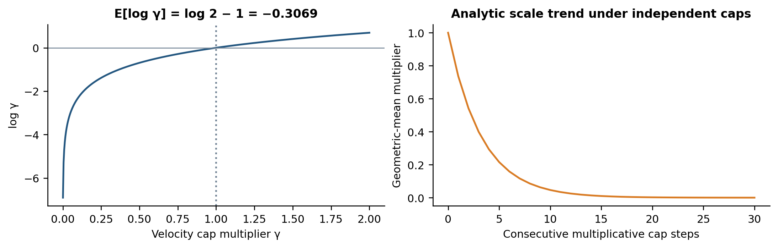
Figure 1. Analytic behavior of the U(0,2) cap multiplier. The right panel is exp[m E(log γ)] under repeated independent multiplicative caps; it is not an empirical FSSO convergence curve. Gradient forcing and inactive caps can change actual velocity behavior.
The fourth change uses R₃ ∼ U(−1.3,1.3) independently per coordinate. For a nonzero coordinate, 1 + R₃ is negative with probability 0.3/2.6, approximately 11.54%. Thus rotation can reverse that coordinate, but its support remains proportional to the current location. At z_{j} = 0, this rotation cannot create a nonzero j-th coordinate. A full-support restart or additive perturbation is a separate mechanism and must not be assumed from the rotation interval alone.

3.3 Complete search pseudocode
Algorithm 2 makes the decision sequence explicit. The jump generator and cap reference are required inputs because their exact settings are not recoverable from aggregate objective tables. The safeguarded procedure is a replication specification; the historic values in Sections 5–6 do not establish that every safeguard was present in the original implementation.
Algorithm 2 SSO or FSSO with explicit candidate selection
INPUT J, gradient routine, D, N, M, L, random seed, variant
timing rule, speed-cap rule, jump trigger and generator
OUTPUT best feasible parameter vector and evaluation history
01 Initialize positions and nondegenerate velocities; evaluate J.
02 elite ← best initial point; count every objective call.
03 FOR stage = 1 to M, while the call budget remains:
04 FOR each agent i:
05 g ← gradient(J, x_i); count its objective calls.
06 Propose velocity by Eq. (7); apply declared speed cap.
07 dt ← 1 for SSO; otherwise the FSSO timing rule.
08 z ← Project_D(x_i + dt × v_i)
09 candidates ← {x_i, z}
10 IF FSSO jump trigger is satisfied: add a jump candidate.
11 Draw L rotations using the variant's R3 interval.
12 Add Project_D(z + R3 * z) for each rotation.
13 Evaluate feasible candidates within the remaining budget.
14 x_i ← candidate with smallest J; resolve ties consistently.
15 Update elite and record calls, stage, objective, and time.
16 RETURN elite and the full record.

In line 11, “*” denotes coordinatewise multiplication. Random coefficients should be drawn at the specified agent, coordinate, or stage scope; drawing one shared scalar instead of a vector changes the search. Reusing an already evaluated point should reuse its cached value only when J is deterministic. A noisy training objective requires a different policy for comparing candidates.

3.4 What can be proved
With a compact D and projection of every candidate, all positions remain bounded. If every accepted point is compared with a retained elite, the best objective values are nonincreasing and bounded below, and therefore converge to a finite limit. This statement does not identify the limit as the global optimum.
A sufficient global-convergence condition is stronger: for every neighborhood B of a global minimizer with positive volume, candidate generation must have a conditional probability at least δ_{B} > 0 of visiting B infinitely often. Independent uniform restarts with a fixed positive restart probability satisfy this condition on a bounded domain. Under continuity and elite retention, the probability of missing B after n opportunities is at most (1−δ_{B})^n, which tends to zero. A gradient-triggered local jump does not automatically satisfy this condition because its trigger may cease or its support may exclude B.
Search boundedness is also different from stability of the recursive fuzzy predictor. For bounded inputs, Eq. (1) is bounded if each affine consequent is bounded, but feeding predictions back into future regressors creates a dynamic system. Rule-wise Schur stability alone is insufficient for an arbitrarily varying blend. A common Lyapunov condition, a suitable multiple-Lyapunov argument, or a direct contraction bound is required [33, 34]. No closed-loop or multi-step stability certificate is inferred from a low one-step RMSE.

3.5 Computation and evaluation budgets
If a gradient requires C_{grad} work, a stage costs O(N[C_{grad} + (L+1)C_{J} + n_{x}]), excluding an occasional jump evaluation. Central finite differences require about 2n_{x} objective calls per gradient, so a first-order call estimate is N + MN(2n_{x} + L + 1), plus jumps and any extra boundary evaluations. Caching and one-sided differences alter this count and must be logged. A finite-difference FSSO iteration is not comparable to a single evaluation per particle in PSO.
If each objective call evaluates a T-sample predictor, C_{J} is O(TRd); solving the consequent subproblem inside each call introduces additional linear-algebra work. Population storage is O(Nn_{x}), but total memory also includes data and any RLS or least-squares matrices. Iteration complexity alone omits these potentially dominant costs.

4 Forecasting and comparison procedures

4.1 Chronological model development
The reported application uses an 80/20 partition, five rules, five sharks, and 50 stages. Exact dates, lag orders, membership breakpoints, optimized coordinates, and data revisions are not identified in the aggregate record. Table 2 separates known settings from the details needed for independent replication.
Table 2. Recorded settings and the information each setting does and does not establish.
Item | Reported setting | Interpretation
Benchmark population / stages | 10 / 50 | Does not equal an objective-call budget
Forecast rules / sharks / stages | 5 / 5 / 50 | Rule construction and parameter bounds need an executable specification
Training and test split | 80% / 20% | Chronological dates and sample counts are unreported
Countries | 7 | USA, India, Russia, Iran, Norway, UK, Japan
Gradient / local candidates | Gradient plus rotations | Numerical-gradient calls must be counted

Algorithm 3 Train the hybrid predictor without test leakage
INPUT time-stamped series; candidate lags and rule structures
chronological train/validation/test boundaries; search budget
OUTPUT frozen model and untouched test predictions
01 Reserve the final test interval before inspecting its errors.
02 Create validation origins inside the earlier training interval.
03 FOR each candidate structure and allowed tuning setting:
04 Fit scaling and membership parameters using past data only.
05 Build training regressors with information available then.
06 Estimate affine consequents by Algorithm 1 or batch ridge LS.
07 Run Algorithm 2 only on the declared nonlinear coordinates.
08 Score each validation origin under the deployment protocol.
09 Select settings by aggregate validation loss and complexity.
10 Refit the selected structure on the complete training interval.
11 Freeze parameters for the fixed-model test experiment.
12 Forecast the test interval and retain every origin-level error.
13 RETURN the model, split manifest, and prediction record.

The chronological validation procedure in Algorithm 3 is the recommended replication design; it should not be mistaken for an undocumented additional experiment. Rolling-origin evaluation reveals whether improvement survives different temporal conditions [35, 36]. Cross-validation must respect the dependency structure of the forecasting problem [37]. Standardization, missing-value treatment, decomposition, and rule selection all belong inside the fitting window.

4.2 One-step and multi-step prediction
For one-step prediction, newly observed y values can populate future regressors only after they become available. For recursive h-step prediction, the model substitutes earlier predictions for unobserved future outputs and cannot use future observed case counts. A direct h-step model instead learns a separate target y_{t+h}. These protocols measure different tasks. The labels “40 days,” “100 days,” and “180 days” in the recorded table do not establish whether they are forecast leads, test-window lengths, or recursive rollouts; the figures therefore use the neutral description “reported evaluation length.”
Algorithm 4 Score fixed-model forecasts at declared origins
INPUT fitted model; forecast origins; lead set; availability log
OUTPUT paired predictions and errors by origin and lead
01 FOR each origin t:
02 Copy only observations available at t into the lag buffer.
03 FOR each recursive step h = 1 to maximum lead:
04 Construct z from the buffer and allowed external inputs.
05 y_hat[t,h] ← model(z)
06 Append y_hat[t,h] to the simulated buffer.
07 When observations are released, align targets by timestamp.
08 Compute metrics on the same valid origin–lead pairs for all methods.
09 Record excluded zero targets, missing targets, and revisions.
10 Aggregate by country and lead; retain raw paired errors.

4.3 Baseline algorithm specifications
FTSOAX denotes the improved-seagull/fuzzy-partition/XGBoost forecasting framework associated with Xian and colleagues [38]. The three other forecasting columns correspond to the cited GA–FCM/multifactor-BPNN, refined exponentially weighted fuzzy-time-series/harmony-search, and hybrid COVID-19 fuzzy-time-series approaches [39, 40, 41]. A PSO-tuned fuzzy-time-series predictor is another directly relevant comparator [42]. Published architectures alone do not establish the settings used to reproduce them in the present application.
Algorithm 5 Particle swarm baseline
INPUT objective J; bounds; swarm; inertia ω; c1 and c2; call budget
01 Initialize positions and velocities; set personal and global bests.
02 UNTIL the evaluation budget is exhausted:
03 FOR each particle, draw independent vectors r1 and r2.
04 v ← ωv + c1*r1*(personal_best − x) + c2*r2*(global_best − x)
05 x ← Project_D(x + v); evaluate J(x).
06 Update the personal and global bests only after evaluation.
07 RETURN the best point and objective-call trace.

Algorithm 6 Differential evolution with binomial crossover
INPUT objective J; bounds; population ≥ 4; F; CR; call budget
01 Initialize and evaluate the population.
02 FOR each generation and each target i:
03 Choose three distinct indices a, b, c, all different from i.
04 mutant ← x_a + F*(x_b − x_c)
05 Select one compulsory crossover coordinate j_rand.
06 trial[j] ← mutant[j] if U < CR or j = j_rand; else x_i[j].
07 Repair trial using the declared boundary rule; evaluate it.
08 Replace x_i only if trial is no worse; retain global elite.
09 Stop at the call budget and RETURN the elite.

Algorithm 7 Real-valued genetic algorithm baseline
INPUT objective J; population; selection, crossover, mutation rules
01 Initialize and evaluate the population; retain an elite.
02 UNTIL the call budget is exhausted:
03 Select parents using the declared fitness-selection rule.
04 Apply the declared real-valued crossover operator.
05 Mutate offspring with the specified probability and scale.
06 Repair bounds and evaluate offspring.
07 Replace the population using the declared elitism policy.
08 RETURN the best solution and full evaluation record.

These pseudocodes explain the main operations; a reproduction must additionally publish numerical hyperparameters and exact operator choices. The table label NSSO is retained as a historical method label because the available record does not unambiguously identify its executable variant. CSSO requires the chaotic map and coefficient mapping; FACS requires its representation, pheromone update, evaporation, and discretization; ISOA requires its precise migration, attack, and improvement rules. Substituting a generic operator for any of these would create a new comparator.
Algorithm 8 Run a named SSO variant or FACS without ambiguity
INPUT exact cited implementation; configuration; seed; common budget
01 Verify the source version and the objective sign convention.
02 For CSSO, load its map, seed, burn-in, and coefficient mapping.
03 For NSSO, load the specifically identified perturbation law.
04 For FACS, load encoding, construction and pheromone-update rules.
05 Initialize from the declared distribution and execute those rules.
06 Count every objective call, including local-search evaluations.
07 Save configuration, final result, runtime, and best-value trace.
08 If a required method definition is absent, mark the run unresolved.

Algorithm 9 FTSOAX comparison pipeline
INPUT time series; exact ISOA operators; fuzzy encoding; XGBoost settings
01 Use the same chronological development and test windows as T–SFSSO.
02 For each ISOA candidate, construct its fuzzy partition on training data.
03 Transform past observations into the prescribed supervised features.
04 Train XGBoost and evaluate the declared inner validation objective.
05 Apply the exact ISOA migration and attack rules; respect tuning budget.
06 Select the configuration and refit on the full training interval.
07 Freeze the model; forecast at the same origins and leads.
08 RETURN paired predictions, errors, tuning cost, and inference time.

5 Optimization experiments and analytic verification

5.1 Weighted quadratic benchmark
The first benchmark is f(x) = ||x||² + (cᵀx)² + cᵀx, with c_{i} = 0.5i and domain [−5,30]^n. It is a strictly convex quadratic, not the standard Zakharov function, which contains a fourth-power term. Its gradient is 2x + 2c(cᵀx) + c and its Hessian is 2(I + ccᵀ), which is positive definite. Setting the gradient to zero gives
$x^{*}=−\frac{c}{2\left(1+w\right)}, f^{*}=−\frac{w}{4\left(1+w\right)}, w=c^{T}c \left(9\right)$
For n = 30, w = 2363.75 and f* = −0.24989428057934243. The minimizer lies inside the stated box, so it is also the constrained minimum. An optimizer returning a number near zero has a substantial optimality gap on this function; it has not solved a zero-minimum benchmark to high precision.
Table 3. Reported SSO-family means and runtimes. The optimality-gap column is calculated using Eq. (9); timing hardware and run counts are not specified in the aggregate record.
Method | Mean f1 | Gap from f1* | f1 time (s) | f2 time (s)
SSO | 5.13e-06 | 0.249899 | 0.636 | 0.478
CSSO | 3.75e-09 | 0.249894 | 0.672 | 0.401
NSSO | 3.68e-06 | 0.249898 | 0.601 | 0.483
FSSO | -0.2483 | 0.00159428 | 0.593 | 0.423

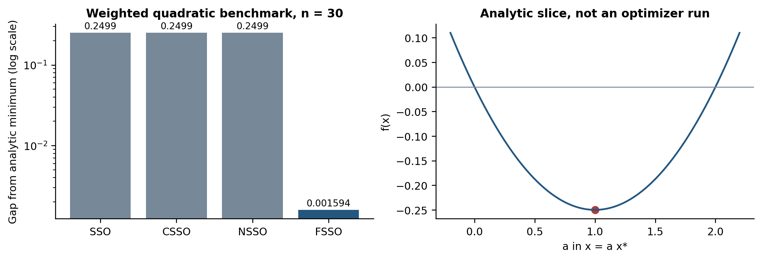
Figure 2. Positive gaps from the true weighted-quadratic minimum and an analytic one-dimensional slice through x*. The slice illustrates the negative basin and contains no reconstructed optimization history.
The reported FSSO mean, −0.2483, has a gap of approximately 0.0015943. The earlier means are all close to zero and therefore about 0.2499 above the optimum. This is a meaningful descriptive contrast on this function, but the function is smooth and convex. A direct quadratic solver and a standard gradient-based optimizer are necessary baselines before attributing the result to global-search capability. Negative-region discovery is an analytic consistency check rather than evidence of escaping a nonconvex local optimum on this particular benchmark.

5.2 Four additional benchmark functions
The additional suite consists of Step, Rastrigin, Ackley, and Zakharov. These probe plateaus, oscillatory local structure, and coupled coordinate effects, but four unshifted functions do not represent the full diversity of continuous optimization. The Step function has a zero gradient almost everywhere, making it especially important to distinguish gradient information from rotational or jump exploration. Table 4 preserves the reported mean values rather than inventing additional trials.
Table 4. Reported mean objective values for the four-function comparison. Displayed zeros and near-machine-precision values should be interpreted at the original numerical precision.
Method | Step mean | Rastrigin mean | Ackley mean | Zakharov mean
FSSO | 0 | 0 | 2.7e-14 | 0
ISOA | 0 | 0.0013 | 0.00054 | 0
PSO | 4423 | 230 | 12.55 | 2.36
GA | 2114 | 150.1 | 8.88 | 1.51
FACS | 203.4 | 152.8 | 8.21 | 0.06
DE | 145.8 | 98.48 | 4.86 | 0.0067

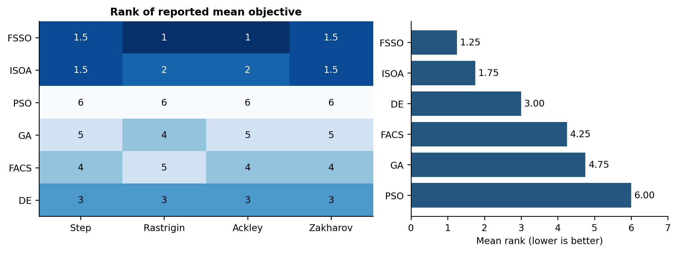
Figure 3. Per-function ranks and descriptive mean ranks from Table 4. Ties receive average ranks. These are rankings of reported rounded means, not a significance test over repeated runs.
FSSO ranks first on Rastrigin and Ackley and ties with ISOA on Step and Zakharov, giving mean rank 1.25. The corresponding ISOA mean rank is 1.75. DE ranks third on each reported function. These summaries should not be converted into a Friedman p-value because the original repeated-run outcomes, matched instances, and comparison design are not available. Statistical procedures require a defensible experimental unit, not merely more decimal places in an aggregate table [43].
Some range and standard-deviation entries in the original optimizer record require reconciliation. For example, a reported SSO Matyas range from roughly 0 to 6.2 × 10⁻⁷ has mean 1.52 × 10⁻⁸ and standard deviation 1.51 × 10⁻⁷. The general bounded-variance relation Var(X) ≤ (b−μ)(μ−a) constrains compatible summaries. Without a run count and precise estimator convention, these values should not be used to draw error bars or infer confidence. Releasing per-run values would make the consistency check and any rounding explanation testable.

5.3 Reproducible ablation and statistical design
The aggregate optimizer table cannot identify which operator produced the reported ranking. A publishable follow-up should therefore use a fixed benchmark suite, common initial populations, identical stopping budgets, and at least 30 independent seeds; a smaller number should be justified and reported as a power limitation. The seed schedule must be shared across variants so that each pair of methods sees the same starting positions and objective instances. Every gradient evaluation, objective call, repair, failed candidate, and wall-clock interval should be logged.
Table 5. Required ablation matrix for the improved shark-smell optimizer. This is an experimental design, not an unexecuted performance result.
Variant | Changed operator | Matched controls | Required output
RLS / exact LS | None | Same antecedents and objective | Reference fit and cost
SSO | Baseline search | Same bounds, seeds, and call budget | Best-so-far trace
SSO + timing | Gradient-dependent timing | All SSO settings unchanged | Gap and extra calls
SSO + jump | Low-gradient jump | Timing disabled | Jump acceptance and failures
SSO + cap | γ ∼ U(0,2) | Only cap interval changed | Velocity and objective trace
SSO + rotation | U(−1.3,1.3) rotation | Only rotation interval changed | Sign reversals and gap
Full FSSO | All four operators | Same benchmark and budget | Paired effect sizes

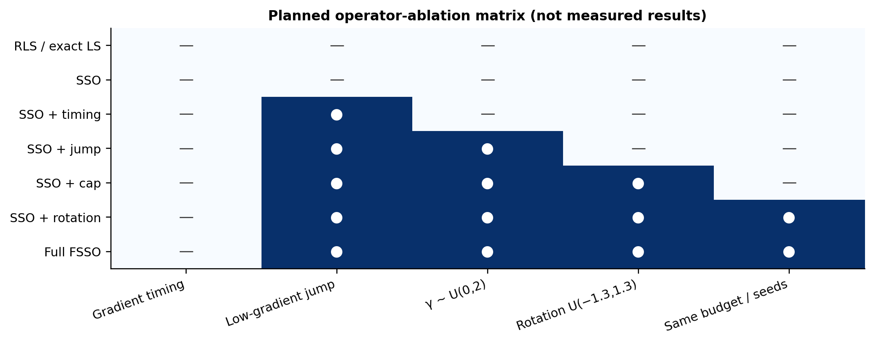
Figure 4. Planned operator-ablation matrix. Filled cells indicate the only operator changed from the immediately preceding variant; the matrix is a protocol rather than an empirical heatmap.
The minimum sequence is exact least squares or a deterministic quadratic solver, RLS-only forecasting, conventional SSO, SSO plus each modification separately, and the complete FSSO. The fuzzy partition, training window, objective, bounds, population, call budget, and repair policy must remain constant. The output is a run-by-run record of best-so-far objective versus objective calls, final objective gap, runtime, and failure count. Mean values alone hide heavy tails and premature convergence.
For benchmark functions, compare matched seed pairs with a Friedman test across methods followed by paired Wilcoxon signed-rank tests with Holm adjustment when the omnibus test is justified [43]. Report rank-biserial effect size and a confidence interval for the median paired difference. For forecasting, the experimental unit is a common origin and lead, not an individual optimizer evaluation; use rolling-origin losses and a dependence-aware Diebold–Mariano or block-bootstrap analysis [44, 36]. Do not pool seven country-level aggregates and call them independent replications.
Algorithm 10 Run a matched-budget optimizer ablation
INPUT objective suite; data folds; variant list; seed list; call budget B
OUTPUT run-level scores, best-so-far traces, timing, and failure logs
01 Freeze bounds, scaling, stopping rules, and comparator implementations.
02 FOR each seed s:
03 Create one initial population and one evaluation-order record.
04 FOR each variant v:
05 Reset to the same initial population and seed s.
06 Evaluate candidates until exactly B objective calls or a declared failure.
07 Record every objective call, best-so-far value, wall time, and invalid point.
08 END FOR
09 END FOR
10 Verify that all successful variants used the same instances and budget.
11 Compute per-run gaps, paired differences, rank-biserial effects, and intervals.
12 Apply Friedman/Wilcoxon procedures only to matched run-level outcomes.
13 RETURN raw records and a summary that keeps failures in the denominator.

The protocol also makes the computational claim testable. A gradient-based variant may use more objective calls than a nominally equal iteration count because finite differences require extra evaluations. The budget must therefore be stated in calls and separately in elapsed time. A future paper should release the seed list, machine and software configuration, and the raw trace needed to reproduce each visual convergence curve.

6 Epidemic forecasting results

6.1 Metrics and comparison denominators
For an aligned set S of n observations, RMSE = sqrt[Σ e_{t}²/n] and MAE = Σ|e_{t}|/n. MAPE averages 100|e_{t}/y_{t}| and is undefined at zero targets; a zero policy must be declared. SMAPE is defined here as 200Σ[|y_{t}−ŷ_t|/(|y_{t}|+|ŷ_t|)]/n, with a zero contribution when both values are zero. Alternative SMAPE conventions differ by a factor of two. Such definitions matter when comparing published values [45].
$\text{Relative reduction (\%)}=100 \frac{E_{baseline}−E_{proposed}}{E_{baseline}} \left(10\right)$
Equation (10) applies only when E_{baseline} > 0 and lower values are better. Country-level RMSE preserves the case-count scale, while SMAPE expresses a relative discrepancy. A pooled RMSE depends on both the number of observations and scale in each country; it is not the arithmetic mean of country RMSE values. Accordingly, the headline comparison in Table 6 is kept separate from the seven-country tables because its exact sample aggregation is not documented.

6.2 Headline training and test comparison
Table 6. Reported headline error values. The row population and aggregation must be documented before interpreting these as pooled country results.
Phase | Method | MAPE (%) | RMSE
Training | FTSOAX | 4.68 | 213.26
Training | T–SFSSO | 2.74 | 99.75
Test | FTSOAX | 7.82 | 406.155
Test | T–SFSSO | 4.93 | 251.032

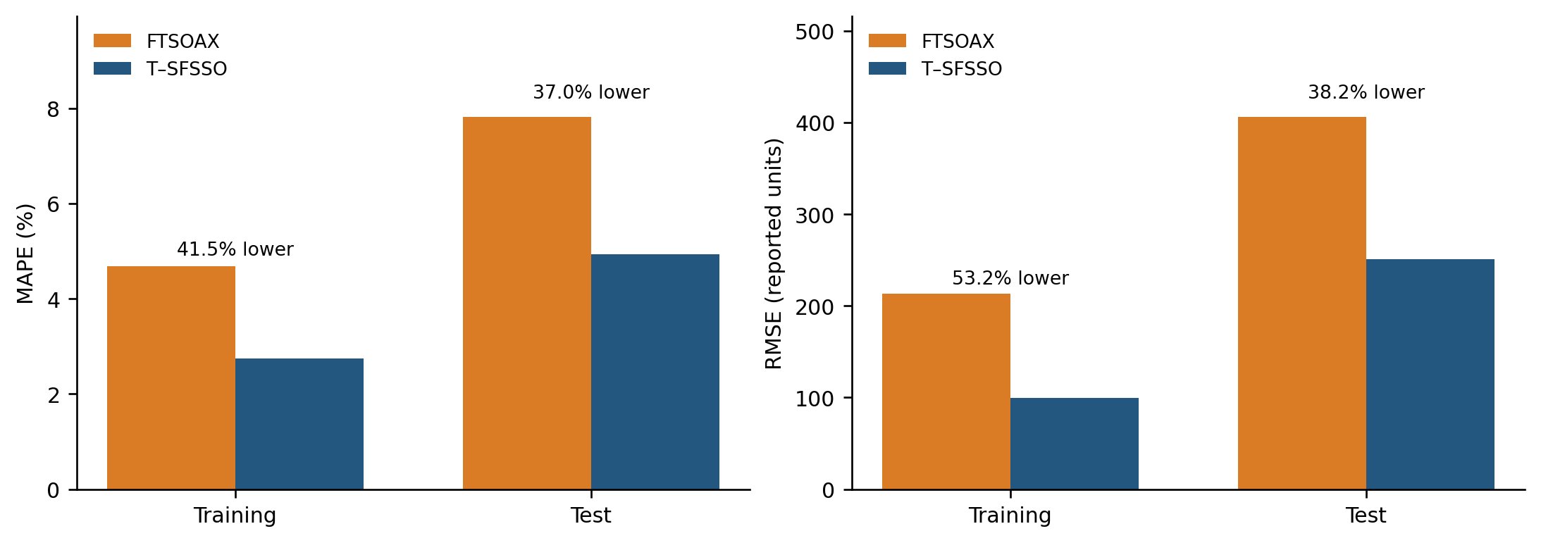
Figure 5. Headline error values and relative reductions calculated from Table 6. Bar heights are reported aggregate values; no sampling uncertainty is implied.
Training MAPE falls by 41.45% and training RMSE by 53.23%. Test MAPE falls by 36.96% and test RMSE by 38.19%. Both metrics favor T–SFSSO in this comparison, but the lower test gains do not by themselves identify overfitting: the training and test periods may have different scales and dynamics. An RLS-only ablation and a same-structure alternative optimizer are needed to isolate the added value of FSSO.

6.3 Country-specific performance
Table 7. Training RMSE / SMAPE (%) for each country. The comparator identities are described in Section 4.3.
Country | GA–FCM / BPNN | EWFTS / IHS | Hybrid FTS | FTSOAX | T–SFSSO
USA | 21763.26 / 23.98 | 24518.61 / 32.76 | 18879.43 / 18.71 | 10236.83 / 15.18 | 9783.29 / 13.84
India | 14332.20 / 29.46 | 13831.16 / 24.02 | 10915.50 / 10.17 | 6476.96 / 7.81 | 6074.28 / 7.32
Russia | 1957.36 / 11.66 | 2133.67 / 13.75 | 1786.00 / 7.80 | 1240.49 / 3.62 | 1052.17 / 3.03
Iran | 2556.53 / 24.65 | 2671.34 / 15.40 | 2674.77 / 10.92 | 1735.81 / 8.02 | 1625.34 / 2.18
Norway | 133.82 / 40.69 | 141.49 / 52.33 | 130.50 / 36.28 | 76.79 / 31.63 | 59.76 / 26.71
UK | 3167.46 / 43.44 | 3202.68 / 36.40 | 2797.58 / 16.99 | 1343.01 / 14.53 | 1293.62 / 13.28
Japan | 1323.14 / 57.91 | 883.20 / 50.46 | 900.65 / 40.46 | 465.13 / 15.45 | 387.44 / 13.47

Table 8. Test RMSE / SMAPE (%) for each country. These are aggregate scores, not uncertainty intervals.
Country | GA–FCM / BPNN | EWFTS / IHS | Hybrid FTS | FTSOAX | T–SFSSO
USA | 25142.50 / 54.59 | 25619.50 / 57.84 | 28685.24 / 54.07 | 23865.82 / 52.36 | 22761.69 / 51.87
India | 13355.95 / 27.67 | 13526.97 / 28.00 | 4822.58 / 9.99 | 4285.90 / 7.98 | 3989.93 / 6.13
Russia | 4349.99 / 7.42 | 4425.84 / 8.03 | 4380.58 / 7.04 | 4255.50 / 5.46 | 4109.84 / 5.26
Iran | 6893.40 / 24.95 | 6856.67 / 24.77 | 7765.32 / 29.13 | 6292.97 / 25.38 | 6085.45 / 23.68
Norway | 156.75 / 55.18 | 139.46 / 47.32 | 131.10 / 47.21 | 133.69 / 46.53 | 102.51 / 43.02
UK | 7727.18 / 15.57 | 7949.36 / 16.59 | 7181.82 / 14.89 | 8515.25 / 15.58 | 7082.93 / 14.13
Japan | 1397.51 / 36.55 | 1371.77 / 34.50 | 1520.70 / 32.90 | 1332.31 / 31.17 | 1309.83 / 31.06

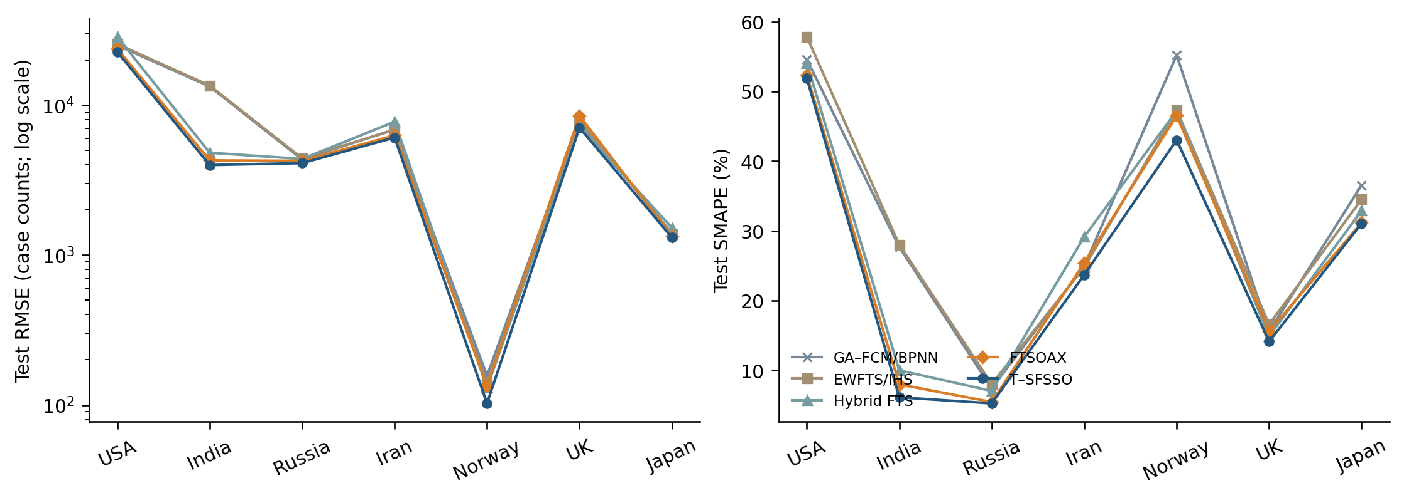
Figure 6. Absolute test RMSE and test SMAPE from Table 8. A logarithmic RMSE axis prevents the largest case-count series from obscuring smaller series.
The proposed method has the smallest reported value in both columns for each of the seven countries. The magnitude of the advantage is heterogeneous. In Norway, the test RMSE is 102.51 compared with the best previous value 131.10. In Japan, 1309.83 is only modestly below 1332.31. This variability is important when deciding whether the added search cost is justified for each series; an average rank conceals such differences.
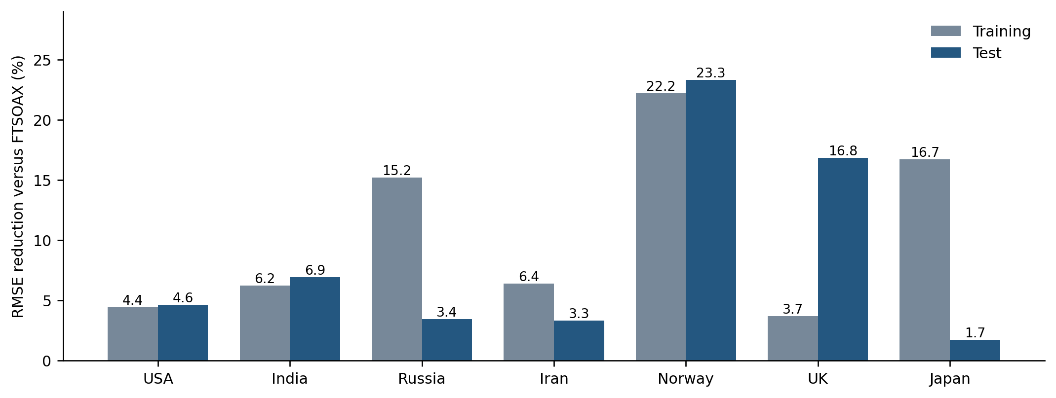
Figure 7. Country-wise training and test RMSE reductions against FTSOAX. Every value is a direct transformation of Tables 7 and 8.
Against FTSOAX, test RMSE reduction ranges from 1.69% in Japan to 23.32% in Norway. The UK illustrates why the baseline definition matters: FTSOAX is not its strongest earlier comparator. Comparing against the best available prior score rather than against a single favored baseline gives a more demanding descriptive assessment.
Table 9. Test error reductions relative to the smallest prior value for the same country and metric. The best prior method can differ between RMSE and SMAPE.
Country | RMSE gain (%) | SMAPE gain (%)
USA | 4.63 | 0.94
India | 6.91 | 23.18
Russia | 3.42 | 3.66
Iran | 3.30 | 4.40
Norway | 21.81 | 7.54
UK | 1.38 | 5.10
Japan | 1.69 | 0.35
Mean | 6.16 | 6.45
Median | 3.42 | 4.40

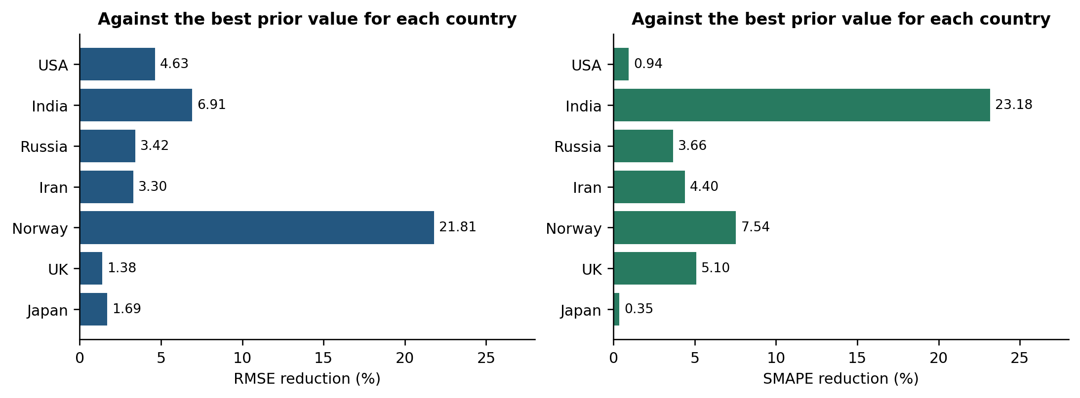
Figure 8. Improvements over the best earlier score in each country. The gains are descriptive effect sizes and do not establish paired statistical significance.
Mean gains are 6.16% for RMSE and 6.45% for SMAPE; the corresponding medians are 3.42% and 4.40%. The larger means show that a few stronger gains influence the overall summary. A tiny positive SMAPE difference, such as Japan’s approximately 0.35%, should not be called practically decisive without knowing the variability and deployment costs.

6.4 Temporal difficulty and evaluation length
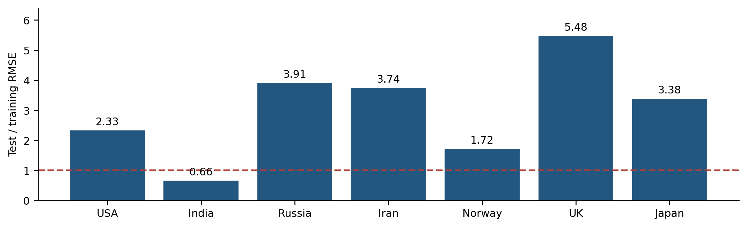
Figure 9. T–SFSSO test RMSE divided by training RMSE for each country. Different periods and data scales prevent this ratio from being interpreted as a pure estimate of model overfitting.
The test/training ratio ranges from about 0.66 in India to 5.48 in the UK. The decrease for India and increase for other countries are compatible with different temporal difficulty and series scales. They demonstrate why a single partition cannot establish stable generalization across epidemic phases. To separate parameter overfitting from temporal shift, a replication should compare methods on multiple common origins and standardize metrics relative to a training-period naïve baseline.
Table 10. Reported evaluation-length RMSE / SMAPE (%) comparison. The 40-, 100-, and 180-day labels are preserved; their exact forecasting protocol is not specified.
Horizon | GA–FCM / BPNN | EWFTS / IHS | Hybrid FTS | FTSOAX | T–SFSSO
40 days | 13613.67 / 28.28 | 13796.58 / 28.63 | 4935.42 / 10.17 | 3532.31 / 7.31 | 3182.35 / 6.81
100 days | 15950.56 / 42.90 | 15787.34 / 40.66 | 5100.16 / 11.68 | 3148.61 / 6.69 | 2907.54 / 6.23
180 days | 12368.06 / 37.36 | 12128.53 / 34.85 | 4490.23 / 15.60 | 2785.22 / 10.77 | 2513.07 / 9.82

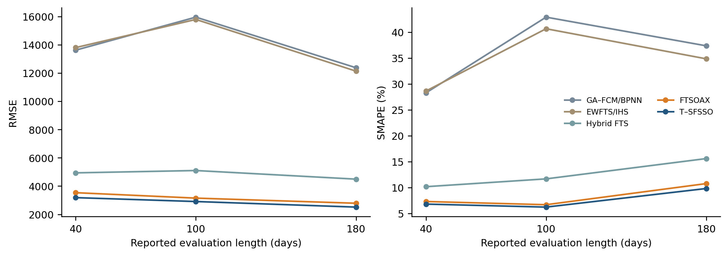
Figure 10. Error profiles across the three reported evaluation lengths. Connecting lines aid comparison between tabulated points and are not measured intermediate trajectories.
The proposed model is below all listed comparators at the three reported lengths. RMSE relative reductions against FTSOAX are 9.91%, 7.66%, and 9.77%. RMSE decreases as the reported length increases, whereas SMAPE does not change monotonically. This should not be explained as a proven long-horizon advantage: changing target windows can change both the scale and difficulty of the problem. The sample origin, lead, and target set must accompany every row before a claim about recursive forecast stability is justified.

7 Discussion and reproducibility

7.1 Supported conclusions and unresolved attribution
The aggregate evidence supports lower reported errors for the combined T–SFSSO framework in the listed comparisons. It does not prove that every proposed operator improves accuracy, that the optimizer is globally convergent as implemented, or that it dominates modern neural and ensemble approaches. The recent literature includes stronger nonlinear consequents and richer uncertainty representations, each of which changes the model class. Comparisons should therefore distinguish equal-architecture optimizer experiments from end-to-end architecture comparisons.
A useful ablation sequence is RLS only, conventional SSO, SSO plus each individual modification, and the complete FSSO. The same antecedents, objective, data windows, random-seed schedule, and evaluation budget must be used. Report the additional gain and additional computation together. For fixed antecedents, include exact ridge least squares; for the convex quadratic benchmark, include its analytic minimizer and a deterministic optimizer. Such controls can reveal whether a result is driven by a modeling change, a numerical defect, or a search operator.

7.2 Statistical and computational reporting
Paired loss differences should be formed at common origins and leads. Serial correlation and overlapping horizons must be considered in significance testing; a Diebold–Mariano-type comparison requires an appropriate variance estimate [44]. Block resampling can preserve temporal dependence when estimating uncertainty. Neither test should be applied to the seven country aggregate scores as though each daily error were independent. Report confidence intervals, effect sizes, and the number of origins together with any adjusted p-values.
Timing requires a processor description, software versions, thread count, objective-call count, and separate fitting and inference measurements. A method with faster wall-clock time on one machine can still use more objective evaluations. Conversely, an expensive optimizer may be acceptable for infrequent training if online inference remains cheap. Both questions are relevant to deployment and should not be collapsed into one runtime number.

7.3 Data and implementation availability
Independent reproduction requires the original source of each series, observation dates, download or revision dates, handling of negative revisions and zeros, training and test counts, exact membership breakpoints, lag orders, parameter bounds, random seeds, stopping rules, and executable comparator versions. The original campaign’s complete records are not available in the manuscript-level aggregate evidence. The figures therefore visualize tabulated values or explicitly labeled analytic relationships; they do not substitute reconstructed curves for observed forecasts or optimization traces.
The pseudocode defines a transparent replication procedure while keeping unresolved variant parameters visible. New rolling-origin experiments, shifted benchmark instances, operator ablations, and interval forecasts should be reported as new studies after execution. Their outcomes cannot be inferred from the current tables.

7.4 Measurement and numerical uncertainty
The numerical-gradient path requires a finite-difference step, parameter scaling, clipping rule, and floating-point precision. These settings should be recorded because a step that is small in case-count units can be large after normalization, while a step that is too small can be dominated by round-off. Invalid membership coverage, non-finite objectives, and boundary projections should be counted as diagnostic events rather than silently discarded. For the epidemic series, reporting revisions, zeros, and negative corrections require a versioned data snapshot; otherwise two nominally identical train/test splits may contain different targets. A replication should propagate measurement or reporting uncertainty through the final error summary and retain prediction intervals separately from point forecasts.
The deployment guardrails are equally explicit: warn when the no-coverage fallback is used, when a candidate repeatedly hits a parameter bound, when RLS conditioning deteriorates, or when the current input range leaves the training universe. These alarms are operational evidence about distribution shift, not additional accuracy claims. They should be evaluated on a held-out chronological period with the same thresholds fixed in advance.

8 Conclusions
T–SFSSO combines a dynamic rule-based predictor with recursive parameter estimation and four modifications to shark smell optimization. The reported forecasting scores favor the combined method across the listed countries and evaluation lengths, and the analytic quadratic calculation corrects the benchmark minimum to −0.24989428. The new visual analysis clarifies the magnitude and heterogeneity of these results.
The interpretation is conditional on the available evidence. Least squares is globally solvable for fixed affine consequents, U(0,2) cap multipliers do not prevent multiplicative shrinkage, local jumps do not establish full-support exploration, and stable local rules do not automatically establish stable recursive forecasts. Publishing the exact parameterization and original run records, followed by matched-budget ablations and chronological validation, is the next step needed to establish which parts of the method deliver reproducible benefit.

References
[1] Zadeh, L. A. (1965). Fuzzy sets. Information and Control, 8(3), 338–353. https://doi.org/10.1016/S0019-9958(65)90241-X
[2] Song, Q., and Chissom, B. S. (1993). Fuzzy time series and its models. Fuzzy Sets and Systems, 54(3), 269–277. https://doi.org/10.1016/0165-0114(93)90372-O
[3] Chen, S.-M. (1996). Forecasting enrollments based on fuzzy time series. Fuzzy Sets and Systems, 81(3), 311–319. https://doi.org/10.1016/0165-0114(95)00220-0
[4] Takagi, T., Sugeno, M. (1985). Fuzzy identification of systems and its applications to modeling and control. IEEE Transactions on Systems, Man, and Cybernetics, 15(1), 116–132. https://doi.org/10.1109/TSMC.1985.6313399
[5] Sugeno, M., and Kang, G. T. (1988). Structure identification of fuzzy model. Fuzzy Sets and Systems, 28(1), 15–33. https://doi.org/10.1016/0165-0114(88)90113-3
[6] Cramer, E. Y., Ray, E. L., Lopez, V. K., et al. (2022). Evaluation of individual and ensemble probabilistic forecasts of COVID-19 mortality in the United States. Proceedings of the National Academy of Sciences, 119(15), e2113561119.
[7] Nixon, K., Jindal, S., Parker, F., Reich, N. G., Ghobadi, K., Lee, E. C., Truelove, S., Gardner, L. (2022). An evaluation of prospective COVID-19 modelling studies in the USA: from data to science translation. The Lancet Digital Health, 4(10), e738–e747. https://doi.org/10.1016/S2589-7500(22)00148-0
[8] Mamdani, E. H., Assilian, S. (1975). An experiment in linguistic synthesis with a fuzzy logic controller. International Journal of Man-Machine Studies, 7(1), 1–13. https://doi.org/10.1016/S0020-7373(75)80002-2
[9] Jang, J.-S. R. (1993). ANFIS: adaptive-network-based fuzzy inference system. IEEE Transactions on Systems, Man, and Cybernetics, 23(3), 665–685. https://doi.org/10.1109/21.256541
[10] Wang, L.-X., and Mendel, J. M. (1992). Generating fuzzy rules by learning from examples. IEEE Transactions on Systems, Man, and Cybernetics, 22(6), 1414–1427. https://doi.org/10.1109/21.199466
[11] Angelov, P. P., and Filev, D. P. (2004). An approach to online identification of Takagi–Sugeno fuzzy models. IEEE Transactions on Systems, Man, and Cybernetics, Part B, 34(1), 484–498. https://doi.org/10.1109/TSMCB.2003.817053
[12] Kukolj, D. (2002). Design of adaptive Takagi–Sugeno–Kang fuzzy models. Applied Soft Computing, 2(2), 89–103.
[13] Dalar, A. Z. (2026). A hybrid fuzzy–ensemble method for time series forecasting. Scientific Reports, 16, 20705. https://doi.org/10.1038/s41598-026-51585-w
[14] Egrioglu, E., Bas, E., Yildirim, A. N., Oguz, U., Sari, I. F. (2026). A Sugeno–multiplicative neuron hybrid system trained by differential evolution algorithm for time series forecasting. Scientific Reports, 16, 21174. https://doi.org/10.1038/s41598-026-51980-3
[15] Cansu, T., Bas, E., Egrioglu, E. (2026). Mixed order single variable intuitionistic fuzzy time series forecasting method based on a new artificial neural network and grey wolf optimization algorithm. Scientific Reports, 16, 15682. https://doi.org/10.1038/s41598-026-45059-2
[16] Gundogdu, O., Egrioglu, E., Bas, E. (2026). Pythagorean fuzzy time series approach based on hybrid high-order artificial neural network for nonlinear time series forecasting. Scientific Reports, 16, 27440. https://doi.org/10.1038/s41598-026-58132-7
[17] Bisht, K., Kumar, S., Pant, M., Negi, S. (2026). Hesitant fuzzy time series forecasting: A novel approach to handle the hesitancy in the system. Journal of Computational and Applied Mathematics, 482, 117322. https://doi.org/10.1016/j.cam.2025.117322
[18] Fulara, S. P., Tak, N., Kumar, S. (2026). Time series forecasting method based on complete ensemble empirical mode decomposition with adaptive noise and hesitant fuzzy cognitive map. Applied Soft Computing, 198, 115282. https://doi.org/10.1016/j.asoc.2026.115282
[19] Abedinia, O., Amjady, N., Ghasemi, A. (2016). A new metaheuristic algorithm based on shark smell optimization. Complexity, 21(5), 97–116. https://doi.org/10.1002/cplx.21634
[20] Abedinia, O., Amjady, N. (2015). Short-term wind power prediction based on hybrid neural network and chaotic shark smell optimization. International Journal of Precision Engineering and Manufacturing-Green Technology, 2(3), 245–254. https://doi.org/10.1007/s40684-015-0029-4
[21] Kennedy, J., Eberhart, R. (1995). Particle swarm optimization. Proceedings of ICNN'95 — International Conference on Neural Networks, 4, 1942–1948.
[22] Goldberg, D. E. (1989). Genetic Algorithms in Search, Optimization and Machine Learning. Addison-Wesley, Reading, MA.
[23] Storn, R., Price, K. (1997). Differential evolution — a simple and efficient heuristic for global optimization over continuous spaces. Journal of Global Optimization, 11(4), 341–359. https://doi.org/10.1023/A:1008202821328
[24] Tao, C.-W., Taur, J.-S., Jeng, J.-T., Wang, W.-Y. (2009). A novel fuzzy ant colony system for parameter determination of fuzzy controllers. International Journal of Fuzzy Systems, 11(4), 298–307.
[25] Suman, A., Gunjan, Udmale, S. S. (2026). Metaheuristic algorithms: A benchmark-driven functional taxonomy and performance analysis. Computer Science Review, 60, 100884. https://doi.org/10.1016/j.cosrev.2025.100884
[26] Molina, D., Del Ser, J., Poyatos, J., Herrera, F. (2025). The paradox of success in evolutionary and bioinspired optimization: Revisiting critical issues, key studies, and methodological pathways. Swarm and Evolutionary Computation, 98, 102063. https://doi.org/10.1016/j.swevo.2025.102063
[27] Kudela, J. (2022). A critical problem in benchmarking and analysis of evolutionary computation methods. Nature Machine Intelligence, 4(12), 1238–1245. https://doi.org/10.1038/s42256-022-00579-0
[28] Hansen, N., Auger, A., Ros, R., Mersmann, O., Tušar, T., and Brockhoff, D. (2021). COCO: A platform for comparing continuous optimizers in a black-box setting. Optimization Methods and Software, 36(1), 114–144. https://doi.org/10.1080/10556788.2020.1808977
[29] Steyn, G. J., van Zyl, J.-P., Engelbrecht, A. P. (2026). Set-based particle swarm optimisation convergence. Swarm Intelligence, 20, 1–33. https://doi.org/10.1007/s11721-026-00262-9
[30] Wolpert, D. H., and Macready, W. G. (1997). No free lunch theorems for optimization. IEEE Transactions on Evolutionary Computation, 1(1), 67–82. https://doi.org/10.1109/4235.585893
[31] Ljung, L. (1999). System Identification: Theory for the User. 2nd ed. Prentice Hall.
[32] Goel, A., Bruce, A. L., and Bernstein, D. S. (2020). Recursive least squares with variable-direction forgetting: Compensating for the loss of persistency. IEEE Control Systems Magazine, 40(4), 80–102. https://doi.org/10.1109/MCS.2020.2990516
[33] Tanaka, K., and Sugeno, M. (1992). Stability analysis and design of fuzzy control systems. Fuzzy Sets and Systems, 45(2), 135–156. https://doi.org/10.1016/0165-0114(92)90113-I
[34] Tanaka, K., and Wang, H. O. (2001). Fuzzy Control Systems Design and Analysis: A Linear Matrix Inequality Approach. Wiley. https://doi.org/10.1002/0471224596
[35] Tashman, L. J. (2000). Out-of-sample tests of forecasting accuracy: An analysis and review. International Journal of Forecasting, 16(4), 437–450. https://doi.org/10.1016/S0169-2070(00)00065-0
[36] Hewamalage, H., Ackermann, K., and Bergmeir, C. (2023). Forecast evaluation for data scientists: Common pitfalls and best practices. Data Mining and Knowledge Discovery, 37, 788–832. https://doi.org/10.1007/s10618-022-00894-5
[37] Bergmeir, C., Hyndman, R. J., and Koo, B. (2018). A note on the validity of cross-validation for evaluating autoregressive time series prediction. Computational Statistics & Data Analysis, 120, 70–83. https://doi.org/10.1016/j.csda.2017.11.003
[38] Xian, S., Chen, K., Cheng, Y. (2022). Improved seagull optimization algorithm of partition and XGBoost of prediction for fuzzy time series forecasting of COVID-19 daily confirmed. Advances in Engineering Software, 173, 103212.
[39] Zhang, W., Zhang, S., Zhang, S. (2019). A novel method based on FTS with both GA-FCM and multifactor BPNN for stock forecasting. Soft Computing, 23(16), 6979–6994.
[40] Sadaei, H. J., Enayatifar, R., Abdullah, A. H., Gani, A. (2014). Short-term load forecasting using a hybrid model with a refined exponentially weighted fuzzy time series and an improved harmony search. International Journal of Electrical Power & Energy Systems, 62, 118–129.
[41] Kumar, N., Kumar, H. (2022). A novel hybrid fuzzy time series model for prediction of COVID-19 infected cases and deaths in India. ISA Transactions, 124, 69–81.
[42] Kumar, N., Susan, S. (2021). Particle swarm optimization of partitions and fuzzy order for fuzzy time series forecasting of COVID-19. Applied Soft Computing, 110, 107611.
[43] Demšar, J. (2006). Statistical comparisons of classifiers over multiple data sets. Journal of Machine Learning Research, 7, 1–30. https://www.jmlr.org/papers/v7/demsar06a.html
[44] Diebold, F. X., and Mariano, R. S. (1995). Comparing predictive accuracy. Journal of Business & Economic Statistics, 13(3), 253–263. https://doi.org/10.1080/07350015.1995.10524599
[45] Hyndman, R. J., and Koehler, A. B. (2006). Another look at measures of forecast accuracy. International Journal of Forecasting, 22(4), 679–688. https://doi.org/10.1016/j.ijforecast.2006.03.001

