Knowledge Guided Virtual Engineering Design and Laboratory Experiments with Coupled Physical and Visual Models

Abstract
Virtual engineering systems become useful decision tools when their displayed geometry, physical calculations, and procedural guidance describe the same engineering state. This study develops a detailed formulation of a knowledge guided architecture implemented for compressor heat exchanger design, virtual tensile testing, and beam vibration experiments. The architecture connects a visual model, mathematical models, a case database, a domain knowledge base, and a rule based supervisory agent. Its computational workflow is expressed through six algorithms covering case retrieval, constrained design revision, state synchronization, diagnostic reasoning, mechanical simulation, and verification. The thermal formulation connects energy conservation, overall heat transfer resistance, geometric area, and hydraulic constraints; the laboratory formulation connects constitutive assumptions and boundary conditions to virtual instruments and rendered deformation. Reassessment of the reported exchanger data gives a 10.295% difference between required and calculated thermal quantities. The listed smooth tube geometry gives approximately 9.95 m² of external area, compared with a reported effective area of 139 m², identifying a specific reconciliation needed before thermal performance can be independently verified. Educational indicators favor the agent guided environment in the reported table, including initiative scores of 88%, 68%, and 35% for agent guided, physical, and earlier virtual instruction, respectively. These comparisons remain descriptive because participant counts and assessment procedures are unavailable. The study contributes a physically explicit integration framework and a traceable reassessment of its application evidence. It also establishes how geometric consistency, physical validity, computational efficiency, and educational effectiveness should be evaluated separately.
Keywords: virtual engineering; knowledge based design; virtual laboratory; heat exchanger; physical verification; engineering education

1 Introduction
Engineering decisions rarely depend on a single calculation. A heat exchanger that satisfies a nominal heat duty can still be unsuitable because its pressure loss is excessive, its tubes cannot be maintained, or its geometry cannot fit the installation. Laboratory interpretation has a similar dependence on connected information. A displayed tensile specimen is educationally useful only when the applied force, gauge length, material response, and calculated stress and strain remain consistent. Virtual environments therefore need more than geometric visualization: they need a disciplined relationship between objects, equations, operating assumptions, and user actions.
Virtual design and construction, decision oriented engineering objects, and digital twin enabled systems increasingly organize these relationships through shared information models [1–4]. Workshop platforms, collaborative electronics laboratories, multidisciplinary product design, and virtual commissioning illustrate the breadth of this integration [5–8]. Virtual sensors introduce another connection between predicted and observable quantities [9]. Across these applications, the central engineering problem is preserving meaning as information passes between representations. A coordinate change has a geometric meaning, a change in tube diameter has thermal and hydraulic consequences, and a procedural error has an instructional meaning. Treating all three as generic graphical events obscures the reasoning needed to assess a result.
The implemented system examined here addresses this problem through a knowledge guided architecture. A visual representation supports inspection and manipulation. A mathematical representation evaluates engineering behavior. A database supplies material properties and previous design cases. A rule based supervisor interprets the current state and provides task dependent guidance. The original software uses conventional graphical and numerical tools, including Qt and OpenGL; its research contribution concerns the coordination of models and decisions, rather than a claim that a particular rendering library establishes physical validity.
The scope is also specific. A documented live connection between a particular physical asset and its virtual representation is absent. The system is consequently treated as a virtual engineering and laboratory architecture. Contemporary digital twin research supplies architectural comparisons and validation criteria, while the historical implementation is assessed on its documented functions.
This paper develops three connected contributions. First, it formalizes the shared state and decision workflow linking geometry, physical calculations, and domain rules. Second, it derives the thermal and mechanical relationships required to interpret the implemented applications. Third, it reassesses the available design and educational tables through visual analysis and consistency checks. These contributions preserve the original applications while providing a more explicit account of what the calculations establish and how the remaining claims can be tested.

2 Related work and research position

2.1 Virtual laboratories and learning objectives
Control engineering laboratories and game based control environments make otherwise inaccessible dynamic behavior repeatable and observable [10,11]. Augmented reality in chemical engineering similarly connects an operation with its physical explanation [12]. Immersive materials laboratories, comparisons of headset and laptop delivery, and solar collector control laboratories show that interface design and the underlying engineering task both affect how a virtual experiment should be evaluated [13–15]. Multiuser laboratory environments add collaboration, synchronization, and individual contribution tracking to these requirements [16].
These studies imply a distinction between access to an experiment and learning from it. A student may complete more trials in a virtual laboratory without becoming better at recognizing a faulty assumption or interpreting a measured curve. Evaluation should therefore distinguish procedural completion, conceptual understanding, transfer to a physical apparatus, and retention. The supervisor in the present architecture is relevant because it can associate a user action with an engineering explanation. Its effectiveness depends on whether the explanation is correct and whether the assessment measures the intended learning outcome.

2.2 Coupled engineering models and design decisions
Recent engineering design literature treats a digital representation as a combination of models, data, and lifecycle decisions [17]. Comparisons of open source frameworks and work on mechanical system modeling highlight the practical importance of model interfaces and consistent state definitions [18,19]. Thermal applications, including ground heat exchangers, further require that model parameters correspond to a declared operating condition [20]. A visual object that carries a temperature label does not by itself establish this correspondence.
Modern exchanger optimization studies consider competing objectives and interacting structural variables. Compact exchanger optimization, fin and tube design, thermal storage exchangers, printed circuit configurations, welded plate design, and network retrofit optimization provide relevant examples [21–26]. These contributions make it inappropriate to claim novelty merely from evaluating several engineering criteria. The narrower contribution of the present system is a workflow that connects stored cases, staged calculations, visual proposals, and knowledge based explanations. Its value should be assessed through traceability and feasible decision quality.
Physics informed exchanger monitoring and virtual bioreactor training extend the connection between physical models and user tasks [27,28]. Recent shell and tube digital transformation and mechatronics laboratory work show continuing interest in model integration and practical experimental access [29,30]. AI assisted virtual laboratory concepts broaden this direction further [31]. The supervisor investigated here remains a rule based expert system. Its behavior can be inspected through the rules and evidence that trigger each recommendation, which is a useful property when a user needs to understand a failed engineering constraint.

2.3 Questions addressed by the architecture
The applications motivate four research questions. Can a geometric revision update all dependent calculations without leaving stale results? Can case retrieval provide feasible starting points while exposing the origin of the selected information? Can laboratory guidance connect an observed anomaly with a defensible physical explanation? Finally, do the available outcome records demonstrate improvements in design or learning performance?
The first three questions concern architecture and reproducible behavior. The fourth requires comparative evidence. Keeping this distinction explicit prevents an implemented feature from being interpreted automatically as a verified performance benefit. The following methods provide a concrete formulation of the architecture; the results then evaluate the numerical evidence available for its applications.

3 Architecture and shared engineering state

3.1 Representations and information ownership
The system contains six functional components: the user interface, visual model, mathematical model, domain database, knowledge base, and supervisory agent. The user interface captures an intended operation. The visual model represents geometric configuration and visible state. The mathematical model calculates physical quantities from declared inputs and assumptions. The database stores cases and material records. The knowledge base stores admissibility and interpretation rules. The supervisor coordinates the permitted next action.
A useful formal state is
$$S_{k}=\{G_{k},q_{k},p_{k},z_{k},A_{k},L_{k}\},\text{ (1)}$$
where $G$ is geometry, $q$ the dynamic or loading state, $p$ the physical parameters, $z$ the calculated or measured instrument values, $A$ the current assumptions, and $L$ the event history. This is an explicit analytical specification of the integration contract. It does not imply that the historical program stored these quantities in one software object.
Each object needs a persistent identifier linking its graphical element, parameter record, and applicable rules. Units and model versions must accompany the values. A tube diameter entered in millimeters should be converted before it reaches a heat transfer equation written in meters. A material name should resolve to a particular property record, rather than an unversioned text label.

3.2 Dependency management and state synchronization
A design revision can invalidate several results. Changing tube diameter changes area, flow cross section, velocity, pressure loss, wall resistance, and possibly structural feasibility. The program should therefore calculate dependencies from the revised state before presenting the revision as accepted. Merely updating the visible cylinder would leave the user looking at a design whose displayed dimensions and calculated performance belong to different versions.
For a user operation $a_{k}$, the accepted transition can be represented by
$$S_{k+1}=F\left(S_{k},a_{k}\right), C_{ℓ}\left(S_{k+1}\right)≤0 \text{for all required constraints }ℓ.\text{ (2)}$$
Constraints include physical consistency and task prerequisites. A rejected proposal should preserve the preceding accepted state and record why the proposal failed. Intermediate calculated states may be displayed for diagnosis, provided they are identified as provisional.
Algorithm 1. Synchronize a proposed engineering state.
Inputs: accepted state S, user operation a, dependency graph
Create a provisional state from S and record operation a
Resolve object identifiers, units and parameter versions
Mark every dependent calculation as requiring recomputation
Recalculate geometry, physical quantities and instruments
Evaluate the applicable physical and procedural constraints
If all required checks pass:
Commit one consistent state and refresh its display
Otherwise:
Retain S and explain each failed check to the user
Store the proposal, results, decision and model versions
The algorithm makes consistency a property of the committed result. Event timestamps should distinguish simulation time from interface time. An instrument value produced at one integration step should not be combined with a deformation produced at another when a student records an observation.

3.3 Geometric transformations and physical deformation
Rigid motion is conveniently represented by homogeneous coordinates:
$$p′=Tp, T=\left[\begin{matrix}R & t \\ 0^{T} & 1\end{matrix}\right].\text{ (3)}$$
The rotation $R$ must preserve length and orientation according to the declared coordinate convention. Rigid transformations are appropriate for positioning a valve, specimen, or support. They do not describe strain. A deformed specimen instead requires a displacement field,
$$x_{display}=X+u\left(X,q\right).\text{ (4)}$$
Here $X$ is the reference geometry and $u$ is obtained from a constitutive or modal model. Surface normals should be recomputed consistently after deformation so that lighting does not create a misleading shape. Visual exaggeration can assist instruction, but its scale factor must be visible and excluded from the numerical strain calculation.

4 Knowledge guided exchanger design

4.1 Case representation and retrieval
The design database contains 20 exchanger cases. Their records include thermal quantities, mass flow, shell and tube dimensions, materials, tube counts, passes, and reported areas. Such a database can reduce the effort required to construct an initial design, particularly when a user recognizes a known arrangement. It is too small to establish broad coverage of all exchanger operating domains.
Retrieval should first remove cases with incompatible fluids, pressure classes, material restrictions, or installation limits. Similarity is then meaningful only after feature scales are declared. A dimensionless distance is
Di=j=1pwjzj−zijsj2, wj≥0, j​wj=1, sj>0. (5)
The query feature $z_{j}$ and case feature $z_{ij}$ must describe the same physical quantity. The scale $s_{j}$ can represent a design range or a dispersion estimated from the case database. It should not be chosen after observing which case yields the preferred result. Equation (5) provides an operational retrieval specification; the original case similarity weights are not available.
Algorithm 2. Retrieve and screen exchanger starting designs.
Inputs: specification, case database, scales, weights, limit k
Remove cases outside the permitted material and fluid domain
Convert compatible case features to a common unit system
Calculate the normalized distance for each remaining case
Sort by distance and retain at most k candidate records
For each retained case:
Check pressure, installation and geometric restrictions
Preserve the case identifier and every adapted parameter
Return feasible starting cases or an explicit no-match result
Adaptation is a separate operation from retrieval. A nearby case may have the wrong tube count or a pressure drop above the new limit. The design workflow must reevaluate the adapted candidate rather than inherit the old case’s acceptance status.

4.2 Thermal balance and heat transfer area
For steady operation with negligible external heat loss and no phase change in either stream, conservation requires
$${\dot{Q}}_{h}={\dot{m}}_{h}c_{p,h}\left(T_{h,in}−T_{h,out}\right), {\dot{Q}}_{c}={\dot{m}}_{c}c_{p,c}\left(T_{c,out}−T_{c,in}\right).\text{ (6)}$$
Temperature dependent properties should be evaluated over an appropriate operating range. The balance residual can be reported as
$$r_{E}=\frac{\left|{\dot{Q}}_{h}−{\dot{Q}}_{c}\right|}{max\left(\left|{\dot{Q}}_{h}\right|,\left|{\dot{Q}}_{c}\right|,ϵ_{Q}\right)}.\text{ (7)}$$
The small reference $ϵ_{Q}$ only prevents division by zero; its units are those of heat rate. A low residual shows consistency between the two calculated stream duties. It does not validate the heat transfer coefficient or prove agreement with measured operation.
The exchanger capacity calculation is
$$\dot{Q}=U_{o}A_{o}F_{T}ΔT_{lm}, ΔT_{lm}=\frac{ΔT_{1}−ΔT_{2}}{ln\left(ΔT_{1}/ΔT_{2}\right)}.\text{ (8)}$$
The terminal differences must correspond to the chosen flow arrangement. If the two differences approach equality, the limiting value should be used to avoid numerical cancellation. A multipass correction factor $F_{T}$ must be justified for the actual arrangement; it is not determined solely by a statement that the exchanger has two passes.
For smooth cylindrical tubes and an external area basis, a resistance model is
$$\frac{1}{U_{o}}=\frac{1}{h_{o}}+R_{f,o}+\frac{d_{o}}{2k_{w}}ln\left(\frac{d_{o}}{d_{i}}\right)+\frac{d_{o}}{d_{i}}\left(\frac{1}{h_{i}}+R_{f,i}\right).\text{ (9)}$$
This formulation makes the area convention explicit. The convection coefficients, fouling resistances, and wall conductivity affect the result through different mechanisms. Increasing wall conductivity has little benefit if convection or fouling dominates the total resistance. Material screening by conductivity divided by purchase price therefore cannot replace a complete thermal and lifecycle calculation.
For $N_{t}$ smooth tubes of active length $L_{t}$, the external area is
$$A_{bare}=πd_{o}L_{t}N_{t}.\text{ (10)}$$
Enhanced surfaces require an additional area and efficiency treatment. Multiple passes change flow allocation and velocity; they do not automatically multiply the installed external tube area. Multiple shells or stages must be counted explicitly.

4.3 Hydraulic and structural coupling
For $N_{p}$ passes with approximately equal parallel flow paths, a first estimate of tube side velocity is
$$v_{t}=\frac{{\dot{m}}_{t}}{ρ_{t}\left(N_{t}/N_{p}\right)πd_{i}^{2}/4}.\text{ (11)}$$
This expression presumes that $N_{t}/N_{p}$ is physically realizable and that maldistribution is neglected. Velocity affects the heat transfer correlation and the hydraulic loss simultaneously. A generic tube side pressure loss model is
$$Δp_{t}=\left(f_{D}\frac{L_{flow}}{d_{i}}+∑K_{minor}\right)\frac{ρ_{t}v_{t}^{2}}{2}, P_{pump}=\frac{Δp_{t}{\dot{V}}_{t}}{η_{pump}}.\text{ (12)}$$
The Darcy friction factor must be distinguished from a Fanning factor, and entrance, return, and nozzle losses must be included consistently. Shell side loss requires a model suited to baffles and the actual flow path. No shell side pressure loss is reconstructed from geometry alone in this study.
Structural checks include shell and tube pressure capability, support spacing, material compatibility, thermal expansion, clearances, and maintenance access. Their coupling explains why a sequential workflow must revisit earlier calculations. Adding passes can improve convection while increasing pumping demand; thinning a tube can improve wall conductance while reducing pressure margin.

4.4 Staged decisions and objective tradeoffs
The implemented workflow separates structural selection, thermal calculation, and hydraulic evaluation. This is a useful way to organize engineering work, provided each accepted revision is checked against all constraints. A general objective vector is
$$f\left(d\right)={\left[M\left(d\right), C\left(d\right), P_{pump}\left(d\right), \left|\dot{Q}\left(d\right)−{\dot{Q}}_{req}\right|\right]}^{T}.\text{ (13)}$$
The components have different units and engineering meanings. A weighted scalar objective requires declared scales and priorities. Alternatively, a nondominated archive preserves feasible alternatives for human selection. Neither approach establishes global optimality unless the design domain and search procedure provide the corresponding guarantee.
Algorithm 3. Revise an exchanger design under coupled constraints.
Initialize an empty archive and a finite calculation budget
For each retrieved starting design:
Repeat within the budget:
Obtain a logged geometric or material revision
Check geometric and structural admissibility
Calculate stream balances, area and thermal capacity
Calculate velocity, pressure loss and pumping demand
Recheck every previously satisfied constraint
If feasible: update the nondominated design archive
Explain the governing constraint and propose a revision
Stop this branch by the declared acceptance rule
Return the archive and the rationale for the selected design
The stopping rule should distinguish meeting a specification from exhausting a search budget. Recording rejected designs also reveals whether a knowledge rule improves the search by preventing repeated infeasible proposals.

5 Supervised virtual mechanical experiments

5.1 Procedural guidance and diagnostic reasoning
The laboratory agent observes specimen identity, apparatus configuration, instrument readings, and user actions. Before a test, it checks prerequisites such as a valid material record and compatible boundary conditions. During the test, it evaluates procedural deviations and physical anomalies. Afterward, it calculates results and applies a declared assessment rubric.
Forward reasoning applies rules whose premises are satisfied by the current state. Backward reasoning starts from an observed anomaly and checks possible causes against available evidence. A causal explanation should identify both the supporting observations and unresolved alternatives. For example, an unexpected slope can arise from an incorrect area, a gauge length error, an unsuitable constitutive record, or a numerical scaling problem. A rule that names only one cause without checking these alternatives can teach an incorrect diagnostic habit.
Algorithm 4. Supervise and explain a laboratory experiment.
Validate the apparatus, specimen and required prerequisites
If a prerequisite fails: explain it before enabling the test
During each accepted experiment step:
Read a consistent state and its instrument snapshot
Match procedural and physical diagnostic rules
For each anomaly:
Test candidate causes against the recorded evidence
Present supported explanations and unresolved causes
Permit only actions allowed by the current test phase
After completion:
Calculate results and apply the declared assessment rubric
Save observations, explanations, rule versions and scores
Conflict resolution is needed when several rules recommend incompatible actions. A transparent order can prioritize physical admissibility, then procedural dependencies, then instructional hints. This ordering is a proposed implementation specification; it is not an experimentally established feature of every historical laboratory session.

5.2 Tensile testing and constitutive consistency
The virtual tensile experiment uses the initial cross sectional area $A_{0}$ and gauge length $L_{0}$ to calculate engineering stress and strain:
$$σ_{e}=\frac{F}{A_{0}}, ε_{e}=\frac{L−L_{0}}{L_{0}}, σ_{e}=Eε_{e} \text{within the elastic regime}.\text{ (14)}$$
The last relationship requires a valid elastic interval. Yield strength, tensile strength, fracture elongation, and area reduction constrain aspects of a material response, but they do not uniquely determine the complete force extension curve. A constitutive interpolation must therefore be declared if the database supplies only these summary properties.
Before necking, approximately uniform deformation and volume conservation permit the familiar conversion
$$ε_{true}=ln\left(1+ε_{e}\right), σ_{true}=σ_{e}\left(1+ε_{e}\right).\text{ (15)}$$
After localization, the second relation cannot recover local true stress without additional geometry. This distinction matters when a rendered specimen visibly develops a neck. A smooth graphical animation does not provide the missing local constitutive information.
The database contains 22 steel grade records. Its values can support instructional comparisons, provided their status is clear. Test standards, specimen orientation, heat treatment, loading conditions, and property provenance are needed before the records can support material certification. Grade identifiers are preserved as source designations rather than assigned new international equivalences.

5.3 Beam vibration and boundary conditions
For a uniform slender beam under small transverse motion, the Euler Bernoulli model is
$$EI\frac{∂^{4}w}{∂x^{4}}+ρA\frac{∂^{2}w}{∂t^{2}}=0.\text{ (16)}$$
Its assumptions include small deformation and negligible shear and rotary inertia effects within the modeled frequency range. A modal approximation writes
$$w\left(x,t\right)=\sum_{n=1}^{n_{m}}{ϕ_{n}}\left(x\right)q_{n}\left(t\right), {\ddot{q}}_{n}+2ζ_{n}ω_{n}{\dot{q}}_{n}+ω_{n}^{2}q_{n}=f_{n}\left(t\right).\text{ (17)}$$
The mode shapes and frequencies depend on support conditions. For a simply supported uniform beam, $ϕ_{n}=sin\left(nπx/L\right)$ and
$$ω_{n}={\left(\frac{nπ}{L}\right)}^{2}\sqrt{\frac{EI}{ρA}}.\text{ (18)}$$
This is an analytical verification case, not an assertion that every experiment used simply supported boundaries. A cantilever or clamped beam requires different eigenvalues and shapes. The interface should show the selected support conditions and use the same conditions in the numerical solver.
Algorithm 5. Advance a mechanical experiment and its display.
Load geometry, material record, units and boundary conditions
Initialize loading or modal states and the instrument model
For each physical time or loading increment:
Accept the permitted user action
Update the constitutive or modal response
Calculate stress, strain, displacement and instrument values
Apply the physical displacement to reference geometry
Update surface normals and any declared visual scale
Render and log the same physical state
Invoke the laboratory supervisor
Repeat with a finer increment for numerical verification
For an unforced undamped vibration test, conservation of modal energy provides an additional solver check. With modal masses $m_{n}$, the quantity 12n​mnqn2+ωn2qn2 should remain constant up to numerical error. Damping should produce physically consistent decay. These checks test the solver independently of educational outcomes.

6 Application results and graphical reassessment

6.1 Compressor cooler specification and thermal consistency
The design application concerns a compressor rated at 90,000 m³/h. The reported gas cooler specification gives a gas mass flow of 10 kg/s, inlet pressure of 0.23 MPa, gas temperatures of 118 and 32 °C, and cooling water temperatures of 20 and 30 °C. The volumetric rating and mass flow should be associated with their respective reference states before they are directly compared.
Table 1. Reported selected exchanger configuration.
Quantity | Value
Shell diameter | 1.2 m
Shell length | 1.4 m
Tube outside diameter | 0.02 m
Active tube length as listed | 0.8 m
Tube count | 198
Passes | 2
Reported effective area | 139 m²
Overall heat transfer coefficient | 180.092 W m⁻² K⁻¹
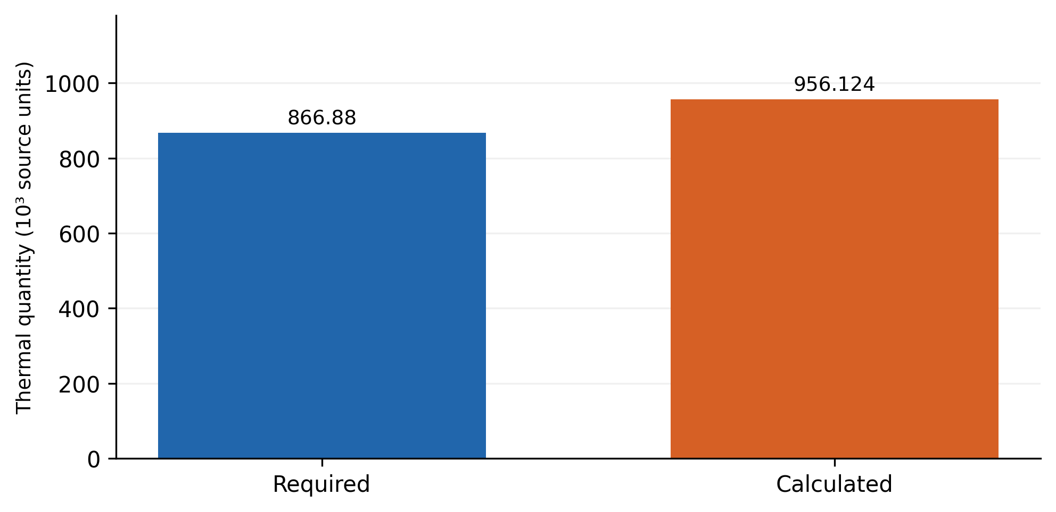
Figure 1. Reported required and calculated thermal quantities. The source labels the numerical values in joules, while its steady flow formulation implies a heat rate. The original numerical scale is preserved pending confirmation of that convention.
The required quantity is 866,880 and the calculated quantity is 956,124.2. Their relative difference is
$$δ_{Q}=\frac{\left|956124.2−866880\right|}{866880}×100=10.2949\%.\text{ (19)}$$
The calculated quantity is therefore approximately 1.103 times the requirement. This can be described as a positive nominal capacity margin only if the quantities share a consistent rate basis and the same operating assumptions. Its engineering acceptability depends on the required tolerance and the consequences of oversizing.
The listed terminal temperatures give counterflow terminal differences of 88 and 12 K. Their logarithmic mean is approximately 38.15 K. The product of this value, the listed area, and the listed coefficient is close to the reported calculated duty when the correction factor is near unity. This arithmetic relationship helps identify how the original calculation may have been organized. It does not establish that a unity factor is appropriate for the documented multipass configuration.
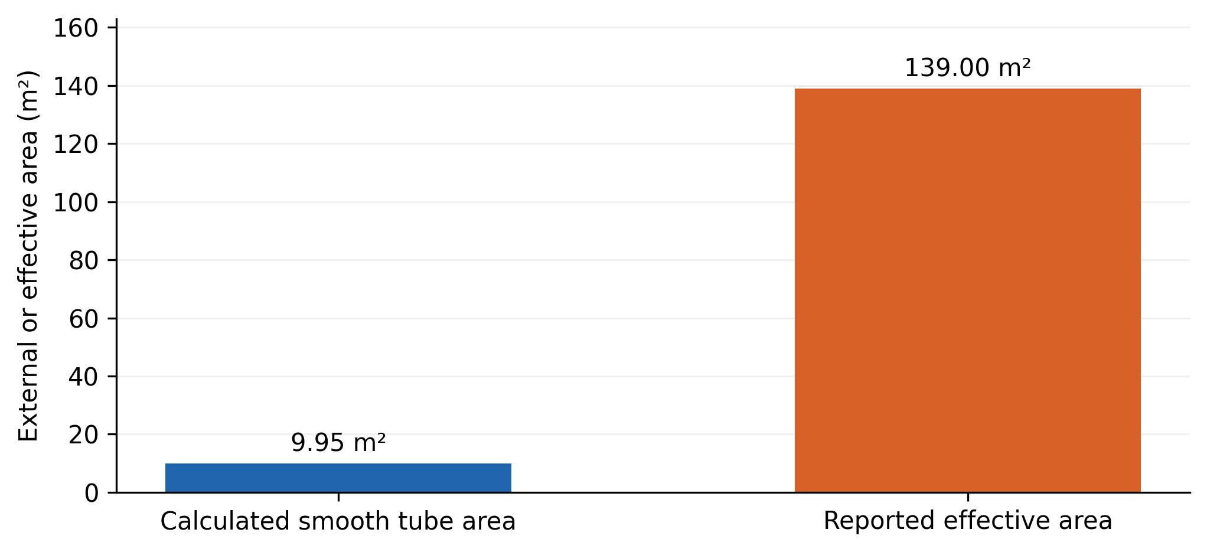
Figure 2. Area consistency check using the reported diameter, active length, and tube count. The smooth tube calculation gives 9.95 m²; the reported effective area is 139 m². The two quantities require a documented explanation of surface enhancement, staging, or a different active length.
Equation (10) gives $A_{bare}=π\left(0.02\right)\left(0.8\right)\left(198\right)=9.953$ m². The reported effective area is approximately 13.97 times this value. Pass count alone does not account for that difference. Possible explanations include enhanced surfaces, a different interpretation of tube length, or multiple assemblies, but the available record does not select among them. The area discrepancy is therefore retained as an unresolved model interface issue.
Pressure loss and pumping measurements are unavailable. Consequently, the thermal reassessment cannot verify the hydraulic part of the design. Reported reductions of 15% in equipment mass and 300 kg in copper use also require baseline drawings and material takeoffs before they can be evaluated independently.

6.2 Material database coverage
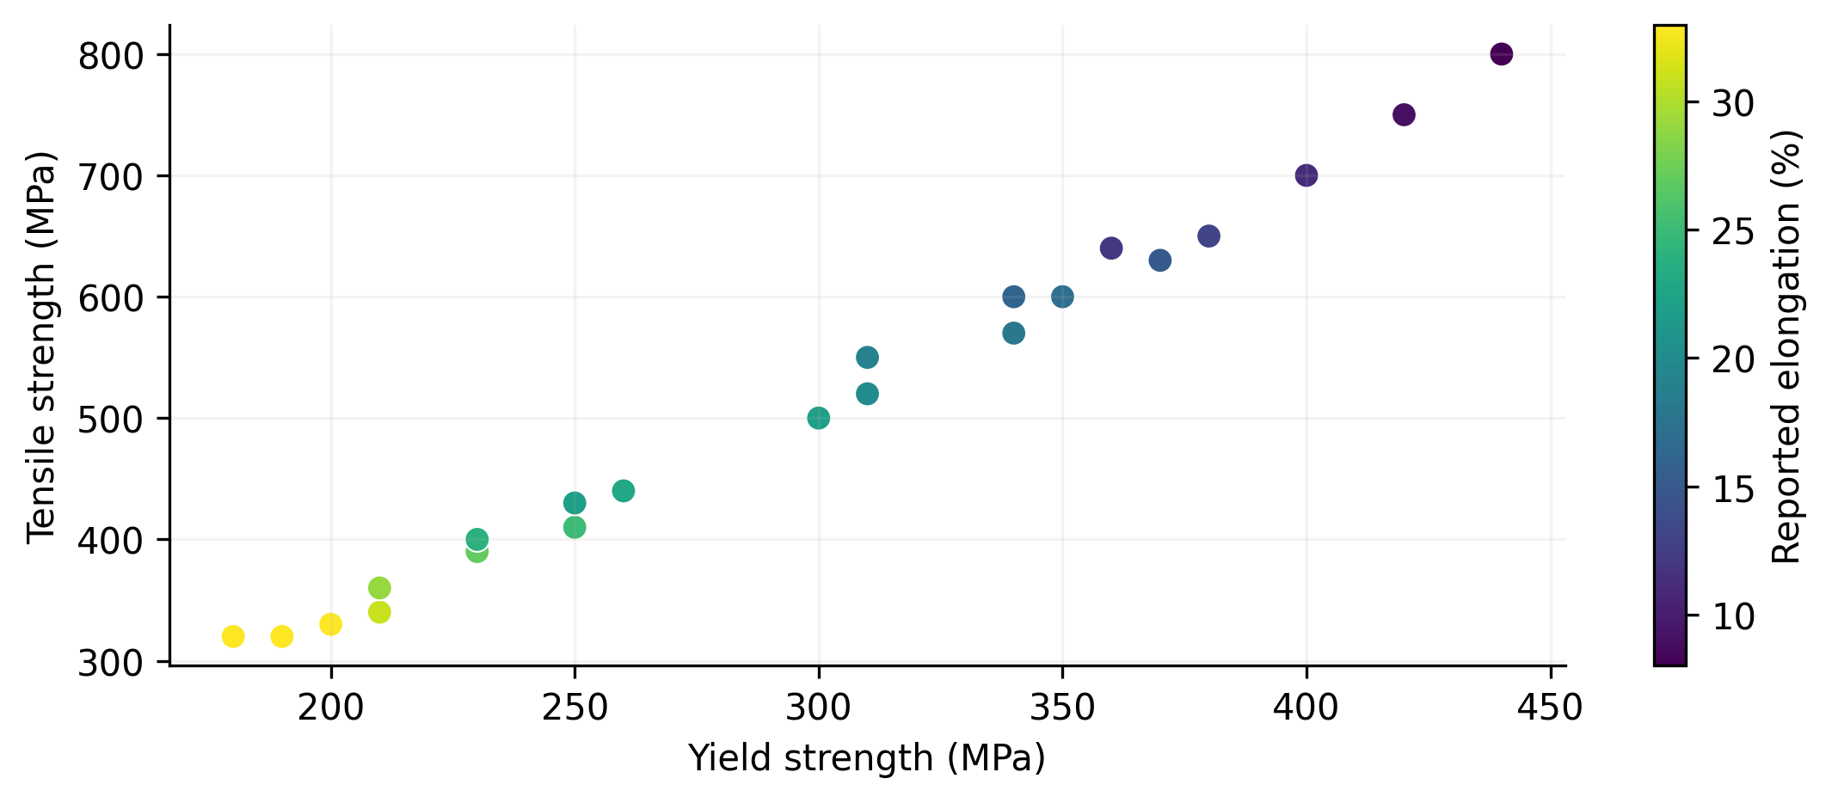
Figure 3. Yield and tensile strength values for the 22 source steel grade records, with color indicating elongation. These are stored teaching data, rather than newly measured material tests.
The database provides examples with different strength and ductility characteristics, enabling students to compare how material choice changes an experiment. Its main verified contribution is information reuse: the same selected record can supply specimen labels, calculated properties, and the supervisor’s expectations. The figure shows the breadth of those records without implying that their scatter represents measurement uncertainty.
A stronger physical validation would compare simulated and measured force extension curves for identified specimens. The comparison should examine elastic slope, yield behavior, peak load, and fracture extension separately. Agreement at ultimate strength would not compensate for an incorrect elastic modulus or an artificial yield plateau.

6.3 Educational outcomes and implementation effort
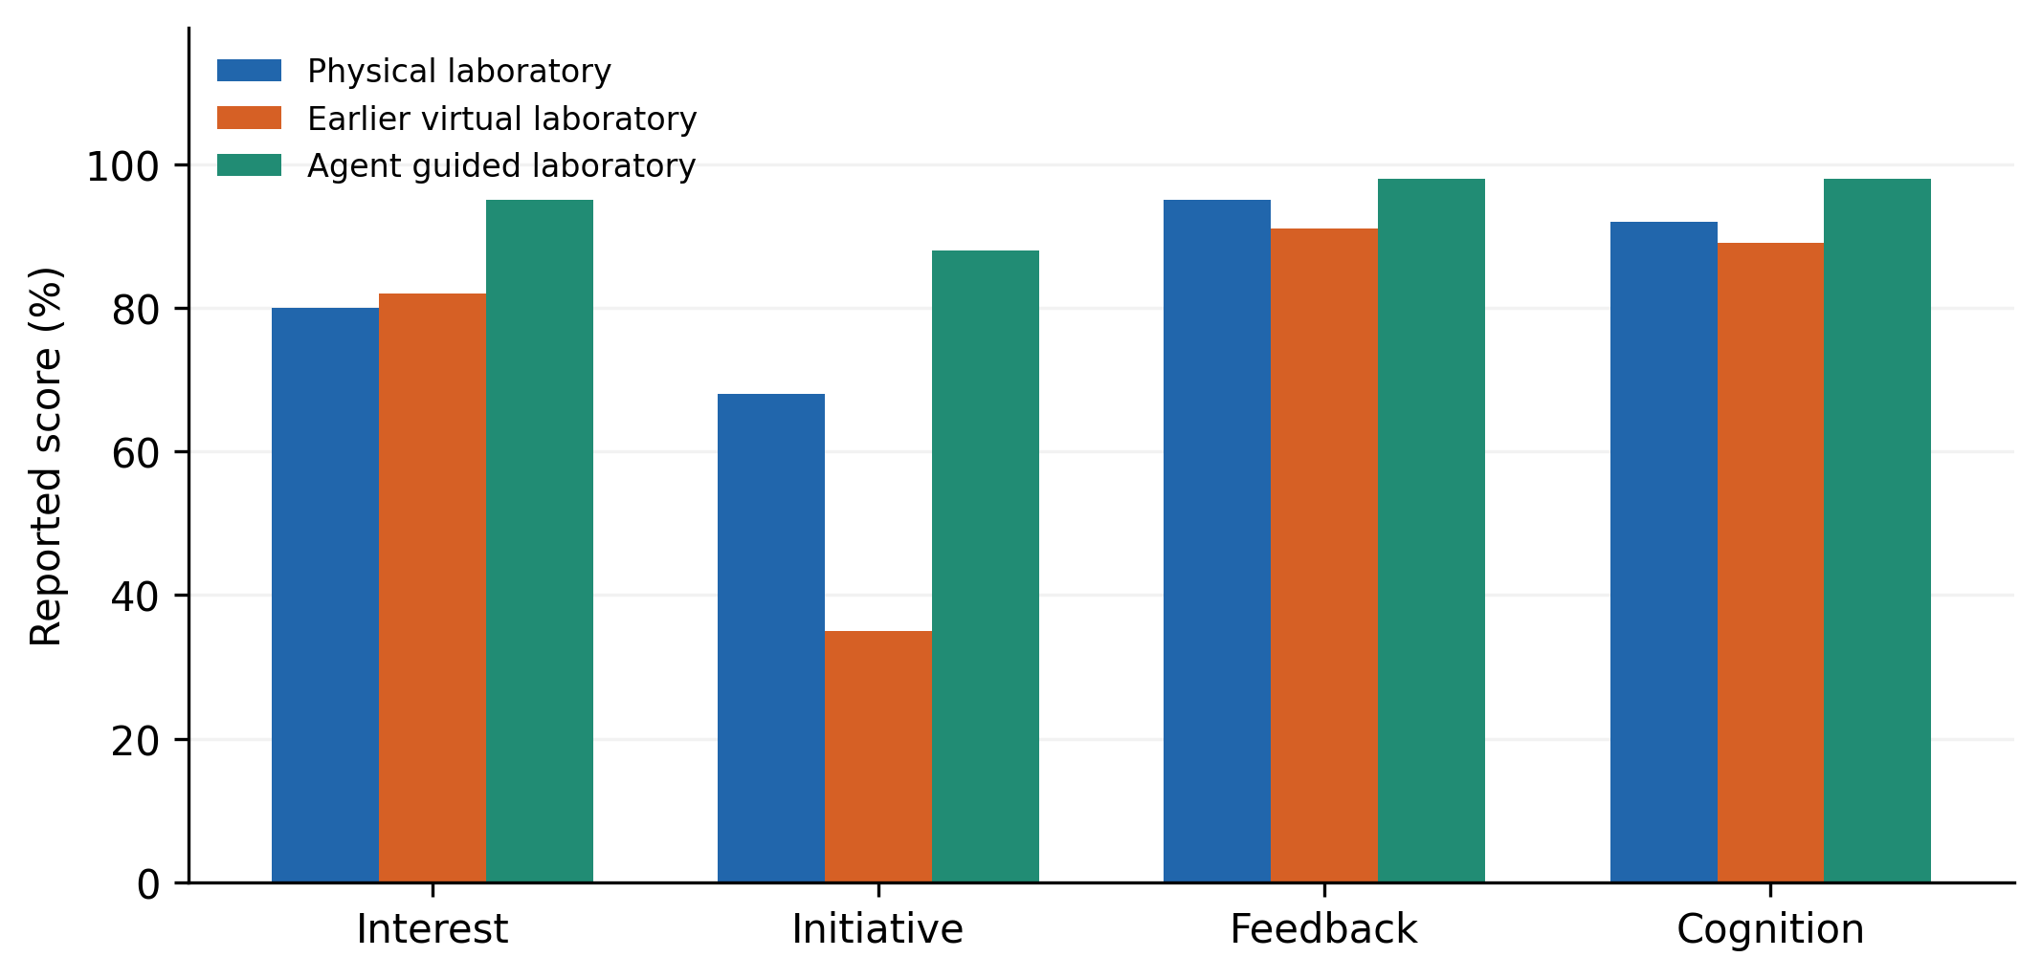
Figure 4. Source educational indicators for physical instruction, an earlier virtual environment, and the agent guided environment. Sample sizes, scoring rubrics, and uncertainty are not reported.
Table 2. Source educational indicator scores.
Indicator | Physical | Earlier virtual | Agent guided
Interest percent | 80 | 82 | 95
Initiative percent | 68 | 35 | 88
Feedback percent | 95 | 91 | 98
Cognition percent | 92 | 89 | 98
The largest descriptive contrast concerns initiative: the agent guided score exceeds the earlier virtual score by 53 percentage points and the physical score by 20 points. Interest increases by 13 points relative to the earlier virtual environment. These differences are compatible with the intended role of guidance, but their interpretation depends on how the indicators were measured.
The earlier virtual environment scores below physical instruction for initiative and cognition. This pattern is useful because it shows that virtualization alone was not uniformly favorable in the reported table. The added guidance may address a practical instructional weakness, but participant allocation, prior knowledge, instructor involvement, and the assessment instrument remain possible explanations for part of the difference.
Initial development is reported as approximately three months for both virtual approaches, while an update task decreases from ten to five days. The latter is a descriptive 50% reduction for the stated task. It does not establish lower total lifecycle cost because developer effort, task scope, maintenance quality, and reuse across later tasks are not documented.
The original search comparison lists 200 genetic algorithm generations, 120 enumerated candidates, and 12 staged search steps. These are different units of work. A generation can evaluate many candidates, while a staged step can invoke several physical calculations. The counts therefore cannot support a runtime ratio without calculation logs and a common workload.

7 Verification and comparative evaluation

7.1 Separate verification targets
Architectural consistency, solver correctness, physical agreement, interface usability, and learning effectiveness answer different questions. A shared identifier test can verify that a dimension change reaches the thermal model. An analytical beam solution can verify the vibration implementation. A measured exchanger trial can assess physical prediction. A controlled student study can assess learning. Success in one category should not replace evidence in another.
Table 3. Quantities for independent verification.
Evaluation target | Observable quantity | Comparison basis
State consistency | Stale or mismatched values | Logged accepted state
Thermal calculation | Balance and capacity residuals | Independently checked equations
Mechanical solver | Frequency and energy errors | Analytical reference cases
Physical prediction | Temperature and deformation errors | Identified apparatus tests
Design efficiency | Calls, elapsed time, feasible yield | Common design specification
Learning effectiveness | Pretest and posttest performance | Declared study and rubric

7.2 Numerical and physical verification protocol
For a computed quantity $z_{h}$ obtained with step size or mesh scale $h$, a practical refinement measure is
$$ε_{ref}=\frac{\left|z_{h}−z_{h/2}\right|}{max\left(\left|z_{h/2}\right|,ϵ_{z}\right)}.\text{ (20)}$$
A small difference supports numerical consistency for that quantity and refinement interval. It does not establish that the constitutive law or boundary conditions represent the real apparatus. Physical validation should additionally report sensor calibration, input uncertainty, repeatability, and the parameter values used without post hoc adjustment.
Algorithm 6. Verify the integrated virtual engineering workflow.
Define the engineering task and acceptance tolerances
Check units, object links and model version consistency
Run analytical thermal and mechanical reference cases
Repeat numerical cases at finer resolution
Compare physical predictions with calibrated apparatus data
For each design method under a common specification:
Count physical model calls and feasible accepted designs
Measure elapsed time on the same hardware
For each laboratory condition:
Apply the same learning tasks and declared assessment
Report each verification target with its own evidence

7.3 Design and educational comparison
A design benchmark should use identical specifications, material choices, feasibility constraints, and stopping budgets. Relevant outcomes include the fraction of feasible designs, objective tradeoffs, calculation counts, and the quality of the final selected configuration. Case retrieval should be ablated to determine whether its benefit comes from starting nearer a feasible region. Rule guidance should be ablated separately to measure whether it reduces invalid proposals.
An educational study should document participant numbers, prior experience, allocation procedure, learning objectives, and the scoring instrument. A pretest can measure baseline differences; a posttest can evaluate immediate understanding; a later task can assess transfer or retention. If students work in groups, group membership affects the independence of observations. Confidence intervals and effect estimates should follow the actual study design rather than treating percentage scores as if their sampling properties were already known.
The purpose of these protocols is to turn the implemented architecture into a testable research contribution. They are proposed evaluations, not additional experiments performed in the historical record.

8 Discussion
The architecture’s strongest methodological feature is its ability to connect a user action with a physical consequence and an explicit explanation. This connection can make virtual interaction more informative than a sequence of graphical manipulations. In exchanger design, it explains why a visually acceptable modification violates pressure loss or area constraints. In laboratory instruction, it connects an instrument reading with the constitutive assumptions that make the reading meaningful.
The thermal consistency checks reveal a broader integration issue. A system can use the correct heat transfer equation while still produce an unreliable engineering decision if the area supplied to that equation belongs to a different geometric interpretation. The 9.95 versus 139 m² comparison identifies such a point of uncertainty. Resolving it requires information at the interface between geometry and the physical model. This is precisely where a shared state contract and provenance record are valuable.
The architecture also separates historical feasibility from contemporary novelty. Current literature already contains extensive digital twin, virtual laboratory, and multiobjective exchanger research. The present contribution is therefore best positioned around its knowledge guided workflow, traceability, and reassessment of documented cases. Claims of generalized optimization superiority or educational effectiveness require the comparative protocols described above.
Knowledge maintenance remains a practical limitation. Rules may become inconsistent when material records, operating limits, or laboratory procedures change. Each rule should identify its scope and supporting domain basis. A recommendation should be reproducible from the recorded state and rule version. This requirement supports scientific review as well as later software maintenance.
The available application evidence is useful but incomplete. It demonstrates implemented functions and supplies descriptive outcomes. It does not provide raw student records, calibrated apparatus measurements, comprehensive runtime logs, or a reconciled exchanger construction drawing. These missing records limit quantitative conclusions, while the explicit equations and algorithms make the next validation steps concrete.

9 Conclusions
A knowledge guided virtual engineering architecture has been developed into an explicit framework linking shared state, case retrieval, physical calculations, graphical interaction, and rule based supervision. The exchanger formulation explains structural, thermal, and hydraulic coupling; the laboratory formulation connects constitutive and modal assumptions with instruments and displayed deformation. Six algorithms make the principal computational operations reviewable.
The reported exchanger quantities differ by 10.295%, and the listed smooth tube geometry gives an area far below the reported effective value. These checks identify necessary corrections or clarifications before physical performance can be certified. Educational indicators favor the agent guided environment descriptively, but the study design is insufficient for causal or statistical conclusions. The resulting framework provides a coherent basis for independent engineering verification and a controlled assessment of learning benefits.

Data and code availability
The accompanying research package retains the 20 case exchanger database, 22 material records, educational indicators, thermal quantities, and graph generation code. The additional area figure is calculated directly from the reported geometry. Independent replication requires the original application source, model interfaces, exchanger construction details, apparatus measurements, and participant level study records.

References
[1] Rafsanjani, H.N.; Nabizadeh, A.H. (2023). Towards digital architecture, engineering, and construction (AEC) industry through virtual design and construction (VDC) and digital twin. Energy and Built Environment, 4(2), 169-178. https://doi.org/10.1016/j.enbenv.2021.10.004
[2] Shafiq, S.I.; Sanin, C.; Szczerbicki, E. (2024). Decisional-DNA-Based Digital Twin Implementation Architecture for Virtual Engineering Objects. Cybernetics and Systems, 55(3), 719-729. https://doi.org/10.1080/01969722.2022.2162742
[3] Clark, T.; Kulkarni, V.; Whittle, J.; Breu, R. (2022). Engineering Digital Twin-Enabled Systems. IEEE Software, 39(2), 16-19. https://doi.org/10.1109/ms.2021.3136325
[4] Orlova, E.V. (2022). Design Technology and AI-Based Decision Making Model for Digital Twin Engineering. Future Internet, 14(9), 248. https://doi.org/10.3390/fi14090248
[5] Yan, J.; Li, X.; Ji, S. (2024). Design and Implementation of Workshop Virtual Simulation Experiment Platform Based on Digital Twin. Systems, 12(3), 66. https://doi.org/10.3390/systems12030066
[6] Sakkas, K.; Ntagka, N.E.; Spyridakis, M.; Miltiadous, A.; Glavas, E.; Tzallas, A.T.; et al. (2025). Multiplayer Virtual Labs for Electronic Circuit Design: A Digital Twin-Based Learning Approach. Electronics, 14(16), 3163. https://doi.org/10.3390/electronics14163163
[7] Wu, Y.; Zhou, L.; Zheng, P.; Sun, Y.; Zhang, K. (2022). A digital twin-based multidisciplinary collaborative design approach for complex engineering product development. Advanced Engineering Informatics, 52, 101635. https://doi.org/10.1016/j.aei.2022.101635
[8] Wang, J.; Niu, X.; Gao, R.X.; Huang, Z.; Xue, R. (2023). Digital twin-driven virtual commissioning of machine tool. Robotics and Computer-Integrated Manufacturing, 81, 102499. https://doi.org/10.1016/j.rcim.2022.102499
[9] Wang, C.; Liu, X.; Zhu, M.; Zhu, C.; Lv, F.; Ni, Z. (2023). Digital twin connection model based on virtual sensor. The International Journal of Advanced Manufacturing Technology, 129(7-8), 3283-3302. https://doi.org/10.1007/s00170-023-12438-2
[10] Deb, A.K.; Chattopadhyay, P. (2024). A Virtual Laboratory for Control System Engineering. IFAC-PapersOnLine, 58(26), 64-69. https://doi.org/10.1016/j.ifacol.2024.10.272
[11] Peregudin, A.A.; Popov, A.M.; Akhmetgaliev, E.R.; Bugrova, A.D.; Bystramovich, M.A.; Stakanov, V.A.; et al. (2022). Virtual Laboratory for Game-Based Control Systems Education*. IFAC-PapersOnLine, 55(17), 344-349. https://doi.org/10.1016/j.ifacol.2022.09.303
[12] Zhou, Z.; Oveissi, F.; Langrish, T. (2024). Applications of augmented reality (AR) in chemical engineering education: Virtual laboratory work demonstration to digital twin development. Computers & Chemical Engineering, 188, 108784. https://doi.org/10.1016/j.compchemeng.2024.108784
[13] Aruanno, B.; Tamburrino, F.; Neri, P.; Barone, S. (2025). Virtual Reality Laboratory for Engineering and Material Science Immersive Learning. Computer Applications in Engineering Education, 33(3), e70041. https://doi.org/10.1002/cae.70041
[14] Viitaharju, P.; Linnera, J.; Nieminen, M.; Yliniemi, K.; Karttunen, A.J. (2025). Differences Between Experiencing a Virtual Laboratory With a Virtual Reality Headset or a Laptop. Computer Applications in Engineering Education, 33(3), e70043. https://doi.org/10.1002/cae.70043
[15] Pataro, I.M.L.; Gil, J.D.; Guzmán, J.L.; Berenguel, M. (2025). Virtual Laboratory for Control Education Using a Solar Collector Field System. Computer Applications in Engineering Education, 33(5), e70077. https://doi.org/10.1002/cae.70077
[16] Norambuena, N.; Ortega, J.; Muñoz-La Rivera, F.; Covarrubias, M.; Valín Rivera, J.L.; Ramírez, E.; et al. (2025). Integrating Digital Twins of Engineering Labs into Multi-User Virtual Reality Environments. Applied Sciences, 15(7), 3819. https://doi.org/10.3390/app15073819
[17] Anwer, N.; Stark, R.; Tao, F.; Erkoyuncu, J.A. (2025). Developing and leveraging digital twins in engineering design. CIRP Annals, 74(2), 843-868. https://doi.org/10.1016/j.cirp.2025.05.002
[18] Gil, S.; Mikkelsen, P.H.; Gomes, C.; Larsen, P.G. (2024). Survey on open‐source digital twin frameworks–A case study approach. Software: Practice and Experience, 54(6), 929-960. https://doi.org/10.1002/spe.3305
[19] Nezzi, C.; Gufler, V.; Vidoni, R.; Rauch, E. (2025). Kinematic and dynamic modeling of mechanical systems towards Digital Twins. Results in Engineering, 26, 104874. https://doi.org/10.1016/j.rineng.2025.104874
[20] Mahmoud, M.; Semeraro, C.; Ramadan, M.; Abdelkareem, M.A.; Olabi, A.G. (2025). Building a Digital Twin for a Ground Heat Exchanger. Chemical Engineering & Technology, 48(1), e202300492. https://doi.org/10.1002/ceat.202300492
[21] Hajabdollahi, H. (2024). New global multi-objective optimization of compact heat exchanger. Chemical Engineering Science, 300, 120462. https://doi.org/10.1016/j.ces.2024.120462
[22] Hajabdollahi, H.; Hajabdollahi, F.; Premnath, K. (2025). A new approach for global and multi-objective optimization of fin and tube heat exchanger. Journal of Building Engineering, 99, 111388. https://doi.org/10.1016/j.jobe.2024.111388
[23] Taghavi, M.; Ferrantelli, A.; Joronen, T. (2024). Multi-objective optimization of a plate heat exchanger thermal energy storage with phase change material. Journal of Energy Storage, 89, 111645. https://doi.org/10.1016/j.est.2024.111645
[24] Wang, J.; Zhang, Z.; Yang, K. (2024). Multi-objective optimization study of airfoil fin printed circuit heat exchanger with tip gap based on machine learning. International Journal of Heat and Mass Transfer, 231, 125859. https://doi.org/10.1016/j.ijheatmasstransfer.2024.125859
[25] Yicong, L.; Chunyu, S.; Wei, L.; Zhichun, L. (2023). Structural parameter design of welded plate heat exchanger based on multi-objective optimization algorithm. International Communications in Heat and Mass Transfer, 146, 106900. https://doi.org/10.1016/j.icheatmasstransfer.2023.106900
[26] Stampfli, J.A.; Ong, B.H.Y.; Olsen, D.G.; Wellig, B.; Hofmann, R. (2023). Multi-objective evolutionary optimization for multi-period heat exchanger network retrofit. Energy, 281, 128175. https://doi.org/10.1016/j.energy.2023.128175
[27] Majumdar, R.; Jadhav, V.; Deodhar, A.; Karande, S.; Vig, L.; Runkana, V. (2025). HxPINN: A hypernetwork-based physics-informed neural network for real-time monitoring of an industrial heat exchanger. Numerical Heat Transfer, Part B: Fundamentals, 86(6), 1910-1931. https://doi.org/10.1080/10407790.2024.2325648
[28] Hassan, M.; Montague, G.; Iqbal, M.Z.; Fahey, J. (2024). Virtual reality-based bioreactor digital twin for operator training. Digital Chemical Engineering, 11, 100147. https://doi.org/10.1016/j.dche.2024.100147
[29] Zhu, Z.; He, H.; Famakinwa, T.; Zhang, Y.X.; Wu, H.; Fox, D.; et al. (2026). Digital transformation of conventional shell-tube heat exchanger using digital twinning and machine learning. Case Studies in Thermal Engineering, 80, 107932. https://doi.org/10.1016/j.csite.2026.107932
[30] Pintilie, I.; Glodean, D.; Lapusan, C. (2026). Development of a Virtual Laboratory Stand Using Simscape for Mechatronic Engineering Education. Education Sciences, 16(9), 1460. https://doi.org/10.3390/educsci16091460
[31] Klami, A.; Damoulas, T.; Engkvist, O.; Rinke, P.; Kaski, S. (2024). Virtual laboratories: transforming research with AI. Data-Centric Engineering, 5, e19. https://doi.org/10.1017/dce.2024.15

