Recursive Scaling Fuzzy Control for Temperature Regulation in Vacuum Sintering

Abstract
Vacuum sintering requires controlled heating and holding while furnace load, heat transfer and process dynamics change throughout the thermal cycle. A fuzzy controller implemented as a small lookup table offers a compact solution, but quantization can conceal small deviations and sustain oscillatory corrections near the reference. This study develops a detailed formulation and analytical reassessment of recursive scaling for a five level fuzzy controller. The method increases input sensitivity while decreasing the actuator increment, preserving two products that determine the gain of a continuous local surrogate. We derive the resulting dead zone contraction, an upper bound on the control increment, and a conditional Schur stability criterion for a sampled first order plant. These results clarify the mechanism without claiming a stability certificate for the complete switched furnace system. Five pseudocode algorithms specify configuration, online control, comparative evaluation, trajectory metrics and a validation campaign. The reported MATLAB and Simulink records are reanalyzed through step response, tracking, disturbance and recursion depth comparisons. Relative to the stated PID baseline, overshoot decreases from 52.3% to 27.0%, step error variance decreases by 31.58%, tracking variance by 30.59%, and disturbance variance by 8.28%. Reported transition time increases from 22.34 to 23.0 s. Residual error changes nonmonotonically with recursion depth, with the smallest listed absolute value of 0.02 occurring at depths eight and ten. The analysis identifies a practical compromise between resolution, noise sensitivity and actuator authority. It also distinguishes numerical controller performance from manufacturing yield, for which the reported value above 98% lacks a controlled comparison. The resulting formulation supports reproducible evaluation of compact fuzzy control under explicitly stated operating and implementation assumptions.
Keywords: vacuum sintering; fuzzy control; recursive scaling; quantized feedback; sampled systems; temperature regulation

1 Introduction
Vacuum sintering combines a prescribed temperature program with a controlled process atmosphere to obtain the required properties of a powder compact. The thermal program generally contains heating segments, holding periods and cooling transitions. Temperature regulation affects the reproducibility of this program, but its influence is mediated by heat transfer from the furnace to the load and by the material response. A controller that maintains the temperature at one sensor does not automatically establish spatial temperature uniformity, a specified density or a particular mechanical property. These outcomes must be evaluated at their respective measurement locations and process scales.
The control problem changes during the cycle. Effective thermal capacity varies with load mass and temperature, heat losses depend on the temperature difference to the surroundings, and the relationship between heater input and measured temperature can change as the load heats. Vacuum pressure also changes the contribution of residual gas heat transfer. Radiation, conduction through supports, sensor response and heat exchange with the load introduce effects that are not represented adequately by a single fixed gain over every operating condition. Consequently, a controller tuned for one heating segment may show excessive overshoot, slow recovery or persistent actuator movement during another segment.
Conventional PID regulation remains an appropriate baseline because its implementation is transparent and its tuning can be related to identified process dynamics. Fuzzy control provides another way to encode the direction and approximate magnitude of a correction. In an error and error change controller, the rule base combines information about the distance to the reference and the current direction of motion. A small rule table can be evaluated with a few arithmetic operations, making the approach attractive when processor capacity, maintenance effort or software verification favors a compact implementation.
However, a digital lookup table introduces a distinction between physical error and represented error. Different physical measurements may map to the same integer table index. Small deviations can therefore remain inside a zero output cell even when the actual temperature has not reached the reference. Increasing the output scale can make the controller more responsive, but also makes each correction larger. Increasing the input scale exposes smaller deviations, but narrows the physical region represented by the table and increases sensitivity to noise. These interactions explain why simply increasing all gains is not a satisfactory resolution strategy.
Recent furnace studies investigate predictive compensation, adaptive fuzzy neural control, hybrid self learning models and interval type 2 approaches [1–8]. Direct work on a vacuum box electric furnace provides an especially relevant numerical and experimental comparison [36]. These developments establish a demanding contemporary context: a small controller must be assessed in terms of what it actually changes, which operating conditions it covers, and what evidence supports its implementation advantage. An older lookup table mechanism cannot be considered novel merely because it is described using current terminology.
The specific question addressed here is whether coordinated scaling can refine a fixed table without changing its stored rules or increasing its nominal local feedback gain. The study retains the reported recursive structure and numerical records, then develops the mathematical explanation needed to interpret them. The resulting contribution is a structured connection between table resolution, incremental actuation, local gain and observed performance tradeoffs. The analysis also identifies the implementation details that determine whether the same idea can be reproduced on another controller.
Three linked issues guide the investigation. First, the controller must be specified with a consistent error sign, quantizer, scaling schedule and actuator update. Second, any analytical statement must identify the plant and controller assumptions under which it holds. Third, favorable changes in one reported metric must be interpreted alongside transition time, residual error, oscillation and measurement limitations. Addressing these issues makes the method more assessable than an argument based only on selected response plots.
The remainder of the paper first positions recursive scaling within current thermal control and quantized feedback research. The furnace model and digital controller are then formulated, followed by analytical properties and operational pseudocode. The experimental sections define the available evidence, calculate comparable effect sizes, and explain the recursion depth results. The final discussion considers implementation, generalization and the validation needed to connect temperature regulation with manufacturing outcomes.

2 Related work and research position

2.1 Adaptive and predictive furnace regulation
Huang et al. combine an autoencoder based temperature predictor with fuzzy PI regulation [1]. Their method uses a learned prediction model to compensate for difficult thermal dynamics. Phan et al. investigate an adaptive fuzzy neural controller for a brick tunnel kiln [2], while Dai et al. develop a hybrid self learning model for sintering furnace temperature [3]. These approaches adapt a model or a richer controller representation. Recursive scaling addresses a narrower mechanism: it changes the physical interpretation of a fixed discrete rule table.
Fuzzy adaptive PID and interval type 2 learning offer further ways to accommodate uncertain thermal behavior [4, 5]. Broad predictive control with event triggering and adaptive compensation changes when calculations or updates are performed [6]. Bayesian optimization and event triggered online learning also make tuning effort and adaptation frequency part of controller design [7, 8]. These studies motivate reporting not only response quality but the computational work, data requirements and update conditions needed to obtain it.
A vacuum furnace comparison should account for the specific thermal plant. The numerical and experimental vacuum box furnace study of Ajorloo et al. is closer in application than a generic tracking benchmark [36]. Conversely, spatial fuzzy control for distributed thermal systems highlights a limitation of a single sensor model [9]. A controller can regulate one measured temperature well while remaining insensitive to an unmeasured load gradient. Therefore, the relevance of a published controller depends on the controlled variable, sensor arrangement, thermal operating range and constraints, rather than on its label alone.

2.2 Compact adaptation and process model dependence
Lyapunov derived temperature adaptation and adaptive fuzzy PI regulation demonstrate different ways to connect variable gains with a plant model [10, 11]. Compact neuro fuzzy control of coupled tanks provides an example in which implementation size is itself a design consideration [12]. The comparison with recursive scaling is useful because both seek an economical online calculation, but their adjustable quantities and physical processes differ. A reduced parameter count is an implementation property, not an independent guarantee of robustness.
Evaporation, biorefinery, drying and organic Rankine cycle studies provide related examples of nonlinear thermal regulation [13–16]. They motivate examining disturbance structure, operating point changes and actuator limitations. They do not supply directly comparable performance numbers for vacuum sintering. Similarly, satisficing predictive control and formulations that incorporate PI behavior within tracking and economic optimization demonstrate how competing objectives can be represented explicitly [17, 18]. Their importance here is the need to evaluate overshoot, transition duration and control effort together.
Model quality is another source of variation. Comparative process identification, deep subspace encoders and recurrent model adaptation show that an identified model and a controller must be evaluated as separate components [19–21]. A good identification score does not establish closed loop reliability outside the identification domain. Data informed fuzzy membership initialization is relevant when initial partitions or gains are selected from observations [22]. The present table is retained explicitly, so its initialization concerns mainly the physical ranges and scaling factors rather than a newly learned membership structure.

2.3 Stability analysis and quantized feedback
Self learning fuzzy control and LMI constrained neuro fuzzy tracking provide examples of methods accompanied by more structured dynamical analysis [23, 24]. Generalized sector representations and nonquadratic stabilization further illustrate how assumptions about the nonlinear plant enter a stability argument [25, 26]. Their theoretical guarantees cannot be transferred to a different lookup table simply because both controllers use fuzzy rules.
Adjustable quantizer sensitivity has an established control theoretic foundation. Brockett and Liberzon analyze stabilization with quantized feedback and changing quantizer sensitivity [37]. That work makes clear why saturation, scaling policy and the underlying stable feedback law matter. The present controller is a particular error and error change table with a finite practical resolution. Its local surrogate analysis therefore supplies a restricted explanatory result, rather than an application of a general quantized stabilization theorem to an unidentified furnace.
Process monitoring, model assisted dual adaptive furnace control and fuzzy predictive control provide additional context for disturbance diagnosis and feedback design [27–29]. Data based robust predictive control, block hierarchical process simulation and energy oriented arc furnace control emphasize model structure, operating constraints and objectives beyond temperature variance [30–32]. These issues remain relevant even when the online controller is small.

2.4 Scope of the present mechanism
Classical fuzzy identification, adaptive network inference and example based rule generation provide the broader modeling background [33–35]. Recursive scaling does not identify a new rule base during operation. It reuses a fixed table at successively finer physical scales. This distinction is essential when comparing its memory requirement, explanatory structure and adaptation cost with learned fuzzy models.
Table 1. Method families and the comparison relevant to recursive scaling.
Method family | Quantity changed during design or operation | Main dependency | Relevant comparison
Fixed PID or fuzzy PI | Gains and filters selected for the operating range | Tuning, sampling and saturation handling | Matched baseline performance
Learned predictive thermal control [1, 3, 19–21] | Predictor and possibly feedback parameters | Representative data and model validation | Benefit of added model complexity
Adaptive fuzzy neural control [2, 5, 7, 8] | Membership, network or controller parameters | Update law and stability assumptions | Adaptation cost and uncertainty handling
Constrained predictive control [17, 18, 30, 31] | An optimized sequence of future inputs | Model, constraints and online solver | Explicit treatment of competing objectives
Recursive scaling considered here | Input sensitivity and output increment | Quantization, trigger and physical resolution | Resolution improvement with a fixed table
The research position is therefore deliberately specific. The paper examines a compact resolution refinement mechanism, derives its consequences under stated assumptions, and reassesses the original comparisons. It does not claim that fixed table scaling replaces predictive optimization, spatial thermal modeling or adaptive neural identification in every furnace installation.

3 Furnace dynamics and control problem

3.1 Physical interpretation of the temperature dynamics
A lumped thermal balance provides a useful explanation of the disturbances seen by a furnace controller. One possible representation is
$$\begin{matrix}C_{eff}\left(T_{f}\right){\dot{T}}_{f} & =η_{h}P_{max}u−Q_{rad}−Q_{gas}−Q_{load}, \\ Q_{rad} & =ε_{eff}σA_{r}\left(T_{f}^{4}−T_{w}^{4}\right).\end{matrix}\text{ (1)}$$
Here the heater command is the fraction of available heater power, effective thermal capacity represents the modeled furnace zone, and the heat transfer terms describe radiation, residual gas exchange and energy transferred to the load. Absolute temperatures in kelvin are required in the fourth power radiation term. Effective emissivity and area represent a simplified exchange description; they are not substitutes for a furnace geometry model or a calibrated radiation network.
Equation (1) is an explanatory balance, not an identified model of the reported apparatus. It shows why local gain and time constant can change with temperature, load and pressure. The load temperature may also lag the measured furnace temperature. If material temperature is the actual process objective, a second thermal state or independent load measurements are needed. The controller studied here regulates the measured output, and the available records do not establish temperature uniformity throughout a production load.
The original numerical comparison uses the normalized first order model
$$G_{0}\left(s\right)=\frac{1}{9s+1}, G_{loc}\left(s\right)=\frac{K_{p}e^{−L_{p}s}}{τ_{p}s+1}.\text{ (2)}$$
The second expression states a more general local model for interpretation. It does not assign an unreported physical delay to the nominal simulation. A process gain, time constant and delay should be identified from a defined operating segment before the controller is transferred to a physical furnace. The normalized simulation model and the physical balance serve different purposes and should not be treated as interchangeable levels of validation.
For zero delay and a constant input over each sampling interval, the deviation model becomes
$$x_{k+1}=ax_{k}+bv_{k}+w_{k}, a=e^{−T_{s}/τ_{p}}, b=K_{p}\left(1−a\right).\text{ (3)}$$
The variables are deviations about a steady operating point, and the disturbance term collects local model mismatch and unmodeled thermal inputs. The stability calculation below assumes positive process gain and a sampling interval that is fixed. Delay, actuator saturation and parameter variation are introduced later as limits of that calculation.

3.2 Error convention and controlled quantities
The physical sign of the rule table must agree with the sign of the error. The five level table applies a positive correction when its error index is negative. We therefore use
$$e_{k}=y_{k}−r_{k}, c_{k}=e_{k}−e_{k−1}.\text{ (4)}$$
A temperature below the reference gives a negative error and calls for increased heating. An implementation that defines error as reference minus measurement must reverse the corresponding table inputs or rule signs consistently. Copying the table while changing only the written definition of error can reverse the feedback direction.
The error change is a first difference, not a derivative in units per second. Its scale therefore incorporates the sampling interval implicitly. Changing the sample period while keeping every scaling coefficient unchanged changes the effective dynamic controller. A reproduction must report both the interval and the rule used to calculate the difference.
Table 2. Main controller quantities and their interpretation.
Symbol or pseudocode name | Meaning | Unit or role
y and r | Measured temperature and reference | Same temperature scale
e and c | Deviation and its first difference | Temperature and temperature per sample
Ke and Kc | Input scaling factors | Inverse of the corresponding input unit
Ku | Output scale | Actuator command per table unit
E and C | Quantized lookup indices | Integers from minus two to two
q and rho | Refinement count and scale ratio | Nonnegative integer and ratio greater than one
u and du | Applied command and command increment | Calibrated actuator units
Q and H | Maximum count and persistence length | Refinements and sampling instants
Ts | Sampling interval | Seconds

3.3 Regulation objectives and constraints
The controller should track a prescribed thermal program with acceptable overshoot, residual error and transition duration. These objectives compete. A smaller increment may reduce oscillation near the reference while making a large corrective movement slower. Conversely, a large increment may provide rapid recovery at the cost of overshoot and actuator cycling. A meaningful comparison must include the actual constraints on heater power and command variation.
The numerical records do not specify heater limits, sensor calibration, sample period or actuator resolution. Accordingly, these quantities are retained as design parameters in the operational specification. They are not assigned favorable values after inspecting the results. Furnace temperature limits, permitted heating rates and independent equipment protection also remain distinct from the nominal feedback performance studied here.

4 Recursive scaling controller

4.1 Quantization and fixed rule table
Let the quantizer round to the nearest integer and then limit the result to the table domain:
$$E_{k}=Q\left(K_{e}e_{k}\right), C_{k}=Q\left(K_{c}c_{k}\right), Q\left(z\right)=clip\left(round\left(z\right),−2,2\right).\text{ (5)}$$
The rule at a half integer depends on the selected rounding convention. This affects values exactly on a boundary, although it does not alter the open central interval used in the derivation. Fixed point and floating point implementations must also agree on overflow, clipping order and conversion to an integer index.
The linguistic levels are negative large, negative medium, zero, positive medium and positive large. Their integer codes are minus two, minus one, zero, one and two. The resulting table contains 25 stored outputs.
Table 3. Integer lookup table with error columns and error change rows.
Change index | −2 | −1 | 0 | 1 | 2
−2 | 2 | 2 | 1 | 1 | 0
−1 | 2 | 1 | 1 | 0 | −1
0 | 1 | 1 | 0 | −1 | −1
1 | 1 | 0 | −1 | −1 | −2
2 | 0 | −1 | −1 | −2 | −2
The central zero cell represents a region in which both scaled inputs round to zero. Other zero output cells represent combinations of error and motion for which the rule base selects no further correction. These cases have different meanings. A zero table output alone is therefore an unsuitable trigger for refinement; it can occur when the process is already moving toward the reference.
The original simulation diagram includes an accumulator after the fuzzy correction. The corresponding digital update is
$$Δu_{k}=K_{u}L\left(C_{k},E_{k}\right), u_{k}=clip\left(u_{k−1}+Δu_{k},u_{min},u_{max}\right).\text{ (6)}$$
This incremental interpretation is important because a zero increment retains the current heater command. It does not switch the heater off. An absolute command interpretation would define a different controller and would require a different equilibrium and stability analysis. Under saturation, the stored command should equal the applied command so that a hidden unsaturated accumulator does not continue to grow.

4.2 Initial scaling and the reported design heuristic
Initial input scales can be related to the intended physical ranges. If the outer index corresponds to an error magnitude of emax and an error change magnitude of cmax, a transparent starting choice is
$$K_{e0}=\frac{2}{e_{max}}, K_{c0}=\frac{2}{c_{max}}, K_{e0}K_{u0}<\frac{A}{K_{p}}.\text{ (7)}$$
The first two relations specify table coverage. The final relation is the heuristic reported in the original study, where the five level table uses a central threshold of 0.5 and the normalized example has unit process gain. It links input sensitivity, output scale and plant response, but it omits sampling, delay, the error change channel and saturation. It is consequently an initialization screen rather than a universal closed loop stability condition.
A practical initialization must also check that the chosen output increment is resolvable by the actuator and does not violate a permitted command rate. When the required error range is very wide, using the whole table for that range makes the central physical dead zone wide as well. Recursive scaling is intended to address this resolution conflict after the process approaches the current operating region.

4.3 General refinement law and source ambiguity
For a scale ratio greater than one, the coordinated law is
$$K_{e}^{\left(q\right)}=ρ^{q}K_{e0}, K_{c}^{\left(q\right)}=ρ^{q}K_{c0}, K_{u}^{\left(q\right)}=ρ^{−q}K_{u0}.\text{ (8)}$$
The source controller diagram multiplies both inputs by a power of the refinement factor and divides the output correction by the same power. However, one printed factor calculation gives a ratio of four, while the accompanying dead zone sequence changes from 0.5 to 0.05 and 0.005, which corresponds to a ratio of ten. These descriptions cannot both define the same numerical schedule. We retain a general ratio in the analysis and pseudocode; neither value is assigned retrospectively to the reported experiments.
Equation (8) gives two exact algebraic invariants:
$$K_{e}^{\left(q\right)}K_{u}^{\left(q\right)}=K_{e0}K_{u0}, K_{c}^{\left(q\right)}K_{u}^{\left(q\right)}=K_{c0}K_{u0}.\text{ (9)}$$
The central physical half widths and the largest possible table increment become
$$h_{e}^{\left(q\right)}=\frac{1}{2ρ^{q}K_{e0}}, h_{c}^{\left(q\right)}=\frac{1}{2ρ^{q}K_{c0}}, \left|Δu_{k}\right|≤2K_{u0}ρ^{−q}.\text{ (10)}$$
Thus refinement simultaneously exposes smaller deviations and reduces the maximum correction available in one sampling interval. It changes resolution and local control authority together. It does not provide a free increase in precision without consequences for disturbance recovery.
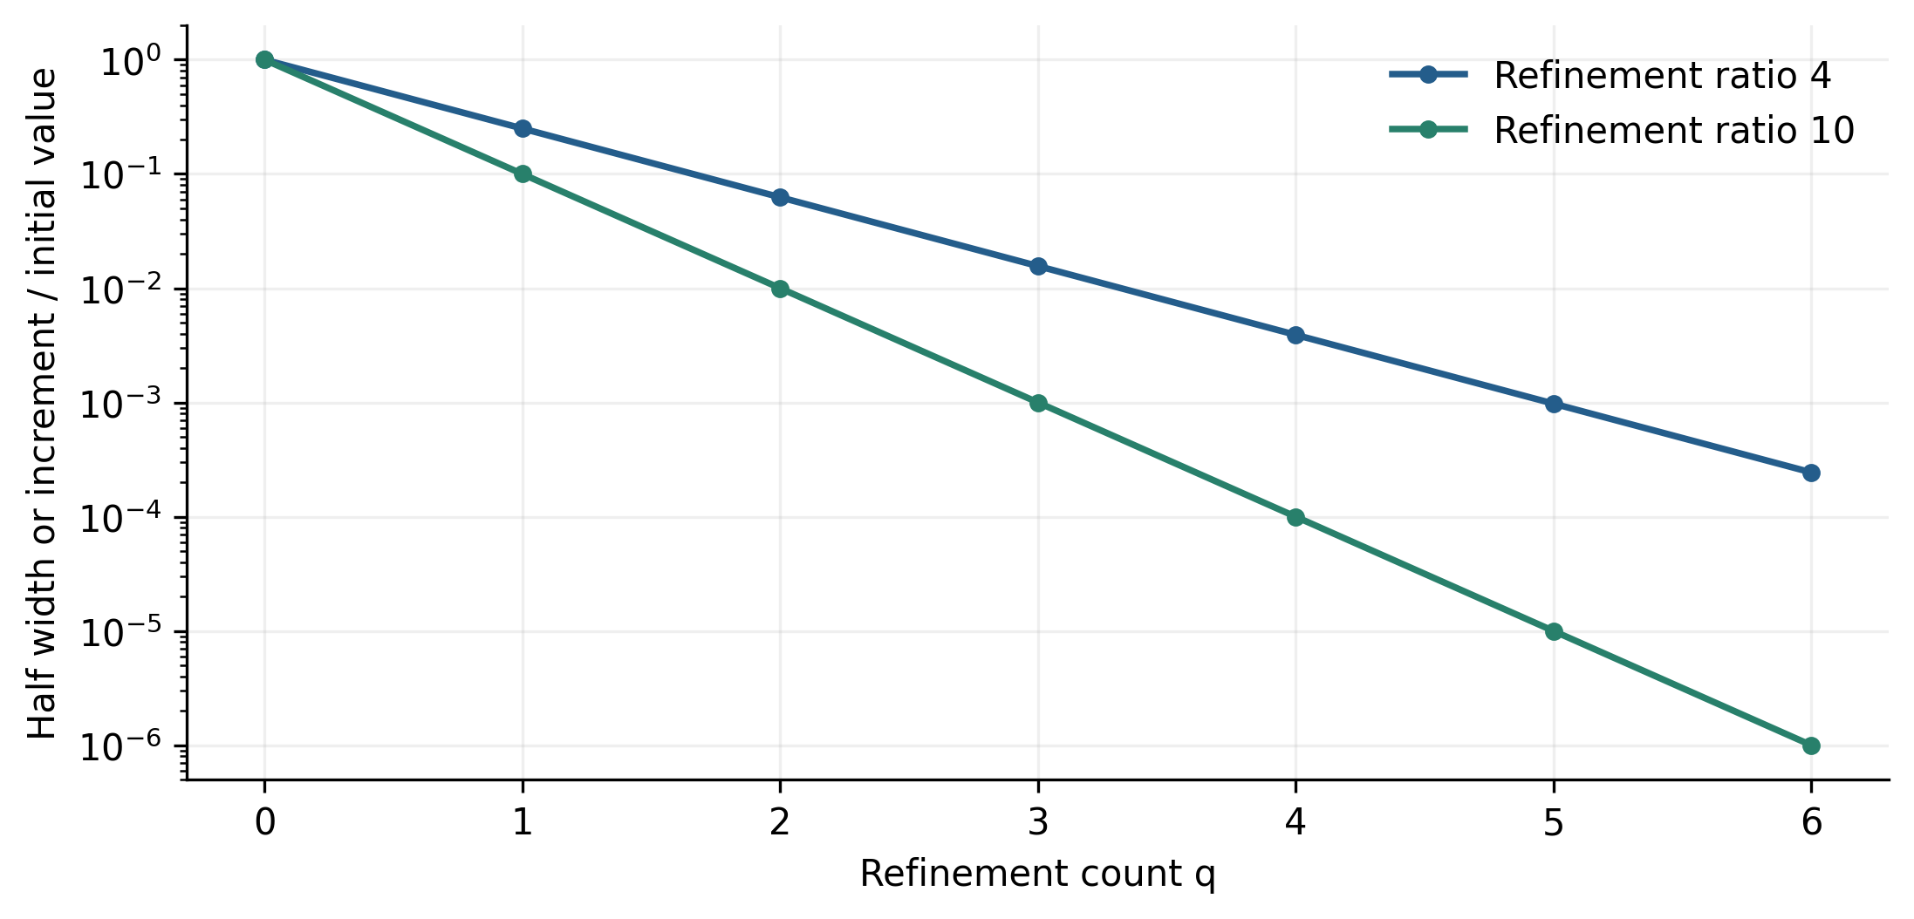
Figure 1. Analytical contraction of central half width and actuator increment, normalized to their initial values, for refinement ratios four and ten. Both normalized quantities equal rho to the power minus q. These curves illustrate Equation (10); they are not new controller experiments and do not resolve the ratio used in the historical implementation.

4.4 Configuration and online execution
Algorithm 1 makes initialization explicit. A declared noise allowance, persistence length and actuator resolution are required before the maximum depth is chosen. The bounds developed in Section 5 provide conservative design checks. If no admissible setting satisfies the required tolerance, the configuration should be rejected instead of increasing depth indefinitely.
Algorithm 1. Configure the controller and refinement limits.
Inputs: process gain range, sample period, table L,
emax, cmax, Ku0, ratio rho, actuator limits,
noise bound, command resolution, tolerance, H
Check rho > 1 and every physical scale is positive
Set Ke0 = 2/emax and Kc0 = 2/cmax
Check the reported gain heuristic over the gain range
Calculate noise and actuator depth limits in Section 5
Select a nonnegative maximum depth Q within those limits
Check that the intended error tolerance is attainable
Record rounding, filtering, reset and saturation policies
Initialize q = 0, persistence = 0, and applied command u
Initialize previous_error from the accepted measurement
Return the complete versioned controller configuration
Algorithm 2 is a proposed operational specification of the mechanism. It permits at most one refinement per sampling instant and requires persistent residence in the central cell. The persistence length and the tolerance prevent refinement from being triggered merely by a single quantized noise crossing or by a deviation that is already acceptable. These choices are explicit implementation decisions; the historical records do not demonstrate that this exact trigger was used.
Algorithm 2. Online recursive scaling fuzzy control.
At each sampling deadline:
Acquire and validate the configured temperature signal
If invalid: execute fault policy and skip this control update
e = y - r; c = e - previous_error
If a reference or operating mode reset is requested:
Apply configured reset to q and persistence; preserve u
Ke = Ke0 * rho^q; Kc = Kc0 * rho^q
Ku = Ku0 / rho^q
E = clip(round(Ke*e), -2, 2)
C = clip(round(Kc*c), -2, 2)
If E = 0 and C = 0 and abs(e) > tolerance:
persistence = persistence + 1
Otherwise: persistence = 0
If persistence >= H and q < Q and no saturation:
q = q + 1; persistence = 0
Recalculate Ke, Kc, Ku, E and C at the new depth
du = Ku * L[C,E]
u = clip(u + du, actuator_min, actuator_max)
Apply u and store the applied command as the next state
previous_error = e
Log y, r, u, q, scales, clipping and refinement events
The phrase bumpless reset means that a scale change does not overwrite the current applied command with a newly calculated absolute value. A reset can restore coarse resolution for a new heating segment, but its timing, error difference state and interaction with the reference must be stated. A conservative reset policy should be evaluated separately from a controller that never resets. Neither policy can be inferred uniquely from the original summary tables.

5 Analytical properties and design limits

5.1 Gain invariance in a continuous local surrogate
The exact lookup controller is piecewise constant and has no ordinary nonzero derivative inside a quantization cell. To interpret the gain products, consider a continuous local table surrogate whose slopes oppose error and error change. In an unsaturated neighborhood its incremental action is
$$Δu_{k}≈−κ_{e}e_{k}−κ_{c}\left(e_{k}−e_{k−1}\right), κ_{e}=ℓ_{e}K_{u}K_{e}, κ_{c}=ℓ_{c}K_{u}K_{c}.\text{ (11)}$$
The positive slope magnitudes describe the local continuous surrogate, not a derivative of the actual integer map. Equation (9) implies that both effective coefficients remain unchanged by coordinated scaling when those slope magnitudes are unchanged. The mechanism can therefore improve quantization resolution without increasing the gain of this surrogate. By contrast, increasing input scale alone increases its effective coefficients, and increasing output scale alone increases both gain and command step.
This distinction explains why paired input and output changes are central to the method. It also sets a clear boundary on the result. Once an input clips at the outer table level, the local slope approximation is inappropriate. Likewise, a change of active rule region or a different interpolant can change the slope magnitudes. Gain invariance is an algebraic property under specified local conditions, not a claim that every closed loop trajectory remains identical. Within a bilinear cell, a cross term in the two scaled inputs produces a physical interaction coefficient proportional to the product of all three scales. That product grows with refinement. Preserving the first order gain therefore does not preserve the complete nonlinear surface over a fixed physical neighborhood.

5.2 Conditional Schur stability result
Consider the zero delay plant in Equation (3) with constant reference, no disturbance and no actuator saturation. Write the surrogate input as the operating point command plus its deviation. Combining the incremental law with the plant and eliminating the preceding input gives
$$e_{k+1}=\left[1+a−b\left(κ_{e}+κ_{c}\right)\right]e_{k}+\left[−a+bκ_{c}\right]e_{k−1}.\text{ (12)}$$
The characteristic polynomial is
$$p\left(z\right)=z^{2}−\left[1+a−b\left(κ_{e}+κ_{c}\right)\right]z+a−bκ_{c}.\text{ (13)}$$
For a real monic polynomial of degree two, both roots lie strictly within the unit circle when the three Jury inequalities hold. Substitution gives
$$bκ_{e}>0, 2\left(1+a\right)−bκ_{e}−2bκ_{c}>0, 1−a+bκ_{c}>0.\text{ (14)}$$
For positive process gain, a stable first order plant and nonnegative error change coefficient, the first and third inequalities follow from a strictly positive error coefficient and the plant assumptions. The remaining inequality limits the combined gain. It depends explicitly on the sample period through the plant coefficients, which is one reason the reported gain product heuristic cannot replace this calculation.
The derivation is direct: insert Equation (11) into the plant update, use the previous plant equation to express the previous input in terms of two successive errors, and collect coefficients. Applying the degree two Schur conditions then yields Equation (14). No observed performance number is used to fit or enforce these inequalities. They are a conditional analytical result for the surrogate.
If Equation (14) is satisfied, the coordinated scaling leaves its coefficients unchanged and therefore leaves its nominal poles unchanged. This provides a useful interpretation of the scaling idea. It does not prove stability of the finite resolution, switched, saturated or delayed controller. In particular, a delay adds states and changes the characteristic equation, and switching the refinement level changes the quantization disturbance even when the surrogate poles remain fixed.

5.3 Quantization disturbance and practical accuracy
A piecewise bilinear interpolant through Table 3 has coordinate slope magnitude at most one because adjacent entries differ by at most one table unit. Away from input clipping, nearest integer quantization changes each coordinate by at most one half. The discrepancy between a table lookup and that interpolant is consequently bounded by
$$\left|ν_{k}\right|≤K_{u}^{\left(q\right)}\left(\left|δE_{k}\right|+\left|δC_{k}\right|\right)≤K_{u0}ρ^{−q}.\text{ (15)}$$
This is a bound on the actuator increment discrepancy relative to the chosen interpolant. It is not a bound on physical temperature error by itself. The plant and controller dynamics determine how that discrepancy propagates to the temperature. The interpolant also need not equal the linear surrogate of Equation (11) throughout the table; any additional approximation error must be treated separately.
For a fixed refinement level, suppose the surrogate error state matrix is Schur stable and satisfies a norm bound with constants M at least one and lambda strictly between zero and one. A bounded additive increment discrepancy then gives
$$∥z_{k}∥≤Mλ^{k}∥z_{0}∥+\frac{M∥B_{ν}∥}{1−λ} \overline{ν}, z_{k}={\left[e_{k},e_{k−1}\right]}^{T}.\text{ (16)}$$
The input matrix maps the increment discrepancy into the two state error representation, and the bound is evaluated in a consistent induced norm. This standard convolution argument explains practical accuracy for an otherwise stable local model: a smaller bounded discrepancy can reduce the ultimate error neighborhood. The constants are not identified for the historical controller, so Equation (16) does not predict its reported residual errors numerically.
A finite maximum depth leaves a nonzero resolution floor. Measurement noise, actuator deadband, thermal disturbances and model mismatch add other error sources. It is therefore inappropriate to infer asymptotic convergence to exact zero merely because the mathematical schedule can be written for arbitrarily large refinement counts.

5.4 Noise and actuator limits on useful refinement
Suppose the accepted temperature measurement has a positive absolute noise allowance nmax. Its first difference can contain an error as large as twice that allowance. Requiring each central half width to exceed the corresponding noise allowance by a factor m greater than one gives conservative depth checks:
$$Q_{e}≤floor\left(\log_{ρ}\left(\frac{1}{2mK_{e0}n_{max}}\right)\right), Q_{c}≤floor\left(\log_{ρ}\left(\frac{1}{4mK_{c0}n_{max}}\right)\right).\text{ (17)}$$
These checks address noise induced index changes near zero. They do not account for every stochastic or correlated noise process, and filtering changes the delay as well as the noise. If a check produces a negative limit, the initial configuration already fails that particular design criterion and should be reconsidered. It should not be silently converted into a positive admissible depth.
For an actuator command resolution dures, a conservative requirement that a one unit table correction remain resolvable gives
$$Q_{u}≤floor\left(\log_{ρ}\left(\frac{K_{u0}}{Δu_{res}}\right)\right), Q≤min\left(Q_{e},Q_{c},Q_{u},Q_{numeric}\right).\text{ (18)}$$
The final term limits refinement for numerical range and precision. The actuator check is sufficient for the stated one unit requirement, not necessary for every possible two unit correction. Backlash, hysteresis and minimum heater firing increments can impose a larger effective resolution than the digital converter alone. Thus, a very fine mathematical table may offer no corresponding physical improvement.

5.5 Switching and large disturbance recovery
Refinement contracts the input domain represented without clipping and reduces the maximum output increment. After substantial refinement, a large disturbance can therefore force the inputs to the outer cells while the actuator can change only slowly. A coarse scale reset or an explicitly designed recovery mode may be useful, but it introduces another switching mechanism that must be evaluated.
Stability of a local fixed level surrogate does not establish stability under arbitrary reset or refinement events. A complete analysis would require a justified invariant region, a common or multiple Lyapunov argument, or another switched system certificate that includes quantization and saturation. Persistence and dwell conditions are practical implementation choices, not substitutes for that proof. The reported qualitative tests under changed time constants are considered separately as numerical evidence.

6 Experimental design and performance measures

6.1 Evidence available for quantitative analysis
The numerical study was performed in MATLAB and Simulink. The nominal comparison uses the unit gain plant with a 9 s time constant in Equation (2). It compares PID, a conventional fuzzy controller and the recursive fuzzy controller. The original records contain summary tables for step response, reference tracking, disturbance response and a recursion depth sweep. They also contain qualitative response plots for time constants of 10, 50 and 100 s and an application temperature curve.
The quantitative reanalysis uses the table values directly. No new time histories are generated to imitate the historical plots. In particular, the published summary values do not determine rise time, integrated error, control energy or the shape of an individual transient. A visually smooth replacement curve would add information that the records do not provide. The figures below therefore show reported metrics, all listed recursion cases and deterministic ratios.
The experiments provide different levels of evidence. The nominal tables permit exact arithmetic comparisons on their stated scales. The changed time constant plots permit a qualitative assessment of the selected cases. The manufacturing statement provides an application observation, but not a controlled comparison of yield. These distinctions determine the strength of the conclusions rather than the visual appearance of the plots.

6.2 Comparable baseline implementation
A reproducible comparison must hold the plant, reference, disturbance, sample period, constraints and initial state fixed while changing only the controller. The conventional fuzzy baseline should use the same table and actuator conversion as the recursive method, with refinement disabled. Otherwise a difference attributed to refinement could instead result from a different rule base or output convention.
The PID baseline requires its tuning rule, integral discretization, derivative filter, command limits and saturation behavior. A well tuned PID with suitable antiwindup is a stronger and more informative comparator than an unspecified default controller. Equal tuning effort does not require identical parameter values; it requires a declared common tuning objective, comparable access to training scenarios and a fixed evaluation budget.
Algorithm 3. Execute a matched controller comparison.
Fix plant, sample period, solver, constraints and scenario
For each controller in {PID, fixed fuzzy, recursive fuzzy}:
Reset the same plant state and the same actuator state
Load the declared controller parameters and initial memory
For every sample in the common evaluation horizon:
Acquire the same class of measurement information
Execute the selected controller with its stated sign
Apply the same command and command-rate constraints
Advance the plant and log reference, output and input
Log saturation, refinement, faults and timing
Evaluate the trajectory with Algorithm 4
Retain every result, including unsettled or failed responses
This algorithm describes the comparison required for a new reproduction. It does not assert that every listed control and tuning condition was documented in the original implementation. Missing controller files and configuration records prevent a bitwise reproduction of the historical results.

6.3 Definitions and limitations of the metrics
For an upward step from an initial reference to a larger final reference, peak overshoot should be normalized by the commanded change:
$$\begin{matrix}M_{p} & =100 \frac{max\left(0,\max_{k}y_{k}−r_{∞}\right)}{r_{∞}−r_{0}}, \\ RMSE & =\sqrt{\frac{1}{N}\sum_{k=1}^{N}{e_{k}^{2}}}, IAE=T_{s}\sum_{k=1}^{N}{\left|e_{k}\right|}.\end{matrix}\text{ (19)}$$
A downward step requires the corresponding signed extremum. Transition time is not automatically settling time. A settling time requires a stated tolerance and the first time after which the response remains within that tolerance for the rest of a sufficiently long evaluation horizon. An oscillatory response that repeatedly leaves the band should be reported as unsettled rather than assigned a favorable finite time.
The source uses the term error variance without consistently stating its normalization or evaluation window. Under the population variance definition, the decomposition is
$$\overline{e}=\frac{1}{N}\sum_{k=1}^{N}{e_{k}}, V_{e}=\frac{1}{N}\sum_{k=1}^{N}{{\left(e_{k}−\overline{e}\right)}^{2}}, MSE=V_{e}+{\overline{e}}^{2}.\text{ (20)}$$
This identity explains why small variance alone does not establish accurate tracking. A constant biased error has zero variance but nonzero MSE. If sample variance with denominator N minus one is used, the corresponding factor must be included in the decomposition. The historical values are therefore retained as reported variance and are not relabeled as MSE, RMSE or integrated error.
Algorithm 4. Calculate trajectory metrics and preserve failures.
Inputs: time, reference, output, applied input, tolerance,
declared evaluation window and final hold interval
Select the same window for every controller comparison
Compute error = output - reference and its mean
Calculate variance with the declared denominator
Calculate RMSE, IAE, peak error and final-window bias
For a step, calculate overshoot relative to step magnitude
Find the first permanent entry into the settling band
If none exists: record unsettled and no finite settling time
Calculate input total variation and saturation duration
Return all metrics, units, intervals and failure indicators

7 Results and detailed analysis

7.1 Step response and the overshoot tradeoff
Table 4 reproduces the numerical step comparison. The oscillatory baseline is kept explicitly because replacing its missing transition time by zero would reverse the meaning of the result.
Table 4. Reported nominal step response summaries.
Controller | Overshoot percent | Residual error on source scale | Transition time s | Reported variance
PID | 52.3 | 0 | 22.34 | 22.8
Conventional fuzzy | 60.1 | Oscillatory | Not reported | 22.2
Recursive fuzzy | 27.0 | 0.03 | 23.0 | 15.6
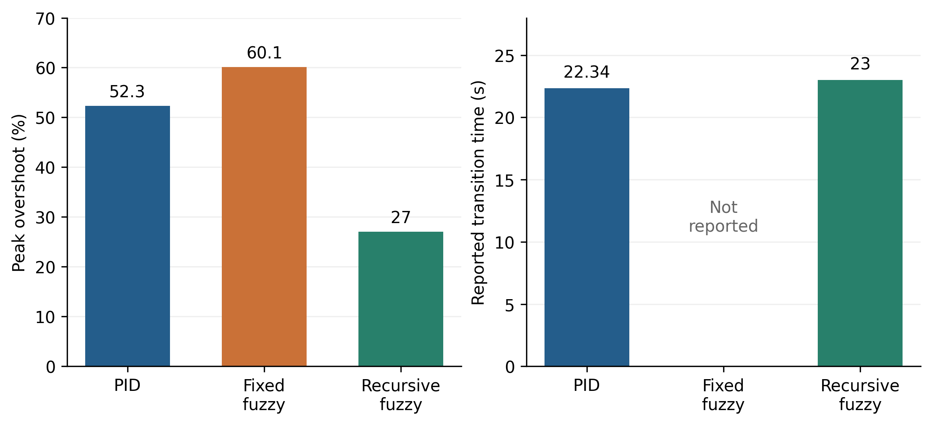
Figure 2. Reported step overshoot and transition duration. The missing conventional fuzzy transition time is shown as unavailable rather than as a zero duration. The two panels display a performance tradeoff; they are not reconstructed transient trajectories.
Relative to PID, recursive fuzzy control reduces overshoot by 25.3 percentage points, corresponding to a 48.37% relative decrease. Relative to conventional fuzzy control, the decrease is 33.1 percentage points or 55.07%. These are substantial changes in peak excursion under the reported nominal test. They support investigating the smaller near-reference corrections as a useful mechanism, but do not isolate that mechanism from the tuning choices of the baselines.
The reported transition time increases by 0.66 s relative to PID, or approximately 2.95%. The PID residual value is zero, whereas the recursive value is 0.03 on the source scale. A relative percentage improvement in residual error cannot be calculated against a zero denominator. Thus the recursive method offers lower overshoot and variance together with a slightly longer reported transition and a small nonzero residual. Calling this an improvement in every aspect of the transient would conceal the actual comparison.
There is also a useful warning in the conventional fuzzy result. Its reported step variance, 22.2, is slightly smaller than the PID value of 22.8 even though it remains oscillatory. This is not a contradiction: the metric window, bias and centering affect variance, and variance does not encode permanent entry into a tolerance band. The result illustrates why several metrics and the full response classification are needed.

7.2 Tracking and disturbance performance
Table 5. Reported variances and recomputed decreases for recursive control.
Experiment | PID variance | Fixed fuzzy variance | Recursive variance | Decrease from PID percent
Step | 22.8 | 22.2 | 15.6 | 31.58
Tracking | 0.71995 | 2.7748 | 0.49973 | 30.59
Disturbance | 30.0035 | 33.3794 | 27.5194 | 8.28
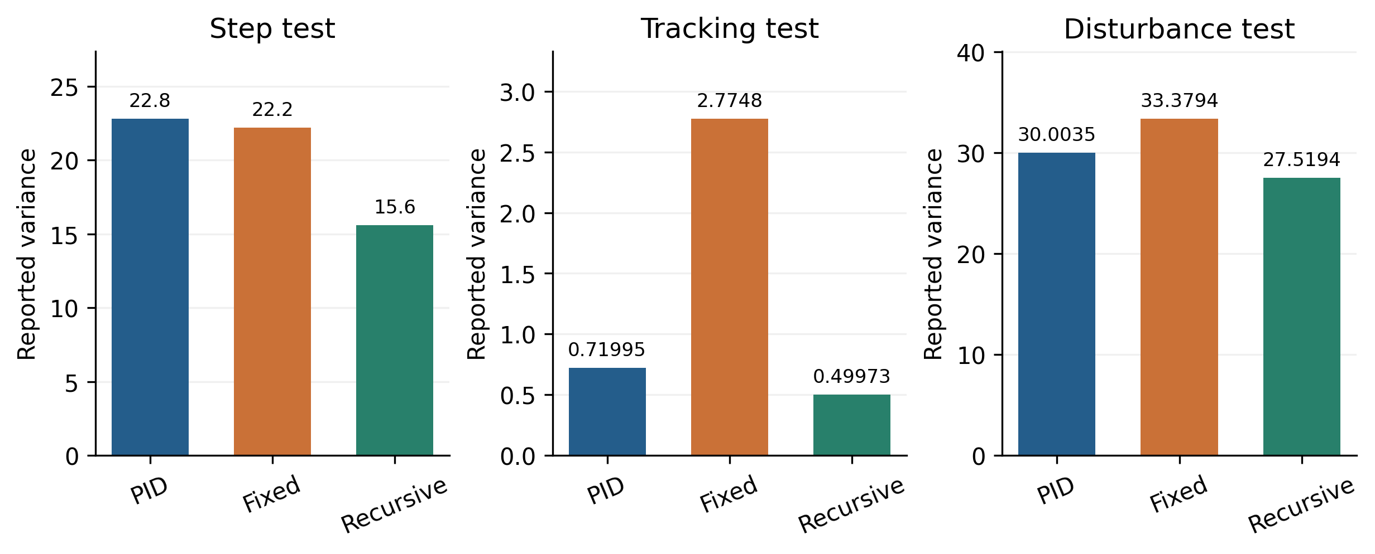
Figure 3. Reported error variances in the three experiments. Separate vertical scales preserve legibility. The magnitudes must not be compared as if they were one common error distribution because the reference, disturbance and evaluation windows differ.
For a metric where a smaller value is favorable and the baseline is positive, the relative decrease and normalized ratio are
$$D_{M}=100\left(1−\frac{M_{recursive}}{M_{baseline}}\right), R_{M}=\frac{M_{controller}}{M_{PID}}.\text{ (21)}$$
In the tracking test, the recursive variance is lower than PID by 0.22022 and lower than conventional fuzzy control by 2.27507. These differences correspond to decreases of 30.59% and 81.99%, respectively. The large difference from fixed fuzzy control is consistent with the source plots showing persistent fluctuations for that baseline. However, a moving reference and a constant hold exercise different parts of the controller, so the comparison should not be interpreted solely as a steady state resolution test.
In the disturbance test, the recursive variance decreases by 2.4841 relative to PID and by 5.86 relative to conventional fuzzy control. The corresponding relative decreases are 8.28% and 17.56%. The smaller improvement relative to PID indicates that the benefit is scenario dependent. A large disturbance may be governed more strongly by plant inertia, actuator limits and recovery behavior than by the central quantization cell.
The step variance decrease relative to conventional fuzzy control is 29.73%. The three experiments therefore support a consistent direction of variance change in favor of the recursive method, while showing markedly different effect sizes. This is stronger evidence than one favorable selected curve, but weaker than a repeated, matched experiment with uncertainty estimates.
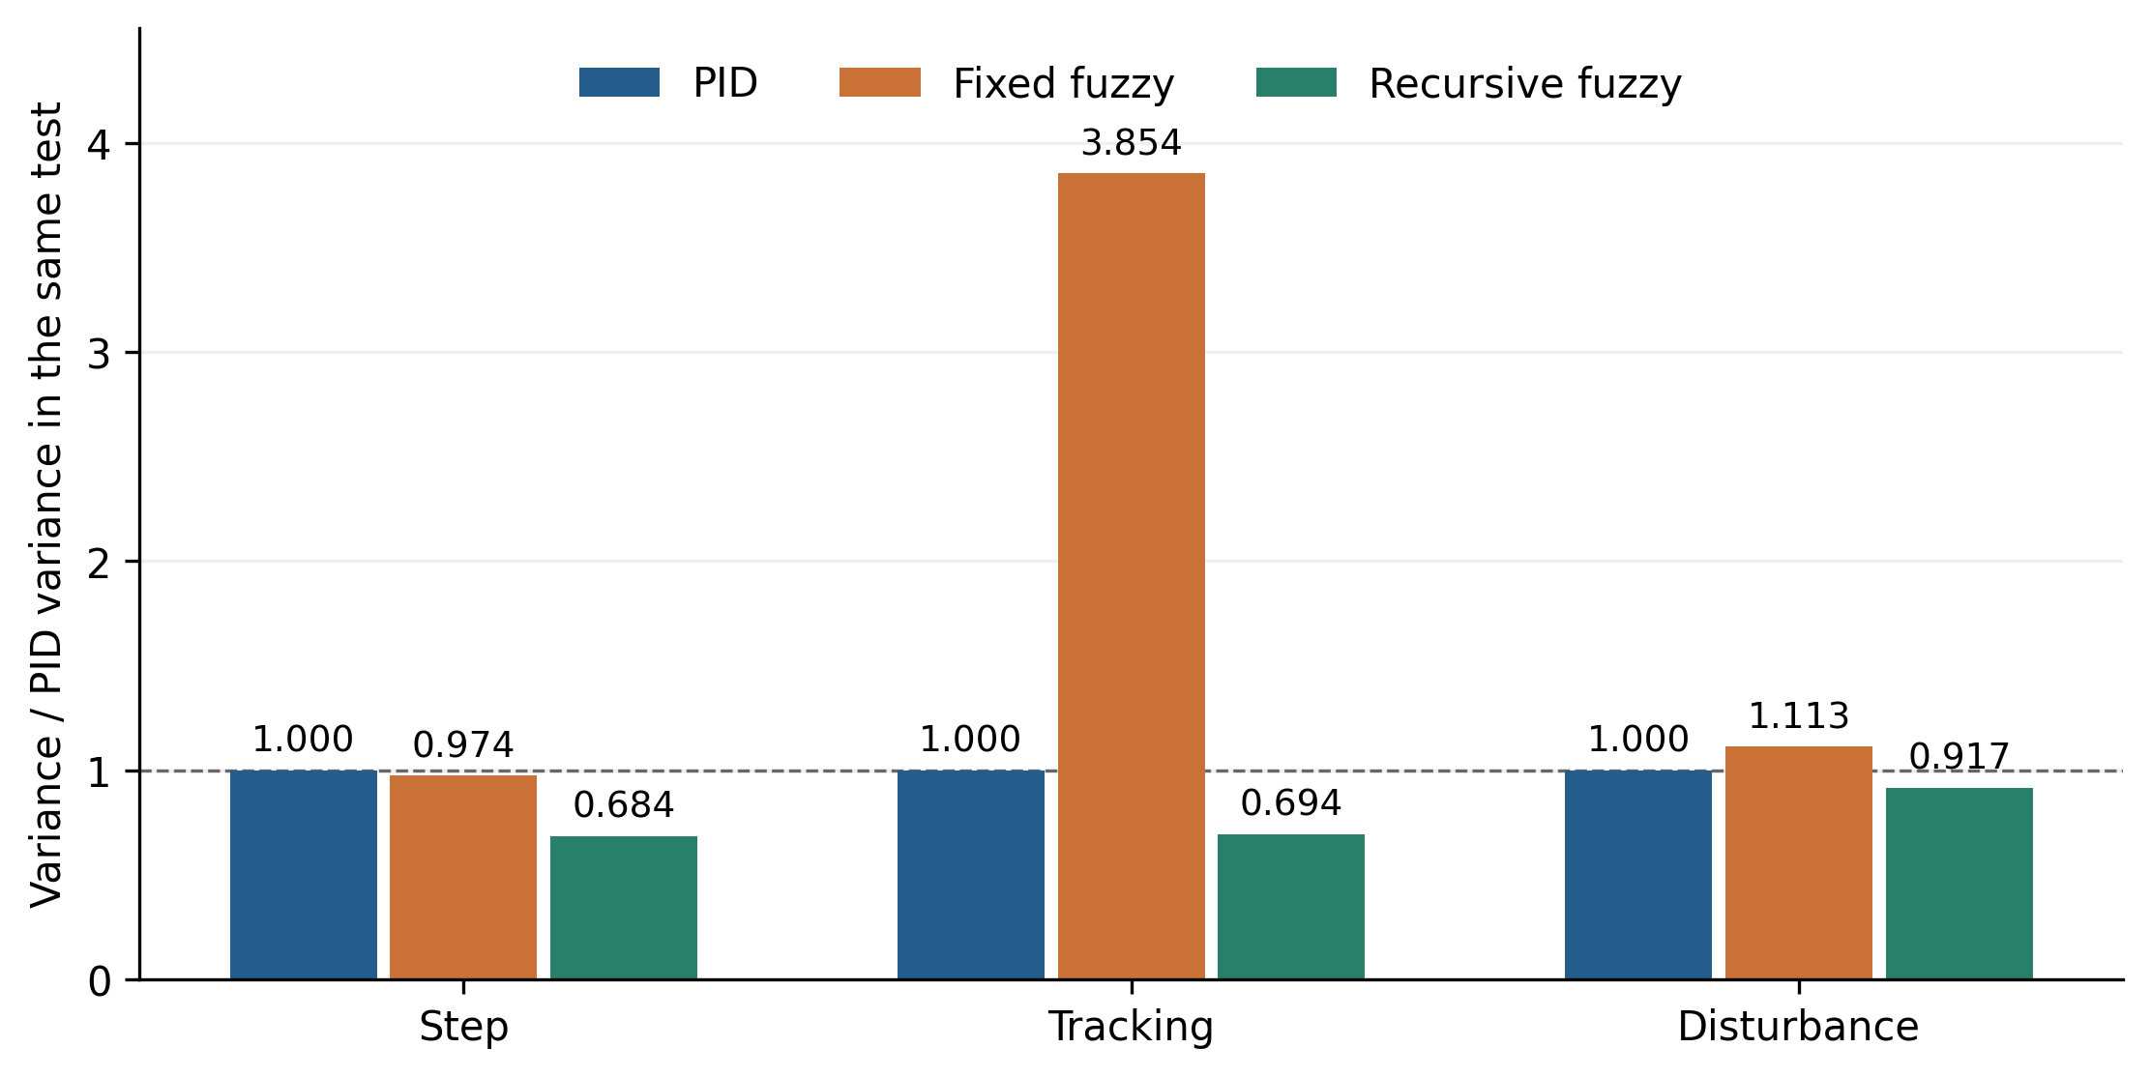
Figure 4. Variance normalized to the PID value separately within each experiment. A value below one indicates a smaller reported variance in that experiment. Normalization permits inspection of relative effect size without treating the original variance scales as identical.
The conventional fuzzy tracking ratio is approximately 3.85, whereas the recursive ratio is approximately 0.69. In the disturbance experiment, the corresponding ratios are approximately 1.11 and 0.92. This contrast makes the interpretation clear: the largest apparent advantage over the fixed table occurs in the particular tracking case, while disturbance rejection remains much closer to PID. No pooled overall improvement is calculated because weighting the experiments would require an explicit application objective.

7.3 Recursion depth and useful stopping
The depth sweep tests ten listed controller configurations. Its depth labels are retained as reported. They are not automatically equated with a zero based count of online refinement events in Algorithm 2, because the historical initialization and event sequence are not fully specified.
Table 6. Reported signed and absolute residual errors by depth.
Reported depth | Signed residual error | Absolute residual error
1 | −10 | 10
2 | 12.5 | 12.5
3 | −4.4 | 4.4
4 | 1.25 | 1.25
5 | −0.16 | 0.16
6 | −0.16 | 0.16
7 | −0.16 | 0.16
8 | 0.02 | 0.02
9 | −0.06 | 0.06
10 | −0.02 | 0.02
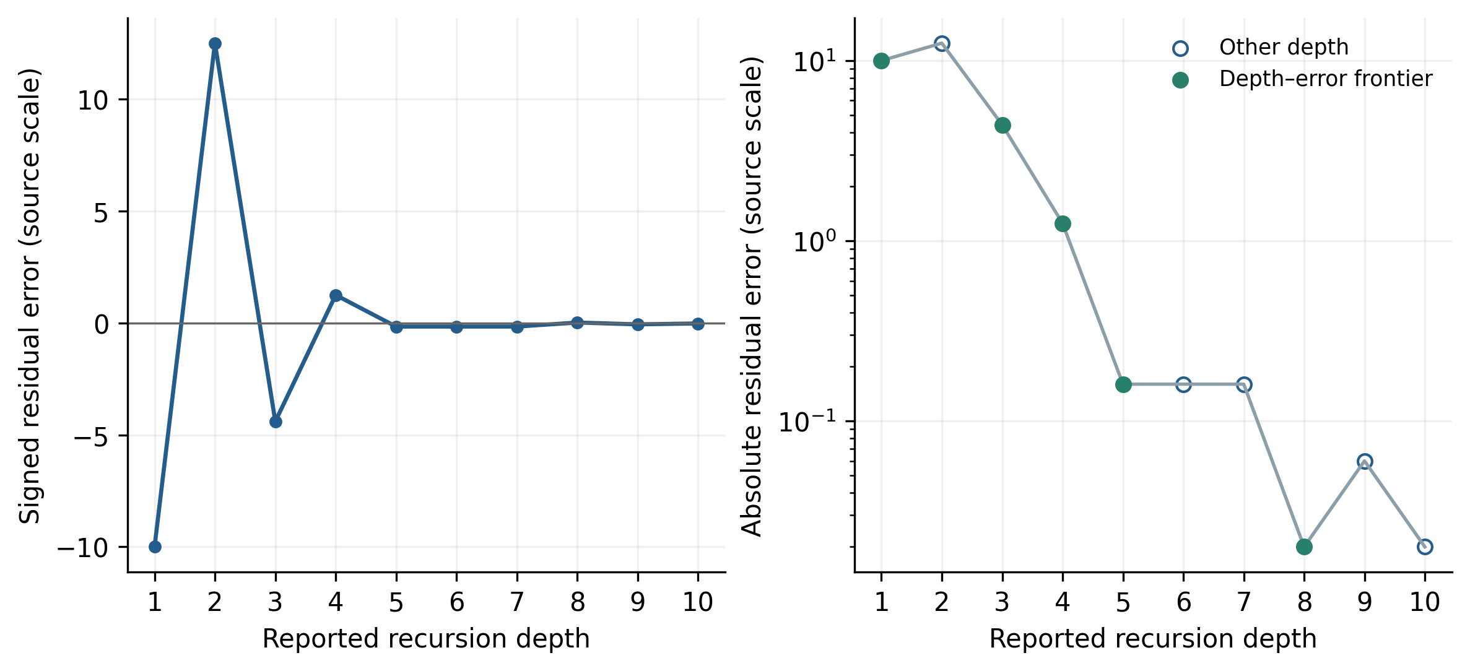
Figure 5. Signed and absolute residual errors across all ten reported depths. The logarithmic absolute-error panel makes the plateau and later reversals visible. Marked frontier points use depth only as a complexity proxy; they do not represent measured execution times.
Absolute error initially increases from 10 to 12.5, then decreases to 4.4, 1.25 and 0.16. Depths five through seven form a plateau. Depth eight reaches 0.02, depth nine becomes worse at 0.06, and depth ten returns to 0.02 with the opposite sign. This sequence directly rules out monotonic improvement with every additional depth. It also shows why reporting only the final signed value can be misleading: a sign reversal does not itself establish a reduction in absolute error.
Compared with the first listed depth, the absolute residual at depth five is 98.4% smaller. The minimum listed absolute residual is 99.8% smaller, but appears at two different depths. If depth is treated only as an increasing complexity proxy, depths two, six, seven, nine and ten are dominated by an earlier configuration with no larger absolute residual. The remaining frontier contains depths one, three, four, five and eight. This is an offline comparison of the reported records, not a proof that online recursion follows the same sequence.
The preferred depth depends on the acceptable error and the hardware. If a residual of 0.16 on the source scale is sufficient, depth five is the first listed configuration meeting it. If the requirement is 0.02, depth eight is the first listed configuration that meets it. No listed depth supports a requirement below 0.02. Consequently, five can be described as an economical setting for a particular tolerance, but not as a universally optimal depth or as evidence that further refinement has no effect.
The theoretical scaling law contracts table resolution monotonically, whereas the measured closed loop residual does not. That distinction is expected because the residual also depends on switching time, state history, finite evaluation duration, noise and actuator conversion. Resolving the ratio ambiguity and logging refinement events are necessary to connect the analytical resolution curve in Figure 1 with the outcomes in Figure 5.

7.4 Changed time constants and robustness
The original study applies controllers designed for a 9 s time constant to plants with time constants of 10, 50 and 100 s. These correspond to approximately 1.11, 5.56 and 11.11 times the nominal value. The selected response plots therefore explore substantial changes in one model parameter. They are useful evidence that the method was considered beyond its nominal tuning case.
However, a plotted response under a changed time constant does not define a certified robustness region. The records do not tabulate a common set of overshoot, settling, input effort and failure metrics for these cases. They also do not establish the effect of simultaneous gain variation, delay, sensor noise or saturation. The defensible conclusion is qualitative tolerance in the displayed simulations, followed by a requirement for a quantitative uncertainty study.
The local criterion in Equation (14) offers one way to organize such a study. Plant coefficients should be recalculated over the declared gain and time constant range, with delay treated explicitly rather than absorbed into an unsupported first order approximation. Because the gain coefficients are invariant under ideal coordinated scaling, a change in resolution alone does not retune the local poles to compensate for arbitrary plant changes.

7.5 Manufacturing interpretation
The source reports product yield above 98% after application of the controller. This is potentially relevant to industrial usefulness, but the statement lacks a baseline yield, batch counts, an acceptance criterion and information about contemporaneous process changes. It therefore remains an application observation. The numerical control comparisons cannot be used to calculate the controller’s causal contribution to yield.
Product quality can depend on furnace loading, powder characteristics, atmosphere, ramp history and holding conditions in addition to the measured sensor temperature. A convincing manufacturing study should link controller logs to identified batches and product measurements. Temperature regulation, energy per acceptable part and product acceptance should be reported separately before their relationship is modeled.

8 Discussion and validation priorities

8.1 What the results establish
The results support a specific design hypothesis. A small fixed rule table can produce finer effective regulation when input sensitivity and output increment are changed together. The strongest reported improvements concern peak overshoot and the tracking comparison with the fixed fuzzy baseline. The less pronounced disturbance improvement, small residual and slightly longer transition relative to PID show that the method changes a tradeoff rather than removing every limitation.
The analytical development explains part of that tradeoff. Coordinated scaling preserves two gain products in a continuous local surrogate, reduces the quantization discrepancy bound and also reduces the maximum command movement per sample. A fine scale is therefore useful near a settled operating point but may be less suitable immediately after a large reference or disturbance change. Reset behavior should be treated as part of the controller rather than an undocumented tuning convenience.

8.2 Computational and embedded implementation
The lookup itself accesses one of 25 stored integers. With precomputed scale values for the current depth, a sample requires input scaling, rounding and clipping, one table access, output scaling, command accumulation and trigger evaluation. The stored rule table does not grow with refinement depth. This offers a credible reason to investigate a small embedded implementation.
Algorithm 2 permits only one refinement at a sample, so its arithmetic work is bounded independently of the selected maximum depth. A different implementation that searches through several depths within one sample can require work proportional to that depth. Both implementations may be practical, but they have different timing behavior. Neither processor execution time nor worst case deadline margin is reported for the historical system.
Memory accounting must include controller state, scale storage, filtering, calibration and logging in addition to the rule table. Similarly, actuator resolution refers to delivered heater action rather than only a numerical converter code. An implementation study should measure timing on the actual target and verify numerical equivalence between its arithmetic and the reference algorithm at every table boundary.

8.3 Tests that would isolate the mechanism
A decisive experiment should compare the unchanged fixed table with coordinated scaling, input-only scaling and output-only scaling. A fixed fine-resolution table is also useful because it tests whether adaptation itself is necessary or whether a well chosen constant fine scale is sufficient. These ablations separate the proposed coupling from generic gain changes.
The study should then vary the refinement ratio, persistence length and maximum depth within prespecified admissible bounds. Selecting these settings on one test trajectory and reporting the same trajectory as independent evaluation would overstate generalization. Separate tuning scenarios and evaluation scenarios are needed, with the disturbance schedule fixed before the comparison.
Algorithm 5. Validate the mechanism and its operating range.
Fix tuning scenarios and independent evaluation scenarios
Compare PID, fixed table, coordinated scaling and ablations
Use the same plant constraints and tuning evaluation budget
Tune ratio, limits and trigger only on tuning scenarios
Freeze each selected controller configuration
For each evaluation load, gain, delay and noise condition:
Reset the plant and execute Algorithm 3
Repeat trials when disturbances or measurements vary
Preserve failures and quantify timing and command use
Summarize performance by scenario before any aggregation
Report uncertainty only when independent records support it
Validate thermal tracking separately from product yield

8.4 Limits of the present evidence
Four limits materially affect interpretation. The first is implementation identity: the source contains inconsistent refinement ratios and omits the complete trigger and reset logic. The second is metric definition: transition bands, variance windows and physical temperature units are not fully recoverable. The third is baseline comparability: tuning effort and constraint handling are undocumented. The fourth is external validity: a normalized first order simulation is not a complete production furnace validation.
These limits do not erase the reported numerical differences. They determine what those differences can establish. Effect sizes can be recalculated exactly from the listed tables, while statistical confidence, unrestricted stability and causal manufacturing benefit cannot. Additional prose, a more complex model description or an assumed noise distribution would not supply the missing experiments.
The most useful next evidence is therefore concrete: executable controller and plant files, the sampling interval, calibrated command conversion, complete trajectories, refinement event logs and repeat trials under matched conditions. For production evaluation, those records should be linked to load configuration, thermal measurements and product acceptance data. This would allow the proposed explanation of the mechanism to be tested rather than inferred solely from aggregate summaries.

9 Conclusions
Recursive scaling provides a compact mechanism for refining an error and error change fuzzy controller while retaining its 25-entry rule table. Increasing the input scales and decreasing the output scale by the same factor preserves two local gain products. The derivation shows how central dead zones and actuator increments contract, while a sampled first order surrogate yields an explicit conditional Schur stability criterion. These results explain the intended behavior and identify the assumptions that prevent their interpretation as a global furnace stability proof.
The reported experiments show a 48.37% overshoot decrease relative to PID and variance decreases of 31.58%, 30.59% and 8.28% in the step, tracking and disturbance comparisons. The reported transition is 2.95% longer, and the residual is small but nonzero. The depth sweep is nonmonotonic: depth five first reaches an absolute residual of 0.16, while depths eight and ten reach the smallest listed value of 0.02.
Useful refinement is therefore limited by the required tolerance, sensor noise, actuator resolution and disturbance recovery requirements. The method merits further testing as a low-complexity regulation strategy, with its main value lying in the coordinated treatment of resolution and increment size. Reproducible controller settings, matched ablations and independent thermal and manufacturing measurements are required to establish a reliable operating range and any production benefit.

Data and code availability
The numerical records used for the present comparisons are reproduced in Tables 4–6. Figures 2–5 are deterministic visualizations or arithmetic transformations of those records; Figure 1 illustrates the analytical scaling law. The pseudocode specifies the proposed operational and evaluation procedures. Full replication of the historical experiments additionally requires the original MATLAB and Simulink models, controller configurations, complete trajectories and manufacturing records.

References
[1] Huang, H.; Luo, Y.; Zhao, C.; Suo, H. (2025). Temperature Control Method for Electric Heating Furnaces Based on Auto-Encoder and Fuzzy PI Control. Sensors, 25(16), 5020. https://doi.org/10.3390/s25165020
[2] Phan, V.D.; Nguyen, X.H.; Dinh, V.N.; Dang, T.S.; Le, V.C.; Ho, S.P.; et al. (2024). Development of an Adaptive Fuzzy-Neural Controller for Temperature Control in a Brick Tunnel Kiln. Electronics, 13(2), 342. https://doi.org/10.3390/electronics13020342
[3] Dai, Y.; Chen, N.; Shao, Z. (2025). Hybrid self-learning model for the prediction and control of sintering furnace temperature. Control Engineering Practice, 154, 106159. https://doi.org/10.1016/j.conengprac.2024.106159
[4] Huang, J.; Huang, F.; Liang, J.; Chen, J.; Li, P. (2024). Fuzzy Adaptive PID Algorithm in Temperature Control System of Lead Patenting Furnace. Advances in Civil Engineering, 2024(1), 4519537. https://doi.org/10.1155/2024/4519537
[5] Tian, H.; Tang, J.; Aljerf, L.; Wang, T.; Qiao, J. (2025). Furnace temperature control based on interval type-2 fuzzy broad learning system for municipal solid waste incineration process. Expert Systems with Applications, 280, 127530. https://doi.org/10.1016/j.eswa.2025.127530
[6] Wang, B.; Tang, J.; Wang, W.; Rong, J. (2025). Interval Type-II Fuzzy Broad Model Predictive Control Based on the Static and Dynamic Hybrid Event-Triggering Mechanism and Adaptive Compensation for Furnace Temperature in the MSWI Process. Applied Sciences, 15(19), 10329. https://doi.org/10.3390/app151910329
[7] Tian, H.; Tang, J.; Xia, H.; Yu, W.; Qiao, J. (2025). Bayesian Optimization-Based Interval Type-2 Fuzzy Neural Network for Furnace Temperature Control. IEEE Transactions on Industrial Informatics, 21(1), 505-514. https://doi.org/10.1109/tii.2024.3453383
[8] Ding, H.; Qiao, J.; Huang, W.; Yu, T. (2024). Event-Triggered Online Learning Fuzzy-Neural Robust Control for Furnace Temperature in Municipal Solid Waste Incineration Process. IEEE Transactions on Automation Science and Engineering, 21(2), 1201-1213. https://doi.org/10.1109/tase.2023.3294420
[9] Xu, B.; Lu, X.; Bai, Y. (2023). A spatiotemporal fuzzy control approach for complex distributed parameter system with application to thermal processes. Journal of Process Control, 127, 102993. https://doi.org/10.1016/j.jprocont.2023.102993
[10] Wang, Y.; Liu, J.; Yu, J. (2025). Lyapunov-derived fuzzy temperature control for thermoelectric cooling system using dynamic updating law. Applied Thermal Engineering, 258, 124600. https://doi.org/10.1016/j.applthermaleng.2024.124600
[11] Li, J.; Wang, W.; Song, Y.; Yang, X.; Cao, F. (2025). Adaptive fuzzy PI control for the dynamic operation of the transcritical CO2 thermal system in electric vehicles. Applied Thermal Engineering, 259, 124737. https://doi.org/10.1016/j.applthermaleng.2024.124737
[12] Espitia, H.; Machón, I.; López, H. (2025). Proposal of a Compact Neuro-Fuzzy Adaptive Controller for Filling Regulation of Two Coupled Spherical Tanks. International Journal of Fuzzy Systems, 27(2), 391-409. https://doi.org/10.1007/s40815-024-01782-4
[13] Nașcu, I.; Diangelakis, N.A.; Muñoz, S.G.; Pistikopoulos, E.N. (2023). Advanced model predictive control strategies for evaporation processes in the pharmaceutical industries. Computers & Chemical Engineering, 173, 108212. https://doi.org/10.1016/j.compchemeng.2023.108212
[14] Emori, E.Y.; Ravagnani, M.A.S.S.; Costa, C.B.B. (2023). Application of fuzzy control in the evaporation stage of a first- and second-generation sugarcane ethanol biorefinery. Chemical Engineering Communications, 210(8), 1340-1357. https://doi.org/10.1080/00986445.2022.2084393
[15] Ortíz-Yescas, G.; Meléndez-Vázquez, F.; Quezada-Téllez, L.A.; Torres-Mendoza, A.; Morales-Peñaloza, A.; Fernández-Anaya, G.; et al. (2025). A Hybrid PI–Fuzzy Control Scheme for a Drum Drying Process. AppliedMath, 5(2), 45. https://doi.org/10.3390/appliedmath5020045
[16] Enayatollahi, H.; Fussey, P.; Nguyen, B.K. (2021). Control of Organic Rankine Cycle, a neuro-fuzzy approach. Control Engineering Practice, 109, 104728. https://doi.org/10.1016/j.conengprac.2021.104728
[17] de Lima, M.L.; Camponogara, E.; Odloak, D.; Jordanou, J.P. (2025). Satisficing Infinite-Horizon Model Predictive Control. Journal of Process Control, 150, 103424. https://doi.org/10.1016/j.jprocont.2025.103424
[18] Kumar, P.; Rawlings, J.B.; Carrette, P. (2023). Modeling proportional–integral controllers in tracking and economic model predictive control. Journal of Process Control, 122, 1-12. https://doi.org/10.1016/j.jprocont.2022.12.003
[19] Ahmed, A.; del Rio-Chanona, E.A.; Mercangöz, M. (2025). Comparative Study of Machine Learning and System Identification for Process Systems Engineering Dynamics. Industrial & Engineering Chemistry Research, 64(8), 4450-4478. https://doi.org/10.1021/acs.iecr.4c03264
[20] Beintema, G.I.; Schoukens, M.; Tóth, R. (2023). Deep subspace encoders for nonlinear system identification. Automatica, 156, 111210. https://doi.org/10.1016/j.automatica.2023.111210
[21] Forgione, M.; Muni, A.; Piga, D.; Gallieri, M. (2023). On the adaptation of recurrent neural networks for system identification. Automatica, 155, 111092. https://doi.org/10.1016/j.automatica.2023.111092
[22] Wang, T.; Gault, R.; Greer, D. (2026). Data Informed Initialization of Fuzzy Membership Functions. International Journal of Fuzzy Systems, 28(2), 597-608. https://doi.org/10.1007/s40815-024-01971-1
[23] Fang, H.; Tu, Y.; He, S.; Wang, H.; Sun, C.; Cheng, S.S. (2024). Self-Learning Takagi–Sugeno Fuzzy Control With Application to Semicar Active Suspension Model. IEEE Transactions on Fuzzy Systems, 32(1), 64-74. https://doi.org/10.1109/tfuzz.2023.3290041
[24] Gil, P.; João, M.; Carvalho, C.; Palma, L.B.; Henriques, J. (2025). Neuro-fuzzy tracking control of discrete-time nonlinear systems under Linear Matrix Inequality region constraints. Engineering Applications of Artificial Intelligence, 153, 110672. https://doi.org/10.1016/j.engappai.2025.110672
[25] Bainier, G.; Marx, B.; Ponsart, J.C. (2024). Generalized nonlinear sector approaches for Takagi-Sugeno models. Fuzzy Sets and Systems, 476, 108791. https://doi.org/10.1016/j.fss.2023.108791
[26] Coutinho, P.H.S.; Oliveira, P.M.; Bessa, I.; Lacerda, M.J.; Palhares, R.M. (2025). Data-driven nonquadratic stabilization of Takagi-Sugeno fuzzy systems. Journal of the Franklin Institute, 362(17), 108131. https://doi.org/10.1016/j.jfranklin.2025.108131
[27] Ali, H.; Liu, J.; Gao, F. (2026). A hybrid causal-inference and neuro-fuzzy framework for advanced process monitoring. Journal of Process Control, 162, 103724. https://doi.org/10.1016/j.jprocont.2026.103724
[28] Kačur, J.; Flegner, P.; Durdán, M.; Laciak, M. (2026). Model-Assisted Dual-Adaptive SMC for Electric Furnace Temperature Control. Processes, 14(18), 2983. https://doi.org/10.3390/pr14182983
[29] Romanov, A.A.; Filippov, A.A.; Yarushkina, N.G. (2023). Adaptive Fuzzy Predictive Approach in Control. Mathematics, 11(4), 875. https://doi.org/10.3390/math11040875
[30] Han, H.G.; Wang, C.Y.; Sun, H.Y.; Qiao, J.F. (2022). Data-based robust model predictive control for wastewater treatment process. Journal of Process Control, 118, 115-125. https://doi.org/10.1016/j.jprocont.2022.08.013
[31] Parker, R.B.; Nicholson, B.L.; Siirola, J.D.; Biegler, L.T. (2023). Model predictive control simulations with block-hierarchical differential–algebraic process models. Journal of Process Control, 132, 103113. https://doi.org/10.1016/j.jprocont.2023.103113
[32] Paranchuk, Y.; Lis, M. (2023). Double-Circuit Adaptive System of Fuzzy Phase-Autonomous and Energy-Efficient Control of Arc Furnace Electric Modes. Energies, 16(14), 5350. https://doi.org/10.3390/en16145350
[33] Takagi, T.; Sugeno, M. (1985). Fuzzy identification of systems and its applications to modeling and control. IEEE Transactions on Systems, Man, and Cybernetics, SMC-15(1), 116-132. https://doi.org/10.1109/tsmc.1985.6313399
[34] Jang, J.S.R. (1993). ANFIS: adaptive-network-based fuzzy inference system. IEEE Transactions on Systems, Man, and Cybernetics, 23(3), 665-685. https://doi.org/10.1109/21.256541
[35] Wang, L.X.; Mendel, J.M. (1992). Generating fuzzy rules by learning from examples. IEEE Transactions on Systems, Man, and Cybernetics, 22(6), 1414-1427. https://doi.org/10.1109/21.199466
[36] Ajorloo, D.; Nazari, M.; Nazari, M.; Sepehry, N.; Mohammadzadeh, A. (2023). Mathematical modeling and designing an optimized fuzzy temperature controller for a vacuum box electric furnace: Numerical and experimental study. Transactions of the Institute of Measurement and Control, 45(7), 1193-1212. https://doi.org/10.1177/01423312221124017
[37] Brockett, R.W.; Liberzon, D. (2000). Quantized feedback stabilization of linear systems. IEEE Transactions on Automatic Control, 45(7), 1279-1289. https://doi.org/10.1109/9.867021

