Adaptive Single Neuron Fuzzy PI Temperature Control for Vacuum Concentration Processes

Abstract
Temperature regulation during vacuum concentration is affected by heat supply, vapor removal, product circulation, and the changing properties of the concentrated liquid. This study examines a compact adaptive controller that combines nine rule fuzzy inference with a two weight single neuron update. A detailed formulation connects the process mass and energy balances, a local delayed plant model, incremental control, reference model tracking, and embedded implementation. The analysis clarifies how the local fuzzy surface produces effective proportional and integral actions, why delayed measurements complicate gradient based adaptation, and why parameter bounds alone do not establish closed loop stability. Five pseudocode algorithms specify inference, delay aligned learning, actuator handling, embedded scheduling, and comparative evaluation. Historical startup, steam availability, and production records are reassessed graphically. Startup transition times decrease from 40 to 21 s as initial temperature increases from 30 to 50 °C, although the corresponding temperature gap divided by transition time does not increase monotonically. Concentration duration rises from 14 to 48 min as the steam availability proxy falls from 100% to 75%, indicating a strong capacity constraint. Twenty baseline and twenty later production records give mean durations of 5.575 and 4.275 h, respectively, a descriptive reduction of 23.32%. The controller’s embedded implementation is documented, but the historical comparisons do not isolate its causal contribution. The resulting treatment provides an explicit basis for reproducing the control structure and evaluating tracking, energy use, concentration quality, and adaptation under common operating conditions.
Keywords: vacuum concentration; fuzzy PI control; adaptive control; single neuron learning; time delay; embedded process control

1 Introduction
Vacuum concentration removes water while reducing the temperature required for boiling. In the application studied here, a liquid intermediate is concentrated from approximately 15% to 35% dry matter before spray drying. The operation must provide enough heat for evaporation while maintaining an appropriate product temperature and vapor removal rate. Changes in feed composition, steam pressure, circulation, and surface fouling can alter both the process dynamics and the achievable throughput.
Temperature control is only one part of this operation, but it is closely connected to the other parts. Increased steam input initially raises temperature or accelerates vapor generation. Vapor generation affects pressure unless the condenser and vacuum system remove the additional vapor. Increasing solids content can change viscosity and heat transfer. These interactions explain why a controller tuned from a single local experiment may behave differently later in the batch.
Current research addresses thermal control through combinations of learned representations, fuzzy PI structures, adaptive fuzzy neural models, and process specific identification [1–3]. Fuzzy PID, interval type 2 methods, event triggered prediction, Bayesian tuning, and online adaptation provide additional ways to accommodate changing behavior [4–8]. Their practical value depends on the information and computing resources available. A small industrial controller may favor a compact adaptive law even when a richer model could improve prediction.
The method considered here retains only two adaptive control weights. A fuzzy component converts the error and its change into a nonlinear correction, while a single neuron mechanism adjusts the weights using reference model tracking error. This combination aims to preserve a simple implementation while allowing the local control response to change during operation. The small parameter count is an implementation advantage; its effectiveness still depends on the quality of the learning signal and the admissibility of the resulting gains.
This paper develops the method beyond a schematic description. It connects the controller to the physical process, derives its local control interpretation, examines sensitivity estimation in the presence of delay, and specifies an operational implementation. It also recalculates the tabulated outcomes and uses graphs to separate startup behavior, heat availability, and production period differences. The contributions are a detailed mathematical and computational formulation and a transparent analysis of the available evidence.

2 Related work and methodological context
Distributed thermal control and Lyapunov based fuzzy temperature regulation emphasize that physical coupling and stability assumptions must be included in the analysis [9,10]. Adaptive fuzzy PI thermal regulation and compact neuro fuzzy tank control show the relevance of variable gain structures for processes with limited implementation resources [11,12]. Predictive evaporation control, fuzzy evaporation regulation, hybrid drying control, and neuro fuzzy Rankine cycle control are closer process analogues because their manipulated heat input interacts with material or phase behavior [13–16].
Predictive control can account explicitly for future behavior and input constraints, but it requires a suitable model and an optimization implementation. Satisficing formulations and explicit PI relationships within tracking and economic predictive control provide useful comparisons [17,18]. Identification studies, deep subspace encoders, and online recurrent model adaptation address the modeling uncertainty that underlies such designs [19–21]. These alternatives make it useful to report both control performance and implementation cost rather than claim an advantage from controller simplicity alone.
Initialization is particularly important for online adaptation because the plant experiences the initial controller before learning can improve it. Membership initialization methods and self learning fuzzy structures therefore provide relevant context [22,23]. LMI constrained tracking, sector based analysis, and nonquadratic fuzzy stabilization illustrate how additional structural assumptions can support closed loop claims [24–26]. A gradient update by itself does not provide an equivalent guarantee.
Process monitoring, model assisted furnace control, fuzzy predictive control, data based robust predictive methods, hierarchical process simulation, and energy oriented furnace control broaden the current thermal comparison space [27–32]. The historical hybrid neuro fuzzy PID formulation supplies the direct methodological basis of the controller, while classical fuzzy identification and adaptive network inference provide its foundational framework [33–35].
The present method occupies a specific point in this landscape: a computationally small controller whose output and learning mechanism are available for direct inspection. The analysis below treats fuzzy inference, adaptive learning, actuator limits, and process capacity as distinct mechanisms. This makes it possible to design ablations that identify which mechanism contributes to an observed result.

3 Process formulation and operating constraints

3.1 Equipment and controlled variables
The documented installation contains a tower heat exchanger with 35 product flow tubes, circulation equipment, a condenser, a vacuum exhaust system, and a motorized steam valve. The manipulated variable is the valve command, and the controlled variable is the measured process temperature. The nominal reference is 60 °C. A two channel ADuC831 based controller provides local operation and communication with a supervisory computer.
The control boundary should distinguish valve command, actual valve position, steam mass flow, and heat delivered to the product. These quantities are related but not identical. Valve characteristics, upstream pressure, condensate conditions, and exchanger fouling can change the heat obtained from the same command. The historical steam experiment uses valve opening as a proxy for availability because steam mass flow was not measured.

3.2 Solids conservation and water removal
Let $M$ be product mass and $x_{s}$ the dry matter mass fraction. For a general well mixed concentration vessel,
$$\frac{dM}{dt}={\dot{m}}_{f}−{\dot{m}}_{p}−{\dot{m}}_{v}, \frac{d\left(Mx_{s}\right)}{dt}={\dot{m}}_{f}x_{f}−{\dot{m}}_{p}x_{s}.\text{ (1)}$$
The vapor is assumed to contain negligible nonvolatile solids. Entrainment or product carryover would violate that assumption and should be measured separately. For an ideal batch with no solids loss, the initial and final masses satisfy
$$M_{i}x_{i}=M_{f}x_{f}, \frac{M_{f}}{M_{i}}=\frac{0.15}{0.35}=\frac{3}{7}, \frac{M_{water,removed}}{M_{i}}=\frac{4}{7}.\text{ (2)}$$
Thus, approximately 57.14% of the initial total mass must be removed as water under the stated assumptions. This calculation does not depend on a controller design. It provides a physical basis for interpreting batch duration: a shorter time is beneficial only when comparable feed mass and the same concentration endpoint are achieved.

3.3 Heat input and pressure coupling
A simplified lumped thermal balance is
$$C_{eff}\left(M,x_{s},T\right)\frac{dT}{dt}={\dot{Q}}_{s}−{\dot{m}}_{v}h_{fg}\left(T,p\right)−{\dot{Q}}_{loss}+{\dot{Q}}_{flow}.\text{ (3)}$$
Here $C_{eff}$ includes the effective product and equipment heat capacity, ${\dot{Q}}_{s}$ is delivered steam heat, and ${\dot{Q}}_{flow}$ represents net sensible enthalpy associated with feed and product flows. Equation (3) is a mechanistic interpretation used in this analysis. The historical application was controlled using a local transfer function rather than a fully identified version of this balance.
During sensible heating, a substantial part of the net heat raises temperature. During established evaporation, much of it supplies latent heat. A small temperature error can therefore coexist with a large change in evaporation rate. Temperature tracking and production throughput must be reported as separate outcomes.
Pressure introduces another dependence. For a boiling solution,
$$T_{b}=T_{sat}\left(p\right)+ΔT_{BPE}\left(x_{s}\right),\text{ (4)}$$
where the boiling point elevation depends on composition. Holding the vacuum pump command fixed does not necessarily hold pressure fixed because vapor load and condenser behavior can change. Pressure measurement is consequently needed to distinguish a thermal control disturbance from a shift in the boiling condition.
A physical lower bound on evaporation time can be expressed through the required energy and available net power:
$$t_{process}≥\frac{E_{sensible}+E_{latent}}{{\overline{P}}_{available}},\text{ (5)}$$
when the denominator represents a valid upper bound on average useful power and both energy terms are consistently defined. Heat losses and operating interruptions increase the required time. The bound explains why gain adaptation cannot compensate for insufficient steam capacity.

3.4 Local dynamic model and stress cases
The identified operating point approximation is
$$G\left(s\right)=\frac{1.8e^{−2.5s}}{{\left(5.3s+1\right)}^{2}}.\text{ (6)}$$
The model has positive steady gain, two equal lag factors, and a 2.5 s delay. Its gain units depend on the scaling of temperature and valve input. Identification amplitude, sampling period, operating solids fraction, and residual analysis are needed to determine the range over which the approximation is reliable.
The source also uses three simulation model families:
$$G_{1}\left(s\right)=\frac{Ke^{−τs}}{{\left(Ts+1\right)}^{2}}, G_{2}\left(s\right)=\frac{1−ρs}{{\left(s+1\right)}^{3}}, G_{3}\left(s\right)=\frac{1}{{\left(s+1\right)}^{2}\left(s−a\right)}.\text{ (7)}$$
The reported sweeps change $τ$ from 2.5 to 4 s, $ρ$ from 1.4 to 2.5, and $a$ from 0.1 to 1. These are delay, inverse response, and instability stress cases. They examine controller behavior beyond the nominal model, but are not presented as identified transfer functions for particular plant disturbances.

4 Fuzzy incremental control

4.1 Input normalization and rule evaluation
The tracking error and discrete error change are
$$e_{k}=r_{k}−y_{k}, Δe_{k}=e_{k}−e_{k−1}, z_{1,k}=G_{e}e_{k}, z_{2,k}=G_{c}Δe_{k}.\text{ (8)}$$
The change is a discrete difference, not a derivative unless divided by the sampling interval. Changing the sampling period without adjusting $G_{c}$ changes the fuzzy input distribution. The scaling factors are therefore part of the controller specification.
Three triangular linguistic sets, negative, zero, and positive, are used for each normalized input. A triangular membership with ordered vertices $l<c<r$ is
$$μ\left(z;l,c,r\right)=max\left\{0,min\left(\frac{z−l}{c−l},\frac{r−z}{r−c}\right)\right\}.\text{ (9)}$$
Boundary shoulder sets or input saturation must provide declared coverage beyond the central triangles. Otherwise all memberships can vanish and normalized inference becomes undefined.
Table 1. Nine rule consequent signs.
Error term | Negative change | Zero change | Positive change
Negative | Negative | Negative | Zero
Zero | Negative | Zero | Positive
Positive | Zero | Positive | Positive
With minimum conjunction and singleton output centers $b_{i}$,
$$a_{i}=min\{μ_{i1}\left(z_{1}\right),μ_{i2}\left(z_{2}\right)\}, v_{k}=G_{u}\frac{\sum_{i=1}^{9}{a_{i}}b_{i}}{\sum_{i=1}^{9}{a_{i}}}.\text{ (10)}$$
The rule table expresses a nonlinear correction based on both the direction of the error and its recent movement. For example, positive error with positive error change requests a positive correction, while opposing signs can reduce the correction. This interpretation presumes that increasing the command increases measured temperature in the relevant operating range.
Algorithm 1. Evaluate the fuzzy correction.
Inputs: error e, error change de, scales, membership vertices
Normalize e and de using the declared sampling convention
Apply the configured input coverage or saturation policy
Evaluate three memberships for each normalized input
For each of the nine rules:
Calculate minimum conjunction and its output contribution
If the total activation is below the coverage tolerance:
Return the declared fallback and log the condition
Otherwise return the normalized singleton average times Gu
The source derives an analytical surface with 36 piecewise regions. Direct rule evaluation provides an operational alternative that is easier to inspect. A region based implementation should be checked against Equation (10) on region boundaries as well as in their interiors.

4.2 Incremental output and local PI interpretation
The controller combines the fuzzy correction and error through
$$Δu_{k}=w_{1,k}v_{k}+w_{2,k}e_{k}, u_{k}=u_{k−1}+Δu_{k}.\text{ (11)}$$
This form accumulates the output increment. The second term therefore supplies integral action, with the sampling period absorbed into its weight. The first weight acts through a two input nonlinear surface, so identifying it directly with a conventional proportional gain requires a local argument.
Within a differentiable region near a working point, let
$$v_{k}≈a_{e}e_{k}+a_{Δ}\left(e_{k}−e_{k−1}\right).\text{ (12)}$$
Substituting into Equation (11) gives the local incremental PI form
$$Δu_{k}≈K_{p}\left(e_{k}−e_{k−1}\right)+K_{i}T_{s}e_{k}, K_{p}=w_{1}a_{Δ}, K_{i}T_{s}=w_{1}a_{e}+w_{2}.\text{ (13)}$$
The effective gains depend on both adaptive weights and the local fuzzy slopes. This explains how the controller changes its response across error regions even before the weights adapt. It also shows why a bounded pair of neuron weights does not automatically imply a desired pair of conventional PI gains throughout the fuzzy domain.

4.3 Saturation and integral accumulation
The physical command must remain in the calibrated valve range:
$$u_{k}=clip\left(u_{k−1}+Δu_{k},u_{min},u_{max}\right).\text{ (14)}$$
If the internal accumulator continues to grow while the valve is saturated, recovery can be delayed after the error changes sign. A constrained implementation can store the applied command as the next accumulator state or use a declared back calculation mechanism. Learning should also distinguish an intended control increment from the increment actually applied.
Algorithm 2. Apply the incremental command with actuator accounting.
Calculate the fuzzy correction and the requested increment
Form the unconstrained command from the preceding state
Apply calibrated valve position and rate limits
Write the accepted command to the actuator interface
Store the applied command and any saturation residual
If anti-windup is enabled:
Correct the accumulator by the declared method
Permit adaptation only under its declared saturation policy
These saturation and anti-windup details are an explicit proposed operational specification. Their use is not established by the historical production records.

5 Single neuron adaptation and stability interpretation

5.1 Reference model and learning objective
The desired response is generated by
$$G_{d}\left(s\right)=\frac{ω_{n}^{2}e^{−τs}}{s^{2}+2ζω_{n}s+ω_{n}^{2}}, e_{d,k}=y_{d,k}−y_{k}, E_{k}=\frac{1}{2}e_{d,k}^{2}.\text{ (15)}$$
The application design uses $ζ=0.6$, $ω_{n}=3$ rad/s, and $τ=2.5$ s. Earlier simulation examples use $ζ=0.5$ and should be reported separately. The model describes a desired response; it does not demonstrate that the delayed plant and bounded actuator can achieve it over every operating condition.
With feature vector $ϕ_{k}={\left[v_{k},e_{k}\right]}^{T}$, the reported momentum update is
$$Δw_{k}=η_{k}s_{k}e_{d,k}ϕ_{k}+λ_{k}Δw_{k−1}.\text{ (16)}$$
The factor $s_{k}$ approximates the direction of the plant sensitivity. Replacing a full dynamic derivative by its sign reduces computation, but changes the interpretation of the update. Equation (16) is a heuristic adaptation law unless its relationship to the delayed loss gradient is established.

5.2 Delay aligned sensitivity
For an undelayed local relation $y_{k+1}=g\left(y_{k},u_{k}\right)$, the derivative of a future tracking loss contains $∂y_{k+1}/∂u_{k}$. For a delayed process, the relevant influence occurs later:
$$\frac{∂E_{k+d}}{∂w_{k}}=−e_{d,k+d}\frac{∂y_{k+d}}{∂u_{k}}\frac{∂u_{k}}{∂w_{k}}.\text{ (17)}$$
This simplified chain rule isolates one causal path. A full recursive derivative can include additional paths through controller states. It is sufficient to show why a current output difference should not automatically be paired with the current input difference.
An operational sign estimate can use lag aligned increments,
$${\hat{s}}_{k}=sign\left(\frac{y_{k}−y_{k−1}}{u_{k−d}−u_{k−d−1}}\right),\text{ (18)}$$
only when the denominator is informative and disturbances are controlled or sufficiently small. The delay index must correspond to the observed response timing, and a thermal lag can require a window rather than one increment. Inverse response can also change the observed short horizon sign relative to the steady gain.
A reasonable implementation can suspend learning when the command change is too small, the sensor is invalid, the valve is saturated under an incompatible policy, or the sensitivity estimate is inconsistent across a declared window. Suspension avoids updating on an uninformative signal; it is not a proof of convergence.

5.3 Learning rates and admissible parameters
The source adjusts learning rate and momentum in addition to the two controller weights. Its rate expression contains a factor of the form
$$1−αe_{d,k}^{2}e_{k−1}^{2}.\text{ (19)}$$
The factor can become negative. Its numerical meaning also depends on the units and normalization of both errors. Consequently, a statement that the update automatically preserves a positive rate requires additional assumptions.
A constrained extension is
$$w_{k+1}=Π_{W}\left(w_{k}+Δw_{k}\right), η_{k+1}=clip\left(η_{k+1}^{raw},η_{min},η_{max}\right),\text{ (20)}$$
with an analogous bound for momentum. The set $W$ should be justified by plant analysis or controlled commissioning. An arbitrary box prevents numerical overflow but may still include unstable controllers.
Algorithm 3. Perform delay aligned adaptive control.
Initialize fuzzy gains, reference model and command history
Declare original or constrained adaptation before execution
At each accepted measurement:
Calculate e, de, fuzzy output v and reference output yd
Retrieve the causally aligned command and feature history
Assess sensor, saturation and sensitivity validity
If learning is permitted:
Calculate the momentum weight increment
Apply the configured parameter projection if enabled
Otherwise retain the weights and log the suspension cause
Apply Algorithm 2 using the accepted weight values
Update bounded learning parameters if configured
Store signals, histories, gain changes and actuator events

5.4 What a local stability check can establish
A simple analytical example clarifies the role of admissible gains. Consider the reduced, delay free plant $y_{k+1}=ay_{k}+bu_{k}$, with $b>0$, and fixed local PI gains from Equation (13). The closed loop characteristic polynomial is
$$p\left(z\right)=z^{2}−\left[1+a−b\left(K_{p}+K_{i}T_{s}\right)\right]z+\left(a−bK_{p}\right).\text{ (21)}$$
For this second order polynomial, strict discrete time stability requires
$$bK_{i}T_{s}>0, 2+2a−b\left(2K_{p}+K_{i}T_{s}\right)>0, 1−a+bK_{p}>0.\text{ (22)}$$
These conditions follow from the second order Jury inequalities. They demonstrate that positive gains alone are insufficient: excessively large gains can violate the middle condition. They are an analytical illustration, not a stability certificate for the actual second order delayed, nonlinear, adaptive process.
For the application, the delay states, thermal states, accumulator, local fuzzy slopes, and adaptation must be included. A frozen gain analysis can examine the spectral radius of the augmented state matrix, but switching among stable frozen controllers does not by itself prove stability under arbitrary adaptation. A rigorous global claim would need an appropriate common or parameter dependent argument together with saturation and uncertainty assumptions.

6 Embedded realization

6.1 Measurement and command conversion
The ADuC831 implementation combines analog conversion, local display and keyboard operation, and RS485 supervisory communication. Analog filtering and a moving average reduce measurement noise. A calibration relation such as $T=a_{T}n_{ADC}+b_{T}$ must be identified from reference measurements, with residuals and valid range reported. A corresponding actuator calibration connects output code to actual valve behavior.
A moving average of length $L$ is
$${\tilde{y}}_{k}=\frac{1}{L}\sum_{ℓ=0}^{L−1}{y_{k−ℓ}}.\text{ (23)}$$
For a uniformly sampled signal, its low frequency group delay is $\left(L−1\right)T_{s}/2$. Filtering therefore trades noise attenuation against additional feedback delay. The filter length should be included when interpreting the sensitivity alignment and nominal process delay.

6.2 Scheduling and communication
Control sampling should have a defined deadline independent of display refresh and supervisory polling. Communication transactions should not block measurement and output updates. A coherent signal snapshot prevents the local display from combining a new temperature with an old gain or command.
Algorithm 4. Schedule embedded control and supervisory tasks.
At each control deadline:
Acquire ADC data and validate conversion status
Filter and calibrate the accepted measurement
Execute Algorithm 3 within the control time budget
Write the calibrated actuator output
Publish one consistent status snapshot
Between control deadlines:
Scan and debounce the keyboard
Refresh the local display from the status snapshot
Process addressed RS485 polls and valid commands
Acknowledge updates and enforce bounded retry handling
On communication loss:
Continue the declared local operating mode
Record the fault without blocking the control task
The source documents polling, acknowledgements, and retransmission. Frame format, integrity checks, retry limits, interrupt priority, and worst case execution time remain necessary for firmware replication. The five main computations—membership evaluation, normalized inference, two weight updates, reference filtering, and output limiting—are small, but actual timing should be measured on the target rather than inferred from parameter count.

7 Experimental results and physical interpretation

7.1 Startup from different initial temperatures
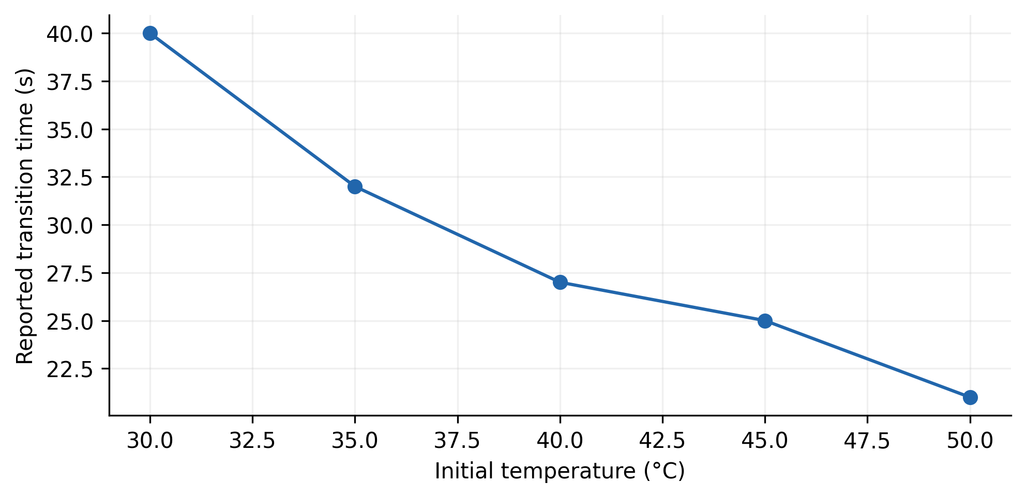
Figure 1. Reported transition times for five initial temperatures under the source’s constant steam condition. Replicate counts and the exact transition criterion are unavailable.
Initial temperatures of 30, 35, 40, 45, and 50 °C correspond to transition times of 40, 32, 27, 25, and 21 s. A warmer start reduces the distance to the 60 °C reference. The decrease in transition time is therefore physically plausible without requiring a change in controller quality.
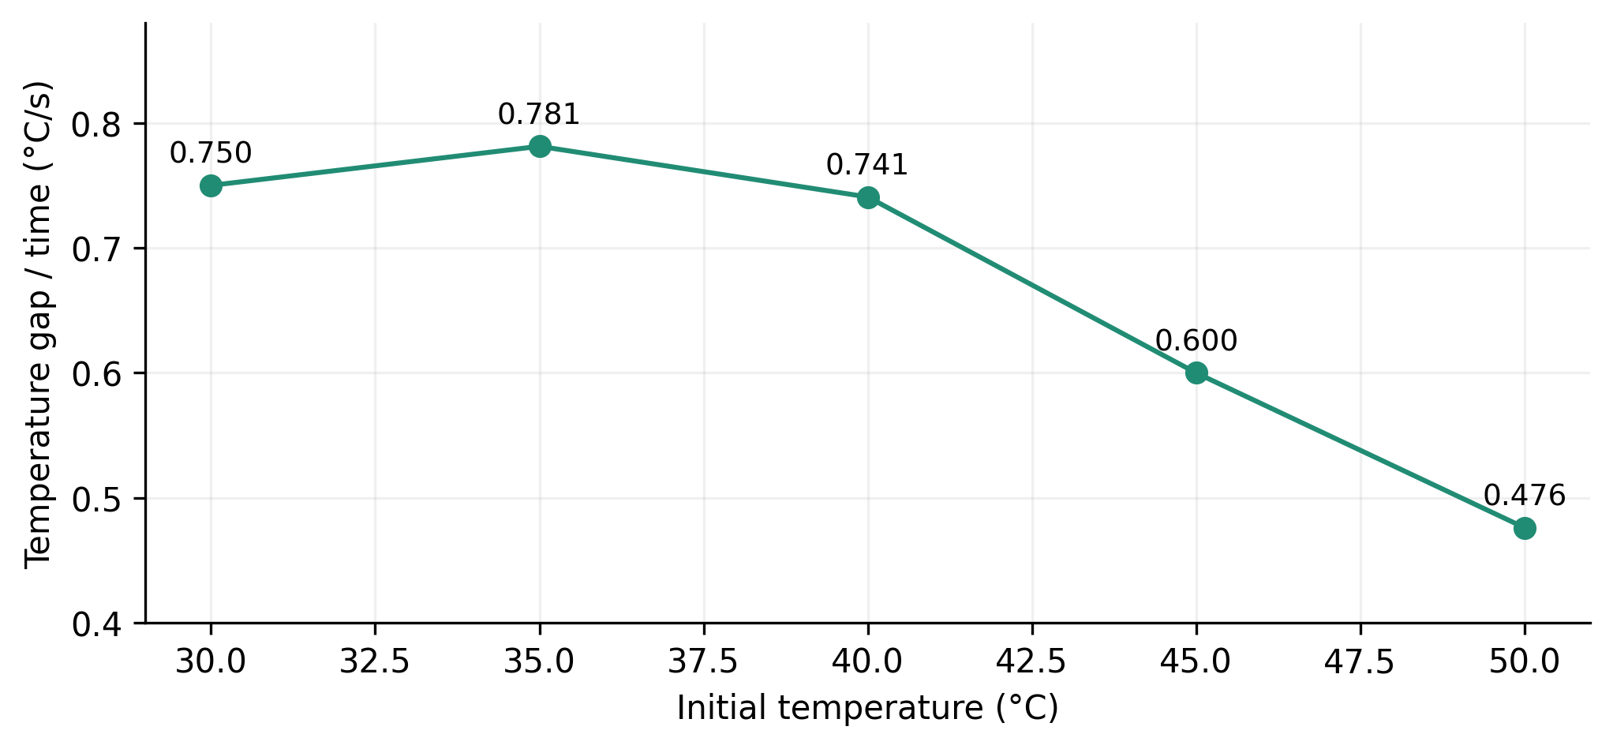
Figure 2. Derived temperature gap divided by transition time. This diagnostic uses the 60 °C reference and the source startup table; it is not a measured temperature slope or a fitted dynamic model.
The ratios $\left(60−T_{0}\right)/t_{transition}$ are approximately 0.750, 0.781, 0.741, 0.600, and 0.476 °C/s. Their pattern shows why the shortest transition should not automatically be interpreted as the fastest heating rate. The ratio combines a changing initial gap with a transition criterion that may include settling behavior. Full trajectories are needed to separate the initial heating slope, overshoot, and final approach.
This experiment characterizes operating dependence. It does not isolate an adaptive benefit because a matched initial temperature sweep for a fixed gain controller is not tabulated.

7.2 Steam availability and throughput
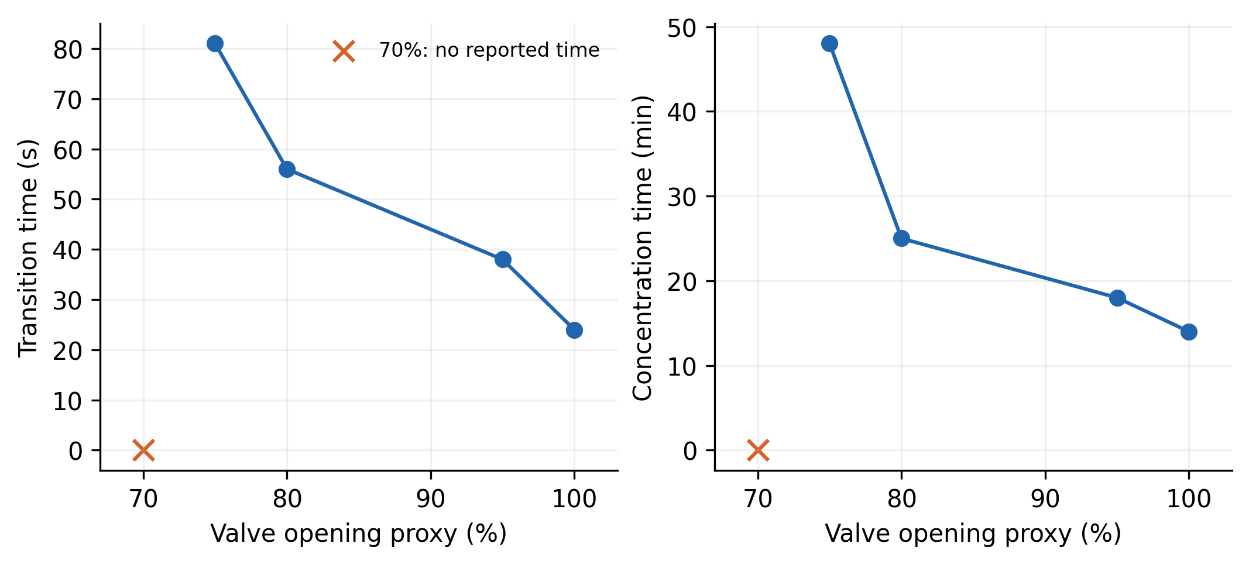
Figure 3. Source steam availability experiment using valve opening as a proxy. The marker at 70% identifies an unreported result; it is not a duration of zero.
Table 2. Steam availability observations.
Valve opening proxy percent | Transition time s | Concentration duration min
100 | 24 | 14
95 | 38 | 18
80 | 56 | 25
75 | 81 | 48
70 | Not reported | Not reported
Concentration duration rises by a factor of 3.43 from the 100% to the 75% condition, while transition time rises by a factor of 3.38. These are substantial changes. The source statement that transition time changes little is therefore not supported across the full listed range.
For comparable batch mass and endpoint, inverse duration is a simple throughput indicator. Relative to the 100% condition, the values $14/t_{concentration}$ are 1.000, 0.778, 0.560, and 0.292. This is a derived production rate proxy, not a measured thermal efficiency. It illustrates how limited heat availability can dominate the operating result.
The sharp change near the lower listed openings is compatible with reduced net heat after losses, but other mechanisms may contribute, including changes in steam pressure, valve characteristics, boiling conditions, or circulation. The 70% row does not identify an exact failure threshold because neither a completion time nor a complete failure criterion is supplied. A new experiment should measure steam flow and pressure directly.

7.3 Production period comparison
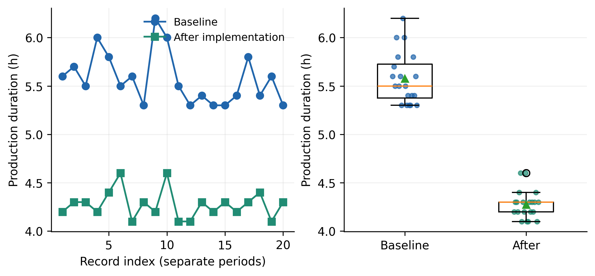
Figure 4. Twenty baseline and twenty later production durations. The records come from different periods. Their displayed indices do not define matched batches.
Table 3. Recalculated production duration summaries.
Period | Number of records | Mean h | Sample standard deviation h
Baseline | 20 | 5.575 | 0.267
After implementation | 20 | 4.275 | 0.145
The difference between period means is 1.300 h. Relative to the baseline,
$$R_{t}=\frac{5.575−4.275}{5.575}×100=23.318\%.\text{ (24)}$$
The later mean is 76.68% of the earlier mean. A statement that time decreased to approximately 80% is broadly compatible with this ratio; a statement of an 80% reduction is not.
The smaller sample standard deviation in the later period is also descriptive. It may indicate more consistent production, but batch composition, feed mass, utility conditions, cleaning state, or operating practice could contribute. Without these covariates, neither the difference in means nor the difference in variability can be assigned uniquely to the controller.
The table labels the baseline as July 2006 and the later period as January 2009, while adjacent narrative identifies the baseline differently. The date should be resolved against the production log before submission. No paired test is appropriate merely because the two periods each contain twenty rows.
The source further reports longer maintenance intervals and disappearance of product loss through the condensate outlet. These outcomes could matter economically, but event counts, exposure periods, comparable production volumes, and maintenance logs are needed to quantify them. They are retained as implementation observations rather than converted into measured reliability gains.

8 Comparative evaluation and discussion

8.1 Matched experimental protocol
A convincing control comparison should hold the plant, sampling period, filtering, actuator limits, initial conditions, and tuning budget constant. Relevant controller variants are fixed PI, fuzzy PI without online learning, adaptation without fuzzy initialization, and the complete method. A constrained extension should be evaluated separately from the historical update.
Algorithm 5. Evaluate control and process performance fairly.
Fix plant models, sampling, filters, actuator limits and budgets
Define training conditions and withheld evaluation conditions
Tune each controller using only the training conditions
Freeze tuning choices before evaluating the withheld cases
For each controller and each evaluation condition:
Record temperature, pressure, valve state and solids content
Measure tracking, overshoot, command activity and saturation
Measure endpoint duration, steam use and product indicators
Preserve unsuccessful runs and adaptation suspension events
Repeat matched conditions with documented independent trials
Summarize tracking and process outcomes separately
For complete trajectories, tracking can be summarized by
IAE=Tsk​ek, ISE=Tsk​ek2, TVu=k​uk−uk−1. (25)
The horizon and units should be stated. Low error with excessive valve movement may increase actuator wear. Specific steam use, such as steam mass per mass of water removed, evaluates a different outcome and requires actual flow measurements. None of these missing trajectory metrics is inferred from the historical transition times.

8.2 Interpretation of compact adaptation
The two weight mechanism limits online parameter dimension, making its arithmetic transparent. The fuzzy surface supplies a structured nonlinear response, and the neuron update adjusts its effective strength. This is a reasonable engineering compromise when embedded resources and model availability are limited.
Its principal vulnerability is the connection between observed error and the parameter update. Delay, filtering, saturation, and disturbance can make a simple secant sign unreliable. The process can also move into a capacity limited regime in which further gain increases cannot improve throughput. In that regime, adaptation should not interpret persistent error as evidence that arbitrarily larger gains are beneficial.
The local PI derivation explains another limitation. A single admissible weight range can produce different effective gains in different fuzzy regions. Stability assessment should therefore examine the fuzzy surface and its scaling together with the neuron weights. Treating the weights as isolated proportional and integral gains loses this dependence.

8.3 Strength of evidence and remaining work
The available records support an implemented low complexity controller and clear operating dependencies. They also show a shorter mean production duration in the later period. The evidence does not yet establish causal productivity improvement, global learning convergence, or guaranteed regulation under the full simulation stress range.
The most valuable additions would be complete synchronized trajectories, calibrated heat and pressure measurements, the exact firmware configuration, and repeated matched controller experiments. These would connect the mathematical learning mechanism to physical outcomes and permit the proposed safeguards to be evaluated rather than merely specified.

9 Conclusions
The adaptive single neuron fuzzy PI structure has been developed into a detailed process and control formulation. Mass and energy balances explain the distinction between temperature tracking and evaporation capacity. The local fuzzy expansion explains the controller’s effective PI action, while the sensitivity analysis identifies the importance of causal delay alignment. Five algorithms make the control and implementation procedures explicit.
Historical startup and steam records reveal substantial operating dependence. The production table shows a descriptive 23.32% reduction in mean duration, with uncertainty about period comparability and controller attribution. The method is a credible compact implementation for further controlled evaluation. Stronger claims require matched experiments, complete trajectories, explicit bounds and timing, and stability analysis that includes delay, saturation, and changing fuzzy gains.

Data and code availability
The research package includes startup, steam availability, and production tables, recalculated statistics, and graph generation code. The normalized startup diagnostic is derived directly from the source temperatures and durations. Independent replication requires firmware, membership vertices, scaling factors, sampling and filtering settings, calibration data, complete control histories, and production covariates.

References
[1] Huang, H.; Luo, Y.; Zhao, C.; Suo, H. (2025). Temperature Control Method for Electric Heating Furnaces Based on Auto-Encoder and Fuzzy PI Control. Sensors, 25(16), 5020. https://doi.org/10.3390/s25165020
[2] Phan, V.D.; Nguyen, X.H.; Dinh, V.N.; Dang, T.S.; Le, V.C.; Ho, S.P.; et al. (2024). Development of an Adaptive Fuzzy-Neural Controller for Temperature Control in a Brick Tunnel Kiln. Electronics, 13(2), 342. https://doi.org/10.3390/electronics13020342
[3] Dai, Y.; Chen, N.; Shao, Z. (2025). Hybrid self-learning model for the prediction and control of sintering furnace temperature. Control Engineering Practice, 154, 106159. https://doi.org/10.1016/j.conengprac.2024.106159
[4] Huang, J.; Huang, F.; Liang, J.; Chen, J.; Li, P. (2024). Fuzzy Adaptive PID Algorithm in Temperature Control System of Lead Patenting Furnace. Advances in Civil Engineering, 2024(1), 4519537. https://doi.org/10.1155/2024/4519537
[5] Tian, H.; Tang, J.; Aljerf, L.; Wang, T.; Qiao, J. (2025). Furnace temperature control based on interval type-2 fuzzy broad learning system for municipal solid waste incineration process. Expert Systems with Applications, 280, 127530. https://doi.org/10.1016/j.eswa.2025.127530
[6] Wang, B.; Tang, J.; Wang, W.; Rong, J. (2025). Interval Type-II Fuzzy Broad Model Predictive Control Based on the Static and Dynamic Hybrid Event-Triggering Mechanism and Adaptive Compensation for Furnace Temperature in the MSWI Process. Applied Sciences, 15(19), 10329. https://doi.org/10.3390/app151910329
[7] Tian, H.; Tang, J.; Xia, H.; Yu, W.; Qiao, J. (2025). Bayesian Optimization-Based Interval Type-2 Fuzzy Neural Network for Furnace Temperature Control. IEEE Transactions on Industrial Informatics, 21(1), 505-514. https://doi.org/10.1109/tii.2024.3453383
[8] Ding, H.; Qiao, J.; Huang, W.; Yu, T. (2024). Event-Triggered Online Learning Fuzzy-Neural Robust Control for Furnace Temperature in Municipal Solid Waste Incineration Process. IEEE Transactions on Automation Science and Engineering, 21(2), 1201-1213. https://doi.org/10.1109/tase.2023.3294420
[9] Xu, B.; Lu, X.; Bai, Y. (2023). A spatiotemporal fuzzy control approach for complex distributed parameter system with application to thermal processes. Journal of Process Control, 127, 102993. https://doi.org/10.1016/j.jprocont.2023.102993
[10] Wang, Y.; Liu, J.; Yu, J. (2025). Lyapunov-derived fuzzy temperature control for thermoelectric cooling system using dynamic updating law. Applied Thermal Engineering, 258, 124600. https://doi.org/10.1016/j.applthermaleng.2024.124600
[11] Li, J.; Wang, W.; Song, Y.; Yang, X.; Cao, F. (2025). Adaptive fuzzy PI control for the dynamic operation of the transcritical CO2 thermal system in electric vehicles. Applied Thermal Engineering, 259, 124737. https://doi.org/10.1016/j.applthermaleng.2024.124737
[12] Espitia, H.; Machón, I.; López, H. (2025). Proposal of a Compact Neuro-Fuzzy Adaptive Controller for Filling Regulation of Two Coupled Spherical Tanks. International Journal of Fuzzy Systems, 27(2), 391-409. https://doi.org/10.1007/s40815-024-01782-4
[13] Nașcu, I.; Diangelakis, N.A.; Muñoz, S.G.; Pistikopoulos, E.N. (2023). Advanced model predictive control strategies for evaporation processes in the pharmaceutical industries. Computers & Chemical Engineering, 173, 108212. https://doi.org/10.1016/j.compchemeng.2023.108212
[14] Emori, E.Y.; Ravagnani, M.A.S.S.; Costa, C.B.B. (2023). Application of fuzzy control in the evaporation stage of a first- and second-generation sugarcane ethanol biorefinery. Chemical Engineering Communications, 210(8), 1340-1357. https://doi.org/10.1080/00986445.2022.2084393
[15] Ortíz-Yescas, G.; Meléndez-Vázquez, F.; Quezada-Téllez, L.A.; Torres-Mendoza, A.; Morales-Peñaloza, A.; Fernández-Anaya, G.; et al. (2025). A Hybrid PI–Fuzzy Control Scheme for a Drum Drying Process. AppliedMath, 5(2), 45. https://doi.org/10.3390/appliedmath5020045
[16] Enayatollahi, H.; Fussey, P.; Nguyen, B.K. (2021). Control of Organic Rankine Cycle, a neuro-fuzzy approach. Control Engineering Practice, 109, 104728. https://doi.org/10.1016/j.conengprac.2021.104728
[17] de Lima, M.L.; Camponogara, E.; Odloak, D.; Jordanou, J.P. (2025). Satisficing Infinite-Horizon Model Predictive Control. Journal of Process Control, 150, 103424. https://doi.org/10.1016/j.jprocont.2025.103424
[18] Kumar, P.; Rawlings, J.B.; Carrette, P. (2023). Modeling proportional–integral controllers in tracking and economic model predictive control. Journal of Process Control, 122, 1-12. https://doi.org/10.1016/j.jprocont.2022.12.003
[19] Ahmed, A.; del Rio-Chanona, E.A.; Mercangöz, M. (2025). Comparative Study of Machine Learning and System Identification for Process Systems Engineering Dynamics. Industrial & Engineering Chemistry Research, 64(8), 4450-4478. https://doi.org/10.1021/acs.iecr.4c03264
[20] Beintema, G.I.; Schoukens, M.; Tóth, R. (2023). Deep subspace encoders for nonlinear system identification. Automatica, 156, 111210. https://doi.org/10.1016/j.automatica.2023.111210
[21] Forgione, M.; Muni, A.; Piga, D.; Gallieri, M. (2023). On the adaptation of recurrent neural networks for system identification. Automatica, 155, 111092. https://doi.org/10.1016/j.automatica.2023.111092
[22] Wang, T.; Gault, R.; Greer, D. (2026). Data Informed Initialization of Fuzzy Membership Functions. International Journal of Fuzzy Systems, 28(2), 597-608. https://doi.org/10.1007/s40815-024-01971-1
[23] Fang, H.; Tu, Y.; He, S.; Wang, H.; Sun, C.; Cheng, S.S. (2024). Self-Learning Takagi–Sugeno Fuzzy Control With Application to Semicar Active Suspension Model. IEEE Transactions on Fuzzy Systems, 32(1), 64-74. https://doi.org/10.1109/tfuzz.2023.3290041
[24] Gil, P.; João, M.; Carvalho, C.; Palma, L.B.; Henriques, J. (2025). Neuro-fuzzy tracking control of discrete-time nonlinear systems under Linear Matrix Inequality region constraints. Engineering Applications of Artificial Intelligence, 153, 110672. https://doi.org/10.1016/j.engappai.2025.110672
[25] Bainier, G.; Marx, B.; Ponsart, J.C. (2024). Generalized nonlinear sector approaches for Takagi-Sugeno models. Fuzzy Sets and Systems, 476, 108791. https://doi.org/10.1016/j.fss.2023.108791
[26] Coutinho, P.H.S.; Oliveira, P.M.; Bessa, I.; Lacerda, M.J.; Palhares, R.M. (2025). Data-driven nonquadratic stabilization of Takagi-Sugeno fuzzy systems. Journal of the Franklin Institute, 362(17), 108131. https://doi.org/10.1016/j.jfranklin.2025.108131
[27] Ali, H.; Liu, J.; Gao, F. (2026). A hybrid causal-inference and neuro-fuzzy framework for advanced process monitoring. Journal of Process Control, 162, 103724. https://doi.org/10.1016/j.jprocont.2026.103724
[28] Kačur, J.; Flegner, P.; Durdán, M.; Laciak, M. (2026). Model-Assisted Dual-Adaptive SMC for Electric Furnace Temperature Control. Processes, 14(18), 2983. https://doi.org/10.3390/pr14182983
[29] Romanov, A.A.; Filippov, A.A.; Yarushkina, N.G. (2023). Adaptive Fuzzy Predictive Approach in Control. Mathematics, 11(4), 875. https://doi.org/10.3390/math11040875
[30] Han, H.G.; Wang, C.Y.; Sun, H.Y.; Qiao, J.F. (2022). Data-based robust model predictive control for wastewater treatment process. Journal of Process Control, 118, 115-125. https://doi.org/10.1016/j.jprocont.2022.08.013
[31] Parker, R.B.; Nicholson, B.L.; Siirola, J.D.; Biegler, L.T. (2023). Model predictive control simulations with block-hierarchical differential–algebraic process models. Journal of Process Control, 132, 103113. https://doi.org/10.1016/j.jprocont.2023.103113
[32] Paranchuk, Y.; Lis, M. (2023). Double-Circuit Adaptive System of Fuzzy Phase-Autonomous and Energy-Efficient Control of Arc Furnace Electric Modes. Energies, 16(14), 5350. https://doi.org/10.3390/en16145350
[33] Chen, M.; Linkens, D.A. (1998). A hybrid neuro-fuzzy PID controller. Fuzzy Sets and Systems, 99(1), 27-36. https://doi.org/10.1016/s0165-0114(96)00401-0
[34] Takagi, T.; Sugeno, M. (1985). Fuzzy identification of systems and its applications to modeling and control. IEEE Transactions on Systems, Man, and Cybernetics, SMC-15(1), 116-132. https://doi.org/10.1109/tsmc.1985.6313399
[35] Jang, J.S.R. (1993). ANFIS: adaptive-network-based fuzzy inference system. IEEE Transactions on Systems, Man, and Cybernetics, 23(3), 665-685. https://doi.org/10.1109/21.256541

