Nonlinear System Identification Using Hierarchical GMDH Networks and Improved Product Fuzzy Inference

Abstract
Neuro fuzzy identification must balance nonlinear approximation, model size, noise sensitivity, and reliable prediction on unseen trajectories. This study develops a detailed formulation of a group method of data handling network whose two input submodels use improved product inference and nonlinear radial consequents. Competitive learning adapts tabulated antecedent memberships, local averaging estimates representative consequent values, and conjugate gradient optimization adjusts positive radial width parameters. The analysis derives the normalized output gradients, the boundedness of the inference output, the activation behavior of the complement product operator, and the difference between stored rule count and parameter complexity. Six algorithms specify inference, representative value estimation, antecedent learning, consequent fitting, hierarchical construction, and dynamic evaluation. Reported function approximation, Mackey Glass, and cart pole experiments are reassessed through score, timing, noise, and complexity graphs. With four rules, the reported function fit score is 98.8% for the proposed submodel and 94.3% for ANFIS, while training times are 5.3 and 3.4 s. At a larger ANFIS budget, both reach 98.8%, with times of 5.3 and 9.7 s. The documented cart pole hierarchy contains fifteen two rule submodels, giving thirty rules per output rather than two. This is a 6.25% rule reduction relative to ANFIS and an 87.65% reduction relative to the effective product comparator. The available evidence supports a useful representation and computation tradeoff, while complete predictions, benchmark generator settings, and independent trajectory tests remain necessary to establish generalization and denoising performance.
Keywords: nonlinear system identification; GMDH; neuro fuzzy networks; hierarchical modeling; competitive learning; nonlinear consequents

1 Introduction
Nonlinear system identification constructs a predictive representation from observed inputs and outputs. A useful model must represent the operating domain adequately, use a manageable amount of computation, and remain reliable when evaluated beyond the observations used for learning. Dynamic applications introduce an additional requirement: small one step errors should not accumulate into unacceptable trajectory errors when predicted outputs are fed back into the model.
Fuzzy models offer a structured representation of local behavior, while learning algorithms adjust that representation from data. A common difficulty is rule growth. If each of $m$ inputs is partitioned into $q$ linguistic sets, a complete grid contains $q^{m}$ combinations. Even when many combinations are weakly supported, the model may still store and train a large parameter set. Reducing the number of rules can improve implementation efficiency, but an overly small rule system may lose the nonlinear interactions needed for accurate identification.
Recent research combines GMDH with signal decomposition, develops deep subspace representations, and adapts recurrent models online [1–3]. Comparative identification studies show that the suitability of a model depends on the process and evaluation protocol, rather than architectural size alone [4]. Fuzzy initialization, self organizing type 2 models, dynamic fuzzy structures, and multihead fuzzy systems provide additional approaches to representation and learning [5–8].
The method examined here combines two mechanisms. Improved product inference uses a complement product activation and nonlinear consequent functions. GMDH organizes two input submodels into a hierarchy, reducing dependence on a single full dimensional rule grid. The combination is intended to represent complex input output relationships through relatively small local modules.
This paper formalizes that combination and examines its consequences. The analysis makes clear that the activation is algebraic OR rather than conventional product AND, derives the consequent learning gradient, and gives an explicit accounting of hierarchy size. The reported experiments are then reinterpreted using consistent metrics and comparison budgets. The objective is a technically reviewable identification method and a precise statement of the evidence available for its performance.

2 Related work and modeling choices
Kernel learning for memberships, generalized sector representations, adaptive fuzzy norms, fuzzy regression trees, and higher order consequents offer different ways to control nonlinear approximation [9–13]. Monotonic constraints and sensitivity analysis address behavior that is not summarized by training error [14,15]. Direct inference clustering, nonquadratic stabilization, and federated fuzzy rule learning concern structure selection, system analysis, and distributed data [16–18].
Recurrent type 2 fuzzy systems and adaptive radial basis identification are relevant comparisons for nonlinear dynamics [19,20]. Lipschitz regularization explicitly addresses sensitivity, while quadratic networks, moving window identification, and state space Kolmogorov Arnold models provide other structured approximators [21–24]. Variational representations, control enabling identification, variational state space models, and benchmark baseline studies further emphasize the need for consistent experimental protocols [25–28].
Wiener Hammerstein methods, prior knowledge guided neural identification, dynamic GMDH forecasting, and echo state networks provide additional comparisons for architecture and dynamic memory [29–32]. Classical fuzzy identification, ANFIS, and example based fuzzy rule construction supply the foundational context [33–35]. The standard Mackey Glass formulation supplies a separate benchmark reference [36].
These methods differ in what is learned and what is supplied in advance. The present approach learns tabulated antecedent shapes, estimates representative consequent values from observations, optimizes radial widths, and selects hierarchical modules. It does not automatically determine every modeling choice. Input variables, delays, rule counts per module, interval resolution, averaging neighborhoods, and stopping criteria remain explicit design or validation settings.
The study therefore evaluates compactness along several axes. Rule count describes the logical organization. Parameter count describes storage and fitting capacity. Model evaluations and elapsed time describe computational effort. Independent prediction error describes generalization. Reporting one of these quantities as a substitute for all the others would obscure the actual tradeoff.

3 Identification problem and inference structure

3.1 Static regressors for dynamic identification
A general observed process can be expressed as
$$y_{k+1}=f\left(z_{k}\right)+ν_{k+1}, z_{k}={\left[y_{k},…,y_{k−n_{y}+1},u_{k},…,u_{k−n_{u}+1}\right]}^{T}.\text{ (1)}$$
The disturbance $ν$ represents measurement noise and unmodeled effects under a declared interpretation. A state based experiment can instead supply measured or simulated state variables as regressors. A feedforward fuzzy hierarchy has dynamic memory only through the variables included in $z_{k}$; the hierarchy itself does not automatically create a recurrent state.
Input scaling is necessary before center distances and radial widths are interpreted. A training based affine scale,
$${\tilde{z}}_{j}=\left(z_{j}−a_{j}\right)/s_{j}, s_{j}>0,\text{ (2)}$$
prevents a variable with large numerical units from dominating a Euclidean distance. The same saved scale must be used for validation and test observations. Values outside the training range should be recorded as extrapolation conditions rather than silently rescaled using test data.

3.2 Complement product activation
For rule $i$ and input $j$, let $μ_{ij}\left(x_{j}\right)∈[0,1]$ be the antecedent membership. The source defines
$$d_{ij}=1−μ_{ij}\left(x_{j}\right), a_{i}=1−\prod_{j=1}^{m}{d_{ij}}.\text{ (3)}$$
The product runs over inputs. By De Morgan’s relationship for this operator pair, the result is algebraic OR aggregation of memberships. If any membership equals one, the activation equals one even when other memberships are zero. By comparison, conventional product conjunction would require all memberships to contribute multiplicatively.
This partial match behavior can keep a small rule system active over a broad domain. It also weakens locality: a good match on one coordinate can dominate poor matches on the others. For equal memberships $μ$ on every input,
$$a_{OR}\left(m\right)=1−{\left(1−μ\right)}^{m}, a_{AND}\left(m\right)=μ^{m}.\text{ (4)}$$
The first expression approaches one as dimension grows when $0<μ<1$; the second approaches zero. This is an algebraic property, not an empirical accuracy result. The use of two input modules limits the dimension of each aggregation and is therefore structurally relevant.
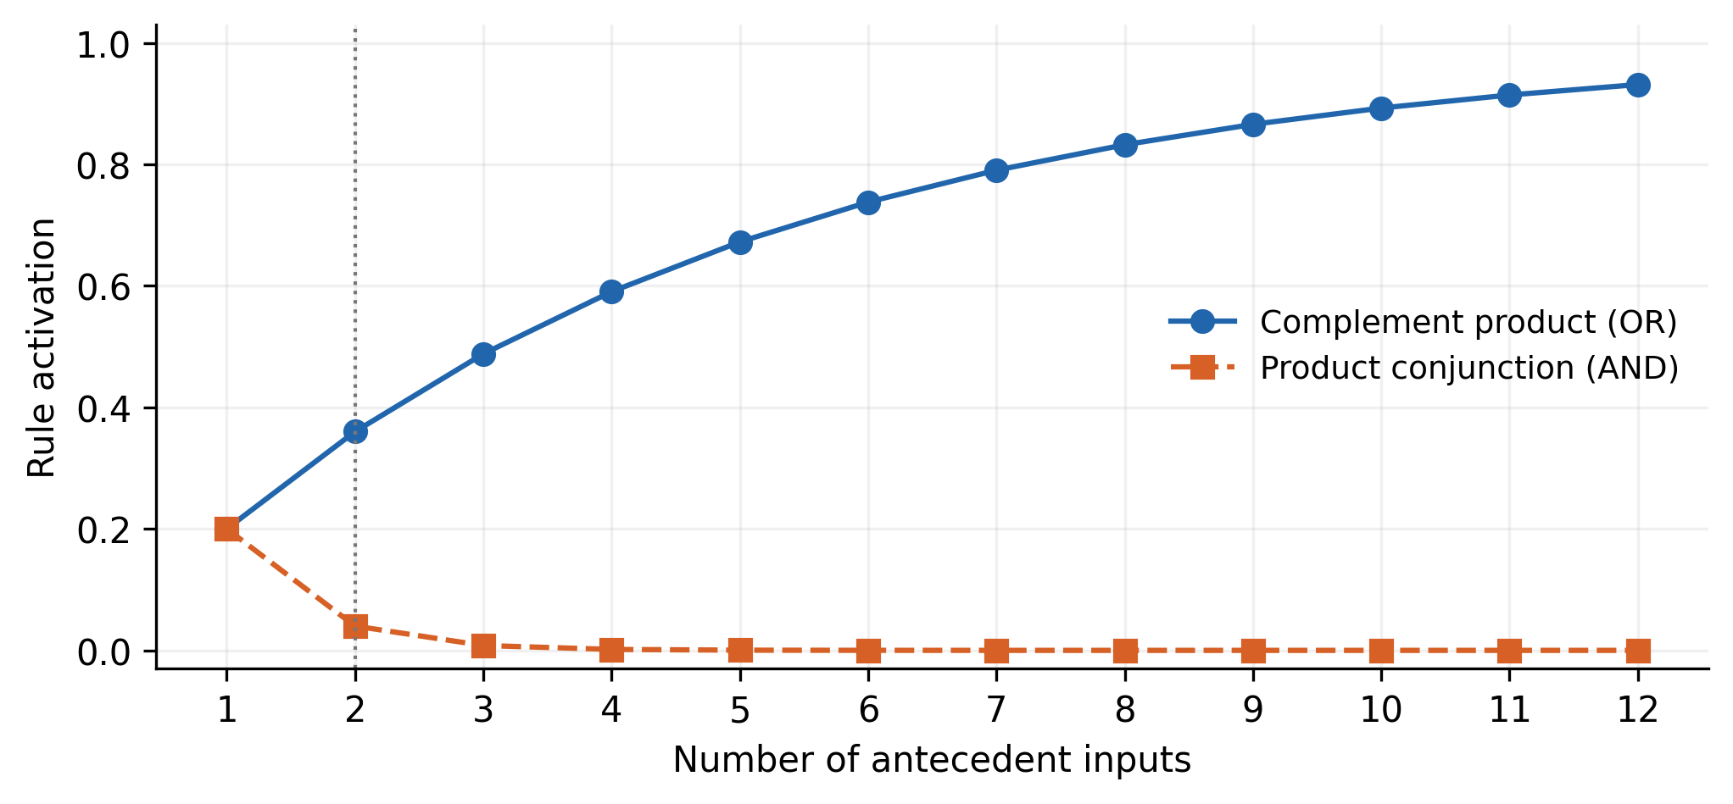
Figure 1. Analytical activations when every input membership is fixed at 0.2. The comparison illustrates operator behavior and is not a new identification experiment. The vertical guide identifies the two input modules used by the hierarchy.

3.3 Normalization and output boundedness
With consequent functions $g_{i}\left(x\right)$, the prediction is
$$A\left(x\right)=\sum_{i=1}^{R}{a_{i}}\left(x\right), ω_{i}\left(x\right)=\frac{a_{i}\left(x\right)}{A\left(x\right)}, \hat{y}\left(x\right)=\sum_{i=1}^{R}{ω_{i}}\left(x\right)g_{i}\left(x\right).\text{ (5)}$$
If $A>0$, the normalized weights are nonnegative and sum to one. Therefore,
$$\min_{i}g_{i}\left(x\right)≤\hat{y}\left(x\right)≤\max_{i}g_{i}\left(x\right).\text{ (6)}$$
The proof follows directly from the convex combination. It bounds the output by the current consequent values, not by the global training output range. A consequent can itself exceed the observed range.
Coverage requires a declared lower tolerance for $A$. Replacing $A$ by $A+ϵ$ changes the normalized model and can bias the output toward zero. A fallback policy should therefore be explicit, such as reporting an uncovered observation or using a separately defined nearest supported module.

3.4 Nonlinear radial consequents
Each consequent uses a mean and two representative deviations:
$$g_{i}\left(x\right)={\overline{y}}_{i}+Δy_{i}^{+}exp\left(−σ_{i}^{+}r_{i,+}^{2}\right)+Δy_{i}^{−}exp\left(−σ_{i}^{−}r_{i,−}^{2}\right).\text{ (7)}$$
Here $r_{i,+}^{2}=∥x−x_{i}^{+}∥^{2}$ and $r_{i,−}^{2}=∥x−x_{i}^{−}∥^{2}$ are squared distances in scaled coordinates. The signed deviations are $Δy_{i}^{+}=y_{i}^{+}−{\overline{y}}_{i}$ and $Δy_{i}^{−}=y_{i}^{−}−{\overline{y}}_{i}$. The lower deviation is ordinarily nonpositive. Keeping its sign is necessary to represent a decrease around the representative minimum. Positive widths prevent radial terms from growing exponentially with distance.
The two radial terms supply curvature that a first order affine consequent cannot represent within one rule. However, overlap between the terms means that $g_{i}\left(x_{i}^{+}\right)$ need not equal $y_{i}^{+}$ exactly. Representative values are parameters of the approximator, rather than guaranteed interpolation constraints. A scalar consequent on a general multidimensional domain is also not assumed to be injective.
Algorithm 1. Evaluate an improved product inference module.
Inputs: scaled x, membership tables, consequent parameters
For each rule:
Locate the input interval in each dimension
Read or interpolate memberships by the declared convention
Calculate activation as one minus product of complements
Calculate the mean and both signed radial contributions
Calculate the sum of rule activations
If coverage is inadequate: invoke the declared fallback
Otherwise normalize activations and average the consequents
Return prediction and activation diagnostics

4 Hybrid parameter learning

4.1 Competitive antecedent adaptation
Input $j$ is partitioned into $B_{j}$ intervals with midpoints $θ_{jk}$. A table entry $a_{ijk}∈[0,1]$ stores membership for rule $i$, input $j$, and interval $k$. The center is
$$b_{ij}=\frac{\sum_{k=1}^{B_{j}}{a_{ijk}}θ_{jk}}{\sum_{k=1}^{B_{j}}{a_{ijk}}}.\text{ (8)}$$
The table notation $a_{ijk}$ is distinct from the scalar activation $a_{i}\left(x\right)$. A nonzero sum is required for a center to exist. Empty tables require reseeding or another declared repair.
Competitive learning finds the rule center nearest the current scaled input. The winning rule and its specified neighbors are updated. Entries between the center interval and the input interval are strengthened; entries beyond the input in the movement direction are weakened. With effective step $γ∈[0,1]$,
$$a_{strengthened}′=\left(1−γ\right)a+γ, a_{weakened}′=\left(1−γ\right)a.\text{ (9)}$$
Both updates preserve the interval $[0,1]$ when the previous value lies in that interval. This boundedness follows from convexity. It does not establish convergence to a particular membership shape or an optimal partition.
Algorithm 2. Learn antecedent membership tables.
Initialize interval boundaries, bounded tables and rule centers
Specify sample order, rule neighborhood and decay schedules
For each training pass within the declared budget:
For each selected training input:
Find the nearest center in scaled input coordinates
For the winner and its declared neighboring rules:
Locate the input interval and center interval
Strengthen entries between those intervals
Weaken entries beyond the input in its direction
Preserve all other entries
Recalculate the center and repair empty tables
Update learning and neighborhood schedules
Stop if the declared table-change criterion is met
The algorithm uses input distribution information. It can organize the antecedent regions without using validation targets, but it does not automatically choose the number of rules. That choice should be selected under the same model selection protocol as other capacity settings.

4.2 Representative extrema and local averaging
The consequent parameters require a local mean and representative high and low response regions. Directly selecting an observed maximum can select a noise excursion. The source instead averages inputs associated with high or low outputs and then averages nearby outputs.
Let $I_{i}$ be observations assigned to rule $i$. A reproducible version defines selection thresholds, a distance radius $h$, and a minimum neighborhood count. The mean is calculated on the assigned training observations. High output observations determine a representative location $x_{i}^{+}$, and a neighborhood around that location determines $y_{i}^{+}$. The lower region is handled symmetrically.
Algorithm 3. Estimate rule representative values.
Assign training observations to a maximum-activation rule
For each rule:
Check the assigned count and apply an empty-set policy
Calculate the assigned mean output
Select high-output inputs using a fixed training rule
Average those inputs to obtain the upper location
Average outputs in its declared neighborhood
Repeat for the lower location and lower output
Record selection counts, radii and repair operations
Return representative locations, values and signed deviations
If a fixed neighborhood contains $n_{h}$ independent zero mean noise terms with variance $σ_{ν}^{2}$, averaging reduces their noise variance to $σ_{ν}^{2}/n_{h}$. This conditional result helps explain the motivation. Selection based on extreme observed outputs can introduce bias, and a larger neighborhood can smooth away actual nonlinear structure. The complete procedure therefore does not eliminate noise exactly.
The radius controls a bias and variance tradeoff. Very small neighborhoods preserve locality but may retain noise. Large neighborhoods improve averaging but can merge distinct response features. Radius and thresholds should be chosen on model selection data, while the representative values themselves must be estimated using training targets only.

4.3 Loss and consequent gradients
With antecedents and representative values fixed, let $ϑ$ contain the radial widths. The fitting loss is
$$J\left(ϑ\right)=\frac{1}{2N}\sum_{k=1}^{N}{{\left({\hat{y}}_{k}−y_{k}\right)}^{2}}.\text{ (10)}$$
Define $r_{ki}^{+2}=∥x_{k}−x_{i}^{+}∥^{2}$. The derivative of a consequent is
$$\frac{∂g_{i}\left(x_{k}\right)}{∂σ_{i}^{+}}=−Δy_{i}^{+}r_{ki}^{+2}exp\left(−σ_{i}^{+}r_{ki}^{+2}\right).\text{ (11)}$$
The corresponding derivative for the lower component uses its signed lower deviation. Because activations are fixed during this stage,
∂J∂σi+=1Nk​yk−ykωixk∂gixk∂σi+. (12)
This expression includes both the normalized rule weight and the actual output residual. Omitting either changes the optimized objective.
Positive widths can be represented by $σ_{i}^{±}=exp\left(ρ_{i}^{±}\right)$, giving
$$\frac{∂J}{∂ρ_{i}^{±}}=σ_{i}^{±}\frac{∂J}{∂σ_{i}^{±}}.\text{ (13)}$$
The representation is a proposed reproducible implementation choice. Exponential overflow should be prevented through a declared numerical range. It is not established as the exact parameterization used in the historical scripts.

4.4 Conjugate gradient fitting
The source specifies conjugate gradient learning. An explicit batch Fletcher Reeves form uses
$$p_{0}=−g_{0}, β_{t}=\frac{∥g_{t+1}∥^{2}}{∥g_{t}∥^{2}}, p_{t+1}=−g_{t+1}+β_{t}p_{t}.\text{ (14)}$$
A line search chooses a step on the current direction. Numerical restart is needed if the direction ceases to be a descent direction or the denominator becomes negligible. The exact historical line search and termination tolerances remain unavailable.
Algorithm 4. Fit positive consequent widths.
Fix antecedents and representative values from training data
Initialize log widths and calculate full loss and gradient
Set the search direction to the negative gradient
While the gradient and fitting budget permit:
Find an acceptable line-search step
Update log widths and recalculate loss and gradient
Calculate the Fletcher Reeves direction coefficient
Restart if the direction is not descending
Record objective calls, gradients and numerical repairs
Return the fitted widths and convergence diagnostics
A finite difference gradient check on a small fixed dataset can verify the analytical derivative implementation. It should compare the same loss and fixed antecedents. Such a check validates code consistency; it does not establish that a local minimum generalizes.

5 Hierarchical GMDH construction and complexity

5.1 Layer organization
The first layer considers all distinct pairs of original inputs. Each pair forms a two input IPINF module. The best $L$ modules are selected by checking error, and their predictions are averaged:
zqx=1Lℓ∈Sq​yq,ℓx. (15)
For later layers, the current aggregate is paired separately with each original input. This preserves access to the original variables while limiting additional candidates to $m$ per layer. It differs from generating every pair among all retained internal features.
For $H$ constructed layers, the candidate module count before pruning is
$$N_{cand}=\left({m \atop 2}\right)+\left(H−1\right)m.\text{ (16)}$$
The count presumes the described architecture and one candidate per listed pair. It describes constructed modules, not automatically the minimal active inference graph after unused branches are removed.
Algorithm 5. Construct and select the hierarchy.
Separate training, model-selection and final test trajectories
Fit scaling from training observations only
Create first-layer candidates from all original input pairs
For each layer up to the maximum:
Fit each candidate using Algorithms 2, 3 and 4
Evaluate candidate predictions on model-selection data
Retain the best L candidates and form their mean output
Save the aggregate, score and required dependency graph
Stop by the declared improvement or patience condition
Pair the aggregate with each original input for the next layer
Select the saved layer by model-selection performance
Evaluate final test trajectories once with all settings frozen
The checking subset in the source participates in selecting modules and stopping depth. Its score is therefore a model selection result. A separate untouched test set is needed for a final generalization estimate.

5.2 Parameter storage and computational work
A module with $m$ inputs, $R$ rules, and $B$ intervals per input stores $mRB$ membership entries. If it separately stores one mean, two deviations, two widths, and two $m$ dimensional locations per rule, its consequent storage is $R\left(5+2m\right)$ scalars. Thus, one explicit storage convention gives
$$P_{module}=R\left(mB+2m+5\right).\text{ (17)}$$
For two inputs, two rules, and thirty intervals, this is 120 membership entries and 18 consequent scalars, or 138 scalars before additional indexing and optimization buffers. Fifteen such modules would store 1,800 membership entries and 270 consequent scalars under this convention.
These are analytical storage counts. Some representative quantities are estimated summaries rather than independently optimized degrees of freedom; derived centers may be cached or recomputed. The historical implementation’s exact memory usage is not inferred from Equation (17). The calculation establishes why rule count alone is incomplete.
With constant time interval lookup, a module evaluation requires work proportional to $Rm$, including memberships, activation, distances, and radial terms. Training also evaluates losses and gradients across observations, with potentially many line-search calls. An epoch in one architecture can therefore have a different cost from an epoch in another.

5.3 Sensitivity through the hierarchy
Each additional layer introduces a derivative through its aggregate input. If a module is locally differentiable, the chain rule can propagate sensitivity to original inputs. Large derivatives can accumulate even when each module has few rules. A compact hierarchy is therefore not automatically a smooth or robust predictor.
For a rollout with local Lipschitz bound $L_{f}$ and one step approximation bound $ϵ$, an illustrative error recursion is
$$∥δ_{h+1}∥≤L_{f}∥δ_{h}∥+ϵ, ∥δ_{h}∥≤ϵ\sum_{j=0}^{h−1}{L_{f}^{j}} \text{if }δ_{0}=0.\text{ (18)}$$
The bound explains why strong one step fit can coexist with poor long horizon behavior when sensitivity exceeds one. It is conditional on the stated bounds and common input sequence; it is not a measured bound for the historical models.

6 Experimental design and score interpretation

6.1 Source score and centered regression metrics
The source defines its hierarchical checking score as
S=1001−k​yk−yk2k​yk2. (19)
This is an output energy normalized fit score. It is not classification accuracy and is not generally centered $R^{2}$. Since $∑y_{k}^{2}=∑{\left(y_{k}−\overline{y}\right)}^{2}+N{\overline{y}}^{2}$, a large output mean can make this score appear favorable even when centered variation is modeled less well.
When centered variation is nonzero, the relationship is
R2=1−1−S100k​yk2k​yk−y2. (20)
The historical table values are retained as source fit scores. Without the associated predictions, they cannot be independently converted into centered $R^{2}$, RMSE, or error distributions.

6.2 Training and evaluation boundaries
Function approximation uses 1,000 observations divided into 500 fitting and 500 checking samples. The Mackey Glass example uses 1,000 indexed observations with the same nominal split. Cart pole identification uses 5,000 training and 1,000 checking observations generated at a 20 ms sampling period from multiple initial conditions.
These boundaries should be interpreted according to the task. Independent sampled function points can support a random split if the sampling distribution is declared. Time series and closed loop trajectories require chronological or trajectory based separation. Scaling, antecedent learning, representative extrema, and hyperparameter selection must all respect those boundaries.

7 Results and graphical reassessment

7.1 Nonlinear function approximation
The source uses the functions
$$f_{1}\left(x_{1},x_{2}\right)=\frac{1}{2}\left[1+sin\left(2πx_{1}\right)cos\left(2πx_{2}\right)\right],\text{ (21)}$$
and
$$f_{2}\left(x_{1},x_{2}\right)=0.5+\frac{64\left(x_{1}−0.5\right)\left(x_{2}−0.5\right)\left(x_{1}+0.125\right)}{1+{\left(4x_{1}−2\right)}^{2}+{\left(4x_{2}−2\right)}^{2}}.\text{ (22)}$$
The IPINF configuration uses four rules and thirty intervals per input. Sampling method and random seed are needed to reproduce the exact fitted surfaces.
Table 1. Function approximation results under two rule budgets.
Model | Equal rules | Equal score percent | Equal time s | Larger rules | Larger score percent | Larger time s
IPINF | 4 | 98.8 | 5.3 | 4 | 98.8 | 5.3
ANFIS | 4 | 94.3 | 3.4 | 9 | 98.8 | 9.7
Effective product | 4 | 90.7 | 8.1 | 49 | 98.2 | 68.6
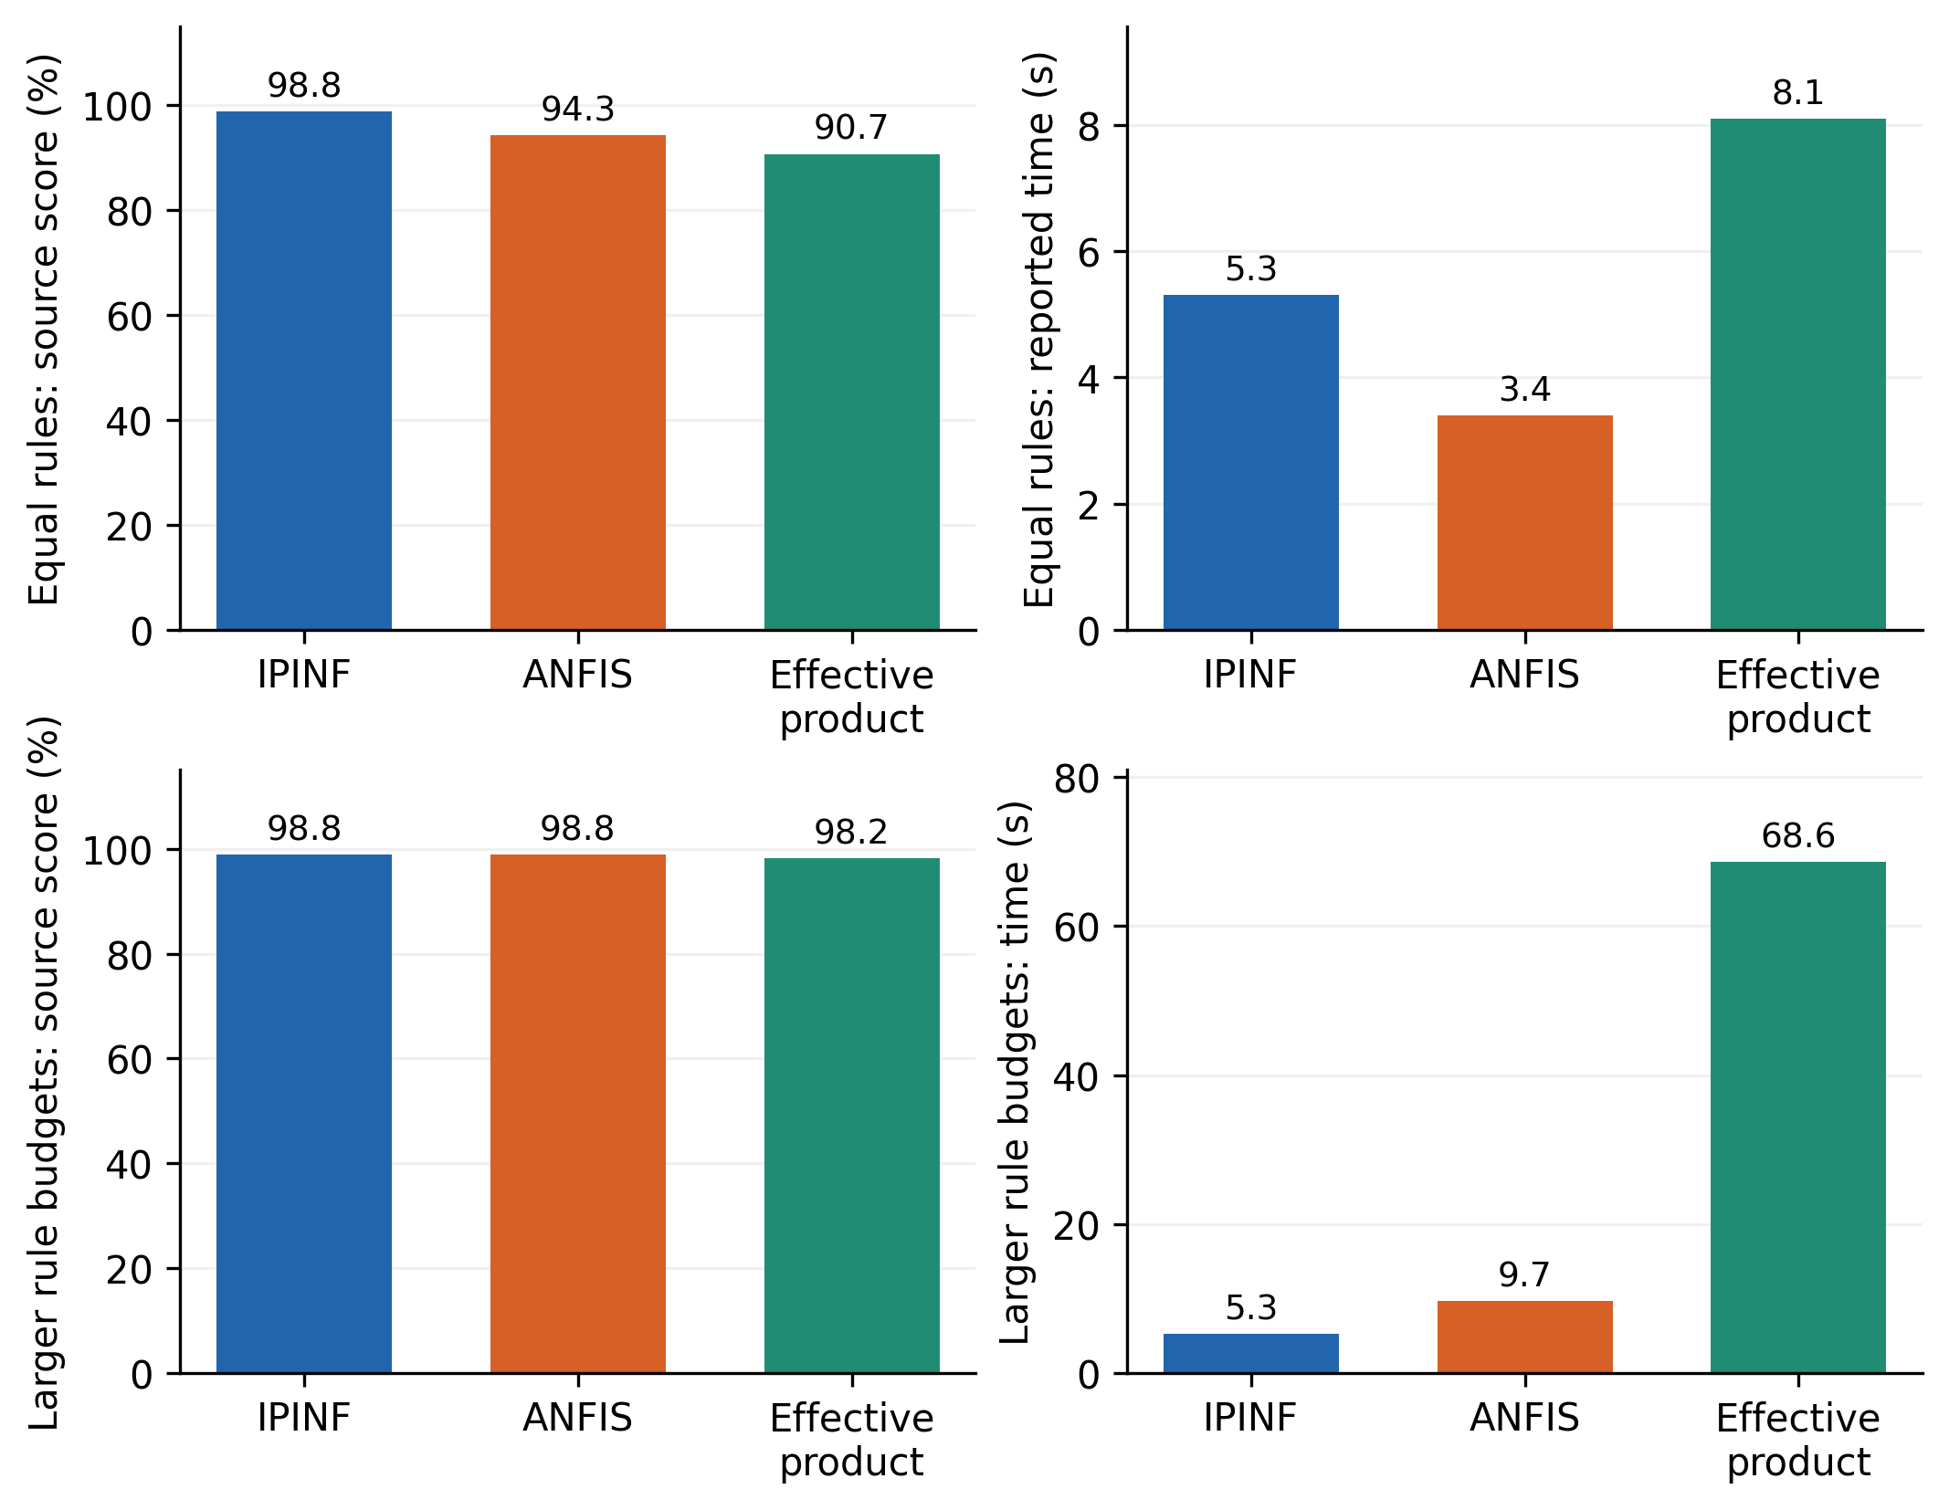
Figure 2. Source function approximation scores and times. Equal rule count and larger rule budget comparisons answer different questions and are shown separately.
With four rules, IPINF has a 4.5 percentage point advantage over ANFIS and an 8.1 point advantage over effective product inference. It is also 1.9 s slower than ANFIS. This combination suggests that the nonlinear consequent representation provides more fitted expressiveness per rule while adding computational work.
When ANFIS uses nine rules, its reported score matches IPINF at 98.8%, and its training time is 9.7 rather than 5.3 s. The records therefore support a representation and computation tradeoff at similar reported fit, while the equal rule comparison does not support a universal speed advantage.

7.2 Noise sensitivity
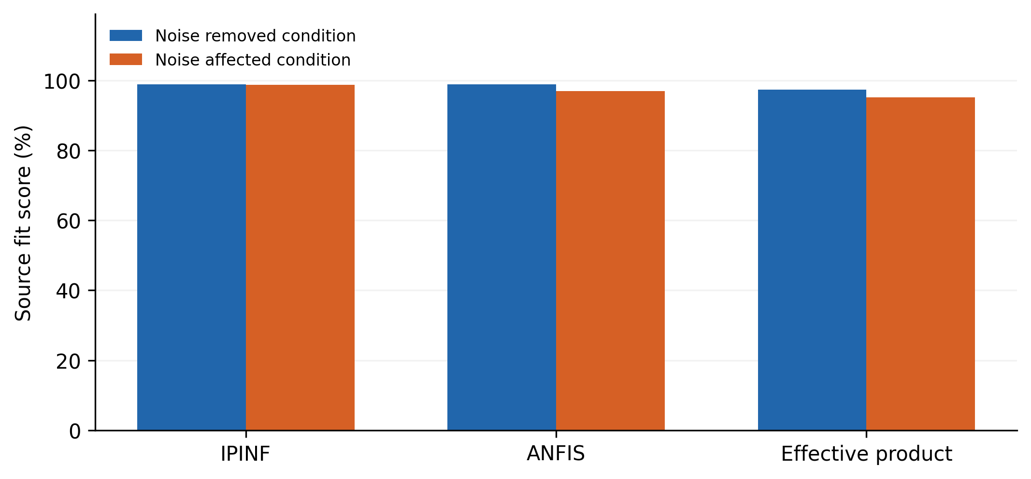
Figure 3. Scores for the source’s noise removed and noise affected conditions. The differences describe one reported experiment and do not represent repeated noise uncertainty.
The score changes are 98.9 to 98.8 for IPINF, 98.9 to 96.9 for ANFIS, and 97.4 to 95.2 for effective product inference. The decreases are 0.1, 2.0, and 2.2 percentage points, respectively.
The pattern is consistent with better retention of agreement in the reported IPINF example. It does not isolate the local averaging mechanism because model structure and consequent learning also differ. An informative ablation would keep the same IPINF architecture and compare representative values selected with and without averaging across repeated noise realizations.
The source describes zero mean unit variance noise. Its practical severity depends on signal scaling and on whether it affects inputs, outputs, or both. Normalized noise amplitude, generation seeds, neighborhood counts, and test noise conditions are needed for a reproducible robustness result.

7.3 Mackey Glass prediction
The predictor inputs are $x\left(t−18\right)$, $x\left(t−12\right)$, $x\left(t−6\right)$, and $x\left(t\right)$, with target $x\left(t+6\right)$. The source selects 1,000 indices from 118 through 1,117 and states a delay parameter of 17 and initial value of 1.2. The standard benchmark convention is
$$\dot{x}\left(t\right)=\frac{0.2x\left(t−17\right)}{1+x{\left(t−17\right)}^{10}}−0.1x\left(t\right).\text{ (23)}$$
The source prints a positive linear term, creating an unresolved generator discrepancy. Equation (23) follows the standard negative damping convention [36]; it does not establish which equation produced the original data. Delay history, integration method, time step, and transient removal must also be specified.
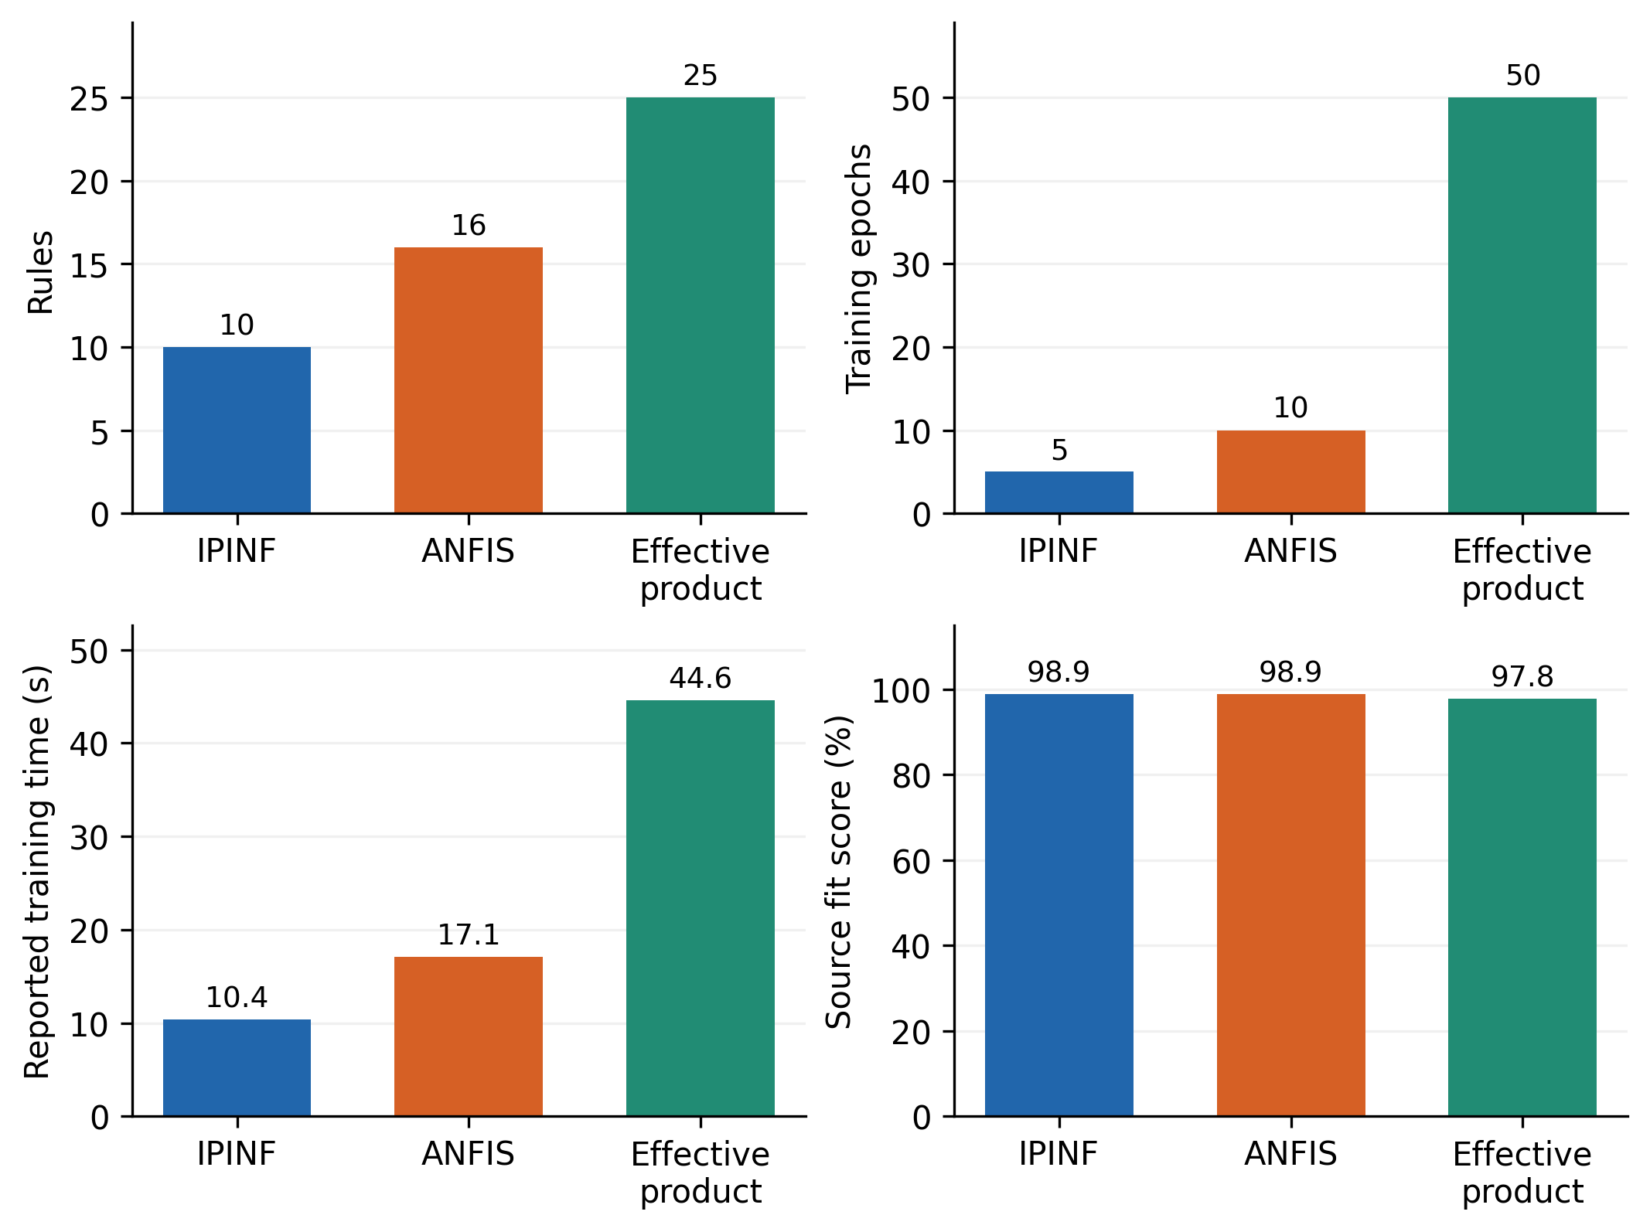
Figure 4. Reported standalone IPINF, ANFIS, and effective product results. This benchmark does not use the complete cart pole hierarchy.
IPINF uses ten rules, five epochs, and 10.4 s to reach a reported score of 98.9%. ANFIS uses sixteen rules, ten epochs, and 17.1 s for the same score. Effective product inference uses twenty five rules, fifty epochs, and 44.6 s for 97.8%.
These figures suggest a favorable tradeoff for the standalone IPINF configuration in that experiment. The generator ambiguity and missing predictions prevent independent verification. Chronological evaluation should also exclude training targets that extend beyond the evaluation boundary. Sharing past observations can be appropriate for an issued time series forecast, but using future target information in scaling or training is not.

7.4 Cart pole model size and training effort
The cart pole example models cart position and pendulum angle separately. The input description includes position, angle, derived motion variables, and control input, but the source is inconsistent about velocity versus acceleration. This choice changes the identification task and must be fixed before replication.
The documented hierarchy contains ten first layer and five second layer modules, each with two rules. Thus,
$$R_{hierarchy}=10\left(2\right)+5\left(2\right)=30 \text{rules per output}.\text{ (24)}$$
Table 2. Source cart pole model counts per output.
Model | Total rules | Reported epochs
ANFIS | 32 | 20
Effective product neuro fuzzy model | 243 | 200
GMDH IPINF | 30 | 10
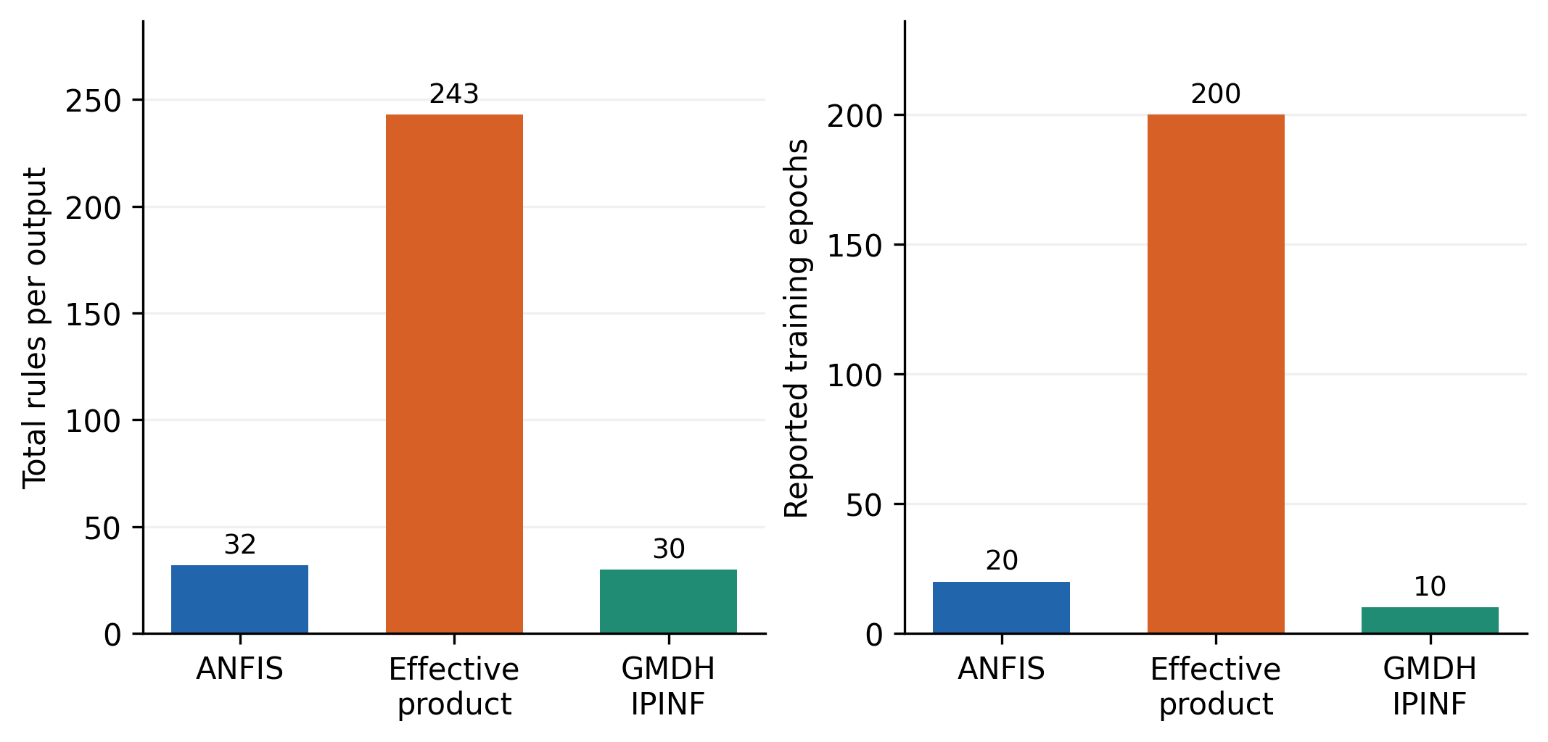
Figure 5. Aggregate rules per output and reported training epochs. Epochs do not establish wall clock speed because per-epoch computation differs.
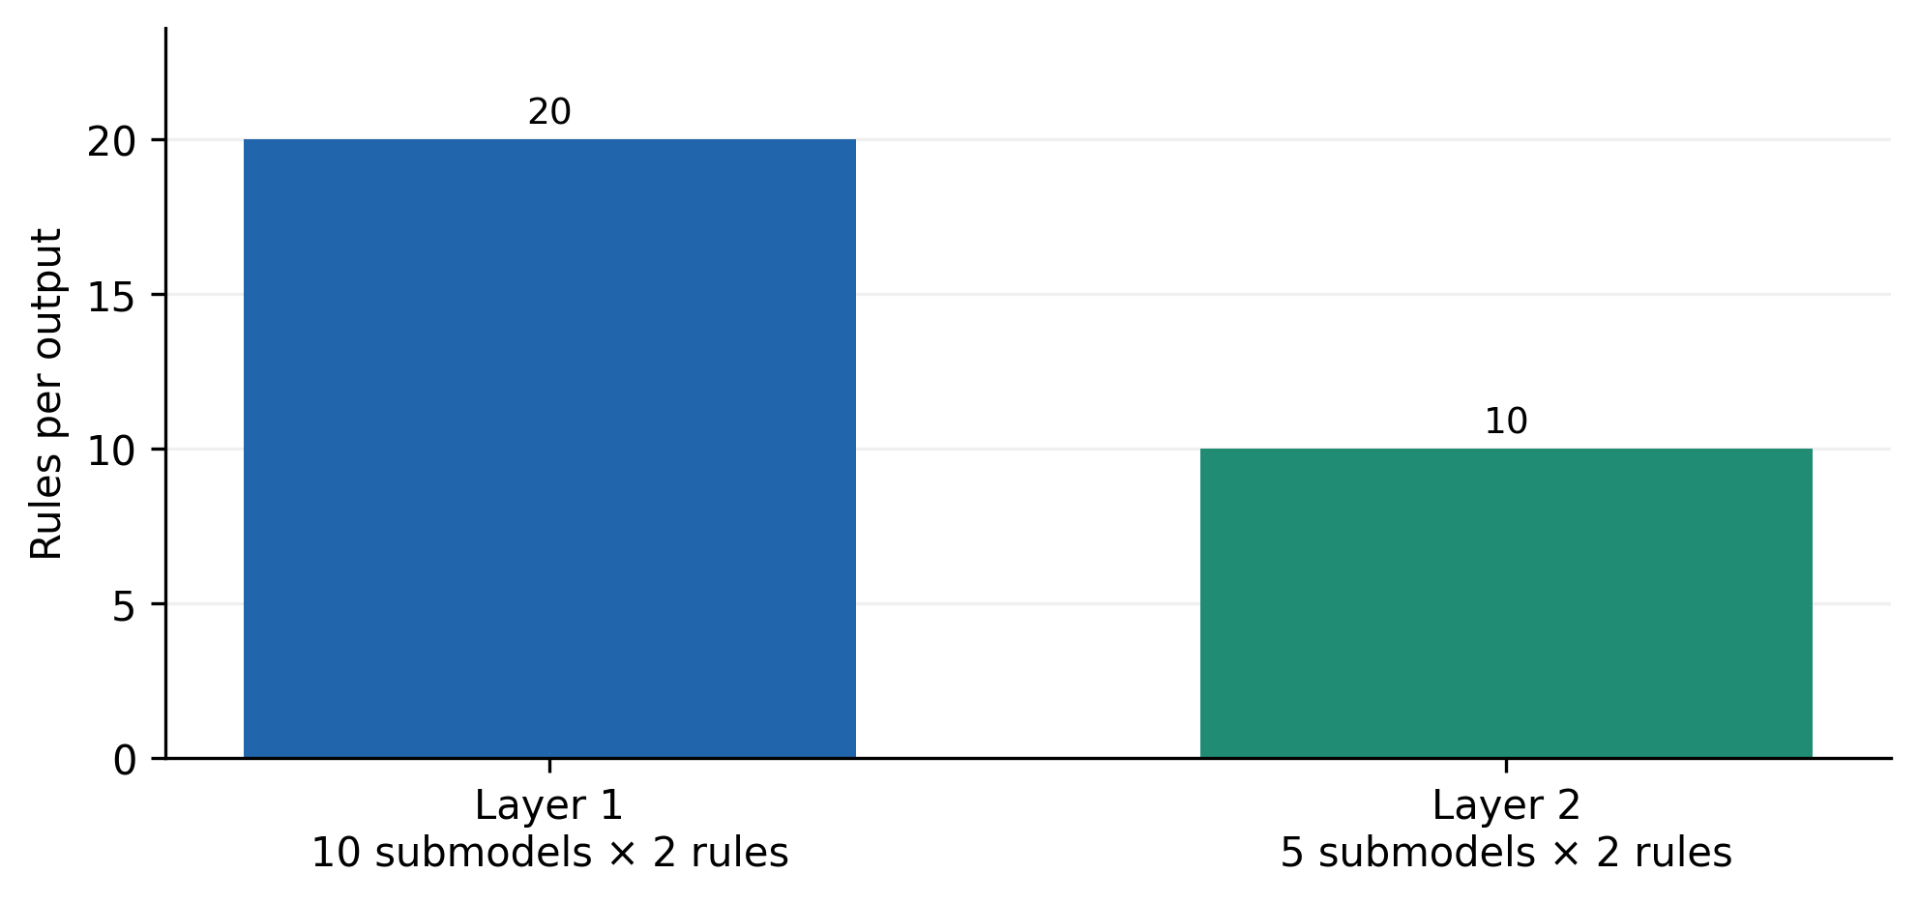
Figure 6. The documented thirty rules are distributed across fifteen modules for one modeled output. Membership tables and nonlinear consequent parameters add further storage.
For both outputs, the hierarchy contains sixty rules, compared with sixty four for ANFIS and 486 for effective product inference. The reductions remain 6.25% and 87.65%, respectively. Counting the two rules in one module as the size of the complete hierarchy would substantially overstate compactness.
The source response curves are described as closely matched, but full numerical errors are unavailable. Accordingly, no new cart pole RMSE or confidence interval is assigned. The appropriate next step is to compare one step and free simulation errors on trajectories withheld from all structure selection.

8 Dynamic validation and discussion

8.1 Independent trajectory evaluation
Algorithm 6. Evaluate dynamic identification beyond one step fit.
Define regressors, delays, target horizon and output units
Separate complete training, selection and test trajectories
Fit all preprocessing and model settings without test targets
For each frozen model and each test trajectory:
Calculate one-step predictions using allowed observations
Initialize a rollout from the same measured starting history
Feed predicted outputs back for the declared rollout horizon
Record horizon-specific errors and numerical failures
Examine residual correlation with past inputs and outputs
Report complexity, objective calls and measured inference time
Keep failed rollouts in the comparison
One step prediction tests the fitted mapping under observed histories. Free simulation tests accumulated model error. Residual autocorrelation can reveal unmodeled dynamics, while residual dependence on past inputs can indicate that useful predictive information remains. Confidence assessments must account for temporal dependence rather than treating every sample from one trajectory as an independent experiment.

8.2 Mechanism specific ablations
The main mechanisms should be isolated through matched variants: conventional product conjunction versus complement product activation; affine versus nonlinear radial consequents; direct extrema versus local averaging; fixed memberships versus competitive learning; and a flat module versus the hierarchy. Common train and test splits, model selection budgets, and parameter accounting are essential.
An equal rule experiment measures expressiveness per rule. An equal parameter experiment measures capacity under a closer storage constraint. An equal time experiment measures practical efficiency. These experiments are complementary. None should be presented as the only fair comparison without explaining the intended engineering objective.

8.3 Interpretation and limitations
The method combines broad partial match activation with flexible local consequents and a low dimensional hierarchy. This combination provides a plausible reason for achieving favorable reported fit with relatively few rules. The activation analysis also identifies a potential weakness: broad weights can reduce local interpretability and make an apparently simple rule respond to poorly matched inputs.
The most persuasive evidence is the documented tradeoff in the function and standalone time series tables. The cart pole example establishes a particular architecture and training count, but lacks sufficient numerical predictions for a complete accuracy comparison. The denoising claim remains conditional on an incompletely specified selection and averaging procedure.
Reproducibility depends on choices that are often omitted from a compact method description: interval interpolation, sample ordering, neighborhood schedules, empty rule handling, extrema thresholds, line search, and hierarchical stopping. The equations and algorithms presented here make those choices visible. Completing the configuration and testing independent trajectories would convert the historical results into a more rigorous comparative identification study.

9 Conclusions
A detailed hierarchical GMDH IPINF formulation has been presented with explicit inference, competitive learning, local averaging, positive width optimization, and model selection procedures. The analysis establishes the operator’s partial match behavior, derives consequent gradients, and distinguishes rule count from parameter and runtime complexity.
The reported experiments indicate a favorable fit and computation tradeoff under several budgets. The complete cart pole hierarchy contains thirty rules per output, yielding a modest reduction relative to ANFIS and a larger reduction relative to effective product inference. Strong claims about generalization, noise removal, and dynamic robustness require resolved benchmark settings, complete predictions, and untouched trajectory tests. The expanded formulation supplies a coherent basis for those evaluations.

Data and code availability
The research package provides transcribed function, noise, Mackey Glass, complexity, and architecture tables with graph generation code. The activation graph is an analytical illustration calculated from Equation (4). Original training scripts, benchmark generators, membership tables, selected modules, and complete predicted trajectories are needed to reproduce the historical accuracy values.

References
[1] Yan, J.; Li, J.; Bai, G.; Zong, T. (2024). Identification of nonlinear system with time delay based on wavelet packet decomposition and Gaussian kernel GMDH network. International Journal of Systems Science, 55(8), 1737-1753. https://doi.org/10.1080/00207721.2024.2317354
[2] Beintema, G.I.; Schoukens, M.; Tóth, R. (2023). Deep subspace encoders for nonlinear system identification. Automatica, 156, 111210. https://doi.org/10.1016/j.automatica.2023.111210
[3] Forgione, M.; Muni, A.; Piga, D.; Gallieri, M. (2023). On the adaptation of recurrent neural networks for system identification. Automatica, 155, 111092. https://doi.org/10.1016/j.automatica.2023.111092
[4] Ahmed, A.; del Rio-Chanona, E.A.; Mercangöz, M. (2025). Comparative Study of Machine Learning and System Identification for Process Systems Engineering Dynamics. Industrial & Engineering Chemistry Research, 64(8), 4450-4478. https://doi.org/10.1021/acs.iecr.4c03264
[5] Wang, T.; Gault, R.; Greer, D. (2026). Data Informed Initialization of Fuzzy Membership Functions. International Journal of Fuzzy Systems, 28(2), 597-608. https://doi.org/10.1007/s40815-024-01971-1
[6] Pham, D.H.; Lin, C.M.; Giap, V.N.; Nguyen, V.T.; Pham, N.T. (2026). Self-Organizing Takagi–Sugeno–Kang Fuzzy Elliptic Type-2 CMAC for Nonlinear Systems with Uncertainty. International Journal of Fuzzy Systems, 28(5), 1691-1707. https://doi.org/10.1007/s40815-025-02046-5
[7] Canbek, K.O.u.; Ulu, C. (2025). Learning-Based Dynamic Takagi–Sugeno Fuzzy Modeling of Nonlinear Systems. International Journal of Fuzzy Systems. https://doi.org/10.1007/s40815-025-02137-3
[8] Bian, Z.; Chang, Q.; Wang, J.; Pal, N.R. (2025). Multihead Takagi–Sugeno–Kang Fuzzy System. IEEE Transactions on Fuzzy Systems, 33(8), 2561-2573. https://doi.org/10.1109/tfuzz.2025.3569227
[9] Wang, J.; Kang, M. (2025). Fuzzy-Membership-Kernel Learning Based on Takagi–Sugeno Models. International Journal of Fuzzy Systems, 27(2), 550-557. https://doi.org/10.1007/s40815-024-01763-7
[10] Bainier, G.; Marx, B.; Ponsart, J.C. (2024). Generalized nonlinear sector approaches for Takagi-Sugeno models. Fuzzy Sets and Systems, 476, 108791. https://doi.org/10.1016/j.fss.2023.108791
[11] Xue, G.; Hu, L.; Wang, J.; Ablameyko, S. (2025). ADMTSK: A High-Dimensional Takagi–Sugeno–Kang Fuzzy System Based on Adaptive Dombi T-Norm. IEEE Transactions on Fuzzy Systems, 33(6), 1767-1780. https://doi.org/10.1109/tfuzz.2025.3535640
[12] Xia, H.; Tang, J.; Yu, W.; Cui, C.; Qiao, J. (2023). Takagi–Sugeno Fuzzy Regression Trees With Application to Complex Industrial Modeling. IEEE Transactions on Fuzzy Systems, 31(7), 2210-2224. https://doi.org/10.1109/tfuzz.2022.3221790
[13] Sun, J.; Dai, Y.; Zhao, K.; Jia, Z. (2021). Second order Takagi-Sugeno fuzzy model with domain adaptation for nonlinear regression. Information Sciences, 570, 34-51. https://doi.org/10.1016/j.ins.2021.04.024
[14] Deng, Z.; Cao, Y.; Lou, Q.; Choi, K.S.; Wang, S. (2022). Monotonic relation-constrained Takagi-Sugeno-Kang fuzzy system. Information Sciences, 582, 243-257. https://doi.org/10.1016/j.ins.2021.09.015
[15] Wang, J.; Chang, Q.; Gao, T.; Zhang, K.; Pal, N.R. (2022). Sensitivity analysis of Takagi–Sugeno fuzzy neural network. Information Sciences, 582, 725-749. https://doi.org/10.1016/j.ins.2021.10.037
[16] Gu, S.; Chou, Y.; Zhou, J.; Jiang, Z.; Lu, M. (2024). Takagi–Sugeno–Kang Fuzzy Clustering by Direct Fuzzy Inference on Fuzzy Rules. IEEE Transactions on Emerging Topics in Computational Intelligence, 8(2), 1264-1279. https://doi.org/10.1109/tetci.2023.3336537
[17] Coutinho, P.H.S.; Oliveira, P.M.; Bessa, I.; Lacerda, M.J.; Palhares, R.M. (2025). Data-driven nonquadratic stabilization of Takagi-Sugeno fuzzy systems. Journal of the Franklin Institute, 362(17), 108131. https://doi.org/10.1016/j.jfranklin.2025.108131
[18] Zhu, X.; Wang, D.; Pedrycz, W.; Li, Z. (2022). Horizontal Federated Learning of Takagi–Sugeno Fuzzy Rule-Based Models. IEEE Transactions on Fuzzy Systems, 30(9), 3537-3547. https://doi.org/10.1109/tfuzz.2021.3118733
[19] El-Nagar, A.M.; El-Bardini, M.; Khater, A.A. (2023). Recurrent general type-2 fuzzy neural networks for nonlinear dynamic systems identification. ISA Transactions, 140, 170-182. https://doi.org/10.1016/j.isatra.2023.06.003
[20] Luo, G.; Min, H.; Yang, Z. (2024). Identification of nonlinear dynamical system based on adaptive radial basis function neural networks. Neural Computing and Applications, 36(25), 15617-15629. https://doi.org/10.1007/s00521-024-09794-9
[21] Negrini, E.; Citti, G.; Capogna, L. (2021). System identification through Lipschitz regularized deep neural networks. Journal of Computational Physics, 444, 110549. https://doi.org/10.1016/j.jcp.2021.110549
[22] Rodrigues, L.; Givigi, S. (2023). System Identification and Control Using Quadratic Neural Networks. IEEE Control Systems Letters, 7, 2209-2214. https://doi.org/10.1109/lcsys.2023.3285720
[23] Kang, H.H.; Ahn, C.K. (2023). Neural Network-Based Moving Window Iterative Nonlinear System Identification. IEEE Signal Processing Letters, 30, 1007-1011. https://doi.org/10.1109/lsp.2023.3301236
[24] Cruz, G.G.; Renczes, B.; Runacres, M.C.; Decuyper, J. (2025). State-Space Kolmogorov Arnold Networks for Interpretable Nonlinear System Identification. IEEE Control Systems Letters, 9, 847-852. https://doi.org/10.1109/lcsys.2025.3578019
[25] Paniagua, J.L.; López, J.A. (2024). Nonlinear system identification using modified variational autoencoders. Intelligent Systems with Applications, 22, 200344. https://doi.org/10.1016/j.iswa.2024.200344
[26] Zisis, K.; Bechlioulis, C.P.; Rovithakis, G.A. (2022). Control-Enabling Adaptive Nonlinear System Identification. IEEE Transactions on Automatic Control, 67(7), 3715-3721. https://doi.org/10.1109/tac.2021.3106870
[27] Courts, J.; Wills, A.G.; Schön, T.B.; Ninness, B. (2023). Variational system identification for nonlinear state-space models. Automatica, 147, 110687. https://doi.org/10.1016/j.automatica.2022.110687
[28] Champneys, M.; Beintema, G.I.; Tóth, R.; Schoukens, M.; Rogers, T.J. (2024). Baseline Results for Selected Nonlinear System Identification Benchmarks. IFAC-PapersOnLine, 58(15), 474-479. https://doi.org/10.1016/j.ifacol.2024.08.574
[29] Brouri, A. (2022). Wiener–Hammerstein nonlinear system identification using spectral analysis. International Journal of Robust and Nonlinear Control, 32(10), 6184-6204. https://doi.org/10.1002/rnc.6135
[30] Frank, D.; Holicki, T.; Scherer, C.W.; Staab, S. (2026). Regularised neural network-based nonlinear system identification with prior system knowledge. International Journal of Control, 99(8), 2658-2686. https://doi.org/10.1080/00207179.2026.2679228
[31] Sobolewski, Ł. (2025). Time Scale Control Using Dynamic GMDH Neural Network Forecasting Based on Real Measurement Data. Applied Sciences, 15(12), 6932. https://doi.org/10.3390/app15126932
[32] Schwedersky, B.B.; Flesch, R.C.C.; Dangui, H.A.S. (2022). Nonlinear MIMO System Identification with Echo-State Networks. Journal of Control, Automation and Electrical Systems, 33(3), 743-754. https://doi.org/10.1007/s40313-021-00874-y
[33] Takagi, T.; Sugeno, M. (1985). Fuzzy identification of systems and its applications to modeling and control. IEEE Transactions on Systems, Man, and Cybernetics, SMC-15(1), 116-132. https://doi.org/10.1109/tsmc.1985.6313399
[34] Jang, J.S.R. (1993). ANFIS: adaptive-network-based fuzzy inference system. IEEE Transactions on Systems, Man, and Cybernetics, 23(3), 665-685. https://doi.org/10.1109/21.256541
[35] Wang, L.X.; Mendel, J.M. (1992). Generating fuzzy rules by learning from examples. IEEE Transactions on Systems, Man, and Cybernetics, 22(6), 1414-1427. https://doi.org/10.1109/21.199466
[36] Mackey, M.C.; Glass, L. (1977). Oscillation and Chaos in Physiological Control Systems. Science, 197(4300), 287-289. https://doi.org/10.1126/science.267326

