Scheduled Shark Smell Optimization for Hierarchical Fuzzy Cart Pole Control and Robustness Evaluation

Abstract
Optimizer based controller tuning must be evaluated through both nominal performance and successful stabilization under conditions withheld from tuning. This study develops a detailed formulation of scheduled shark smell optimization for a hierarchical fuzzy cart pole controller. The analysis connects the underactuated mechanical model, swing up and local regulation, controller parameter optimization, coefficient schedules, velocity restriction, local search, and objective evaluation cost. Seven algorithms specify controller execution, trajectory evaluation, gradient estimation, scheduled search, rotational alternatives, ant colony comparison, and independent robustness testing. Particular attention is given to the original magnitude based velocity formula, its direction convention, and the absorbing effect of a zero preceding velocity. Historical run tables are reassessed graphically. Across six nominal comparisons with shark smell optimization, mean total error decreases from 13.157 to 10.726 and reported transition time decreases from 4.525 to 3.905 s. Across twelve comparisons with a fuzzy ant colony baseline, recalculated mean total error decreases from 12.779 to 10.760, a reduction of 15.80%. In a seventeen case angular velocity sweep, the scheduled method settles in four cases, remains oscillatory in eleven, and diverges in two; the baseline settles in none. The results indicate improved nominal summaries and fewer divergent cases, but do not establish a broad guaranteed stabilization region. The formulation provides a coherent basis for reproducing the optimization mechanism and testing its contribution under equal objective-call budgets, explicit physical constraints, and visible failure accounting.
Keywords: cart pole; fuzzy control; shark smell optimization; parameter scheduling; underactuated systems; robustness evaluation

1 Introduction
The cart pole combines a translating cart with a pendulum driven indirectly by the cart force. One input must influence both cart position and pendulum angle. The system is consequently useful for studying underactuation, nonlinear coupling, swing up, and stabilization. Its apparent simplicity can be misleading: performance depends strongly on coordinate conventions, initial state, actuator limits, and the way a controller changes between operating regions.
Controller parameters can be selected through numerical optimization when the closed loop objective is difficult to minimize analytically. Population methods offer a way to explore a nonconvex tuning space, but they add their own parameters, stochastic variation, and computational cost. A lower training objective does not automatically imply improved control on a new initial condition.
Recent work studies LQG design, robust fuzzy descriptor methods, adaptive fuzzy sliding modes, polynomial fuzzy control, real world decoupling, and optimization based adaptive sliding regulation [1–6]. Combined optimal and sliding methods, velocity controlled robotic experiments, interval type 2 modeling, and second order sliding approaches further illustrate the current range of cart pole related control research [7–10].
The present study examines a scheduling modification to shark smell optimization. The proposed search decreases the gradient coefficient, increases momentum, and decreases the velocity restriction coefficient over the optimization horizon. It tunes parameters of a hierarchical fuzzy controller that coordinates swing up and local regulation.
The contribution is developed at two levels. The method section explains how the search relates to controller mechanics, constrained trajectory evaluation, and actual computational effort. The results section recalculates all nominal summaries and preserves failed robustness cases. This structure makes it possible to assess whether the scheduling mechanism offers an engineering benefit without treating favorable nominal averages as proof of general stabilization.

2 Related work and optimizer identity

2.1 Distinguishing the search algorithms
Shark smell optimization and the white shark optimizer are separate methods. The white shark optimizer has its own published formulation [11]. Modified shark smell methods have been applied to odor localization and parking trajectory planning, while white shark variants use their own search structures [12–14]. Biological terminology is insufficient to identify an algorithm.
The method studied here follows the shark smell mechanism of gradient influenced forward movement, momentum, velocity restriction, and local rotational alternatives [34]. The source also discusses white shark background material. That discussion is not used to substitute a different optimizer’s equations into the scheduled method.
Reproducible multimetric benchmarking and large scale comparisons of metaphor based heuristics emphasize implementation identity, common budgets, repeated runs, and appropriate established baselines [15,16]. These requirements are particularly relevant when each objective evaluation simulates a nonlinear closed loop trajectory.

2.2 Controller analysis and learned model comparisons
Self learning fuzzy control, LMI constrained tracking, sector representations, and nonquadratic stabilization address closed loop properties beyond optimizer performance [17–20]. Their analytical guarantees depend on explicit assumptions. A population search that finds a low cost controller does not inherit those guarantees.
If tuning uses a learned plant, deep subspace identification, recurrent adaptation, and comparative process modeling provide relevant model assessment tools [21–23]. Membership initialization, self organizing fuzzy models, multihead structures, direct inference clustering, and sensitivity analysis address the structure of the fuzzy controller or surrogate [24–28]. Quadratic networks, control enabling identification, Wiener Hammerstein methods, and interpretable state space models offer additional identification alternatives [29–32].
Critical work on metaphor based optimization argues for evaluating mathematical mechanisms and reproducible results rather than algorithm names [33]. This paper follows that principle by expressing the schedules and update rules directly. The original shark smell method and fuzzy ant colony controller tuning supply the historical optimization comparisons [34,35].
The comparison task is kept specific: optimize the same controller architecture for the same plant and objective, then evaluate frozen parameters on independent conditions. Changing both controller architecture and optimizer would make it difficult to identify the source of a performance difference.

3 Cart pole dynamics and hierarchical control

3.1 Coordinates and physical model
A consistent coordinate convention is needed before interpreting angle error or swing up. For the analytical formulation below, $x$ is cart displacement, $θ=0$ is the upright pendulum, and positive horizontal force acts in the positive $x$ direction. The pendulum center of mass is at horizontal coordinate $x+lsinθ$ and vertical coordinate $lcosθ$.
Let $M$ be cart mass, $m$ pendulum mass, $l$ the pivot to center of mass distance, and $J_{c}$ the pendulum inertia about its center of mass. Define $J_{p}=J_{c}+ml^{2}$. With viscous terms $b\dot{x}$ and $d\dot{θ}$, the equations are
$$\begin{matrix}\left(M+m\right)\ddot{x}+mlcosθ \ddot{θ}−mlsinθ {\dot{θ}}^{2} & =F−b\dot{x}, \\ J_{p}\ddot{θ}+mlcosθ \ddot{x}−mglsinθ & =−d\dot{θ}.\end{matrix}\text{ (1)}$$
They follow from the kinetic and potential energies
$$\begin{matrix}T & =1/2\left(M+m\right){\dot{x}}^{2}+mlcosθ \dot{x}\dot{θ}+1/2J_{p}{\dot{θ}}^{2}, \\ V & =mglcosθ.\end{matrix}\text{ (2)}$$
The mass matrix determinant is $\left(M+m\right)J_{p}−m^{2}l^{2}\cos^{2}θ$. It is positive under the usual nondegenerate positive mass and length assumptions. Solving the coupled equations gives both accelerations from one force input. The coupling is the reason cart and pendulum corrections cannot be selected independently.
The historical tables state an initial angle near 3.14 rad but do not fully resolve the angle origin and angle error convention. Equation (1) declares a coherent convention for analysis; it is not used to infer an undocumented source convention or generate new experimental trajectories.

3.2 Swing up and local regulation
Near upright, the gravitational term destabilizes the angle. Far from upright, a local linear controller may not inject enough pendulum energy to reach the regulation region. A hierarchical architecture therefore separates a swing up contribution from local angle and position correction.
A useful partial pendulum energy is
$$E_{p}=1/2J_{p}{\dot{θ}}^{2}+mglcosθ, E_{p}^{*}=mgl.\text{ (3)}$$
This is energy associated with motion relative to the pivot and gravitational height; it is not the complete coupled cart and pendulum energy. From Equation (1),
$${\dot{E}}_{p}=−mlcosθ \ddot{x} \dot{θ}−d{\dot{θ}}^{2}.\text{ (4)}$$
Cart acceleration can add or remove pendulum energy depending on its phase relative to angular motion. Equation (4) exposes this indirect actuation mechanism while retaining the dissipative effect of pivot friction.
In an ideal undamped acceleration controlled illustration, choosing $\ddot{x}=k_{E}\left(E_{p}−E_{p}^{*}\right)\dot{θ}cosθ$ makes the derivative of $1/2{\left(E_{p}−E_{p}^{*}\right)}^{2}$ nonpositive. This illustrates the swing up mechanism; it does not specify the source fuzzy swing up rule base, guarantee escape from a motionless downward state, or enforce cart travel limits.
For local regulation, define errors relative to declared references and sliding variables
$$s_{θ}={\dot{e}}_{θ}+c_{θ}e_{θ}, s_{x}={\dot{e}}_{x}+c_{x}e_{x}, c_{θ},c_{x}>0.\text{ (5)}$$
If a sliding variable could be held at zero, its associated error would decay exponentially. One actuator cannot generally enforce both surfaces independently, so the coordination law is part of the controller design.

3.3 Fuzzy coordination and tuned parameters
A generic hierarchical representation is
$$F=\left(1−h\right)F_{swing}+h\left[γF_{θ}+\left(1−γ\right)F_{x}\right], h,γ∈[0,1].\text{ (6)}$$
Here $h$ determines the swing up versus regulation contribution, and $γ$ balances local pendulum and cart corrections. The functions may depend on angle, angular velocity, sliding variables, and fuzzy memberships. Equation (6) provides an explicit conceptual organization, rather than reconstructing unavailable source coefficients.
The tuned vector $ϑ$ must identify every adjustable quantity: gains, membership breakpoints, scaling factors, coordination parameters, and any switching thresholds. The source sometimes calls the problem PID tuning while describing fuzzy swing up and sliding components. A new implementation must identify the actual controller being optimized.
Algorithm 1. Execute the hierarchical fuzzy controller.
Inputs: measured state, references, fixed parameter vector
Convert angle to the declared reference convention
Calculate cart and pendulum errors and sliding variables
Evaluate high-level memberships for swing up and regulation
Calculate the active swing-up and local corrective outputs
Combine them using the fixed coordination law
Apply calibrated force and force-rate constraints
Return force, active memberships and controller mode
Mode hysteresis or smooth blending can reduce rapid switching, but changes to these mechanisms must be declared. An optimizer comparison should not alter them implicitly.

4 Tuning objective and trajectory evaluation

4.1 Parameter constraints and cost
The optimization problem is
$$\min_{ϑ∈Ω}J\left(ϑ\right), J\left(ϑ\right)=\frac{1}{K}\sum_{k=1}^{K}{J}\left(ϑ;ξ_{k}\right),\text{ (7)}$$
where $Ω$ contains feasible controller parameters and $ξ_{k}$ are tuning conditions. A complete condition includes initial state, plant parameters, disturbance sequence, and solver settings.
A contemporary trajectory cost could combine normalized angle error, cart error, control effort, and constraint penalties. Its weights and scales must be fixed in advance. The source’s TE, AE, and DE values are not redefined through an invented cost, because their exact integration windows and normalization are not consistently documented.
Constraints should include finite simulation states, actuator limits, travel limits when a physical track is claimed, and a well defined stabilization objective. A low integrated error can coexist with unacceptable late oscillation or a brief constraint violation. Cost and success status should therefore both be retained.

4.2 Failure and settling definitions
Let the regulation condition require angle, cart displacement, and relevant velocities to stay within declared tolerances. A settling time can be defined as
$$t_{s}=inf\{t:\text{all required tolerances hold for every }τ∈[t,T_{eval}]\}.\text{ (8)}$$
The definition is conditional on the finite evaluation horizon. A minimum dwell requirement can be added, but must be common to all methods. An oscillatory or divergent trajectory does not have an ordinary finite settling time under this definition.
Algorithm 2. Evaluate one controller parameter vector.
For each declared tuning condition:
Initialize the same plant, solver and controller states
Simulate with Algorithm 1 over the fixed horizon
Record tracking, force, limits and numerical status
Classify the outcome using fixed tolerance and failure rules
Calculate the declared trajectory cost
Apply the fixed failure handling without discarding the run
Aggregate costs over all tuning conditions
Return aggregate cost, condition costs and success statuses
A large penalty must be documented if used. Lexicographic feasibility ranking is another option, but it can create a nonsmooth search objective. Neither convention should replace failed runs by zero error.

5 Scheduled shark smell optimization

5.1 Cost and odor sign convention
The original odor interpretation maximizes an objective. For controller cost minimization, define
$$F_{odor}\left(ϑ\right)=−J\left(ϑ\right), ∇F_{odor}=−∇J.\text{ (9)}$$
A positive step along the odor gradient is then a cost descending step locally. Forgetting this sign conversion reverses the intended search direction.
Parameter scaling affects gradients. A gain measured in hundreds and a membership location restricted to a fraction of a radian should not be treated as equivalent coordinate steps without a declared scale. Normalizing parameter bounds to a common search domain is a possible implementation extension, but the transformation must be saved and applied consistently.

5.2 Coefficient schedules
For iterations $t=0,…,T_{max}−1$ with $T_{max}>1$, define $q_{t}=t/\left(T_{max}−1\right)$. The schedules are
$$η_{t}=η_{start}+\left(η_{end}−η_{start}\right)q_{t}, α_{t}=α_{start}+\left(α_{end}−α_{start}\right)q_{t}.\text{ (10)}$$
The proposed gradient coefficient decreases from one to zero, while the momentum coefficient increases from zero to one. Each start and end subscript refers to that coefficient’s own endpoints, avoiding a reversal of the momentum schedule.
The source restriction coefficient has the form
$$β_{t}=\frac{V_{max}}{V_{min}N_{P}}\left[ω_{start}+\left(ω_{end}−ω_{start}\right)q_{t}\right], V_{min}>0.\text{ (11)}$$
Here $N_{P}$ is population size and the bracketed schedule decreases from one to zero. The velocity ratio and population factor remain part of the numerical restriction; the normalized schedule alone does not specify its magnitude.
Table 1. Proposed coefficient trends.
Coefficient | Start | End | Role
Gradient eta | 1 | 0 | Scales current gradient
Momentum alpha | 0 | 1 | Scales preceding velocity
Normalized beta | 1 | 0 | Restricts velocity magnitude
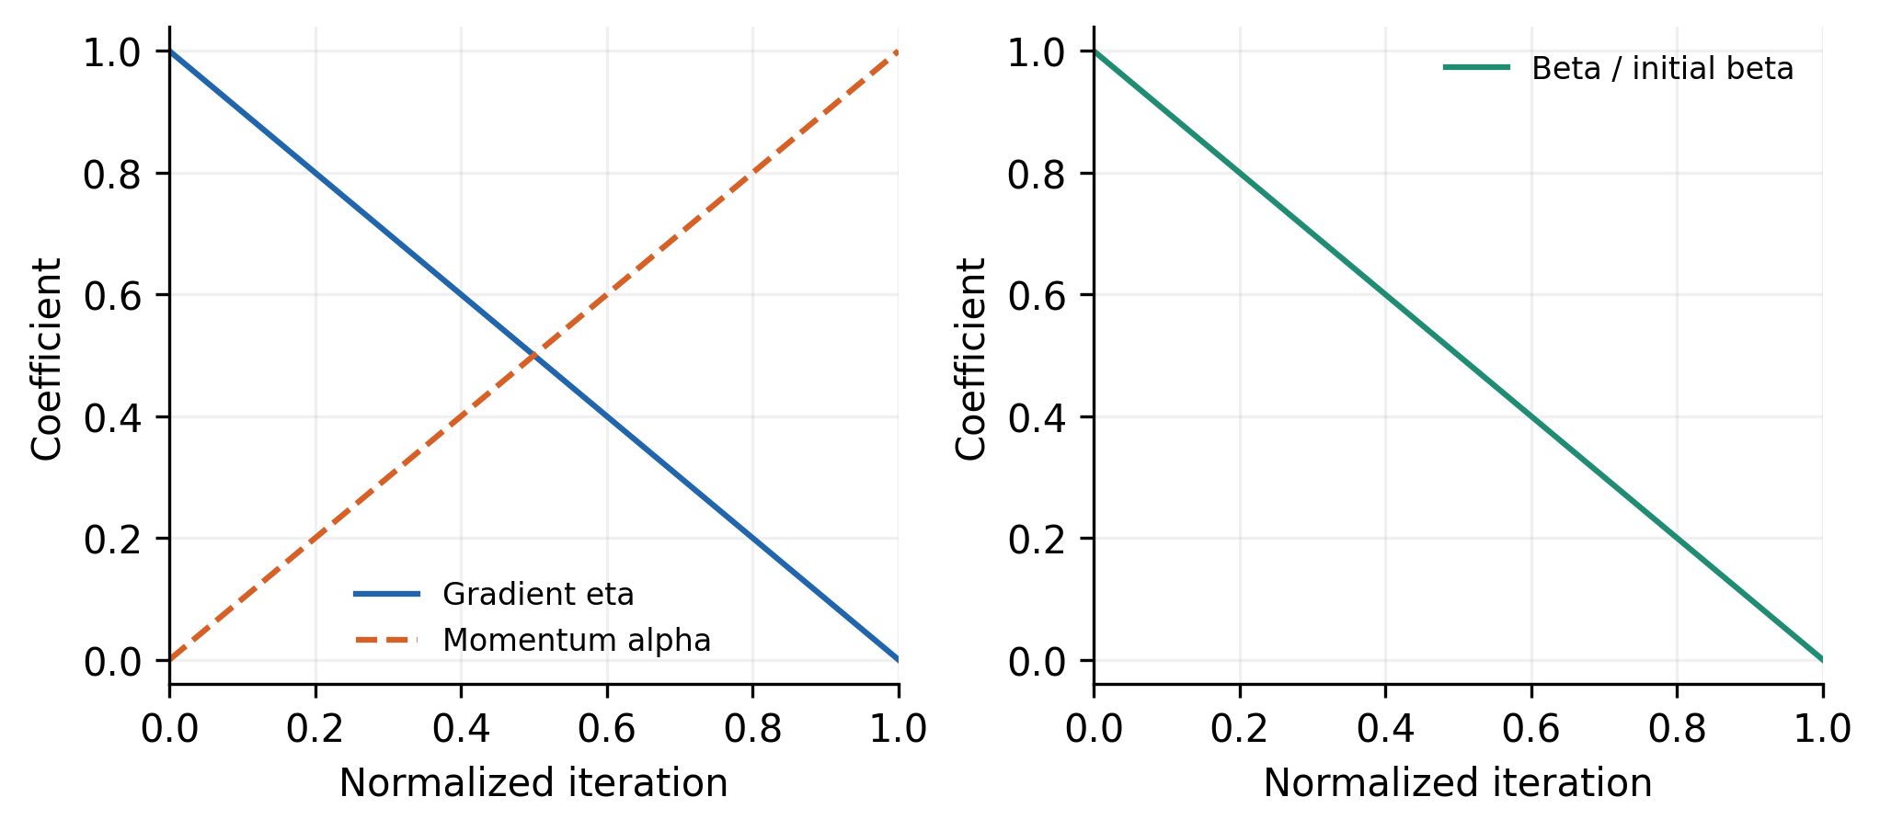
Figure 1. The proposed linear trends against normalized iteration. The restriction curve is divided by its initial value; its absolute value also depends on the velocity ratio and population size. This is an algorithm illustration, not an observed convergence curve.
The schedules are deterministic functions of iteration. They should be described as scheduling, rather than feedback adaptation to measured search quality, unless an additional feedback mechanism is implemented.

5.3 Gradient estimation and objective calls
For an interior parameter coordinate, a central difference estimate is
$$\frac{∂F_{odor}}{∂ϑ_{j}}≈\frac{F_{odor}\left(ϑ+h_{j}e_{j}\right)−F_{odor}\left(ϑ−h_{j}e_{j}\right)}{2h_{j}}.\text{ (12)}$$
Step sizes depend on parameter scaling and numerical noise. Shared disturbance realizations can reduce comparison noise when stochastic trajectories are used. Near bounds, an appropriate one-sided or feasible difference is needed.
Algorithm 3. Estimate a feasible odor gradient.
Inputs: candidate, bounds, coordinate steps, remaining budget
For each parameter coordinate:
Select feasible positive and negative perturbations
Confirm that their objective calls fit the remaining budget
Evaluate full controller costs using Algorithm 2
Form the central or declared one-sided odor difference
Record calls, failures and the actual perturbation distance
Return the gradient and updated evaluation count
If failure penalties create discontinuities, a finite difference can reflect a classification boundary rather than a smooth local improvement. Such gradients should be interpreted as numerical search information, not a differentiability guarantee.

5.4 Velocity restriction and its direction convention
For population member $i$, the unrestricted proposal is
$${\tilde{v}}_{i,t}=η_{t}r_{1,i,t}∇F_{odor}\left(ϑ_{i,t}\right)+α_{t}r_{2,i,t}v_{i,t−1}.\text{ (13)}$$
The random factors follow the declared uniform convention. The source restricts component magnitudes through a minimum. One explicit operational direction convention is
$$v_{ij,t}=sign\left({\tilde{v}}_{ij,t}\right)min\{\left|{\tilde{v}}_{ij,t}\right|, \left|β_{t}v_{ij,t−1}\right|\}.\text{ (14)}$$
Equation (14) preserves the proposal direction. The printed source magnitude equation does not uniquely establish this convention; choosing the sign of the selected minimum argument could produce different behavior when momentum and gradient oppose each other. Historical replication therefore requires the original code.
If $v_{ij,t−1}=0$, Equation (14) gives $v_{ij,t}=0$ regardless of gradient. That component of forward velocity remains zero unless a declared restart or alternative rule changes it. Rotational candidates can still change the position. At the final scheduled endpoint, $β_{t}=0$ suppresses forward movement under this restriction even though momentum reaches one. These consequences should be tested rather than hidden by a convergence claim.

5.5 Forward and rotational candidates
The forward candidate is
$$y_{i,t}=Π_{Ω}\left(ϑ_{i,t}+Δt v_{i,t}\right).\text{ (15)}$$
The source takes the stage interval as one. Its local alternative formula is
$$z_{i,t}^{\left(m\right)}=y_{i,t}+r_{3}^{\left(m\right)}y_{i,t}, r_{3}^{\left(m\right)}∼U[−1,1].\text{ (16)}$$
As printed with a scalar random number, this is a multiplicative perturbation along the ray through $y$. Independent coordinate factors would produce a different multidimensional neighborhood. The scalar or componentwise convention should therefore be explicit.
The formula is also coordinate dependent: a zero component cannot change through a multiplicative perturbation alone, and translating the search origin changes its behavior. It should not be interpreted automatically as a uniform rotation or a fixed radius Euclidean neighborhood.
Algorithm 4. Generate and select rotational alternatives.
Inputs: forward candidate y, local count M, bounds, convention
Evaluate y if it is not already cached
For each local alternative within the remaining budget:
Draw a scalar or componentwise uniform factor as declared
Form z = y + factor * y
Apply the common bound-handling rule
Evaluate z and retain its cost and failure status
Select the best admissible forward or local candidate
Return the selected vector and all objective-call records
The selection among forward and local candidates is distinct from retaining the preceding population member. A separate best-so-far archive can preserve the best feasible vector without silently changing the population acceptance rule.

5.6 Complete scheduled search
Algorithm 5. Tune controller parameters by scheduled search.
Declare parameter bounds, population, seed and total call budget
Initialize candidate vectors and previous nonzero velocities
Evaluate initial vectors and create a best-so-far archive
For each iteration while objective calls remain:
Calculate eta, alpha and beta from the fixed schedules
For each population member:
Estimate the odor gradient with Algorithm 3
Form and restrict the velocity using the declared sign
Generate the bounded forward candidate
Select forward or rotational results with Algorithm 4
Update the population member and preceding velocity
Apply a restart only if it is part of the declared method
Update the archive and log cost versus actual calls
Return the best feasible vector and the complete search log
A source-matching execution can disable restarts; an enhanced execution can specify them as a separate variant. Their effects must not be attributed to scheduling alone.

5.7 Computational budget
For $d$ parameters, $M$ local alternatives, and central differences at every interior point, one population iteration requires approximately
$$N_{calls,iter}=N_{P}\left(2d+1+M\right),\text{ (17)}$$
before cache reuse, early termination, or additional repairs. Initialization requires another $N_{P}$ calls. If each objective averages $K$ initial conditions, the trajectory simulation count is approximately $K$ times the objective count.
This accounting explains why equal population size and iteration count do not establish equal tuning effort. Gradient based search can consume substantially more simulations per iteration than a comparator without numerical gradients. Performance should be plotted against actual objective calls and elapsed time.

6 Ant colony comparison and evaluation design

6.1 Comparator formulation
The historical fuzzy ant colony system selects controller parameters through pheromone guided search [35]. A generic discrete transition probability can be written
Pjℓ=τjℓa Hjℓbr∈Cj​τjra Hjrb, (18)
where $C_{j}$ contains available values, $τ$ is pheromone, and $H$ is a heuristic desirability. Exponents, discretization, fuzzy adjustments, evaporation, and deposit rules determine the actual FACS implementation.
Algorithm 6. Tune the common controller with an ant colony comparator.
Fix candidate values, pheromone settings and evaluation budget
Initialize pheromone and the same trajectory cost definition
While calls remain:
For each ant within budget:
Construct parameters with the declared transition rule
Evaluate the full controller through Algorithm 2
Record cost, constraints and failure status
Apply the declared evaporation and deposit updates
Apply the identified fuzzy adjustments if using FACS
Return the best feasible vector and complete evaluation log
The pseudocode explains the comparison mechanism. The historical result table alone cannot reconstruct its exact fuzzy transition and pheromone rules.

6.2 Independent robustness protocol
The data provide six nominal SSO comparisons, twelve nominal FACS comparisons, and changed initial state sweeps. Corresponding row numbers do not prove matched random seeds. The proposed method’s results in the two nominal tables are kept as separate comparison sets.
Algorithm 7. Evaluate nominal performance and robustness.
Fix plant, solver, horizon, constraints and metric definitions
Choose tuning states and independent evaluation states
For each optimizer and each declared seed:
Tune only on the tuning states under an equal call budget
Freeze the resulting controller parameter vector
Evaluate all independent states and plant variations
Classify settled, oscillatory and divergent outcomes
Calculate common metrics without removing failures
Report cost distributions and success counts separately
Use paired inference only when the design establishes pairing
Compare schedule ablations under the same full protocol
Robustness tests should include initial state variation and, where supported, mass, inertia, friction, delay, noise, and actuator uncertainty. A grid of deterministic stress cases measures behavior on that grid; it is not automatically a probability of success under an unknown operating distribution.

7 Results and graphical reassessment

7.1 Nominal comparison with shark smell optimization
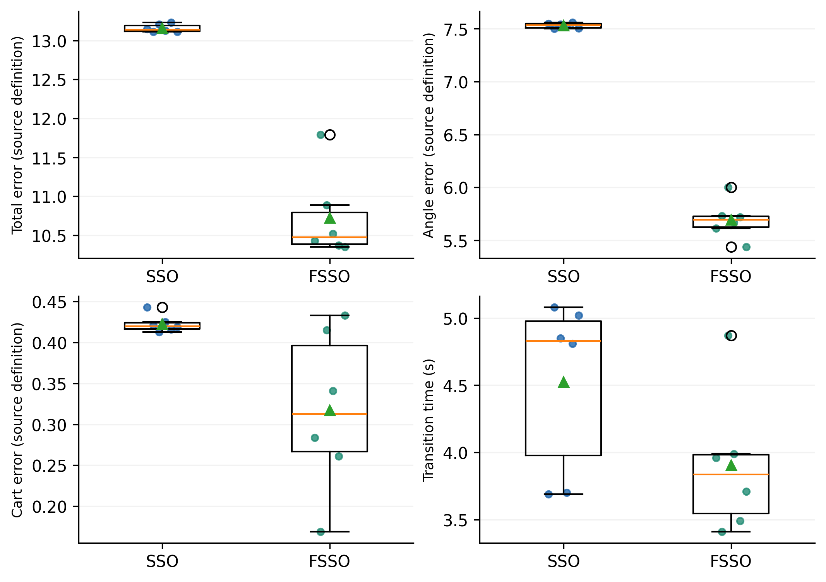
Figure 2. Source nominal runs against SSO. Points retain all observations, while boxes and mean markers summarize their distributions. Run indices do not establish seed pairing.
Table 2. Recomputed means for the six SSO comparisons.
Metric | SSO mean | Scheduled mean | Relative reduction percent
Total error TE | 13.1572 | 10.7255 | 18.48
Angle error AE | 7.5303 | 5.6940 | 24.39
Displacement error DE | 0.42283 | 0.31717 | 24.99
Transition time ST s | 4.5250 | 3.9050 | 13.70
All four means improve in this table. However, total error sample standard deviation increases from 0.0505 for SSO to 0.5571 for the scheduled method. Lower mean cost therefore coexists with greater run variability for that criterion.
The scheduled transition time is worse in three of the six rowwise comparisons, despite the lower overall mean. These reversals demonstrate why the distribution and complete observations matter. No paired significance claim is assigned because a shared seed or matched initialization design is not documented.

7.2 Nominal comparison with fuzzy ant colony tuning
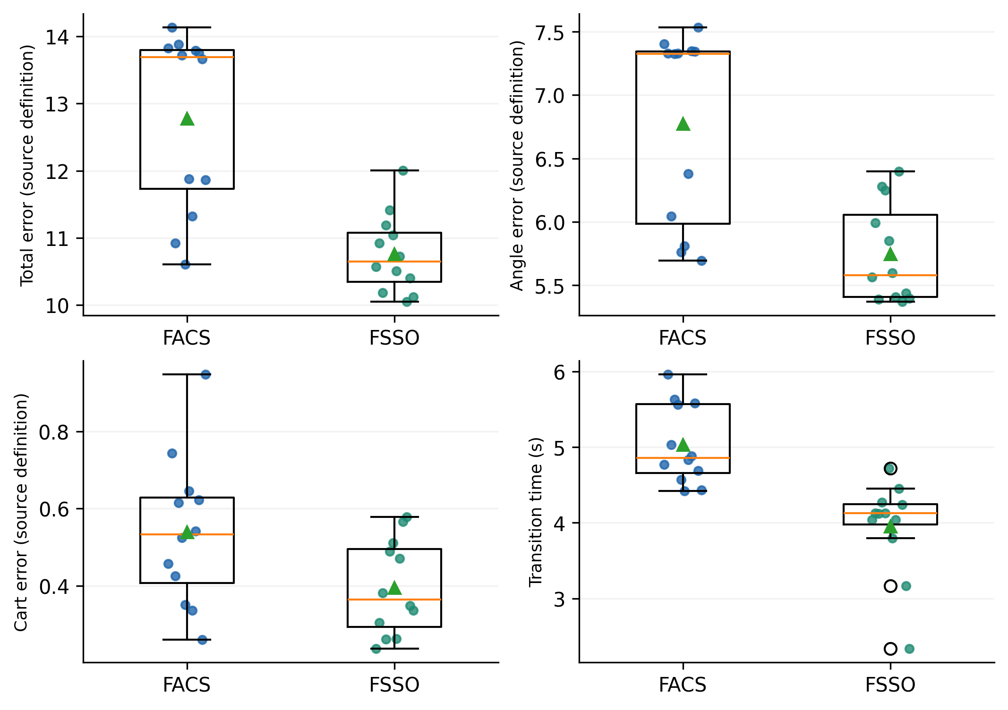
Figure 3. Source nominal comparison with FACS. All listed values are retained, including metric reversals.
Table 3. Recomputed means for the twelve FACS comparisons.
Metric | FACS mean | Scheduled mean | Relative reduction percent
Total error TE | 12.7791 | 10.7596 | 15.80
Angle error AE | 6.7748 | 5.7433 | 15.23
Displacement error DE | 0.53917 | 0.39525 | 26.69
Transition time ST s | 5.0292 | 3.9542 | 21.38
The source gives a baseline total error mean of 12.169, but its twelve listed values average to 12.7791. The corrected relative reduction is
$$R_{TE}=\frac{12.7790833−10.7595833}{12.7790833}×100=15.803\%.\text{ (19)}$$
Recalculation avoids propagating the incorrect summary into the abstract and conclusions. The scheduled total error standard deviation in this set is approximately 0.5829, compared with 1.3389 for FACS. Variability therefore behaves differently across the two baseline comparisons and should not be summarized as a universal reduction.
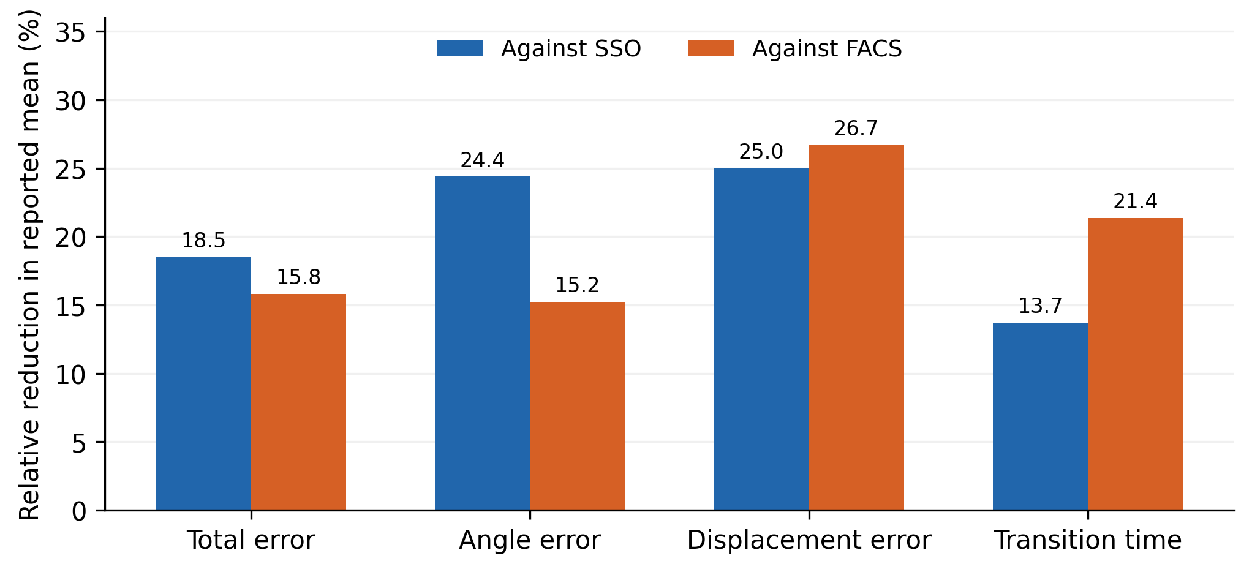
Figure 4. Relative reductions in each source metric, recalculated separately for the six SSO and twelve FACS comparison sets. These are descriptive mean differences, not uncertainty intervals or causal schedule effects.
The table supports improved nominal summaries under the recorded settings. Unknown objective-call budgets, tuning seeds, stopping conditions, and controller configurations prevent assigning the full difference to coefficient scheduling. The matched evaluation protocol is needed to isolate that contribution.

7.3 Changed initial states and stabilization failures
The source varies initial cart position, cart velocity, and pendulum angular velocity. Some cart positions extend to 15 m and velocities to 10 m/s. Without corresponding track, force, and speed limits, these are mathematical stress tests rather than demonstrations on a particular apparatus.
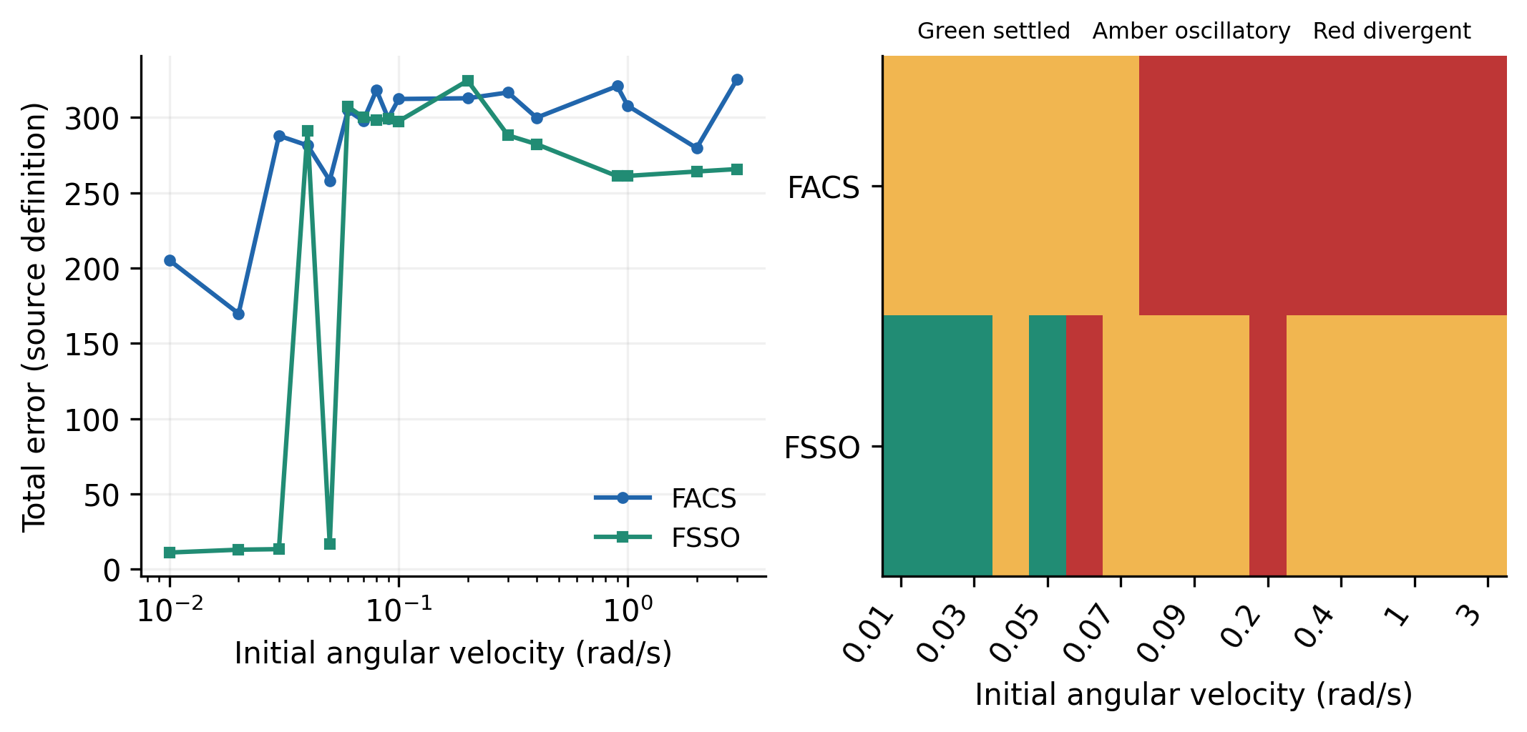
Figure 5. Total error and categorical outcomes for seventeen initial angular velocities from 0.01 to 3 rad/s. The classification panel preserves oscillatory and divergent cases that a mean error can obscure.
Table 4. Outcomes on the seventeen case angular velocity grid.
Outcome | FACS count | Scheduled count
Settled | 0 | 4
Oscillatory | 7 | 11
Divergent | 10 | 2
The scheduled method settles in four of seventeen cases, or 23.53% of this particular grid. Eleven cases remain oscillatory and two diverge. The FACS baseline has seven oscillatory and ten divergent cases, with no settled result.
The reduction in divergence is substantial in the listed cases, but oscillation remains a failure of the stabilization objective. Treating oscillatory trajectories as successful because they remain bounded would overstate robustness.
The four settled angular velocities are 0.01, 0.02, 0.03, and 0.05 rad/s. The intermediate 0.04 rad/s case does not settle. The records therefore do not establish a monotonic guaranteed region such as every initial angular velocity below 0.05 rad/s. They identify successful points interspersed with failure under the recorded settings.
Nor do seventeen angular velocity points establish a basin volume in the four dimensional state space. A region of attraction claim requires a defined state domain, controller, constraints, and an analytical or sufficiently systematic numerical argument. The complete outcome map is consequently a central result rather than a secondary qualification.

8 Discussion

8.1 Interpretation of the scheduling mechanism
Decreasing gradient influence and increasing momentum changes the balance between current local information and accumulated direction. A decreasing restriction can progressively reduce forward step magnitude. These choices provide a plausible exploration-to-refinement rationale, but their interaction is more complex than the verbal description suggests.
In particular, the multiplicative cap can suppress a coordinate after a zero preceding velocity, and the final zero restriction removes forward motion. The local alternative formula can still move candidates, but its multiplicative geometry depends on parameter origin and scaling. A reproducible analysis should measure how often the cap is active, how many coordinates become stationary, and how frequently local alternatives supply the accepted improvement.
These diagnostics would identify whether scheduling improves useful search or merely changes the balance of forward and local evaluations. They would also help compare proposal-sign and selected-argument sign conventions without confusing either with the historical implementation.

8.2 Search performance and closed loop stability
Optimizer convergence and controller stability are separate properties. A best-so-far cost curve can be nonincreasing by archive construction even if the search has no global convergence guarantee. Likewise, a low cost controller on tuning states can fail on a nearby initial condition.
A local stability analysis can linearize the fixed controller and plant near upright and inspect the resulting eigenvalues. Such a result applies within its assumptions and local region. Global swing up with mode changes, saturation, and cart constraints requires additional analysis. The historical run tables do not provide those guarantees.
The angular velocity outcomes are consistent with this distinction. Several nominal metrics improve, yet most tested angular velocity cases do not settle. The useful engineering conclusion is that the optimizer found better nominal parameters in the reported comparisons while the controller’s successful operating region remained limited.

8.3 Mechanism specific ablations and practical evaluation
The necessary ablations are unchanged SSO, gradient scheduling only, momentum scheduling only, restriction scheduling only, and the complete combination. Parameter scaling, velocity restart, bound handling, and rotational conventions should be held fixed or evaluated as separately named variants.
At least one established numerical optimizer should also be tested under the same objective-call budget. The comparison should include objective versus calls, elapsed tuning time, independent-state success count, constraint violations, and control effort. Reporting successful trials alone would bias both error and settling summaries.
If a physical experiment is intended, the plant parameters, track length, force calibration, sample period, sensor processing, and reset procedure must be documented. Initial state sweeps should respect the apparatus domain. Large mathematical offsets remain useful stress cases, but their interpretation should remain distinct from physical feasibility.
The available evidence is strongest for the arithmetic of the nominal tables and the categorical robustness outcomes. It is weaker for causal attribution to scheduling because tuning budgets and implementation details are missing. Completing those records would make the proposed mechanism directly testable.

9 Conclusions
Scheduled shark smell optimization has been developed into a detailed tuning framework connected to cart pole mechanics, hierarchical fuzzy control, trajectory costs, gradient estimation, local alternatives, and actual evaluation budgets. Seven algorithms make the principal procedures explicit. The analysis identifies direction ambiguity in the source velocity restriction and explains important consequences of zero velocities and multiplicative local search.
The reported nominal comparisons show lower mean errors and transition times. Correcting the FACS total error mean gives a 15.80% reduction in that comparison. The angular velocity sweep shows four settled cases, eleven oscillatory cases, and two divergent cases for the scheduled method. These results support further investigation of scheduling while defining clear limits to the robustness claim. Equal budget ablations, independent evaluation conditions, and explicit physical constraints are required for a stronger conclusion.

Data and code availability
The research package retains nominal run tables, initial state stress transcriptions, recalculated statistics, and figure generation code. The schedule and mean reduction graphs are derived from the stated equations and original run values. Independent replication requires controller rule bases, the complete tuned parameter vector, plant and solver settings, optimizer code, objective definitions, random seeds, and velocity and local-search conventions.

References
[1] Rani, M.; Kamlu, S.S. (2025). Optimal LQG controller design for inverted pendulum systems using a comprehensive approach. Scientific Reports, 15(1), 4692. https://doi.org/10.1038/s41598-025-85581-3
[2] Pham, D.B.; Dao, Q.T.; Bui, N.T.; Nguyen, T.V.A. (2024). Robust-optimal control of rotary inverted pendulum control through fuzzy descriptor-based techniques. Scientific Reports, 14(1), 5593. https://doi.org/10.1038/s41598-024-56202-2
[3] Mohammed, T.K.; Ezez, S.F.; Siraj, A.Z.; Abdissa, C.M. (2026). Adaptive fuzzy sliding mode control applied to inverted pendulum. Scientific Reports, 16(1), 14938. https://doi.org/10.1038/s41598-026-45197-7
[4] Ku, C.C.; Jian, S.H. (2023). Parameter-Dependent Polynomial Fuzzy Control of Nonlinear Inverted Pendulum System. International Journal of Fuzzy Systems, 25(5), 1770-1781. https://doi.org/10.1007/s40815-023-01473-6
[5] Chiu, C.H.; Hung, Y.T.; Peng, Y.F. (2021). Design of a Decoupling Fuzzy Control Scheme for Omnidirectional Inverted Pendulum Real-World Control. IEEE Access, 9, 26083-26092. https://doi.org/10.1109/access.2021.3057658
[6] Pathak, R.R.; Mohanty, S.; Sengupta, A. (2024). An Optimization-based Adaptive Sliding Mode Control for an Inverted Pendulum. IETE Journal of Research, 70(1), 542-557. https://doi.org/10.1080/03772063.2022.2127941
[7] Susanto, E.; Sumaryo, S.; Hassan, M.F. (2025). LQR, LQG, Extremum Seeking and Sliding Mode controls combined with Fuzzy for a rotary inverted pendulum stabilization. Results in Control and Optimization, 21, 100629. https://doi.org/10.1016/j.rico.2025.100629
[8] Costanzo, M.; Mazza, R.; Natale, C. (2025). Digital Control of an Inverted Pendulum Using a Velocity-Controlled Robot. Machines, 13(6), 528. https://doi.org/10.3390/machines13060528
[9] Dao, Q.T. (2026). Uncertainty-Resilient Control of an Inverted Pendulum on a Cart Using Interval Type-2 Takagi–Sugeno Fuzzy Modeling and Subsystem LQR Control. Automation, 7(3), 92. https://doi.org/10.3390/automation7030092
[10] Leng, X. (2024). Second-order sliding mode optimization control of an inverted pendulum system based on fuzzy adaptive technology. Frontiers in Mechanical Engineering, 10, 1458852. https://doi.org/10.3389/fmech.2024.1458852
[11] Braik, M.; Hammouri, A.; Atwan, J.; Al-Betar, M.A.; Awadallah, M.A. (2022). White Shark Optimizer: A novel bio-inspired meta-heuristic algorithm for global optimization problems. Knowledge-Based Systems, 243, 108457. https://doi.org/10.1016/j.knosys.2022.108457
[12] Lin, Q.; Wu, S.; Wu, S.; Wang, H.; Zhang, J. (2025). Development and simulation of two novel indoor odor source localization methods using a modified shark smell optimization algorithm. Measurement, 240, 115562. https://doi.org/10.1016/j.measurement.2024.115562
[13] Chen, Y.; Liu, G.; Wang, L.; Xia, B. (2024). Automatic Vertical Parking Reference Trajectory Based on Improved Immune Shark Smell Optimization. Algorithms, 17(7), 308. https://doi.org/10.3390/a17070308
[14] Liu, J.; Liu, Y.; Yang, Y.; Zhao, Z. (2025). Hybrid strategy collaborative enhancement of white shark optimization algorithm. The Journal of Supercomputing, 81(5), 660. https://doi.org/10.1007/s11227-025-07167-0
[15] Ghiaskar, A.; Taheri, F. (2026). Reproducible Multi-Metric Benchmarking Framework for Metaheuristic Algorithms in Constrained Engineering Optimization. Archives of Computational Methods in Engineering, 33(7), 9959-10000. https://doi.org/10.1007/s11831-026-10592-w
[16] Vermetten, D.; Doerr, C.; Wang, H.; Kononova, A.V.; Bäck, T. (2024). Large-Scale Benchmarking of Metaphor-Based Optimization Heuristics. Proceedings of the Genetic and Evolutionary Computation Conference, 41-49. https://doi.org/10.1145/3638529.3654122
[17] Fang, H.; Tu, Y.; He, S.; Wang, H.; Sun, C.; Cheng, S.S. (2024). Self-Learning Takagi–Sugeno Fuzzy Control With Application to Semicar Active Suspension Model. IEEE Transactions on Fuzzy Systems, 32(1), 64-74. https://doi.org/10.1109/tfuzz.2023.3290041
[18] Gil, P.; João, M.; Carvalho, C.; Palma, L.B.; Henriques, J. (2025). Neuro-fuzzy tracking control of discrete-time nonlinear systems under Linear Matrix Inequality region constraints. Engineering Applications of Artificial Intelligence, 153, 110672. https://doi.org/10.1016/j.engappai.2025.110672
[19] Bainier, G.; Marx, B.; Ponsart, J.C. (2024). Generalized nonlinear sector approaches for Takagi-Sugeno models. Fuzzy Sets and Systems, 476, 108791. https://doi.org/10.1016/j.fss.2023.108791
[20] Coutinho, P.H.S.; Oliveira, P.M.; Bessa, I.; Lacerda, M.J.; Palhares, R.M. (2025). Data-driven nonquadratic stabilization of Takagi-Sugeno fuzzy systems. Journal of the Franklin Institute, 362(17), 108131. https://doi.org/10.1016/j.jfranklin.2025.108131
[21] Beintema, G.I.; Schoukens, M.; Tóth, R. (2023). Deep subspace encoders for nonlinear system identification. Automatica, 156, 111210. https://doi.org/10.1016/j.automatica.2023.111210
[22] Forgione, M.; Muni, A.; Piga, D.; Gallieri, M. (2023). On the adaptation of recurrent neural networks for system identification. Automatica, 155, 111092. https://doi.org/10.1016/j.automatica.2023.111092
[23] Ahmed, A.; del Rio-Chanona, E.A.; Mercangöz, M. (2025). Comparative Study of Machine Learning and System Identification for Process Systems Engineering Dynamics. Industrial & Engineering Chemistry Research, 64(8), 4450-4478. https://doi.org/10.1021/acs.iecr.4c03264
[24] Wang, T.; Gault, R.; Greer, D. (2026). Data Informed Initialization of Fuzzy Membership Functions. International Journal of Fuzzy Systems, 28(2), 597-608. https://doi.org/10.1007/s40815-024-01971-1
[25] Pham, D.H.; Lin, C.M.; Giap, V.N.; Nguyen, V.T.; Pham, N.T. (2026). Self-Organizing Takagi–Sugeno–Kang Fuzzy Elliptic Type-2 CMAC for Nonlinear Systems with Uncertainty. International Journal of Fuzzy Systems, 28(5), 1691-1707. https://doi.org/10.1007/s40815-025-02046-5
[26] Bian, Z.; Chang, Q.; Wang, J.; Pal, N.R. (2025). Multihead Takagi–Sugeno–Kang Fuzzy System. IEEE Transactions on Fuzzy Systems, 33(8), 2561-2573. https://doi.org/10.1109/tfuzz.2025.3569227
[27] Gu, S.; Chou, Y.; Zhou, J.; Jiang, Z.; Lu, M. (2024). Takagi–Sugeno–Kang Fuzzy Clustering by Direct Fuzzy Inference on Fuzzy Rules. IEEE Transactions on Emerging Topics in Computational Intelligence, 8(2), 1264-1279. https://doi.org/10.1109/tetci.2023.3336537
[28] Wang, J.; Chang, Q.; Gao, T.; Zhang, K.; Pal, N.R. (2022). Sensitivity analysis of Takagi–Sugeno fuzzy neural network. Information Sciences, 582, 725-749. https://doi.org/10.1016/j.ins.2021.10.037
[29] Rodrigues, L.; Givigi, S. (2023). System Identification and Control Using Quadratic Neural Networks. IEEE Control Systems Letters, 7, 2209-2214. https://doi.org/10.1109/lcsys.2023.3285720
[30] Zisis, K.; Bechlioulis, C.P.; Rovithakis, G.A. (2022). Control-Enabling Adaptive Nonlinear System Identification. IEEE Transactions on Automatic Control, 67(7), 3715-3721. https://doi.org/10.1109/tac.2021.3106870
[31] Brouri, A. (2022). Wiener–Hammerstein nonlinear system identification using spectral analysis. International Journal of Robust and Nonlinear Control, 32(10), 6184-6204. https://doi.org/10.1002/rnc.6135
[32] Cruz, G.G.; Renczes, B.; Runacres, M.C.; Decuyper, J. (2025). State-Space Kolmogorov Arnold Networks for Interpretable Nonlinear System Identification. IEEE Control Systems Letters, 9, 847-852. https://doi.org/10.1109/lcsys.2025.3578019
[33] Aranha, C.; Camacho Villalón, C.L.; Campelo, F.; Dorigo, M.; Ruiz, R.; Sevaux, M.; et al. (2022). Metaphor-based metaheuristics, a call for action: the elephant in the room. Swarm Intelligence, 16(1), 1-6. https://doi.org/10.1007/s11721-021-00202-9
[34] Abedinia, O.; Amjady, N.; Ghasemi, A. (2016). A new metaheuristic algorithm based on shark smell optimization. Complexity, 21(5), 97-116. https://doi.org/10.1002/cplx.21634
[35] Tao, C.W.; Taur, J.S.; Jeng, J.T.; Wang, W.Y. (2009). A Novel Fuzzy Ant Colony System for Parameter Determination of Fuzzy Controllers. International Journal of Fuzzy Systems, 11(4), 298-307. https://eecs.niu.edu.tw/index.php?Action=o_niutchdetail&Plugin=o_niu&niuid=cwtao

