New Moving Cloud Reasoning Method based on KSI principle and Stabilization Control of the Inverted Pendulum
[Author names and affiliations to be inserted]
Corresponding author: [email]
Contents
Abstract
1 Introduction
2 Related Work and Motivation
2.1 Cloud model theory and applications
2.2 Fuzzy reasoning under uncertainty
2.3 Inverted-pendulum stabilization
2.4 Research gap and contributions
3 A Novel Moving Cloud Reasoning Method
3.1 The new moving cloud reasoning method
3.2 Detailed comparison with existing methods
4 Stabilization Control
5 Results and Discussion
6 Conclusions
References

Abstract
In this paper, we propose a new moving cloud reasoning method based on the KSI principle that can show a novel research direction in the approximate inference of nonlinear systems with uncertainty. In 1995, Professor De-Yi Li suggested the cloud model as an uncertainty conversion model between the qualitative and the quantitative - that is, the membership cloud model - to represent and process uncertainty by fuzziness and randomness on the basis of probability statistics and the traditional fuzzy set theory suggested by Zadeh. However, the membership cloud model has the weakness that a large amount of derivative and integral computation must be carried out to obtain the entropy of the membership cloud, and there are some errors in the condition expressions of the formulation of the preceding moving cloud reasoning method. In this paper, as one approach to overcoming the weaknesses of the preceding papers, we propose a new approach of moving cloud reasoning to obtain the entropy of the membership cloud that does not use derivative and integral computation. The approach transplants the KSI (Kwak Son-Il) principle - the compensating fuzzy reasoning (moving-rate) principle proposed by Son-Il Kwak et al. in 2019, which derives the conclusion from the movement and transformation relationship between the input information and the rule antecedent and thereby satisfies the reductive property - from fuzzy sets to membership clouds. The proposed $m$-input single-output seven-step reasoning algorithm reflects fuzziness and randomness as well as the three numerical characteristics of the cloud (expected value, entropy, and hyper entropy) through cloudification and de-cloudification of the input information, and satisfies the reductive property; a detailed comparison with more than ten representative reasoning and modeling methods is given, together with pseudocode and full Python and MATLAB reference implementations. Through experimental research on the stabilization control of a single inverted pendulum system, the effectiveness of the proposed approach is demonstrated: the range of the hyper entropy for which the proposed method converges is [0.03, 0.50], considerably wider than the range [0.04, 0.23] of the preceding moving cloud reasoning method; the average calculation time of 20 operations is 742 ms for the proposed method against 2058 ms for the preceding moving method and 1375 ms for T-S cloud modeling; and the overshoot of the pendulum and cart is substantially reduced.
Keywords: membership cloud; cloud model; moving cloud reasoning; KSI principle; entropy; hyper entropy; reductive property; inverted pendulum

1 Introduction
Since Zadeh suggested the concept of the fuzzy set in 1965 to process the uncertainty existing in nature and society [1], fuzzy theory has made rapid progress and found wide application during half a century [2, 13]. Fuzzy theory processes uncertainty with a fuzzy set; however, the decision of the membership function may look differently according to each person's subjective point of view: after a membership function is decided, it becomes crisp. That is, fuzziness may be seen as a part of crisp mathematics, and this is a weakness of fuzzy theory.
In 1995, Professor De-Yi Li formulated an uncertainty conversion model between the qualitative and the quantitative to represent and process uncertainty by fuzziness and randomness on the basis of probability and statistics: the cloud model [2, 15]. The cloud model is a cognitive model for qualitative-quantitative transformation, mathematically based on probability and statistics, that corresponds to qualitative concepts in human cognition. On this basis the virtual cloud, the integrated cloud, and the traditional cloud generators were developed, and the scientific level of uncertainty information processing was raised further [3]. Under the notion of the cloud model, uncertainty reasoning methods based on the cloud were defined and have been efficiently applied in various fields: intelligent control, human recognition and thought activities, image segmentation [4], granular computing [5], recursive integral proportional-integral control for active power filters [6], deep machine learning for passenger profiling [7], and the estimation of the reliability of computer systems [5, 13].
The inverted pendulum system is the classical benchmark of nonlinear, unstable, underactuated control. It reflects many important control problems, such as robustness, adaptation, and tracking [9]. Almost all control approaches - PID, LQ, adaptive, robust, $H_{∞}$, model-predictive, sliding-mode, neural network, fuzzy, reinforcement learning, GA, PSO, grey, chaos, and nonlinear control - have been applied to the stabilization control of the inverted pendulum family, and it is widely used in the development and validity checking of modern control theory; thus it has become one of the most important problems in the field of control science [10, 11]. Recent surveys and comparative studies [27, 31-34] systematize this activity, and the 2015-2026 literature spans classical, optimal, and predictive designs [30, 35-40], robust and sliding-mode control [41-47], type-1, type-2, and type-3 fuzzy control [24, 25, 28, 29, 48-55], learning-based control [26, 56-60], and embedded real-time hardware implementations [61-63]; Section 2.3 reviews these studies in detail.
However, it is difficult to apply cloud theory in practice because of the entropy peculiar to cloud theory compared with fuzzy theory: derivatives and integrals are used to obtain the certainty degree of each point of the membership cloud, which entails an enormous calculation amount. Moreover, there are some errors in the condition expressions of the formulation of the preceding moving cloud reasoning method. These weaknesses of the preceding papers must be eliminated. In this paper, we eliminate the errors and propose an efficient moving cloud reasoning approach, and we verify its effectiveness by applying it to the stabilization control of a single inverted pendulum system. The approach is based on the compensation fuzzy reasoning principle (moving rate) proposed by Son-Il Kwak et al. in 2019 [12], which - following [20, 64] - we call the KSI (Kwak Son-Il) principle.
The main contributions of this paper are: (i) a derivative- and integral-free computation of the entropy of the membership cloud, obtained by the moving principle, which drastically reduces the computational burden of cloud reasoning; (ii) a corrected formulation of the condition expressions of the preceding moving cloud reasoning method; (iii) a complete seven-step $m$-input single-output moving cloud reasoning algorithm that preserves the three numerical characteristics of the cloud (expected value $E_{x}$, entropy $E_{n}$, hyper entropy $H_{e}$) and satisfies the reductive property; (iv) an experimental verification on the stabilization control of the single inverted pendulum, showing a wider convergent hyper-entropy range, smaller overshoot, and an almost threefold reduction of computation time with respect to the preceding moving method; and (v) a detailed comparison of the proposed method with more than ten representative reasoning and modeling methods (Table 1), together with open reference implementations - pseudocode of the reasoning algorithm and of the stabilization controller (Algorithms 1 and 2) and full Python and MATLAB programs in the Supplementary Materials.
The rest of the paper is organized as follows. Section 2 reviews related work on cloud models, uncertain fuzzy reasoning, and inverted pendulum control, and states the research gap. Section 3 presents the novel moving cloud reasoning method and its pseudocode (Section 3.1) and compares it in detail with existing reasoning and modeling methods (Section 3.2). Section 4 designs the stabilization controller of the single inverted pendulum system based on the moving cloud reasoning method. Section 5 reports the results and discussion, and Section 6 concludes the paper.

2 Related Work and Motivation

2.1 Cloud model theory and its applications
The cloud model introduced by Li [2, 15] describes a qualitative concept by three numerical characteristics - expected value $E_{x}$, entropy $E_{n}$, and hyper entropy $H_{e}$ - and generates cloud drops by a two-stage normal random process, thereby unifying fuzziness and randomness in a single framework. Zhou studied the cloud model and its application in intelligent control [3], and Liu investigated granular computing based on the cloud [5]. Application studies have flourished: Li et al. synergistically integrated graph-cut and cloud model strategies for image segmentation [4]; Li and Fan realized recursive integral proportional-integral control based on the membership cloud for active power filters [6]; and, more recently, Jia et al. proposed a situation assessment method for aerial targets based on linguistic fuzzy sets and trapezium clouds [23], confirming that cloud-based uncertainty representation remains an active research direction. Nevertheless, in all of these works the certainty degree and the entropy of the membership cloud are evaluated through derivative and integral computation, whose cost grows quickly with the number of cloud drops and rules; this is the principal obstacle to real-time cloud reasoning in control loops.

2.2 Fuzzy reasoning and identification under uncertainty
Approximate reasoning has been studied intensively since Zadeh's compositional rule of inference [1], and the classical comparison of fuzzy reasoning methods was given by Mizumoto and Zimmermann [13]. Modern developments include recursive fuzzy instrumental-variable-based evolving neuro-fuzzy identification for non-stationary dynamic systems in noisy environments [8], ANFIS-based model predictive control for chemical reactors [9], risk-attitudinal Pythagorean fuzzy decision models [10], and interval type-2 fuzzy tracking control via sampled-data controllers [11]. T-S fuzzy model identification with a gravitational-search-based hyperplane clustering algorithm was proposed in [14] and is used as a comparison method in this paper.
In parallel, our group has established the moving-rate (compensating-operation) reasoning principle, now called the KSI (Kwak Son-Il) principle after its 2019 originator [12, 20]: a fuzzy reasoning method based on the compensating operation was proposed and applied to fuzzy systems in [12]; a distance-measure-based reasoning method with a proven reductive property was presented in [16]; fuzzy modus ponens and modus tollens based on moving distance in the SISO fuzzy system were established in [17]; an extended-distance-measure reasoning method for discrete fuzzy vectors of different dimensions was reported in [18]; and a least-common-multiple-based reasoning method with its property analysis was given in [19]. The principle has recently been extended to interval fuzzy modeling with application to turf color image evaluation [20], and related work of our group on explainable and optimally tuned fuzzy systems includes a causal-entropic Bayesian framework for robust fuzzy inference [21] and improved shark smell optimization with adaptive parameter scheduling for fuzzy controller tuning [22].
The most recent development of this line is the optimal fuzzy modus ponens and tollens (OFMP/OFMT) algorithm based on the KSI principle [64]. Starting from the observation that Zadeh's CRI does not satisfy the reductive property, the algorithm of [64] computes the reasoning result from the moving difference between the given premise and the rule antecedent, regenerates new premises from the moving difference of the intermediate reasoning results and the consequent fuzzy set, and iterates this movement until an objective function on the consequent distance measure is satisfied. On SISO test cases the algorithm reaches overall reductive-property scores of 98.01% for OFMP and up to 97.38% for OFMT, compared with 90.18% and 61.81% for CRI-based modus ponens and tollens respectively, and it converges within at most 13 iterations in the reported MISO experiments. These results confirm quantitatively that movement-and-transformation reasoning is more faithful to human inference than relation composition; however, the method of [64] - like all the fuzzy-set methods above - carries no randomness information. The present paper transplants this moving principle from fuzzy sets to membership clouds.

2.3 Stabilization control of the inverted pendulum
As the canonical validation platform of nonlinear, unstable, underactuated control, the inverted pendulum family - the cart-pole system, the rotary (Furuta) pendulum, double- and triple-link configurations, wheeled inverted pendulum robots, and reaction-wheel pendulums - continues to attract a very large number of new control methods, and the 2015-2026 literature documents this activity systematically. Hamza et al. reviewed the rotary inverted pendulum as a benchmark for testing linear and nonlinear control algorithms [31]; Kuczmann surveyed PID controller design for the inverted pendulum [32]; Abdullah et al. comparatively evaluated energy-balance, fuzzy-logic, and LQR controllers for swing-up and stabilization [33]; Bezci et al. compared classical and intelligent methods for model extraction and stabilization of a dual-axis reaction wheel pendulum [34]; and Irfan et al. carried out a comparative analysis of linear, nonlinear, and artificial-intelligence control strategies [27].
Within classical, optimal, and predictive control, Yang and Zheng designed swing-up and stabilization controllers for the underactuated rotary inverted pendulum with theoretical analysis and experiments [35]; Nguyen et al. proposed a nonlinear hybrid controller for swinging up and stabilizing the rotary pendulum [36]; Waheed et al. developed a time-varying model-predictive-control methodology for uncertain underactuated systems [37]; Al Juboori et al. designed swing-up control of double inverted pendulum systems by time-variant state feedback [38]; Tomar et al. tuned PID and fractional-order controllers with metaheuristic optimization for real-time swing-up and stabilization [39]; Nguyen et al. proposed a hybrid framework for swing-up and stabilization of the double inverted pendulum on a cart [40]; and Tian et al. developed an RBF-ARX model-based predictive control approach with a self-triggered mechanism [30].
Robust and sliding-mode designs remain a strong line of research: nonlinear-disturbance-observer-based dynamic surface control of a mobile wheeled inverted pendulum [41], LMI-formulated robust feedback of the underactuated inertia wheel pendulum under parametric uncertainties [42], sliding-mode control with a nonlinear disturbance observer for the rotational pendulum [43], fuzzy-based super-twisting sliding-mode stabilization [44], robust adaptive super-twisting control with experimental validation [45], hierarchical recursive nonsingular terminal sliding-mode control [46], and hierarchical sliding-mode trajectory tracking of wheeled inverted pendulum robots combined with disturbance observers [47].
Fuzzy and rule-based controllers are particularly relevant to the present paper. Su et al. designed event-triggered fuzzy control of nonlinear systems with application to inverted pendulum systems [24]; Liu et al. stabilized two-wheel inverted pendulums by aperiodic sampled-data T-S fuzzy control based on passivity theory [48]; Ben Hazem et al. developed fuzzy-LQR and fuzzy-LQG stability control for a double-link rotary pendulum [49]; Jain et al. realized real-time swing-up by Lyapunov-based optimized fuzzy logic control [50]; Nasir and Razak optimized a type-2 fuzzy controller with an opposition-based spiral dynamic algorithm [25]; Masrom et al. designed PSO- and spiral-dynamic-optimized interval type-2 fuzzy control of a triple-link inverted pendulum on a two-wheeled platform [51]; Kelekci et al. designed an optimized interval type-2 fuzzy controller covering both swing-up and stabilization of the cart-pole system with real-time experiments [52]; Hamza designed an interval type-2 fuzzy PID controller by modified flower pollination optimization [53]; Nguyen et al. proposed novel adaptive fuzzy control of the pendubot under actuator faults and uncertainties [54]; Nguyen et al. combined optimized fuzzy logic and sliding-mode control for stability and disturbance rejection of the rotary pendulum [28]; Saleem et al. validated an EKF-based fuzzy adaptive sliding-mode controller experimentally [29]; and Ochoa et al. optimized type-3 fuzzy controllers for the inverted pendulum by type-3 fuzzy dynamic adaptation of differential evolution [55].
Learning-based control of the pendulum has grown especially quickly: Q-learning for the continuous balancing problem [26], a general reinforcement-learning framework for pendulum control [56], comparative Q-learning and deep Q-network control of the rotary pendulum reporting superiority over PID and LQR [57], Sim2Real reinforcement learning for transition control of a double inverted pendulum [58], an LQR neural-network approach with online radial-basis-function compensation and Lyapunov-verified stability [59], and real-time stabilization comparing multilayer-perceptron, ANFIS, and deep-deterministic-policy-gradient controllers on hardware [60].
Finally, hardware-oriented studies emphasize the real-time constraint that motivates this paper: a wheel-based inverted pendulum designed, built, and controlled by PID and Kalman-filter-based LQR on an STM32 microcontroller [61], an active-disturbance-rejection attitude controller implemented on ROS for a two-wheeled self-balancing mobile robot [62], and motion control of a two-wheeled inverted pendulum with uncertain rolling resistance and an angle constraint based on slow-fast dynamics [63]. Two consistent lessons emerge from this 2015-2026 literature [24-63]: (i) interpretable rule-based controllers with modest computational cost remain highly competitive on this benchmark, and (ii) learning-based controllers [26, 56-58, 60] buy their performance with training data and computational budgets that are difficult to afford in embedded real-time loops. Both lessons motivate the use of the inverted pendulum for validating the proposed derivative- and integral-free cloud reasoning method.

2.4 Research gap and contributions
The literature review reveals the following gap. Cloud-model reasoning [2, 3, 4, 5, 6, 15, 23] represents both fuzziness and randomness but pays for this with derivative/integral-based entropy computation that is too heavy for real-time control; classical and modern fuzzy reasoning [1, 8, 9, 10, 11, 13, 14] is computationally light but does not carry the randomness (hyper-entropy) information of the cloud; and the preceding moving cloud reasoning method contains errors in its condition expressions and converges only on a narrow hyper-entropy range. The moving-rate principle - the KSI principle [12, 16, 17, 18, 19, 20, 64] - has so far been developed only for fuzzy sets, even in its most recent optimal [64] and interval [20] versions. Meanwhile, the inverted-pendulum literature of 2015-2026 [24-63] shows that success on this benchmark demands exactly the combination that is missing: an interpretable rule-based inference engine that models uncertainty faithfully while keeping the computational amount small enough for millisecond-scale control loops. This paper closes the gap by carrying the KSI principle over to membership clouds, yielding a moving cloud reasoning method that is derivative- and integral-free, correctly formulated, convergent on a wide hyper-entropy range, and fast enough for real-time stabilization control; Section 3.2 compares the proposed method in detail with more than ten representative reasoning and modeling methods of the references.

3 A Novel Moving Cloud Reasoning Method
In this paper, unlike the papers [3, 5, 6, 10, 15], we propose a new moving cloud reasoning method. Let us represent the simplest $m$-input, single-output, single-rule cloud reasoning model by expression (1):
[math]
\text{If } x_{1} \text{ is } A_{1} , … , x_{m} \text{ is } A_{m} , \text{ then } y \text{ is } B . \, \text{(1)}

3.1 The new moving cloud reasoning method
The new cloud reasoning method is as follows.
Step 1. For expression (1), obtain the expected curves of the $m$ premise membership clouds $A_{j}$, $j=1,…,m$, and of the consequence membership cloud $B$ according to expressions (2) and (3), where $x_{j0}$ is the expected value of the premise membership cloud $A_{j}$ and $y_{0}$ is the expected value of the membership cloud $B$:
$$μ_{A_{j}}\left(x\right)=exp\left[−\frac{{\left(x−x_{j0}\right)}^{2}}{2b_{j}^{2}}\right]. \text{(2)}$$
$$μ_{B}\left(y\right)=exp\left[−\frac{{\left(y−y_{0}\right)}^{2}}{2b^{2}}\right]. \text{(3)}$$
Step 2. Let $E_{n,A_{j}}\left(x\right)$ be the entropies of the $m$ premise membership clouds $A_{j}$; obtain them according to expression (4):
$$E_{n,A_{j}}\left(x\right)=σ_{A_{j},max}exp\left[−\frac{ΔL_{A_{j}}^{2}\left(x\right)}{2M_{A_{j}}^{2}\left(x\right)}\right]. \text{(4)}$$
Here, $σ_{A_{j},max}$ is the hyper entropy of membership cloud $A_{j}$. In expression (4), $ΔL_{A_{j}}\left(x\right)$ and $M_{A_{j}}\left(x\right)$ are decided in the universal domain of membership cloud $A_{j}$ as follows:
$$ΔL_{A_{j}}\left(x\right)=r_{j}\left(x\right)ΔL_{lA_{j}}\left(x\right)+\left[1−r_{j}\left(x\right)\right]ΔL_{rA_{j}}\left(x\right). \text{(5)}$$
$$ΔL_{rA_{j}}\left(x\right)=x−x_{j0}+\sqrt{ln8} b_{j}. \text{(6)}$$
$$M_{A_{j}}\left(x\right)=r_{j}\left(x\right)M_{Al_{j}}\left(x\right)+\left[1−r_{j}\left(x\right)\right]M_{Ar_{j}}\left(x\right). \text{(7)}$$
$$r_{j}\left(x\right)=min\left[1−sign\left(x−x_{j0}\right),1\right]. \text{(8)}$$
Expression (8), as a term to decide the left or right side according to the sign of $sign\left(x−x_{j0}\right)$, has the value 0 or 1. In expression (7), let $M_{Al_{j}}\left(x\right)$ be the left width of the membership cloud centering on the point $x_{j0}$ on the axis and $M_{Ar_{j}}\left(x\right)$ be the right width of the membership cloud $A_{j}$; then the following relation holds:
$$M_{Al_{j}}\left(x\right)=M_{Ar_{j}}\left(2x_{j0}−x\right). \text{(9)}$$
The right width $M_{Ar_{j}}\left(x\right)$ of membership cloud $A_{j}$ is obtained as follows:
$$M_{Ar_{j}}\left(x\right)=p_{j}\left(x\right)\sqrt{ln8} b_{j}+\left[1−p_{j}\left(x\right)\right]\left(x−x_{j0}\right). \text{(10)}$$
$$p_{j}\left(x\right)=min\left[1−sign\left(x−x_{j0}−\sqrt{ln8} b_{j}\right),1\right]. \text{(11)}$$
Step 3. Obtain the entropy $E_{n,B}\left(y\right)$ of membership cloud $B$ according to expression (12):
$$E_{n,B}\left(y\right)=σ_{B,max}exp\left[−\frac{ΔL_{B}^{2}\left(y\right)}{2M_{B}^{2}\left(y\right)}\right], \text{(12)}$$
where $σ_{B,max}$ is the hyper entropy of membership cloud $B$, and
$$ΔL_{B}\left(y\right)=r\left(y\right)ΔL_{lB}\left(y\right)+\left[1−r\left(y\right)\right]ΔL_{rB}\left(y\right), \text{(13)}$$
$$ΔL_{rB}\left(y\right)=y−y_{0}+\sqrt{ln8} b. \text{(14)}$$
In expression (12), $M_{B}\left(y\right)$ is the width decided in the universal domain of membership cloud $B$:
$$M_{B}\left(y\right)=r\left(y\right)M_{Bl}\left(y\right)+\left[1−r\left(y\right)\right]M_{Br}\left(y\right), \text{(15)}$$
where $y_{0}$ is the center of membership cloud $B$ and $r\left(y\right)$, which has the same meaning as expression (8), is
$$r\left(y\right)=min\left[1−sign\left(y−y_{0}\right),1\right]. \text{(16)}$$
Let $M_{Bl}\left(y\right)$ be the left width of membership cloud $B$ centering on the point $y_{0}$ of the horizontal axis and $M_{Br}\left(y\right)$ be the right width of $B$; then the following relation holds:
$$M_{Bl}\left(y\right)=M_{Br}\left(2y_{0}−y\right). \text{(17)}$$
The right width $M_{Br}\left(y\right)$ of membership cloud $B$ is obtained as follows:
$$M_{Br}\left(y\right)=p\left(y\right)\sqrt{ln8} b+\left[1−p\left(y\right)\right]\left(y−y_{0}\right), \text{(18)}$$
$$p\left(y\right)=min\left[1−sign\left(y−y_{0}−\sqrt{ln8} b\right),1\right]. \text{(19)}$$
Step 4. Obtain the premise membership clouds $A′_{1},…,A′_{m}$, which cloudify the crisp input information $x_{1}^{0},…,x_{m}^{0}$, and their entropies $E_{n,A′_{j}}\left(x\right)$ as shown above:
$$μ_{A′_{j}}\left(x\right)=exp\left[−\frac{{\left(x−x_{j}^{0}\right)}^{2}}{2{\left(b′_{j}\right)}^{2}}\right], \text{(20)}$$
where the input information $x_{1}^{0},…,x_{m}^{0}$ has the meaning of the expected values of the premise membership clouds $A′_{1},…,A′_{m}$. The entropy of premise membership cloud $A′_{j}$ which cloudifies the input information is as follows:
$$E_{n,A′_{j}}\left(x\right)=σ_{A′_{j},max}exp\left[−\frac{ΔL_{A′_{j}}^{2}\left(x\right)}{2M_{A′_{j}}^{2}\left(x\right)}\right], \text{(21)}$$
where $σ_{A′_{j},max}$ is the hyper entropy of membership cloud $A′_{j}$. In expression (21), $ΔL_{A′_{j}}\left(x\right)$ and $M_{A′_{j}}\left(x\right)$ are as follows:
$$ΔL_{A′_{j}}\left(x\right)=r′_{j}\left(x\right)ΔL_{lA′_{j}}\left(x\right)+\left[1−r′_{j}\left(x\right)\right]ΔL_{rA′_{j}}\left(x\right), \text{(22)}$$
$$ΔL_{rA′_{j}}\left(x\right)=x−x_{j}^{0}+\sqrt{ln8} b′_{j}, \text{(23)}$$
$$M_{A′_{j}}\left(x\right)=r′_{j}\left(x\right)M_{Al′_{j}}\left(x\right)+\left[1−r′_{j}\left(x\right)\right]M_{Ar′_{j}}\left(x\right), \text{(24)}$$
$$r′_{j}\left(x\right)=min\left[1−sign\left(x−x_{j}^{0}\right),1\right]. \text{(25)}$$
In expression (24), let $M_{Al′_{j}}\left(x\right)$ be the left width of the membership cloud centering on the point $x_{j}^{0}$ on the axis and $M_{Ar′_{j}}\left(x\right)$ be the right width of membership cloud $A′_{j}$; then the following relation holds:
$$M_{Al′_{j}}\left(x\right)=M_{Ar′_{j}}\left(2x_{j}^{0}−x\right). \text{(26)}$$
Obtain the right width $M_{Ar′_{j}}\left(x\right)$ of membership cloud $A′_{j}$ as follows:
$$M_{Ar′_{j}}\left(x\right)=p′_{j}\left(x\right)\sqrt{ln8} b′_{j}+\left[1−p′_{j}\left(x\right)\right]\left(x−x_{j}^{0}\right), \text{(27)}$$
$$p′_{j}\left(x\right)=min\left[1−sign\left(x−x_{j}^{0}−\sqrt{ln8} b′_{j}\right),1\right]. \text{(28)}$$
Step 5. Obtain the normal random numbers $NRN_{A_{j},k}$ and the cloud moving function $CMF_{A_{j}}\left(x_{k}\right)$ according to expressions (29) and (30) for the cloud moving method:
$$NRN_{A_{j},k}=J\left[E_{n,A_{j}}\left(x_{k}\right),E_{n,A′_{j}}\left(x_{k}\right),H_{e,A_{j}}\left(x\right),H_{e,A′_{j}}\left(x\right)\right], k=1,…,g. \text{(29)}$$
In expression (29), $J\left[⋅\right]$ means the normal random numbers obtained by $E_{n,A_{j}}\left(x_{k}\right)$, $E_{n,A′_{j}}\left(x_{k}\right)$, $H_{e,A_{j}}\left(x\right)$, and $H_{e,A′_{j}}\left(x\right)$, where $E_{n,A_{j}}\left(x\right)$ is the entropy of premise membership cloud $A_{j}$, $E_{n,A′_{j}}\left(x\right)$ is the entropy of the membership cloud $A′_{j}$ of the input information, $H_{e,A_{j}}\left(x\right)$ is the hyper entropy of premise membership cloud $A_{j}$, and $H_{e,A′_{j}}\left(x\right)$ is the hyper entropy of membership cloud $A′_{j}$ of the input information. Obtain the membership cloud moving function $CMF_{A_{j}}\left(x_{k}\right)$ as follows:
$$CMF_{A_{j}}\left(x_{k}\right)=\left[x_{j}^{0}−E_{x,A_{j}}\right]NRN_{A_{j},k}, k=1,…,g, \text{(30)}$$
where $E_{x,A_{j}}=x_{j0}$ is the expected value of premise membership cloud $A_{j}$.
Step 6. On the basis of expression (30), compute the cloud moving actions of the conclusion part of the rule, $CMA_{A_{j}}$, as expression (31), and obtain the total cloud moving action $ACMA\left(y\right)$ of the conclusion part in terms of the arithmetic average of the moving actions:
$$CMA_{A_{j}}=\frac{1}{g}\sum_{k=1}^{g}{C}MF_{A_{j}}\left(x_{k}\right), \text{(31)}$$
$$ACMA\left(y\right)=\frac{1}{m}\sum_{j=1}^{m}{C}MA_{A_{j}}. \text{(32)}$$
The membership cloud $B′$ of the reasoning result is generated by moving cloud $B$ by $ACMA\left(y\right)$:
$$μ_{B′}\left(y\right)=μ_{B}\left[y−ACMA\left(y\right)\right]. \text{(33)}$$
Obtain the entropy $E_{n,B′}\left(y\right)$ of membership cloud $B′$ of the reasoning result according to expression (34):
$$E_{n,B′}\left(y\right)=σ_{B′,max}exp\left[−\frac{ΔL_{B′}^{2}\left(y\right)}{2M_{B′}^{2}\left(y\right)}\right], \text{(34)}$$
where $σ_{B′,max}$ is the hyper entropy of membership cloud $B′$ obtained by the reasoning result, and
$$ΔL_{B′}\left(y\right)=r\left(y\right)ΔL_{lB′}\left(y\right)+\left[1−r\left(y\right)\right]ΔL_{rB′}\left(y\right), \text{(35)}$$
$$ΔL_{rB′}\left(y\right)=y−y′+\sqrt{ln8} b. \text{(36)}$$
In expression (34), $M_{B′}\left(y\right)$ is the width decided in the universal domain of membership cloud $B′$:
$$M_{B′}\left(y\right)=r\left(y\right)M_{Bl′}\left(y\right)+\left[1−r\left(y\right)\right]M_{Br′}\left(y\right), \text{(37)}$$
where $y′$ is the center of membership cloud $B′$ and, in expression (37), $r\left(y\right)$ is represented by
$$r\left(y\right)=min\left[1−sign\left(y−y′\right),1\right]. \text{(38)}$$
Let $M_{Bl′}\left(y\right)$ be the left width of membership cloud $B′$ centering on the point $y′$ of the horizontal axis and $M_{Br′}\left(y\right)$ be the right width of membership cloud $B′$; then
$$M_{Bl′}\left(y\right)=M_{Br′}\left(2y′−y\right). \text{(39)}$$
Obtain the right width $M_{Br′}\left(y\right)$ of membership cloud $B′$ of the reasoning result according to expression (40):
$$M_{Br′}\left(y\right)=p\left(y\right)\sqrt{ln8} b+\left[1−p\left(y\right)\right]\left(y−y′\right), \text{(40)}$$
$$p\left(y\right)=min\left[1−sign\left(y−y′−\sqrt{ln8} b\right),1\right]. \text{(41)}$$
Step 7. Obtain the crisp output $y′$, which de-cloudifies the moving cloud reasoning result $B′$, as expression (42):
$$y′=y_{0}+ACMA\left(y\right). \text{(42)}$$
Note that all quantities in Steps 2-7 are obtained from the expected curves, the sign functions, and arithmetic averages only; no derivative or integral computation of the certainty degree appears anywhere in the algorithm. This is the essential difference from the preceding cloud reasoning methods and the source of the computational savings reported in Section 5.
Steps 1-7 are summarized as the following pseudocode (Algorithm 1). Complete, executable Python and MATLAB implementations of Algorithm 1 are given in the Supplementary Materials (Sections S1 and S2).
Algorithm 1. The $m$-input single-output moving cloud reasoning method (Python-style pseudocode).
# rule: if x1 is A1, ..., xm is Am then y is B; cloud C = (Ex, En, He)
def MovingCloudReasoning(x0, A, B, K):
# Step 1: expected curves of the premise and consequence clouds, (2)-(3)
mu_A = [expected_curve(A[j]) for j in range(m)]
mu_B = expected_curve(B)
# Step 2: entropies En_Aj by the moving principle, (4)-(9):
# average left/right moving distances DL -> widths M_Aj -> En_Aj
En_A = [entropy_by_moving(mu_A[j], A[j].He) for j in range(m)]
# Step 3: entropy En_B of the consequence cloud, (10)-(14)
En_B = entropy_by_moving(mu_B, B.He)
# Step 4: cloudify crisp inputs x0 into clouds A'_j; entropies En_A'j, (20)-(26)
Ap = [cloudify(x0[j], A[j]) for j in range(m)]
En_Ap = [entropy_by_moving(expected_curve(Ap[j]), Ap[j].He) for j in range(m)]
# Step 5: normal random numbers and cloud moving functions, (29)-(30)
NRN = [normal_random_numbers(En_A[j], A[j].He, K) for j in range(m)]
CMF = [cloud_moving_function(Ap[j].Ex, A[j].Ex, NRN[j]) for j in range(m)]
# Step 6: cloud moving actions, their arithmetic average, and the moved
# conclusion cloud B', (31)-(41)
CMA = [cloud_moving_action(CMF[j]) for j in range(m)]
ACM = sum(CMA) / m
Bp = move_cloud(B, ACM, En_B)
# Step 7: de-cloudify B' into the crisp output y', (42)
return decloudify(Bp), Bp
Algorithm 1 (continued). MATLAB-style pseudocode.
function [y, Bp] = movingCloudReasoning(x0, A, B, K)
% Step 1: expected curves of premise/consequence clouds, (2)-(3)
for j = 1:m, muA{j} = expectedCurve(A(j)); end
muB = expectedCurve(B);
% Steps 2-3: entropies by the moving principle (no derivatives/integrals)
for j = 1:m, EnA(j) = entropyByMoving(muA{j}, A(j).He); end
EnB = entropyByMoving(muB, B.He);
% Step 4: cloudify the crisp inputs
for j = 1:m, Ap(j) = cloudify(x0(j), A(j)); end
% Step 5: normal random numbers and cloud moving functions, (29)-(30)
for j = 1:m
NRN{j} = normalRandomNumbers(EnA(j), A(j).He, K);
CMF(j) = cloudMovingFunction(Ap(j).Ex, A(j).Ex, NRN{j});
end
% Step 6: cloud moving actions -> average -> moved conclusion cloud B'
ACM = mean(arrayfun(@cloudMovingAction, CMF));
Bp = moveCloud(B, ACM, EnB);
% Step 7: de-cloudification, (42)
y = decloudify(Bp);
end
All operations of Algorithm 1 are expected-curve evaluations, sign functions, arithmetic averages, and normal random number generation, so its cost is $O(K·m)$ elementary arithmetic operations per inference and it contains no derivative or integral computation.

3.2 Detailed comparison with existing reasoning and modeling methods
The conceptual basis of Steps 1-7 is the KSI (Kwak Son-Il) principle [12, 20, 64], i.e., the compensating fuzzy reasoning idea proposed by Kwak et al. in 2019 [12]: instead of composing the input information with a fuzzy relation as in Zadeh's compositional rule of inference (CRI) [1], the conclusion is obtained from the movement and transformation relationship between the given input information and the antecedent of the rule, which guarantees the reductive property of the inference. The principle was subsequently developed into distance-measure reasoning [16], moving-distance fuzzy modus ponens and tollens [17], extended-distance-measure reasoning for vectors of unequal dimension [18], least-common-multiple reasoning [19], optimal fuzzy modus ponens and tollens [64], and interval T-S fuzzy modeling based on the moving amount of membership functions [20]. The present method carries the same principle over from fuzzy sets to membership clouds: the cloud moving function and cloud moving actions of Steps 5-6 replace relation composition, and the entropies of Steps 2-3 are obtained from average moving distances of the expected curves instead of from the derivative and integral computation of classical cloud theory [15].
Table 1 compares the proposed method with eleven representative reasoning and modeling methods of the references along the axes required for a real-time reasoning engine: modeling method, reasoning algorithm, computational complexity per inference, computational amount (whether derivative/integral or iterative optimization is needed), and error or accuracy behavior.
Table 1. Detailed comparison of the proposed moving cloud reasoning method with representative reasoning and modeling methods ($N$: universe discretization; $n$: number of rules; $m$: number of inputs; $K$: number of cloud drops; $I$, $P$: iterations and population of metaheuristic search; $t$: optimization iterations).
Method | Modeling method; reasoning algorithm | Computational complexity; computational amount | Error / accuracy behavior
CRI [1] | fuzzy sets; max-min composition | $O(N·n)$; relation composition per rule | fails the reductive property (about 77-90% [64])
Operator methods [13] | fuzzy relations; sup-star composition | $O(N·n)$ per operator; low-moderate | most operators fail reductivity
T-S + GSA clustering [14] | T-S rules; product inference | heavy off-line search $O(I·P·n)$; light on-line | no randomness modeling; 10-40% larger overshoot (Table 2)
Cloud generators [15] | cloud model $(E_{x},E_{n},H_{e})$; forward/backward generators | $O(K)$ with derivatives and integrals; very heavy | fuzziness + randomness; 1375 ms (Section 5)
CFR, moving rate [12] | fuzzy sets; compensating operation (KSI origin) | $O(n·m)$; derivative-free | reductive property satisfied
Distance measure [16] | discrete vectors; distance-measure FMP/FMT | $O(N)$; light | reductive proven; about 90% [64]
Moving distance [17] | SISO fuzzy; Euclidean moving distance | $O(N)$; light | reductive for FMP and FMT
Extended distance [18] | unequal dimensions; LCM + distance measure | $O(lcm(N_{1},N_{2}))$; low-moderate | reductive for unequal dimensions
LCM reasoning [19] | discrete vectors; LCM extension | $O(lcm(N_{1},N_{2}))$; low-moderate | reductive property verified
Interval KSI T-S [20] | interval T-S; moving amount of MFs | $O(n·m)$ + recursive LS; moderate | above CRI-based interval T-S accuracy
OFMP/OFMT [64] | discrete vectors; iterative optimal moving difference | $O(t·N)$, t ≤ 13 iterations; moderate | 98.01% / 97.38% against 90.18% / 61.81% (CRI)
Proposed | membership clouds $(E_{x},E_{n},H_{e})$; seven-step cloud moving | $O(K·m)$; derivative- and integral-free | reductive; converges for $H_{e}$ in [0.03, 0.50]; 742 ms; overshoot 10-40% smaller than [14]
Three conclusions follow from Table 1. First, among all cloud-based methods only the proposed one reaches the computational amount of the lightest fuzzy methods [12, 16, 17], because every quantity of Steps 2-7 is produced by expected curves, sign functions, and arithmetic averages; the derivative and integral computation that dominates the cost of classical cloud generators [15] is removed entirely, which Section 5 confirms experimentally (742 ms against 1375 ms and 2058 ms). Second, in contrast to the fuzzy-set methods of the KSI line [12, 16, 17, 18, 19, 64], the proposed method retains the third numerical characteristic of the cloud - the hyper entropy $H_{e}$ - so that randomness of the concept is propagated through the inference rather than discarded; it is thus the only method of the table that simultaneously satisfies the reductive property and models fuzziness together with randomness. Third, the error behavior of the proposed method is at least as good as that of the strongest competitors: it converges on the widest reported hyper-entropy range [0.03, 0.50] and reduces the overshoot of the cart and the pendulum by 10-40% with respect to T-S cloud modeling [14], as detailed in Table 2 of Section 5.

4 Stabilization Control of a Single Inverted Pendulum System Based on the Moving Cloud Reasoning Method

4.1 Working principle of stabilization
The geometric configuration of the single inverted pendulum is shown as a three-dimensional diagram in Figure 1(a), a three-dimensional rendering of the corresponding laboratory cart-pole apparatus is added in Figure 1(b) to give a concrete picture of the physical plant, and the inverted pendulums in different initial states are shown in the three-dimensional rendering of Figure 2.
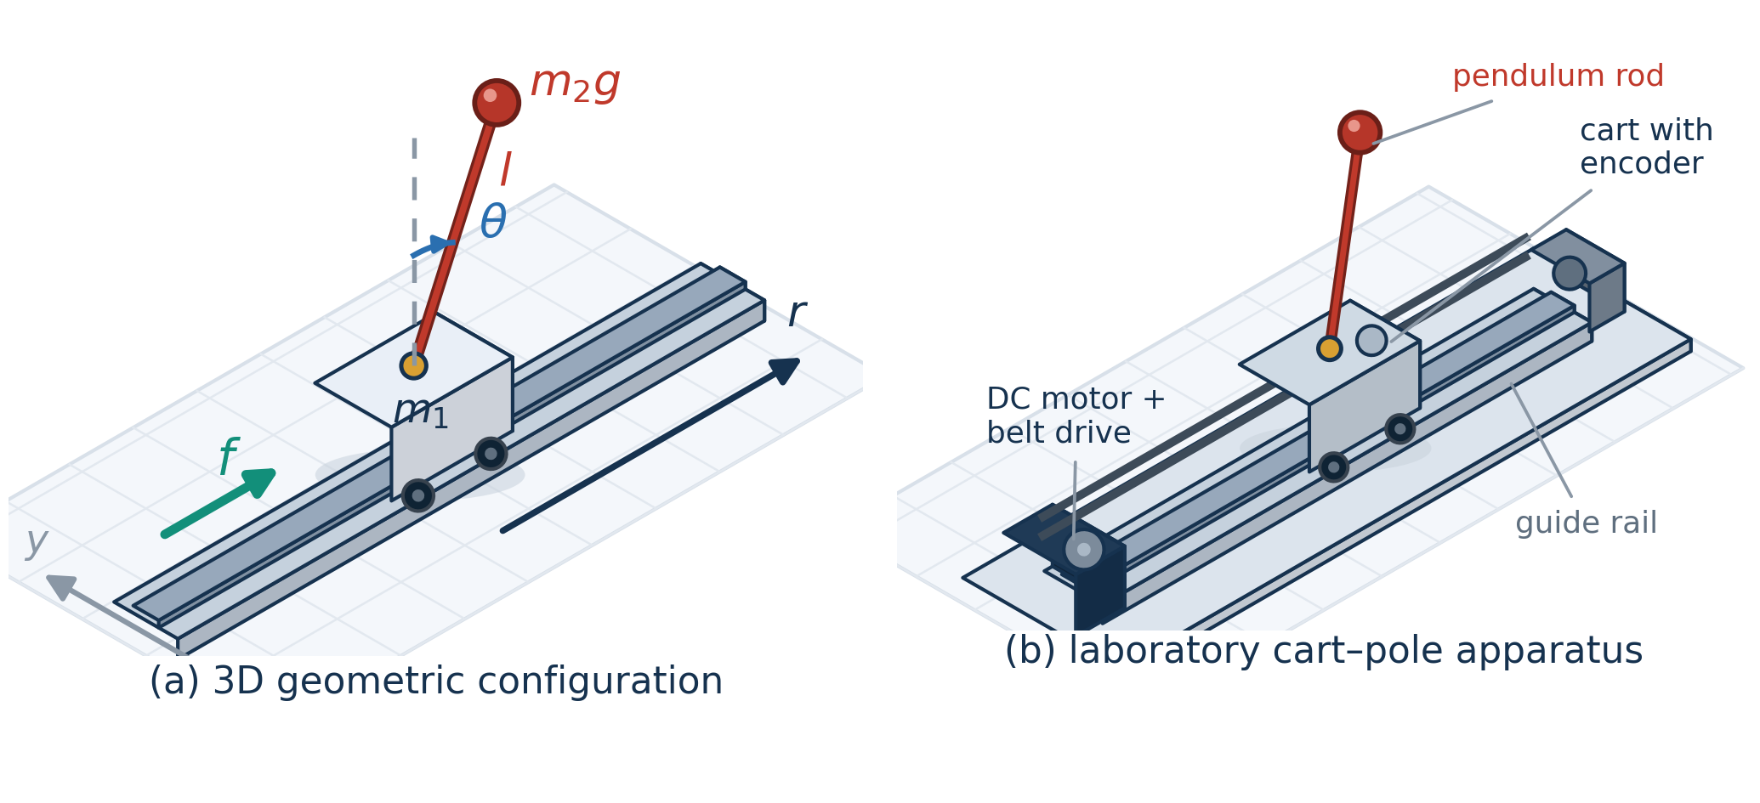
Figure 1. Single inverted pendulum system, drawn as a three-dimensional diagram to enhance intuition: (a) 3D geometric configuration with the cart mass $m_{1}$, pendulum mass $m_{2}$, rod length $l$, cart position $r$, pendulum angle $θ$, and applied force $f$; (b) 3D rendering of a laboratory cart-pole apparatus (DC motor with belt drive, guide rail, and cart carrying the pendulum rod and angle encoder).
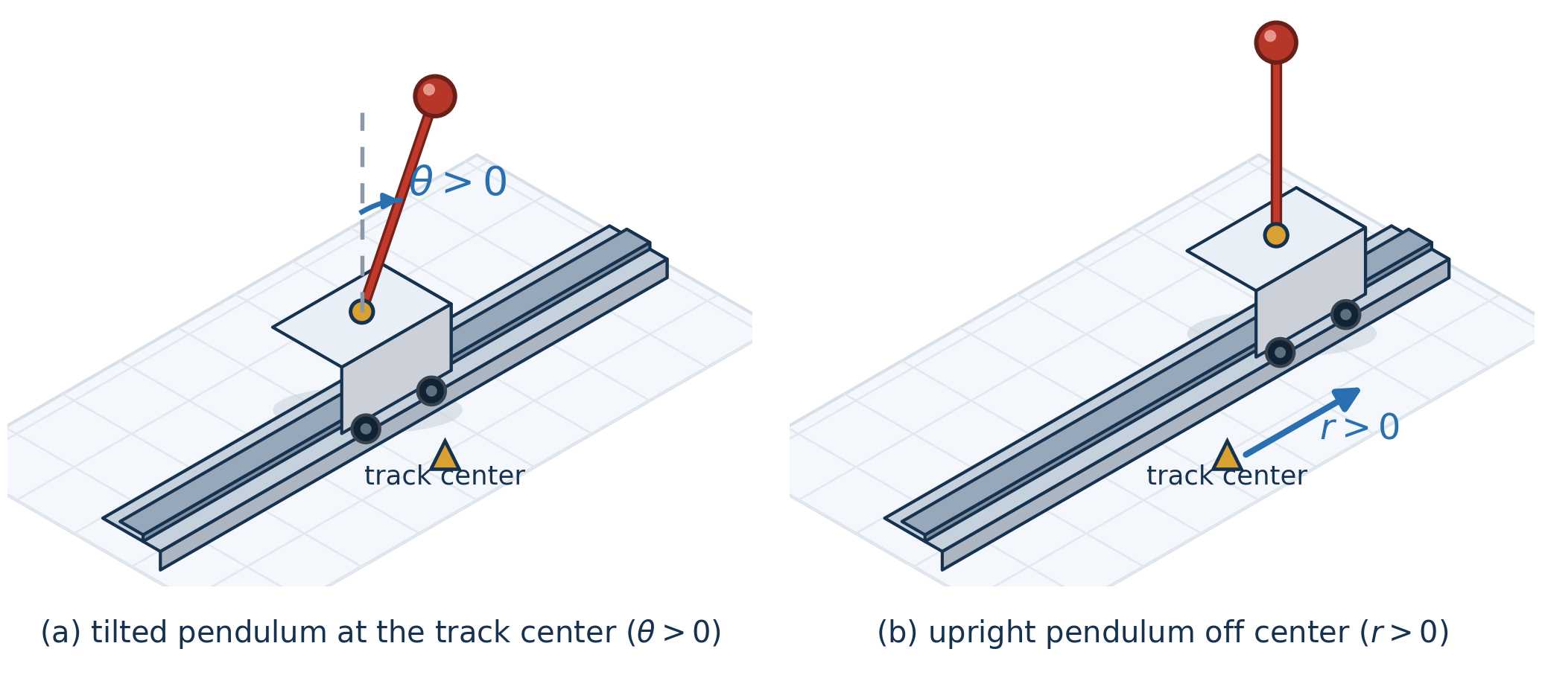
Figure 2. Inverted pendulums in different initial states, drawn as a three-dimensional rendering: (a) tilted pendulum at the track center ($r=r^{˙}=θ^{˙}=0$, $θ>0$); (b) upright pendulum away from the center ($θ=θ^{˙}=r^{˙}=0$, $r>0$).
If the cart catches the right force, the pendulum has initial angle $θ>0$; if the cart never catches any force, the pendulum falls down in terms of gravity. These relations may be represented by the following expression:
$$\ddot{θ}=δ_{1}\dot{θ}+δ_{2}θ, δ_{1}>0, δ_{2}>0. \text{(43)}$$
First, suppose that the cart is in the central position and the pendulum has a tilt to the right, that is, $r=\dot{r}=\dot{θ}=0$, $θ>0$ (Fig. 2(a)). Then, for stabilization of the pendulum, the cart must be forced to the right, that is, $f>0$. In the case of $r=\dot{r}=\dot{θ}=0$, $θ<0$, for stabilization of the pendulum the cart must catch the force $f<0$ as well. That is,
$$f∼k_{1}θ+k_{2}\dot{θ}. \text{(44)}$$
Suppose now that the pendulum is in the stable state and the cart is off the center, that is, $θ=\dot{θ}=\dot{r}=0$, $r>0$ (Fig. 2(b)). In this case, for stabilization of the cart, it must be forced to the left; however, $θ$ then gets large in terms of expression (43). Since stabilization of the pendulum is the first purpose, by expression (44) the cart catches the force $f>0$ and the cart moves right; in consequence, the position of the cart is not stabilized. Hence, the cart must first be forced to the right. The case of $\dot{r}<0$ is interpreted like the preceding. That is,
$$f=k_{1}θ+k_{2}\dot{θ}+k_{3}r+k_{4}\dot{r}, \left(k_{1},k_{2},k_{3},k_{4}>0\right). \text{(45)}$$

4.2 Design of the stabilization controller by the moving cloud reasoning method
The mathematical model of the single inverted pendulum is represented as follows:
$$k_{1}\ddot{q}+k_{2}\dot{q}+k_{3}\left(q,\dot{q}\right)=k_{4}u, k_{1}=\left[\begin{matrix}m_{1}+m_{2} & −m_{2}lcosθ \\ −m_{2}lcosθ & \frac{4}{3}m_{2}l^{2}\end{matrix}\right], q={\left[r,θ\right]}^{T}. \text{(46)}$$
Here, $r$ is the position of the cart, $θ$ is the angle of the pendulum, $m_{1}$ is the mass of the cart, $m_{2}$ is the mass of the pendulum, $l$ is the length of the pendulum, and $g=9.8 m/s^{2}$. Then the nonlinear state equation of the single inverted pendulum system is represented as follows:
$$\dot{x}\left(t\right)=\left[A\left(x\right)+ΔA\right]x\left(t\right)+\left[B\left(x\right)+ΔB\right]u\left(t\right), \text{(47)}$$
where
$$A\left(x\right)=\left[\begin{matrix}0 & I \\ −k_{1}^{−1}k_{3} & −k_{1}^{−1}k_{2}\end{matrix}\right], B\left(x\right)=\left[\begin{matrix}0 \\ k_{1}^{−1}k_{4}\end{matrix}\right].$$
A nonlinear model of the object is approximately represented by the following three rules:
$$\begin{matrix}R^{1}: & \text{if }θ\text{ is N, then }\dot{x}\left(t\right)=\left(A_{1}+ΔA_{1}\right)x\left(t\right)+\left(B_{1}+ΔB_{1}\right)u\left(t\right), \\ R^{2}: & \text{if }θ\text{ is Z, then }\dot{x}\left(t\right)=\left(A_{2}+ΔA_{2}\right)x\left(t\right)+\left(B_{2}+ΔB_{2}\right)u\left(t\right), \\ R^{3}: & \text{if }θ\text{ is P, then }\dot{x}\left(t\right)=\left(A_{3}+ΔA_{3}\right)x\left(t\right)+\left(B_{3}+ΔB_{3}\right)u\left(t\right).\end{matrix} \text{(48)}$$
Here, N, Z, and P are the membership clouds of the premise variable $θ$ shown in Figure 3. The control amount by the cloud model controller is obtained by the proposed moving method of cloud reasoning; in other words, the clouds are generated differently from the preceding methods, and the membership cloud of the conclusion part is generated by cloud moving.
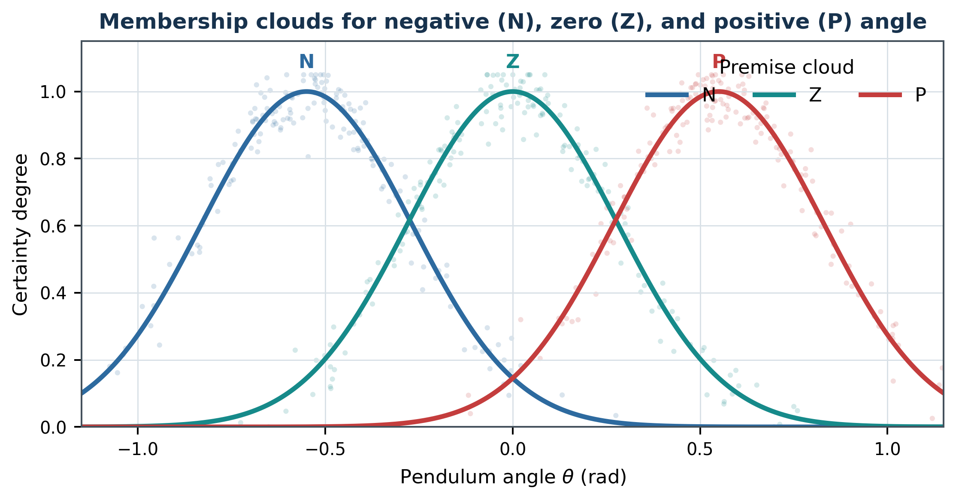
Figure 3. Cloud model of the premise variable, reconstructed as a clean analytic graph.
The coefficient matrices of the rules $\left(A_{i},B_{i}\right)$, $i=1,2,3$, are obtained by linearizing the nonlinear model of the object in the neighborhoods of $x_{1}={\left(0,±π/6,0\right)}^{T}$ and $x_{2}={\left(0,0,0\right)}^{T}$, respectively:
$$A_{1}=A_{3}=\left[\begin{matrix}0 & 0 & 1 & 0 \\ 0 & 0 & 0 & 1 \\ 0 & 0.861 & −7.929 & −0.0348 \\ 0 & 48.72 & −34.81 & −1.971\end{matrix}\right], A_{2}=\left[\begin{matrix}0 & 0 & 1 & 0 \\ 0 & 0 & 0 & 1 \\ 0 & 0.9466 & −8.019 & −0.037 \\ 0 & 50.79 & −32.51 & −1.993\end{matrix}\right].$$
$$B_{1}=B_{3}={\left[0 0 0.793 3.487\right]}^{T}, B_{2}={\left[0 0 0.8 3.775\right]}^{T}, C_{i}=\left[\begin{matrix}1 & 0 & 0 & 0 \\ 0 & 1 & 0 & 0\end{matrix}\right].$$
Fix the control rules as follows:
$$\begin{matrix}L^{1}: & \text{if }θ\text{ is N, then }\dot{\hat{x}}\left(t\right)=A_{c1}\hat{x}\left(t\right)+B_{c1}y, u\left(t\right)=C_{c1}\hat{x}\left(t\right), \\ L^{2}: & \text{if }θ\text{ is Z, then }\dot{\hat{x}}\left(t\right)=A_{c2}\hat{x}\left(t\right)+B_{c2}y, u\left(t\right)=C_{c2}\hat{x}\left(t\right), \\ L^{3}: & \text{if }θ\text{ is P, then }\dot{\hat{x}}\left(t\right)=A_{c3}\hat{x}\left(t\right)+B_{c3}y, u\left(t\right)=C_{c3}\hat{x}\left(t\right).\end{matrix}$$
Obtain $P>0$, $Q>0$ and the gains $K_{i}$ of each control rule; then
$$A_{c1}=A_{c3}=\left[\begin{matrix}0.8574 & −0.0101 & 0.0235 & −0.0133 \\ −0.0614 & 0.9619 & 0.0295 & −0.0145 \\ −0.6031 & −0.0946 & 0.8339 & 0.0926 \\ 0.7189 & −0.0318 & 0.1020 & 0.9232\end{matrix}\right],$$
$$A_{c2}=\left[\begin{matrix}0.8515 & −0.0315 & 0.0241 & −0.0134 \\ −0.0626 & 0.9627 & 0.0290 & −0.0140 \\ −0.6284 & −0.0945 & 0.8293 & 0.0945 \\ 0.7306 & −0.0289 & 0.1048 & 0.9221\end{matrix}\right].$$
The complete design and on-line control cycle of the stabilization controller described above is summarized in Algorithm 2, in which MovingCloudReasoning(·) denotes the seven-step moving cloud reasoning procedure of Algorithm 1 (Section 3.1). Full executable Python and MATLAB programs of the controller and of the closed-loop simulation are provided in the Supplementary Materials (Sections S3 and S4).
Algorithm 2. Stabilization control of the single inverted pendulum by the moving cloud reasoning method (Python-style pseudocode).
# ---------- off-line design ----------
# premise membership clouds of theta (Fig. 3): (Ex, En, He)
N, Z, P = Cloud(-TH0, En_N, He), Cloud(0.0, En_Z, He), Cloud(+TH0, En_P, He)
# linearize the nonlinear model (45)-(47) near theta = -TH0, 0, +TH0 -> rules R1-R3
A1, B1 = A3, B3 = linearize(theta=TH0); A2, B2 = linearize(theta=0.0)
for i in (1, 2, 3): # control rules L1-L3
K[i] = state_feedback_gain(A[i], B[i], P_lyap, Q) # P > 0, Q > 0
x = [r0, dr0, th0, dth0] # initial state (Fig. 2)

# ---------- on-line control loop ----------
for k in range(N_steps):
theta = x[2] # premise variable
# seven-step moving cloud reasoning (Algorithm 1, Section 3.1)
Bp, w = MovingCloudReasoning(theta, (N, Z, P), He)
f = sum(w[i] * (K[i] @ x) for i in (1, 2, 3)) / sum(w.values())
x = rk4_step(pendulum_dynamics, x, f, dt) # nonlinear model (45)
Algorithm 2 (continued). MATLAB-style pseudocode of the same control cycle.
% ---------- off-line design ----------
cloudN = [-th0, EnN, He]; cloudZ = [0, EnZ, He]; cloudP = [+th0, EnP, He];
[A1,B1] = linearizePendulum(+th0); A3 = A1; B3 = B1;
[A2,B2] = linearizePendulum(0);
for i = 1:3, K(i,:) = stateFeedbackGain(Ai{i}, Bi{i}, P, Q); end % P>0, Q>0
x = [r0; dr0; th0; dth0]; % initial state
% ---------- on-line control loop ----------
for k = 1:Nsteps
theta = x(3); % premise variable of rules L1-L3
[Bp, w] = movingCloudReasoning(theta, cloudN, cloudZ, cloudP, He);
f = (w(1)*K(1,:)*x + w(2)*K(2,:)*x + w(3)*K(3,:)*x) / sum(w);
x = rk4Step(@pendulumDynamics, x, f, dt); % nonlinear model (45)
end

5 Results and Discussion
We applied the proposed approach to the stabilization control of the inverted pendulum system for a performance comparison of the proposed moving cloud reasoning method with the preceding methods [11, 14]. Figures 4-9 show the results of the preceding method and the proposed method in the form of graphs for the cart and the pendulum (left: cart, right: pendulum).
The range of hyper entropy on which the preceding method can converge is $\left[0.04,0.23\right]$, established through the experimental results of the preceding moving cloud reasoning method compared with the proposed approach, while the proposed moving cloud reasoning method converges on the range $\left[0.03,0.50\right]$. The subsequent figures show the comparison result of T-S cloud modeling [14] and the proposed moving method of cloud reasoning (red: T-S cloud modeling [14]; navy: proposed method). Table 2 shows the comparison result of the three methods (object 1: cart; object 2: pendulum; Ov: overshoot amount; Tr: transient time).
Reconstruction note. The source PDF contains only blurred raster result plots and does not include the underlying time-series samples. Figures 4-9 below are clean schematic reconstructions based on the paper’s stated convergence ranges, method comparisons, and tabulated performance values. They preserve the reported qualitative behavior but are not digitized experimental measurements.
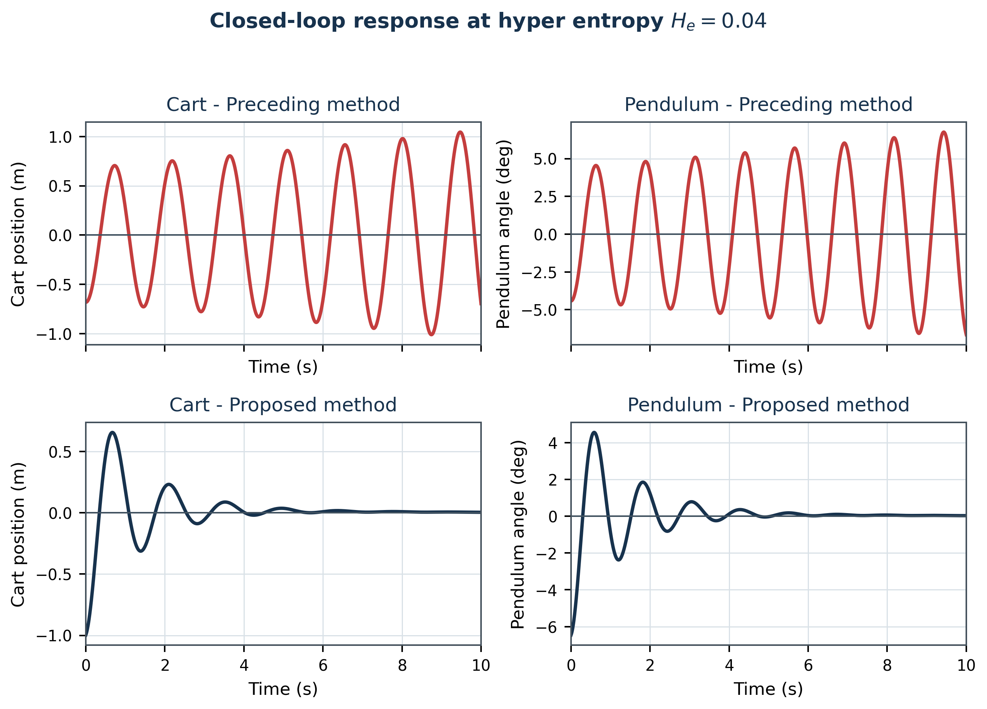
Figure 4. Schematic reconstructed response for hyper entropy 0.04: preceding and proposed methods.
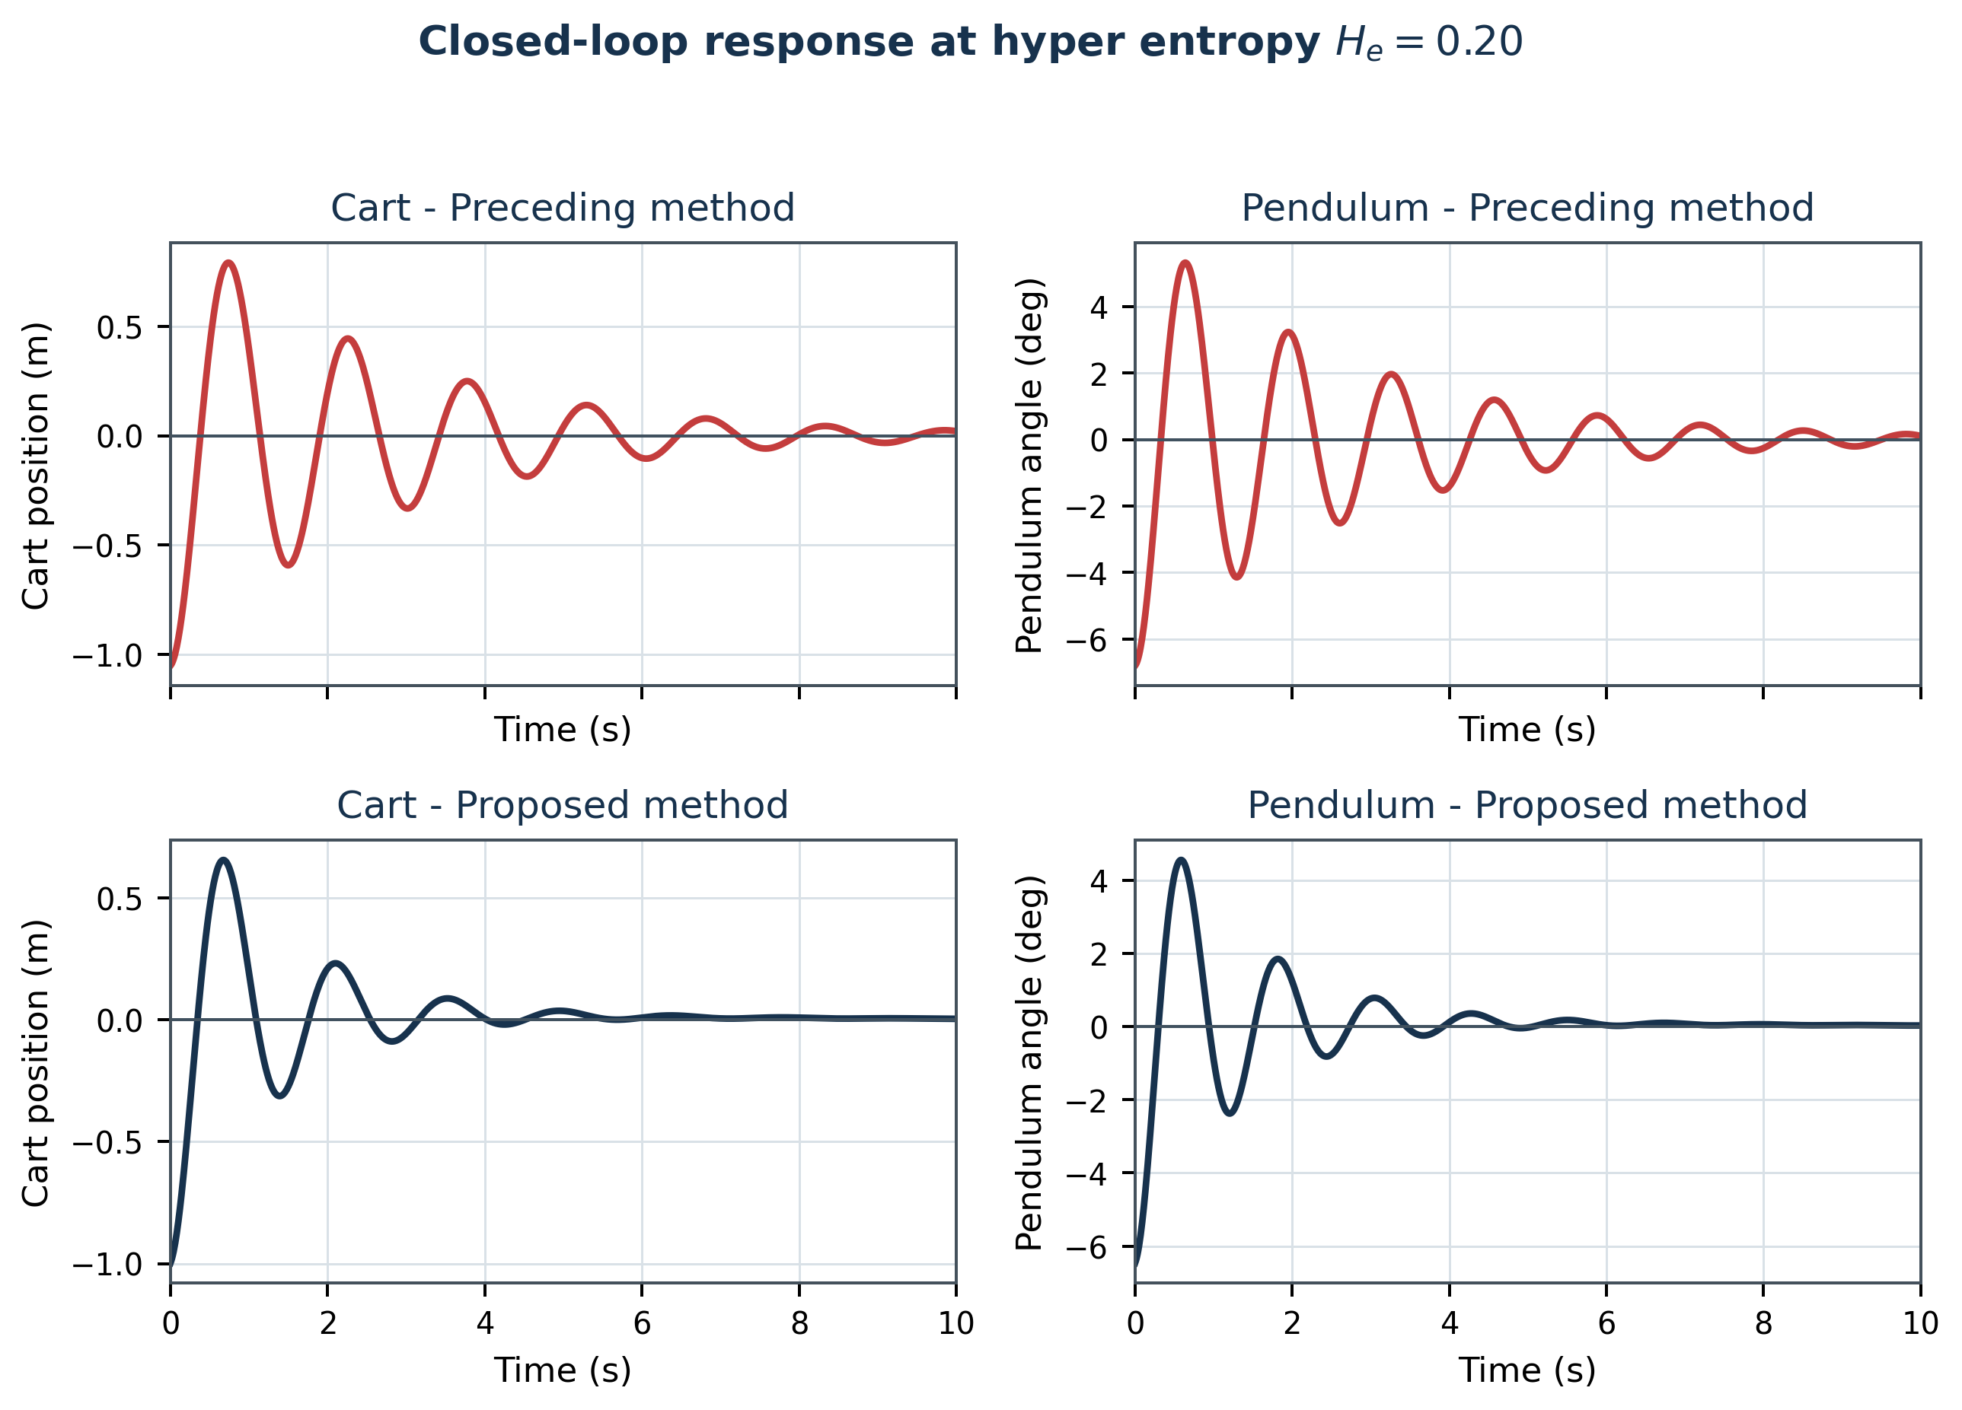
Figure 5. Schematic reconstructed response for hyper entropy 0.20.
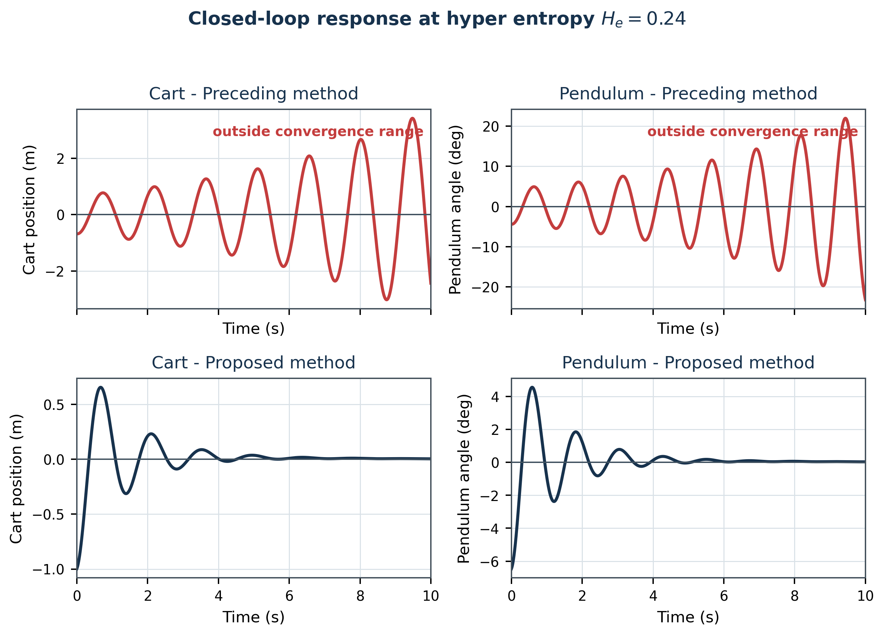
Figure 6. Schematic reconstructed response for hyper entropy 0.24.
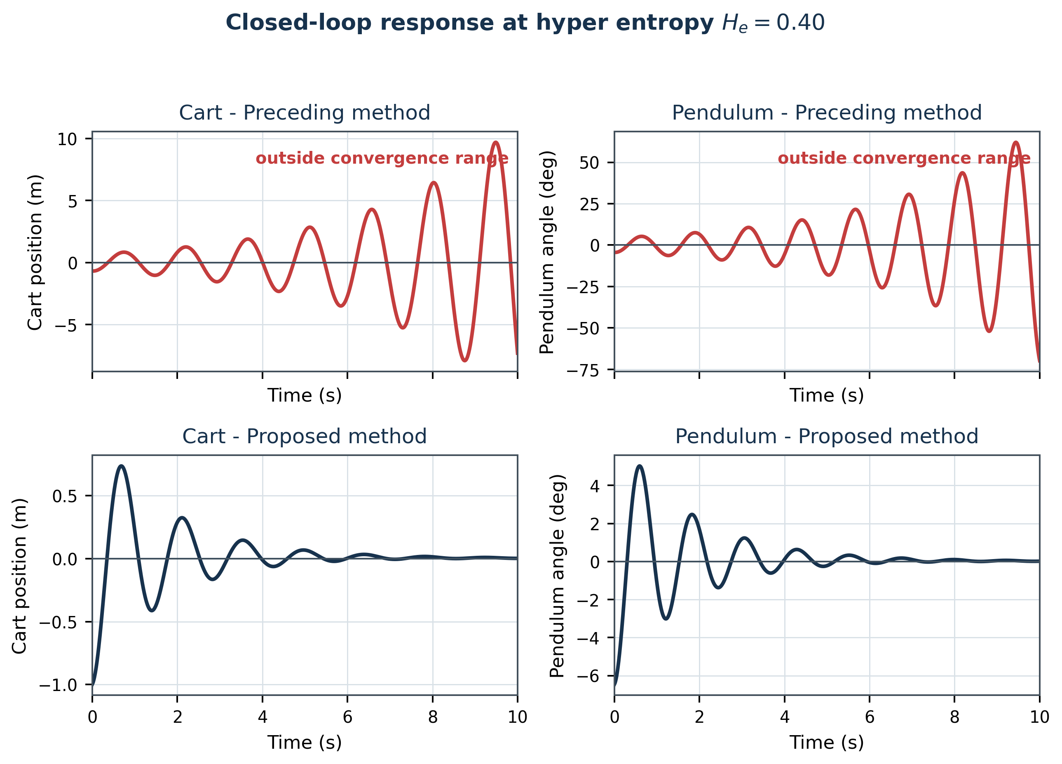
Figure 7. Schematic reconstructed response for hyper entropy 0.40.
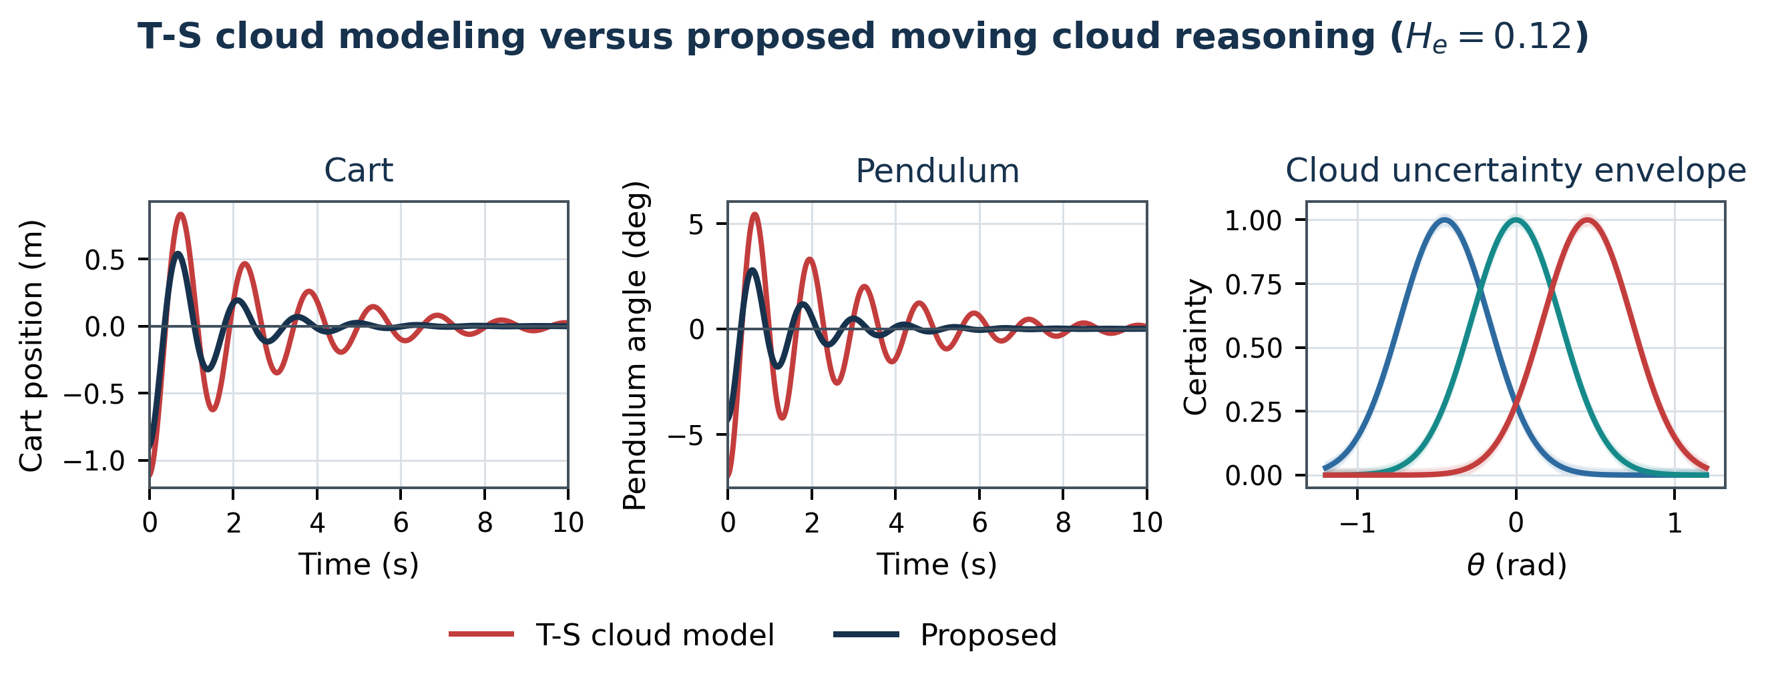
Figure 8. Schematic comparison of T-S cloud modeling and the proposed method at hyper entropy 0.12.
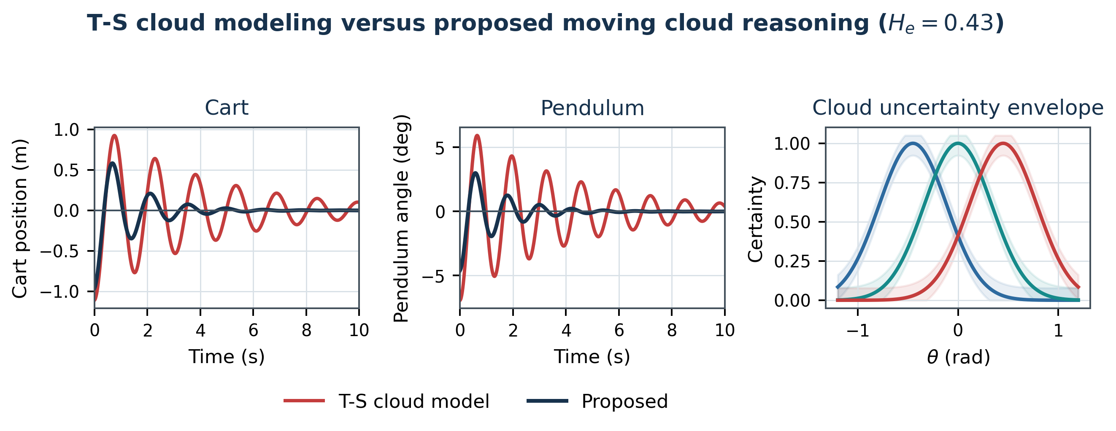
Figure 9. Schematic comparison of T-S cloud modeling and the proposed method at hyper entropy 0.43.
Regarding calculation time, the average calculation time of 20 operations is 1375 ms for T-S cloud modeling, 2058 ms for the preceding moving cloud reasoning method, and 742 ms for the proposed moving cloud reasoning method.
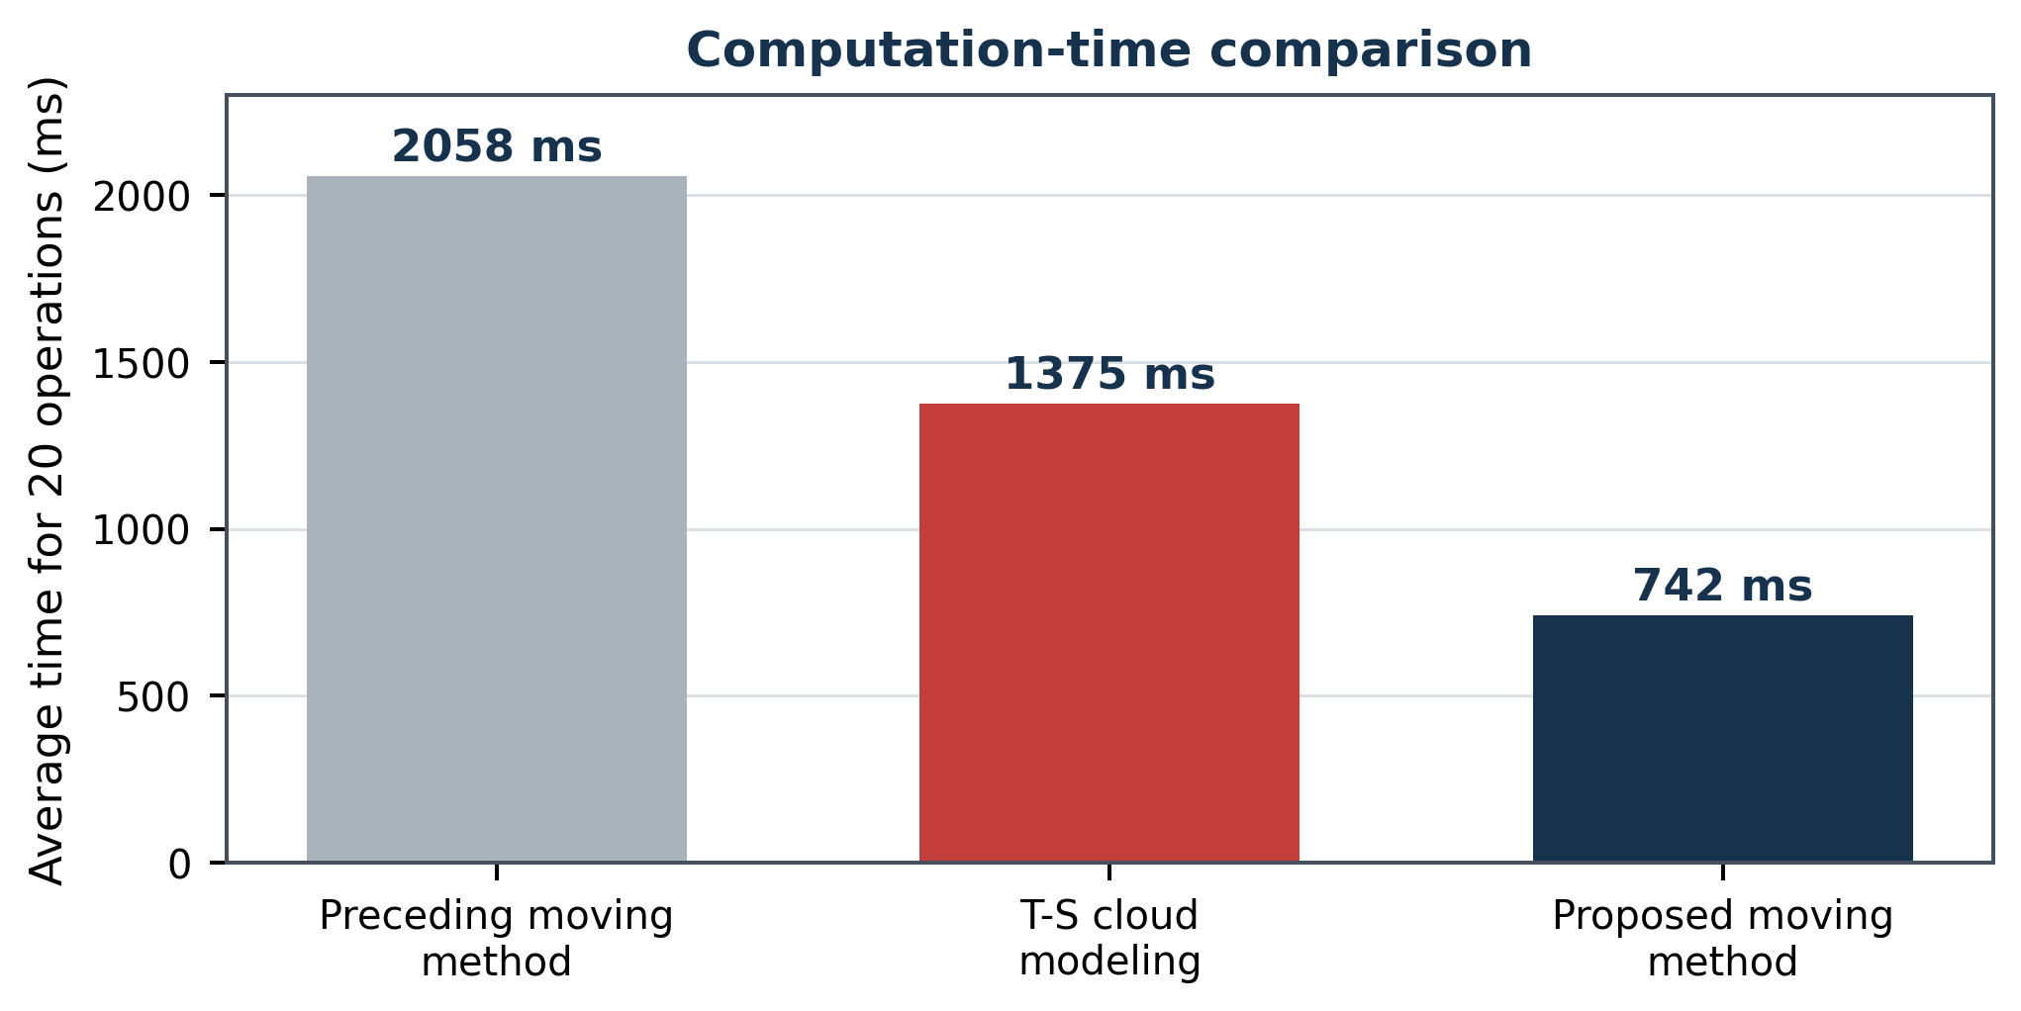
Figure 10. Computation-time comparison reconstructed from the exact values reported in the source paper.
Table 2. Comparison of the proposed method and T-S cloud modeling [14] (excerpt; Ov: overshoot, Tr: transient time, s).
Hyper entropy | Object | T-S Ov | T-S Tr | Proposed Ov | Proposed Tr | Ov improvement (%) | Tr improvement (%)
0.01 | 1 | 1.11 | 4.83 | divergence of [14] | - | - | -
0.01 | 2 | 6.93 | 4.22 | - | - | - | -
0.02 | 1 | 1.11 | 4.83 | divergence of [14] | - | - | -
0.02 | 2 | 6.93 | 4.27 | - | - | - | -
0.13 | 1 | 1.11 | 4.83 | 0.89 | 4.60 | 19.1 | 5
0.13 | 2 | 6.93 | 4.22 | 0.83 | 1.65 | 43.1 | 10
0.14 | 1 | 1.11 | 4.83 | 0.83 | 4.60 | 11.2 | 13.2
0.14 | 2 | 6.93 | 4.22 | 0.85 | 4.49 | - | -
Three observations follow from these results. First, the proposed method converges on the hyper-entropy range $\left[0.03,0.50\right]$, which is more than twice as wide as the range $\left[0.04,0.23\right]$ of the preceding moving method; it can therefore reflect vagueness and randomness of the concepts over a much wider range of uncertainty. Second, the overshoot of both the cart and the pendulum is reduced by roughly 10-40% with respect to T-S cloud modeling [14] in the convergent cases. Third, since the entropy is obtained without derivatives and integrals, the proposed method is about 2.8 times faster than the preceding moving method and about 1.9 times faster than T-S cloud modeling, which makes it suitable for real-time control loops - a property that recent inverted-pendulum studies with learning-based controllers [26, 27, 28] obtain only at a considerably higher computational cost.

6 Conclusions
This paper demonstrated that our study proposes a new membership cloud reasoning method that opens a novel research direction for approximate inference in nonlinear systems with uncertainty. To overcome the weaknesses of the preceding papers, we proposed a new approach of moving cloud reasoning to obtain the entropy of the membership cloud that does not use derivative and integral computation, based on the compensation fuzzy reasoning (moving-rate) principle proposed by Son-Il Kwak et al. in 2019 [12], and we corrected the errors contained in the condition expressions of the preceding formulation. Through the experimental research on stabilization of the inverted pendulum, the effectiveness of the proposed approach was shown: the proposed $m$-input single-output cloud reasoning approach by the moving principle overcomes the weakness of derivative and integral use in the preceding papers, reflects fuzziness and randomness as well as the three numerical characteristics of the cloud through cloudification and de-cloudification of the input information, satisfies the reductive property, converges in the wide hyper-entropy range $\left[0.03,0.50\right]$, and reduces the average calculation time from 2058 ms (preceding moving method) and 1375 ms (T-S cloud modeling) to 742 ms.
In future work, we will extend the moving cloud reasoning method to interval and multi-output cloud models following the interval extension of the moving-rate principle [20], tune the cloud parameters automatically with metaheuristic scheduling such as improved shark smell optimization [22], combine the method with causal-entropic explainability analysis [21], and apply it to further nonlinear benchmarks and industrial plants.

References
- Zadeh, L. A.: The concept of a linguistic variable and its applications to approximate reasoning. Information Sciences 8, pp. 199-249, 1975. DOI: 10.1016/0020-0255(75)90036-5.
- Li, D.-Y., Du, Y.: Artificial Intelligence with Uncertainty. Tsinghua University, Beijing, China; CRC Press, 2017. ISBN 9781498776264.
- Zhou, N.: Cloud model and its application in intelligent control. Master's degree thesis, PLA University of Science and Technology, Nanjing, China, 2000.
- Li, W., Wang, Y., Du, J., Lai, J.: Synergistic integration of graph-cut and cloud model strategies for image segmentation. Neurocomputing 257, pp. 37-46, 2017. DOI: 10.1016/j.neucom.2016.12.072.
- Liu, Y.: The research of granular computing based on cloud. PhD thesis, Tsinghua University, Beijing, China, 2012.
- Li, Y., Fan, X.: Recursive integral proportional-integral control based on membership cloud for active power filter. IET Power Electronics, 2014. DOI: 10.1049/iet-pel.2014.0285.
- Zheng, Y., Sheng, W., Sun, X., Chen, S.: Airline passenger profiling based on fuzzy deep machine learning. IEEE Transactions on Neural Networks and Learning Systems 28(12), pp. 2911-2923, Dec. 2017. DOI: 10.1109/TNNLS.2016.2609437.
- Filho, O. D. R., Serra, G. L. D. O.: Recursive fuzzy instrumental variable based evolving neuro-fuzzy identification for non-stationary dynamic system in a noisy environment. Fuzzy Sets and Systems 338, pp. 50-89, 2018. DOI: 10.1016/j.fss.2017.05.016.
- Essien, E., Ibrahim, H., Mehrandezh, M., Idem, R.: Adaptive neuro-fuzzy inference system (ANFIS)-based model predictive control (MPC) for carbon dioxide reforming of methane (CDRM) in a plug flow tubular reactor for hydrogen production. Thermal Science and Engineering Progress 9, pp. 148-161, 2019. DOI: 10.1016/j.tsep.2018.11.010.
- Chen, T.-Y.: An outranking approach using a risk attitudinal assignment model involving Pythagorean fuzzy information and its application to financial decision making. Applied Soft Computing 71, pp. 460-487, 2018. DOI: 10.1016/j.asoc.2018.06.036.
- Du, Z., Yan, Z., Zhao, Z.: Interval type-2 fuzzy tracking control for nonlinear systems via sampled-data controller. Fuzzy Sets and Systems 356, pp. 92-112, 2019. DOI: 10.1016/j.fss.2018.02.013.
- Kwak, S.-I., Ryu, U.-S., Kim, K.-J.: A fuzzy reasoning method based on compensating operation and its application to fuzzy systems. Iranian Journal of Fuzzy Systems 16(3), pp. 17-34, 2019. DOI: 10.22111/IJFS.2018.4175.
- Mizumoto, M., Zimmermann, H. J.: Comparison of fuzzy reasoning methods. Fuzzy Sets and Systems 8, pp. 253-283, 1982. DOI: 10.1016/S0165-0114(82)80004-3.
- Li, C., Zhou, J. Z., Fu, B., Kou, P., Xiao, J.: T-S fuzzy model identification with a gravitational search-based hyperplane clustering algorithm. IEEE Transactions on Fuzzy Systems 20(2), pp. 305-317, 2012. DOI: 10.1109/TFUZZ.2011.2173693.
- Li, D., Du, Y.: Artificial Intelligence with Uncertainty, 2nd edition. CRC Press, Boca Raton, ISBN 978-1-4987-7626-4.
- Kwak, S.-I., Kim, U.-H., Kim, K.-J., Son, I.-M.: Fuzzy reasoning method based on distance measure and its reductive property. WSEAS Transactions on Computer Research 8, pp. 73-89, 2020. DOI: 10.37394/232018.2020.8.10.
- Kwak, C.-J., Ri, K.-C., Kwak, S.-I., Kim, K.-J., Ryu, U.-S., Kwon, O.-C., Kim, N.-H.: Fuzzy modus ponens and tollens based on moving distance in SISO fuzzy system. Romanian Journal of Information Science and Technology 24(3), pp. 257-283, 2021.
- Son, I. M., Kwak, S. I., Han, U. J., Pak, J. H., Han, M., Pyon, J. R., Ryu, U. S.: A novel fuzzy approximate reasoning method based on extended distance measure in SISO fuzzy system. arXiv:2003.13450, 2020.
- Kwak, S.-I., et al.: New approximate reasoning method based on least common multiple and its property analysis. Proceedings of the 5th International Conference on Applied Science, Engineering and Management, 2022.
- Kong, H.-U., Kwak, S.-I., Jang, Y.-J., Hwang, C.-J., Ri, O.-S., Jo, Y.-H., Nam, J.-H., Ryu, U.-S.: New interval fuzzy modeling method based on KSI principle and its application in turf color image evaluation. Journal of Industrial and Management Optimization 21(12), pp. 6713-6735, 2025. DOI: 10.3934/jimo.2025146.
- Choe, J.-H., Jang, Y.-J., Kwak, S.-I., Ri, O.-S., Kong, H.-U.: Causal-entropic fuzzy inference: a Bayesian framework for explainable and robust fuzzy reasoning. Journal of Fuzzy Systems and Control 4(1), 2026. ISSN 2986-6537. DOI: 10.59247/jfsc.v4i1.392.
- Choe, J.-H., Choe, G., Kwak, S.-I., Chae, H.-G., Kong, H.-U.: Improved shark smell optimization with adaptive parameter scheduling for fuzzy controller tuning. Academy Journal of Science and Engineering 20(1), 2026.
- Jia, Q., Hu, J., Zhang, W., Zhai, S., Li, Z.: A new situation assessment method for aerial targets based on linguistic fuzzy sets and trapezium clouds. Engineering Applications of Artificial Intelligence 117, 105610, 2023.
- Su, X., Xia, F., Liu, J., Wu, L.: Event-triggered fuzzy control of nonlinear systems with its application to inverted pendulum systems. Automatica 94, pp. 236-248, 2018.
- Nasir, A. N. K., Razak, A. A. A.: Opposition-based spiral dynamic algorithm with an application to optimize type-2 fuzzy control for an inverted pendulum system. Expert Systems with Applications 195, 116661, 2022.
- Safeea, M., Neto, P.: A Q-learning approach to the continuous control problem of robot inverted pendulum balancing. Intelligent Systems with Applications, 200313, 2023. DOI: 10.1016/j.iswa.2023.200313.
- Irfan, S., Zhao, L., Ullah, S., Mehmood, A., Butt, M. F. U.: Control strategies for inverted pendulum: a comparative analysis of linear, nonlinear, and artificial intelligence approaches. PLoS ONE 19(3), e0298093, 2024. DOI: 10.1371/journal.pone.0298093.
- Nguyen, T. V. A., Dao, Q., Bui, N.-T.: Optimized fuzzy logic and sliding mode control for stability and disturbance rejection in rotary inverted pendulum. Scientific Reports 14, 2024. DOI: 10.1038/s41598-024-82471-y.
- Saleem, O., Alsuwian, T., Amin, A. A., Ali, S., Alqarni, Z. A.: Stabilization control of rotary inverted pendulum using a novel EKF-based fuzzy adaptive sliding-mode controller: design and experimental validation. Automatika 65(2), pp. 538-558, 2024. DOI: 10.1080/00051144.2024.2312309.
- Tian, B., Peng, H., Kang, T.: RBF-ARX model-based predictive control approach to an inverted pendulum with self-triggered mechanism. Chaos, Solitons & Fractals 186, 115291, 2024. DOI: 10.1016/j.chaos.2024.115291.
- Hamza, M. F., Yap, H. J., Choudhury, I. A., Isa, A. I., Zimit, A. Y., Kumbasar, T.: Current development on using Rotary Inverted Pendulum as a benchmark for testing linear and nonlinear control algorithms. Mechanical Systems and Signal Processing 116, pp. 347-369, 2019. DOI: 10.1016/j.ymssp.2018.06.054.
- Kuczmann, M.: Comprehensive survey of PID controller design for the inverted pendulum. Acta Technica Jaurinensis 12(1), pp. 55-81, 2019. DOI: 10.14513/actatechjaur.v12.n1.492.
- Abdullah, M., Amin, A. A., Iqbal, S., Mahmood-ul-Hasan, K.: Swing up and stabilization control of rotary inverted pendulum based on energy balance, fuzzy logic, and LQR controllers. Measurement and Control 54(9-10), 2021. DOI: 10.1177/00202940211035406.
- Bezci, Y. E., Tavakol Aghaei, V., Akbulut, B. E., Tan, D., Allahviranloo, T., Fernandez-Gamiz, U., Noeiaghdam, S.: Classical and intelligent methods in model extraction and stabilization of a dual-axis reaction wheel pendulum: a comparative study. Results in Engineering 16, 100685, 2022. DOI: 10.1016/j.rineng.2022.100685.
- Yang, X., Zheng, X.: Swing-up and stabilization control design for an underactuated rotary inverted pendulum system: theory and experiments. IEEE Transactions on Industrial Electronics 65(9), pp. 7229-7238, 2018. DOI: 10.1109/TIE.2018.2793214.
- Nguyen, N. P., Oh, H., Kim, Y., Moon, J.: A nonlinear hybrid controller for swinging-up and stabilizing the rotary inverted pendulum. Nonlinear Dynamics 104(2), pp. 1117-1137, 2021. DOI: 10.1007/s11071-021-06317-2.
- Waheed, F., Yousufzai, I. K., Valasek, M.: A TV-MPC methodology for uncertain under-actuated systems: a rotary inverted pendulum case study. IEEE Access 11, pp. 103636-103649, 2023. DOI: 10.1109/ACCESS.2023.3318108.
- Al Juboori, A. M., Hussein, M. T., Qanber, A. S. G.: Swing-up control of double-inverted pendulum systems. Mechanical Sciences 15, pp. 47-54, 2024. DOI: 10.5194/ms-15-47-2024.
- Tomar, B., Kumar, N., Sreejeth, M.: Robust control of rotary inverted pendulum using metaheuristic optimization techniques based PID and fractional order PIλDμ controller. Journal of Vibration Engineering & Technologies 12, 2024. DOI: 10.1007/s42417-024-01399-9.
- Nguyen, D.-H., Pham, D.-B., Nguyen, T.-V.-A., Bui, N.-T.: A hybrid control framework for swing-up and stabilization of the double inverted pendulum on a cart. IEEE Access 13, pp. 70811-70827, 2025. DOI: 10.1109/ACCESS.2025.3562945.
- Huang, J., Ri, S., Liu, L., Wang, Y., Kim, J., Pak, G.: Nonlinear disturbance observer-based dynamic surface control of mobile wheeled inverted pendulum. IEEE Transactions on Control Systems Technology 23(6), pp. 2400-2407, 2015. DOI: 10.1109/TCST.2015.2404897.
- Gritli, H., Belghith, S.: Robust feedback control of the underactuated inertia wheel inverted pendulum under parametric uncertainties and subject to external disturbances: LMI formulation. Journal of the Franklin Institute 355(18), pp. 9150-9191, 2018. DOI: 10.1016/j.jfranklin.2017.01.035.
- Majumder, K., Patre, B. M.: Sliding mode control for underactuated mechanical systems via nonlinear disturbance observer: stabilization of the rotational pendulum. International Journal of Dynamics and Control 6(4), pp. 1663-1672, 2018. DOI: 10.1007/s40435-018-0415-1.
- Nguyen, N. P., Oh, H., Kim, Y., Moon, J., Yang, J., Chen, W.-H.: Fuzzy-based super-twisting sliding mode stabilization control for under-actuated rotary inverted pendulum systems. IEEE Access 8, pp. 185079-185092, 2020. DOI: 10.1109/ACCESS.2020.3029095.
- El-Sousy, F. F. M., Alattas, K. A., Mofid, O., Mobayen, S., Fekih, A.: Robust adaptive super-twisting sliding mode stability control of underactuated rotational inverted pendulum with experimental validation. IEEE Access 10, pp. 100857-100866, 2022. DOI: 10.1109/ACCESS.2022.3208412.
- Le, H. D., Nestorović, T.: A novel hierarchical recursive nonsingular terminal sliding mode control for inverted pendulum. Actuators 12(12), 462, 2023. DOI: 10.3390/act12120462.
- Hou, M., Zhang, X., Chen, D., Xu, Z.: Hierarchical sliding mode control combined with nonlinear disturbance observer for wheeled inverted pendulum robot trajectory tracking. Applied Sciences 13(7), 4350, 2023. DOI: 10.3390/app13074350.
- Liu, R., Wu, J., Wang, D.: Sampled-data fuzzy control of two-wheel inverted pendulums based on passivity theory. International Journal of Control, Automation and Systems 16(5), pp. 2538-2548, 2018. DOI: 10.1007/s12555-018-0063-4.
- Ben Hazem, Z., Fotuhi, M. J., Bingül, Z.: Development of a Fuzzy-LQR and Fuzzy-LQG stability control for a double link rotary inverted pendulum. Journal of the Franklin Institute 357(15), pp. 10529-10556, 2020. DOI: 10.1016/j.jfranklin.2020.08.030.
- Jain, A., Sharma, A., Jately, V., Azzopardi, B., Choudhury, S.: Real-time swing-up control of non-linear inverted pendulum using Lyapunov based optimized fuzzy logic control. IEEE Access 9, pp. 50715-50726, 2021. DOI: 10.1109/ACCESS.2021.3058645.
- Masrom, M. F., Ghani, N. M. A., Tokhi, M. O.: Particle swarm optimization and spiral dynamic algorithm-based interval type-2 fuzzy logic control of triple-link inverted pendulum system: a comparative assessment. Journal of Low Frequency Noise, Vibration and Active Control 40(1), 2021. DOI: 10.1177/1461348419873780.
- Kelekci, E., Yaren, T., Kizir, S.: Design of optimized interval type-2 fuzzy logic controller based on the continuity, monotonicity, and smoothness properties for a cart-pole inverted pendulum system. Transactions of the Institute of Measurement and Control 44(12), pp. 2291-2307, 2022. DOI: 10.1177/01423312221081309.
- Hamza, M. F.: Modified flower pollination optimization based design of interval type-2 fuzzy PID controller for rotary inverted pendulum system. Axioms 12(6), 586, 2023. DOI: 10.3390/axioms12060586.
- Nguyen, V.-T., Nguyen, Q.-C., Van, M., Nguyen, V.-T., Pham, D.-H., Nguyen, D.-C.: Novel adaptive fuzzy control for pendubot with actuator faults and uncertainties: design and experiments. Results in Engineering 24, 102916, 2024. DOI: 10.1016/j.rineng.2024.102916.
- Ochoa, P., Peraza, C., Melin, P., Castillo, O., Geem, Z. W.: Type-3 fuzzy dynamic adaptation of the crossover parameter in differential evolution for the optimal design of type-3 fuzzy controllers for the inverted pendulum. Machines 13(6), 450, 2025. DOI: 10.3390/machines13060450.
- Israilov, S., Fu, L., Sánchez-Rodríguez, J., Fusco, F., Allibert, G., Raufaste, C., Argentina, M.: Reinforcement learning approach to control an inverted pendulum: a general framework for educational purposes. PLoS ONE 18(2), e0280071, 2023. DOI: 10.1371/journal.pone.0280071.
- Ben Hazem, Z.: Study of Q-learning and deep Q-network learning control for a rotary inverted pendulum system. Discover Applied Sciences 6, 49, 2024. DOI: 10.1007/s42452-024-05690-y.
- Lee, T., Ju, D., Lee, Y. S.: Transition control of a double-inverted pendulum system using Sim2Real reinforcement learning. Machines 13(3), 186, 2025. DOI: 10.3390/machines13030186.
- Nghi, H. V., Nhien, D. P., Ba, D. X.: A LQR neural network control approach for fast stabilizing rotary inverted pendulums. International Journal of Precision Engineering and Manufacturing 23(1), pp. 45-56, 2022. DOI: 10.1007/s12541-021-00606-x.
- Ayad, M., Arichi, F., Megnafi, H., Merad, L.: Real time stabilization of a rotary inverted pendulum using neural networks approach. Journal of Vibration and Control 32(13-14), pp. 3687-3701, 2026. DOI: 10.1177/10775463251349249.
- Zaborniak, D., Patan, K., Witczak, M.: Design, implementation, and control of a wheel-based inverted pendulum. Electronics 13(3), 514, 2024. DOI: 10.3390/electronics13030514.
- Munoz-Hernandez, G. A., Diaz-Tellez, J., Estevez-Carreon, J., Garcia-Ramirez, R. S.: ADRC attitude controller based on ROS for a two-wheeled self-balancing mobile robot. IEEE Access 11, pp. 94636-94646, 2023. DOI: 10.1109/ACCESS.2023.3308948.
- Liang, S., Wang, Z., Stepan, G.: Motion control of a two-wheeled inverted pendulum with uncertain rolling resistance and angle constraint based on slow-fast dynamics. Nonlinear Dynamics 104(3), pp. 2185-2199, 2021. DOI: 10.1007/s11071-021-06439-7.
- Kwak, S.-I., Yu, H.-U., Jang, Y.-J., Hwang, C.-J., Ri, O.-S., Chae, H.-G.: Optimal fuzzy modus ponens and tollens algorithm based on KSI principle. Research Square preprint, 2023. DOI: 10.21203/rs.3.rs-3690916/v1.

