Hotkey Scene Switcher user manual
In this document you will find the instructions on how to set up and use Hotkey Scene Switcher.

Step 1.
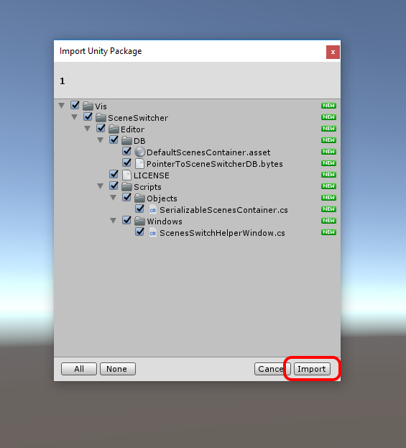
Import package from asset store.

Step 2.
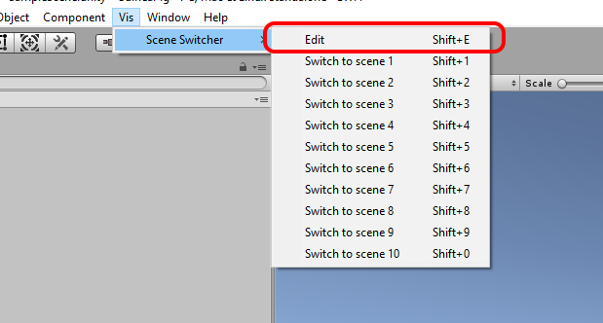
Now you should have a new menu item in the top panel called “Vis”, which will have submenu called “Scene Switcher”. From there you can pop up Edit window and navigate through your scenes with the mouse. Now click on Edit button.

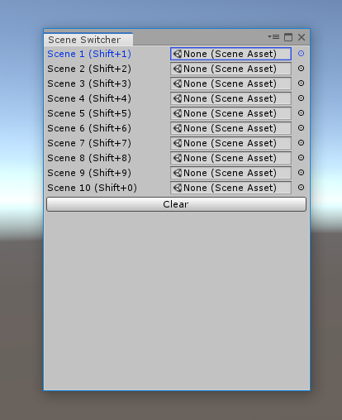
Step 3.
The Edit window will show. Here you can set up your hotkeys layout.

Step 4.
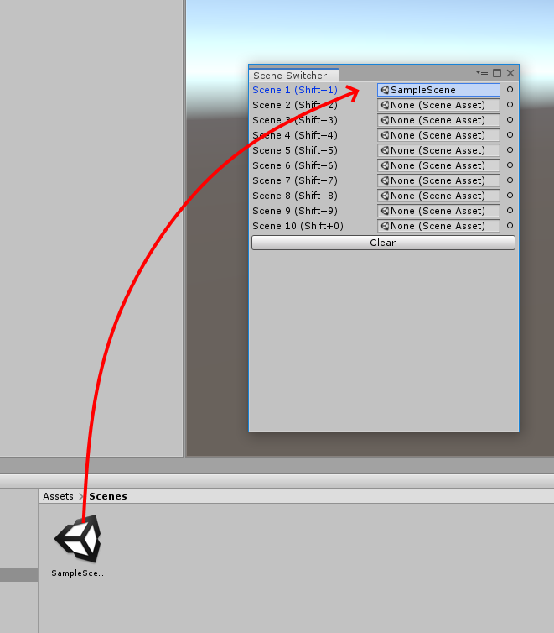
Drag your scene to any of the fields. That scene now will be accessible through hotkey on the left of the field!
In this case – Shift+1
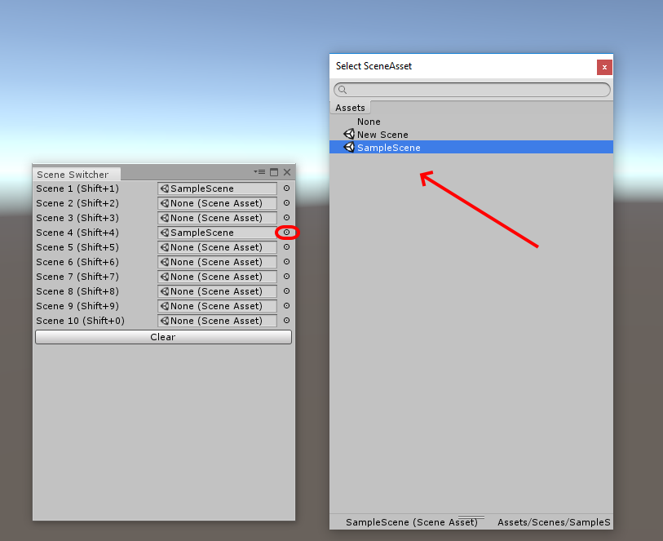
You can also click on a little circle on the right of the field and select desired scene from the separate window.

Support: celtic.gua@gmail.com

