Sprite Editor Pro user manual

In this document you will find the instructions on how to set up and use Sprite Editor Pro.

If you have any question, feature request or bug report about this asset please contact me by email: celtic.gua@gmail.com

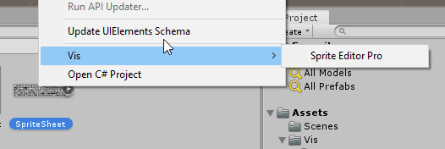
In order to start editing, right click on any sprite in your project and choose Vis → Sprite Editor Pro
The Sprite Editor Pro window will open:
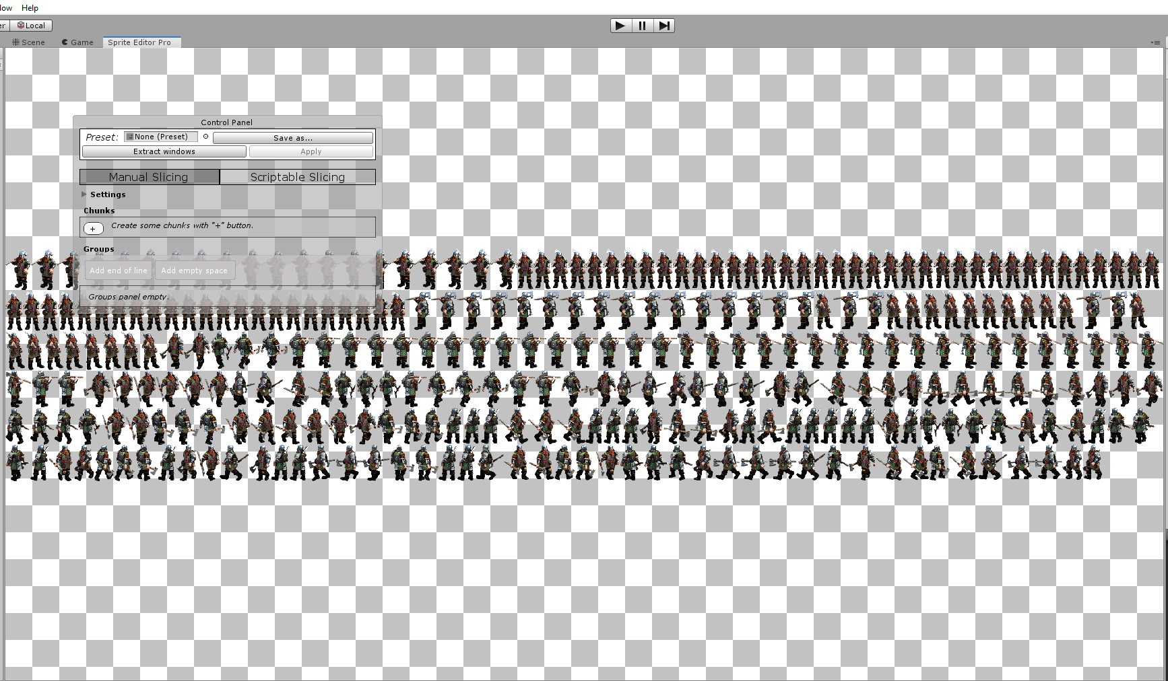
This window consists of two main parts – Texture View and Control Panel. In the next screenshot Texture View is highlighted with red color, and Control Panel with green color:

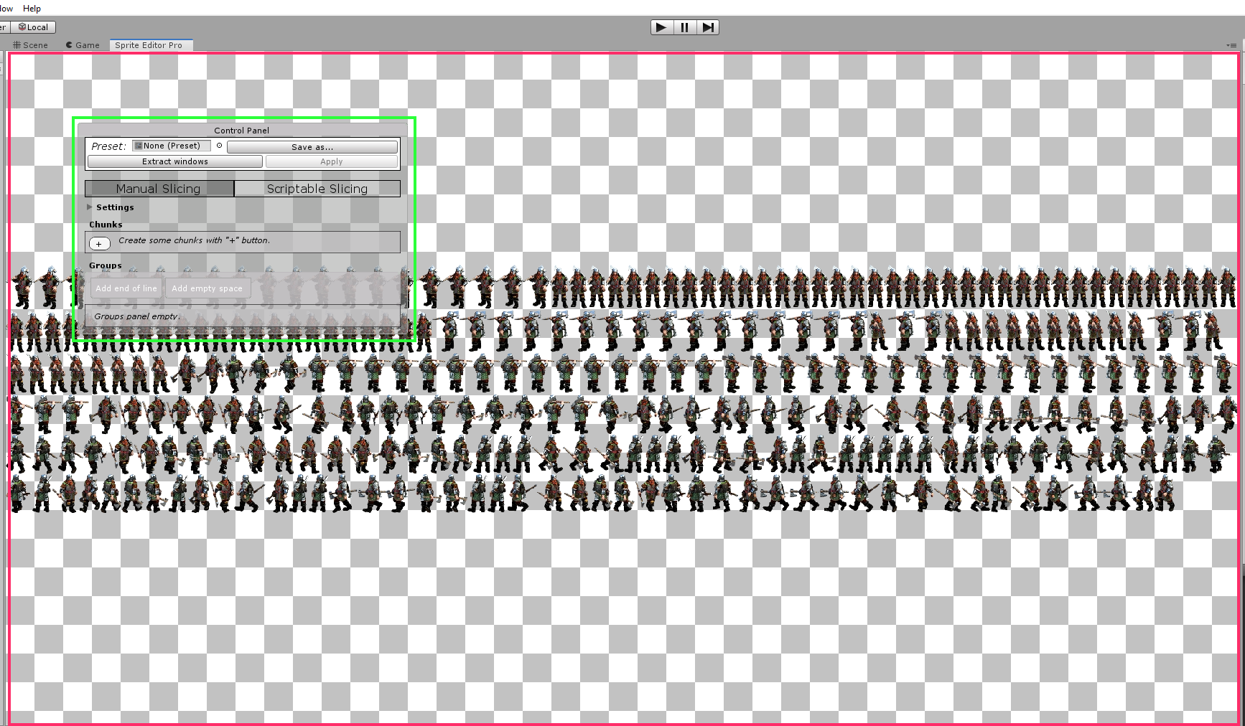
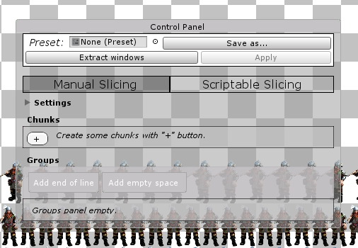
Control Panel consist of multiple parts. The Top Panel part contains the application-wise controls. That includes managing presets, windows and Apply button, which executes sprite slicing.

Presets managing
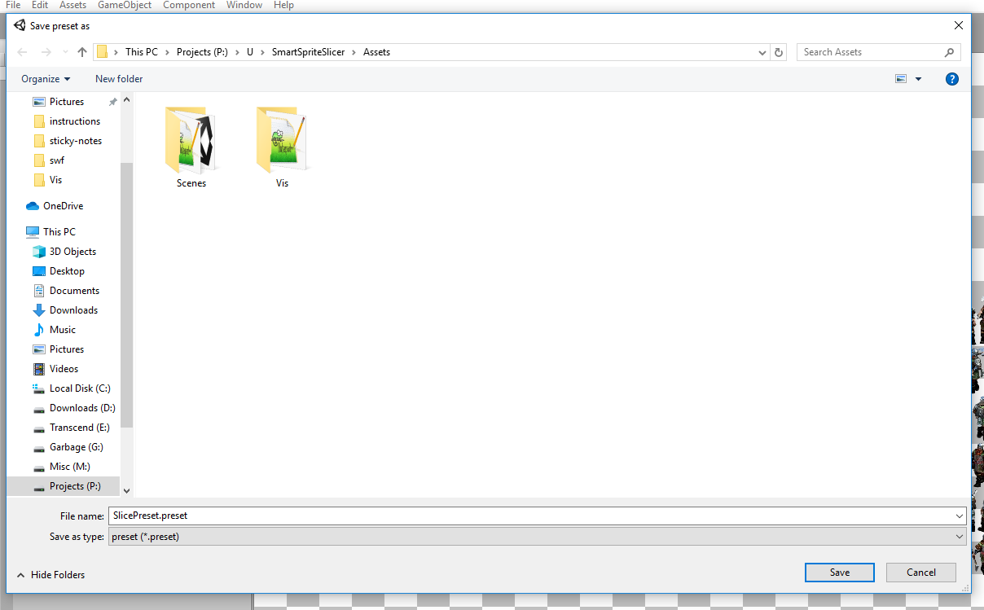
Your slicing patterns can be stored in separate files in order for you to reuse them later. If you click “Save as...” button, the file saving dialog window will open:
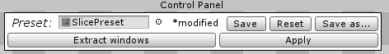
Here you can specify folder and file name for your preset file and save it. When you make some changes, the “* modified” subscript will appear next to the preset field, notifying that current state of slicing settings doesn't correspond with saved ones. So you can choose to either save changes to disk, or load setting from disk via “Reset” button. Beware that resetting will erase all your unsaved changes.

Windows
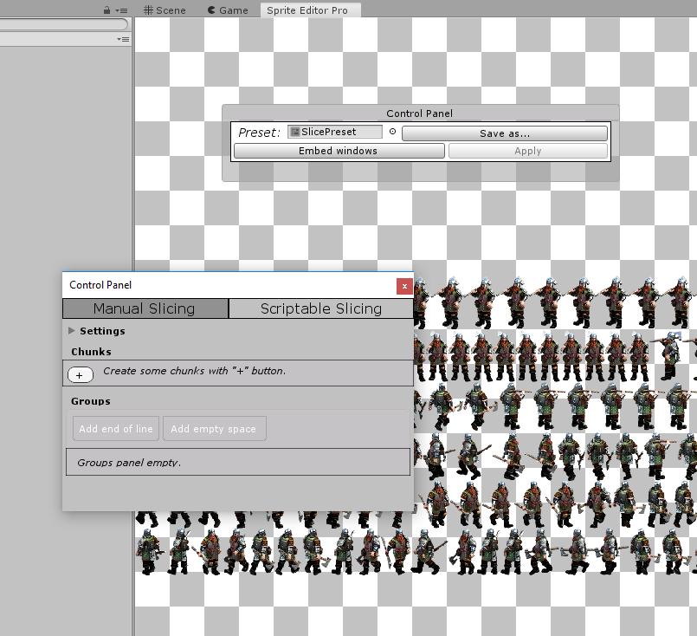
You can work with application windows in two modes. Windows can be either embedded to main window (in that case they are partially transparent to not obstruct view) or floating around, so you can place them in any spot of your screen. You can switch between this modes by clicking Extract windows – Embed windows button. Floating mode:

Executing sprite slicing
You can slice your sprite by clicking “Apply” button. This button will be disabled if there's not enough information to apply. Add some manual or scriptable slicing logic in order to make it active.
When you have slicing logic and click “Apply” button it will slice your edited sprite accordingly. If the sprite you slicing is already in Multiple Sprite Mode and have some sprites inside it, they will be deleted before slicing.
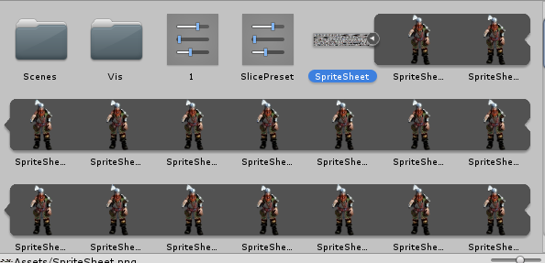

Slicing Logic editing
There are two modes that you can utilize in order to slice yout texture – Manual and Scriptable. Switching between them performed by utilizing tabs right under Top Panel

Manual Slicing mode
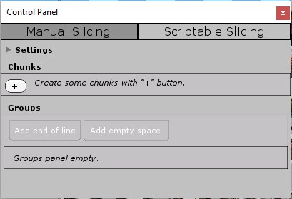
Empty manual slicing tab looks like this.
There's two main types of objects in manual slicing mode – Chunks and Groups.
Chunks represent a type of sprite. Groups are sets of instances of some type of sprite (chunk). So you can have, say, a Dwarf-chunk, which size is 72x44 and a group of 10 Dwarf chunks going one after another. That system allows you to reuse settings for similar sprites.

Workflow
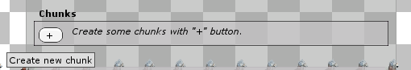
Start by adding some chunks in the “Chunks” panel by clicking on “+” button.

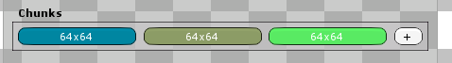
If you select some chunk you'll see editable setting under it:
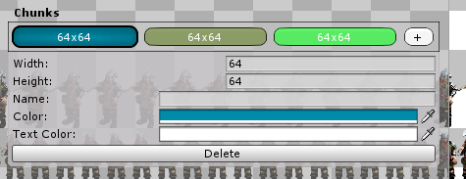
Editing them you can define that chunk's properties:
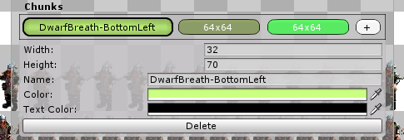

Now drag and drop some chunks in Groups panel:
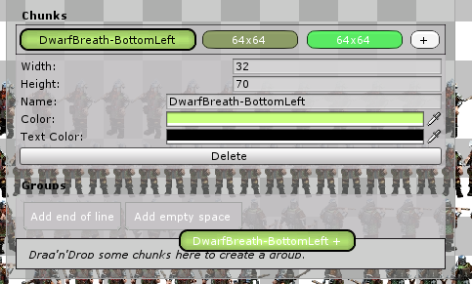
This will create a group of that chunk's type. You will also see the representation of that group in Texture View. The group representation looks like set of rectangles of the color of a chunk and a circle of the same color, representing pivot point:
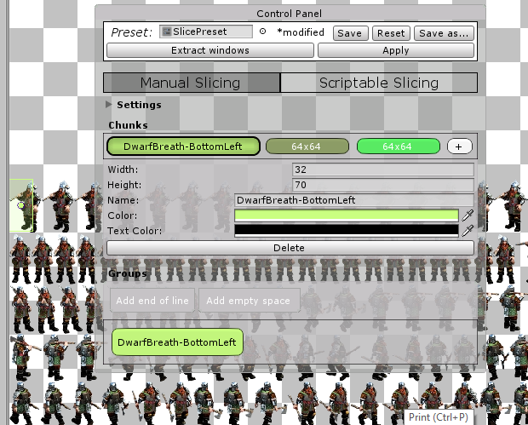
If you click on a group you'll see it's settings under it:
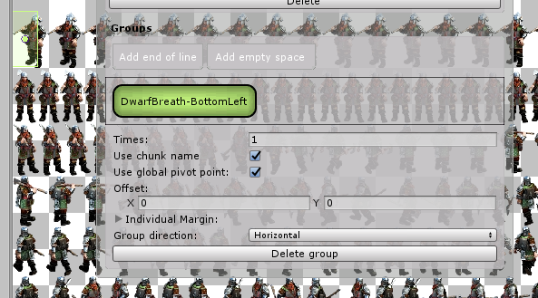
Times – how many time chunk should be repeated.
Use chunk name – whether or not group should be named after chunk.
Use global pivot point – whether or not group should use global pivot point settings or override them.
Offset – the offset from the preceding group or origin if there're no groups preceding.
Individual Margin – the margin from each side of every chunk in group.
Group direction – can be either Horizontal or Vertical.
Delete – deletes the group.

Editing “Times” property allows you more easily define chunk's size.
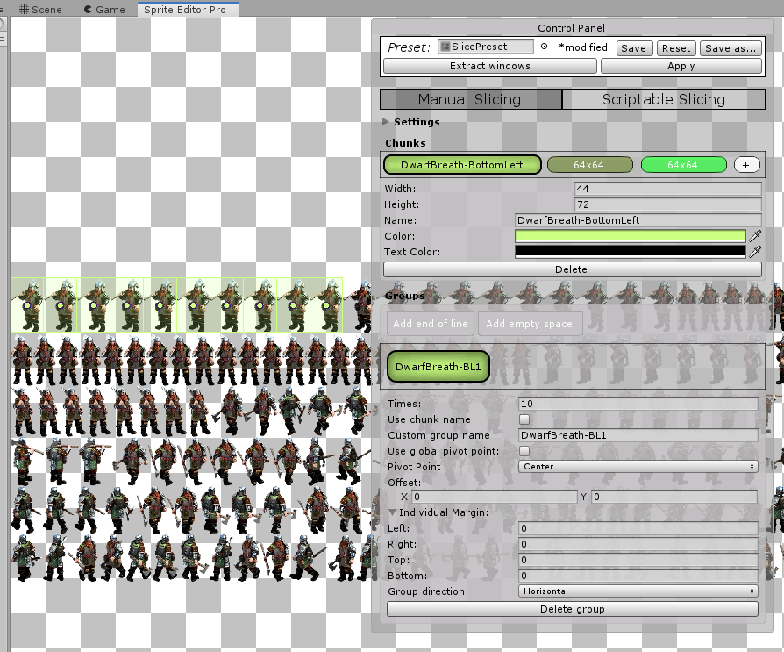
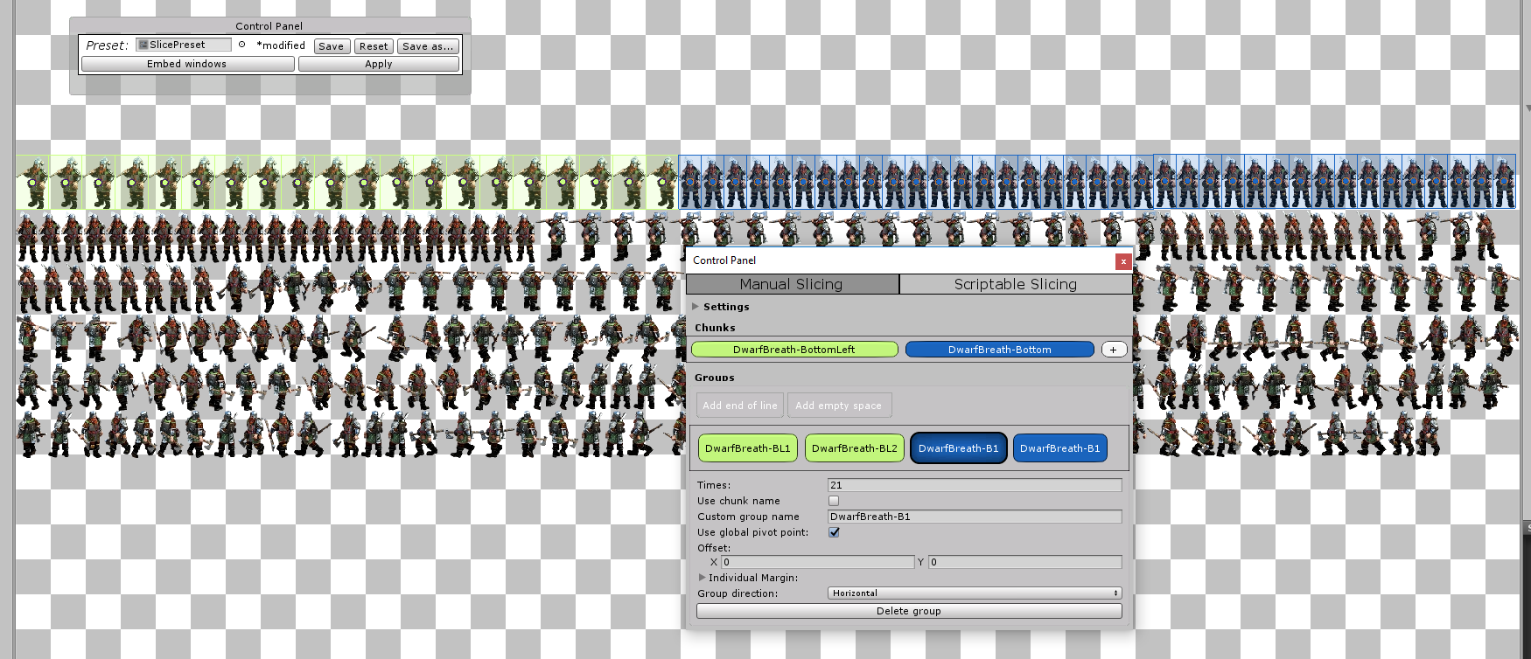
Add more chunks and groups.
As you see chunks and groups are added one by one in a line. When you reach end of line click “Add end of line” button on top of group the group editing area. That will allow you to start a new line and continue working with groups.
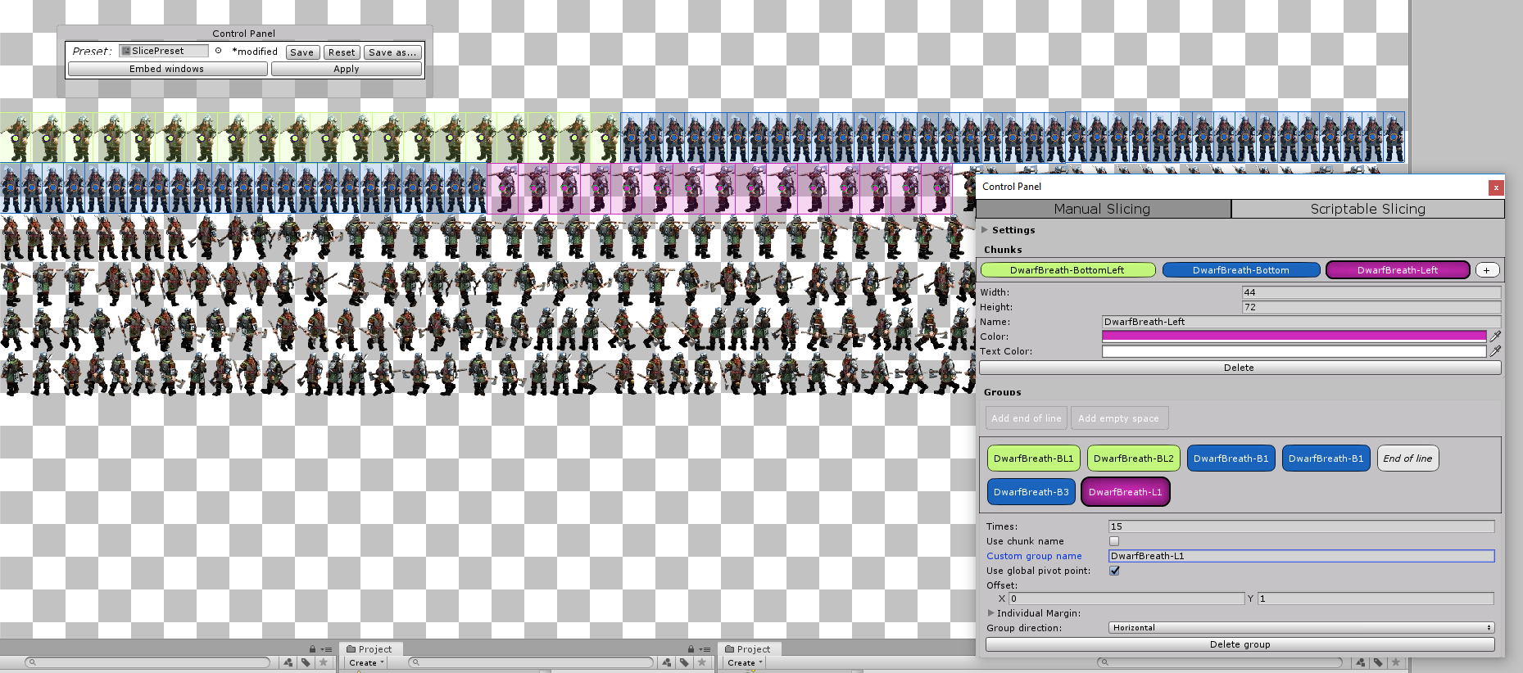
End Of Line group just resetting X to origin's value, in our case – 0. But it also can add some additional offset and can be added multiple times. By default additional offset equals to the last group's height.
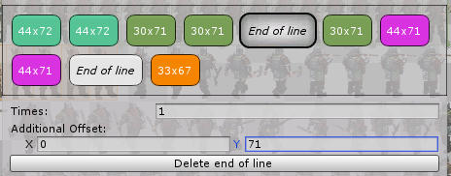
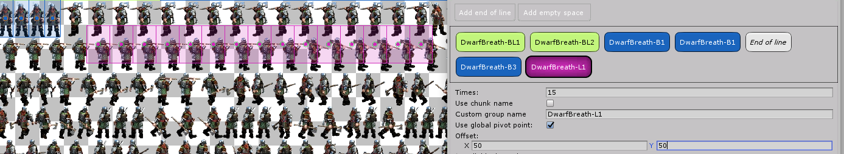
You can utilize Offset setting if your group requires it:

Margin setting allows you to add and offset to each chunk in a group:
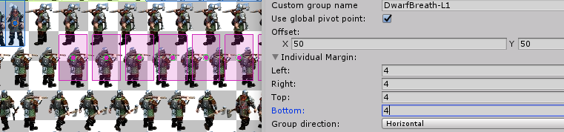
If your sprites area layed out vertically – utilize Group direction setting:
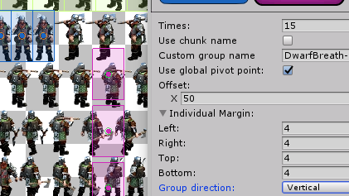
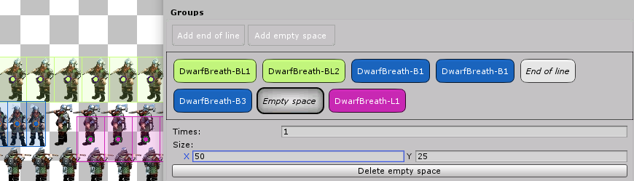
If you need just add some arbitrary offset between the groups you can add Empty Space group, by clicking “Add empty space” button on the top of groups editing area.
As you see the pink group is now shifted by 50 pixels on the x axis and 25 on y axis.

You can add that group multiple times too:
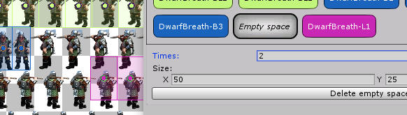
Settings
There is foldable settings area on the top of Manual Slicing view.
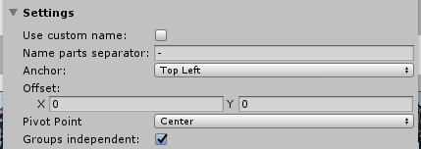
That area contains mode-wize settings.
Use custom name – that allows you to set custom name instead of texture's name.
Name pats separator - that allows you to set custom name separator instead of “-”.
Anchor – defines the origin for all groups.
Offset – the global offset of all groups.
Pivot Point – the default pivot point.
Groups independent – allows you to edit groups offsets and margins without any effect on the next groups.

Naming
The naming schema of a sliced sprites is <global name>{separator}<group name>{separator}(index).
The global name by default is an edited texture's name. It can be overriden by “Use custom name” property in the settings area.
Group name – is a name of group. By default it's the same as chunks name, but can be overriden in the individual group's settings.
Index – is an index of a chunk in a group. Can't be overriden.
Separator – is an arbitrary text, that can be set in Settings. By default - “-”.

Anchoring
The origin of a groups can be changed in Settings. There are 4 possible choices:
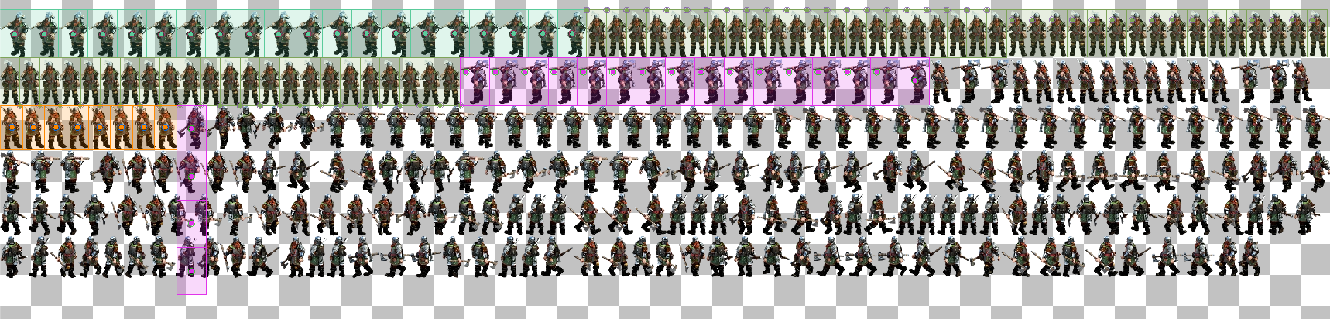
TopLeft
TopRight
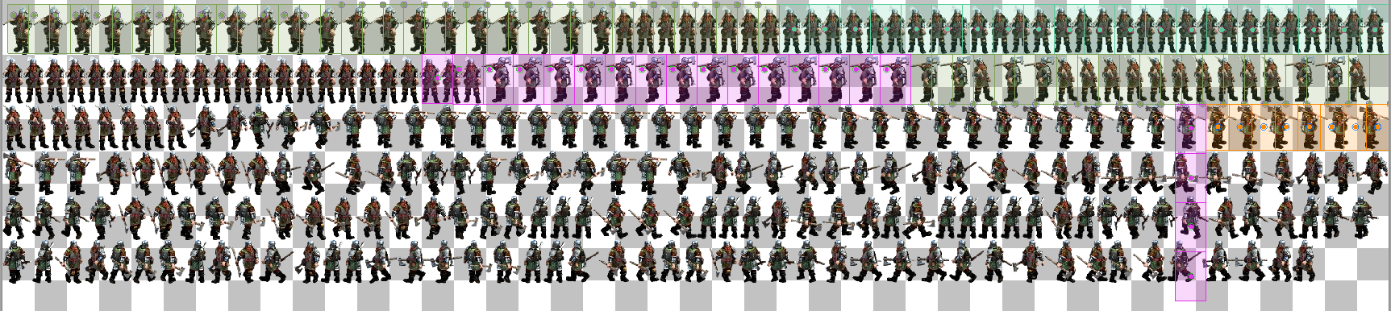

BottomLeft
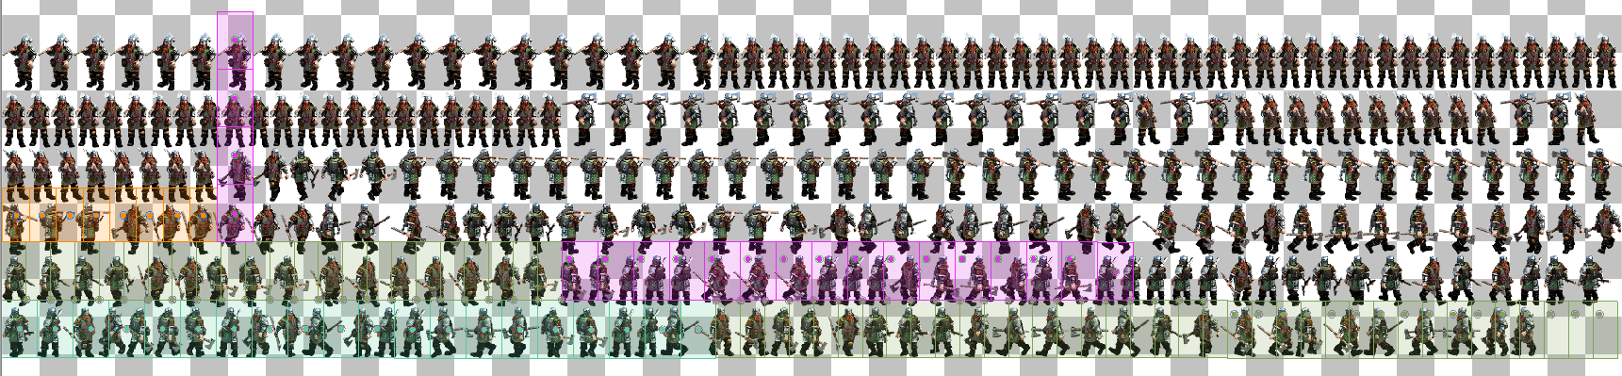
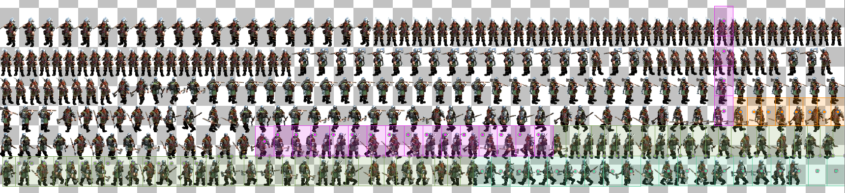
BottomRight

Groups offset editing modes
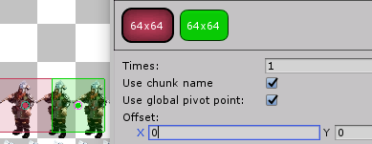
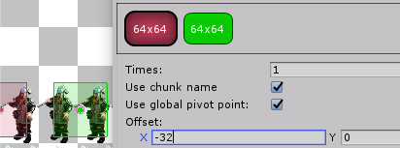
When you edit group's offset or margin, it can affect groups next to it. By default the “Groups independent” option is set to true, so it will not be the case.
As you see the changes to offset of red group doesn't affect group next to it. But if you change “Groups independent” option to false....
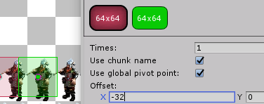
…the changes to the red group's offset will affect position of the next group – it will stick to the right border of preceding one.

Pivot points
Pivot points can be edited by multiple ways. By default all groups utilize global pivot point setting, which you can edit in Settings area.
There are 6 options:
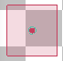
Center
TopLeft

TopRight
BottomLeft

BottomRight

Custom
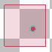
When you choose custom option the absolute pivot editing field will appear, allowing you to set any pivot point you want.
Every group can define it's own custom pivot point behaviour, differing from the global setting. Uncheck “Use global pivot point” option int the groups settings for it.

Also you can edit pivot point by just dragging the circle.
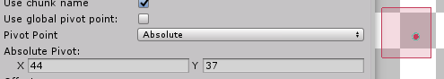
That action will automatically set the “Use global pivot point” group's option to false and “Pivot Point” setting to Custom.

Global offset
Global offset allows you to add offset to all the groups
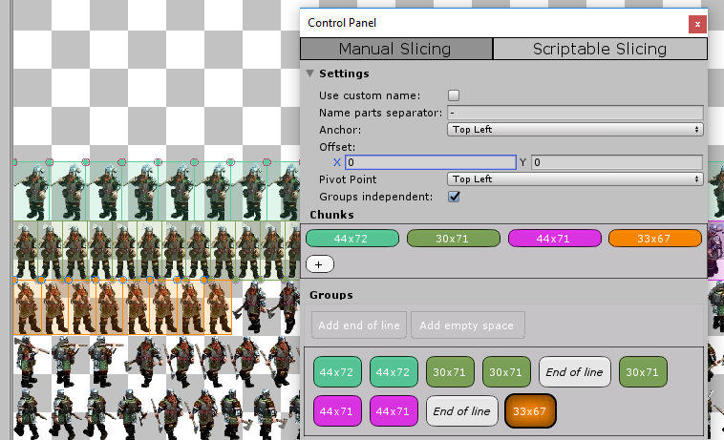
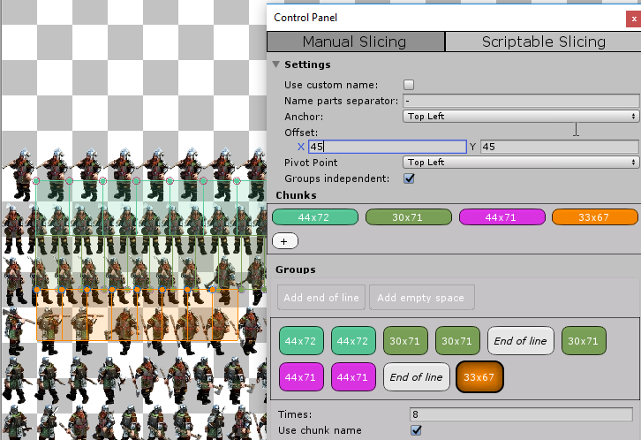
Scriptable Scicing mode
This mode of slicing is enabled by clicking on “Scriptable Slicing” button in the top tabs view. The empty scriptable slicing mode window looks like this:
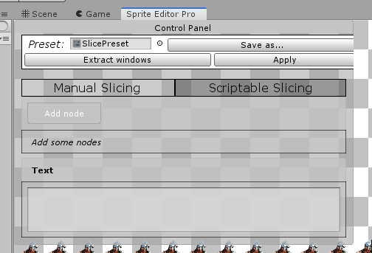
The main idea of that mode is that you have a text description of the sprites layout in some arbitrary format and wish to parse it to get sprites sliced properly.
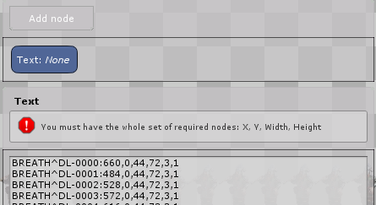
So first thing you want to do is enter the text you have in the Text area and add a node:

The error hint you see tell you that you must have the minimal set of nodes for your pattern to use it on that text.
Nodes define the pattern that will be used on that text to fetch the layout info. The minimal set of required nodes are:
X, Y, Width, and Height
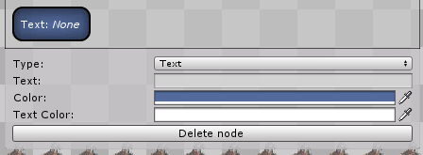
Click on the node to see it's available settings.
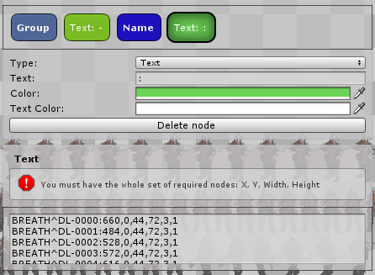
Type is the type of node. There're two main categories in the node types – separators and data. There are two separator types: Text and End of line. The data-types of nodes are X, Y, Width, Height, PivotX, PivotY, Group and Main. The data-types can be used once in pattern and separators can be used many times. All data-type nodes must be separated by Text of EndOfLine type of nodes. Also there must be some separator-typed node in the beginning or in the end of the pattern. Lets give it a try.
As you see we've added a Group node that fetches the info about group name. Then there is a Text separator with the Text property set to “-”. So the group data will be filled by all text before the “-” symbol encountered. After that we added Name group, so the Name data will start to be filled. And it will be filled until the “:” text will be encountered, because we added that Text “:” node.
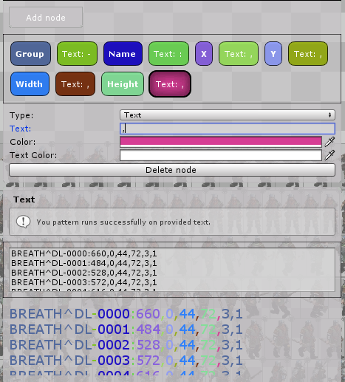
The finished pattern looks like this:
As you see is contains all 4 required types of node and also some additional ones – Group and Name. When you have you pattern minimally finished the text parsing helper view will appear below the text area. In that helper area the same text is colorized with nodes color, so you can see which node corresponds with which part of text.
Also when you have your pattern minimally finished, you'll see the sprites in the Texture Area
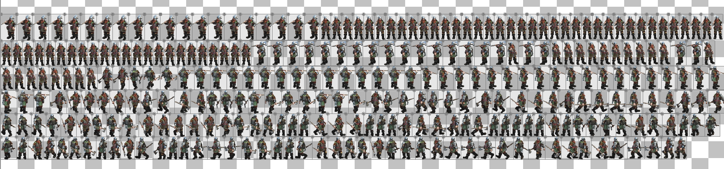
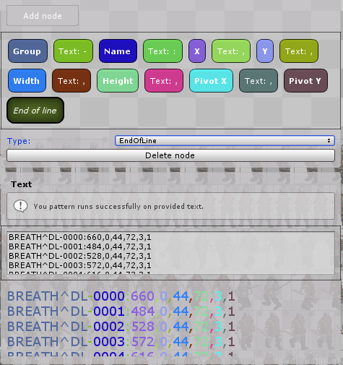
As you see the group-node here contains not only the beginning of each line but the ending also. That's because the text contains also pivot point info. Lets add it.
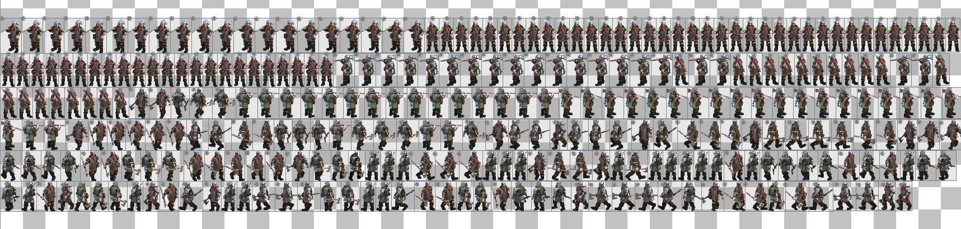
Now the pattern is complete. And you can see properly parsed pivot points appeared in the Texture View.

Preview Window
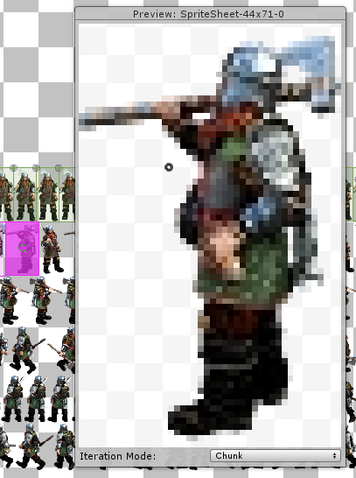
When you click on some chunk in the Texture View the Preview window will appear.
You can navigate through the chunks by “←” and “→” buttons. That will iterate through chunks. The exact behaviour or that iteration can be set int the bottom of the preview window.
There're 3 iteration modes:
Chunk – will iterate through all chunks of the same type.
Group – will iterate through one particular group.
Global – will iterate through all possible chunks.
The pivot point is rendered as a little gray circle on top of a sprite.

