Auto Image Cropper user manual
In this document you will find the instructions on how to set up and use Auto Image Cropper.

Step 1.
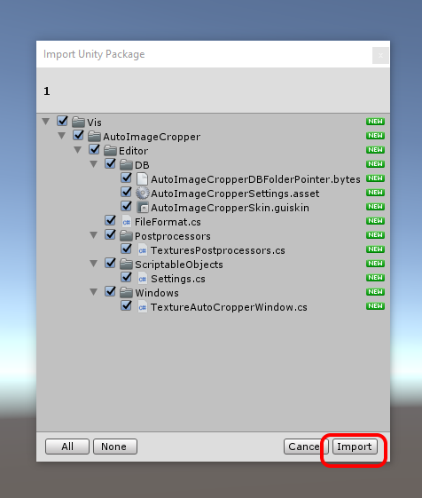
Import package from asset store.

Step 2.
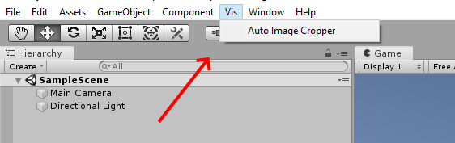
Now the new menu item should appear in the top panel:

Click on Auto Image Cropper button.

Step 3.
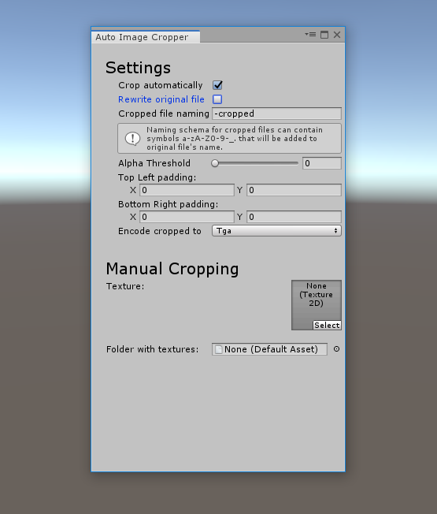
Main window opens. Let's go through all the settings and features available from it.
Settings
The very first setting is «Crop automatically». It's enabled by default and it basically controls whether imported textures will be cropped automatically or not.
The second option is called «Rewrite original file» and it's unchecked by default. When unchecked the cropped image will be stored next to original image, so the original image remains intact. In this case you will have a “Cropped file naming option” showing, that controls the name of cropped file. It's value is added to the end of original file's name and acts as a cropped file's name.
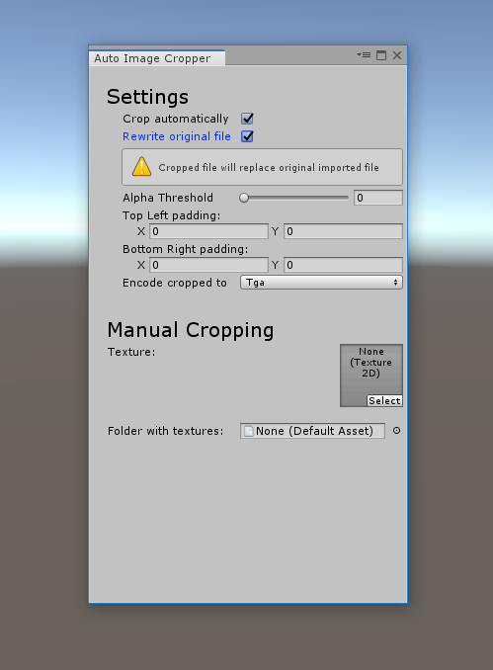
If “Rewrite original file” option is checked original file would will be replaced by cropped file, and therefore no renaming will be necessary.
“Alpha Threshold” settings controls the amount in alpha-channel that is considered transparent while performing cropping, so you can have not completely transparent areas cropped if you want. 0 is complete transparency and 1 is opaque.
Next settings “Top Left padding” and “Bottom Right padding” allow you to set a padding around the resulting image if you wish. You may think of it as not the tight cropping but leaving some space of transparency on each side. The amount of that space is what you control with that pair of settings.
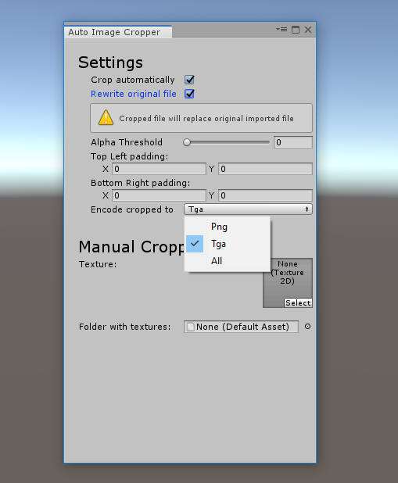
Next is “Encode cropped to” setting, which controls the output format of cropped image. “All” option means – maintain original format of file, i.e. .png original file will produce .png cropped file, and same goes for other formats. Currently only PNG and TGA is supported as output formats and only PNG as input!

Manual Cropping
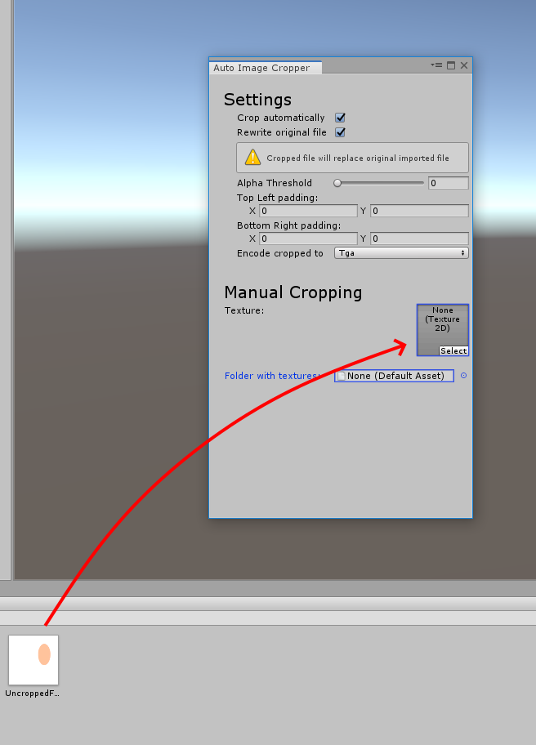
This is section where you can crop files manually. Just drag and drop the texture you want to crop into the “Texture” field:
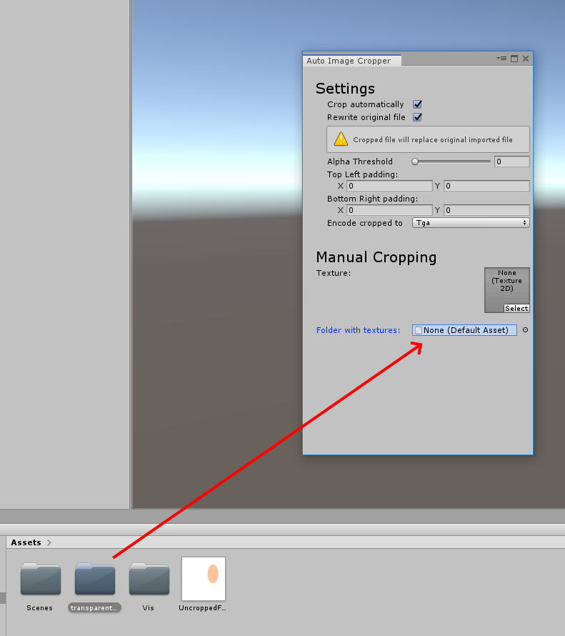
Also you can drag and drop the whole directory containing uncropped textures to the “Folder with textures” field.

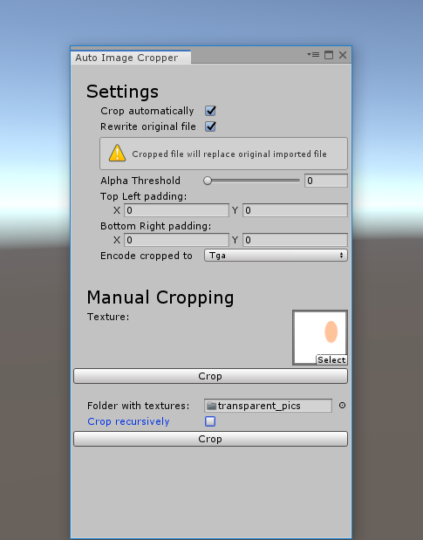
When you dragged file or folder the “Crop” button will appear. If you hit it the texture will be cropped. In case of the directory – all textures in that directory will be cropped. It you check “Crop recursively” option – all sub-directories of that directory will be affected also.
When you perform manual crop the settings applied are the same as for automatic crop.

Support: celtic.gua@gmail.com

