StickyNotes user manual
In this document you will find the instructions on how to set up and use StickyNotes.

How to set up
Step 1.
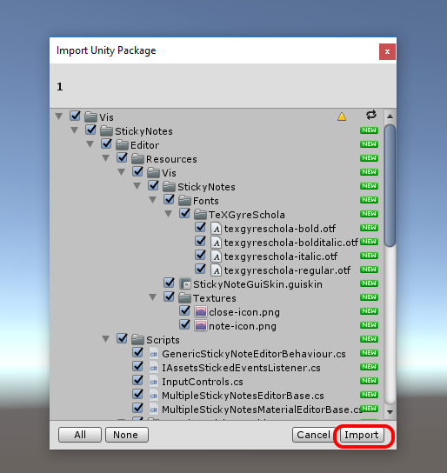
Import package from asset store.
Step 2.
That's all! Now you can manage your sticky notes in project!

How to use
Components
Just add StickyNote component to a GameObject standard way – by clicking Add Component button in a GameObject inspector and finding StickyNote component.
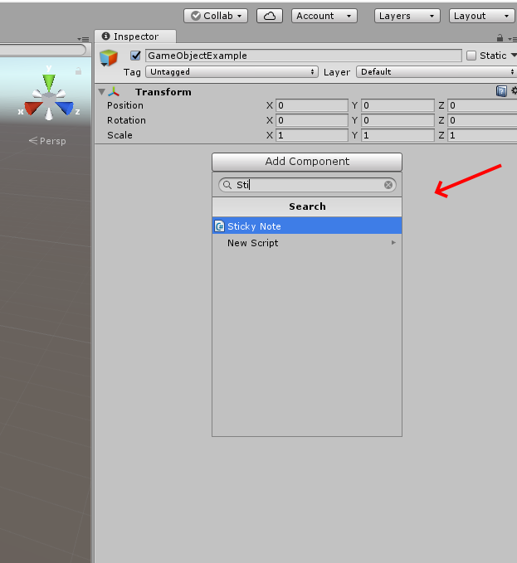

Now you can edit sticky note by clicking Edit button. You also and go to edit mode with the shortcut Ctrl+E.

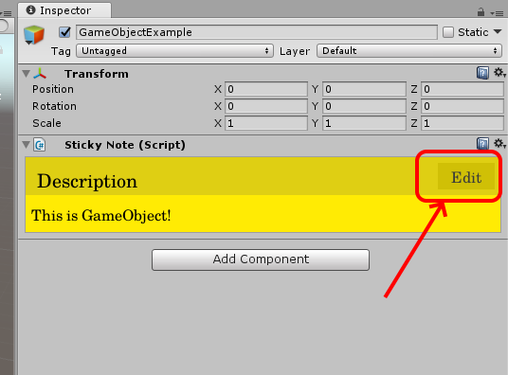

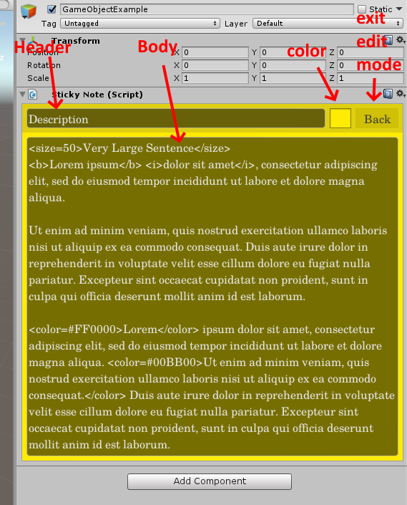
Edit mode allows you to set Color of a note and any text for Header and Body
You can exit edit mode by clicking Back button.

You can use Rich Text tags when editing texts. They are:
<b> - bold
<i> - italic
<color> - color (use hex representation for that like #00FF00)
<size> - set size of font
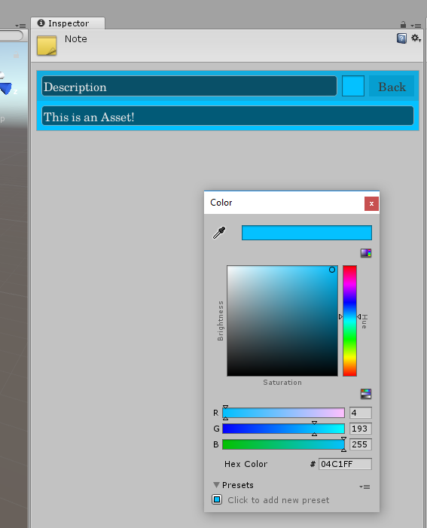
When you click Color button – standard Unity color picker window pops up and allow you to customize color of note.

Assets
You can create standalone Note-assets and embedded ones.
To create Standalone asset, right-click on the empty directory area in Project window and choose Vis → Create
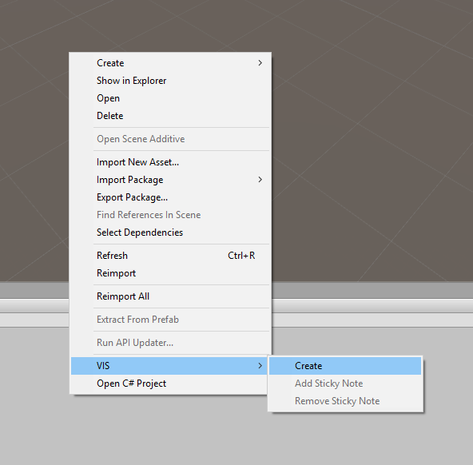

Standalone Sticky Note asset will be created in that directory and it can serve as a Note for the whole directory:
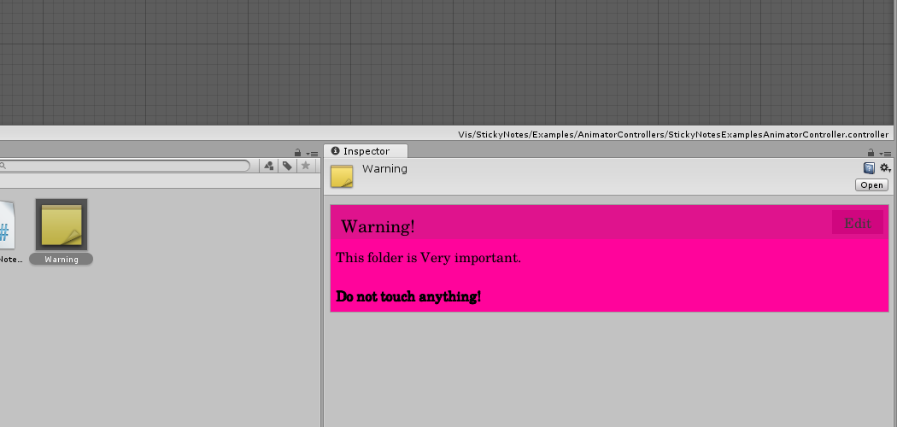

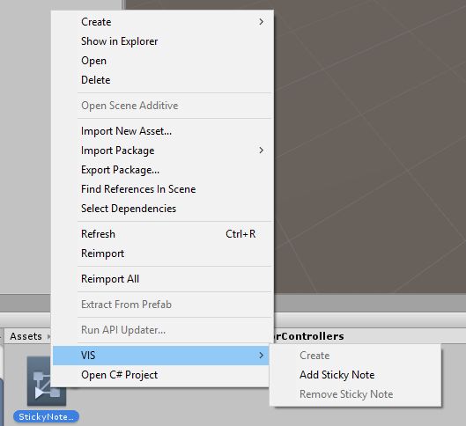
You can add Sticky Notes as sub-assets to existing assets also. For example, you can right click on AnimatorController asset and choose Vis → Add Sticky Note

You'll find all sub-assets by unfolding parent asset with a little triangle button.
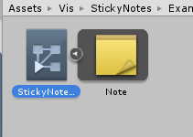
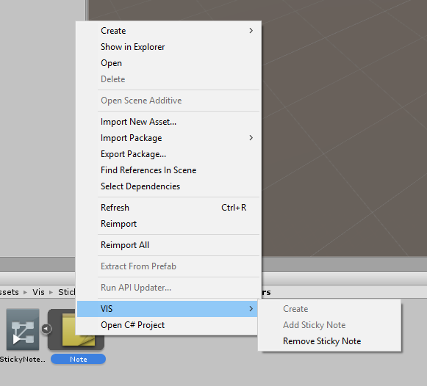
To remove sub-asset right click on it and choose Vis → Remove Sticky Note

StateMachineBehaviours
To add a Note to AnimatorState click on Add Behaviour button, just like adding regular StateMachineBehaviour script, and choose StickyNote.
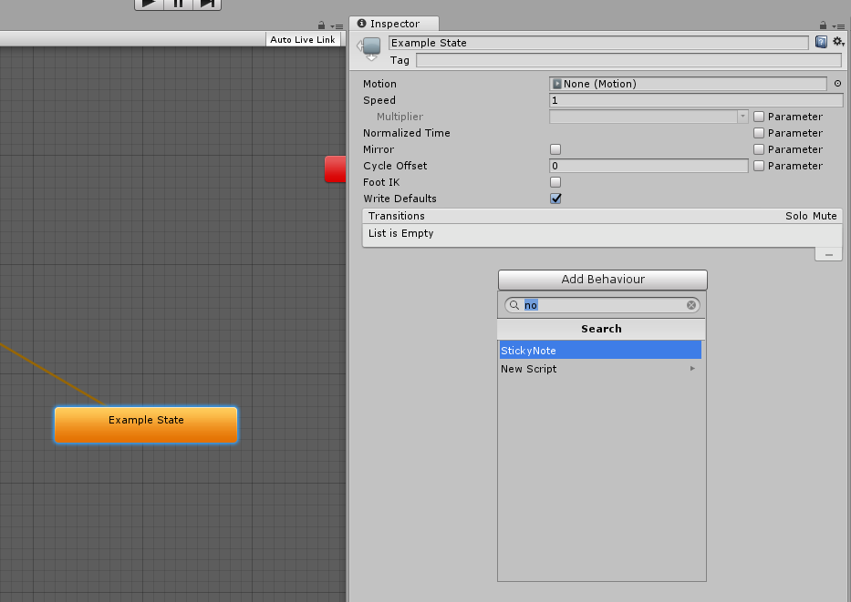
To remove – click on little gear button and choose Remove
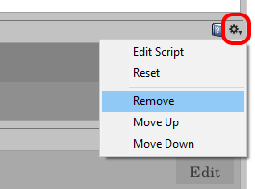

Extending Your Custom Asset Classes with StickyNotes scripting API
To extend your asset class with StickyNotes sub-assets drawing, create custom editor class for the class you wish to extend (add CustomEditor attribute with your target class' type as a parameter) but inherit it from MultipleStickyNotesEditorBase class instead of regular Editor class. You'll find MultipleStickyNotesEditorBase class in VIS.StickyNotes.Editor namespace.
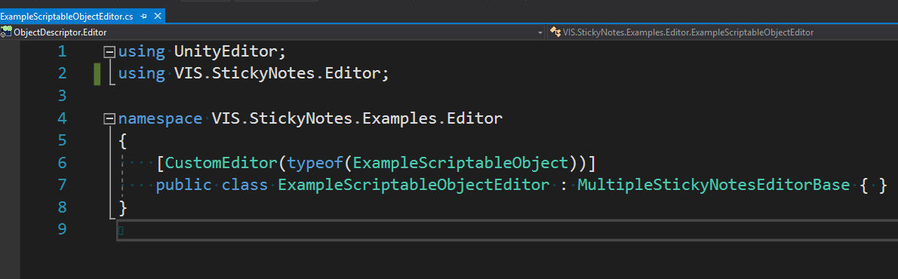
That's it! Now your asset will draw notes if there would be any note subasset inside it.
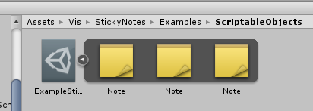
In other ways MultipleStickyNotesEditorBase will behave as regular Editor class, i.e. you can build your custom editors based on this class.

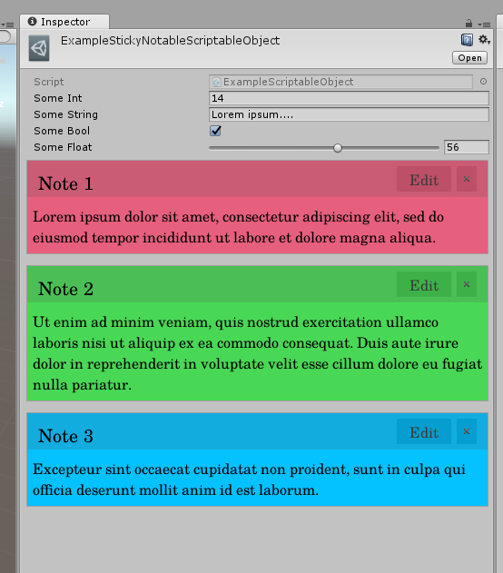
When StickyNotes embedded in such way, another notes-removing option will appear – with the Close button.
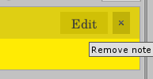

Console Mode
There is another mode which you can trigger by clicking on “Console mode” item from the components context menu:
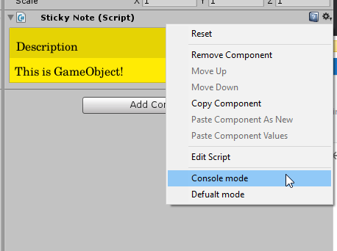
When you're in console mode additional controls appear:
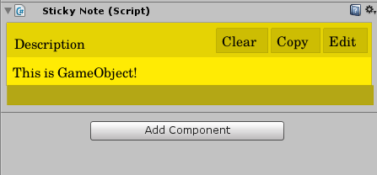
Clear – will clear all text from the note
Copy – will copy all the text from the note to the system buffer
And the darker area on the bottom is the Input Field where you supposed to type commands. All text you type will appear in the text area. You also can make use of it from your code.

Scripting API
StickyNote components expose a handful of useful methods which you can use. These are:
void Write(string text) – appends the text to the end of current notes' text.
void WriteLine(string text) – appends the text to the end of current notes' text and also append the \r\n symbols for the new line.
void Log(string text) – similar to the WriteLine method but it first writes system date and time in front of the text.
void ClearBody() – resets the text.

There's also an event:
Action<StickyNote, string> ConsoleTextEntered – whenever you enter a value to the console and hit Enter it will trigger this event and pass itself and the text entered in it.

Support: celtic.gua@gmail.com

