**Safe-Home System Documentation**

Software Engineering

Final Project Credit hour: 2 weeks

David Bukedi Diela

Student ID: **2018529627050**

## ￣￣￣￣￣￣￣￣￣￣￣￣￣￣￣￣￣￣￣￣￣￣￣￣￣￣￣￣￣￣￣￣￣￣

## **User Requirements**

### **User Story: Requirement Scenario**

**The Players:** John Peters, software team member; Berry Tims Software team member; Ed Robbins, software team member; James Maxim, Software Engineering Manager; 3 members of the marketing team, Chun Li; ZSTU Dorm Coordinator.

**James Maxim:** Gentlemen, Mr. Li here would like to install new Powerful Surveillance Camera’s in his house in Beijing.

**John Peters:** Lets list down the objects and services for the home security function.

**Berry Tims:** I think Mr. Chun’s SafeHome surveillance should be accessible via the internet. That would include the home security function, right?

**Marketing Team:** Yes, that’s right. The camera feed will be recorded and send directly to Mr. Chun’s phone and PC.

**Mr. Chun Li:** I understand you have to install motion sensors and smoke sensors to the walls. What constraints do you expect?

**Ed Robbins:** Well, we expect technical challenges in this project.

**James Maxim:** Yes, very true. We have to make sure an outsider can’t into the system, disarm it, and rob the place or worse. That’s a heavy liability on our part.

**Marketing Team:** That’s easier said than done and…

**John Peters:** The final SafeHome System will undergo both integration, beta testing and finally alpha testing.

**Chun Li:** I don’t know what that is, but that sure put my heart at ease.

**Berry Tims:** I have the feeling we need an efficient Agile Team as more requirements will come up.

**Ed Robbins:** Ok, great then, now we begin the use case diagrams

## **UML User Case Diagram**

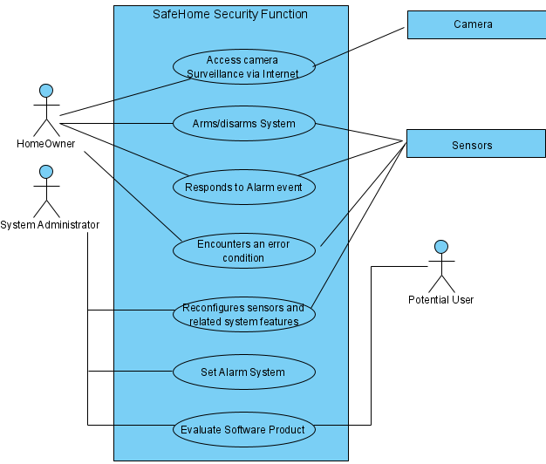

### **Class Diagram for Safe Home**

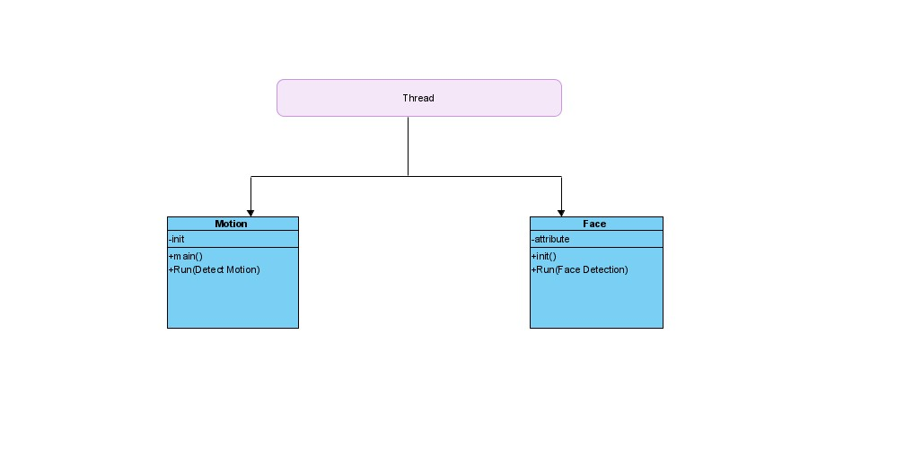

## **State-Machine Diagram**

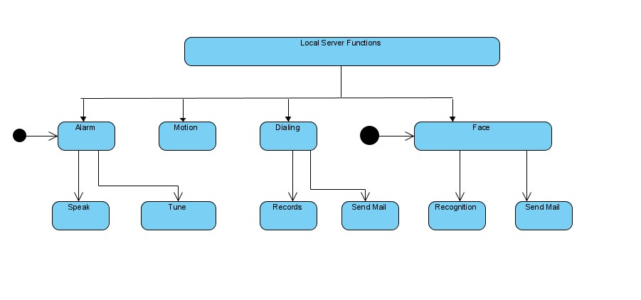

**Flow Chart for Safe home system**

