1. Business-Case

- History provide by Service, made access-able both on-stack, as well as outside

company corporate.

- Connections

- Integration

- Interfaces

- Flow analysis comparable to All reports, cornering off the Code, Code-Block

that should reflect as Business-Rules.

- Flat data: Data presented without any clauses, influences.

- Computed data: Data presented with any clauses, influences.

- Documenting Error Rates where Sub Modal entries accumulate for delaying

data-entry.

- Codification of Conditions, assessing Hard-coded or Code Table application thereof

by Performance, Ease of Maintenance, Business Influence moving from an As-Is

to Where-we-want-to-be situation.

1. Audit-Case

- Standard operating process for Audit firms be that they if asked or choose too

Include transaction record external to Company being audited.

1. Legal-Case

- Surmounting to most of the pressures alleviating per Case, per Document, per Line

evidence to court.

1. Job-Case

- Employment in a Task-per-Unit assignment can now be generated, distributed in

co-working with every Rural and Urban Area.

1. Statistical-Case

- 50 mil Transactions Card (2016)

- ?? mil Transactions Point of Sale

- ?? mil Transactions Cash

- ?? mil Transactions App

1. Personnel-Case

- Expertise available from Management, Analyst, Architect, Technologist, Advisor

1. Vendor-Case

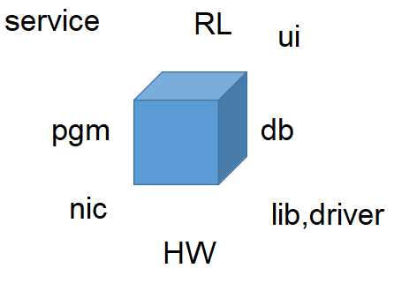

- Per stock code <sample below>

|  |  |  |  |  |  |
| --- | --- | --- | --- | --- | --- |
|  | MSFT | AAPL | SMSN | CashR* |  |
| Win |  |  |  |  |  |
| iOS |  |  |  |  |  |
| Android |  |  |  |  |  |
| Nix* |  |  |  |  |  |

1. Process-Case

- Functional Drill report, Toolbar

- Technical-1 SCIE Class-Object

- Technical-2 MAT, RAM

Summary:

Course of action required, by those responsible when deploying and maintaining Licensed Service, deliverable from either or SDLC, or Projects Office.

Registration with Asset management the Service, componentised as Install-able Software, Drivers, Runtime KBA’s required for the Service to function.

Space Requirements for data volumes.

Reference:

32-143_Standard for Handling of Classified Items.pdf

itassetmanagement.net/2019/05/27/blockchain-for-slm/

www2.deloitte.com/us/en/pages/financial-services/articles/digital-currency-vs-cash-question-of-liberty.html