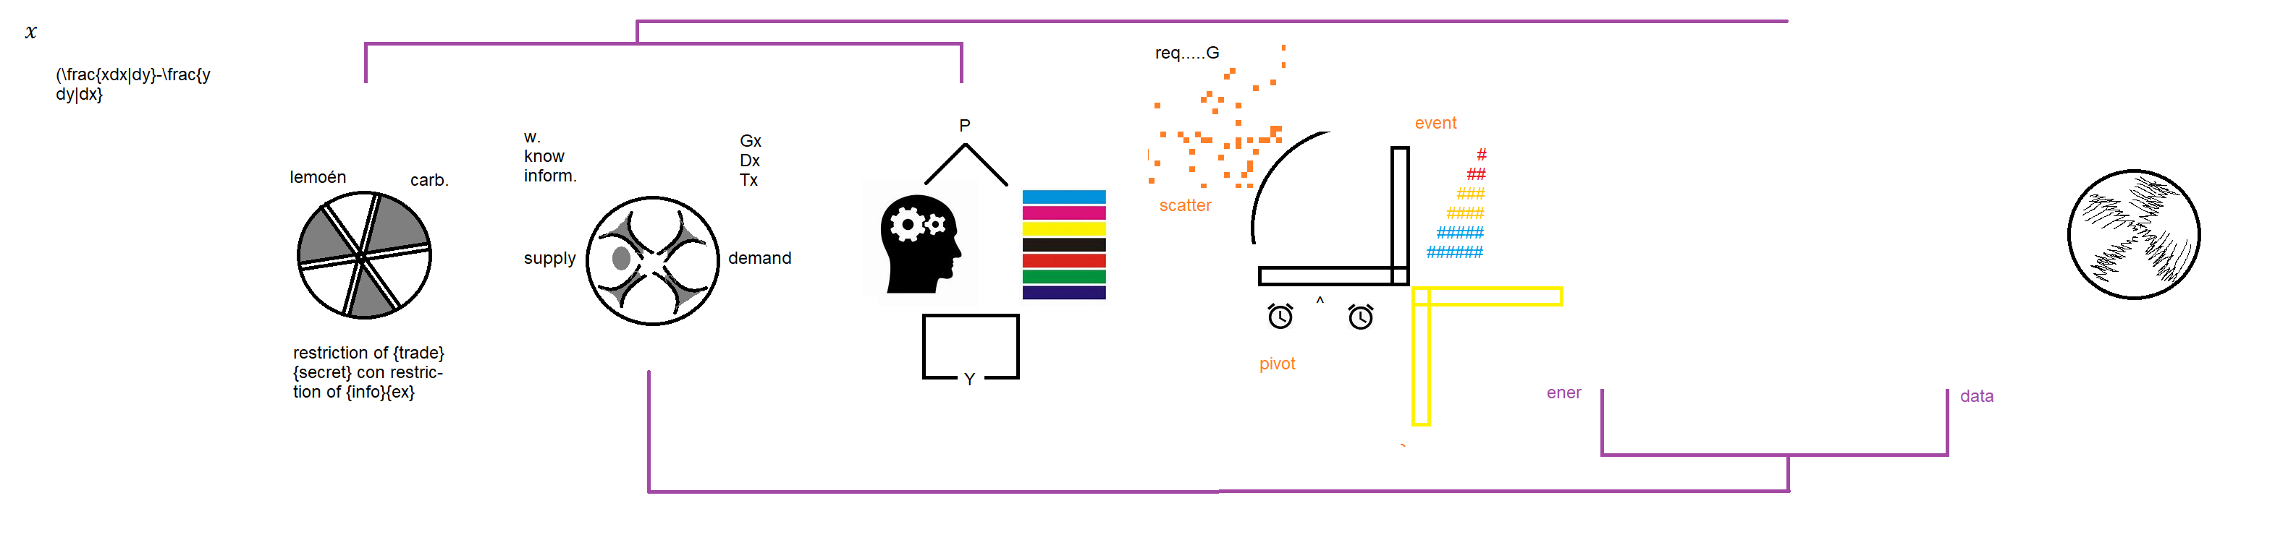

fork

* area,
  + service-discovery, service-offering (range;baud;..)
* unit,
  + session-buffering, session-activity (transmit; message)

b-board

…..

List

person

event

sched

image

comms

buffer

ram

circuit



Energy\* & Data\* in it’s application and distribution thru communication, infrastructure & architecture

as campaign thru interconnected systems, perplexed Music, Biology, Drama

Sub-Service to Services

