Incumbent repel Task from Task-List, selecting indicative most Paying one, after Session ended with Chat-Like of which the Local Centre Servant, declare on App on phone money for Tasks. Once-off, Weekly.

On completing with spending to complete Task, ALOG would create same/similar new Task in future, remaining Pay to be used for warmth, and meals.

The higher the activity, in a Community, ranging fromsocial worker assisted thru the middle-low income workers up to R12500 all the way to R133200

Shortages in Area: Municipal District

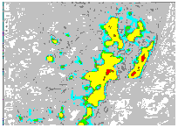

* Petroleum (J500)
* Basic Materials (J510)
* Factories (J520)
* Consumer Goods (J530)
* Health Care (J540)
* Consumer Services (J550)
* Telecommunications (J560)
* Utilities (J570)

Summary

Local Government Plan, Policy and Project indicative of Scheduling, Servicing, Self-Esteem Stresses. Proposition for Basic / Zero-Session app-device-service, collecting detail, attending detail of predicating detail.

---------------

Task