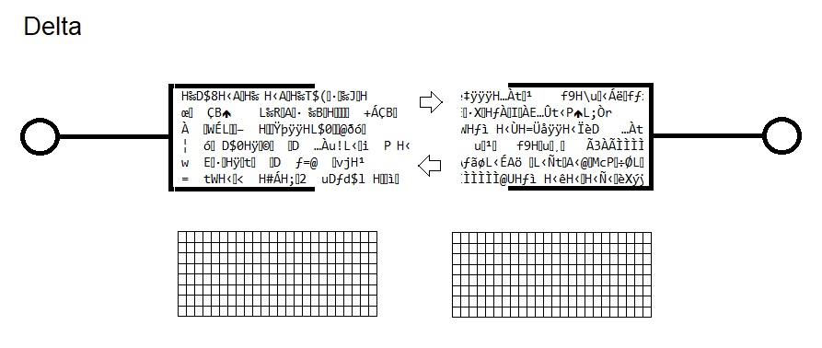

Introduction

Event :

To declare a minimum event, on obtaining ROM or RAM ignoring HIGH/LOW RAM described.

To low minimum declare on/off DWORD and less Breadboard described.

To extreme low minimum declare fuse, Breadboard described NON-GATED.

Position of a Byte

- Event change BYTE in position

- Event Byte change from another BYTE

- Change consecutive Bytes from Byte

Sub-Heading

Bidirectional buffer RAM described ALWAYS with ~~Bidirectional~~ Duplex buffer networked.

Chem

Reagents, Solutions Substrate bond requirement prolonged durability requirement Temp 70, Printed Circuit Board.

