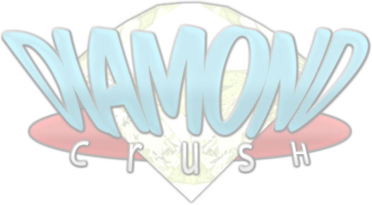
Diamond Crush

Game Description

- Genre – Puzzle game with online features
- Gameplay orientation – basically, 1 vs. 1
- Purpose – Winning 2 rounds out of 3

Introduction:

Quick synopsis:
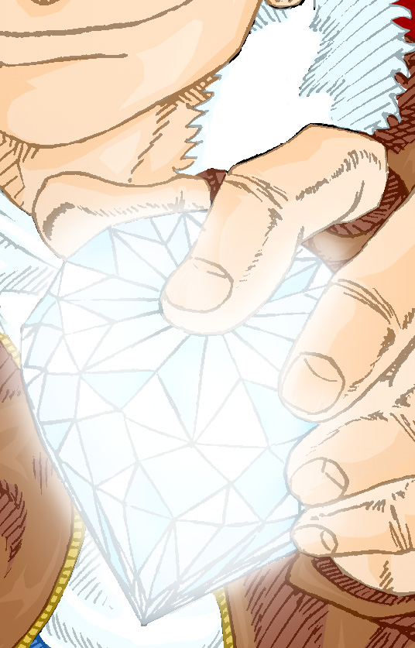
Diamond Crush is a competitive-oriented puzzle game. Each player will choose a character out of a limited cast, to engage battles against other human players (via internet connection), or against the CPU (in a complete plot-oriented Story Mode).
The players won’t be allowed to control the characters by themselves, but they’ll have the task to strategically move and place pairs of differently colored and shaped gems, falling from above, in their own rectangular screen area (from now on, play area).
Special pieces such as the treasure boxes will allow the players to delete gems of the same color and shape, and even to trigger chain reactions (Crushes). These Crushes will fill the opponent’s screen with useless stones. The one whose play area will be totally full, will lose the current round. The players will have to win two rounds out of three to win the match, and they’ll automatically get a victory if their opponent gives up, or his internet connection goes inactive.
In Story Mode, the matches are 1 round only, and the CPU-controlled opponent hasn’t any own play area, but a fighting game-style health bar. The fireworks, ignited by the player’s Crushes, will decrease its health to zero.

Visualization:
Fixed 800x600 truecolor screen – full screen by default, with optional window mode.
The base screen has two possible configurations:
- Single Player: the player’s 256x448px play area is situated on the left of the screen, while the CPU-controlled opponent is in behind a small window on the top. The right side of the screen is filled with indicators. Multiplayer: both players have 256x448px play areas, on the left and on the right of the screen. Each player will see on his monitor his play area on the left, and his opponent’s one on the right. In the middle, two characters, representing the two players, will battle with animations that follow closely the status of the match. Events like Crushes will allow the player’s character to perform destructive attacks against his opponent.

Base screen data:
Resolution: 800x600
Color depth: truecolor
Play areas size: 256x448px (14x8 cells)
Gems size: 32x32px
Gem types:
The game will feature 5 gem types:
- Diamond (white)
- Ruby (red)
- Emerald (green)
- Sapphire (blue)
- Topaz (yellow)
The players will be able to distinguish the different gem types by shape, other than by color, since every gem type has an unique one.

Main characters:
Each player will be allowed to choose a character out of the following cast:
- Dynamite Josh – the main character, Josh is protected by a bizarre spirit with the ability to change its shape and consistency;
- Kathy Pillar – a rich and lethal woman, Kathy doesn’t fight by herself: her butler Ambrogio does all the dirty work for her;
- Ice Berk – a digger from the cold Northern regions, Ice has the ability to control… ice. Even his shovel is made of it;
- Jamal Rock – a professional boxer, Rock is strong enough to crush rocks by using his fists only;
- Agent N-00b – a futuristic soldier, N-00b uses a laser rifle and various cybernetic implants;
- Vlad F. Tepes – an immortal vampire, Vlad uses hordes of vampire bats… beware of his bite;
- SAM A. ELroy – a really bizarre character… somebody says he could be the demon Samael in disguise. He’s the final boss;
- Handy – a giant hand. Hidden character and semi-boss, Handy uses its fingers to attack.
In multiplayer mode, the player will be allowed to choose his avatar out of a really limited roster: only Josh, Kathy and Ice will be available right from the start. The player will unlock all the other ones by winning online matches.
Apart from the graphical appearance, every character will basically be the same. The only difference is found in the desperation moves, unique for each, and available once per round in Advanced Mode.

Hardware used by the game:
Mouse and Keyboard, with the option to manually configure the command layout. The default configuration is:

- Side movement: left and right buttons
- Vertical acceleration: down button
- 90° Rotation (clockwise): X button
- 90° Rotation (anti-clockwise): Z button
- (opt.) 180° Rotation: C button
- (opt.) Dynamite: spacebar
- (opt.) Desperation Move: left Ctrl button

During the gameplay, the players will be able to change the soundtrack, and to execute pre-recorded .mp3 and .wav files, by using the function keys.

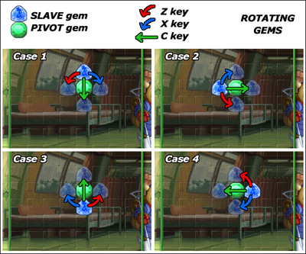

Matches:
In single-player matches, based on the Story Mode, the player will have to delete gems from the screen, to ignite the fireworks by friction, to damage his opponent and reduce its life bar. Battles will be 1-round only.
In multiplayer matches, the players need to win 2 rounds out of 3. The stage backgrounds will be randomly chosen.
While this mode will initially be p2p 1vs.1 only, soon the players will be able to organize server-aided large scale tournaments.
The players will be able to define their own game rules via scripting, and to share them, creating all-new game modes. The best ideas will be hosted on the game’s website (http://www.diamondcrush.net).

Game modes:
The main game modes are the following:
- Single Player (offline):
- Story Mode – plot-oriented story mode;
- Multiplayer (online):
- Basic Mode – classic online matches, with basic rules;
- Advanced Mode – online matches, with some advanced rules.
By scripting, each player will be able to create and share his own user-defined game modes.

Profiles:
Each player will have his own profile, defined by:
- Nickname (min.3 max.12 characters long), unique for each player.
- 60x60px Avatar (.gif, .png or .jpg are allowed file types) uploaded from local computer or URL.
- Rank (depending on the victory count only), each rank has a number of stars from 1 to 5, who summarizes the player’s skill level. Every level up will unlock a hidden character.
Multiple profiles handling will be possible on the same computer.
Base screen layout:
Single Player:

Coming soon!
Multiplayer:
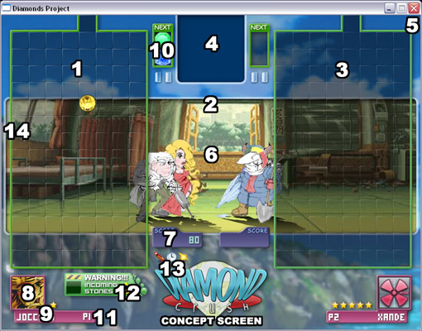

Legenda:
- Player’s play area (each player sees his own area on the left);
- Central zone of the screen, with the characters, their names, the round indicators, and the Next box;
- Opponent’s play area;
- Small area with animated clockworks or (in an eventual Cooperative Story Mode) a CPU-controlled opponent;
- External frame with different patterns;
- Background, each character has his own;
- Score boxes for each player;
- Player’s (60x60px) avatar;
- Player’s nickname/rank;
- Next box, it shows the next pair of falling gems;
- Player number, useful in tournaments to distinguish people;
- Warning box for the gems who are about to fall after an opponent’s Crush;
- Advanced Mode-only icons for Dynamite, Clocks and Desperation Moves;
- Area for the Crushes notify messages.

Note: the concept screens could be slightly different from the final ones.
Gameplay mechanics:

Single Player:
- Story Mode: please refer to the “Story Mode Script” attachment.

Multiplayer:
- Basic Mode: The base gameplay mechanics is actually simple. Each player is able to delete groups of adjacent gems (or eventual Gem Agglomerates) with the same color, by using a special piece, the Treasure Box, with the same different colors of gems.
Each deletion could trigger chain reactions (Crushes), whose main effect, other than giving bigger Scores to the player, will be to fill the opponent’s play area with lots of temporarily useless Stones, who will morph into gems after three turns.
The Flashing Gems will delete from the play area EVERY gem with the same color of the first one who comes in touch with them (the priority list is: below, left, right, over).
- Advanced Mode: Other than the basic rules, Advanced Mode has a slightly different mechanics, thanks to other special pieces, such as Dynamite and Clocks, a different balance of the pieces occurrency, the introduction of Desperation Moves and the (rare) possibility that Stones crumble without leaving anything in their place.
Dynamite is a rare piece (the maximum on-screen allowed number is 3), directly activated by the player with the spacebar key. A simple key press will detonate it (or them), deleting the eight adjacent pieces (in the eight directions). Keeping the key pressed will cause a Bomberman-like cross-shaped explosion, with every branch two pieces long, along the four main directions: up, down, left, right (the involved pieces will still be eight).
Clocks, on the other hand, are automatically activated after a deletion of gems adjacent to them (independenty of their color) and, for three turns, they will slow down the gems falling speed in the player’s play area, and will speed it up in the opponent’s one. Clocks are rarer than Dynamite, and each player can have on-screen one Clock only.
Desperation Moves are only available once per round, when the player has at least one piece in the third higher row of his play area. Each character has his own Desperation Move, and their effects will be analyzed in detail later, in the Characters section. These moves are generally activated by a single Left Ctrl key press, but some require other inputs by the player (often, with some timing).
While the Dynamite and Desperation Move icons will be shown when those features will be ready to be activated, and will disappear right after their use, the Clock icon will be shown only after the activation of this piece, and will disappear after the end of its effects.
Characters

Main characters (players can select them):
- Dynamite Josh:

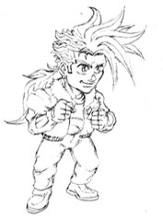
Age: 16
Birthday: June 7th
Birthplace: Japan
Height: 182 cm
Weight: 74 Kg
Bloodtype: 0+
Hobbies: videogames
Likes: his sister Joruri, Italian food, motorcycles
Dislikes: guys who harass girls, hypocrisy

Bio: Josh is a Japanese boy that, since he was a little child, was the only one who could see a bizarre mechanized spirit, able to change its appearance and consistency. This kept all people far from him, and the only one who saved him from solitude and depression was his beloved sister Joruri. Now Josh is looking for money, to save his family from bankrupt, but soon something weird will start to happen.

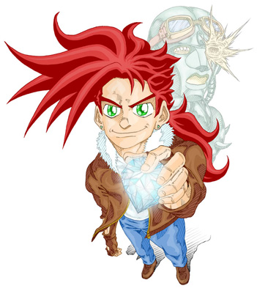
- Ice Berk:

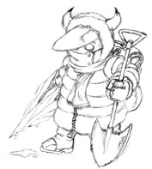
Age: 17
Birthday: December 24th
Birthplace: North Pole
Height: 170 cm
Weight: 80 Kg
Bloodtype: 0-
Hobbies: digging
Likes: his “dog” Godz, ice
Dislikes: heat, unluck

Bio: Ice comes from the cold Northern regions, to sell the gems he found digging in his birthplace to earn some money. He was born exactly in the middle of the magnetic North Pole, so he strangely gained the ability to manipulate ice (even his shovel is made of it). He comes together with Godz, a female baby gozzilla (she maybe got hybernated some millennia ago), as a pet. Since Ice has never seen one, he thinks Godz is actually a dog.

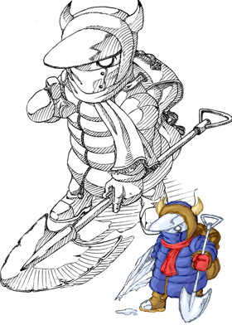
- Jamal Rock:

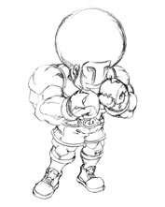
Age: 38
Birthday: July 4th
Birthplace: USA
Height: 196 cm
Weight: 98 Kg
Bloodtype: B-
Hobbies: gambling
Likes: poker, casinò, winning
Dislikes: mafia, losing

Bio: American boxer and ex-world champion, Jamal Rock has had seriously bad times because of gambling, and his life is still in danger for this reason. He actually owes a lot of money to Italo-American mafia, and he has just three days left to earn it. So, Rock tries to use his astonishing muscles (somebody says he even managed to dig up a tunnel in a mountain with his bare hands) to find precious gems to sell and extinguish his debts.

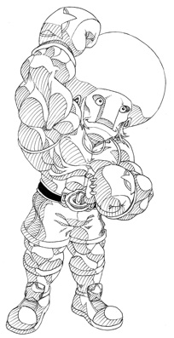
- Kathy Pillar:

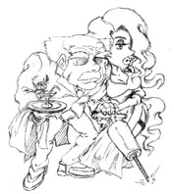
Age: 18
Birthday: May 1st
Birthplace: UK
Height: 168 cm
Weight: (don’t ask, please)
Bloodtype: A+
Hobbies: shopping
Likes: Josh, money, jewels, lux
Dislikes: strange-looking guys, ugliness

Bio: Kathy is a rich and stone-cold woman of British origins. Her only purpose is to gather richness, to live her life without any problem of money. She will soon fall in love with Josh and start following him, but he won’t ever notice it. Kathy’s always together with her butler Ambrogio, who’s always protecting her like a true bodyguard. Ambrogio is totally dominated by Kathy’s charm, and he’s even able to fight without spilling the cocktails he always prepares for her.

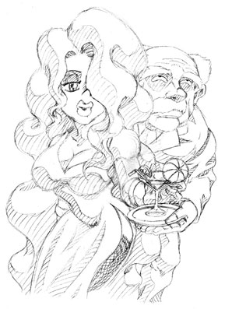

- Vlad F. Tepes:

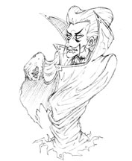
Age: 589
Birthday: November 13th
Birthplace: Wallachia (Romania)
Height: 174 cm
Weight: 56 Kg
Bloodtype: AB+
Hobbies: drinking blood
Likes: his castle, bats, dark places, hospitals
Dislikes: highways, sunlight

Bio: Count Vlad, a disgraced noble from Romania, is in crisis because of the progress. His castle in Transylvania is located exactly where the government is about to build a new futuristic highway, and the only way to save his home is to earn by himself enough money to modify the project, redirecting the highway route to avoid its demolition. Somebody says he’s a bloodthirsty vampire, but maybe he just likes drinking the blood-transfusion plasma he usually gets in a nearby hospital.

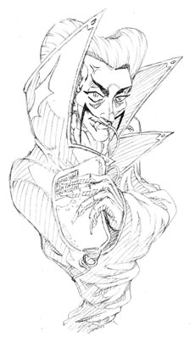
- Agent N-00B:

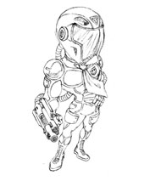
Age: 0
Birthday: Unknown
Birthplace: Nowhere
Height: 170 pixels
Weight: 512 Kbyte
Bloodtype: FAT32
Hobbies: executing commands
Likes: anything
Dislikes: anything

Bio: Agent N-00B isn’t actually human. He’s nothing more than a software, programmed by an unknown entity, who acts inside the Escavatrix, an unknown place that seems to be an electronic simulation of the real world, where all the characters in this game are kept as prisoners, and whose final purpose is unknown. N-00B’s main task is to stop every one who potentially could wake up from the Escavatrix. Everybody but one, chosen and still unknown, person.

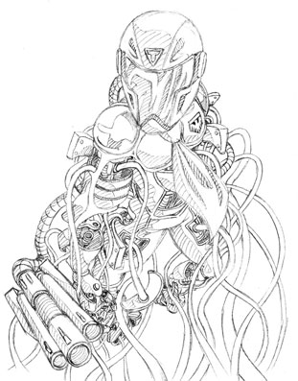
- Handy:

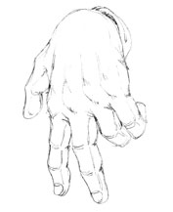
Age: 0
Birthday: September 19th
Birthplace: Escavatrix
Height: 190 cm
Weight: 87 Kg
Bloodtype: No blood
Hobbies: pointing
Likes: life
Dislikes: the fact he/she can’t speak

Bio: Handy is actually the main cursor used by the game. One day, he acquired a self-awareness, without any apparent reason. He hasn’t any purpose but living and learning everything about the world around him, and his biggest desire is to find out why he’s a right hand when he’s facing right, and why he’s a left hand when he’s facing left. This won’t be easy at all: not having any vocal chords nor facial expressions, he can’t speak or communicate with anybody.

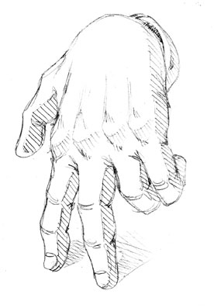
- SAM A. ELroy:

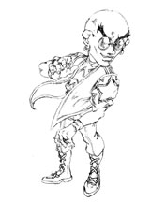
Age: Unknown
Birthday: Unknown
Birthplace: Unknown
Height: Unknown
Weight: Unknown
Bloodtype: Unknown
Hobbies: Unknown
Likes: Unknown
Dislikes: Unknown

Bio: Sam A. Elroy is a bizarre character shrouded by mystery. Nobody has ever heard of him, and somebody says he could actually be the demon Samael, in a badly crafted disguise. He could even be the real figure behind all this weirdness, and everything could be nothing more than his perverted game. One of the biggest mysteries about Mr. Elroy and his plots is the name Metatron… who the hell is him?

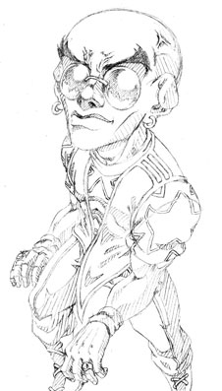
- SAMAEL (not playable):

Age: eternal
Birthday: the beginning of time
Birthplace: everywhere
Height: N/A
Weight: N/A
Bloodtype: every bloodtype
Hobbies: observing humans
Likes: human emotions
Dislikes: eternal boredom

Bio: Samael is an eternal entity, born at the beginning of time. He hasn’t any true physical form, and human emotions are a true mystery to him. So, to escape from the boredom brought by his eternal life, he started observing humans. The only emotion he could reach was envy. Envy for those who feel something, and envy for the one who created them and their emotions. Samael needed to emulate this mysterious entity, and this led him to a new project, where he could re-create emotions on his own.

Minor characters:
- Joruri: Josh’s sister, Joruri is the cutiest girl in her school. She’s always admired her bigger brother, and she’s his only confidante. Kathy thinks she’s trying to seduce him, so she’ll even try to eliminate her.
- Ambrogio: Kathy Pillar’s butler and bodyguard, he dedicated his whole life to his “Ma’am”, whose charm fully dominates him. He will successfully accomplish any mission, and he’s even ready to die for her.
- Godz: She’s a female baby gozzilla, found by Ice by chance while he was digging. He believes she’s a dog, but nobody knows why, despite she’s a reptile, Godz has a belly button (she thinks it’s just a hole!).

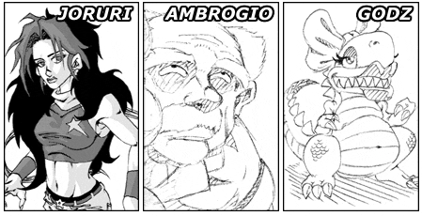
Game Design Document:
Jocchan & Raoul Benneth

