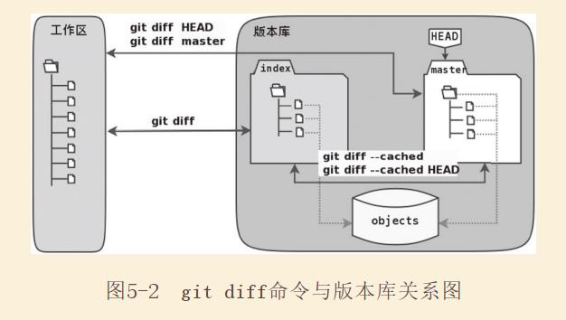

# 1、git diff

$ echo "bye-bye." >> welcome.txt

$ mkdir -p a/b/c

$ echo "Hello." > a/b/c/hello.txt

$ git add .

$ echo "Bye-Bye." >> a/b/c/hello.txt

**$ git status -s**

AM a/b/c/hello.txt

M welcome.txt

**$ git diff**

warning: LF will be replaced by CRLF in a/b/c/hello.txt.

The file will have its original line endings in your working directory.

**diff --git a/a/b/c/hello.txt b/a/b/c/hello.txt**

**index 18832d3..e8577ea 100644**

**--- a/a/b/c/hello.txt**

**+++ b/a/b/c/hello.txt**

@@ -1 +1,2 @@

Hello.

+Bye-Bye.

$ git diff --cached

**diff --git a/a/b/c/hello.txt b/a/b/c/hello.txt**

**new file mode 100644**

**index 0000000..18832d3**

**--- /dev/null**

**+++ b/a/b/c/hello.txt**

@@ -0,0 +1 @@

+Hello.

**diff --git a/welcome.txt b/welcome.txt**

**index d3160ea..38aea8d 100644**

**--- a/welcome.txt**

**+++ b/welcome.txt**

@@ -1 +1,2 @@

created by redcomet 2018-08-08.

+bye-bye.

$ git diff HEAD

warning: LF will be replaced by CRLF in a/b/c/hello.txt.

The file will have its original line endings in your working directory.

**diff --git a/a/b/c/hello.txt b/a/b/c/hello.txt**

**new file mode 100644**

**index 0000000..e8577ea**

**--- /dev/null**

**+++ b/a/b/c/hello.txt**

@@ -0,0 +1,2 @@

+Hello.

+Bye-Bye.

**diff --git a/welcome.txt b/welcome.txt**

**index d3160ea..38aea8d 100644**

**--- a/welcome.txt**

**+++ b/welcome.txt**

@@ -1 +1,2 @@

created by redcomet 2018-08-08.

+bye-bye.

$ git log --graph --oneline