**Overview**

AnimTexture convert bone’animation to vertex’s animation, use MeshRenderer rendering instead of SkinnedMeshRenderer. So support gpu instancing for lots characters.

Support any number of bones,any precision of animtionClips.

Size of Anim’Texture limited by:

Horizontal: mesh ‘vertex.

Vertical : AnimationClip’s time length

So more less vertex and more short time smaller animTexture.

Need more precision rendering. You can use Tesselation shader.

**Basic work flow is**

1. bake animation’s mesh to an atlas(include all animationClip),
2. renderer animation use animTexture.
3. embed into bone.

**Version**

0.1

**Unity version**

Developed in unity 2018.3.0.

Scripting runtime version : .NET 4.X.

below this, need change something maybe.

**Features**

1. Bake animationClips to a texture
2. Support Mecanim worlflow by Play AnimTexture with Animator
3. Support Blend 2 Animation
4. Support gpu instancing for lots of animation Character.

**SkinnedAnimation vs AnimTexture:**

|  |  |  |
| --- | --- | --- |
| **Name** | **SkinnedMesh** | **AnimTexture** |
| **Need skinned calculate** | **Y** | **N** |
| **Bone count limit** | **Y** | **N** |
| **Support Embed into bone** | **Y** | **y** |
| **Need bone data** | **Y** | **N** |
| **Need AnimationClip** | **Y** | **Y,when Embed into bone** |
| **AnimTexture More Memory** | **N** | **Y,format:RGBHalf** |

**1 Bake Animation To Texture.**:

1. prepare models(include animationClips).
2. set Model’s Animation Type is Legacy. Drag prefab to hierarchy window.
3. Set Model’s AnimationClips to Animation Component’s Animations for bake. 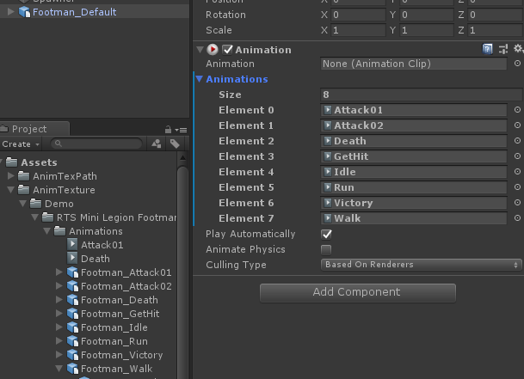
4. Select object that you want to bake.
5. Click menu “AnimTexture/BakeAnimClipsToAtals”. You will get 2 files;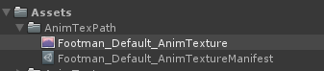
6. Done.

**2 Play Animations.**

1. Select Model in hierarchy. Click AnimTexture’s CreatePlayer. You will get a new gameObject. Last object no longer needed. You can disable or delete.

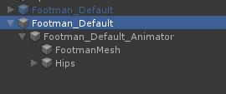

1. Click XXX_Animator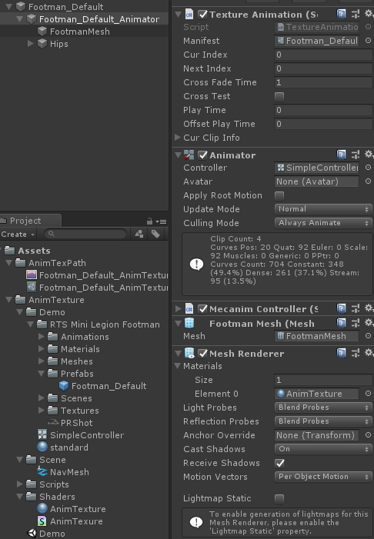
2. **TextureAnimation**’s Manifest need AnimTextureManifest file.
3. **Animator** need Controller file. SimpleController for example.
4. **Mesh Renderer** ‘Materials need AnimTexture material. Assets/AnimTextures/Shaders/AnimTexture.mat
5. If set all. Will see. 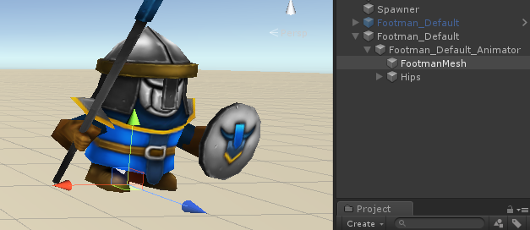
6. Press play and click ground in Game VIew.

**3 Embed gameObject into bone.**

1. set model and animation model’s Animation Type is Generic. 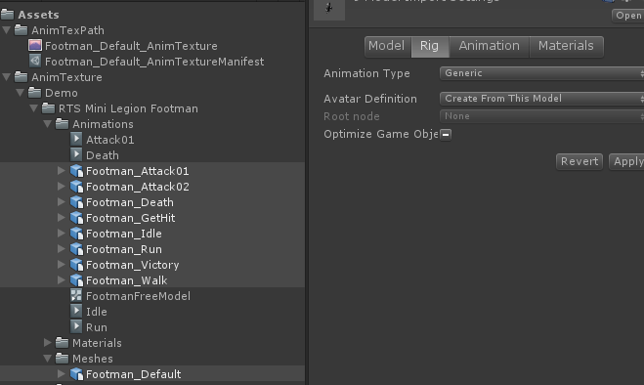
2. Expose model’s transform.

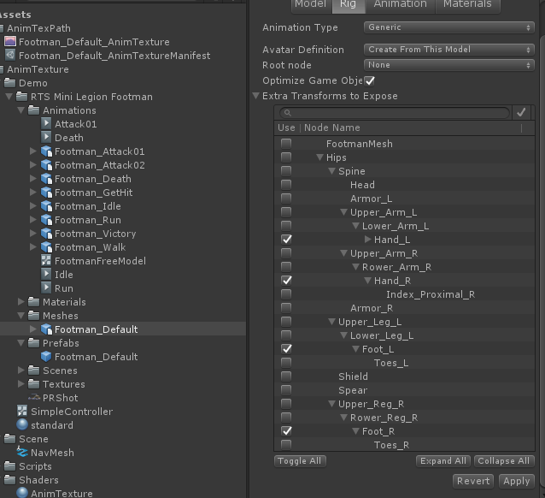

1. Drag model to Hierrarchy again. Select it

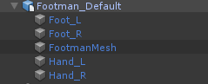

1. click AnimTexture/CreatePlayer and select new object.
2. Set all properties. See 2.2
3. Press play. Show results
4. **Embed objects**. 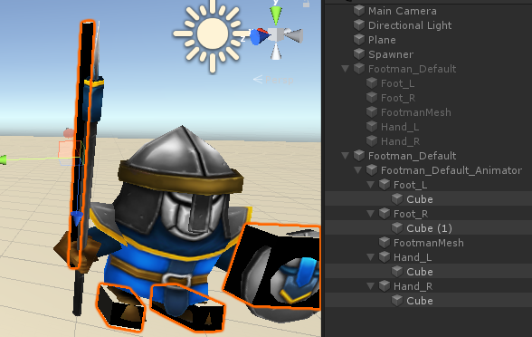

Embed object’s material need check gpu instancing.

**4 Check batches and fps.**

1. Create empty object in hierarchy, attach Spawner component.
2. Drag finished animTexture object to Spawner’s Prefabs.

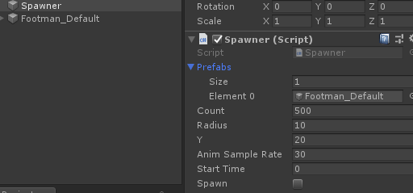

1. Press play, then click Spawn, will see 500 object in Game View. 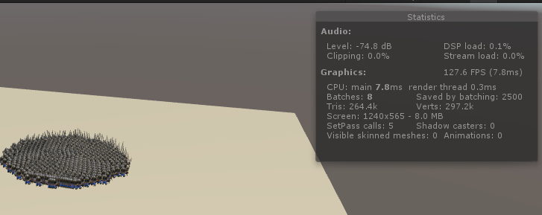

500 characters.

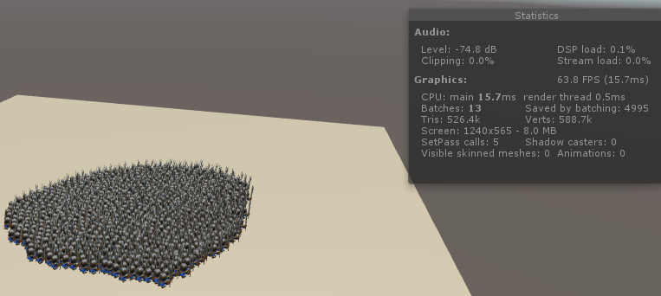

1000 characters.

1. All done, Congratulations.

**Questions**

1. 501 characters but FPS < 20?

Keep model animation type same with animatorStateMachine’s stateclip. Otherwise fps is very low.

Generally 501 characters noUpdateBone fps>140. UpdateBone fps > 120.