# MaterialGroupDrawer

## 概述:

对材质的属性应用[Group类特性],可以快速的构建材质的分组显示

## 地址:

https://github.com/redcool/PowerUtilities.git

Shader Demo如下:

Shader "Unlit/GroupDrawDemo"

{

Properties

{

//show a new Group

[Group(group1)]

[GroupItem(group1)]_MainTex1 ("Texture1", 2D) = "white" {}

// show group item

[GroupItem(group1)]_FloatVlaue("_FloatVlaue",range(0,1)) = 0.1

[GroupItem(group1)]_FloatVlaue2("_FloatVlaue",range(0,1)) = 0.1

[GroupItem(group1)]_FloatVlaue3("_FloatVlaue",range(0,1)) = 0.1

// show Toggle

[GroupToggle(group1)]_ToggleNoKeyword("_ToggleNoKeyword",int) = 1

[GroupToggle(group1,_Ker)]_ToggleWithKeyword("_ToggleWithKeyword",int) = 1

[GroupHeader(group1,b)]

// show Enum with keyword

[GroupEnum(group1, _kEYA _KEYB,true)]_GroupKeywordEnum("_GroupKeywordEnum",int) = 0

// show Enum, space is splitter

[GroupEnum(group1,A 0 B 1)]_GroupEnum("_GroupEnum",int) = 0

[GroupEnum(group1,UnityEngine.Rendering.BlendMode)]_GroupEnumBlend("_GroupEnumBlend",int) = 0

[Group(group2)]

[GroupItem(group2)]_MainTex2 ("Texture2", 2D) = "white" {}

}

}

样式:

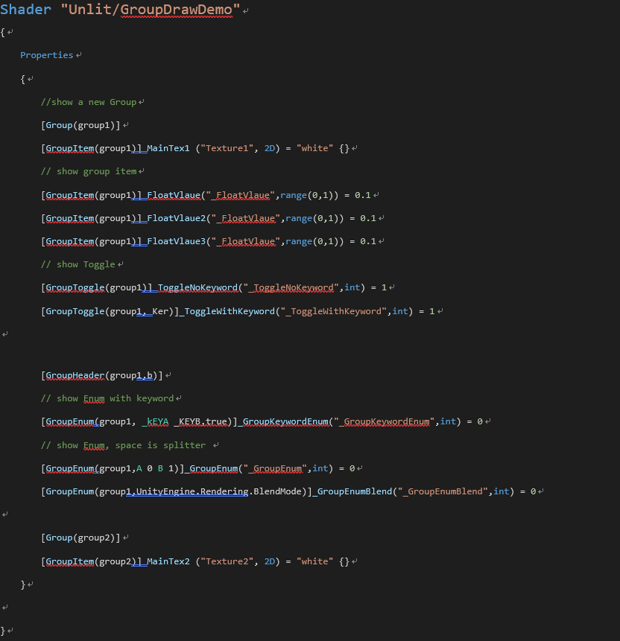

Inspector中的样式:

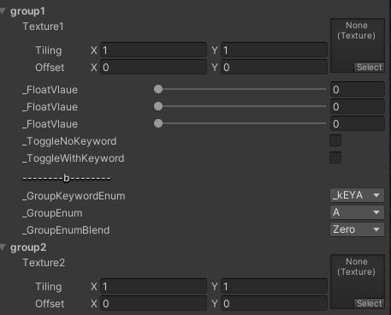

Group特性与样式的对照:

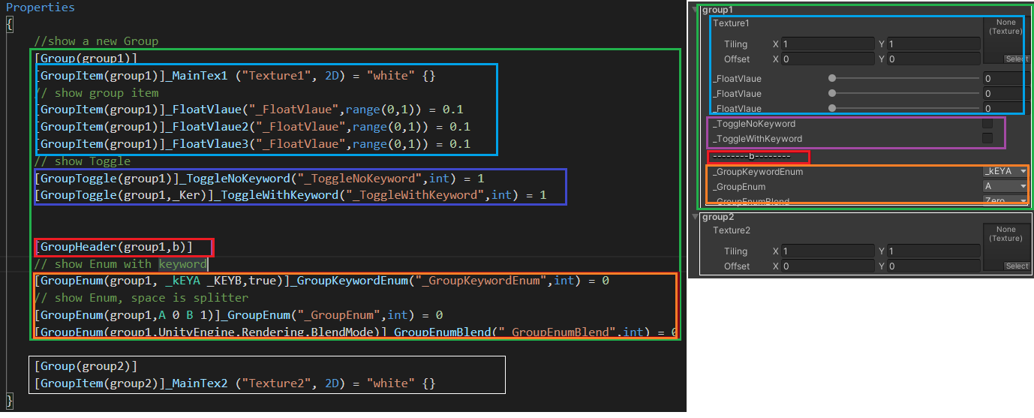

## API参考:

###### 构建一个组,

[Group(group1)]

public GroupDecorator(string groupName)

###### 构建组内的材质属性

[GroupItem(group1)]_MainTex1 ("Texture1", 2D) = "white" {}

[GroupItem(group1)]_FloatVlaue2("_FloatVlaue",float) = 0.1

public GroupItemDrawer(string groupName)

###### 构建组内一个Header

[GroupHeader(group1,b)]

public GroupHeaderDecorator(string groupName, string header)

###### 构建组内的enum

1 支持使用Enum类型

[GroupEnum(group1,UnityEngine.Rendering.BlendMode)]_GroupEnumBlend("_GroupEnumBlend",int) = 0

2 形式(k1 v1 k2 v2), 空格为间隔符

[GroupEnum(group1,A 0 B 1)]_GroupEnum("_GroupEnum",int) = 0

public GroupEnumDrawer(string groupName,string enumName)

3 形式(kw1 ke2),空格为间隔符

[GroupEnum(group1, _kEYA _KEYB,true)]_GroupKeywordEnum("_GroupKeywordEnum",int) = 0

public GroupEnumDrawer(string groupName, string enumName,string keyword)

###### 构建组内的Toggle

1 单选,无keyword操作

[GroupToggle(group1)]_ToggleNoKeyword("_ToggleNoKeyword",int) = 1

public GroupToggleDrawer(string groupName)

2 单选,有keyword操作

[GroupToggle(group1,_Ker)]_ToggleWithKeyword("_ToggleWithKeyword",int) = 1

public GroupToggleDrawer(string groupName, string keyword)