Rmarkdown

Rio em Dados

09/08/2021

library("tidyverse")

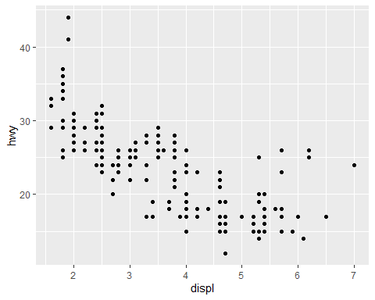

ggplot(data = mpg) +  
 geom_point(mapping = aes(x = displ, y = hwy, color = class))

