YUVA INTERN – AGRICULTURE & AGRIBUSINESS SECTOR
Week 1 Task: Initial Data Gathering and Problem Statement Definition
Focus Area: Post-Harvest Losses in India's Agricultural Supply Chain
Prepared by: Maride Yashwanth Reddy
Date: 30-09-2026

Executive Summary
India loses an estimated 74 million tonnes of food every year — about 22% of its foodgrain and horticulture output — between harvest and final consumption. Perishable categories are hit hardest: livestock produce loses roughly 22%, fruits 19%, and vegetables 18%, with individual crops such as guava (15.05%) and tomato among the worst affected. Independent studies value these losses at anywhere between ₹92,651 crore and over ₹1.5 lakh crore annually, driven chiefly by a severe cold-chain infrastructure gap: only about 6% of India's produce moves through refrigerated storage and transport, compared to roughly 60% in developed economies. This report consolidates publicly available research on the scale, causes, and economic impact of post-harvest losses, defines a precise problem statement centred on smallholder fruit and vegetable supply chains, and outlines how data science methodologies — from descriptive trend analysis to predictive spoilage modelling — can help close this gap in subsequent phases of the internship.

1. Objective
The objective of this Week 1 task is to build a comprehensive understanding of an existing challenge within the Agriculture & Agribusiness sector using publicly available data, and to define a clear, data-driven problem statement. The focus area selected for this report is post-harvest losses in agricultural supply chains — the loss of quantity and quality of produce that occurs after harvest, during storage, transport, processing, and distribution, before it reaches the consumer or market.

2. Research Summary and Data Collection

2.1 Scale of the Problem
According to ICAR data for 2022-23, India loses approximately 74 million tonnes of food annually, equivalent to 22% of foodgrain output and 10% of total foodgrain-plus-horticulture production. The losses are heavily skewed toward perishable commodities: livestock produce (eggs, fish, meat) accounts for a 22% loss share, fruits 19%, and vegetables 18%.
A commodity-level study by NABARD Consultancy Services (NABCONS), commissioned by the Ministry of Food Processing Industries and conducted over 2020-22 across 54 agricultural commodities, found guava suffers the highest post-harvest loss among fruits at 15.05% (11.59% at the farm stage and 3.46% at the market stage), with tomato also among the worst-affected crops. An earlier ICAR-CIPHET (2015) assessment had valued national post-harvest losses at about ₹92,651 crore; more recent industry estimates put the figure above ₹1.5 lakh crore (roughly USD 17.7 billion) per year, reflecting both inflation and methodology differences across studies.
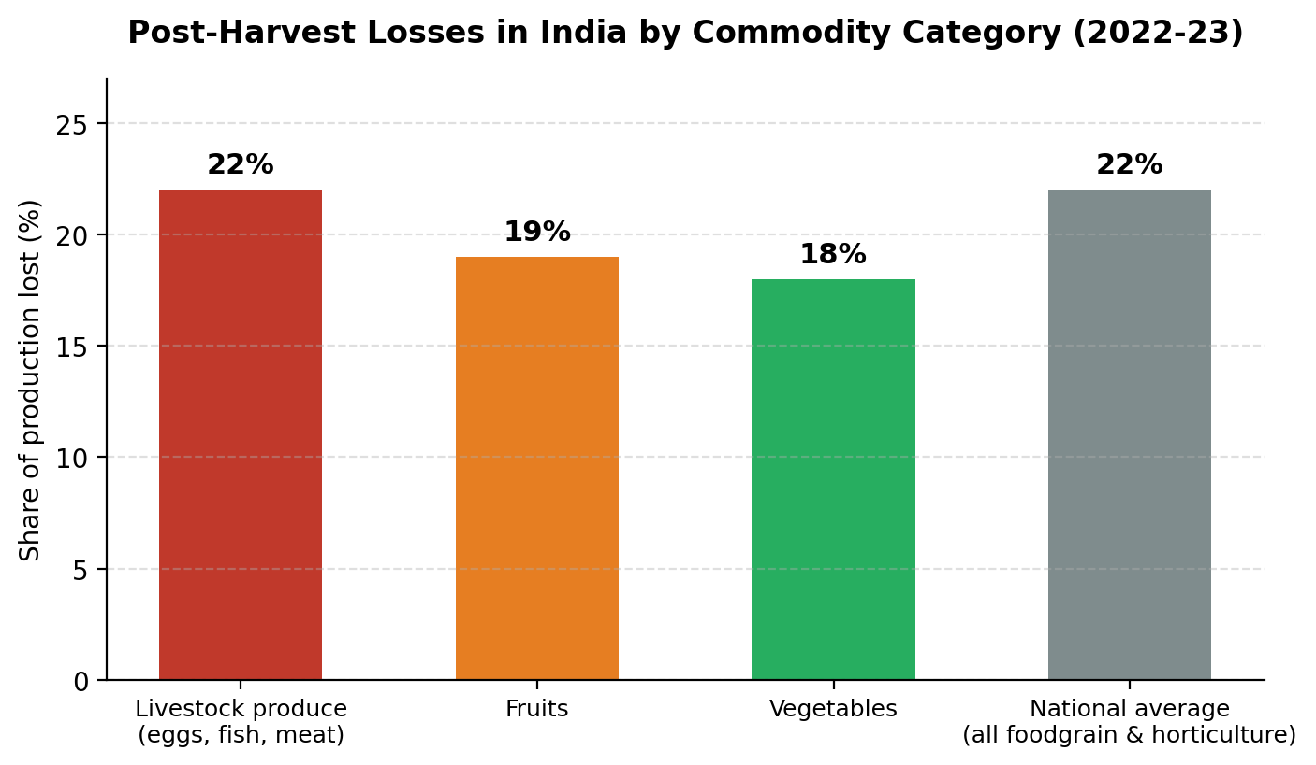
Figure 1: Post-harvest loss share by commodity category, 2022-23 (Source: ICAR)

2.2 Where and Why Losses Occur
- Cold-chain infrastructure gap: Only around 6% of India's produce moves through cold storage and refrigerated transport, versus about 60% in developed countries; a shortfall of 12.6 million tonnes of cold storage capacity was recorded as of early 2020 (National Centre for Cold Chain Development).
- Farm-level constraints: Farmers often need immediate cash at harvest and cannot afford to hold produce in storage, forcing distress sales at low prices.
- Fragmented supply chains: Multiple intermediaries, poor logistics, and price-information asymmetry add brokering costs (in some cases up to 14% commission, versus an international norm closer to 0.5%).
- Handling and grading gaps: Manual sorting/grading, inadequate pest control during storage, and limited farmer knowledge of post-harvest management practices amplify spoilage.
- Seasonal market gluts: Peak-harvest supply surges cause sudden price crashes, especially for vegetables like onion and tomato.

2.3 Regional and Commodity-Level Evidence
A 2024 WRI India study of Madhya Pradesh and Maharashtra found that inefficiencies in onion, soybean, and custard apple supply chains alone waste around 1.7 million tonnes of produce, costing an estimated ₹4,818 crore annually — pointing to gaps in storage, harvesting machinery, and farmer access to finance. A Middle Gujarat field study similarly recorded field-level damage rates of up to 6.6% in banana and lower single-digit losses in mango, papaya, and lime, reinforcing that loss rates vary significantly by crop and region.

Table 1: Summary of post-harvest loss evidence by commodity

3. Key Industry Trends
- Government push on storage infrastructure: Initiatives such as the world's largest cooperative-sector grain storage plan (launched February 2024) and the Integrated Cold Chain & Value Addition Infrastructure Scheme under PMKSY aim to close the cold-chain gap.
- Rising horticulture output outpacing storage capacity: India's horticulture production is projected to reach 377.8 million tonnes in 2025-26, but fragmented sourcing and weak processing continue to limit value capture.
- Emergence of data-driven cold-chain models: Pilot initiatives such as “Your Virtual Cold Chain Assistant” (BASE & Empa) use machine learning and physics-based food modelling to give smallholders access to decentralised cold storage and post-harvest market intelligence.
- Market-linkage reform: Expansion of e-NAM and upgrading of rural haats into Gramin Agricultural Markets to improve price transparency and reduce delayed/distress sales.
- Investment interest from strategic buyers: Analysts are pointing to produce aggregation, packhouses, traceability, and regional processing as priority areas for private investment in high-loss categories (tomato, onion, banana, mango, potato, leafy vegetables).

4. Problem Statement
Fragmented cold-chain infrastructure and information asymmetry across India's fruit and vegetable supply chains cause an estimated 18–22% of perishable produce to be lost between farm and final market each year — rising above 15% for individual high-value crops such as guava and tomato — costing the sector upwards of ₹1.5 lakh crore annually. Smallholder farmers bear a disproportionate share of this loss because they lack affordable storage, real-time market price information, and bargaining power against intermediaries, forcing distress sales at below-market prices. A data-driven approach to predicting spoilage risk, matching supply with cold-storage capacity, and improving price transparency at the farm-gate level could materially reduce these losses and raise farmer incomes.

5. Potential Impact of Data Science
Post-harvest loss is fundamentally a prediction and coordination problem — knowing which produce is at risk of spoiling, when, and where surplus supply will crash prices — which makes it well suited to data science interventions. Reliable, granular data on storage conditions, transit times, commodity-level spoilage rates, and mandi (market) prices could power tools that help both farmers and cold-chain operators make faster, better-informed decisions, directly reducing the volume of produce lost and increasing the share of harvest value that reaches the farmer.

6. Initial Data Analysis Overview: Proposed Methodologies
- Descriptive statistics and trend analysis: Aggregate existing loss-percentage data (as in Table 1) by commodity, region, and supply-chain stage to identify the highest-priority intervention points.
- Regression / predictive modelling: Model spoilage risk as a function of storage temperature, transit time, and commodity type to flag shipments likely to incur high losses before they occur.
- Clustering and segmentation: Group districts or mandis by cold-storage capacity, loss rate, and production volume to prioritise where infrastructure investment would have the greatest impact.
- Price and demand forecasting: Use historical mandi price and arrival-volume data to anticipate seasonal gluts and support advisory tools that help farmers time their sales.
- Dashboarding and visualization: Build a monitoring view that tracks loss hotspots, cold-chain capacity gaps, and price volatility together, to make findings actionable for policymakers and FPOs (Farmer Producer Organisations).

7. Conclusion
Post-harvest losses remain one of the most persistent and costly inefficiencies in India's agricultural supply chain, with perishable commodities such as fruits, vegetables, and livestock produce bearing losses of 18–22% annually and an estimated cost exceeding ₹1.5 lakh crore. These losses are driven primarily by an under-built cold chain, fragmented market linkages, and information asymmetry that leaves smallholder farmers exposed to distress sales. The evidence gathered in this report points to a clear, measurable problem — and a clear opening for data science: predictive spoilage models, price forecasting, and infrastructure-gap analytics can help direct limited storage and logistics investment to where it will reduce the most waste and protect the most farmer income. Subsequent weeks of this internship can build on this foundation by sourcing granular mandi-level price and arrival data to prototype one of the proposed methodologies.

References
ICAR / PMFIAS – Post Harvest Loss in India, pmfias.com
ICRIER Policy Brief 20 – Reducing Post-Harvest Losses in Indian Agriculture, icrier.org
NABCONS study (2020-22) via Global Agriculture – India's Highest Post-Harvest Losses: Guava and Tomato, global-agriculture.com
National Economic Forum – Addressing Post-Harvest Losses in India: A Silent Crisis in Agriculture, nationaleconomicforum.org
StarAgri – India's Post-Harvest Losses & Tech Solutions, staragri.com
WRI India (via Whalesbook) – India Loses ₹4,818 Crore Yearly to Post-Harvest Farm Waste
Cool Coalition / SEforALL / data.org – Your Virtual Cold Chain Assistant (Coldtivate), coolcoalition.org, seforall.org, data.org
Understanding Food Inflation in India: A Machine Learning Approach, arxiv.org/pdf/1701.08789
RetailIntel – India's Horticulture Scale Highlights a Retail Supply-Chain Opportunity, retailintel.in

