**Homework 1**

Kristopher Redding

2.5



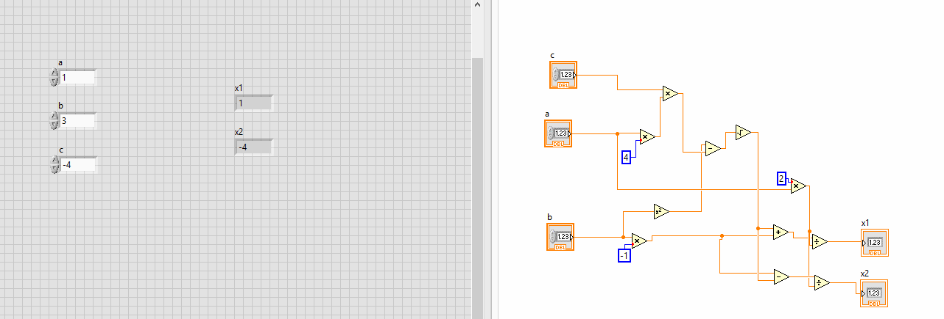

3.4

Unable to find Using Supplied Probes.vi to complete question. Attempted to find online and was also unsuccessful.

4.5

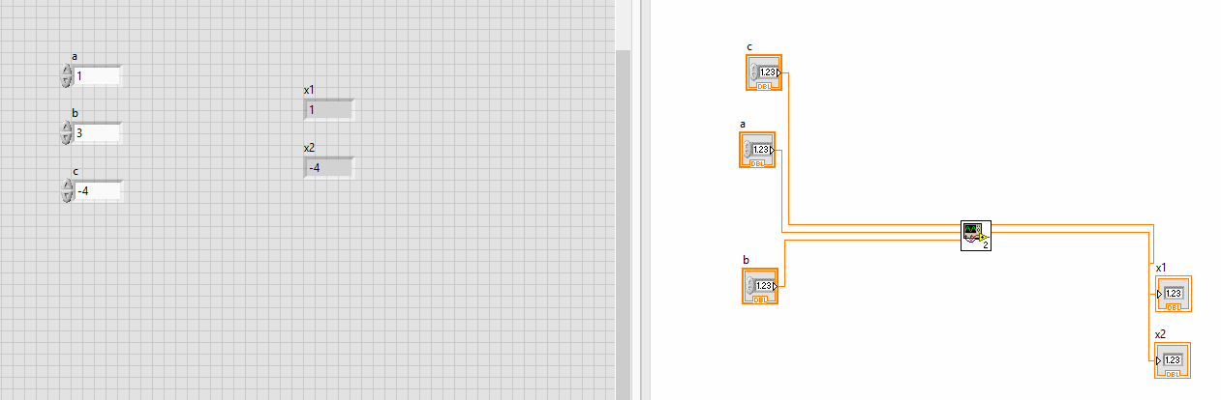

5.2

