Date:15.10.25

TASK:10
Implement simple facts using python

Implement simple fact for following: CO5 S3

a. Ram likes mango.
b. Seema is a girl.
c. Bill likes Cindy.
d. Rose is red.
e. John owns gold.
Tool-Python

Date:15.10.25
TASK:10

Implement simple facts using python

AIM:
To implement simple facts and verify using python

ALGORITHM:

Step:1Define a list of facts containing the statements to be verified.
Step:2 Create a function named verify_fact that takes a fact as input and returns a boolean value indicating whether the fact is true or false.
Step:3 In the verify_fact function:
a. Remove the trailing period from the fact using the rstrip function.
b. Check the fact against the known conditions to determine its truth value. You can use conditional statements (if, elif, else) for this.
- If the fact matches a known condition, return True to indicate that the fact is true.
- If the fact does not match any known condition, return False to indicate that the fact is false.
Step:4 Iterate over each fact in the list of facts:
a. Call the verify_fact function for each fact.
b. Print the fact and the corresponding "Yes" or "No" based on its truth value.

PROGRAM:
# Define a list of facts
facts = [
"john_is_cold.", # john is cold
"raining.", # it is raining
"john_Forgot_His_Raincoat.", # john forgot his raincoat
"fred_lost_his_car_keys.", # fred lost his car keys
"peter_footballer." # peter plays football
]

# Function to check if a fact is true
def verify_fact(fact):
# Remove the trailing period
fact = fact.rstrip(".")

# Perform some logic to verify the fact
if fact == "john_Forgot_His_Raincoat":
return True
elif fact == "raining":
return True
elif fact == "foggy":
return True
elif fact == "Cloudy":
return False # Assume it's not cloudy
else:
return False

# Verify each fact
for fact in facts:
if verify_fact(fact):
print(f"{fact} - Yes")
else:
print(f"{fact} - No")

OUTPUT:
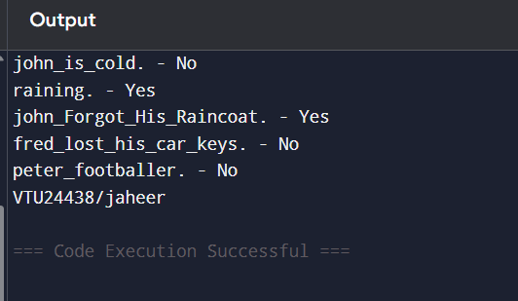

RESULT:
Thus, the implementation of simple facts using python was successfully executed and output was verified.

