

A Course End Project Report on

Employee Payroll System

A9511 – Python Programming Laboratory

Submitted by
E.Akshay
25881A0569
N.Manicharan
25881A0594

Course Facilitator

P.S.Madhavi
Assistant Professor

Department of Computer Science and Engineering Vardhaman College of Engineering, Hyderabad
Academic Year 2026-27



Autonomous Institute, Affiliated to JNTUH,
Approved by AICTE, Accredited by NAAC with A++ Grade Kacharam, Shamshabad, Hyderabad- 501 218, Telangana, India.

DEPARTMENT OF COMPUTER SCIENCE AND ENGINEERING

This is to certify that the Course End Project titled “Title Employee Payroll System” is carried out by E. Akshay, and N.Manicharan with Roll Numbers 25881A0569 and 25881A0594 towards A9511 – Python Programming Laboratory course in partial fulfilment of the requirements for the award of degree of Bachelor of Technology in Computer Science and Engineering during the Academic year 2026-27.

Signature of HOD
Dr. Y. Yijayalatha Proffesor, Head of The Department & Dean (Student Mentoring)
Dept of Computer Science and Engineering, Vardhaman College of Engineering
Signature of the Course
Facilitator
P.S.Madhavi
Assistant Professor,
Computer science and
Engineering

Contents
- Introduction 3
- Literature Review 3
- Objectives 3
- Methodology 3
  - Architectural Diagram 3
  - Hardware and Software Requirements 3
  - Working Principle 4
  - Software Implementation 4
- Results and Discussion 4
- Mapping POs and SDGs 5
  - Program Outcomes (POs) Mapping 5
  - Sustainable Development Goals (SDGs) Mapping 5
- Conclusion 5
Bibliography 6

Abstract
The Employee Payroll System is a software-based application developed to automate and manage the payroll activities of an organization in an efficient, accurate, and systematic manner. Payroll management is an important administrative process that involves maintaining employee information, calculating salaries, managing allowances and deductions, and generating salary details. Performing these activities manually can be time-consuming and may lead to calculation errors and difficulties in maintaining records.
The proposed Employee Payroll System provides a centralized platform for storing and managing employee-related information such as Employee ID, Employee Name, Department, Designation, Basic Salary, Allowances, Bonuses, Deductions, Gross Salary, and Net Salary. The system automatically calculates the salary based on the available salary components and reduces the need for repetitive manual calculations.
The system can also maintain employee payroll records for future reference and generate useful payroll reports. It helps the organization keep salary information organized and makes it easier to search, update, and retrieve employee records whenever required. By automating payroll calculations, the system improves accuracy, reduces human errors, saves time, and increases overall productivity.
The Employee Payroll System can be implemented using programming and database technologies to provide secure and reliable data management. The system can also be extended with additional features such as attendance management, leave management, tax calculation, payslip generation, employee login, administrator login, and monthly payroll reports.
Overall, the Employee Payroll System provides a simple, reliable, and efficient solution for handling employee salary processing and payroll records. It helps organizations modernize their payroll operations and provides better accuracy, transparency, and accessibility compared with traditional manual payroll management.

Keywords
Employee Payroll System, Payroll Management, Employee Records, Salary Calculation, Basic Salary, Gross Salary, Net Salary, Allowances, Deductions, Tax Calculation, Attendance Management, Database Management, Payslip Generation, Payroll Automation, Salary Processing, Employee Information, Payroll Reports, Data Management, Human Resource Management, Automation, Accuracy, Security.

Introduction

The Employee Payroll System is a software-based application developed to manage and automate the payroll activities of an organization. Payroll management is one of the most important administrative functions in any organization because it involves maintaining employee information, calculating salaries, managing allowances and deductions, and preparing accurate salary records. A properly designed payroll system helps an organization process employee salaries efficiently while reducing manual effort and errors.
In traditional payroll systems, employee salary information is often maintained using paper records or spreadsheets. These methods require significant time and effort, especially when the number of employees increases. Manual calculations may also result in errors while calculating allowances, deductions, taxes, provident fund contributions, and final salaries. Searching and updating employee records can also become difficult when a large amount of data is involved.
The proposed Employee Payroll System provides a computerized solution to these problems. It allows the organization to store employee details in a structured database and automatically process salary information. The system can maintain details such as Employee ID, Employee Name, Department, Designation, Basic Salary, Allowances, Deductions, Gross Salary, and Net Salary.
The system calculates the salary based on predefined formulas. The gross salary can be obtained by adding the basic salary and applicable allowances. Various deductions are then subtracted from the gross salary to obtain the final net salary payable to the employee.
The main purpose of this project is to make payroll processing faster, easier, more accurate, and reliable. By automating repetitive calculations, the system reduces the possibility of human errors and saves valuable time for payroll administrators. It also provides a systematic approach to maintaining employee records and retrieving salary information whenever required.
The Employee Payroll System can be useful for small businesses, educational institutions, offices, organizations, and other establishments that need a simple method for managing employee payroll information. The system can also be extended in the future to include features such as attendance management, leave management, tax calculation, employee login, automated payslip generation, salary reports, and administrator authentication.
Another important advantage of the system is data organization. Employee and salary information can be stored in a database instead of maintaining multiple physical files. This makes it easier to add new employees, update existing records, search for employee information, and generate payroll reports.
The project also demonstrates the practical application of programming, database management, software design, and problem-solving concepts. It provides an example of how a real-world administrative problem can be converted into a computerized solution.

Literature Review

Payroll management is an important administrative activity in every organization because it involves maintaining employee information, calculating salaries, managing allowances and deductions, and preparing accurate salary records. In traditional organizations, payroll activities were mainly performed manually using registers, paper files, calculators, and spreadsheets. Although these methods can be suitable for a small number of employees, they require considerable time and effort when the number of employees increases. Manual calculations may also result in errors in salary, allowances, deductions, and final payment. Searching for previous employee records and updating information can also be difficult.
With the development of information technology, computerized payroll management systems have become widely used to overcome the limitations of manual payroll processing. A computerized payroll system stores employee information digitally and performs salary calculations automatically according to predefined rules. Such systems can maintain employee details such as employee ID, name, department, designation, basic salary, allowances, deductions, gross salary, and net salary. Automation helps reduce repetitive work, improves calculation accuracy, saves time, and provides a systematic method for managing payroll information.
Database technology plays an important role in modern payroll systems. Instead of maintaining employee information in separate physical files, a database can store all employee and salary records in an organized and structured manner. Database-based payroll systems allow authorized users to add, update, search, and retrieve employee information easily. They can also maintain payroll history and generate useful reports. The use of databases improves data consistency and reduces problems such as duplicate records and loss of information.
Salary calculation is one of the major functions of a payroll management system. The system can calculate gross salary by adding the basic salary and applicable allowances. Deductions such as provident fund, tax, insurance, loans, and other deductions can then be subtracted from the gross salary to determine the final net salary. Automating these calculations reduces arithmetic errors and ensures that the same calculation procedure is followed for every employee. The system can also be extended to manage attendance, leave, overtime, and other factors that affect employee salaries.
Modern payroll systems also provide features such as automated payslip generation and payroll reporting. A payslip can contain employee details, salary components, allowances, deductions, gross salary, and net salary. Payroll reports can provide information about individual employees, departments, monthly salary expenses, deductions, and payroll history. These features help administrators manage payroll more efficiently and provide employees with clear information about their salaries.
Security is another important consideration in payroll management because employee salary information is sensitive and confidential. A payroll system should provide appropriate access control, authentication, password protection, database security, and backup facilities. Only authorized users should be able to access or modify payroll information. Proper security measures help protect employee information from unauthorized access and accidental modification.
Existing payroll applications provide advanced features such as employee management, attendance tracking, leave management, tax calculation, payslip generation, reporting, and integration with accounting systems. However, some advanced payroll applications may be expensive, complicated, or require specialized training. Small organizations and academic projects may not require all these advanced features. Therefore, there is a need for a simple, affordable, customizable, and user-friendly payroll system that focuses on the essential requirements of payroll processing.
The proposed Employee Payroll System addresses these requirements by providing a computerized method for managing employee records and processing salaries. The system can be developed using programming technologies such as Python along with a database such as MySQL or SQLite. It can store employee information, calculate allowances and deductions, determine gross and net salaries, and maintain payroll records. The system reduces manual work, improves accuracy, saves time, and makes employee information easier to manage and retrieve.

Objectives

The main objective of the Employee Payroll System is to develop a computerized application that can efficiently manage employee information and automate the payroll calculation process. The system is designed to reduce the difficulties associated with manual payroll processing and provide an accurate, reliable, and user-friendly solution for organizations.
The system aims to maintain complete and organized employee records, including employee ID, name, department, designation, basic salary, allowances, and deductions. By maintaining all employee information in a structured database, the system makes it easier to add new employees, update existing information, search records, and retrieve payroll details whenever required.
Another important objective is to automate salary calculations. The system calculates the gross salary by combining the basic salary with applicable allowances and calculates the net salary after subtracting the required deductions. This reduces manual calculations and minimizes the possibility of human errors.
The system also aims to efficiently manage different salary components, such as basic salary, House Rent Allowance (HRA), Dearness Allowance (DA), travel allowance, medical allowance, provident fund, tax, and other applicable deductions. Automating these components makes the payroll process faster and more consistent.
The project aims to reduce the time and effort required for payroll processing. Instead of manually calculating the salary of every employee, the system can process the required information automatically. This allows payroll administrators to handle a larger number of employee records more efficiently.
Another objective is to provide accurate and reliable payroll records. The system stores calculated salary information in a database so that payroll history can be maintained and accessed when needed. This can help organizations keep proper records for administrative and financial purposes.
The system also aims to provide easy searching and retrieval of employee information. Authorized users should be able to find employee records using information such as employee ID or name without manually checking multiple files or documents.
An additional objective is to reduce paperwork and support digital record management. Storing payroll information electronically reduces the need for physical registers and files, making record management more convenient and organized.
The project also aims to provide a foundation for payroll report generation. The system can be extended to generate employee-wise, department-wise, and monthly payroll reports. Such reports can help management understand salary-related information and maintain proper records.
The system is designed with security and controlled access in mind. Since payroll information is confidential, the application can be enhanced with administrator login, authentication, password protection, and role-based access to prevent unauthorized users from modifying employee information.
Finally, the objective of the project is to create a simple, scalable, customizable, and user-friendly payroll solution that can be used as a foundation for real-world payroll management. The system can be further enhanced with attendance management, leave management, overtime calculation, tax processing, automated payslip generation, cloud storage, and graphical payroll reports.

Methodology

Architectural Diagram

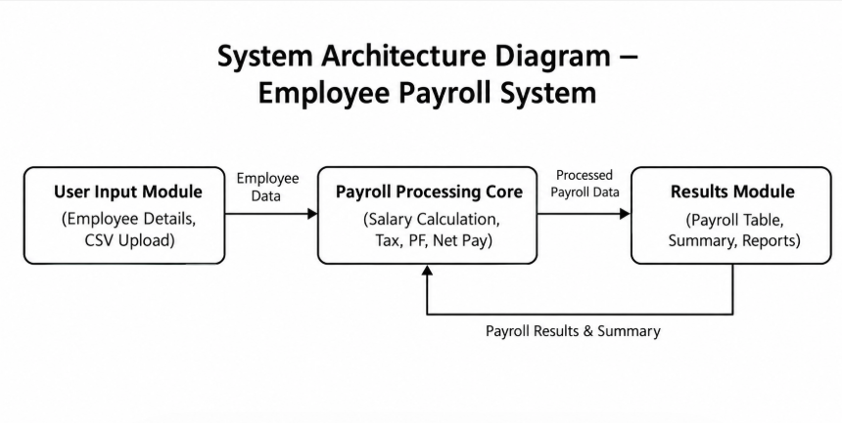
Figure 1: Architectural Diagram
The user interacts with the system through a menu-driven interface. Employee Management handles operations such as adding, viewing, updating, and deleting employees. The Payroll Calculation module calculates gross salary, deductions, and net salary.
The Data Handling module manages reading and writing employee records to the JSON file. The modular architecture makes the system easier to maintain and provides opportunities for future expansion.

Hardware and Software Requirements

Hardware:
- Intel/AMD processor
- Minimum 4 GB RAM
- Minimum 500 MB available storage
- Keyboard and mouse
- Standard display

Software Requirements
- Python 3.x
- Any Python-supported operating system
- IDLE / Visual Studio Code / PyCharm
- Standard Python libraries:
  - json
  - os
  - datetime

Working Principle

The Employee Payroll System starts by loading existing employee information from the employees.json file. If the file does not exist, an empty employee database is created.
The user is presented with a menu containing different payroll operations. The user can add a new employee by entering employee details. The system validates the information and stores the record.
When payroll information is required, the system uses the employee's salary information to calculate the different components of salary.

Salary Calculation
The payroll calculation can be represented as:
Gross Salary = Basic Salary + Allowances
The deductions are calculated based on predefined rates.
For the implemented system:
Tax = Gross Salary × Tax Rate
PF = Gross Salary × PF Rate
Total Deductions = Tax + PF
Net Salary = Gross Salary − Total Deductions
The system can use the following predefined rates:
- Tax Rate = 10%
- PF Rate = 12%
For example, if:
- Basic Salary = ₹30,000
- Allowances = ₹5,000
Then:
Gross Salary = ₹30,000 + ₹5,000
Gross Salary = ₹35,000
Tax:
Tax = ₹35,000 × 10% = ₹3,500
PF:
PF = ₹35,000 × 12% = ₹4,200
Total deductions:
₹3,500 + ₹4,200 = ₹7,700
Net salary:
₹35,000 − ₹7,700 = ₹27,300
Thus, the system automatically calculates the employee's final payable salary.

Software Implementation

import io
import streamlit as st
import pandas as pd

from config import REQUIRED_COLUMNS, COLUMN_DESCRIPTIONS, APP_TITLE
from payroll import calculate_payroll, payroll_summary
from data_loader import load_and_validate_csv

st.set_page_config(page_title=APP_TITLE, page_icon="💰", layout="wide")

st.title("💰 Employee Payroll System")
st.caption("Python + Pandas + Streamlit | Dataset-driven payroll processing")

with st.sidebar:
st.header("Dataset")
uploaded = st.file_uploader(
"Upload a custom CSV with the same format",
type=["csv"],
help="Use the sample CSV as the template. Keep the same column names and data types."
)
st.divider()
st.subheader("Required columns")
for col in REQUIRED_COLUMNS:
st.write(f"• `{col}`")

try:
if uploaded is not None:
df = load_and_validate_csv(uploaded)
source_name = uploaded.name
else:
df = load_and_validate_csv("data/employees.csv")
source_name = "data/employees.csv"
except Exception as exc:
st.error(str(exc))
st.stop()

st.success(f"Loaded dataset: **{source_name}**")

payroll = calculate_payroll(df)

# KPIs
summary = payroll_summary(payroll)
c1, c2, c3, c4 = st.columns(4)
c1.metric("Employees", summary["employees"])
c2.metric("Gross Payroll", f"₹{summary['gross_payroll']:,.2f}")
c3.metric("Total Deductions", f"₹{summary['deductions']:,.2f}")
c4.metric("Net Payroll", f"₹{summary['net_payroll']:,.2f}")

st.subheader("Payroll Records")
st.dataframe(payroll, use_container_width=True, hide_index=True)

st.subheader("Department-wise Payroll")
dept = payroll.groupby("Department", as_index=False).agg(
Employees=("EmployeeID", "count"),
GrossPayroll=("GrossSalary", "sum"),
NetPayroll=("NetSalary", "sum")
)
st.dataframe(dept, use_container_width=True, hide_index=True)

st.subheader("Employee Search")
search = st.text_input("Search by Employee ID, name, department or designation")
if search.strip():
mask = (
payroll["EmployeeID"].astype(str).str.contains(search, case=False, na=False)
| payroll["Name"].astype(str).str.contains(search, case=False, na=False)
| payroll["Department"].astype(str).str.contains(search, case=False, na=False)
| payroll["Designation"].astype(str).str.contains(search, case=False, na=False)
)
st.dataframe(payroll.loc[mask], use_container_width=True, hide_index=True)

st.subheader("Download")
csv_bytes = payroll.to_csv(index=False).encode("utf-8")
st.download_button(
"⬇️ Download Payroll CSV",
data=csv_bytes,
file_name="payroll_output.csv",
mime="text/csv"
)

with st.expander("Dataset format / switching to another dataset"):
st.write("Your replacement CSV only needs the same column names and compatible values.")
st.dataframe(pd.DataFrame({
"Column": REQUIRED_COLUMNS,
"Meaning": [COLUMN_DESCRIPTIONS[c] for c in REQUIRED_COLUMNS]
}), hide_index=True, use_container_width=True)

Results and Discussion

The Employee Payroll System was successfully implemented using Python. The application provides the basic functionalities required for maintaining employee records and calculating payroll
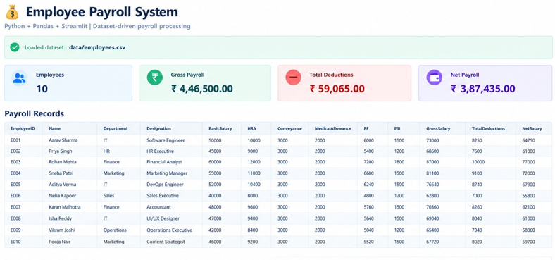
Figure 2: Output (Employee Payroll System)

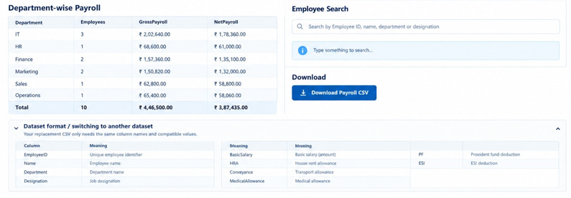
Figure 3: Output(Department Payrolls)
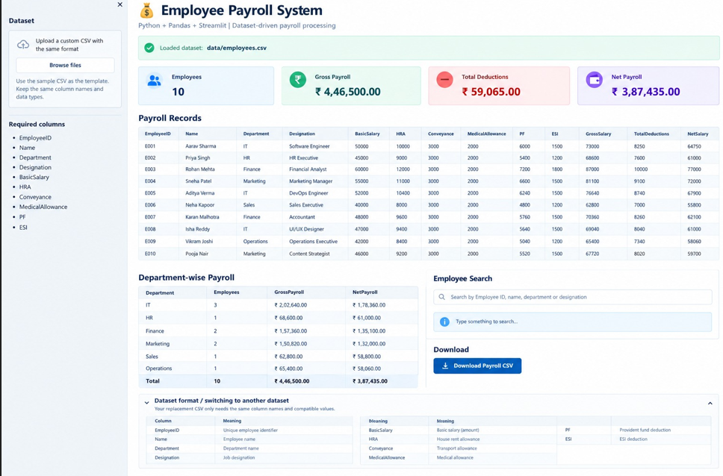
Figure 4: Output(Total page)

Summary of Results

The system successfully performs the following operations:
Operation | Result
Add Employee | Successfully implemented
View Employees | Successfully implemented
Search Employee | Successfully implemented
Delete Employee | Successfully implemented
Salary Calculation | Successfully implemented
Tax Calculation | Successfully implemented
PF Calculation | Successfully implemented
Net Salary Calculation | Successfully implemented
JSON Data Storage | Successfully implemented
.

Mapping POs and SDGs

6.1Program Outcomes (POs) Mapping
Table 1: Mapping of Program Outcomes (POs) to Project Relevance
PO No. | Program Outcome | Relevance
PO1 | Engineering Knowledge | Applied Python programming concepts and computational principles to develop the payroll system.
PO2 | Problem Analysis | Analyzed the problems associated with manual employee and salary management.
PO3 | Design/Development of Solutions | Designed a modular payroll application with employee management and salary calculation features
PO4 | Conduct Investigations of Complex Problems | tested salary calculations and employee management operations using different input cases..
PO5 | Engineering Tool Usage | Used Python, JSON file handling, IDEs, and standard Python libraries.
PO8 | Individual and Collaborative Team work | Applied programming, testing, documentation, and project development skills.
PO9 | Communication | Presented the system functionality through documentation, output screens, and project explanation.
PO11 | Life-Long Learning | Developed practical programming knowledge through independent implementation and debugging

Table 1.1: Mapping of Program Specific Outcomes (PSOs) to Project Relevance
PSO No. | Program Specific Outcome | Relevance
PSO1 | Professional Skills | Applied programming, data handling, and software design knowledge to develop a working payroll application.
PSO2 | Problem-Solving Skills | Used logical and algorithmic thinking with Python to automate salary, tax, and PF calculations.
PSO3 | Successful Career and Entrepreneurship | Built a practical and extendable software solution suited to real-world organizational payroll needs.

6.2Sustainable Development Goals (SDGs) Mapping

Table 2: Mapping of Sustainable Development Goals (SDGs) to Project Relevance

SDG No. | Goal | Relevance
SDG 4 | Quality Education | Provides practical experience in Python programming, file handling, and software development
SDG 7 | Industry, Innovation and  infrastructure | Demonstrates the development of a software-based solution for automating organizational processes.
SDG 8 | Decent Work and Economic Growth | Payroll automation supports efficient employee and salary administration in organizations

7. Conclusion

The Employee Payroll System is a computerized application developed to simplify and automate the process of employee payroll management. The system provides an organized method for maintaining employee information and processing salary-related activities. It reduces the dependency on manual calculations and paperwork, making payroll processing faster, easier, and more reliable..

The system allows the user to maintain important employee details such as employee ID, name, department, designation, and basic salary. It also manages different salary components, including allowances and deductions. Based on the available information, the system calculates the gross salary and net salary accurately according to the defined payroll rules.

The project also demonstrates the practical application of programming, database management, software design, and problem-solving concepts. It provides a simple solution that can be useful for small organizations, educational institutions, offices, and other establishments that require basic payroll management.

The Employee Payroll System can be further improved by adding advanced features such as attendance management, leave management, overtime calculation, tax calculation, automated payslip generation, employee login, administrator authentication, cloud database integration, mobile application support, and graphical payroll reports.

8. Bibliography

Online Resources
[1] Python Software Foundation – Python Documentation
Python Documentation
[2] Oracle – MySQL Documentation
MySQL Documentation
[3] SQLite – SQLite Documentation
SQLite Documentation
[4] GeeksforGeeks – Python Programming and Database Management
GeeksforGeeks
[5] TutorialsPoint – Python Programming Tutorials
TutorialsPoint Python Tutorials
[6] W3Schools – Python Programming and SQL Tutorials
W3Schools
[7] Programiz – Python Programming Tutorials
Programiz Python Tutorials

Research Article / Book References
[1] Silberschatz, A., Korth, H. F., & Sudarshan, S. (2019). Database System Concepts. McGraw-Hill Education.
[2] Elmasri, R., & Navathe, S. B. (2016). Fundamentals of Database Systems. Pearson Education.
[3] Pressman, R. S., & Maxim, B. R. (2020). Software Engineering: A Practitioner's Approach. McGraw-Hill Education.
[4] Sommerville, I. (2016). Software Engineering. Pearson Education.
[5] Ramakrishnan, R., & Gehrke, J. (2003). Database Management Systems. McGraw-Hill.
[6] Date, C. J. (2003). An Introduction to Database Systems. Pearson Education.
[7] Python Software Foundation. Python Programming Language Documentation. Python Software Foundation.
[8] Oracle Corporation. MySQL Reference Manual. Oracle Corporation.
[9] SQLite Consortium. SQLite Database Documentation. SQLite.

