**Amazon Prime Dashboard Insights**

**Overview**

The Amazon Prime Dashboard provides a comprehensive analysis of the content library, offering valuable insights into trends, genre preferences, regional distributions, and overall growth of the platform. These visualizations aid in identifying key patterns and areas for strategic improvements.

**1. Total Titles and Content Growth (Bar Chart)**

**Description:** A time-series analysis of the total number of movies and TV shows released annually.

**Insight:**

Exponential growth observed in content production, especially after the year 2000.

Indicates increasing investments and demand for digital content.

**Recommendation:** Continue investing in new content production, focusing on recent high-demand genres.

**2. Genre-Wise Distribution by Content Category (Donut Chart)**

**Description:** Distribution of content across categories such as High, Medium, and Low, based on popularity or ratings.

**Insight:**

Most content belongs to the High and Medium categories, indicating strong audience engagement in these genres.

Suggests a balanced approach to content targeting different viewer demographics.

**Recommendation:** Increase production of highly consumed genres and improve underperforming categories.

**3. Country-Wise Content Analysis (Pie Chart and Map)**

**Description:**

The Pie Chart shows the top 5 countries contributing to the Amazon Prime library.

The Map visualizes the global distribution of titles.

**Insight:**

The United States leads in content contribution, followed by India and other countries.

Regional diversity in content indicates a global outreach strategy.

**Recommendation:** Expand localized content production in regions with fewer titles, especially in Asia and Europe.

**4. Ratings and Genres Overview (KPI Cards)**

**Description:**

Total Ratings: A measure of viewer engagement and feedback quality.

Total Genres: Highlights the platform’s diversity in content offerings.

**Insight:**

With 25 total ratings, there is scope for improving the variety and distribution of content ratings.

The availability of 519 genres ensures a wide variety of content catering to all audience preferences.

**Recommendation:** Promote highly rated content while exploring niche genres to capture untapped audience segments.

**5. Directors and Content Creation (KPI Card)**

**Description:** Displays the number of directors contributing to the platform’s content.

**Insight:**

A total of 5,771 directors indicates collaboration with diverse creative talents worldwide.

**Recommendation:** Highlight works of renowned directors and introduce emerging directors to bring in fresh content.

**6. Top 5 Countries With Most OTT Content (Pie Chart)**

**Description:** A pie chart representation of the countries contributing the most to Amazon Prime's content library.

**Insight:** The United States dominates with 47% of total titles, followed by India and the United Kingdom.

**Recommendation:** Invest in content production for emerging markets to expand the audience base.

**Conclusion:**

The dashboard provides actionable insights into content trends, global distribution, and audience preferences. By leveraging these insights, Amazon Prime can optimize its content strategy, focusing on high-demand genres, emerging markets, and localized production to enhance user engagement and retention.

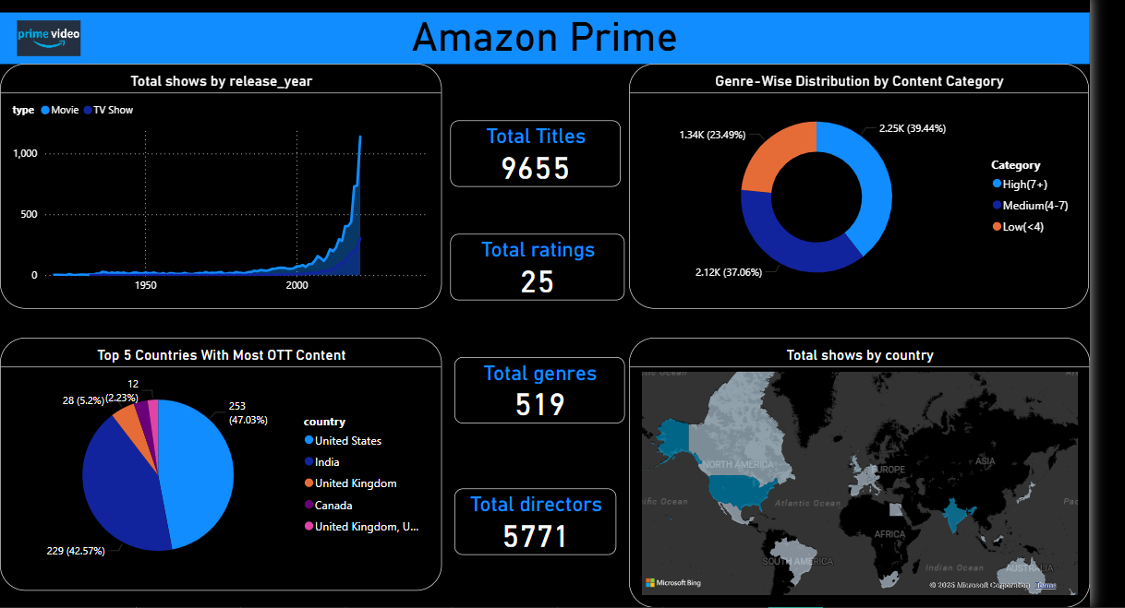

**Apple TV Dashboard Report**

**Overview**

The dashboard provides key insights into the Apple TV dataset, which includes attributes such as age certification, genres, IMDB ratings, production countries, release years, runtime, and type of content (Movies or TV Shows). The visualizations highlight trends, distributions, and summaries of the data.

**Key Highlights**

**Total Titles:**The dataset contains 170 titles, showcasing a mix of Movies and TV Shows.

**Average IMDB Score:**The average IMDB score across all titles is 7.19, indicating an overall positive reception.

**Total Runtime:**The cumulative runtime of all content is 8,688 minutes.

**Top Genres by Popularity:**The top genre based on popularity metrics is 270.03 (measured using TMDB popularity or equivalent metrics).

**Visualizations**

**Yearly Trends in Content Releases:**A line chart displays the count of titles released per year.

**Key observation:** A significant increase in content releases is visible post-2000, with a peak in the year 2019.

**Genre-Wise Analysis by Type:**A bar chart compares the distribution of Movies and TV Shows across different genres.

**Observation:** Genres such as Drama, Comedy, and Animation are prevalent across both Movies and TV Shows.

**Country-Wise Content Distribution:**A bubble map highlights the global distribution of content based on production countries.

**Observation:** The highest concentration of content comes from North America, followed by Europe and Asia.

**Insights**

Content Production Boom: There is a noticeable rise in the number of titles produced in recent decades, reflecting the growing demand for digital content.

Popular Genres: Drama and Comedy are the most common genres, appealing to a broad audience.

Geographical Trends: North America dominates content production, showcasing the influence of the US entertainment industry.

**Recommendations**

Focus on producing more diverse genres to cater to untapped audience segments.

Expand content production in regions outside North America to capture emerging markets.

Increase efforts to improve IMDB scores by focusing on quality content to maintain viewer satisfaction.

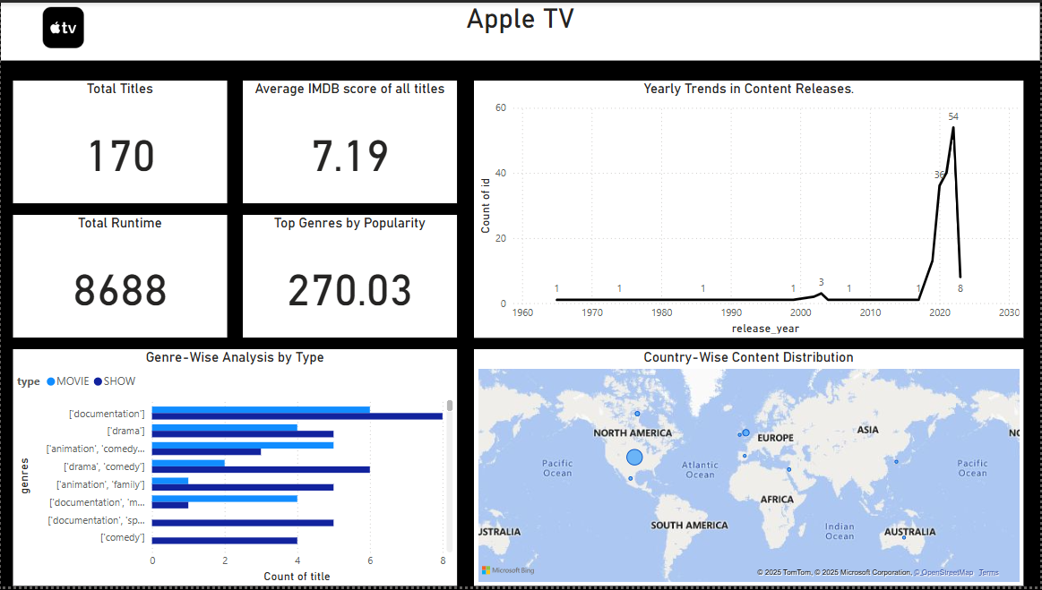

**Bollywood Dashboard**

**Summary of Insights:**

**Average Score:** The average score of Bollywood movies is 58.38, indicating a moderate audience reception.

**Budget and Revenue:**The total budget for movies is 3.80 billion, with a total revenue of 2 billion.

There is a visible gap between budget and revenue, suggesting the need to optimize spending or increase monetization strategies.

**ROI%:** A high ROI of 1093% showcases that some movies yield excellent returns despite the moderate revenue.

**Revenue Distribution:**

India (IND) is the dominant contributor, accounting for 100% of the revenue.

**Movie Count:** Out of a total of 2624 movies, only 1312 titles generate substantial revenue, highlighting significant room for improvement in movie performance.

**Key Takeaways:**

**Budget vs. Revenue:** While Bollywood invests heavily in production, only a portion of the titles generates returns, suggesting inefficiencies.

**Country-Specific Insights:** Revenue is entirely dominated by India, presenting opportunities to target international markets.

**High ROI:** The return on investment indicates that some films perform exceptionally well, possibly due to niche genres or targeted marketing.

**Strategic Recommendations:**

**Budget Optimization:** Reallocate budgets to focus on movies with proven profitable genres or production teams.

**Expand International Reach:** Leverage Bollywood's brand to enter global markets and diversify revenue streams.

**Quality Over Quantity:** Increase focus on content quality to boost the performance of more titles, reducing the gap between the top-performing and underperforming movies.

**Marketing Insights:** Study high-ROI movies to replicate their success factors, such as genre selection, marketing strategies, and distribution channels.

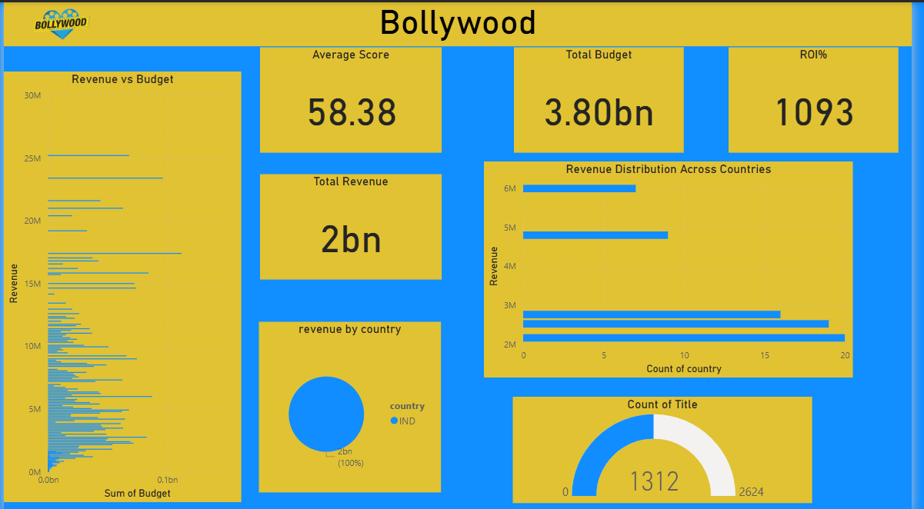

**Hollywood Dashboard**

**Summary of Insights:**

**Total Budget:** A staggering 660.37 billion, indicating significant investment in Hollywood productions.

**Total Revenue:** The total revenue generated is 2.58 trillion, reflecting substantial profitability from the global box office.

**Average Score:** With an average score of 63.50, Hollywood movies generally receive favorable audience ratings.

**Total Profit:** A total profit of 10.18K, showcasing profitability across multiple ventures despite the high expenditure.

**Total Movies Produced:** 9,656 movies, demonstrating Hollywood's immense scale of production.

**Key Insights:**

**Revenue Distribution:**

The top revenue-contributing countries are:

US (44.87%): Dominates revenue generation, underscoring Hollywood's strong domestic market.

KR (35.43%): South Korea contributes significantly, reflecting the rising influence of Korean markets.

FR (10.46%): France's share shows Hollywood's appeal in European markets.

AU (6.02%) and JP (3.22%) round out the top 5 contributors.

Budget vs. Revenue: The scatter plot reveals a concentration of movies with a low-to-moderate budget but high revenue, emphasizing efficient resource allocation.

Market Reach: The global spread of revenue highlights Hollywood's extensive market penetration.

**Strategic Recommendations:**

**Enhance Regional Focus:**Strengthen marketing and distribution in emerging markets like South Korea and Japan to maximize returns.Develop culturally relevant content to further penetrate non-US markets.

**Optimize Budget Allocation:** Leverage data to identify the optimal budget range for maximum profitability.

**Quality Improvements:** Focus on improving audience scores for long-term brand reputation and global appeal.

**Market Expansion:** Increase investment in underperforming regions to diversify revenue streams.

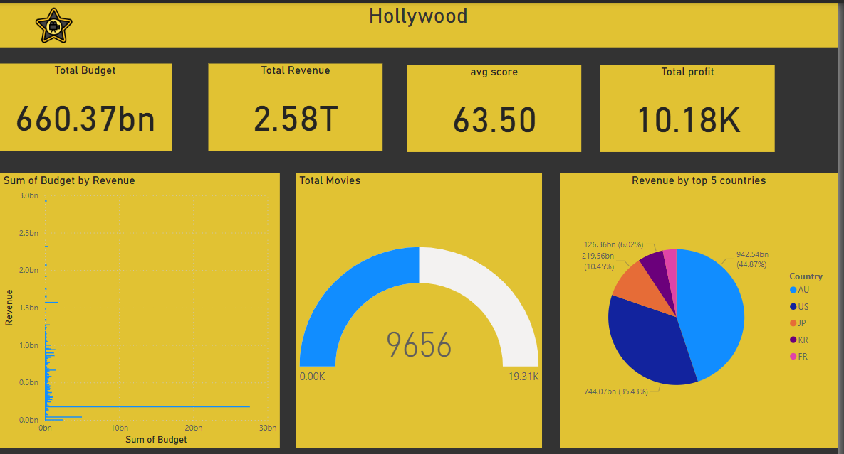

**Hotstar Dashboard**

**Summary of Insights:**

**Total Titles:** A total of 6,865 titles are available on Hotstar, reflecting its vast content library.

**Content Distribution by Type:**

**Movies:** 66.41% (4,565 titles) dominate the platform, making movies the most prevalent content type.

**TV Shows:** 33.53% (2,300 titles) represent a significant portion of the content mix.

**Other Types:** A minor fraction (0.06%) belongs to other content types.

**Total Types:** The platform features 3 distinct content types, ensuring diversity.

**Total Genres**: There are 6,865 genres, showcasing the platform's versatility in catering to varied audience preferences.

**Key Insights:**

**Content Rating:**Titles are primarily rated as U/A 13+ and U, catering to family and general audiences.

This aligns with the platform's goal to be a family-friendly streaming service.

**Content Growth Over Time:**A consistent increase in titles is noticeable, with significant growth post-2000, reflecting the platform's response to the rising demand for digital streaming.Peak content addition occurred in recent years, indicating an aggressive push toward expanding the library.

**Popular Content Format:**Movies form the backbone of the platform's library, but TV shows contribute a substantial share, ensuring balance in user engagement.

**Strategic Recommendations:**

**Targeted Marketing for Key Genres:** Leverage insights on genre popularity to design campaigns tailored for target audiences, ensuring higher engagement and retention.

**Expand TV Content:** While movies dominate, increasing TV show offerings can capture binge-watchers and diversify user retention strategies.

**Regional Content Focus:** Analyze country-wise performance to localize content creation and improve regional market penetration.

**Quality vs. Quantity:** Focus on maintaining high ratings while expanding the library to align with audience preferences and sustain viewership quality.

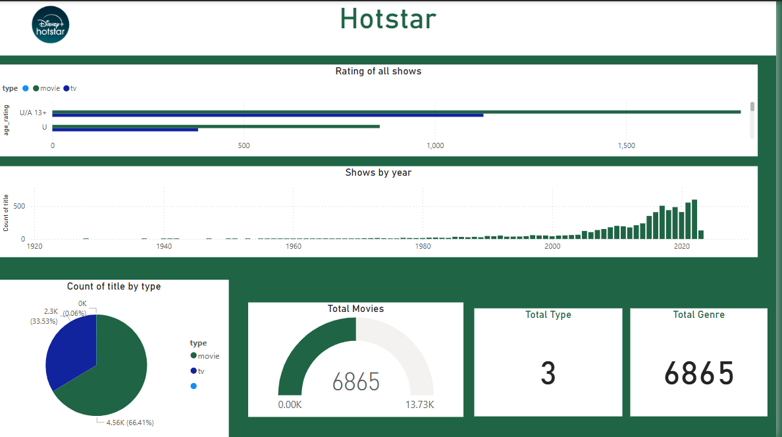

**Netflix Dashboard**

**Summary of Insights:**

**Total Cast Members:** 5,200 cast members are featured across all titles on Netflix.

**Total Directors:** 3,944 directors contribute to the platform's diverse content.

**Total Genres**: Netflix offers content across 336 genres, showcasing its variety.

**Total Movies:** 3,872 movies form a significant portion of the content library.

**Key Insights:**

**Top 5 Countries with High Ratings:**The United States leads in highly rated content, followed by India, United Kingdom, Canada, and Spain.

This indicates the prominence of content produced in English and other globally dominant languages.

**Distribution of Movies by Rating:**TV-MA (32.92%) dominates, indicating a strong presence of mature content.Other significant ratings include TV-14, TV-PG, PG-13, and G, highlighting a mix of family-friendly and mature content.Minor contributions come from ratings like TV-Y, TV-Y7, and NR.

**Focus on Movies:**Movies constitute a significant share of the platform's library, underscoring Netflix’s emphasis on feature-length films.

**Strategic Recommendations:**

**Boost Global Appeal:** Increase content targeted at emerging markets and languages, leveraging the existing high-rated content strategy.

**Expand Family-Friendly Content:** Diversify content for younger audiences and families, as the share of TV-Y and TV-Y7 is relatively low.

**Strengthen Genre Diversity:** Analyze less-represented genres for growth opportunities, especially in trending categories like thrillers or documentaries.

**Leverage Popular Directors and Cast:** Promote titles featuring top directors and cast members to boost viewer engagement.

