**Report of cla2**

**Hirarechy relations:**

product name(data)-name(product master)->*:1

Category name(product maser)-order type name(sheet1)->*:*

**DAX Measures**

**Total Sales** = SUM('data'[Sales Amount])

**Total Quantity** = SUM('data'[Quantity])

**AOV** = DIVIDE([Total Sales], COUNT('Table 1 (Sheet1)'[Ordertype name]), 0)

**Total Profit** = SUMX('data', 'data'[Sales Amount] - 'Data'[Cost Amount])

**Profit Margin %** = DIVIDE([Total Profit], [Total Sales], 0) * 100

**Sales Last Month** = CALCULATE([Total Sales], PREVIOUSMONTH('Data'[Sale date]))

**MoM Growth** = DIVIDE([Total Sales] - [Sales Last Month], [Sales Last Month], 0) * 100

**YTD Sales** = TOTALYTD([Total Sales], 'Data'[Sale date])

**Sales LY** = CALCULATE([Total Sales], SAMEPERIODLASTYEAR('Data'[Sale date]))

**Top Product** = TOPN(1, VALUES('Product Master'[Name]), [Total Sales], DESC)

**Sales by Category** = SUMX(VALUES('product master'[Category Name]), [Total Sales])

**Sales % by Product** = DIVIDE([Total Sales], CALCULATE([Total Sales], ALL('data')), 0) * 100

**Orders by Category** = COUNTROWS(RELATEDTABLE('Table 1 (Sheet1)'))

**Total Orders** = COUNT('Table 1 (Sheet1)'[Ordertype name])

**Avg Orders per Customer** = DIVIDE([Total Orders], DISTINCTCOUNT('Table 1 (Sheet1)'[Customer name]), 0)  
**Returning Customers** =

VAR LastYearDate = MAX('Table 1 (Sheet1)'[Sale Date]) - 365

RETURN

CALCULATE(

DISTINCTCOUNT('Table 1 (Sheet1)'[Customer Name]),

'Table 1 (Sheet1)'[Sale Date] >= LastYearDate)

**Sales & Profit Dashboard Report**

**Overview:**

This dashboard provides insights into sales performance and profitability trends. It includes various key metrics and visualizations to analyze total sales, profit margins, and best-selling products.

**Key Visuals & Insights:**

**Profitability Trends:**

Displays the percentage of profit margin across different months.

A sudden dip in mid-year indicates potential losses or increased costs.

**Total Sales by Year:**

Highlights sales performance from 2016 to 2018.

A declining trend in 2018 suggests a possible reduction in demand.

**Total Cost Distribution by Category:**

Visualizes spending across different product categories (Casual Wear, Formal, Accessories, and Semi-Formal).

Helps understand which category incurs the most cost.

**Best-Selling Products:**

Ranks products based on total sales.

Jeans Levi’s and Denim are the top performers.

**Key Metrics:**

**Total Sales:** 6M

**Total Profit:** 1M

**Profit Margin %:** 22.92

**Actionable Insights:**

Investigate the cause of the mid-year profit dip and implement corrective measures.

Focus on promoting declining product categories to maintain consistent sales.

Analyze customer preferences to sustain sales growth in upcoming years.

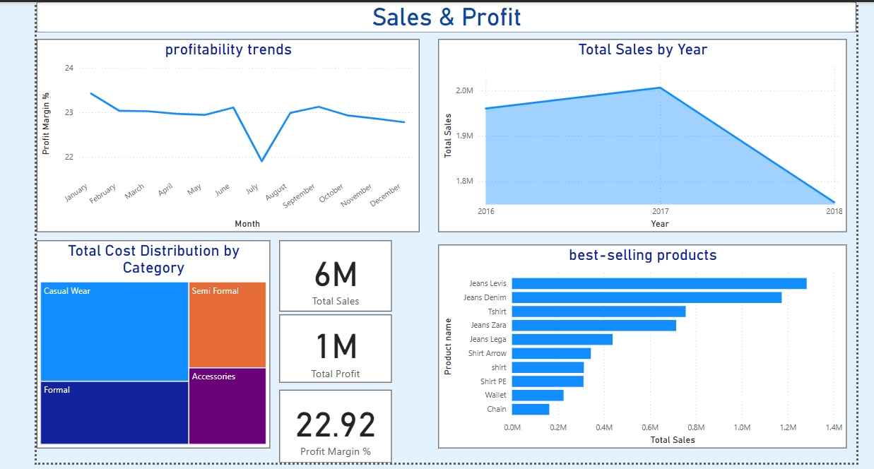

**Product Performance Dashboard Report**

**Overview:**

This dashboard analyzes product sales trends, their contributions to total sales, and profitability by category.

**Key Visuals & Insights:**

**Product Sales Rank Over Time:**

A Sankey-style visualization shows how different products performed from 2016 to 2018.

Helps in understanding product popularity shifts over time.

**Contribution of Each Product to Total Sales:**

Pie chart displaying the share of total sales contributed by each product.

Jeans and T-shirts hold the largest portion of sales.

**Sales vs. Profit by Product Category:**

Bubble chart comparing sales vs. profit across different product categories (Accessories, Casual Wear, Formal, Semi-Formal).

Larger bubbles indicate higher profits in a category.

**Actionable Insights:**

Focus marketing efforts on high-performing products to maximize revenue.

Improve sales strategies for lower-contributing categories.

Identify trends in sales patterns to optimize inventory management.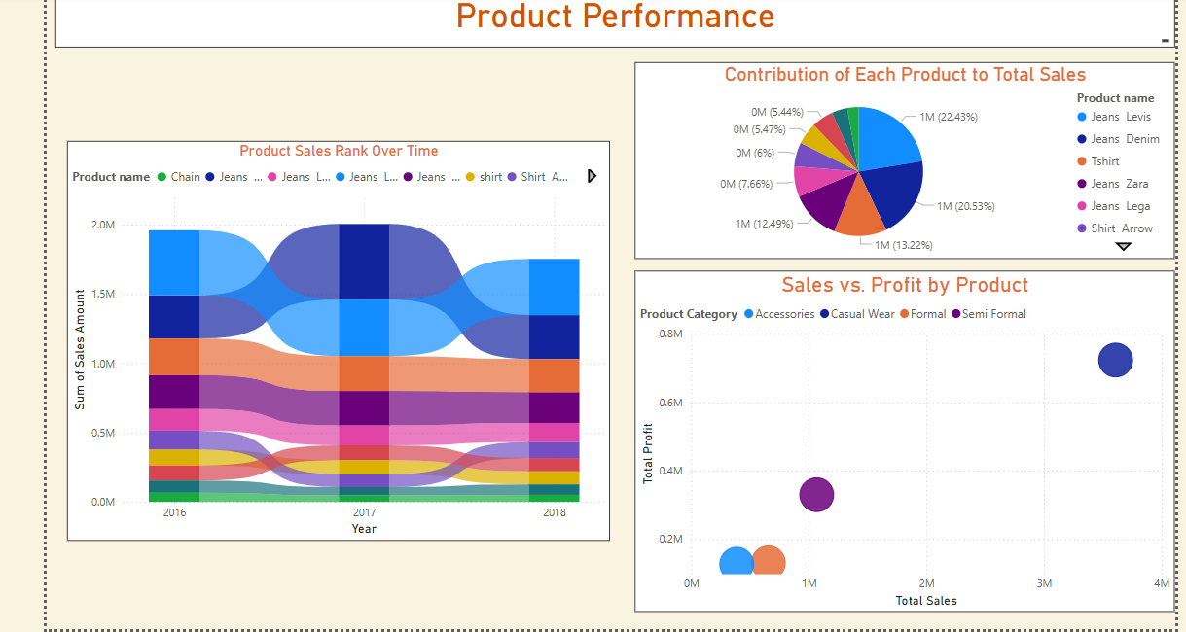

**Customer Insights Report**

**Overview**

This report provides an analysis of customer sales, profit distribution, and product category profitability. It highlights top customers, total orders, and returning customer trends to offer a better understanding of customer behavior.

**Key Findings**

**1. Total Sales by Customer Name**

Mahesh and Naga are the top contributors to total sales.

Other high-value customers include Ganesh, Kumar, Vijay, and Sunil.

Customer retention strategies can be improved to increase repeat purchases.

**2. Sum of Profit by Location**

Profit is evenly distributed across three major cities:

Hyderabad: 33.27%

Bangalore: 33.84%

Chennai: 32.89%

Expansion efforts can be equally focused across these locations.

**3. Top Customers by Sales**

Ganesh, Kumar, and Mahesh are the highest revenue-generating customers.

Total Orders: 134

Returning Customers: 7 (Low percentage, indicating room for improvement in customer loyalty).

**4. Total Profit by Product Category**

Casual Wear dominates in profitability.

Accessories and Semi-Formal categories are also contributing significantly.

Formal wear has the least contribution, suggesting the need for better marketing strategies.

**Actionable Insights :**

Launch a loyalty program to increase returning customers.

Provide personalized offers to top customers (Mahesh, Naga, Vijay) to boost sales.

Improve formal wear sales through discounts or bundled deals.

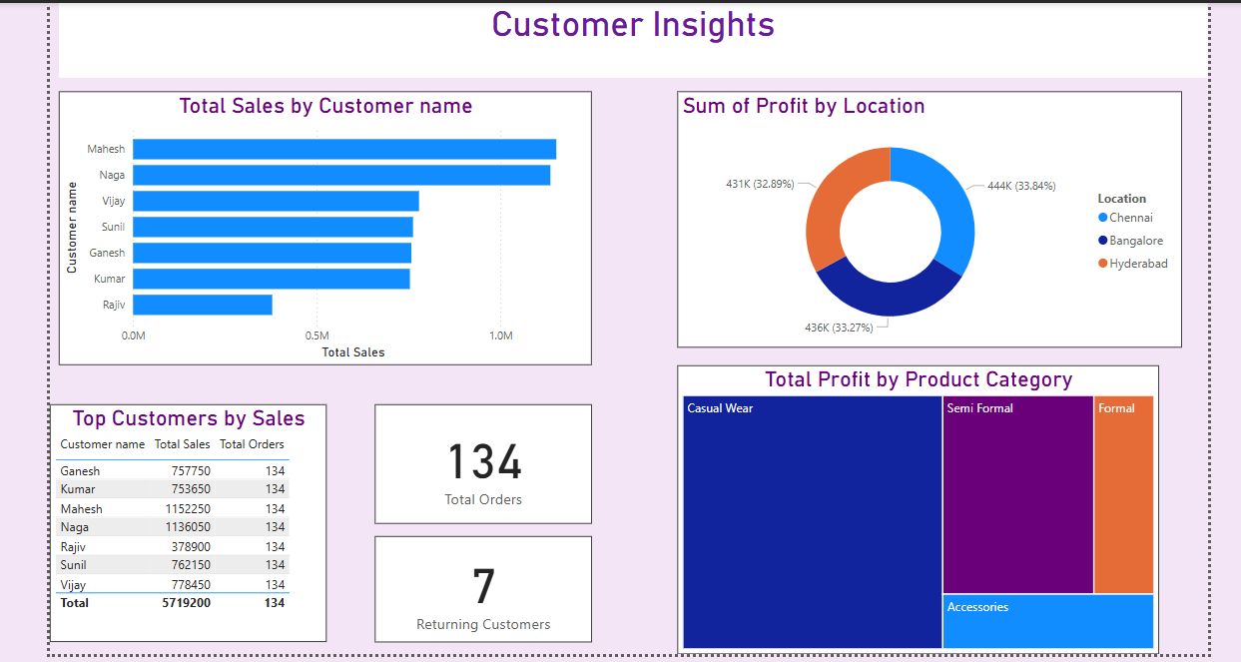

**Time Intelligence Sales Report**

**Overview**

This report analyzes sales performance using Year-to-Date (YTD) calculations and total sales trends across months, years, and locations.

**Key Findings**

**1. YTD Sales by Month**

The YTD sales trend fluctuates over the months.

Highest sales observed in March and May, while June and September show a decline.

Consistent YTD performance towards the end of the year.

**2. Total Sales by Year**

Steady increase in total sales from 2016 to 2017.

Drop in total sales in 2018, indicating a potential issue that requires further investigation.

**3. YTD Sales by Location**

Sales are concentrated in major regions like Hyderabad, Vijayawada, Chennai, and Bangalore.

Some regions contribute lower sales, suggesting potential areas for market expansion.

**Actionable Insights :**

Focus marketing efforts in March & April when sales peak.

Introduce discounts and offers in months with lower sales (June, September, October).

Investigate the drop in total sales in 2018 and adjust sales strategies accordingly.

