Azure Devops with Azure Databricks

1. Setup Azure Devops in Azure cloud

Go to the Project which was created for development work.

Create the repository in Azure Devops.

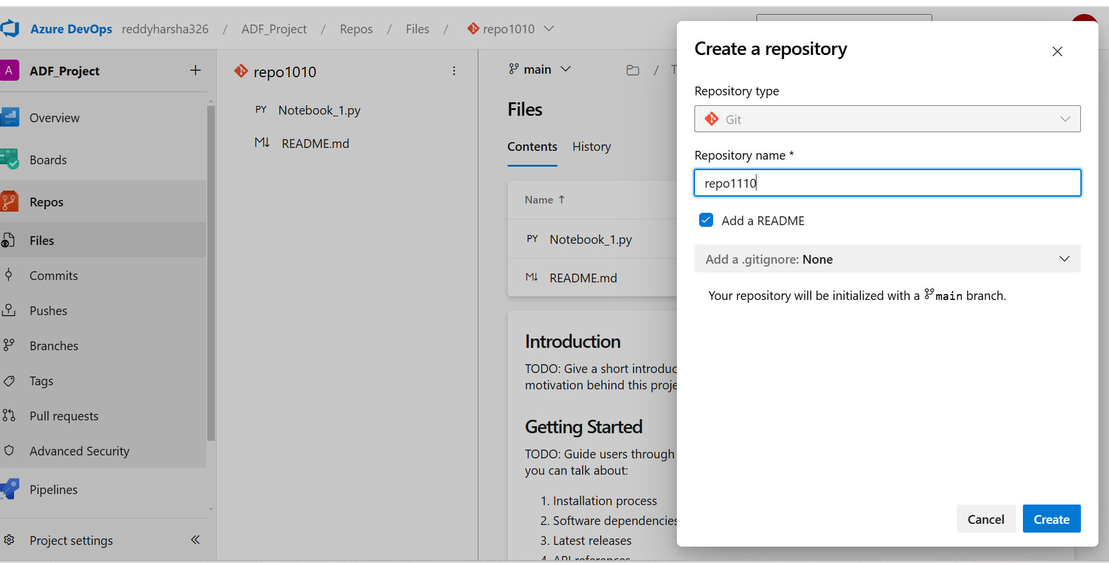

After creating repository in Azure Devops then login to Databricks workspace.

Here in ADB, we can Create GIT Folder for developing notebooks.

We can provide Git repository URL as ADO repo URL.  
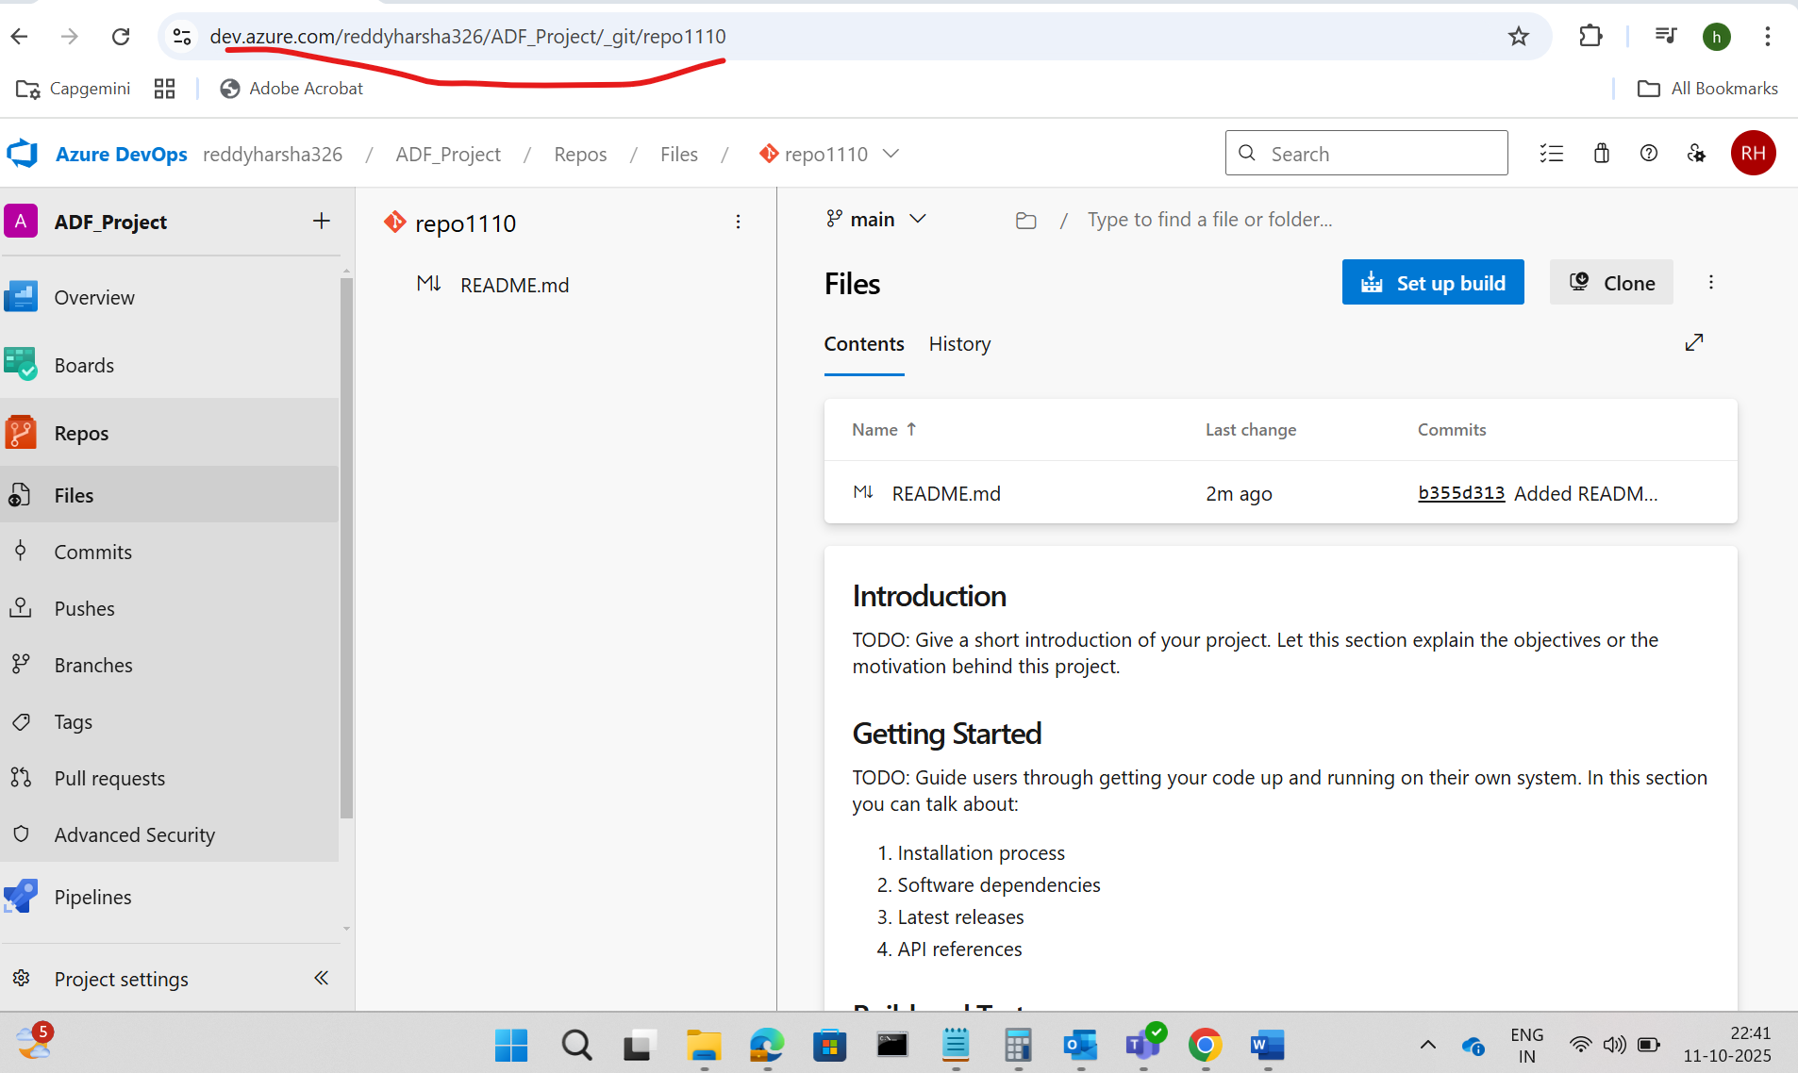

After copying url automatically it will fetch Git Provider and repository.

After Creating Git folder by default, it will be main branch. We can create feature branch and implement code and merge into Main branch by using pull request.

Ex: Implemented one notebook in feature branch and raising pull request to main branch.

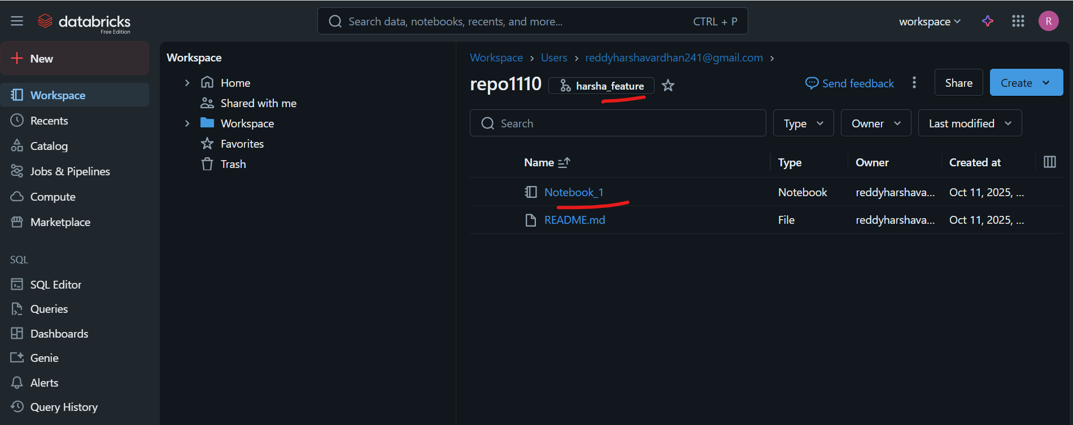

After committing changes , those changes will reflect in ADO repo

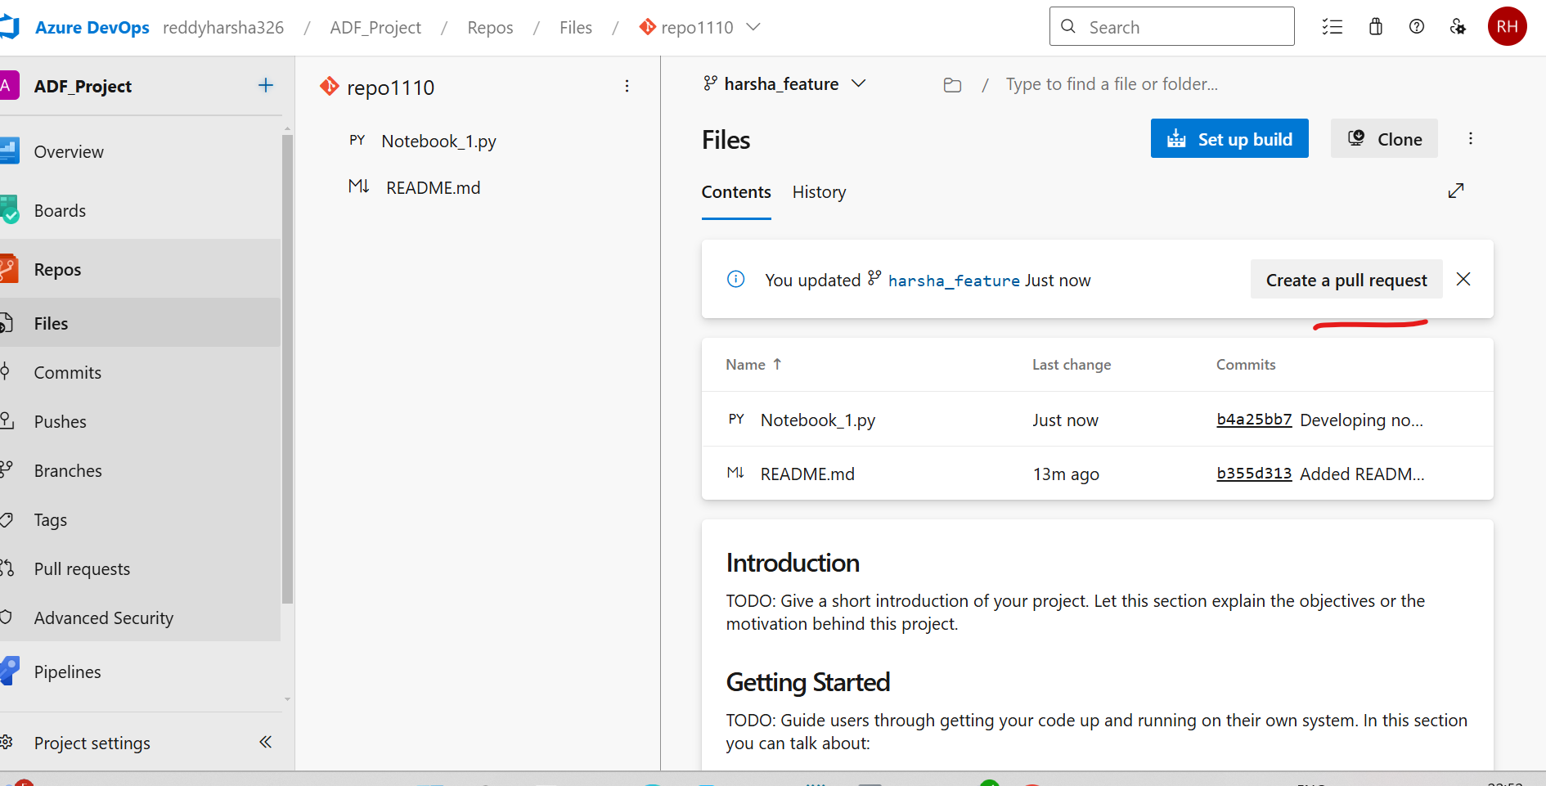

Creating pull request and assigning reviewer for approval.

