***INTERNETWORKING ESSENTIALS - CSE307***

***Section – K23UP***

***Submitted by:***

***Reddy Manjunath***

***Registration & Roll Number:***

***12312640, 07***

***DATE: - 04/03/2025***

***In partial fulfilment for the requirements of the award of the***

***degree of***

***“B. Tech CSE Data Science and Machine Learning” ***

***“School of Computer Science and Engineering”***

***Lovely Professional University***

***Phagwara, Punjab***

**Project7: You are hired as a network engineer for Pixel Infotech Ltd., a mid-sized enterprise with a nine-floor office building. Each floor is equipped with 6 computers, and the organization requires a well-structured network to ensure efficient communication and scalability.**

**Network Design Requirements:** 1. Topology Selection: Design a ring topology for 2 floors and then a star topology for the remaining floors, considering performance and fault tolerance.

**2. IP Addressing Scheme**: The company has decided to use Class B private IPv4 addresses following a classful addressing scheme. Allocate IP addresses properly for each floor, ensuring uniqueness.

**3. Routing Strategy for Inter-Floor Communication & Connectivity:** Recommend a routing approach that is static for inter-floor communication.

• Design how the floors will be connected for seamless interdepartment communication.

• Suggest the appropriate network devices (e.g., switches, routers, access points) and their placement.

• If using dynamic routing, suggest an appropriate routing protocol (e.g., RIP, OSPF, or EIGRP) with justification.

• If using static routing, define the static routes for efficient data flow. • Specify the number of default gateways along with IP addresses

***1. How you created the physical scenario. Attach snapshot***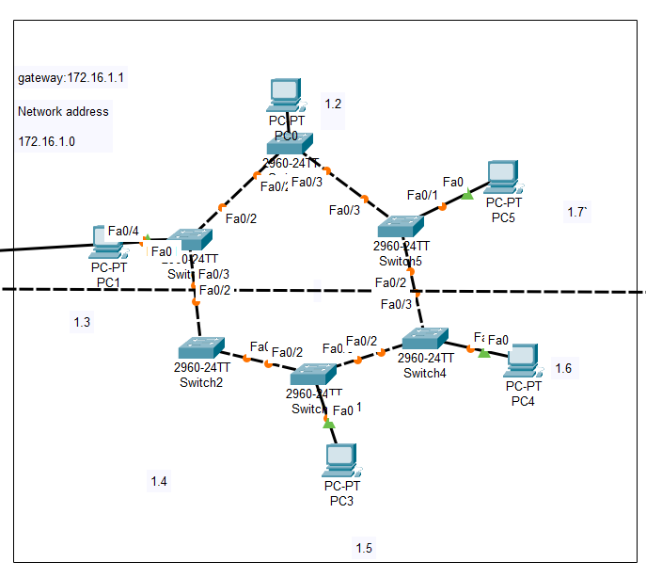

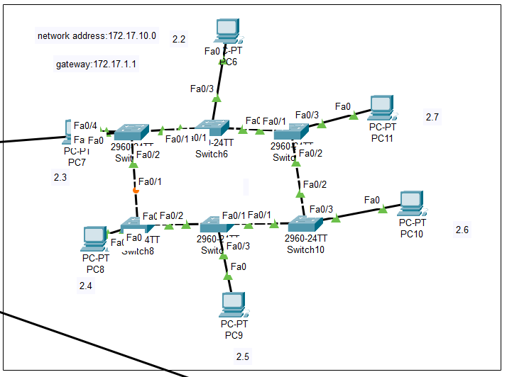

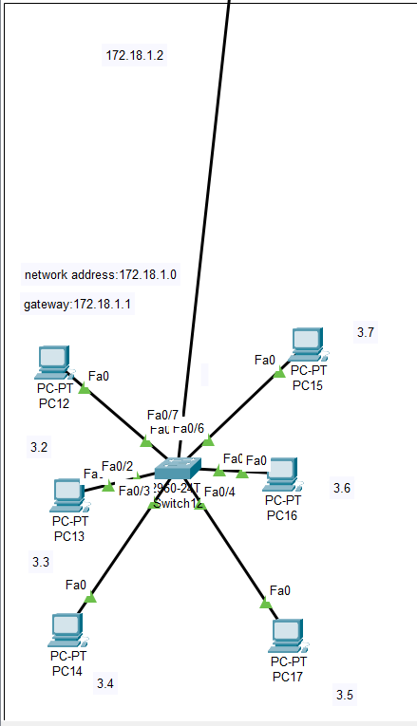

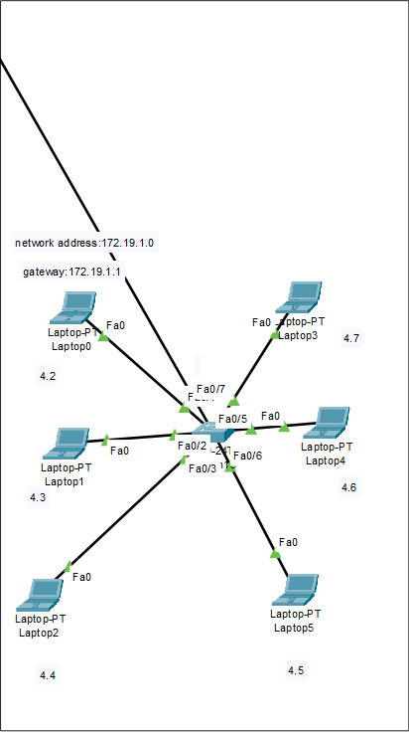

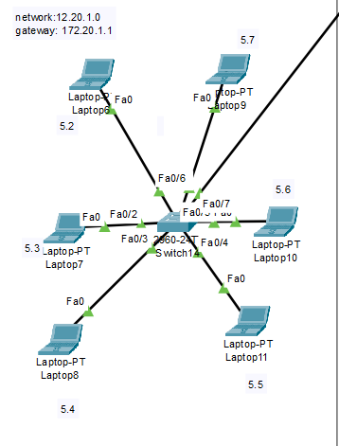

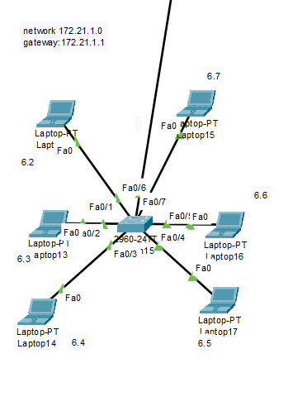

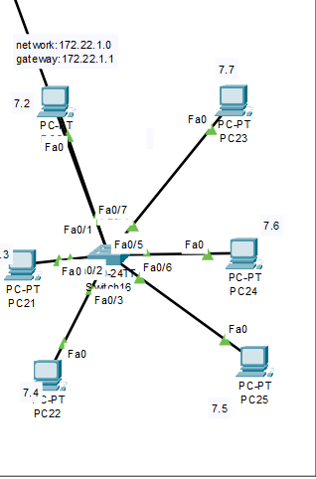

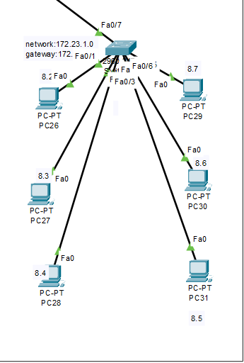

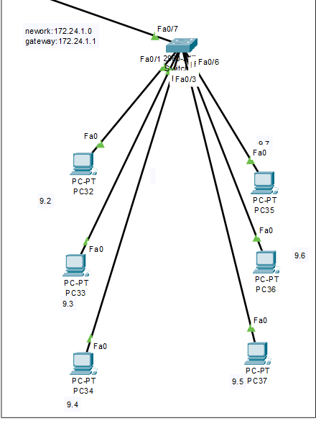

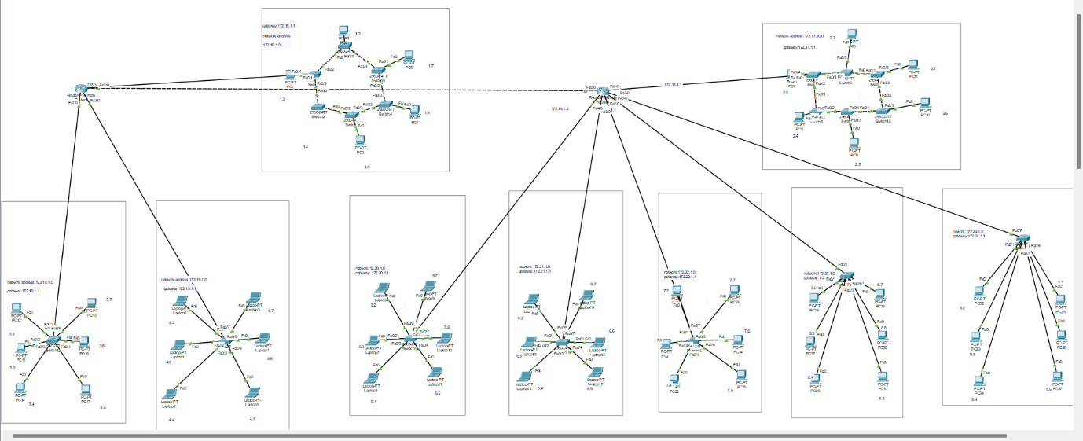

* **Network addresses to each floor:**

|  |  |  |
| --- | --- | --- |
| **S.no.** | **Floors** | **Network Address** |
| 1. | Floor 1 | 172.16.1.0 |
| 2. | Floor 2 | 172.17.1.0 |
| 3. | Floor 3 | 172.18.1.0 |
| 4. | Floor 4 | 172.19.1.0 |
| 5. | Floor 5 | 172.20.1.0 |
| 6. | Floor 6 | 172.21.1.0 |
| 7. | Floor 7 | 172.22.1.0 |
| 8. | Floor 8 | 172.23.1.0 |
| 9. | Floor 9 | 172.24.1.0 |

* **Number of Floor’s: -** 9 Floors
* **Type of Networking: -** Static
* **Number of Topology’s: -** 2
* **Type of Topology: -** 1st and 2nd floor it’s **Ring Topology**,

3-9 it’s **Star Topology**.

* **Number of devices connected in each floor: -** 6 Devices connected each floor
* **GitHub Link: -** <https://github.com/reddy-manjunath/network_project.git>

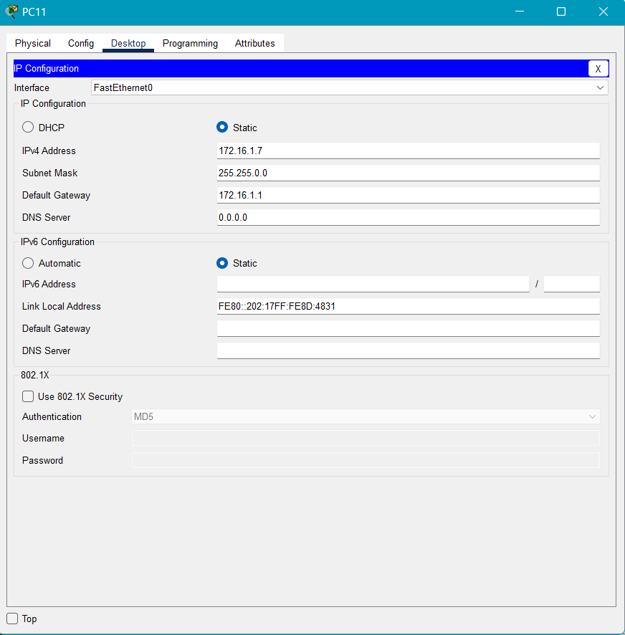***2. How you have assigned the IP. Attach snapshot.***

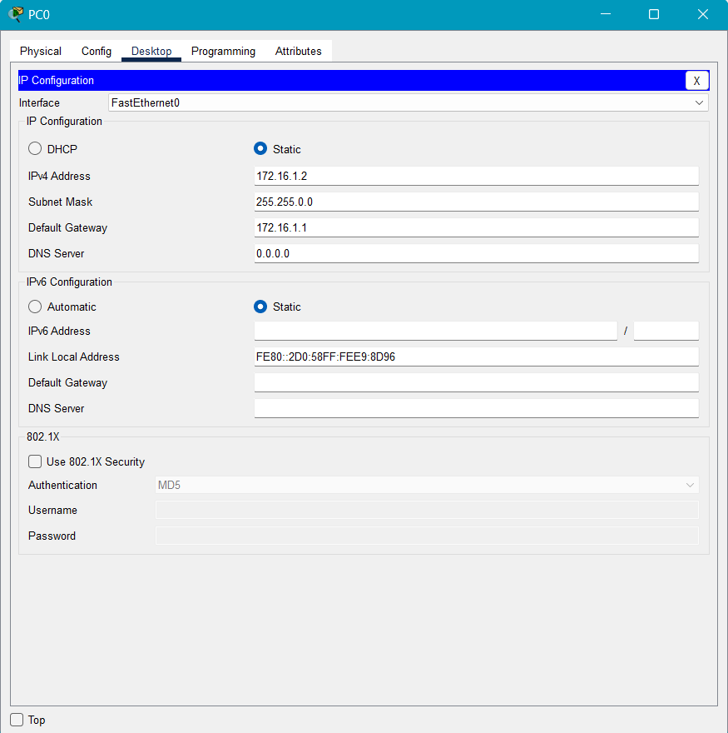

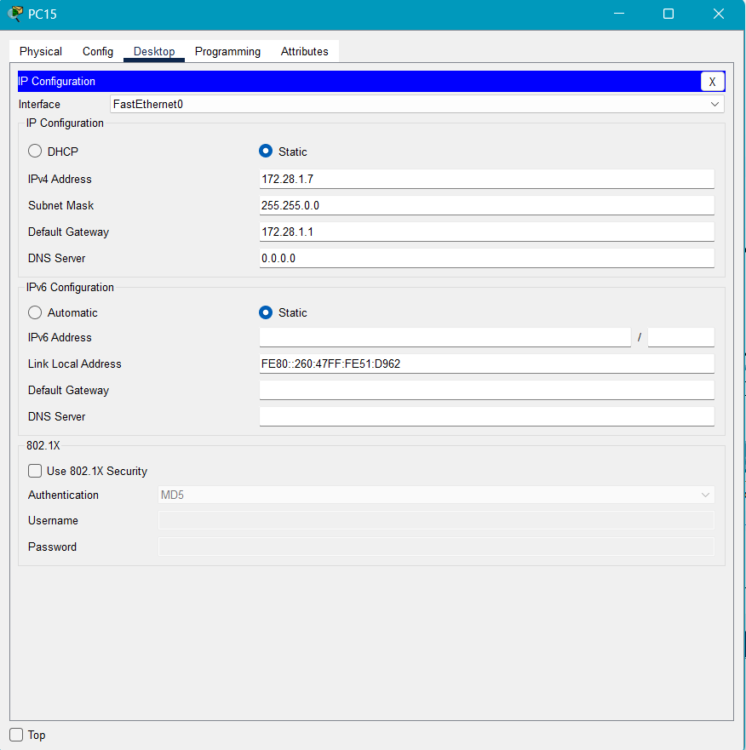

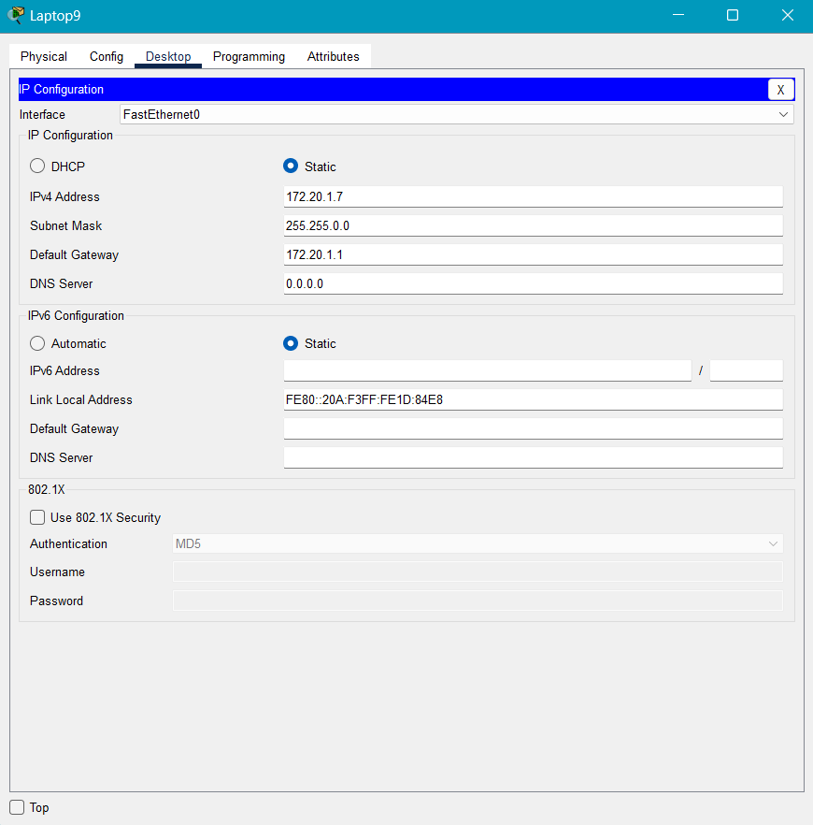

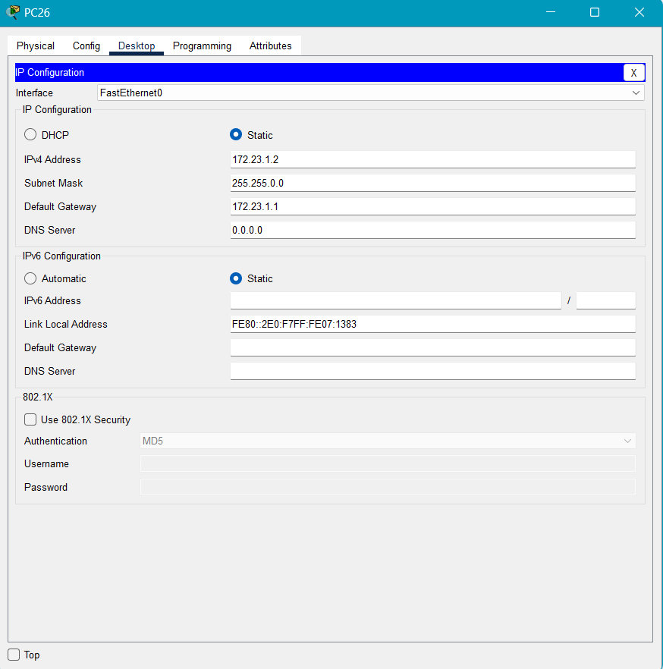

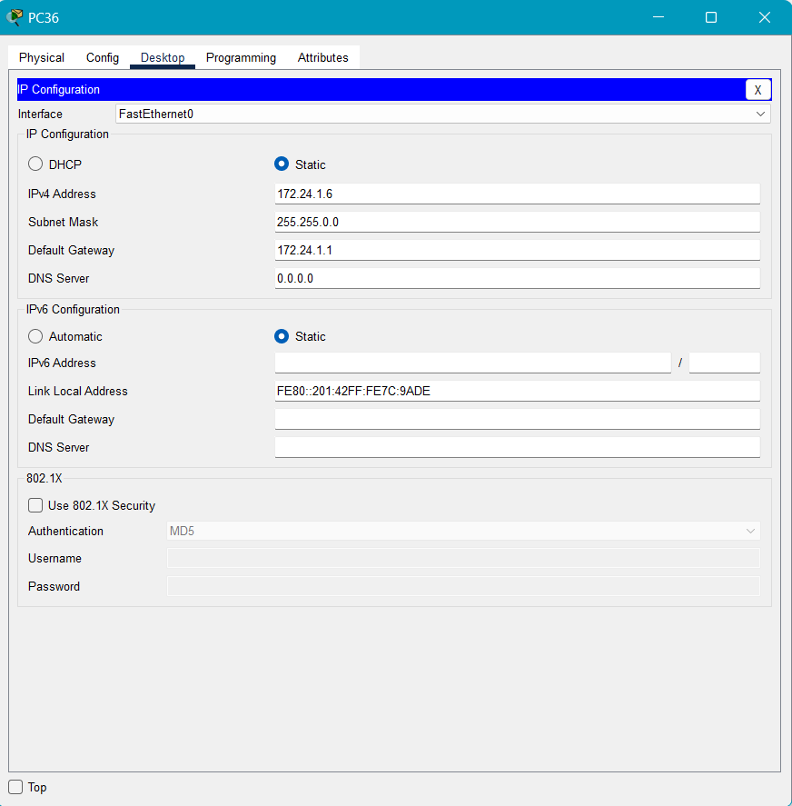

***3. How you have done the routing. Attach snapshot.***

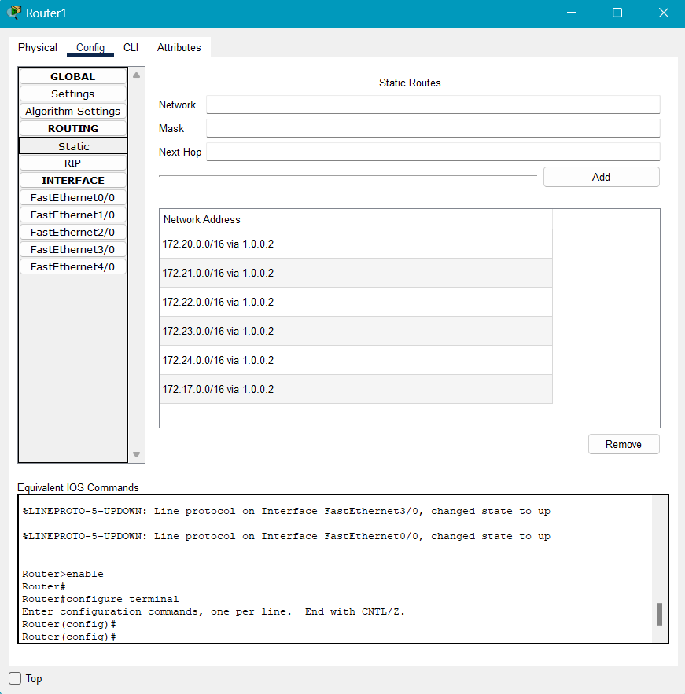

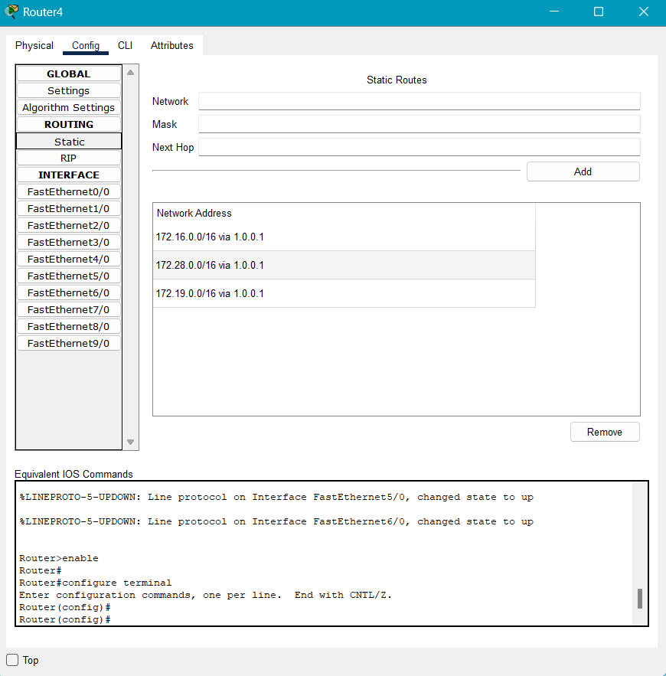

**4. Then show the communication between all pc. Attach snapshot.**

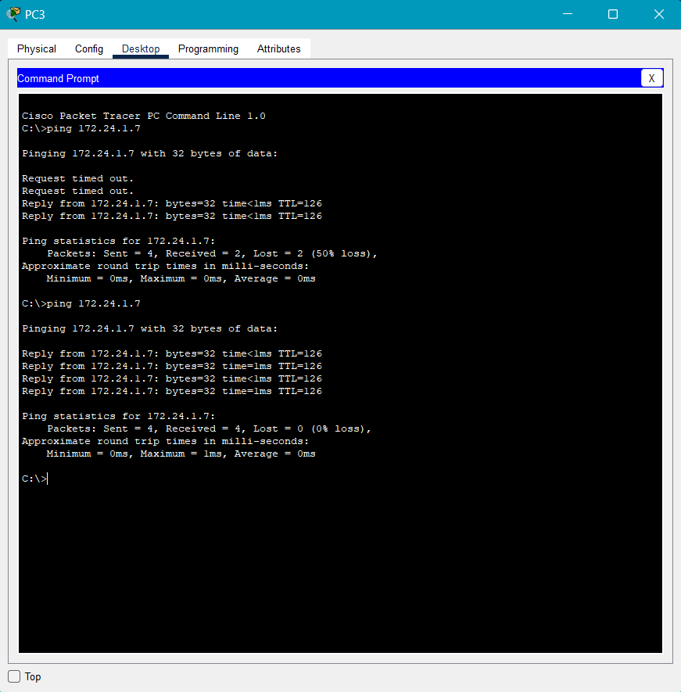

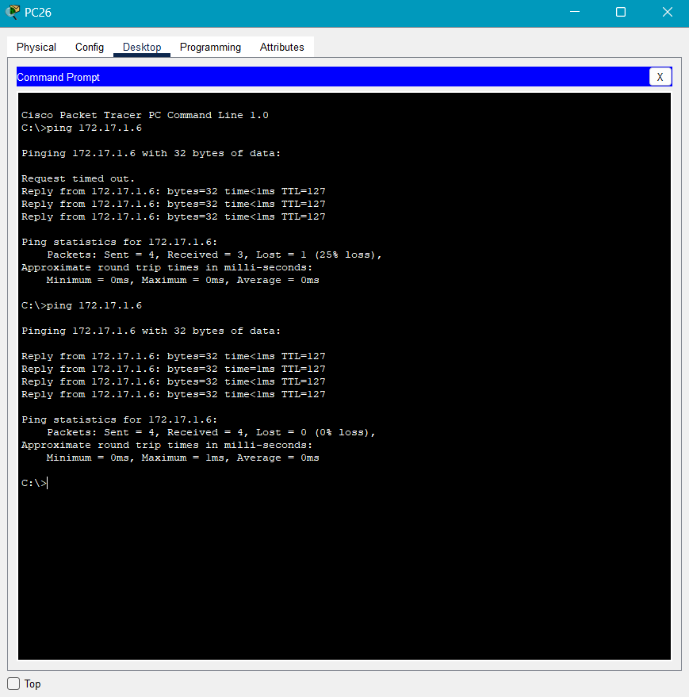

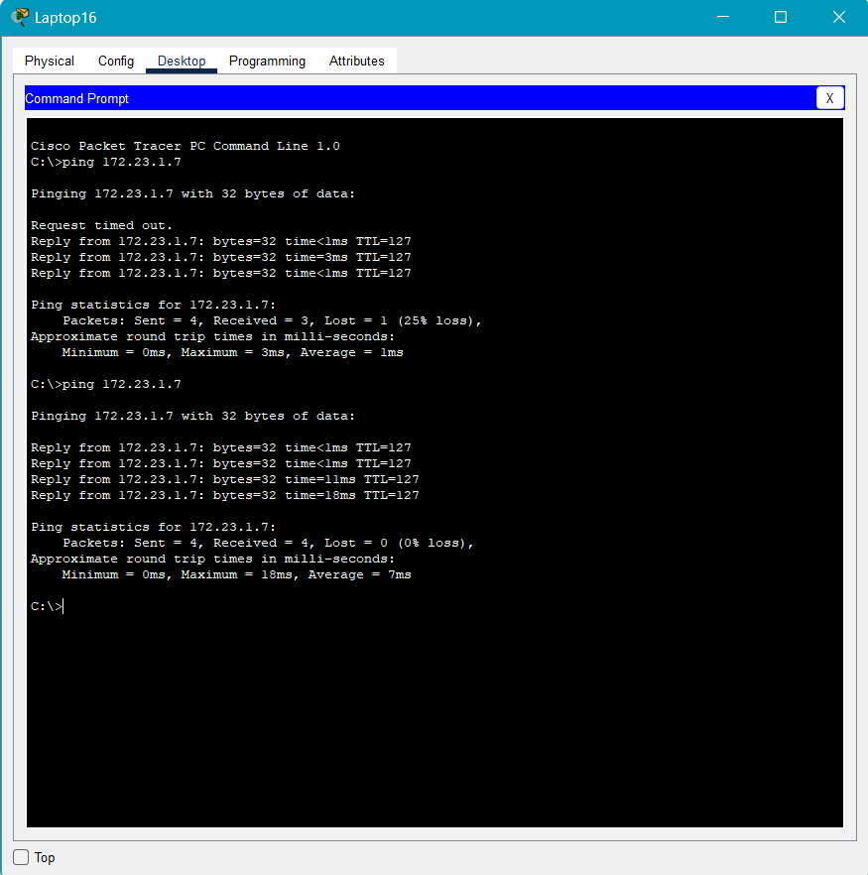

**GitHub Link: -**[**https://github.com/reddy-manjunath/network_project.git**](https://github.com/reddy-manjunath/network_project.git)